VYNL
Product Requirements Document (PRD)
AI-Powered Personalized Music Streaming Platform
Document Title | VYNL — Product Requirements Document
Version | 1.0
Status | Draft --- Technology Stack Defined
Date | 12 August 2026
Product | VYNL Web Application (MVP)
Prepared For | VYNL Product & Engineering Team

1. Executive Summary
VYNL is an AI-powered music streaming web platform built around a continuous personalization loop. Rather than relying on static playlists and generic recommendation logic, VYNL observes how each user actually listens — what they play, skip, search for, and queue — and sends the current song together with relevant user activity and listening context to a configured LLM API, which generates personalized song recommendations and optional reasoning. The MVP combines AI-assisted queueing, AI-assisted playlist generation, collaborative human+AI playlists, synchronized and customizable interactive lyrics, high-quality streaming/download, and a personalized Monthly Wrap into a single cohesive web product.
This document defines the product's purpose, target users, feature scope, and success criteria for the initial (MVP) release, and provides the shared reference from which the accompanying SRS and System Architecture documents are derived.

2. Problem Statement
Most mainstream streaming platforms generate recommendations from broad collaborative-filtering signals and present them without explanation, which makes the experience feel generic and opaque. Users cannot easily tell why a song was suggested, cannot easily build a playlist around a very specific mood using only a few reference tracks, and have limited ways to build music experiences collaboratively with friends. Lyrics experiences are typically static text overlays rather than an immersive, customizable part of playback.
VYNL addresses this by making personalization transparent (via LLM-generated reasoning), making playlist creation AI-assisted and mood/reference-driven, enabling collaborative playlist curation between multiple users and AI, and turning lyrics into a customizable, synchronized, immersive surface.

3. Goals and Objectives

3.1 Business Goals
- Launch a differentiated MVP web product that demonstrates clear personalization value within the first listening session.
- Establish an efficient, cost-controlled audio storage and delivery pipeline that minimizes repeated external API usage.
- Build a foundation of user activity data sufficient to provide rich context to future LLM recommendation and personalization requests.
- Validate user engagement and retention signals (returning sessions, wrap engagement) to justify further investment (mobile apps, monetization).

3.2 Product Objectives
- Deliver song recommendations that are explainable, not just accurate — every recommendation carries a human-readable reason.
- Let users generate a complete, coherent playlist from a small set of seed inputs (genres, artists, 3-5 reference songs).
- Support collaborative playlists where multiple users and the AI contribute to a single shared playlist.
- Provide an immersive, customizable synchronized-lyrics experience during playback.
- Provide reliable high-quality streaming with minimal repeat-latency for previously requested songs.
- Summarize each user's monthly listening activity into an engaging, shareable Monthly Wrap.

4. Target Audience and User Personas

4.1 Primary Audience
Digitally engaged music listeners (roughly ages 16-35) who listen to music daily, are active playlist curators, and value discovery and personalization over passive consumption.

4.2 User Personas

Persona 1 — "The Curator"
- Actively builds and maintains playlists for different moods and occasions.
- Wants AI assistance to speed up playlist creation without losing creative control.
- Values explanations for recommendations over black-box suggestions.

Persona 2 — "The Social Listener"
- Shares music with friends and enjoys building playlists together.
- Wants a collaborative space where multiple people (and AI) shape one playlist.

Persona 3 — "The Immersive Listener"
- Listens with lyrics on, wants a visually engaging, personalized playback screen.
- Cares about audio quality and the ability to download for offline listening.

Persona 4 — "The Reflective Listener"
- Enjoys end-of-period recaps (e.g., existing "year/month in review" features on other platforms).
- Engages with the Monthly Wrap as a way to understand and share their own listening identity.

5. Scope

5.1 In Scope (MVP — Web Application)
- AI-assisted queue creation and next-song recommendation through the configured LLM API.
- AI-assisted playlist generation from user-specified genres, artists, and 3-5 reference songs.
- Collaborative playlists shared between multiple registered users, with AI-assisted suggestions.
- Custom, interactive, synchronized lyrics with selectable or user-uploaded backdrops.
- High-quality streaming and, where supported, download for offline/personal use.
- Personalized Monthly Wrap summarizing listening activity and preferences.
- Fetch-once-and-reuse audio storage and streaming pipeline (Telegram-based persistent storage).
- Context-driven LLM recommendation using the current song and accumulated user activity; no VYNL-owned recommendation model is trained.

5.2 Out of Scope (MVP)
- Native iOS/Android mobile applications (web-only for this release).
- Offline-first mobile playback and background sync.
- Paid subscription tiers, billing, and monetization workflows.
- Podcast, audiobook, or non-music audio content.
- Real-time (sub-daily) recommendation-model retraining.
- Social graph features beyond collaborative playlists (e.g., public profiles, follower feeds).

6. Key Features

6.1 AI-Assisted Queue Creation and Song Recommendation
When a user plays a song or playlist, the system prepares an AI context containing the current track, relevant song attributes, listening history, recent interactions, and other useful user activity. This context is sent to the configured LLM API, which returns a structured set of recommended songs. The system resolves each returned song through the Storage & Streaming pipeline before adding it to the user's queue.

6.2 AI-Assisted Playlist Suggestion and Creation
Users specify genres and artists of interest and provide approximately 3-5 reference songs representing the desired mood or direction. The backend sends these inputs and available reference-song context to the configured LLM API, which returns a complete ordered playlist. VYNL resolves the returned songs through the Storage & Streaming pipeline before presenting the playlist for review and saving.

6.3 Collaborative Playlists Between Users and AI
Multiple users can contribute to the same playlist — adding, removing, or reordering songs together. The LLM API can receive the combined playlist contents, participant contributions, and relevant group context and return additional song suggestions. Suggested songs are resolved through the Storage & Streaming pipeline before being added or presented.

6.4 Custom and Interactive Synchronized Lyrics
Lyrics are synchronized with playback and progress in real time with the currently playing section. Users can select from pre-designed lyric backdrops or upload their own image, turning the lyrics screen into a personalized, visually immersive surface rather than a plain text overlay.

6.5 High-Quality Music Streaming and Download
Songs acquired for the first time are permanently stored in the platform's audio storage system, with a unique file reference retained for reuse. Subsequent requests for the same song are served from this stored reference rather than being re-fetched from the external source. Where supported, users can download songs for offline or personal use.

6.6 Monthly Wrap
Each user receives a personalized Monthly Wrap summarizing their listening activity, including:
- Total listening activity
- Most-played songs and most-listened-to artists
- Favorite genres and listening patterns
- Frequently replayed and skipped songs
- Newly discovered artists
- Other relevant listening statistics

7. Success Metrics / KPIs
Metric | Description | MVP Target
Recommendation engagement rate | % of AI-recommended queue songs played to completion or > 50% | ≥ 35%
Explanation view/interaction rate | % of users who view or interact with LLM recommendation explanations | ≥ 40%
AI playlist completion rate | % of started AI playlist-generation flows that result in a saved playlist | ≥ 60%
Collaborative playlist adoption | % of active users who join or create at least one collaborative playlist | ≥ 15%
Cache-hit / reuse rate | % of song requests served from stored File ID vs. new external API fetch | ≥ 70% after ramp-up
Monthly Wrap engagement | % of eligible users who open their Monthly Wrap | ≥ 50%
7-day retention | % of new users returning within 7 days | ≥ 25%

8. Assumptions and Constraints

8.1 Assumptions
- Users access VYNL through a modern desktop or mobile web browser; no native app is required for MVP.
- An open-source Song API, ReccoBeats/FreqBlog, and Discogs remain available and usable as external data/audio sources.
- A private Telegram channel is an acceptable persistent audio storage mechanism for the MVP stage.
- Sufficient user activity is retained to provide useful context to the LLM API for future recommendation and personalization requests.

8.2 Constraints
- The technology stack has been defined: React + Vite + TypeScript (Frontend), FastAPI (Backend), Supabase (Database without ORM), Google OAuth (Authentication), Telegram Private Channel (Audio Storage), and Configured External LLM API Provider.
- Reliance on third-party/open-source APIs introduces dependency on their availability, rate limits, and terms of use.
- Audio storage via a Telegram channel is subject to Telegram's platform policies and file-handling limits.
- Recommendation quality depends on the quality, recency, and availability of the context supplied to the external LLM API; no daily model retraining is performed.

9. Release Milestones (High-Level)
Phase | Milestone | Key Deliverables
Phase 1 | Core Playback & Storage | Auth, search/play, Storage & Streaming pipeline, base DB schema
Phase 2 | Recommendations & Explanations | LLM API recommendation service, response validation, song resolution, personal queue
Phase 3 | Playlists & Collaboration | AI playlist generation, collaborative playlists
Phase 4 | Immersive Lyrics | Synchronized lyrics, backdrop customization / upload
Phase 5 | Insights & Learning Loop | Activity logging, LLM context pipeline, Monthly Wrap
Phase 6 | MVP Hardening | Performance, security review, beta feedback incorporation

10. Stakeholders
Role | Responsibility
Product Owner | Defines and prioritizes product scope and roadmap
Engineering / Backend Team | Implements application services, storage & streaming, and API integrations
ML / Data Team | Implements and maintains the LLM API integration, recommendation context, and response validation
Frontend Team | Builds the web client, playback, lyrics, and playlist UI
QA | Validates functional and non-functional requirements prior to release
End Users | Primary consumers of the platform; source of listening/activity data

11. Open Questions
- What are the licensing/rate-limit terms of the open-source Song API and fallback services at production scale?
- Will monetization (ads, subscription) be introduced in a later phase, and how might it affect download/offline features?
- What is the target initial user base size for capacity planning beyond the general MVP scale assumed in the SRS?

VYNL
Software Requirements Specification (SRS)
AI-Powered Personalized Music Streaming Platform
Document Title | VYNL — Software Requirements Specification
Version | 1.0
Status | Draft --- Technology Stack Defined
Date | 12 August 2026
Conformance | Structured per IEEE 830 conventions
Related Documents | VYNL PRD v1.0, VYNL System Architecture v1.0

1. Introduction

1.1 Purpose
This Software Requirements Specification (SRS) defines the functional and non-functional requirements for VYNL, an AI-powered personalized music streaming web platform. It translates the product intent described in the PRD into verifiable software requirements that guide design, implementation, and testing.

1.2 Scope
VYNL enables registered users to search, stream, and download music; receive AI-generated, explainable song and playlist recommendations; build playlists individually or collaboratively with AI assistance; experience synchronized and customizable lyrics; and view a personalized Monthly Wrap of their listening activity. The system also maintains an internal Storage & Streaming pipeline, an AI Recommendation & Personalization pipeline, and an activity/context pipeline used to supply relevant information to the configured LLM API. This release targets the web platform only.

1.3 Definitions, Acronyms, and Abbreviations
Term | Definition
AI/ML | Artificial Intelligence
LLM | Large Language Model API used as the AI decision layer for recommendations, playlists, collaborative suggestions, and reasoning
File ID | Unique reference issued by the audio storage channel for a stored song file
MVP | Minimum Viable Product
NFR | Non-Functional Requirement
FR | Functional Requirement
Queue | The ordered list of upcoming songs for a user's current listening session
Wrap | The Monthly Wrap listening-activity summary feature
Fetch-once-and-reuse | Pattern where a song is fetched from an external source only once and reused from storage thereafter

1.4 References
- VYNL Product Requirements Document (PRD), v1.0
- VYNL System Architecture Document, v1.0
- VYNL project brief / feature description (source material provided by stakeholders)

1.5 Overview
Section 2 describes the product context and overall characteristics. Section 3 specifies detailed functional requirements grouped by feature area. Section 4 specifies external interface requirements. Section 5 specifies non-functional requirements. Section 6 describes data requirements. Section 7 documents key use cases.

2. Overall Description

2.1 Product Perspective
VYNL is a new, self-contained web-based product. It integrates with external services for song acquisition (an open-source Song API), audio-feature enrichment (a local dataset with ReccoBeats/FreqBlog as fallback), and release metadata (Discogs), and uses a private Telegram channel as its persistent audio storage layer. It is not a plug-in or extension of an existing platform.

2.2 Product Functions (Summary)
- User registration, authentication, and session management.
- Song search, playback, and queue management.
- Fetch-once-and-reuse audio storage and streaming pipeline.
- LLM-driven next-song recommendation using the current song and relevant user activity/context, with optional LLM-generated reasoning.
- AI-assisted playlist generation from user-specified seeds.
- Collaborative, multi-user playlist editing with AI suggestions.
- Synchronized, customizable interactive lyrics display.
- Song download for offline/personal use (where supported).
- User activity logging and context preparation for LLM-powered recommendations.
- Personalized Monthly Wrap generation.

2.3 User Classes and Characteristics
User Class | Characteristics
Registered Listener | Primary user class; searches, streams, downloads, and interacts with recommendations and playlists
Collaborative Playlist Member | A registered listener participating in a shared playlist with other users
System / Background Processes | Non-human actor representing the background enrichment, activity processing, and LLM API request workflows
Administrator (limited MVP scope) | Monitors system health, data pipeline status, and content availability

2.4 Operating Environment
- Client: modern desktop and mobile web browsers (current versions of Chrome, Firefox, Safari, Edge).
- Server-side: cloud or server-hosted FastAPI (Python) backend service with Supabase (PostgreSQL) database.
- External dependencies: open-source Song API, ReccoBeats/FreqBlog, Discogs, and a private Telegram channel used as the audio storage backend.

2.5 Design and Implementation Constraints
- The backend technology stack is FastAPI (Python) with a Supabase database, and the frontend is React 18 + Vite + TypeScript.
- Audio persistence depends on a private Telegram channel and its File ID mechanism, which the system must treat as an external storage dependency.
- LLM recommendation requests are made at runtime using the current song and relevant user activity/context; no recommendation-model retraining occurs.
- Song attribute lookups prioritize a local dataset before falling back to external enrichment sources.

2.6 Assumptions and Dependencies
- External APIs (Song API, ReccoBeats/FreqBlog, Discogs) remain available and within usable rate limits.
- Telegram's file storage and File ID mechanism remain stable and accessible to the backend.
- Sufficient user activity is available to provide useful context for runtime LLM requests.

3. Functional Requirements

3.1 User Account & Authentication
ID | Requirement
FR-1.1 | The system shall allow a new user to register an account with a unique identifier (e.g., email) and credentials.
FR-1.2 | The system shall authenticate a registered user before granting access to search, playback, playlist, and wrap features.
FR-1.3 | The system shall maintain a user session for the duration of an active visit and expire it after a defined period of inactivity.
FR-1.4 | The system shall allow a user to log out, terminating the active session.

3.2 Song Search, Playback, and Storage/Streaming
ID | Requirement
FR-2.1 | The system shall allow an authenticated user to search for a song by name.
FR-2.2 | Upon a song request, the system shall check the database to determine whether the song is already stored.
FR-2.3 | If the song already exists in the database, the system shall retrieve its stored File ID and generate a temporary playable/downloadable link without contacting the external Song API.
FR-2.4 | If the song does not exist in the database, the system shall request it from the open-source Song API, which shall return the song as an audio file.
FR-2.5 | The system shall upload a newly fetched audio file to the private Telegram channel used as persistent audio storage.
FR-2.6 | The system shall store the resulting unique File ID, together with the song's metadata and attributes, in the database for future reuse.
FR-2.7 | The system shall generate a temporary streaming/download link from a stored File ID whenever a song is requested.
FR-2.8 | The system shall play the requested song to the user via the generated temporary link.
FR-2.9 | Where supported, the system shall allow the user to download a song for offline or personal use.
FR-2.10 | The system shall retrieve song attributes (song_name, artist_name, artist_genres, artist_popularity, release_year, danceability, energy, valence, tempo, acousticness, speechiness, instrumentalness, liveness, popularity) from the local dataset when available.
FR-2.11 | If a song's attributes are not present in the local dataset, the system shall retrieve them from ReccoBeats/FreqBlog as a fallback source.
FR-2.12 | The system shall retrieve release-related metadata for a song/artist/album from Discogs and display it to the user during playback.
FR-2.13 | The system shall persist retrieved Discogs metadata in the database for reuse in future requests.

3.3 AI-Assisted Queue & Recommendation
ID | Requirement
FR-3.1 | When a user plays a song or playlist, the system shall send the current track, relevant listening history, prior interactions, and available song attributes as context to the configured LLM API.
FR-3.2 | Upon completion of the current song or playlist, the system shall present a queue of AI-recommended songs returned by the configured LLM API after response validation and song resolution.
FR-3.3 | For each recommended song, the system shall display any recommendation reason returned by the LLM API.
FR-3.4 | The LLM recommendation context shall incorporate the user's listening history/preferences and the current/recent song attributes where available.
FR-3.5 | The system shall add AI-recommended songs to the user's personal queue.

3.4 AI-Assisted Playlist Creation
ID | Requirement
FR-4.1 | The system shall allow a user to specify one or more genres and artists as playlist seeds.
FR-4.2 | The system shall allow a user to provide approximately 3-5 reference songs representing the desired mood, style, or direction.
FR-4.3 | The system shall generate a complete, custom-curated playlist aligned with the specified genres, artists, and reference songs.
FR-4.4 | The system shall allow the user to save the AI-generated playlist for future access.

3.5 Collaborative Playlists
ID | Requirement
FR-5.1 | The system shall allow a user to create a playlist that supports contributions from multiple users.
FR-5.2 | The system shall allow invited/participating users to add, remove, or reorder songs within a shared playlist.
FR-5.3 | The system shall analyze the combined preferences and contributions of participating users to suggest additional songs likely to appeal to the group.
FR-5.4 | The system shall reflect changes made by any collaborator to all participants viewing the shared playlist.

3.6 Synchronized Interactive Lyrics
ID | Requirement
FR-6.1 | The system shall display lyrics synchronized to the currently playing position of a song, where lyric data is available.
FR-6.2 | The system shall progress the highlighted/active lyric line in real time as playback continues.
FR-6.3 | The system shall allow a user to select a pre-designed lyric backdrop for the lyrics display.
FR-6.4 | The system shall allow a user to upload a custom image to use as the lyrics backdrop.

3.7 Activity Logging
ID | Requirement
FR-7.1 | The system shall log user activities including songs searched, played, and skipped.
FR-7.2 | The system shall log listening duration for each played song.
FR-7.3 | The system shall log songs added to or removed from the queue and/or playlists.
FR-7.4 | The system shall log likes and user interactions with recommended songs and explanations.
FR-7.5 | The system shall persist logged activity in an accumulated activity store for context in future LLM API requests.

3.8 LLM API Recommendation & Context
ID | Requirement
FR-8.1 | The system shall send the current song and relevant user activity/context to the configured LLM API when generating recommendations.
FR-8.2 | The system shall validate, normalize, and resolve the LLM API's structured song response before serving recommendations.
FR-8.3 | The system shall continue logging user activity throughout the day so that relevant context is available to future LLM requests.

3.9 Monthly Wrap
ID | Requirement
FR-9.1 | The system shall generate a personalized Monthly Wrap for each active user at the end of each calendar month (or on-demand for the current month-to-date).
FR-9.2 | The Monthly Wrap shall include total listening activity, most-played songs, most-listened-to artists, favorite genres, listening patterns, frequently replayed songs, skipped songs, and newly discovered artists.
FR-9.3 | The system shall allow the user to view their Monthly Wrap within the application.

4. External Interface Requirements

4.1 User Interfaces
- A responsive web UI providing: search, playback controls, personal queue, playlist management, collaborative playlist view, synchronized lyrics view, and Monthly Wrap view.
- Recommendation explanations shall be visibly associated with their corresponding song in the queue/UI.

4.2 Hardware Interfaces
- No specialized hardware is required; standard client devices (desktop/laptop/mobile) with audio output and internet connectivity are sufficient.

4.3 Software Interfaces
Interface | Purpose
Open-Source Song API | Provides audio files for songs not already stored in the system
Telegram (Private Channel / Bot API) | Persistent audio storage; issues File IDs used for stream/download link generation
Local Song Attributes Dataset | Primary source of song/artist audio-feature metadata
ReccoBeats / FreqBlog | Fallback source for audio features when a song is absent from the local dataset
Discogs API | Source of release-related metadata (song, artist, album, release)
LLM Recommendation Service | Service integrating with the configured LLM API to produce personalized song recommendations
LLM API Service | External/internal LLM API used for recommendations, playlist generation, collaborative suggestions, and reasoning

4.4 Communications Interfaces
- All client-server communication shall occur over HTTPS.
- Temporary streaming/download links shall be time-limited and shall not permanently expose the underlying storage reference.

5. Non-Functional Requirements

5.1 Performance
ID | Requirement
NFR-1.1 | For a song already stored in the system, playback shall begin within 3 seconds of request under normal load.
NFR-1.2 | For a song requiring first-time acquisition from the external Song API, playback shall begin within 10 seconds under normal load, excluding third-party API latency outside system control.
NFR-1.3 | The system shall support at least 500 concurrent active listening sessions at MVP/startup scale without degradation of core playback functionality.
NFR-1.4 | AI playlist generation from user seeds shall complete within 15 seconds under normal load.
NFR-1.5 | LLM API recommendation requests shall complete within the defined runtime latency target without blocking core playback.

5.2 Scalability
- The system shall be designed to scale horizontally at the application-service layer to accommodate MVP-to-growth-stage user increases.
- The Storage & Streaming pipeline shall avoid redundant external API calls as the user base and song catalog grow, preserving the fetch-once-and-reuse pattern.

5.3 Availability and Reliability
ID | Requirement
NFR-3.1 | Core playback, search, and streaming functionality shall target 99.5% monthly uptime for the MVP stage.
NFR-3.2 | If the LLM recommendation service is temporarily unavailable, the system shall degrade gracefully (e.g., fall back to previously queued, recently played, or deterministic songs) rather than blocking playback.
NFR-3.3 | If LLM reasoning is unavailable but the recommendation response is usable, the system shall still present the resolved recommended songs without blocking on reasoning.
NFR-3.4 | Failure of an LLM API request shall not corrupt playback or existing queues; the system shall retain existing queue state and use a defined fallback.

5.4 Security
ID | Requirement
NFR-4.1 | User credentials shall be stored using industry-standard hashing; plaintext passwords shall never be persisted or logged.
NFR-4.2 | All communication between client and server shall be encrypted in transit (HTTPS/TLS).
NFR-4.3 | Temporary streaming/download links shall expire after a limited time window and shall not be guessable/enumerable.
NFR-4.4 | Access to collaborative playlist edit actions shall be restricted to authenticated participants of that playlist.
NFR-4.5 | Credentials/tokens for external services (Song API, Telegram, Discogs) shall be stored securely and never exposed to the client.

5.5 Usability
- Core actions (search, play, queue, save playlist) shall be reachable within 3 interactions from the main screen.
- Recommendation explanations shall be written in plain, non-technical language understandable to a general listener.
- The interface shall be responsive across common desktop and mobile browser viewport sizes.

5.6 Maintainability
- The Storage & Streaming, Recommendation, and LLM Explanation capabilities shall be logically separable services/modules to allow independent updates.
- Audio-feature and metadata schemas shall be documented and versioned to support future dataset or provider changes.

5.7 Data Retention & Compliance
- User activity data used as LLM personalization context shall be retained according to a defined retention policy to be established prior to production launch.
- The system shall provide a mechanism for a user to request deletion of their account and associated personal data, consistent with applicable data-protection practices.

6. Data Requirements
The following core entities are required to support the functional requirements above. Exact schema/field types are to be finalized during detailed design.
Entity | Key Attributes (indicative)
User | user_id, email, password_hash, created_at, preferences
Song | song_id, song_name, artist_name, artist_genres, release_year, telegram_file_id, danceability, energy, valence, tempo, acousticness, speechiness, instrumentalness, liveness, popularity
Discogs Metadata | song_id (ref), release info, label, catalog details
Playlist | playlist_id, owner_id, title, is_collaborative, song_ids[], created_at
Playlist Collaborator | playlist_id (ref), user_id (ref), role/permissions
Queue | user_id (ref), ordered song_ids[], generated_at, source (AI/manual)
Recommendation Explanation | recommendation_id, user_id (ref), song_id (ref), explanation_text, generated_at
User Activity Log | activity_id, user_id (ref), song_id (ref), action_type (search/play/skip/like/queue_add/queue_remove), timestamp, listening_duration
Monthly Wrap | wrap_id, user_id (ref), period, top_songs[], top_artists[], top_genres[], stats
LLM Request / Recommendation Record | request_id, user_id (ref), current_song_id (ref), context_window, provider, model, response_status, generated_at

7. Key Use Cases

UC-1: Play a Song and Receive AI Recommendations
- Actor: Registered Listener
- Precondition: User is authenticated.
Main flow:
- User searches for and selects a song.
- System checks the database for an existing File ID; fetches from the Song API and stores in Telegram if not found.
- System retrieves/enriches song metadata and audio features.
- System streams the song to the user.
- On completion, system sends the current song and relevant user activity/context to the configured LLM API, which returns structured song recommendations.
- System validates the LLM response, resolves each returned song through Storage & Streaming, and presents the resulting queue with any returned recommendation reasons.

UC-2: Generate an AI-Assisted Playlist
- Actor: Registered Listener
Main flow:
- User provides genres, artists, and 3-5 reference songs.
- System analyzes inputs and generates a curated playlist.
- User reviews and saves the playlist.

UC-3: Collaborate on a Shared Playlist
- Actors: Multiple Registered Listeners
Main flow:
- A user creates a collaborative playlist and invites participants.
- Participants add, remove, or reorder songs.
- System analyzes group contributions and suggests additional songs.
- Changes are reflected for all participants.

UC-4: View Monthly Wrap
- Actor: Registered Listener
Main flow:
- System aggregates the user's activity data for the completed period.
- System generates the Wrap summary.
- User views their personalized Monthly Wrap.

UC-5: Generate LLM-Powered Recommendations (Runtime)
- Actor: System / LLM API integration
Main flow:
- The backend prepares the current-song and user-activity context for the LLM API.
- The backend sends the prepared context to the configured LLM API.
- The system validates and normalizes the structured LLM response.
- The system resolves the returned songs through Storage & Streaming and adds them to the user's queue; the activity is retained for future context.

VYNL
System Architecture Document
AI-Powered Personalized Music Streaming Platform
Document Title | VYNL — System Architecture Document
Version | 1.0
Status | Draft --- Technology Stack Defined
Date | 12 August 2026
Related Documents | VYNL PRD v1.0, VYNL SRS v1.0

1. Purpose and Architectural Approach
This document describes the architecture of VYNL. The core technology stack has been defined to guide the implementation of backend services, database storage, and integrations, while maintaining clean separation of concerns between layers.

1.1 Architectural Principles
- Separation of concerns: streaming/storage, recommendation, explanation, and collaboration are distinct logical services.
- Fetch-once-and-reuse: external audio and metadata sources are called only when data is not already persisted.
- Graceful degradation: the LLM API is auxiliary to core playback and must not block playback if unavailable.
- Context-driven personalization: recommendation quality is improved by supplying the LLM API with the current song and relevant, recent user activity rather than by training a separate model.

1.2 Core Technology Stack
Frontend: React 18 + Vite + TypeScript (TSX), utilizing CSS Modules for component styling and framer-motion for transitions.
Backend / API Layer: FastAPI (Python), providing asynchronous REST API endpoints and WebSockets for real-time collaborative playlists.
Database: Supabase (PostgreSQL) is the primary relational database. No traditional ORM is used for the MVP; the backend interacts with the database directly using SQL drivers (asyncpg) or the official supabase-py client library.
Audio Storage: Persistent storage in a Telegram Private Channel. Audio files are stored under Telegram File IDs, and streaming/download links are generated dynamically.
Authentication: Google OAuth 2.0.
LLM Provider: Configured external LLM API used as the AI decision layer for song recommendations, playlist generation, collaborative suggestions, and recommendation reasoning.
Machine Learning: No separate VYNL-owned recommendation model is required for the MVP; recommendation decisions are delegated to the configured LLM API.

2. High-Level Architecture Overview
VYNL is organized into five conceptual layers: a Client Layer (web application), an Application/API Layer (authentication and request routing), a Core Service Layer (domain services), a Data & Storage Layer (application database, persistent audio storage, and local dataset), and an External Integrations layer containing the configured LLM API and music/metadata providers.
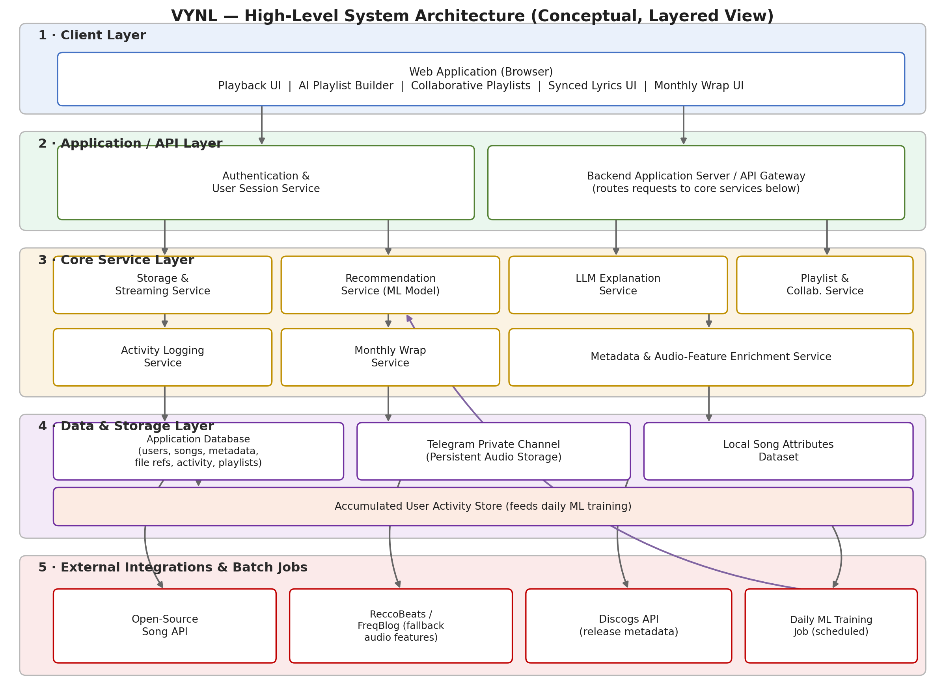
Figure 1 — VYNL high-level layered architecture (conceptual).

2.1 Layer Descriptions
Layer | Responsibility
1. Client Layer | Web application UI: playback, AI playlist builder, collaborative playlists, synchronized lyrics, Monthly Wrap
2. Application / API Layer | Authentication/session management and a backend API gateway that routes requests to core services
3. Core Service Layer | Storage & Streaming, Recommendation (ML), LLM Explanation, Playlist/Collaboration, Activity Logging, Monthly Wrap, Metadata/Audio-Feature Enrichment
4. Data & Storage Layer | Application database, Telegram-based persistent audio storage, local song-attribute dataset, accumulated activity store
5. External Integrations & Batch Jobs | Open-source Song API, ReccoBeats/FreqBlog, Discogs, and the configured LLM API

3. Component Descriptions

3.1 Web Application (Client)
The single web client through which all user interaction occurs. It hosts playback controls, search, the personal queue, AI playlist builder, collaborative playlist editor, synchronized/customizable lyrics view, and the Monthly Wrap view. It communicates with the backend exclusively through the API layer.

3.2 Authentication & Session Service
Handles registration, login, credential verification, and session/token lifecycle management. All other services treat this as the source of truth for "who is making this request."

3.3 Backend Application Server / API Gateway
Receives client requests, enforces authentication, and routes each request to the appropriate core service. Acts as the single entry point so the client does not need to know the internal service topology.

3.4 Storage & Streaming Service
Implements the fetch-once-and-reuse pipeline described in Section 4. Responsible for checking the database for an existing song, fetching from the external Song API when necessary, uploading new audio to the Telegram private channel, storing the resulting File ID, and generating temporary streaming/download links.

3.5 Metadata & Audio-Feature Enrichment Service
Resolves song attributes (danceability, energy, valence, tempo, etc.) by first checking the local dataset and falling back to ReccoBeats/FreqBlog when a song is not present locally. Also retrieves and persists Discogs release metadata for display and reuse.

3.6 AI Recommendation Service (LLM API)
Prepares the current song, relevant user activity, listening history, and song metadata/audio attributes, sends that context to the configured LLM API, validates the structured response, and returns resolved song recommendations for the user's personal queue. No separate recommendation model is trained or served by VYNL.

3.7 LLM Recommendation & Reasoning Service
Handles the LLM API integration for recommendation reasoning. The same LLM request may return both the recommended songs and the reasons they fit the user's context, eliminating the need for a separate explanation-only model call where supported.

3.8 Playlist & Collaboration Service
Manages creation, editing, and membership of both individual and collaborative playlists. For collaborative playlists, aggregates the contributions/preferences of all participants and forwards this context to the Recommendation Service to source group-suggested songs.

3.9 Activity Logging Service
Captures user interaction events — searches, plays, skips, listening duration, queue/playlist changes, likes, and interactions with recommendations — and persists them to the accumulated activity store that provides context for future LLM API requests and Monthly Wrap analytics.

3.10 LLM API Integration Service
No daily recommendation-model training job is required. Runtime recommendation requests send the current song and relevant user activity/context to the configured LLM API. Activity data remains available for future requests and analytics.

3.11 Monthly Wrap Service
Aggregates a user's activity data over a monthly period to compute listening statistics (top songs, top artists, favorite genres, listening patterns, skipped/replayed songs, newly discovered artists) and produces the personalized Monthly Wrap.

3.12 Data Stores
- Application Database — canonical store for users, songs, metadata, File ID references, playlists, and activity summaries.
- Telegram Private Channel — persistent audio storage; source of unique File IDs used to generate temporary streaming/download links.
- Local Song Attributes Dataset — primary lookup source for audio features and song metadata.
- Accumulated User Activity Store — durable log of user interactions, used as context for future LLM API requests and Monthly Wrap analytics.

4. Storage & Streaming Pipeline (Detailed View)
This pipeline governs how songs are acquired, stored, enriched, and delivered while avoiding unnecessary repeated external API calls. When a song is requested, the system first checks whether it is already present in the database. If present, the stored File ID is used to generate a temporary playback/download link directly. If absent, the song is fetched from the open-source Song API, uploaded to the private Telegram channel for persistent storage, and the resulting File ID is saved to the database along with retrieved metadata and audio features.
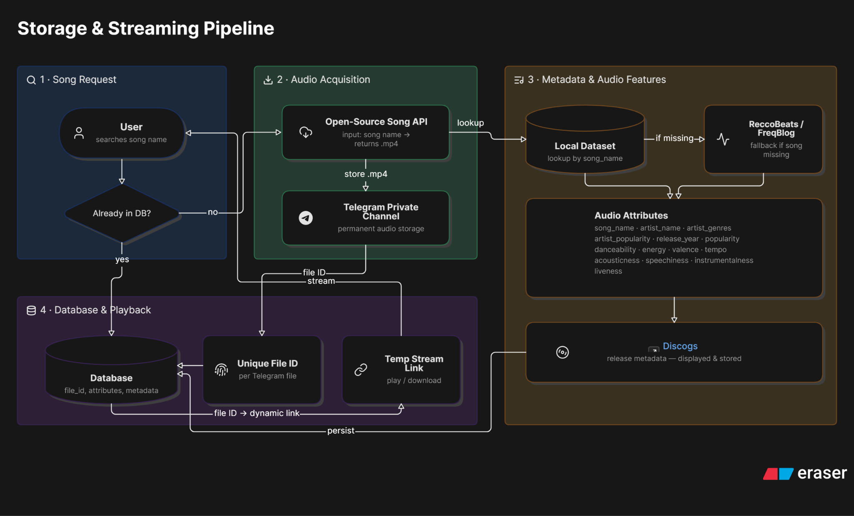
Figure 2 — Storage & Streaming pipeline.
Audio-feature attributes are resolved from the local dataset first, with ReccoBeats/FreqBlog used only as a fallback when a song is not found locally. Discogs metadata is retrieved separately and stored alongside the song record for reuse on future requests. The overall flow follows a fetch-once-and-reuse pattern: user requests a song → database lookup → (if missing) fetch from external API → store audio in Telegram → save File ID → retrieve/store metadata and audio features → generate a temporary playback link → stream to the user.

5. Recommendation & Learning Pipeline (Detailed View)
This pipeline governs how personalized recommendations are produced using the configured LLM API. Playback requests flow through the Storage & Streaming pipeline; in parallel, the backend prepares the current song, user activity, listening history, and song attributes and sends that context to the LLM API.
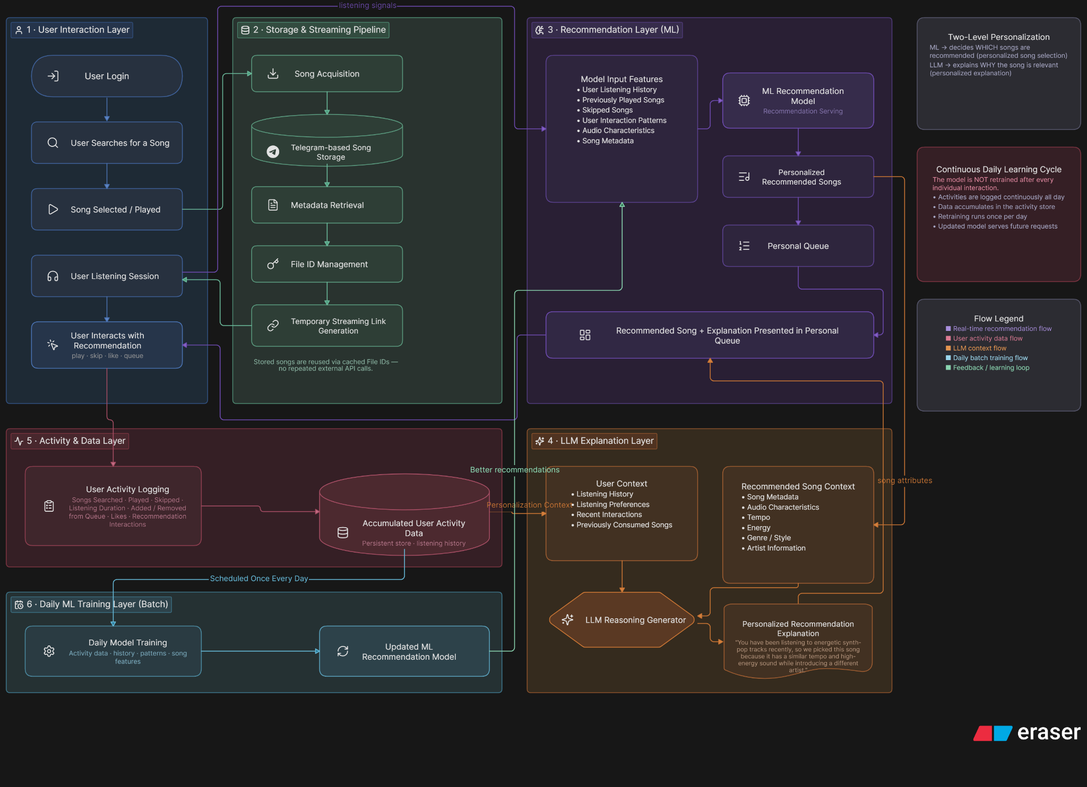
Figure 3 — LLM recommendation pipeline using current-song and user-activity context.
The LLM API can return each recommended song together with a reason based on the user's listening behavior and the song's attributes. User interactions continue to be logged and become available as context for future LLM requests. There is no daily model-training loop.

6. End-to-End Data Flow Summary
- User authenticates via the Authentication & Session Service.
- User searches for and plays a song; the request is routed through the API Gateway to the Storage & Streaming Service.
- The Storage & Streaming Service resolves the song (database hit or external fetch + Telegram storage) and returns a temporary streaming link.
- The Metadata & Audio-Feature Enrichment Service ensures attributes and Discogs metadata are available and persisted.
- The Activity Logging Service records the play event and subsequent interactions (skip, duration, likes, queue changes).
- On completion of playback, the AI Recommendation Service sends the current song, listening history, and relevant user activity/context to the LLM API and receives structured song recommendations.
- The LLM Recommendation & Reasoning Service validates the returned songs and reasoning, and the backend resolves those songs through Storage & Streaming before attaching them to the queue.
- User activity remains in the activity store and is used as context for subsequent LLM API requests; no VYNL-owned recommendation model is retrained.
- At the end of each month, the Monthly Wrap Service aggregates the user's activity into a personalized summary.

7. Deployment & Operational Considerations (Conceptual)

7.1 Deployment Topology
Each core service (Storage & Streaming, Recommendation, LLM Explanation, Playlist/Collaboration, Activity Logging, Monthly Wrap, Metadata Enrichment) is deployable as an independently scalable unit — whether implemented as separate processes/services or as modules within a shared backend — so that recommendation or explanation load does not compete with core playback traffic. The specific deployment model (e.g., containers, managed services) is left open pending the technology-stack decision noted in the PRD.

7.2 Scheduling
LLM recommendation requests run at runtime when a queue, playlist, or collaborative suggestion is needed; there is no daily model-training schedule.

7.3 Resilience
- If the LLM Recommendation Service is unavailable, the system falls back to a simpler queue (e.g., previously queued, recently played, or otherwise deterministic songs) rather than blocking playback.
- If LLM reasoning is unavailable, the system may still present validated/resolved recommended songs without explanations, provided the recommendation response itself is usable.
- If an external enrichment source (ReccoBeats/FreqBlog, Discogs) is unavailable, playback proceeds using whatever attributes/metadata are already available, with enrichment retried later.

7.4 Observability
- Cache-hit rate (songs served from stored File ID vs. new external fetch) should be tracked as a core storage-efficiency metric.
- LLM API request success/failure, response validation failures, provider latency, and recommendation resolution latency should be logged and monitored.
- Latency of song resolution, recommendation generation, and explanation generation should be tracked against the NFR targets defined in the SRS.

8. Traceability to Requirements
The table below maps major architectural components to the functional requirement groups they fulfil, as defined in the SRS.
Component | Related SRS Requirements
Authentication & Session Service | FR-1.x
Storage & Streaming Service | FR-2.x
Metadata & Audio-Feature Enrichment Service | FR-2.10 – FR-2.13
Recommendation Service (ML) | FR-3.x
LLM Recommendation & Reasoning Service | FR-3.3, FR-3.4
Playlist & Collaboration Service | FR-4.x, FR-5.x
Client — Lyrics View | FR-6.x
Activity Logging Service | FR-7.x
LLM API Recommendation Service | FR-8.x
Monthly Wrap Service | FR-9.x

9. Open Architectural Decisions
- Whether backend services are deployed as independent microservices or as modules within a monolithic FastAPI backend for the MVP (monolithic modules are recommended for initial simplicity).
- The specific external LLM API provider/model, request/response schema, authentication method, rate limits, and cost controls.
- Hosting and deployment topology for the FastAPI backend and the configured LLM API integration.
- Long-term suitability and limits of Telegram-based audio storage at scale, and a possible migration path to dedicated object storage if needed.

