**Report**

Efficient Illumination: Arduino-Based Street Light Automation for Energy Savings

Authors: Dhairya Mehra, Rutu Bhanderi, Anushka Hegade

**Abstract:** In this research paper, a novel approach is introduced to address the issue of energy wastage associated with the continuous illumination of street lights. The proposal centers on the implementation of an Arduino-based system that autonomously activates street lights solely when there is vehicle or pedestrian presence. This smart street lamp control system is designed to optimize energy efficiency and minimize maintenance requirements.

The backdrop for this endeavour is the current scenario of population expansion and industrial growth, which has led to an unprecedented surge in energy demand. The need to conserve resources has become paramount. The intelligent street lamp control system is put forward as a solution that not only results in substantial energy savings but also prolongs the lifespan of street lamps.

Across metropolitan areas, energy consumption is escalating, predominantly due to the extensive street lighting networks. Remarkably, even in low-footfall areas, the energy consumed by street lights is comparable to high-traffic zones. This translates to a considerable energy squander. The proposed system suggests replacing conventional high-intensity discharge lamps with energy-efficient LEDs capable of adjusting their brightness as required. Vehicle movement is detected through Light Dependent Resistors (LDR), allowing the system to reduce the light intensity during periods of inactivity.

The principal objective of this project is to trigger street lights exclusively when essential, specifically when vehicles and pedestrians are present. This approach promises substantial energy conservation, cost reductions, and an eco-friendlier urban environment. Furthermore, this adaptable system can be customized to cater to the unique requirements of diverse communities, thus contributing to the creation of a sustainable and economically viable urban lighting infrastructure.

**Keywords:** Arduino UNO, IR sensor, Led, Jumper wires, Resistors, Breadboard.

**Introduction:** Street lighting plays a vital role in any city in contribution of traffic and pedestrian safety. The existing lighting systems in our streets use old techniques that require manual intervention and lack latest technology. Thus, the existing model is observed to be inefficient leading to wastage of manpower as well as electric power. Conventionally, sodium vapor lamps are used for the purpose of street lighting. These lamps usually emit a huge amount of heat and gases into the atmosphere. In our proposed system we use LED (light emitting diode) lamps instead of sodium vapor lamps. The life span of LED lamps is almost 50 times better than other conventional lamps. LEDs are both cost and energy efficient. It also avoids greenhouse gas emission into the environment. LED bulbs use only 2- 17watt of electricity which is 1/3rd of incandescent. In addition to these, the intensity of the LED lamps can be controlled using PWM (Pulse Width Modulation) technique which helps in automating the lamp. In a city, there will always be some or the other streets where the traffic could be irregular and the full intensity of the street light may not be required. In such cases, automating the street lamp can help to conserver a fair amount of energy. Thus, we have devised a smart street lighting system which includes dimming control circuit that can increase or decrease the intensity of the street lamps accordingly.

The system's operation begins with low-intensity lighting, typically around 20%. However, as a vehicle is detected by an LDR sensor, responding to the vehicle's headlights, the lamp's intensity is promptly increased to 100%. Additionally, our system is engineered to integrate cutting-edge technologies, including GSM, to create an intelligent street light system that minimizes maintenance costs and prolongs the life of the entire street lighting infrastructure. In this paper, we thoroughly investigate related work, delve into system design and architecture, explore implementation details, present results, and offer conclusive insights.

**Objectives:** This project is about Smart Street light, street light will turn on while vehicle is passing through it. Here we are using 4 IR sensors that senses the position of the vehicle, each IR sensor controls 3 LED's. When vehicle passes by a particular IR sensor it senses the position of vehicle and gives its signal to the Arduino board and it will turn on the LED's. This project work is complete on its own in remotely and automatically switching on or off of an electrical appliance not limited to household appliances and sends a feedback message indicating the new present state of the appliance.

**Problem Definition**: We have seen in the number of cities where the street lights is the one of the huge energy expense for a city. Currently we have manual system where the light will be switched ON in the evening before the sunset and they are switched OFF next day morning after there is sufficient light outside. So, there is lot of energy waste between ON and OFF timing.

**LDR “Light dependent resistor”**and **IR “Infrared Sensor”**are among the most widely used electronics components. In this article we are going to use these sensors with the Arduino to build an amazing Smart Street light project. With smart street light system, we can greatly reduce the energy cost and moreover smart street lights more efficiently manage electricity with lower chances of the automatic street light system overheating and risk of accidents is also minimized. Instead of turning ON the street lights for the entire night, we can design a low cost and efficient smart street light system using the Arduino, IR sensors or Ultrasonic Sensors, and some other basic electronics components. In this tutorial, we will learn to design a smart street light that will be turned on and off whenever there is some vehicle or object.

**Methodology:** The Smart Street light control system adopts a dynamic control methodology. According to the proposed plan, initially when it becomes dark, all the street lights automatically glow for a few seconds and switches off. But throughout the night, only one street lights remain switched on for security concerns. When a vehicle passes by, a block of street lights glows and as the vehicle moves forward, the next block of lights starts glowing where the previous block switches off.

**Block Diagram:**

**Components Diagram:**

**Circuit Diagram:**

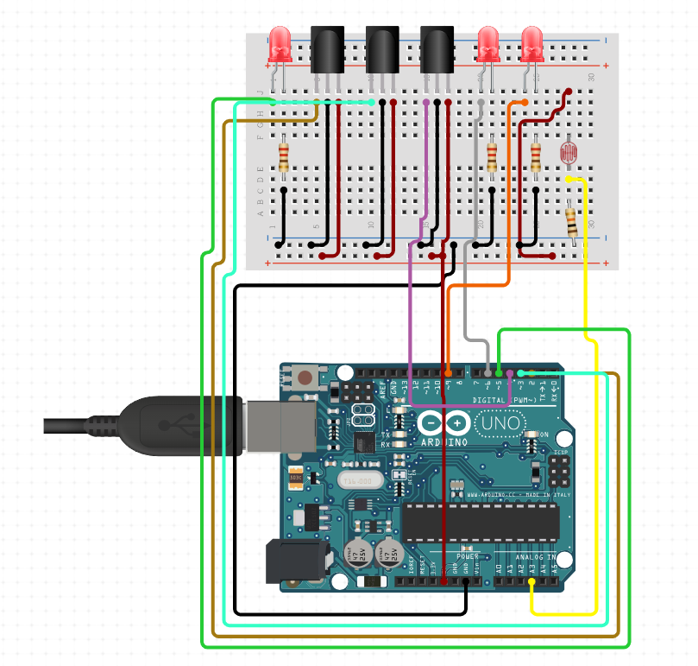

**Conclusion:** The implementation of our smart street light system yields substantial energy savings through the replacement of sodium vapor lamps with energy-efficient LEDs and the incorporation of advanced security features. This system effectively eliminates the unnecessary wastage of electricity incurred through manual light control. Notably, it operates with a high degree of efficiency, leveraging IR sensors to reduce energy consumption and associated costs. Furthermore, this versatile system can be tailored to suit the specific requirements of different communities, ultimately contributing to a sustainable and economically efficient urban lighting infrastructure.