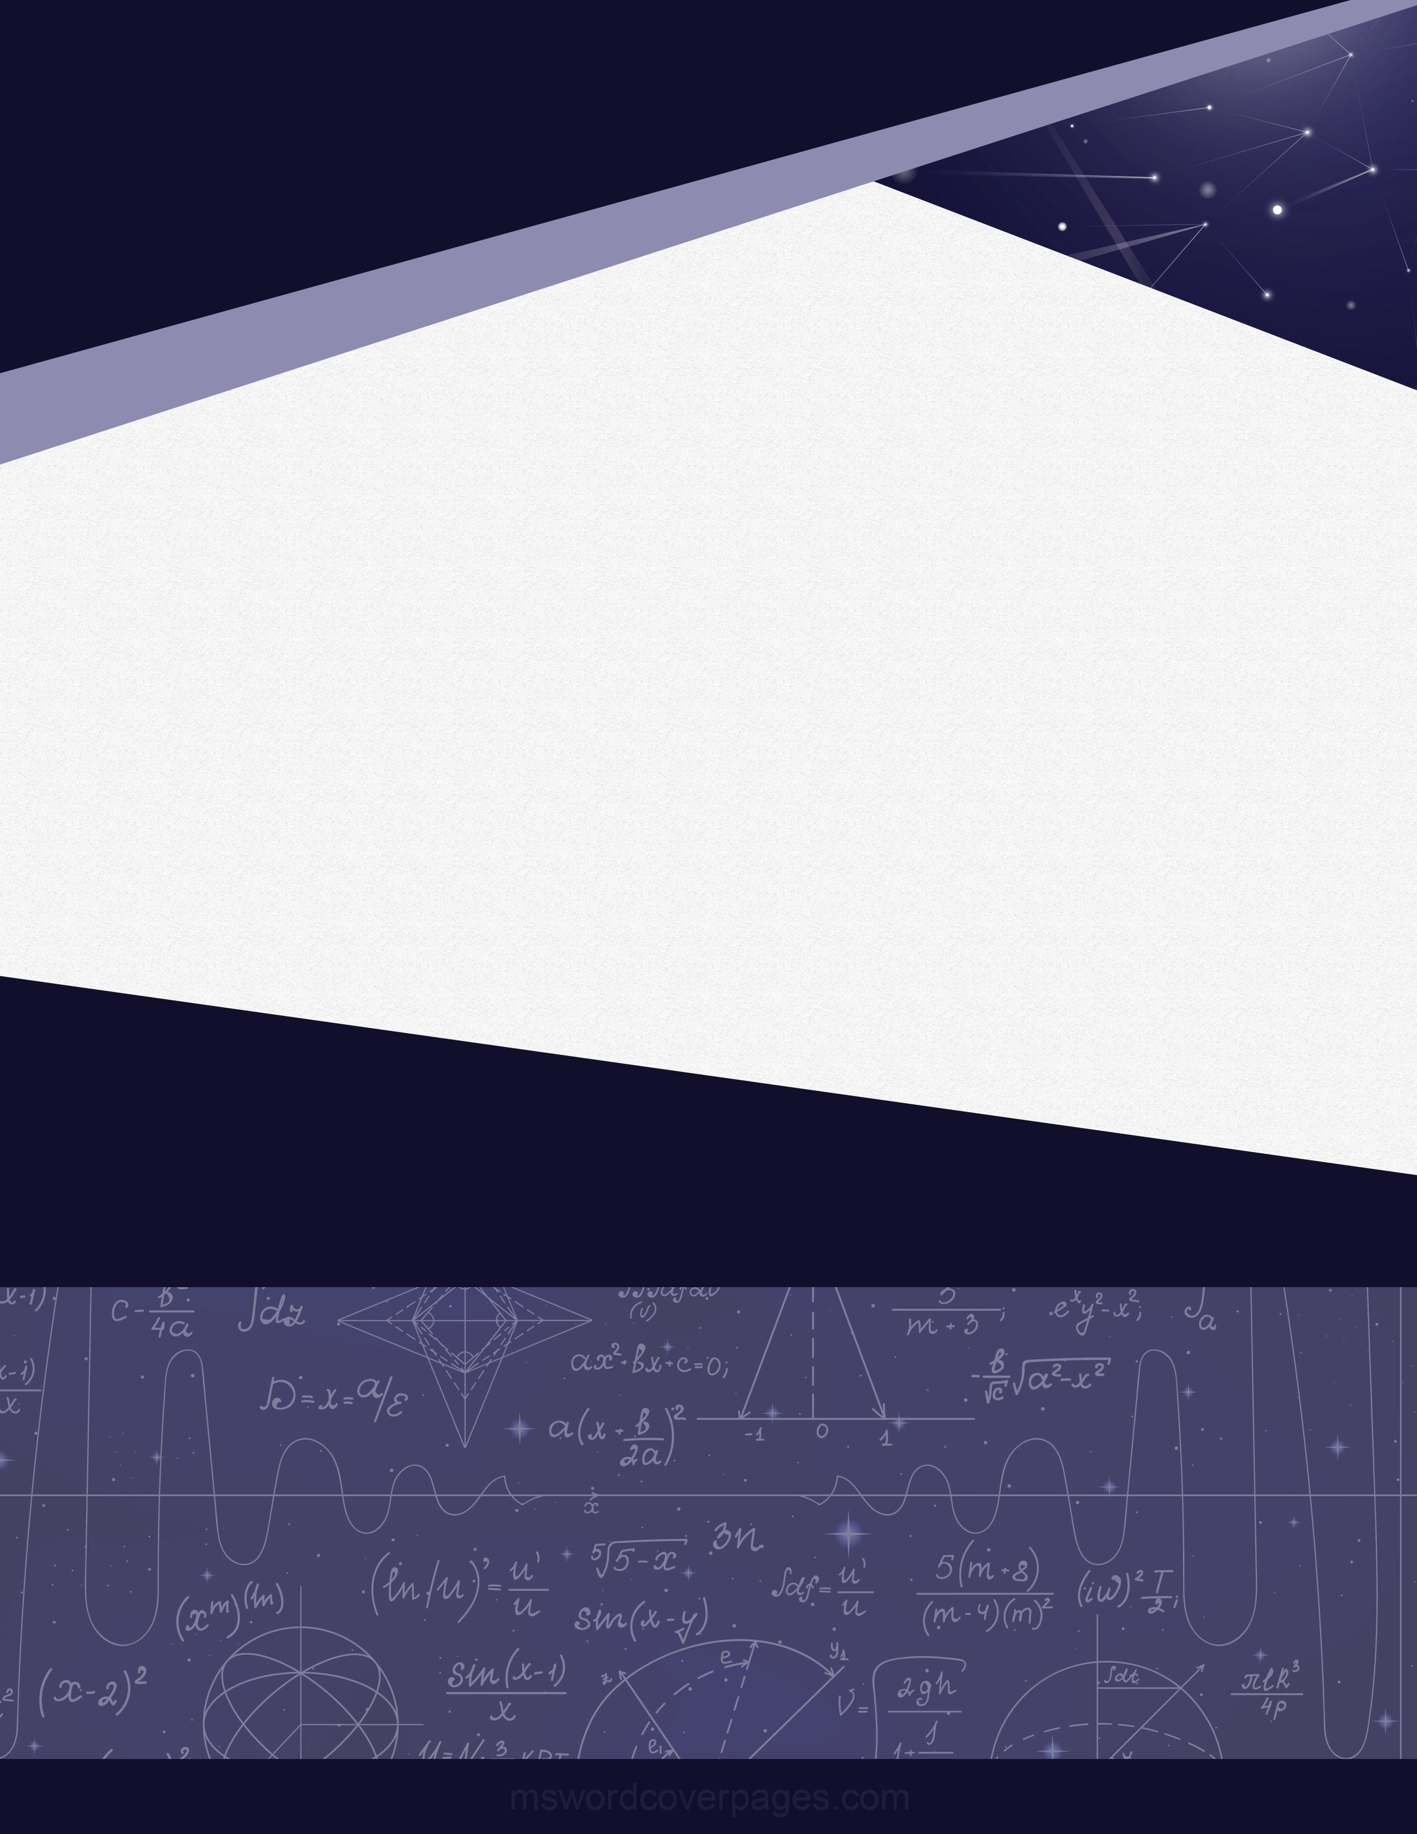­

Software

Engineering

Practical - XX

Dhairya Vora

19162171011

Start Here