**SCREENSHOTS of RestAPI**

**assignment solution**

**ADMIN Account**

1. **Adding role**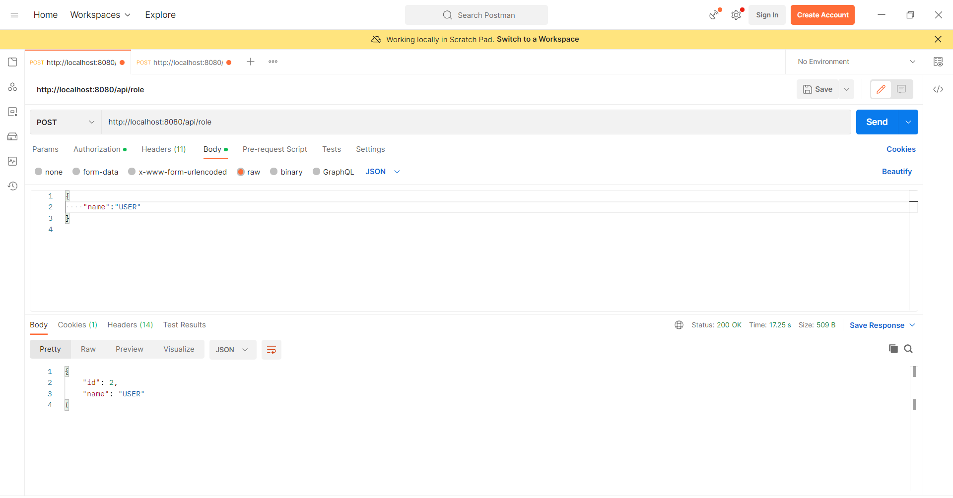
2. **Adding User which can be used for authentication purpose**

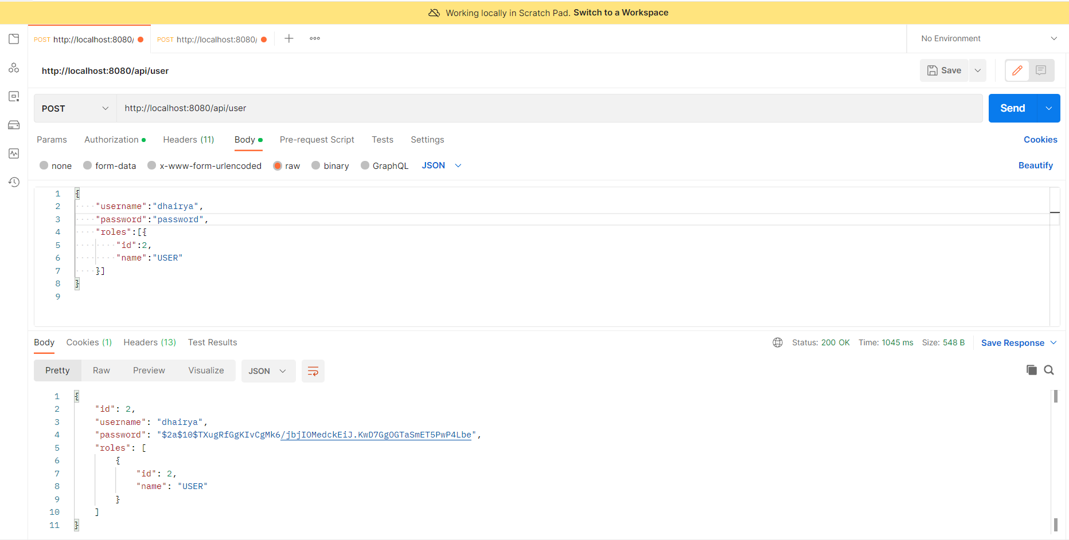

1. **Adding details of an Employee**

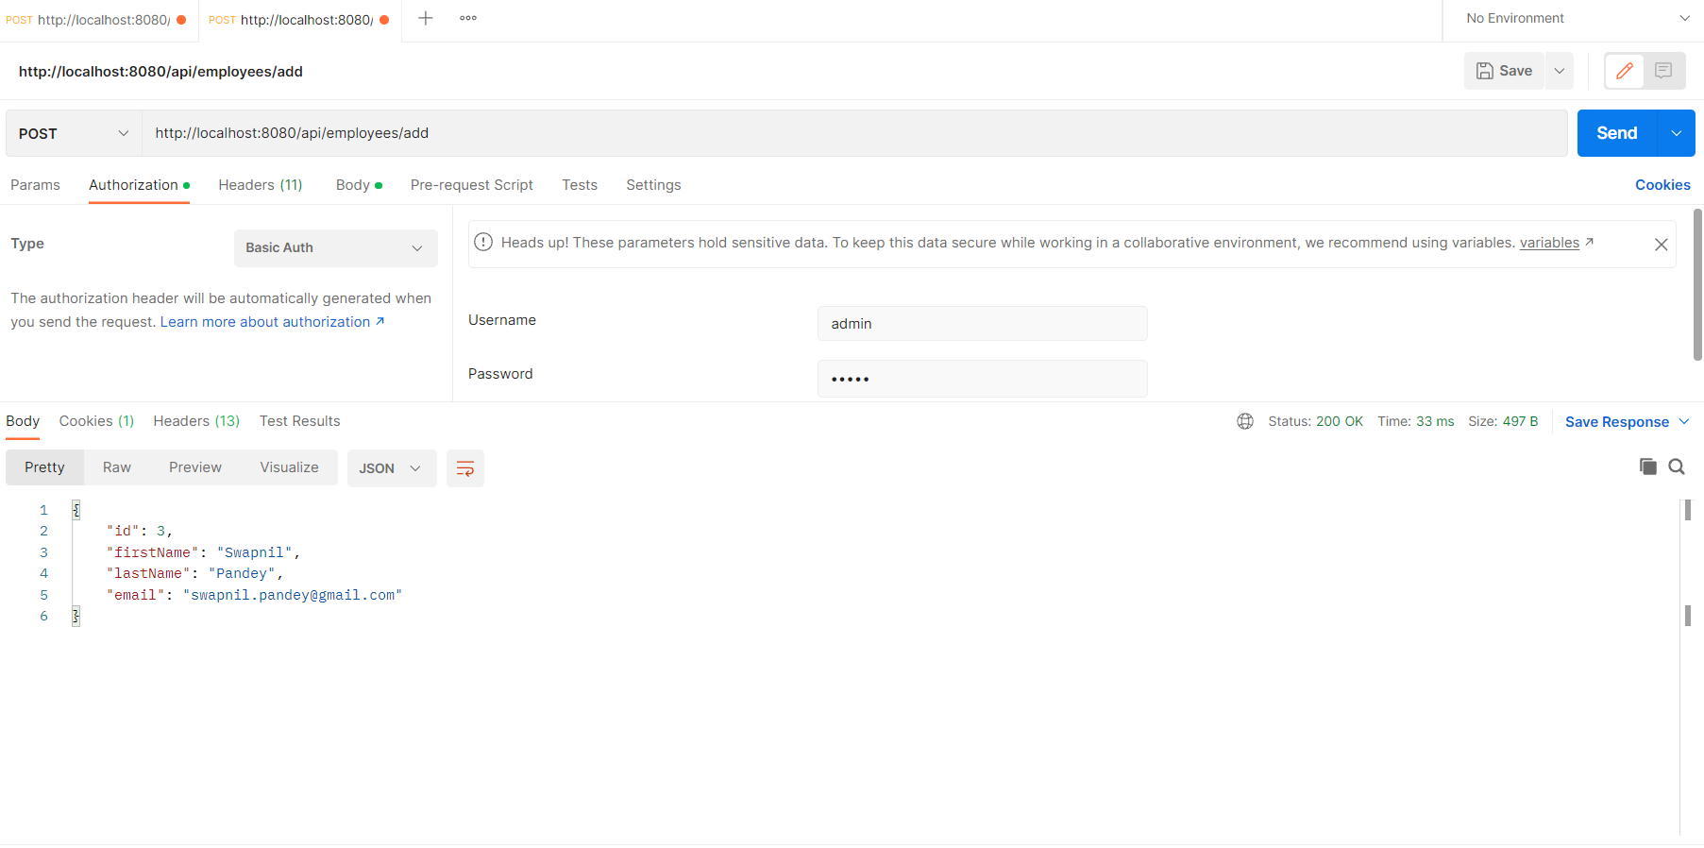

1. **List of details of all Employees**

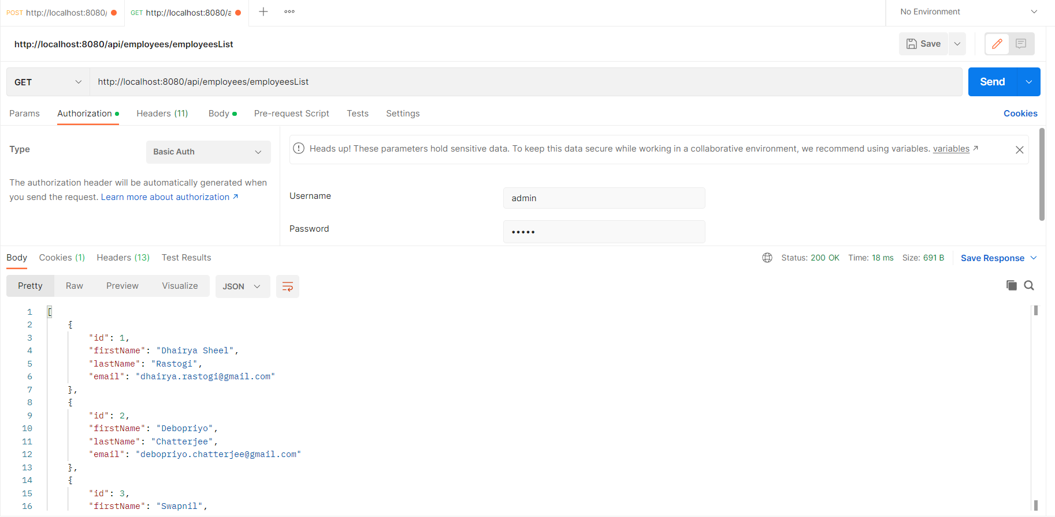

1. **Get details of an Employee based upon its ID**

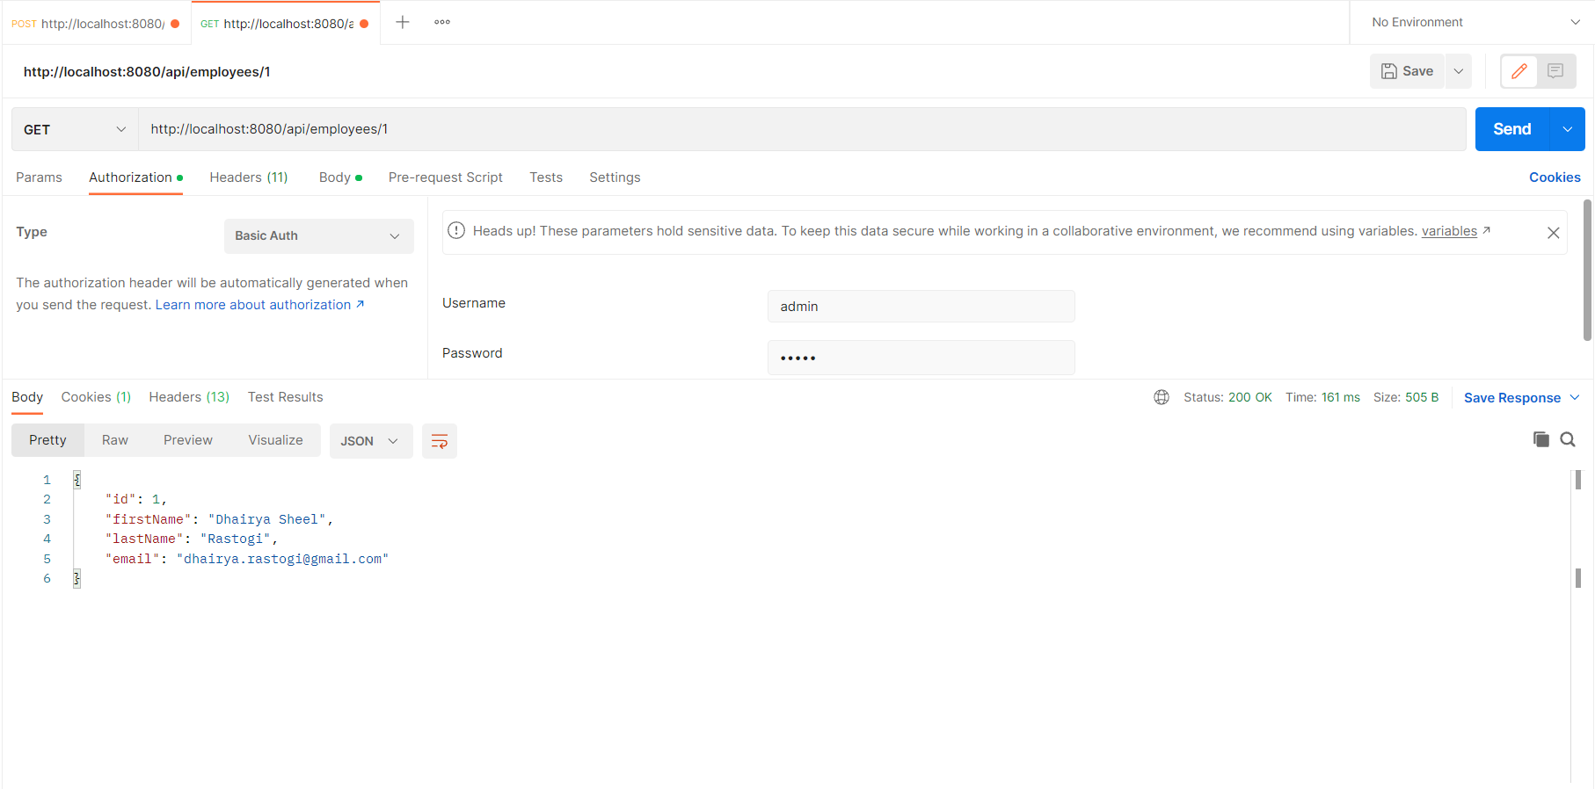

1. **Updating an Employee’s Detail**

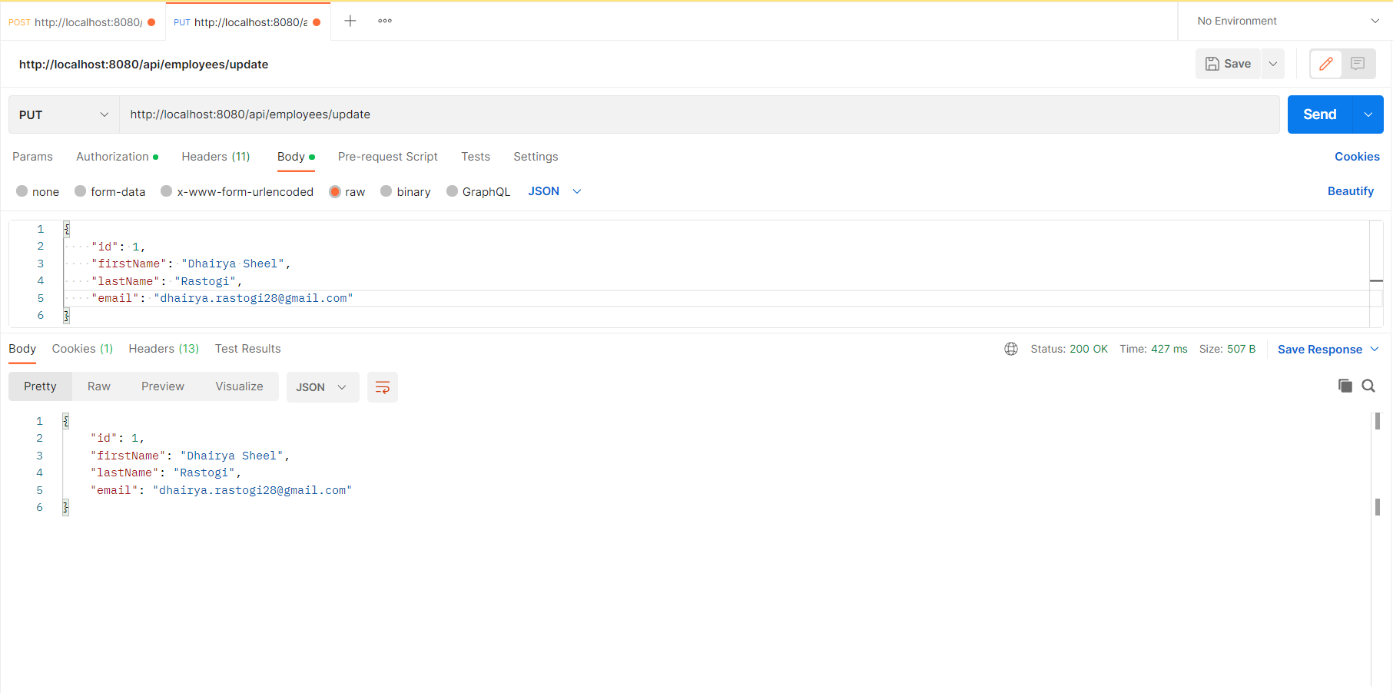

1. **Deleting an Employee’s Detail**

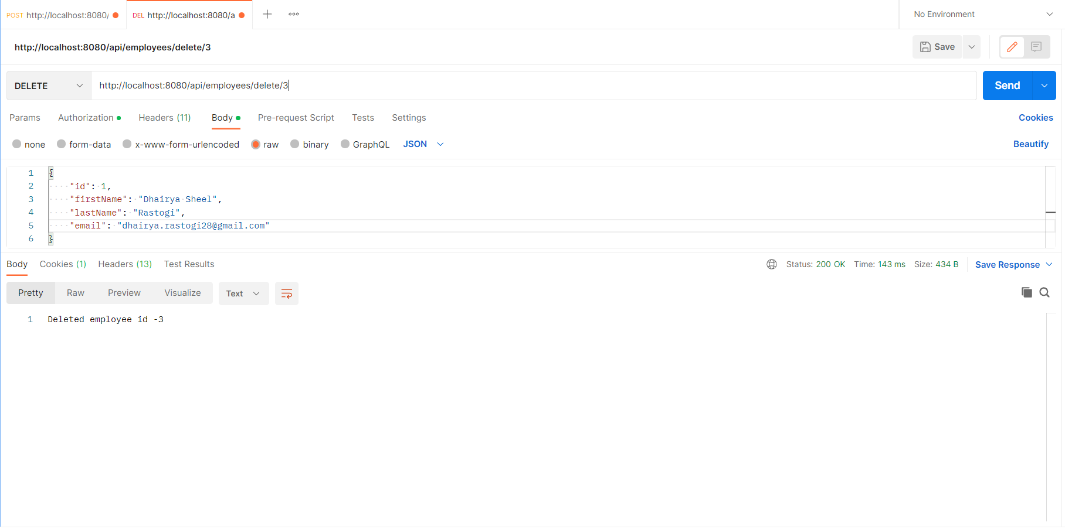

1. **Searching Employee based upon the First Name**

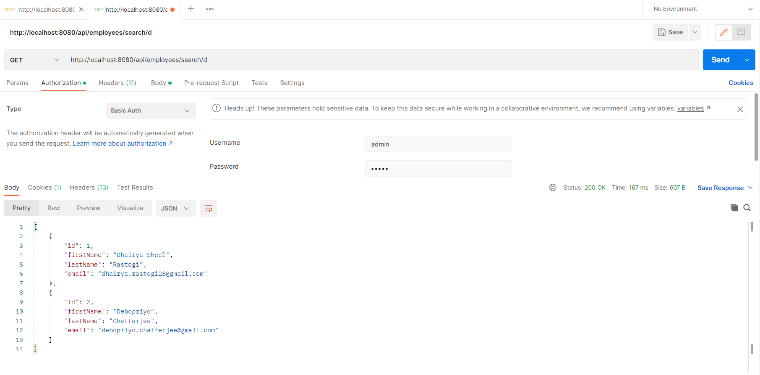

1. **List of details of all Employees in Ascending Order**

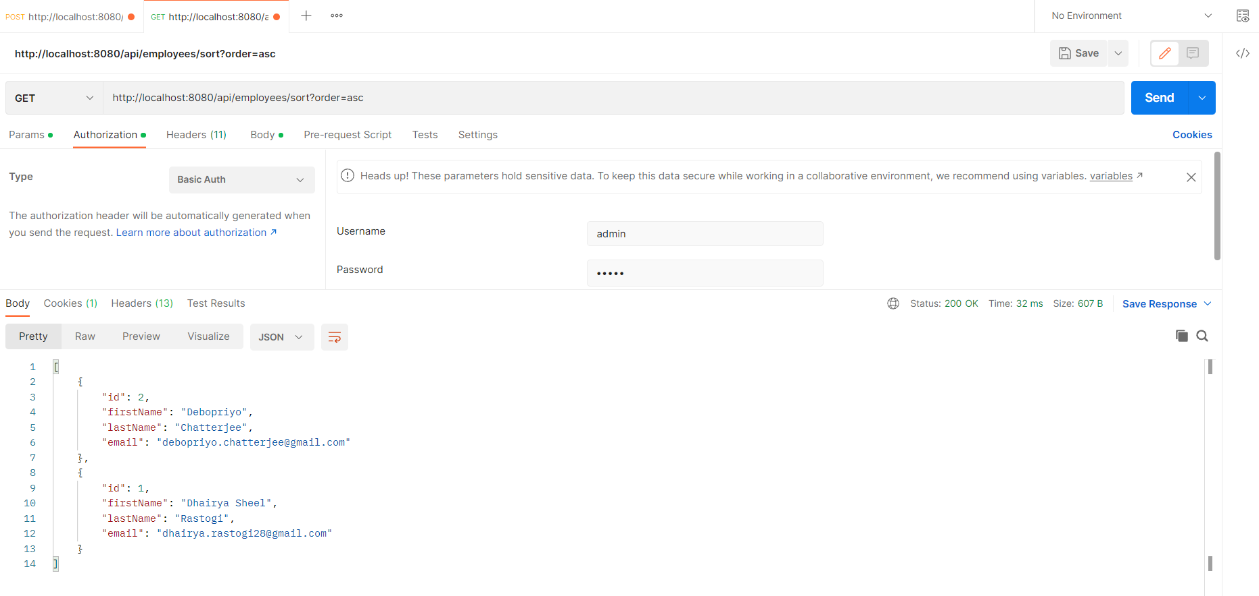

1. **List of details of all Employees in Descending Order**

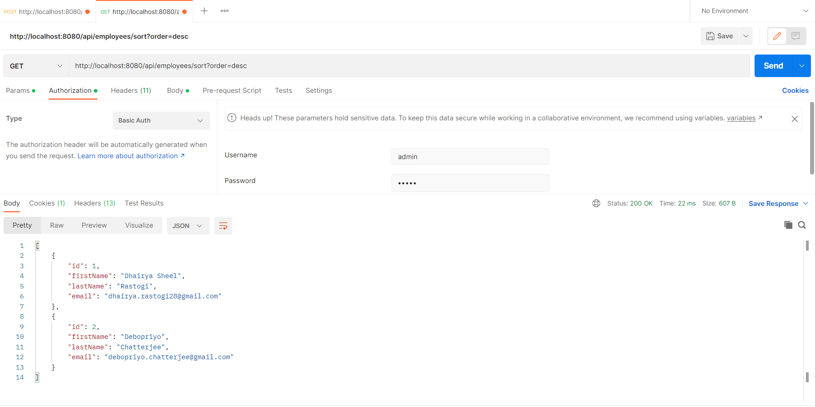

**USER Account**

1. **List of details of all Employees  
   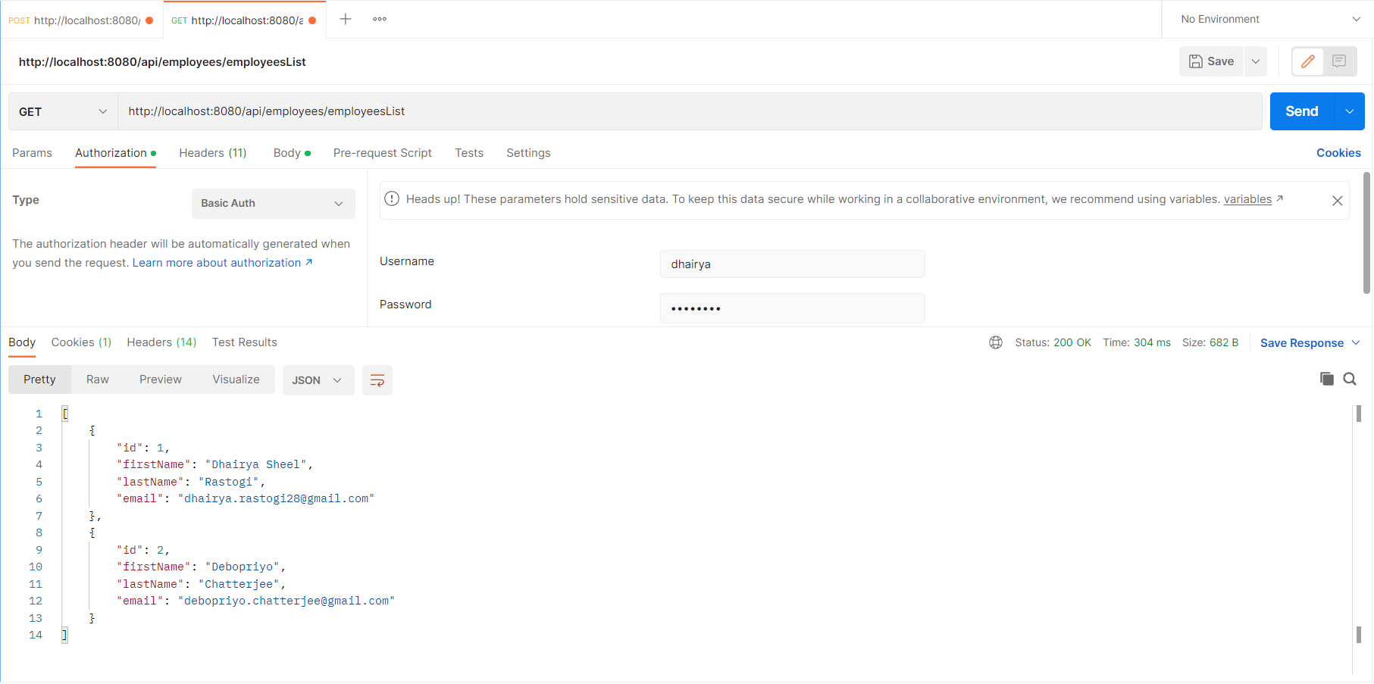**
2. **Get details of an Employee based upon its ID**

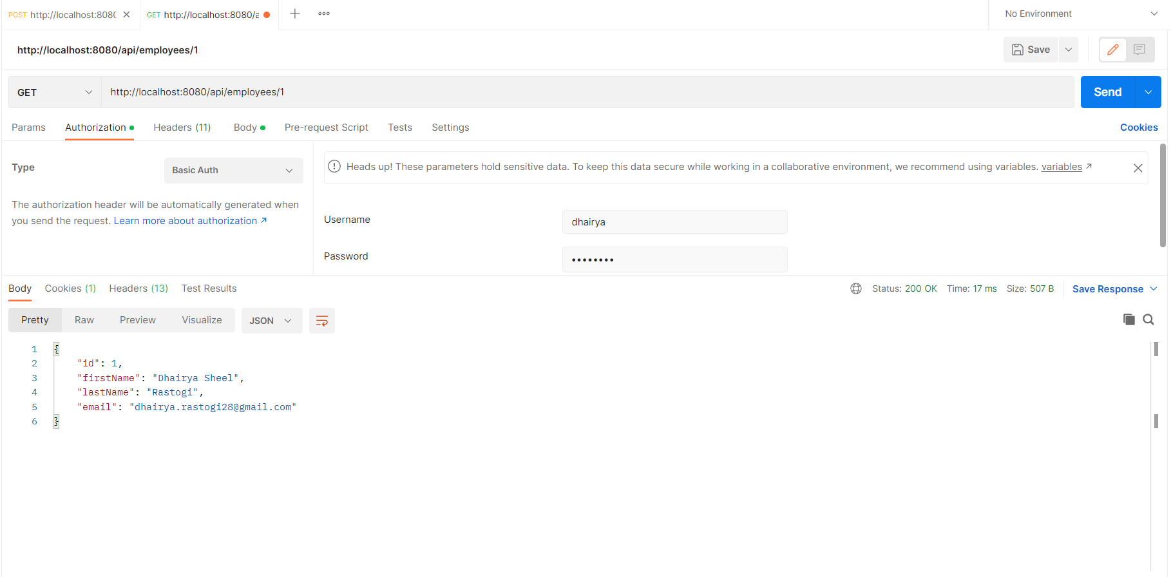

1. **Adding details of an Employee**

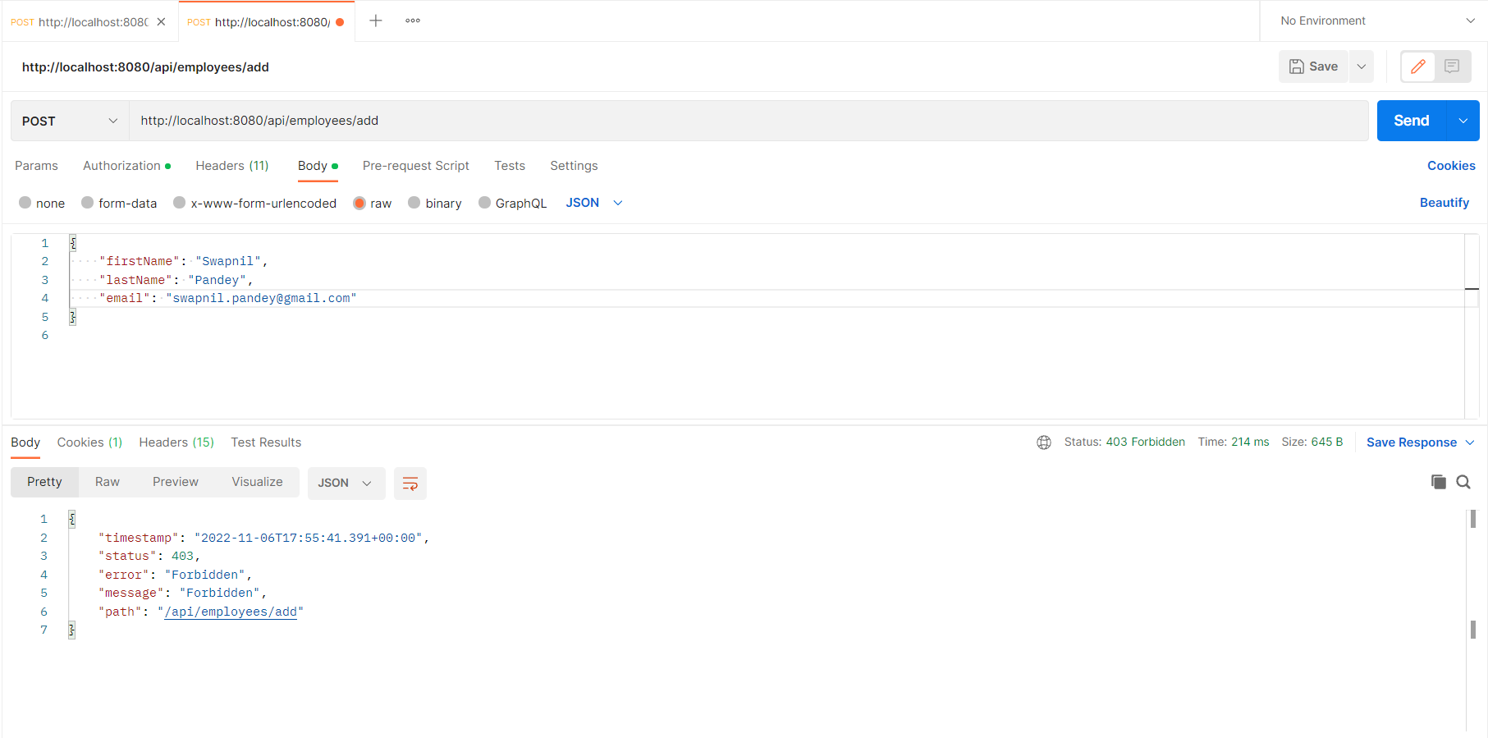

1. **Updating details of an Employee**

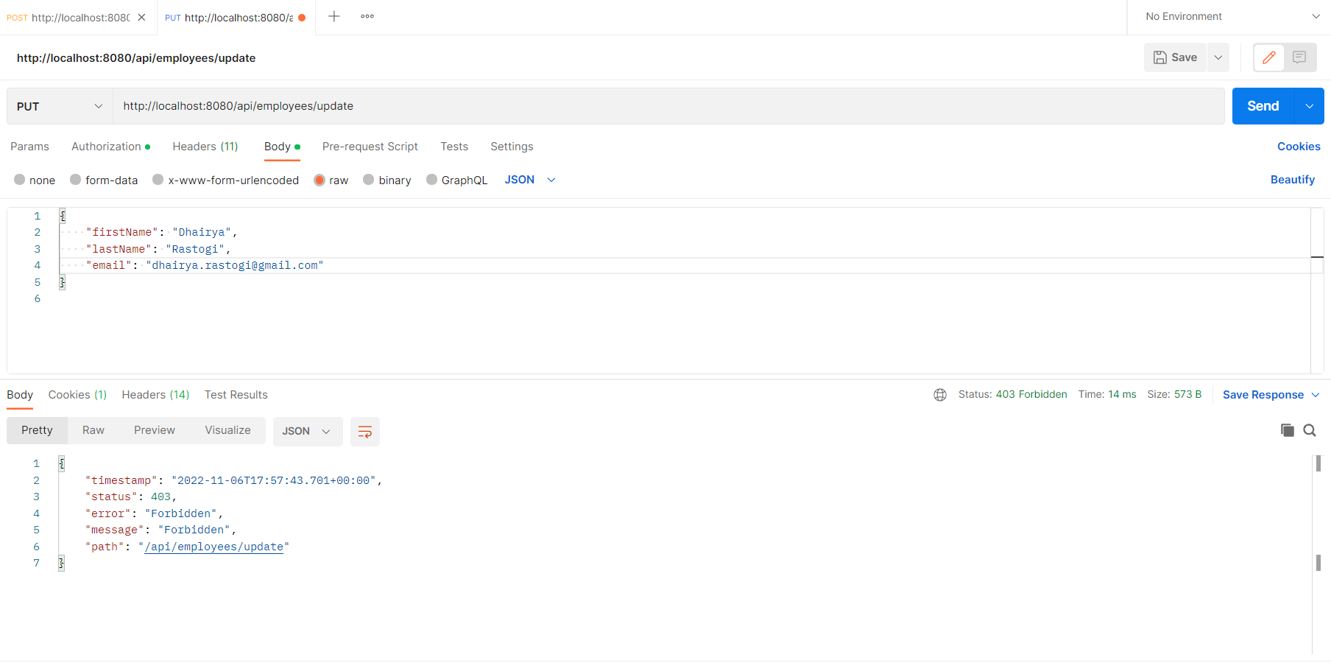

1. **Deleting an Employee’s Detail**

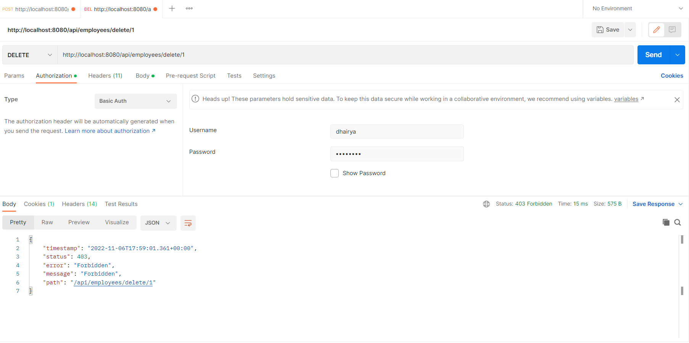

1. **Searching Employee based upon the First Name**

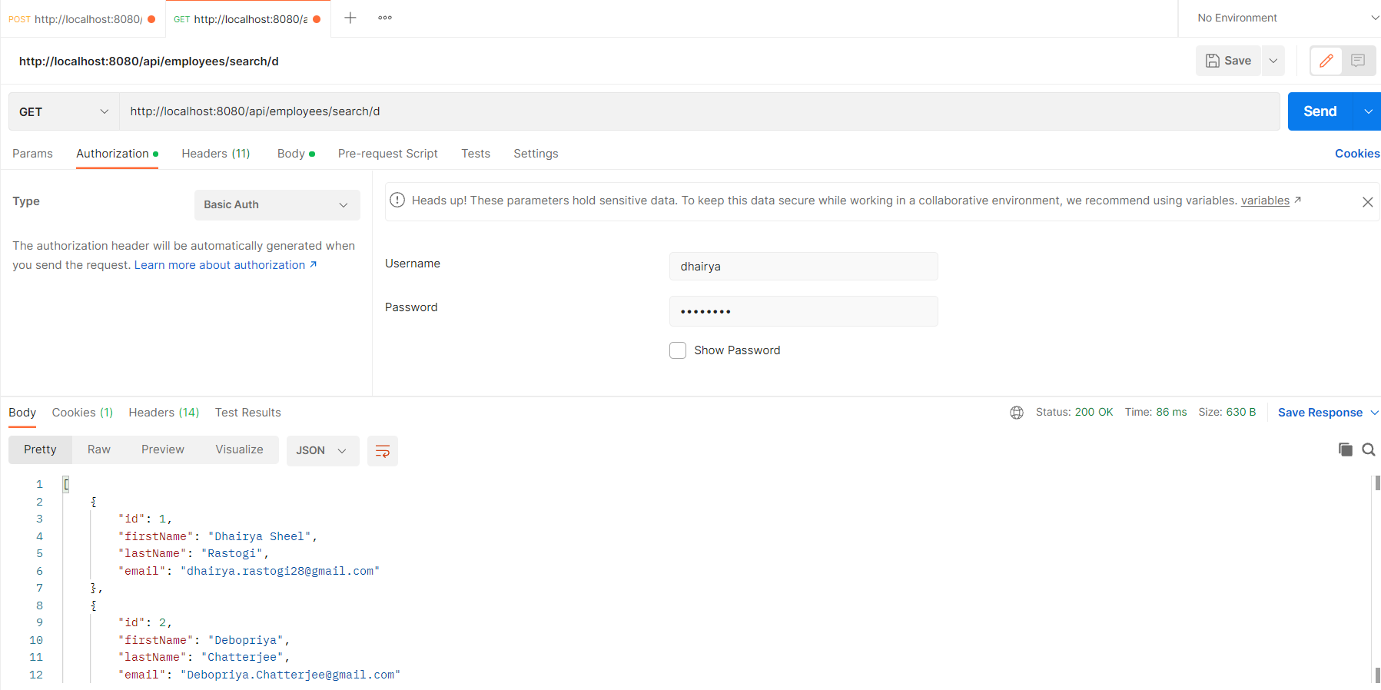

1. **List of details of all Employees in Ascending Order**

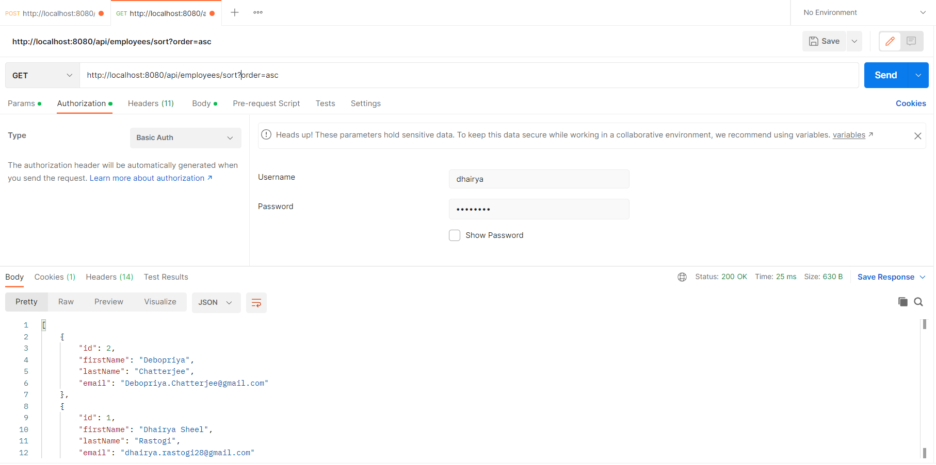

1. **List of details of all Employees in Descending Order**

