**Customer Relationship Management**

1. **This is the main page of CRM where you can see the customer details that are present in our database**

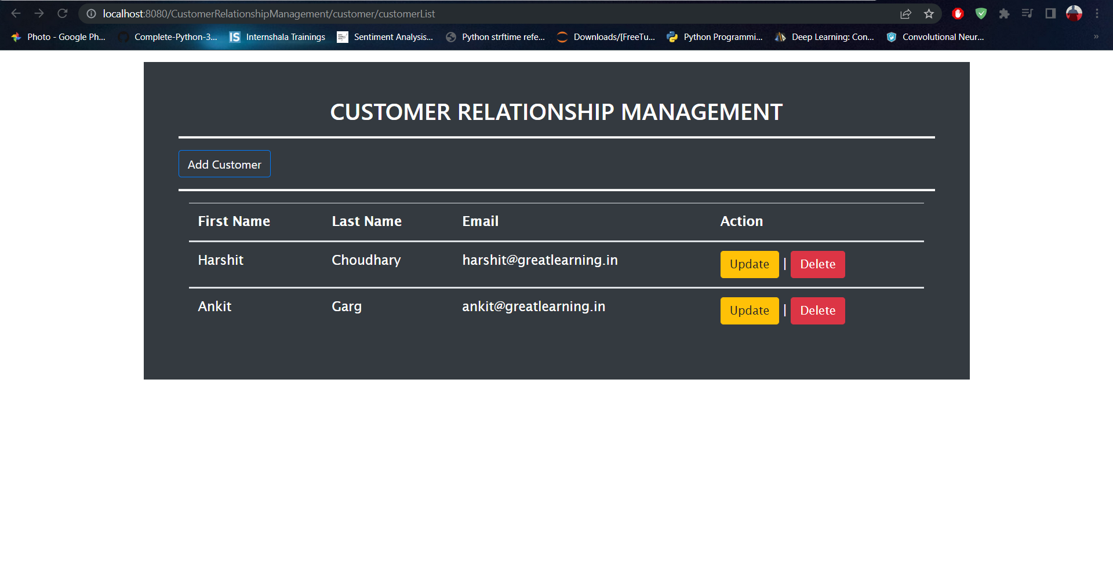

**2. clicking on add customer button will redirect you to save a new customer.**

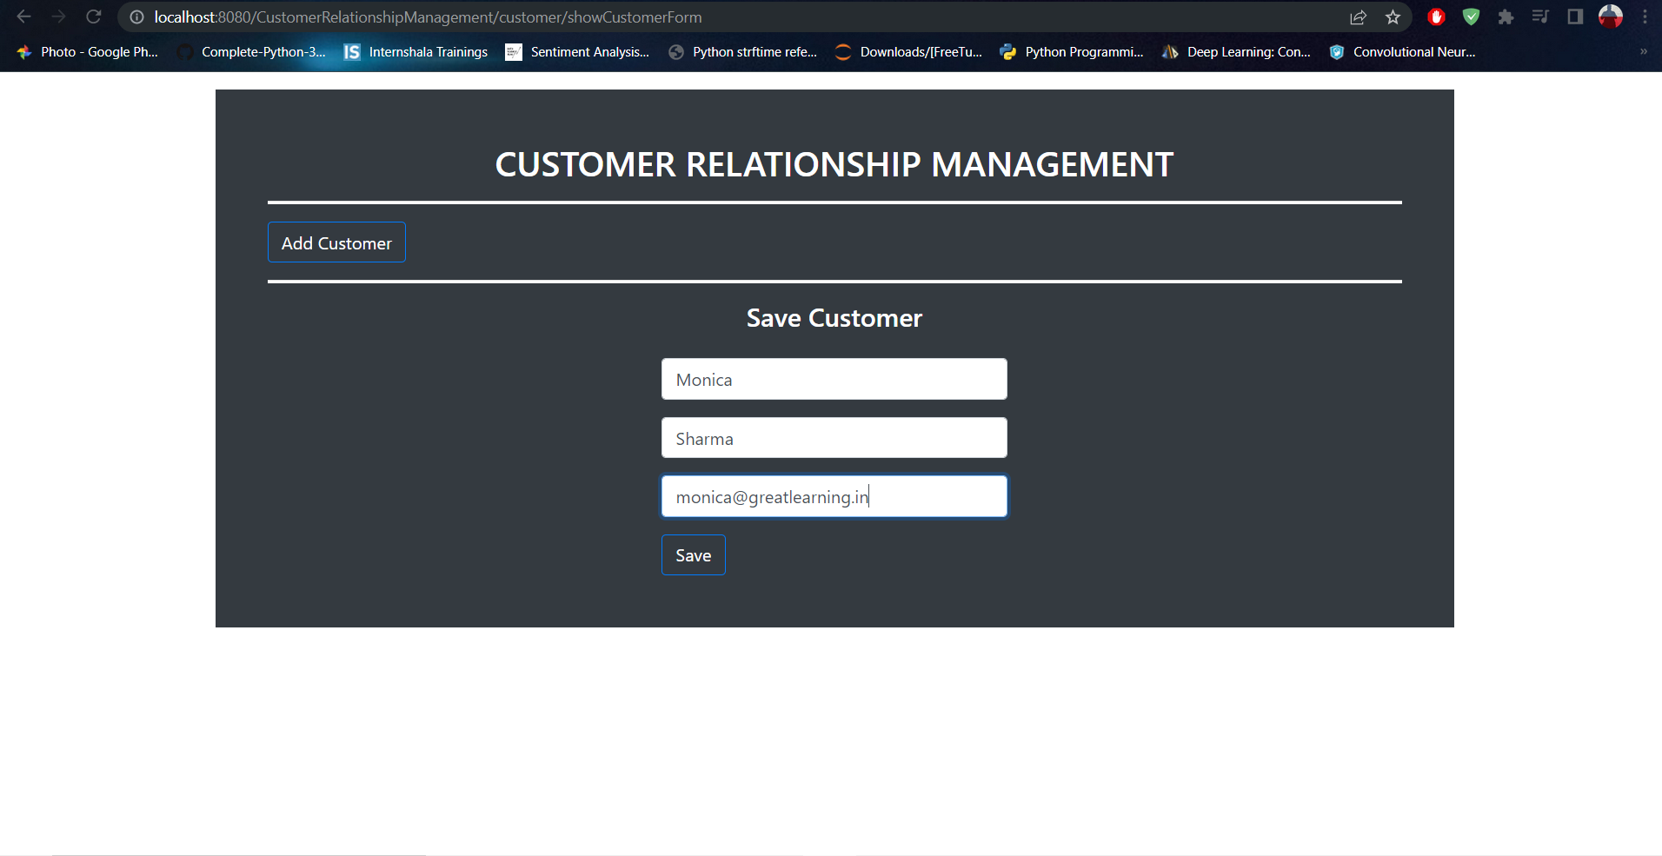

1. **After clicking save button we can see the new customer in the Customer relationship management page.**

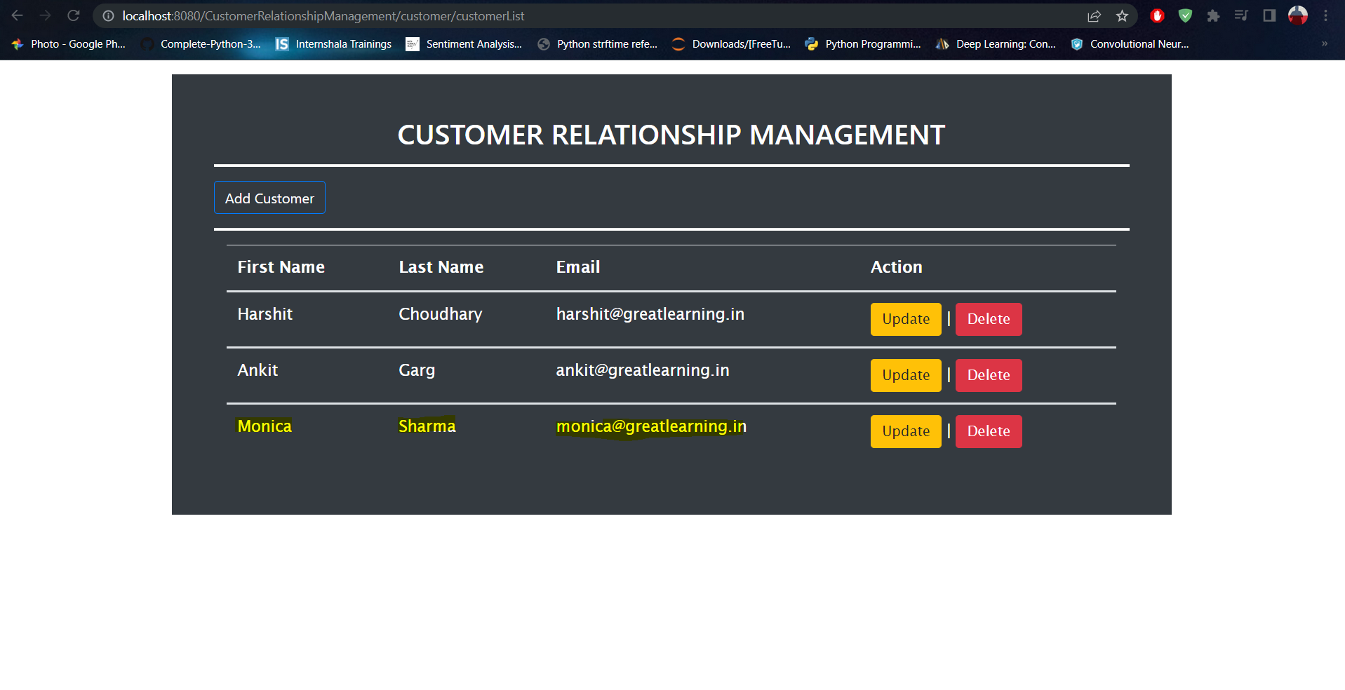

1. **If you want to update any customer details. Click on update button under action in main page. It will redirect you to the update customer page where you can enter the updated details of the customer. After that click on save button you will be redirect to the main page of the CRM.**

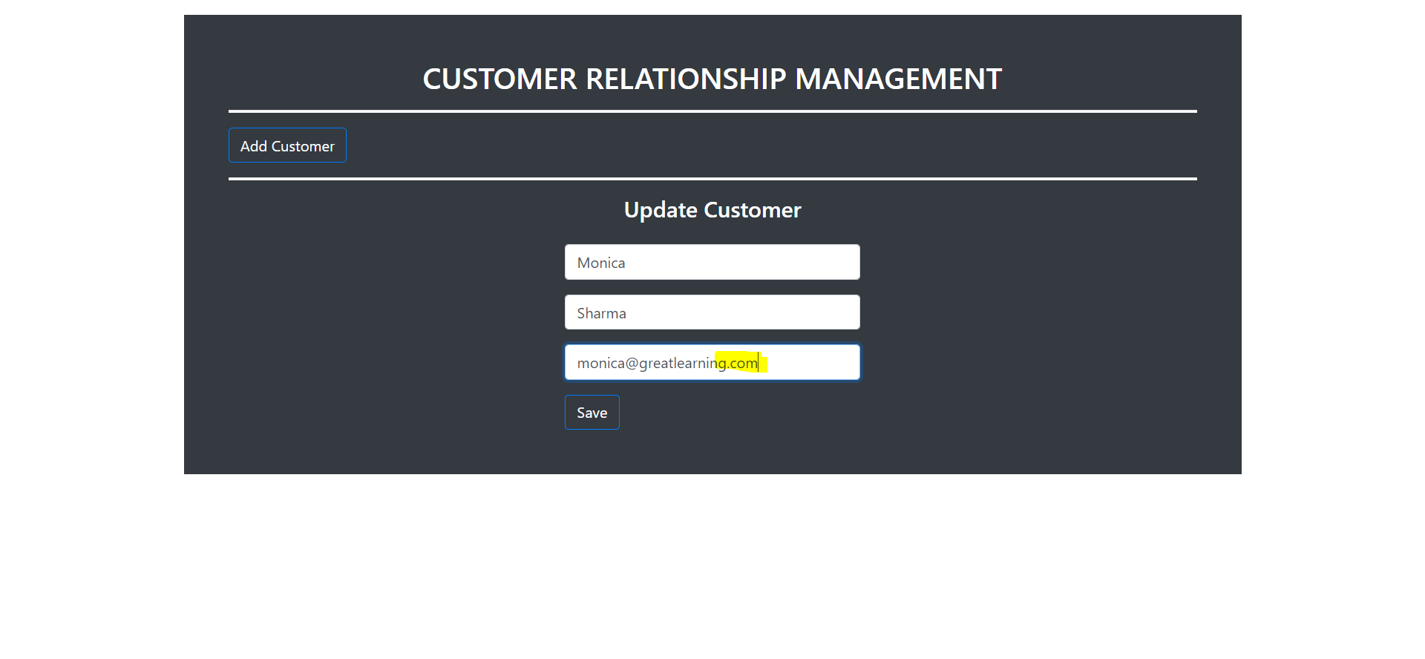

1. **After you clicked on save button updated details of the customer are showing in the main page of CRM.**

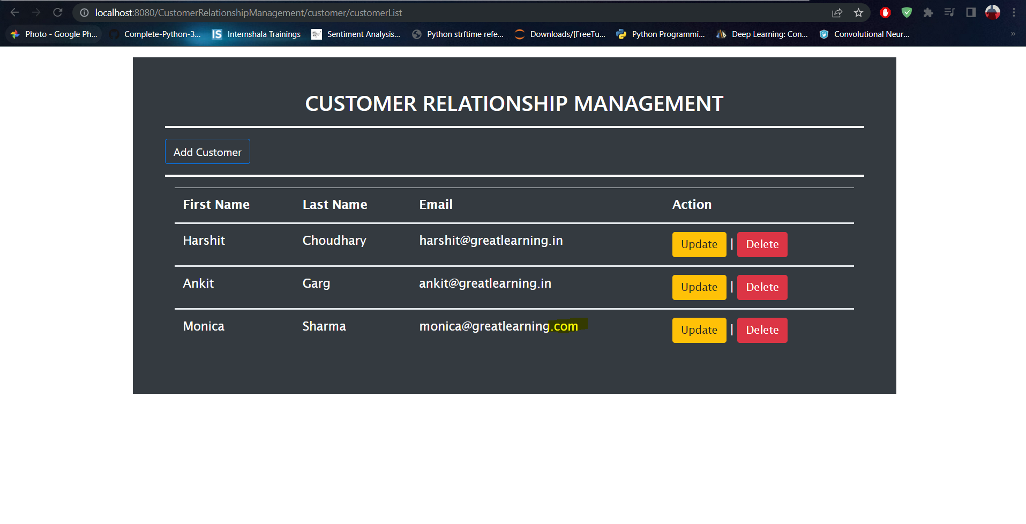

1. **If you want to delete any customer details click on the delete button under action a pop up will come are you sure to delete the customer details.**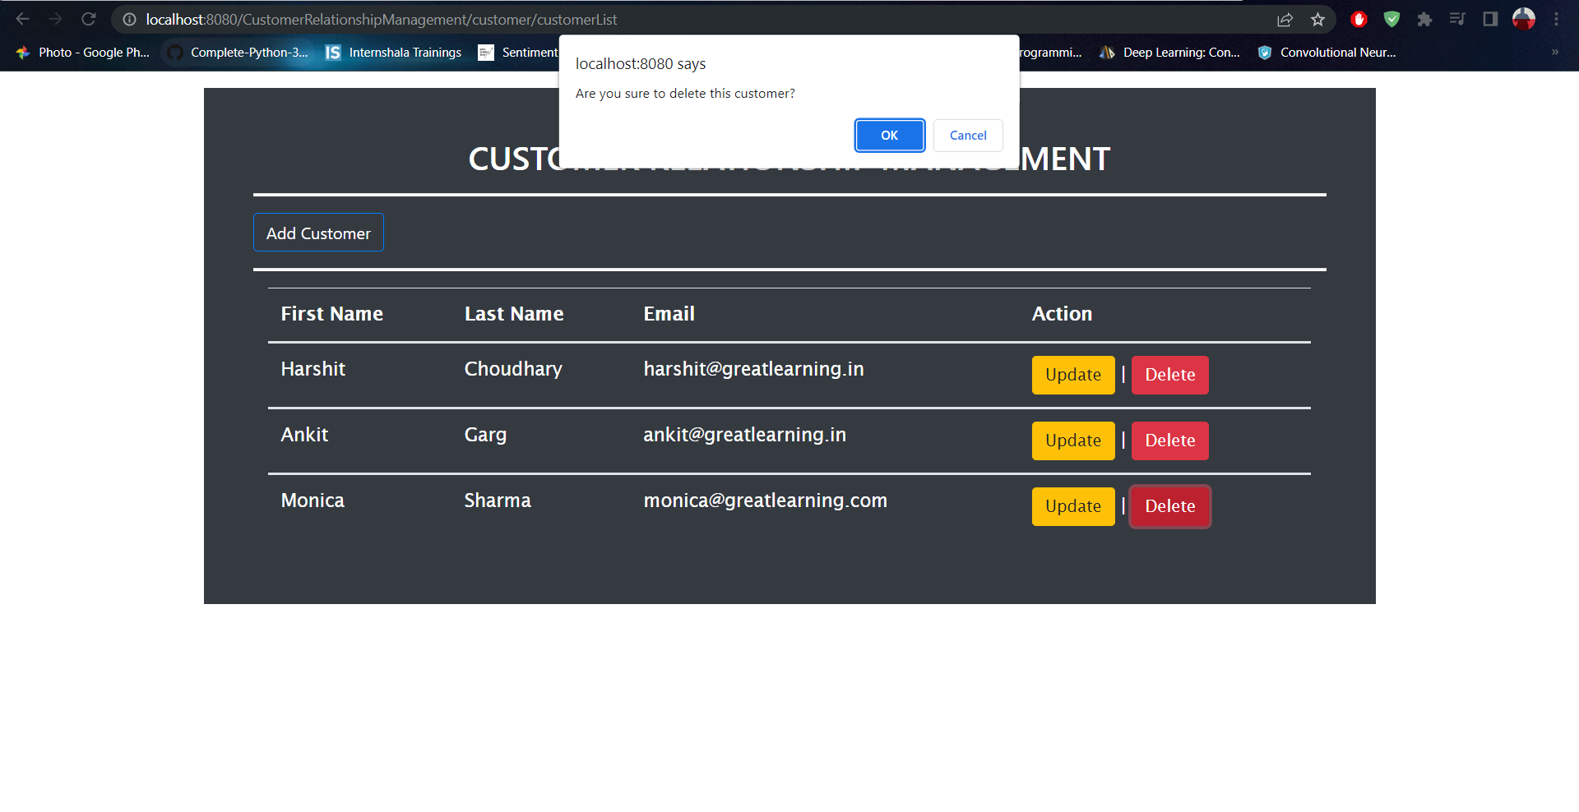
2. **If you click on ok the selected record will deleted from main page of the CRM page as well as from the database.**