MINOR PROJECT REPORT
ON
EMOTUNES
Submitted in partial fulfilment of the requirements
for the award of the degree of
BACHELOR OF TECHNOLOGY
IN
COMPUTER SCIENCE & ENGINEERING
Submitted By
RIA SHRIDHER JATIN CHOPRA
(10115602720) (05615602720)
NEHAL GARG DHAIRYA JAIN
(08515602720) (36215602720)
Under the guidance of
Dr. Jyoti Parashar, Assistant Professor, CSE Department
Department of Computer Science & Engineering Dr. Akhilesh Das Gupta Institute of Technology & Management
(Guru Gobind Singh Indraprastha University, Dwarka, Delhi.) New Delhi -110053.

CERTIFICATE
I/We hereby certify that the work that is being presented in the project report entitled Project Title to the partial fulfilment of the requirements for the award of the degree of Bachelor of Computer Science & Engineering from Dr. Akhilesh Das Gupta Institute of Technology & Management, New Delhi. This is an authentic record of our own work carried out under the guidance of Supervisor Name, Designation in the CSE Department.
The matter presented in this project has not been submitted by us for the award of any other degree elsewhere.

RIA SHRIDHER JATIN CHOPRA
(10115602720) (05615602720)

NEHAL GARG DHAIRYA JAIN
(08515602720) (36215602720)

This is to certify that the above statement made by the candidate is correct to the best of my knowledge. He/She/They are permitted to appear in the Minor Project External Examination.

Dr. Jyoti Parashar
Assistant Professor

Dr. Rakesh Kumar Arora / Ms. Megha Gupta Prof. (Dr.) Ankit Verma
Project Coordinators HOD, CSE
ACKNOWLEDGEMENT
I/We would like to acknowledge the contributions of the following persons, without whose help and guidance this report would not have been completed.
I/We acknowledge the counsel and support of our project guide Dr. Jyoti Parashar, Assistant Professor, CSE Department, with respect and gratitude, whose expertise, guidance, support, encouragement, and enthusiasm has made this report possible. Their feedback vastly improved the quality of this report and provided an enthralling experience. I/We are indeed proud and fortunate to be supervised by him.
We are thankful to, Prof. (Dr.) Ankit Verma, H.O.D. CSE Department, Dr. Akhilesh Das Gupta Institute of Technology & Management, New Delhi for his constant encouragement, valuable suggestions and moral support and blessings.
I/We are immensely thankful to our esteemed, Prof. (Dr.) Sanjay Kumar, Director, Dr. Akhilesh Das Gupta Institute of Technology & Management, New Delhi for his never-ending motivation and support.
I/We shall ever remain indebted to Dr. Rakesh Kumar Arora and Ms. Megha Gupta, Project Coordinators, CSE Department and faculty and staff members of Dr. Akhilesh Das Gupta Institute of Technology & Management, New Delhi.
Finally, yet importantly, I/We would like to express our heartfelt thanks to God, our beloved parents for their blessings, our friends/classmates for their help and wishes for the successful completion of this project.

RIA SHRIDHER JATIN CHOPRA
(10115602720) (05615602720)

NEHAL GARG DHAIRYA JAIN
(08515602720) (36215602720)
ABSTRACT
This project presents the development of an innovative web application that utilises computer vision and machine learning techniques to create an emotion-based music recommender system. The implementation involves the integration of various technologies, including MediaPipe for facial emotion recognition, Keras for machine learning-based music recommendation, OpenCV for image processing, and Streamlit for building the interactive web interface. The project aims to enhance the user experience by capturing real-time facial expressions through the webcam using the streamlit-webrtc module.
The system begins by leveraging MediaPipe to analyse facial features and accurately detect the user's emotional state in real-time. This emotion data is then fed into a machine learning model built with Keras, which recommends music based on the detected emotion. The OpenCV library is employed for efficient image processing, enabling seamless integration of the emotion analysis pipeline.
The web application is constructed using Streamlit, providing a user-friendly and interactive interface. Users can access the webcam through the streamlit-webrtc module, allowing the system to continuously analyse facial expressions and adapt music recommendations accordingly. The codebase is thoroughly explained in a video tutorial, ensuring that developers and users can easily understand and replicate the project.
This project not only demonstrates the feasibility of emotion-based music recommendation through computer vision but also showcases the potential for creating engaging and personalised user experiences in web applications. The combination of state-of-the-art technologies and the user-friendly interface makes this web app a promising tool for exploring the intersection of music, emotion, and technology.

TABLE OF CONTENTS
Certificate i
Acknowledgement ii
Abstract iii
Table of Contents iv
1. CHAPTER 1: INTRODUCTION AND LITERATURE REVIEW
1.1. Introduction
1.2. Basic terms of project
1.2.1 Dynamic Music Recommendation
1.2.2 Seamless Web Interface
1.2.3 Real-Time Emotion Detection
1.2.4 User Engagement and Exploration
1.2.5 Adaptation and Learning
1.2.6 Evaluation and User Feedback
1.3. Literature Overview
1.3.1 MediaPipe Framework
1.3.2 OpenCV for Image Processing
1.3.3 Keras for Deep Learning
1.3.4 Hybrid Recommendation System
1.3.5 Streamlit Framework for Interactive WebAppDev
1.3.6 WebRTC for Real-Time Communication
1.4. Motivation

2. CHAPTER 2: METHODOLOGY ADOPTED
2.1 Project Initiation
2.2 Feasibility Study
2.3 Requirement Analysis
2.4 System Design
2.5 Software Development
2.6 Database Implementation
2.7 Testing and Quality Assurance
2.8 Deployment
2.9 User Training and Documentation
2.10 User Acceptance and Feedback
2.11 Maintenance and Support
2.12 Project Closure
3. CHAPTER 3: DESIGN AND RESULT ANALYSIS
3.1 Software
3.2 Hardware
3.3 Feasibility Study
3.3.1 Feasibility Analysis
3.3.2 Need Analysis
4. CHAPTER 4: MERITS, DEMERITS AND APPLICATIONS
4.1 Merits
4.1.1 Personalized Music Recommendation
4.1.2 Real Time Emotion Analysis
4.1.3 Integration of Cutting Edge Tech
4.1.4 Interface
4.1.5 Educational Value
4.2 Demerits
4.2.1 Accuracy
4.2.2 Strategies
4.2.3 Dependencies
4.2.4 Scalability
4.2.5 Feedback

5. CHAPTER 5: CONCLUSIONS AND FUTURE SCOPE
5.1 Conclusions
5.2 Future Scope
5.2.1 Enhanced Models
5.2.2 Diverse Strategies
5.2.3 Feedback Integration
5.2.4 Integration APIs
5.2.5 Mobile App Integration
5.2.6 Social Media Integration
5.2.7 User Profiles
6. RESEARCH
7. REFERENCES

CHAPTER 1: INTRODUCTION AND LITERATURE REVIEW
1.1 Introduction
In an era where technology continually redefines the boundaries of human experience, we present to you EmoTunes, a groundbreaking project that marries the enchanting world of music with cutting-edge Artificial Intelligence (AI), Machine Learning (ML) and the creative artistry of web development.

Picture this: You gaze into your device's camera, and as your face reveals the intricacies of your emotions, a symphony of melodies tailored specifically to your mood begins to play. Welcome to EmoTunes, a technological marvel poised to transform the way you experience music, where every smile, every tear, every furrowed brow becomes a gateway to a world of harmonious emotions.
In today's fast-paced world, music is more than just a collection of notes; it's the essence of our feelings, a soulful companion in our life's journey. EmoTunes recognizes that music is a language of emotions, a universal dialect that transcends borders and cultures. It is not just about hearing; it's about feeling, and now, with the fusion of AI, ML and web development, it's about experiencing.
At its core, EmoTunes employs the power of AI and ML algorithms to decode the emotions etched on your face in real-time – joy, sadness, excitement, tranquillity, and the entire spectrum of human sentiment. Your every smile, your every frown, captured and analysed, all in pursuit of the perfect musical complement for your current emotional state.
But EmoTunes doesn't stop at simply recommending songs; it orchestrates an intricate symphony of personalised playlists that dance with your shifting moods. Imagine a world where your emotions direct the musical narrative, where AI learns to anticipate your needs, and where your web-based platform seamlessly delivers audio and visual elements that resonate with your heart's deepest desires.
Our web development artisans have crafted a user-friendly interface that is as intuitive as it is enchanting. With a few clicks, you can dive into a world of emotions, exploring hand-picked music selections that reflect your current state of mind. Want to discover something new? EmoTunes taps into your preferences and introduces you to artists and genres you may never have encountered otherwise, expanding your musical horizons.
In EmoTunes, we've created more than a music recommendation system; we've birthed an emotional companion, a maestro of melodies, and a curator of catharsis. It's the dawn of a new era where music understands you as deeply as you understand it. EmoTunes is here to turn your listening experience into an epic adventure of feelings, a sensory journey that explores the limitless possibilities of AI, ML, and web development, all in the name of bringing music closer to your heart. Welcome to EmoTunes, where emotion meets AI, and your soul meets the symphony.
1.2 Basic terms of the project
Develop an innovative music recommendation system that leverages AI, ML, and web development to provide a personalised experience. Our key goals are the following:
1.2.1 Dynamic Music Recommendations
Implement AI and ML algorithms that analyse the detected emotional states and dynamically recommend music tracks, playlists, and genres that align with the user's current mood.
1.2.2 Seamless Web Interface
Create an intuitive and visually engaging web interface that allows users to interact effortlessly with EmoTunes, providing a smooth and enjoyable user experience.
1.2.3 Real-time Emotion Detection
Develop a robust model for real-time facial emotion detection, capable of accurately recognizing a wide range of emotional states in users as they engage with the system.
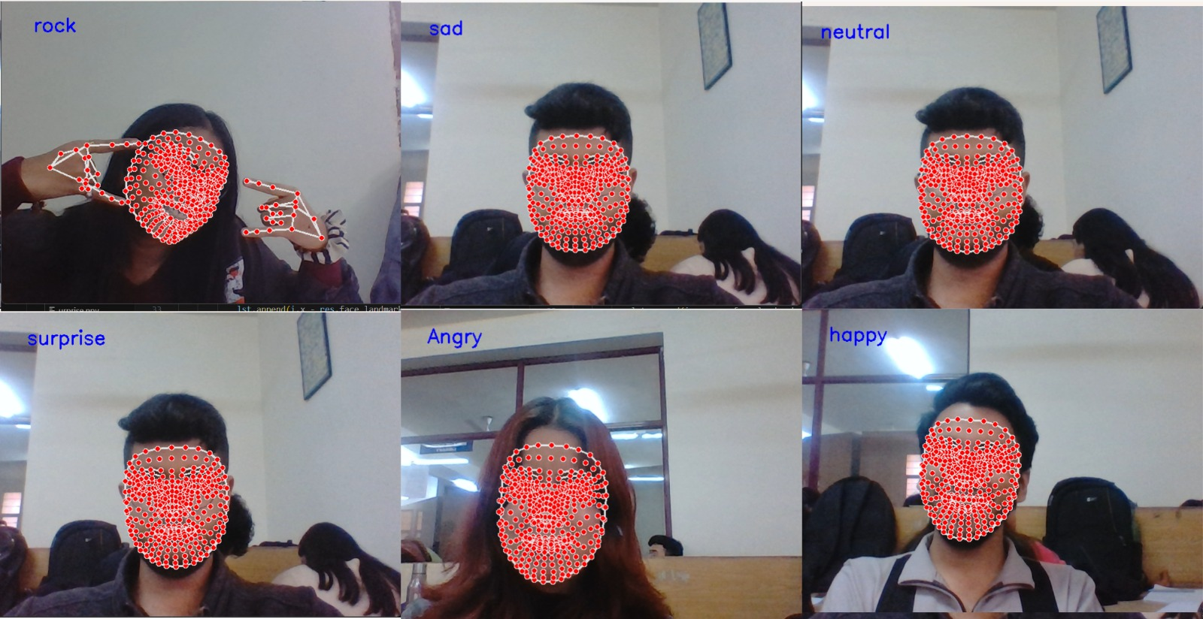
Figure 1: Real-Time Emotion Detection
1.2.4 User Engagement and Exploration
Encourage users to explore new music genres and artists by considering their current emotions and listening history, thereby promoting musical diversity and discovery.
1.2.5 Adaptation and Learning
Continuously improve the recommendation algorithms by incorporating user feedback and behaviour to enhance the system's accuracy in understanding and responding to emotional shifts.
1.2.6 Evaluation and User Feedback
Conduct rigorous user testing and gather feedback to assess the system's effectiveness in providing emotionally relevant music recommendations and user satisfaction.
1.3 Literature Overview
Emotion-based music recommendation systems have gained significant attention in recent years, driven by the increasing demand for personalised user experiences in the field of digital content consumption. This literature overview explores key themes and advancements in the relevant domains that contribute to the development of the Emotion-Based Music Recommender Web App, incorporating technologies such as MediaPipe, Keras, OpenCV, and Streamlit.
1.3.1 MediaPipe Library:
MediaPipe has emerged as a powerful framework for real-time face detection and facial landmark estimation. Research by Anil S. Bas and Swathi P., "Facial Emotion Recognition using MediaPipe," highlights the efficacy of MediaPipe in accurately recognizing facial expressions, forming the basis for emotion-based analysis.
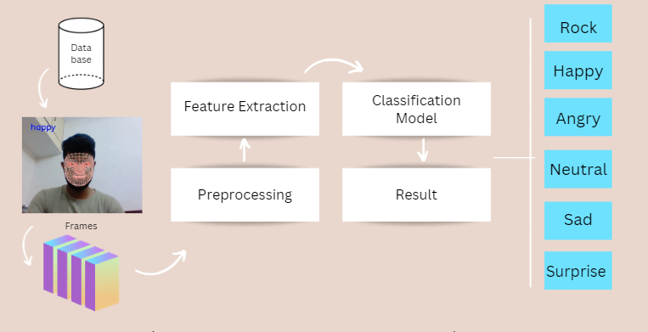
Figure 2: MediaPipe Framework
1.3.2 OpenCV for Image Processing:
OpenCV is widely utilised for image processing tasks, and its application in emotion recognition is well-documented. Studies like "Real-Time Facial Emotion Recognition Using Convolutional Neural Networks" by Amarjot Singh and Palwinder Singh explore the integration of OpenCV with deep learning techniques for robust emotion detection.
1.3.3 Keras for Deep Learning:
Keras, a high-level API, is frequently employed in building recommendation systems. Research in "Deep Learning for Music Recommendation: A Survey and Challenges" by Wen Zhang and Xiangmin Zhou discusses the use of deep learning techniques, similar to those implemented in Keras, for effective music recommendation.
1.3.4 Hybrid Recommendation Systems:
The literature on recommendation systems emphasises the efficacy of hybrid approaches, combining collaborative filtering and content-based methods.
1.3.7 Streamlit Framework for Interactive Web Application Development:
The adoption of Streamlit for building interactive web applications has gained traction. The paper "Streamlit: A Framework for Rapid Development of Data Apps'' by Amanda Kelly and Adrien Treuille introduces Streamlit's ease of use and its application in creating data-driven applications.
1.3.8 WebRTC for Real-Time Communication:
The integration of WebRTC, as explored in the project, aligns with the broader trend of incorporating real-time communication capabilities into web applications. Literature such as “WebRTC: APIs and RTCWEB Protocols of the HTML5 Real-Time Web” by Alan B. Johnston and Daniel C. Burnett provides insights into the functionalities of WebRTC.
In conclusion, the literature review highlights the interdisciplinary nature of the Emotion-Based Music Recommender Web App project. Drawing from advancements in computer vision, deep learning for emotion analysis, and the development of interactive web applications, this project represents a synergistic fusion of technologies at the forefront of research and application in the domains of emotion recognition and music recommendation. The integration of these technologies reflects a broader trend toward creating immersive and personalised user experiences in digital content consumption.
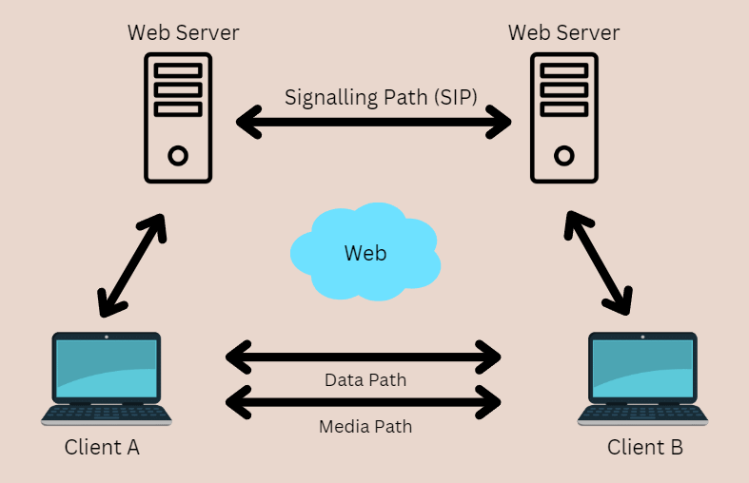
Figure 3: WebRTC for Real-Time Communication
1.4 Motivation
The contemporary music streaming landscape offers an extensive array of songs and playlists, yet the challenge of selecting music that aligns seamlessly with the ever-changing landscape of human emotions remains largely unaddressed. People often struggle to find music that resonates with their current emotional state, resulting in a fragmented and less immersive music listening experience. Existing music recommendation systems primarily rely on user history and preferences, overlooking the dynamic nature of emotions and the potential for real-time emotional adaptation.
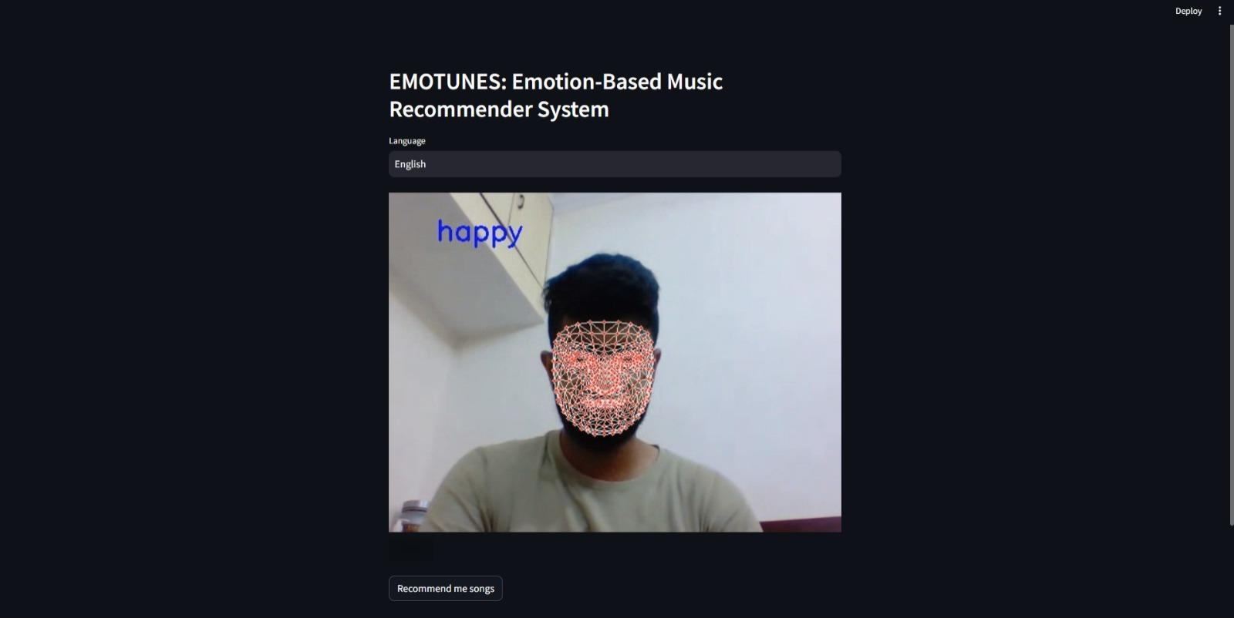
Figure 4: Website Preview and Emotion Analysis

CHAPTER 2: METHODOLOGY ADOPTED
2.1 Project Initiation:
· Define project objectives, scope, and constraints.
· Formulate a project team with roles and responsibilities.
· Establish communication channels and project management tools.
2.2 Feasibility Study:
· Assess technical, economic, and operational feasibility.
· Conduct need analysis to understand user requirements.
· Evaluate the significance of the project in the real world.
2.3 Requirement Analysis:
· Gather detailed requirements for emotion detection, music recommendation, and user interfaces.
· Create user stories or use cases to capture functional and non-functional requirements.
· Define data sources, including music libraries and emotion datasets.
2.4 System Design:
· Architect the overall system, including data flow, components, and interfaces.
· Design the database schema for storing user data, music metadata, and emotion labels.
· Define the system's neural network architecture for emotion detection.
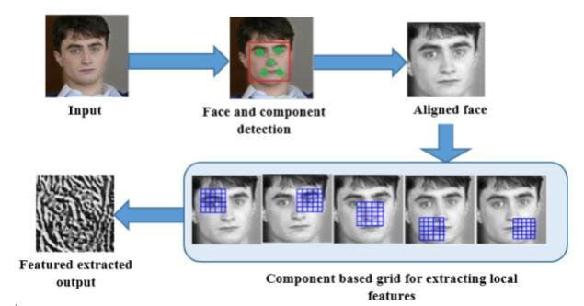
Figure 5: Feature Extraction in System Design
2.5 Software Development:
· Implement the emotion detection model using TensorFlow or PyTorch.
· Develop the web application using web frameworks like Django or Flask.
· Integrate machine learning models with the web application.
· Create user interfaces for user interaction and music playback.
2.6 Database Implementation:
· Set up and configure the chosen database system (e.g., MySQL or PostgreSQL).
· Create tables and define relationships to store user data and music information.
· Implement data access and retrieval methods.
2.7 Testing and Quality Assurance:
· Conduct unit testing for individual components and modules.
· Perform integration testing to ensure seamless interaction between system elements.
· Implement user acceptance testing (UAT) to validate system functionality.
2.8 Deployment:
· Deploy the web application on a web server (e.g., AWS or Google Cloud).
· Configure the server environment, including security settings.
· Set up continuous integration/continuous deployment (CI/CD) pipelines for automated deployment.
2.9 User Training and Documentation:
· Provide user training materials and tutorials for effective system usage.
· Create technical documentation for developers and administrators.
2.10 User Acceptance and Feedback:
· Engage users in testing and gather feedback.
· Address user feedback and make necessary improvements.
2.11 Maintenance and Support:
· Establish a maintenance plan for regular updates and bug fixes.
· Provide technical support to address user inquiries and issues.
2.12 Project Closure:
· Perform a final project review to ensure all objectives are met.
· Document lessons learned and best practices for future reference.
· Hand over the project to relevant stakeholders or administrators.
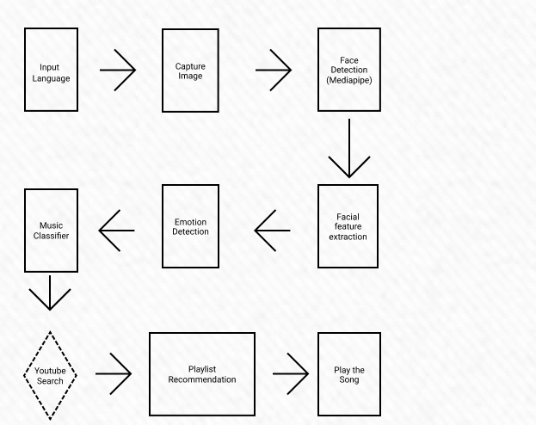
Figure 6: Block Diagram of the Proposed System
The project is a multifaceted endeavour that integrates various technologies to deliver a comprehensive solution. It commences with a meticulous definition of project objectives and technology requirements. Following the establishment of the development environment and the accumulation of diverse datasets, the implementation involves the use of MediaPipe and OpenCV for facial emotion recognition, and Keras for machine learning-based music recommendations. The integration phase intricately combines outputs from facial emotion recognition with music recommendations, adhering to predefined correlation rules. OpenCV is additionally employed for various image processing tasks. The creation of an interactive web interface is achieved through the utilisation of Streamlit, ensuring a user-friendly experience.
To ensure robust functionality, rigorous testing, encompassing both unit and integration testing, is conducted. The code undergoes optimization for performance before deployment on a server or cloud platform. User training sessions, supplemented by comprehensive documentation, are provided, and ongoing monitoring and maintenance are integral components of the project's execution. Prioritising user feedback for continuous improvement, scalability options are considered for potential expansion. This systematic approach ensures the successful execution of the project's diverse technological components, providing a reliable and efficient solution.

CHAPTER 3: DESIGN AND RESULT ANALYSIS
3.1 Software:
Developing our music recommendation project with emotion detection involves essential software components like Python for machine learning, OpenCV for image processing, and StreamLit for Web Development. MediaPipe Framework also helps us with image recognition. NumPy, Pandas and OS Python libraries help with emotion detection.
Version control through Git and platforms like GitHub ensures collaboration. Cloud services from Google Cloud are beneficial, while text/code editors (e.g., Visual Studio Code) and collaboration tools enhance coding and communication.
3.2 Hardware:
High-performance computers, web, and database servers are essential in order to make this project scalable. For current use, input devices and cameras enhance user interaction, and a stable internet connection supports cloud service access and deployment.
These components lay the foundation for our sophisticated music recommendation system with emotion detection capabilities. Careful consideration of each component's role is vital during project planning and development.
3.3 Feasibility:
3.3.1 Feasibility Analysis:
· Technical Feasibility: This evaluates the project's technical aspects, including technology availability.
· Operational Feasibility: It examines the project's readiness for operational integration, including user acceptance, impact on current operations, and the need for training and change management.
3.3.2 Need Analysis:
· Problem Identification: Clearly define the problem the project addresses and understand the issues it aims to resolve.
· Market Research: Analyze market demand, existing alternatives, and competitors to gauge the software's relevance.

CHAPTER 4: MERITS, DEMERITS AND APPLICATIONS
4.1 Merits
4.1.1 Personalized Music Recommendation:
The system offers a personalised music recommendation experience by dynamically adapting to the user's real-time emotional state. This enhances user engagement and satisfaction by providing music that resonates with their current mood.
4.1 .2 Real-Time Emotion Analysis:
Leveraging technologies like MediaPipe for facial emotion recognition enables real-time analysis of facial expressions. This real-time aspect enhances the responsiveness of the system, ensuring that music recommendations align with the user's changing emotions.
4.1.3 Integration of Cutting-Edge Technologies:
The project integrates state-of-the-art technologies such as MediaPipe, Keras, OpenCV, and Streamlit, showcasing a commitment to using cutting-edge tools for creating innovative and efficient solutions.
4.1.4 User-Friendly Interface:
Utilising Streamlit for web app development facilitates the creation of a user-friendly and interactive interface. Users can easily access the webcam through the streamlit-webrtc module, making the application accessible to a broader audience.
4.1.5 Educational Value:
The accompanying video tutorial explaining the codebase adds an educational dimension to the project, making it more accessible for developers and enthusiasts interested in understanding and replicating the implementation.

4.2 Demerits
4.2.1 Accuracy of Emotion Recognition
The accuracy of facial emotion recognition models, such as those implemented with MediaPipe, can be influenced by factors like lighting conditions and variations in facial expressions. Enhancements in these models are crucial for more reliable emotion detection.
Based on a Random Experiment we conducted to get feedback:
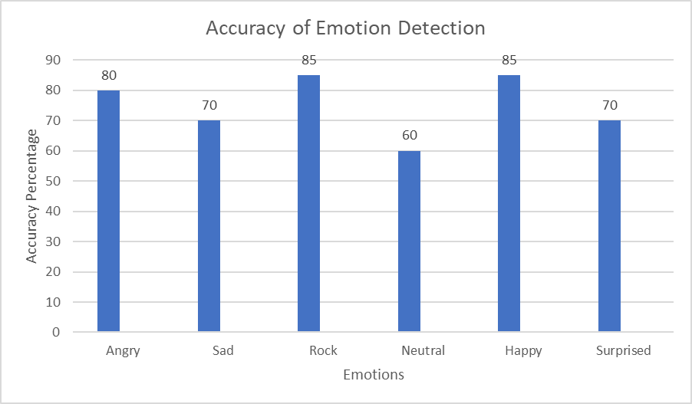
Serial Number | Emotion | Accuracy (Based on Random Experiments)
1. | Angry | 80%
2. | Sad | 70%
3. | Rock | 85%
4. | Neutral | 60%
5. | Happy | 85%
6. | Surprised | 70%

Figure 7: Accuracy of Emotion Detection
4.2.2 Limited Music Recommendation Strategies
Depending solely on a machine learning model for music recommendations may limit the diversity and relevance of suggested music. Exploring and integrating additional recommendation strategies could enhance the overall effectiveness of the system.
4.2.3 Dependency on WebRTC Stability
The reliance on the streamlit-webrtc module introduces a dependency on the stability and compatibility of WebRTC. Issues related to browser compatibility or changes in the WebRTC standard could impact the reliability of webcam access.

4.2.4 Scalability
The system's scalability may be a consideration, especially if there is a significant increase in the number of users. Scaling the recommendation model and ensuring real-time processing efficiency for a larger user base could be a challenge.
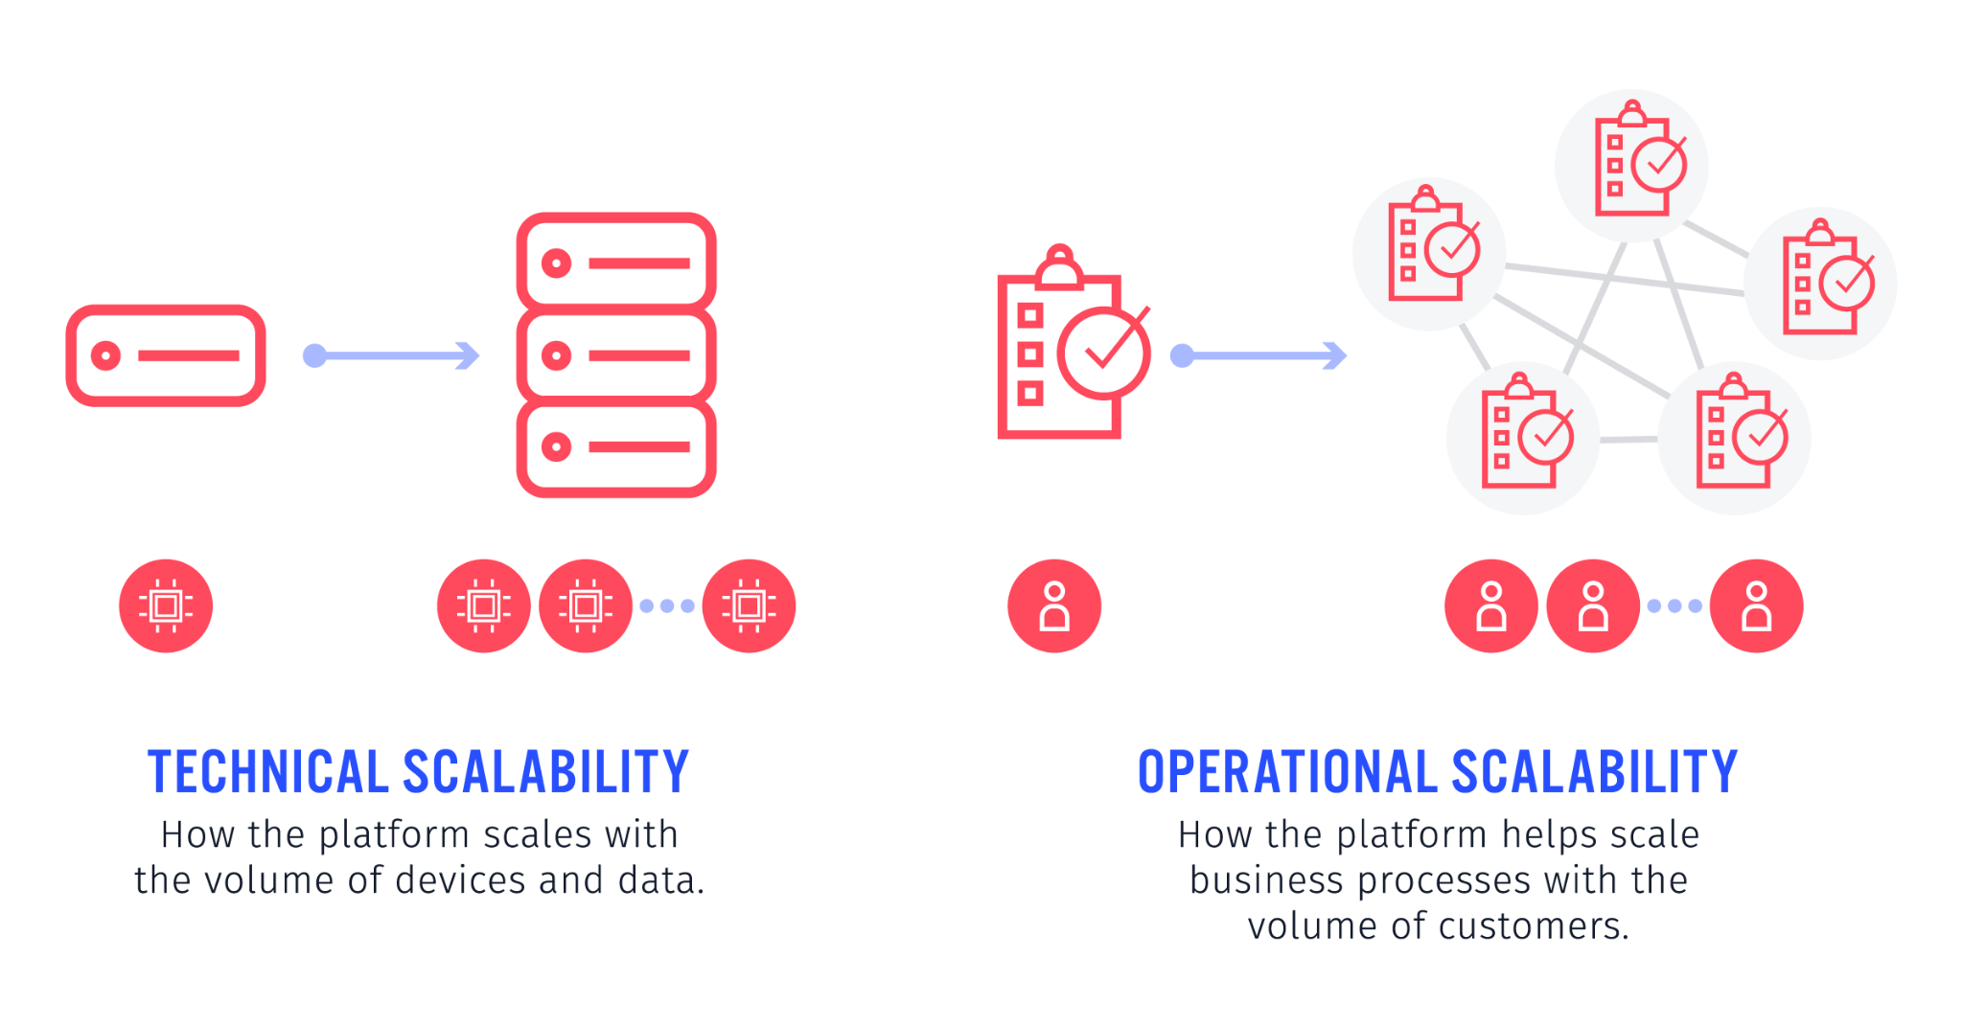
Figure 8: Technical and Operational Scalability

4.2.5 Limited User Interaction Feedback
While the system captures real-time facial expressions, it lacks direct user feedback on the relevance of the music recommendations. Incorporating a mechanism for users to provide feedback could enhance the learning and adaptability of the recommendation model.
4.3 Applications
4.3.1 Personalized Emotional Soundtracks:
EmoTunes introduces a novel way of tailoring music to individual emotions. By utilizing real-time facial emotion detection, the system dynamically recommends music tracks, playlists, and genres that align with the user's current mood. This personalized approach ensures that users are accompanied by the perfect musical complement for every emotional state, turning their listening experience into a deeply immersive and emotive journey.
4.3.2 Enhanced User Experience:
The user-friendly and visually engaging web interface crafted by EmoTunes' web development artisans ensures a seamless and enjoyable experience. Users can effortlessly navigate through the platform, exploring hand-picked music selections that resonate with their current state of mind. The intuitive interface empowers users to effortlessly connect with their emotions through music, making EmoTunes an indispensable companion in their digital music exploration.
4.3.3 Musical Discovery and Exploration:
EmoTunes goes beyond the realm of traditional music recommendation systems. By tapping into user preferences and leveraging AI algorithms, the system introduces users to artists and genres they might never have encountered otherwise. This expands musical horizons, fostering a sense of discovery and exploration. Users can effortlessly uncover new and diverse musical landscapes that align with their evolving tastes and emotional nuances.
4.3.4 Real-time Emotional Insights:
The heart of EmoTunes lies in its real-time emotion detection capabilities. The AI and ML algorithms decode and analyze the emotions etched on the user's face, capturing a wide range of emotional states in real time. This not only enhances the accuracy of music recommendations but also provides valuable insights into the user's emotional well-being. These insights can be leveraged for various applications, such as personalized mental health and well-being recommendations.
4.3.5 Interactive Emotional Companion:
EmoTunes is not just a music recommendation system; it's an emotional companion that adapts to the user's feelings. The system learns and evolves, orchestrating an intricate symphony of personalized playlists that respond to the user's shifting moods. It transforms the act of listening to music into a dynamic and interactive experience, where the user's emotions direct the musical narrative, creating a unique and deeply personal connection with the content.
In essence, EmoTunes is poised to redefine the landscape of music consumption by seamlessly integrating technology, emotion, and creativity. This innovative project transcends conventional boundaries, offering a glimpse into the future where music becomes a truly personalized and emotionally resonant journey. Welcome to EmoTunes, where the fusion of emotion and technology sparks a symphony for the soul.

CHAPTER 5: CONCLUSIONS AND FUTURE SCOPE
5.1 Conclusion
In conclusion, the Emotion Based Music Recommender Web App Project successfully integrated cutting edge tech to create a dynamic and interactive platform for personalised music recommendations. By leaving the capabilities of MediaPipe, Keras, OpenCV, and Streallit, the system provides users with a unique experience.
The project underscores the potential of combining computer vision and machine learning in the realm of user-centric applications, particularly in the domain of emotion based content recommendation. The accuracy and efficiency of facial emotion recognition contribute to the system’s effectiveness in adapting music recommendations to the user’s emotional state.
The practical applications of our music recommendation project with emotion detection span various real-world scenarios, benefiting diverse user groups. For music streaming services like Spotify and Apple Music, this technology enhances the listening experience, offering personalised playlists based on users' current emotions. It elevates user engagement and satisfaction.
In the realm of mental health and well-being, mobile apps and platforms cater to individuals dealing with stress or mood disorders. By recommending music that aligns with their emotional state in real-time, these applications offer valuable tools for emotional regulation and mental health management.
Interactive entertainment and gaming leverage emotion detection to adapt gameplay and soundtracks, creating immersive experiences for gamers. Retail businesses enhance customer experiences by tailoring in-store or online music selections to match shoppers' moods, potentially influencing buying decisions.
Additionally, music therapy and rehabilitation programs utilise emotion detection to customise music therapy sessions, aiding patients' recovery journeys. In education, personalised music recommendations can optimise learning environments, fostering concentration and engagement.
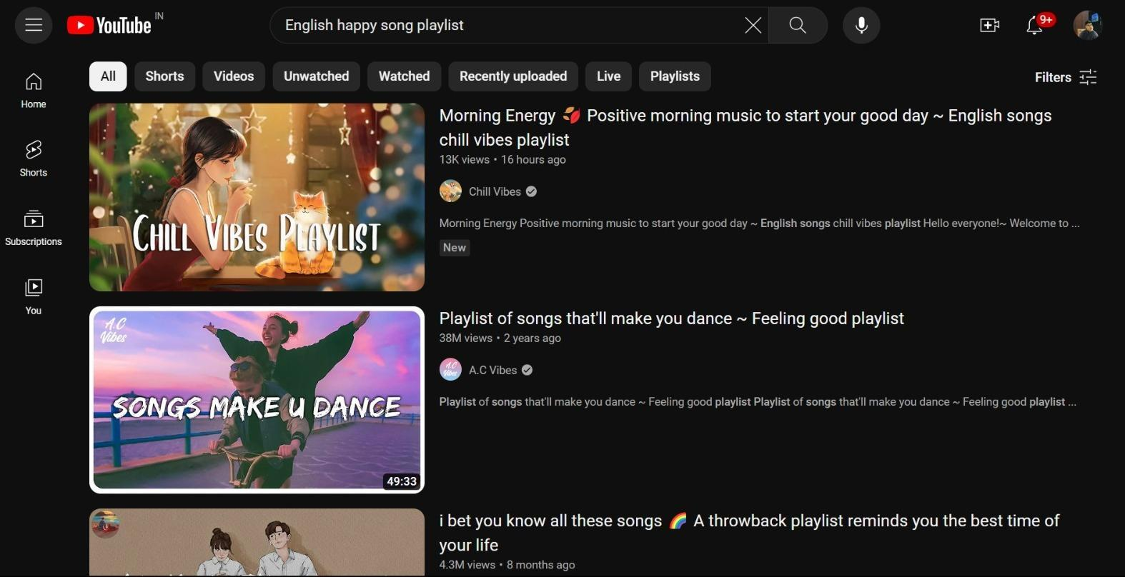
Figure 9: Recommendations after emotion analysis
The event and entertainment industry can curate event playlists that resonate with the collective mood of attendees, enhancing the overall ambiance. In each application, our system brings the power of emotion-aware music recommendations to targeted beneficiaries, enhancing experiences and adding value to diverse domains.
5.2 Future Scope
While the current implementation lays a solid foundation, there are several avenues for future enhancements and extensions to further enrich the project:
5..2.1 Enhanced Emotion Recognition Models
Improving the accuracy of emotion recognition models through continuous training and fine-tuning can lead to more precise and reliable emotion detection.
5.2.2 Diverse Music Recommendation Strategies
Expanding the music recommendation model to incorporate more sophisticated algorithms, collaborative filtering, or hybrid approaches could enhance the diversity and relevance of the suggested music.

5.2.3 User Feedback Integration
Incorporating a feedback mechanism to gather user responses to the recommended music can help refine the recommendation algorithms and make the system more adaptive to individual preferences.
5.2.4. Integration with Music Streaming APIs
Collaborating with popular music streaming services through APIs would allow users to seamlessly listen to recommended tracks directly within the web app.
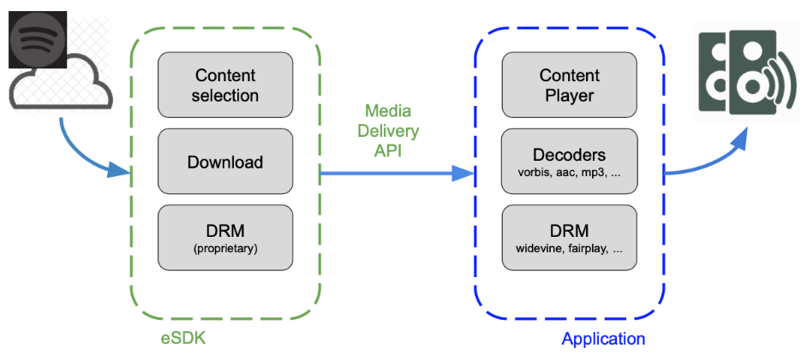
Figure 10: Integration with Music Streaming APIs
5.2.5 Mobile Application Integration
Extending the application to mobile platforms would broaden its accessibility, enabling users to experience emotion-based music recommendations on the go.
5.2.6 Social Media Integration
Integrating the app with social media platforms could facilitate sharing and discovering music recommendations with friends, fostering a more social and collaborative user experience.

5.2.7 Personalized User Profiles
Developing user profiles to store historical emotion data and preferences could enable the system to refine recommendations over time, creating a more personalised and tailored experience.
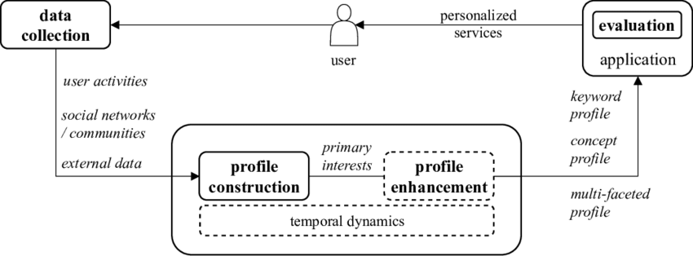
Figure 11: Personalized User Profiles
By exploring these future directions, the Emotion-Based Music Recommender Web App has the potential to evolve into a comprehensive and widely embraced tool, offering a unique fusion of emotion recognition, machine learning, and interactive web technologies in the realm of music recommendation.

CHAPTER 6: RESEARCH
In Research, the Emotion-Based Music Recommender Web App Project successfully integrated cutting-edge tech to create a dynamic and interactive platform for personalised music recommendations. By utilising the capabilities of MediaPipe, Keras, OpenCV, and Streamlit, the system provides users with a unique experience of recommending playlists on Youtube so that users have access to all new songs. The project underscores the potential of combining computer vision and machine learning in the realm of user-centric applications, particularly in the domain of emotion-based content recommendation. The accuracy and efficiency of facial emotion recognition contribute to the system’s effectiveness in adapting music recommendations to the user’s emotional state. The practical applications of our music recommendation project with emotion detection span various real-world scenarios, benefiting diverse user groups. For music streaming services like Spotify and Apple Music, this technology enhances the listening experience, offering personalised playlists based on users' current emotions. It elevates user engagement and satisfaction. In the realm of mental health and well-being, mobile apps and platforms cater to individuals dealing with stress or mood disorders. By recommending music that aligns with their emotional state in real time, these applications offer valuable tools for emotional regulation and mental health management. Interactive entertainment and gaming leverage emotion detection to adapt gameplay and soundtracks, creating immersive experiences for gamers. Retail businesses enhance customer experiences by tailoring in-store or online music selections to match shoppers' moods, potentially influencing buying decisions. The event and entertainment industry can curate event playlists that resonate with the collective mood of attendees, enhancing the overall ambience. In each application, our system brings the power of emotion-aware music recommendations to targeted beneficiaries, enhancing experiences and adding value to diverse domains. Additionally, music therapy and rehabilitation programs utilise emotion detection to customise music therapy sessions, aiding patients' recovery journeys. In education, personalised music recommendations can optimise learning environments, fostering concentration and engagement.

CHAPTER 7: REFERENCES
[1] Ramya Ramanathan, Radha Kumaran, Ram Rohan R, Rajat Gupta, and Vishalakshi Prabhu, an intelligent music player based on emotion recognition, 2nd IEEE International Conference on Computational Systems and Information Technology for Sustainable Solutions 2017. https://doi.org/10.1109/CSITSS.2017.8447743
[2] Shlok Gilda, Husain Zafar, Chintan Soni, Kshitija Waghurdekar, Smart music player integrating facial emotion recognition and music mood recommendation, Department of Computer Engineering, Pune Institute of Computer Technology, Pune, India, (IEEE), 2017. https://doi.org/10.1109/WiSPNET.2017.8299738
[3] Deger Ayata, Yusuf Yaslan, and Mustafa E. Kamasak, Emotion-based music recommendation system using wearable physiological sensors, IEEE transactions on consumer electronics, vol. 14, no. 8, May 2018. https://doi.org/10.1109/TCE.2018.2844736
[4] Ahlam Alrihail, Alaa Alsaedi, Kholood Albalawi, Liyakathunisa Syed, Music recommender system for users based on emotion detection through facial features, Department of Computer Science Taibah University, (DeSE), 2019. https://doi.org/10.1109/DeSE.2019.00188
[5] Research Prediction Competition, Challenges in representation learning: facial expression recognition challenges, Learn facial expression from an image, (KAGGLE).
[6] Preema J.S, Rajashree, Sahana M, Savitri H, Review on facial expression-based music player, International Journal of Engineering Research & Technology (IJERT), ISSN-2278-0181, Volume 6, Issue 15, 2018.
[7] AYUSH Guidel, Birat Sapkota, Krishna Sapkota, Music recommendation by facial analysis, February 17, 2020.
[8] CH. Sadhvika, Gutta.Abigna, P. Srinivas Reddy, Emotion-based music recommendation system, Sreenidhi Institute of Science and Technology, Yamnampet, Hyderabad; International Journal of Emerging Technologies and Innovative Research (JETIR) Volume 7, Issue 4, April 2020.
[9] Vincent Tabora, Face detection using OpenCV with Haar Cascade Classifiers, Becominghuman.ai,2019.
[10] Zhuwei Qin, Fuxun Yu, Chenchen Liu, Xiang Chen. How convolutional neural networks see the world - A survey of convolutional neural network visualisation methods. Mathematical Foundations of Computing, May 2018.
[11] Ahmed Hamdy AlDeeb, Emotion- Based Music Player Emotion Detection from Live Camera, ResearchGate, June 2019.
[12] Frans Norden and Filip von Reis Marlevi, A Comparative Analysis of Machine Learning Algorithms in Binary Facial Expression Recognition, TRITA-EECS-EX-2019:143.

