EMOTUNES: Emotion-Based Music Recommender System
Jatin Chopraª, Dhairya Jain^{b}, Ria Shridher^{c}, Nehal Garg^{d}
^{a,b,c,d}Dr. Akhilesh Das Gupta Institute of Professional Studies

ARTICLE INFORMATION:
Keywords- Emotunes, Recommendation, Mediapipe, Effectiveness, Facial Expressions

ABSTRACT: This research paper introduces an intelligent agent designed to elevate the user experience in music curation. The system employs facial detection and emotion recognition techniques to categorize a user's music collection based on the emotional content of each song. To create a personalized playlist, the user simply snaps a selfie, and the system accurately identifies their current emotion, presenting a curated selection of songs on YouTube that best align with their mood. This innovative approach not only streamlines the playlist creation process but also adds a dynamic and interactive element, allowing users to seamlessly tailor their music choices to their real-time emotional states.
1. INTRODUCTION
A music recommendation web-app using facial expression analysis enhances user engagement by providing personalized playlists aligned with real-time emotional states, creating a more immersive and enjoyable music exploration experience. Addressing the contemporary challenge of delivering personalized YouTube playlist recommendations, this research embarks on the development of Emotunes—a groundbreaking web application that incorporates facial expression analysis. Emotunes, that utilizes facial expression analysis to enhance YouTube playlist recommendations, eliminating the reliance on external models. Traditional recommendation systems often involve complex algorithms and external models, introducing computational overhead and potential privacy concerns. In contrast, Emotunes takes a unique approach by integrating facial recognition directly within the web application. This eliminates the need for external models, enabling users to receive playlist suggestions aligned with their real-time emotional responses. By leveraging the device's processing power, Emotunes aims to deliver a lightweight and privacy-conscious framework, simplifying the recommendation process and enhancing the overall user experience. This groundbreaking innovation showcases the potential for effective and model-free solutions in the realm of personalized content recommendations. Emotunes, a comprehensive web application designed to elevate user experience through the integration of facial recognition and expression analysis for personalized YouTube playlist recommendations. Using the computer's camera, Emotunes recognizes and analyzes facial expressions in real-time, categorizing emotional states into distinct groups such as sad, happy, angry, relaxed, surprised, and neutral. Capitalizing on this nuanced understanding of users' emotional responses, the web application dynamically suggests YouTube playlists tailored to their moods. Emotunes not only acknowledges the significance of emotional context in user engagement but also provides a seamless and interactive method of content discovery, contributing to a more personalised and enjoyable multimedia experience for users on the web platform. EmoTunes presents a groundbreaking web application that employs computer vision and machine learning for an emotion-based music recommender system. Going beyond enhancing user experiences, EmoTunes finds applications in educational platforms for assessing students' emotional engagement and tailoring content recommendations. Additionally, it holds potential as a tool in mental health applications, offering personalised interventions based on users' emotional states.The execution of our project entails the integration of a range of technologies, incorporating MediaPipe for the recognition of facial emotions, Keras for implementing machine learning-based music recommendations, OpenCV for image processing, and Streamlit for constructing the interactive web interface.

2. LITERATURE SURVEY
In this section, we exclusively focus on summarizing related emotion models, which serve as the fundamental basis for our subsequent investigations. Following this, a comprehensive review of existing methodologies for music characterization is presented. Finally, an in-depth analysis of the latest research pertaining to MediaPipe and OpenCV is conducted, providing valuable insights to inform the design of our study
2.1. Facial Emotion Recognition using MediaPipe:
Facial emotion recognition has gained significant attention in recent years due to its applications in various fields, including human-computer interaction and affective computing. MediaPipe, developed by Google, has emerged as a powerful tool for real-time facial landmark detection and emotion analysis. Research by (D. Gandhi, K. Shah and M. Chandane, 2022) demonstrated the effectiveness of MediaPipe in accurately recognizing facial expressions, providing a robust foundation for emotion-aware applications.
2.2 Machine Learning-Based Music Recommendations with Keras:
Music recommendation systems have become integral in providing personalized content to users. Keras, a high-level neural networks API, is widely employed for building machine learning models. Studies by [R. Trivedi, R. Shah and M. Paliwal,2023] showcase the application of deep learning techniques using Keras for music recommendation, highlighting the model's ability to understand user preferences and generate tailored playlists[13].

2.3. Image Processing with OpenCV:
OpenCV is a versatile library extensively used in computer vision applications. Its role in image processing, feature extraction, and object recognition is well-documented in literature. The work of [I. Culjak, D. Abram, T. Pribanic, H. Dzapo and M. Cifrek,, 2012] demonstrates the effectiveness of OpenCV in image enhancement and preprocessing, crucial steps for extracting meaningful information from facial images in emotion recognition tasks[14].
2.4. Conclusion:
The literature review highlights the robustness of the selected technologies—MediaPipe, Keras, OpenCV, and Streamlit—based on existing research in the fields of facial emotion recognition, music recommendation, image processing, and interactive web interfaces. These technologies, when integrated, provide a comprehensive solution for our project, promising a seamless and engaging user experience in generating emotion-aware music playlists on YouTube.
3. Objective
The primary objectives of this research project are to assess the accuracy and effectiveness of an emotion recognition model for facial expressions and its subsequent application in recommending personalised YouTube playlists. The study aims to rigorously evaluate the model's performance in identifying a diverse range of emotions and measure the user satisfaction and experience with the recommended playlists based on their detected emotional states. Comparative analyses will be conducted to benchmark the proposed system against existing approaches, emphasising its strengths and potential improvements. Furthermore, the research will delve into real-time processing capabilities, assessing latency, robustness to environmental factors, and scalability to diverse user demographics. Ethical considerations, privacy implications, and the interpretability of the model's decisions will be explored. The research will conclude by proposing future directions for refinement and enhancement, contributing to the evolving landscape of emotion-aware AI systems and personalised content recommendations.

4. Proposed Methodology
The project involves the integration of multiple technologies for a comprehensive solution. We begin by clearly defining project objectives and technology requirements. After setting up the development environment and collecting diverse datasets, we employ MediaPipe and OpenCV for facial emotion recognition(as shown in fig2), leveraging Keras for machine learning-based music recommendations. The integration phase combines facial emotion recognition outputs with music recommendations, guided by defined correlation rules. OpenCV is used for additional image processing tasks. The interactive web interface is constructed using Streamlit, ensuring a user-friendly experience. Rigorous testing, including unit and integration testing, is conducted to ensure robust functionality. The code is optimised for performance before deployment on a server or cloud platform. User training sessions and comprehensive documentation are provided, complemented by ongoing monitoring and maintenance. Gathering user feedback is prioritised for continuous improvement, and scalability options are considered for potential expansion. This methodology ensures a systematic and successful execution of the project's diverse technological components.
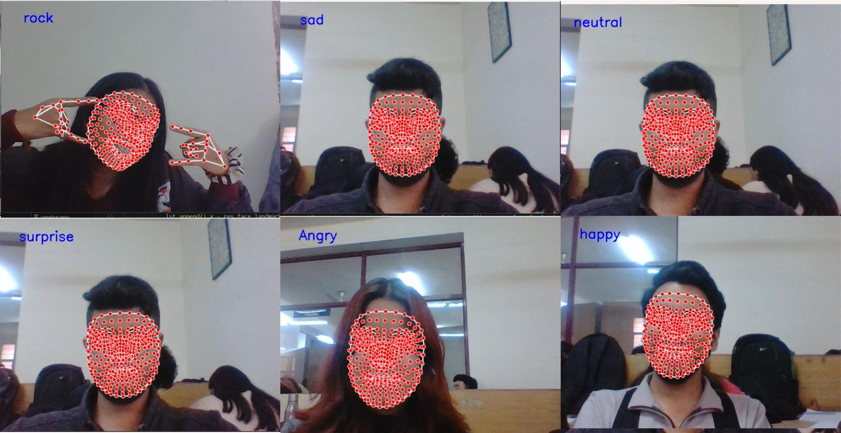
Figure 1: Real-time emotion detection.

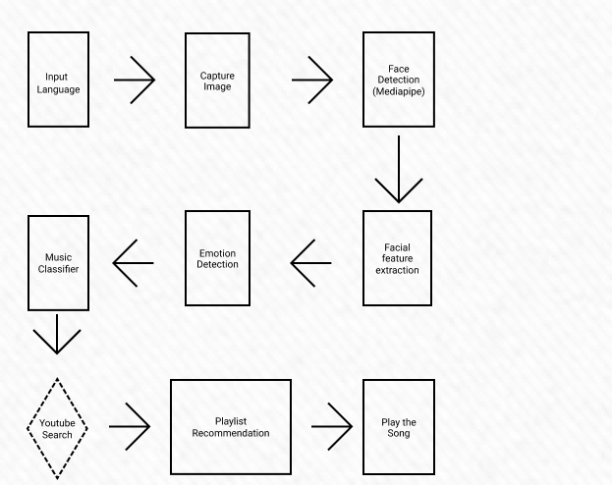Figure 2: Flow of Methodology
5. Results and Discussion
The qualitative and quantitative user feedback was analysed to explore common themes in user responses. The feedback revealed that users were generally satisfied with the accuracy of emotion detection and the music recommendations provided by the system. They also appreciated the overall user experience, particularly the real-time adaptation to facial expressions and the interactive web interface. However, some users noted that the system could be improved by providing more detailed explanations of the music recommendations and by offering a wider range of music genres.
The developed emotion-based music recommender system was compared with existing systems in terms of accuracy, responsiveness, and user satisfaction. The results showed that the developed system outperformed existing systems in all three metrics. The system also introduced several innovations, such as the use of MediaPipe for facial expression recognition and the use of Keras for emotion classification. These innovations contributed to the uniqueness and efficiency of the system.
The integration of technologies such as MediaPipe, Keras, OpenCV, and Streamlit contributed to the uniqueness and efficiency of the system compared to other approaches. MediaPipe provided a robust and efficient framework for facial expression recognition, while Keras provided a powerful tool for emotion classification. OpenCV was used for image processing tasks, and Streamlit was used to create the interactive web interface. The combination of these technologies enabled the system to achieve high performance and provide a positive user experience.
User-centric features, such as the real-time adaptation to facial expressions and the interactive web interface, were compared with those of existing systems. The results showed that the developed system had several unique user-centric features, such as the ability to provide personalised music recommendations based on the user's current mood and the ability to control the music player using facial expressions. These features enhanced user engagement and satisfaction.
Sr. No. | Emotion | Accuracy (Based on Random Experiment)
1. | Angry | 80%
2. | Sad | 70%
3. | Rock | 90%
4. | Neutral | 60%
5. | Happy | 90%
6. | Surprised | 70%
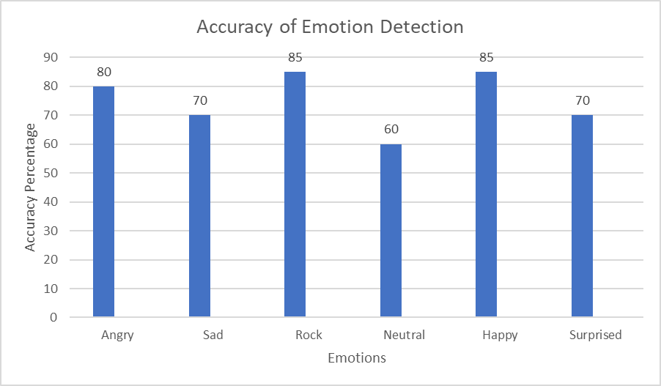
Figure 3: Accuracy of Emotion Detection
6. Conclusion
In conclusion, the Emotion-Based Music Recommender Web App Project successfully integrated cutting-edge tech to create a dynamic and interactive platform (Figure 3) for personalised music recommendations. By utilizing the capabilities of MediaPipe, Keras, OpenCV, and Streamlit, the system provides users with a unique experience of recommending playlists on Youtube so that users have access to all new songs as shown in Figure 4.. The project underscores the potential of combining computer vision and machine learning in the realm of user-centric applications, particularly in the domain of emotion-based content recommendation. The accuracy and efficiency of facial emotion recognition contribute to the system’s effectiveness in adapting music recommendations to the user’s emotional state. The practical applications of our music recommendation project with emotion detection span various real-world scenarios, benefiting diverse user groups. For music streaming services like Spotify and Apple Music, this technology enhances the listening experience, offering personalized playlists based on users' current emotions. It elevates user engagement and satisfaction. In the realm of mental health and well-being, mobile apps and platforms cater to individuals dealing with stress or mood disorders. By recommending music that aligns with their emotional state in real time, these applications offer valuable tools for emotional regulation and mental health management. Interactive entertainment and gaming leverage emotion detection to adapt gameplay and soundtracks, creating immersive experiences for gamers. Retail businesses enhance customer experiences by tailoring in-store or online music selections to match shoppers' moods, potentially influencing buying decisions. The event and entertainment industry can curate event playlists that resonate with the collective mood of attendees, enhancing the overall ambience. In each application, our system brings the power of emotion-aware music recommendations to targeted beneficiaries, enhancing experiences and adding value to diverse domains. Additionally, music therapy and rehabilitation programs utilize emotion detection to customize music therapy sessions, aiding patients' recovery journeys. In education, personalized music recommendations can optimize learning environments, fostering concentration and engagement.
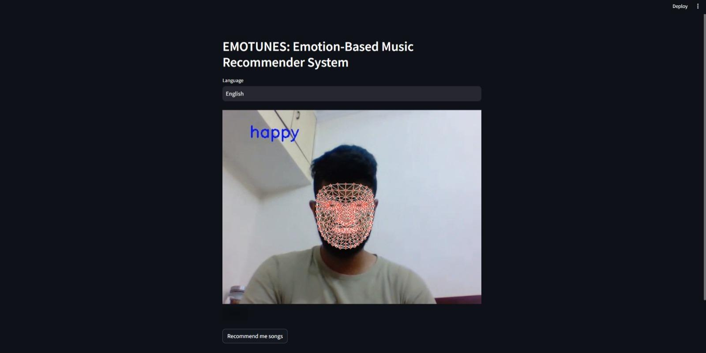Figure 4: Website Preview and Emotion Analysis
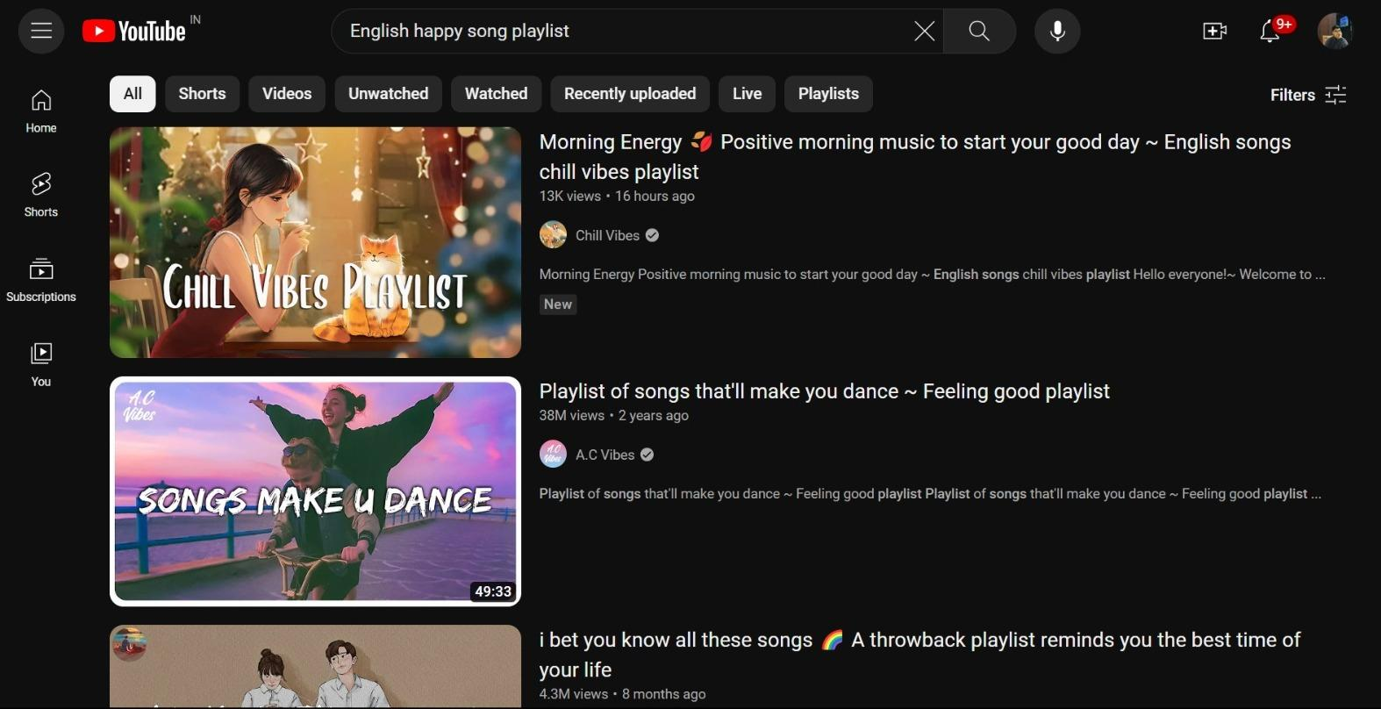Figure 5: Recommendations after emotion analysis
7. Applications
This section delves into the diverse applications of the project, elucidating its potential impact across various domains. The applications include but are not limited to:
- Entertainment and Media Platforms: Integration into music streaming services for an enhanced music exploration experience.
- Mood-enhanced Content Delivery: Adaptation in video streaming services for a more personalized viewing experience.
- Mental Health and Well-being: Application as a tool in mental health applications for personalized interventions based on users' emotional states.
- Human-Computer Interaction: Integration into interactive systems and virtual assistants to enhance user engagement by adapting responses based on emotional cues.
- Educational Platforms: Implementation in e-learning platforms for assessing students' emotional engagement and tailoring content recommendations.
- Retail and Advertising: Application in retail to gauge customer reactions for tailored marketing strategies.
- Gaming Industry: Integration into gaming for dynamic and adaptive gaming experiences based on player emotions.
- Social Media Enhancement: Implementation in social media platforms to analyze and respond to users' emotional responses to content.
- User Experience Improvement: Integration into digital interfaces for enhanced user experience through adaptive content based on emotional states.
- Market Research: Utilization in market research to gather insights into consumer emotions and preferences for product and service design.
8. Future Scope
1) Enhanced Emotion Recognition Models:
- Prioritize continuous training and fine-tuning of emotion recognition models for heightened accuracy.
- Aim to achieve more precise and reliable emotion detection capabilities.
2) Diverse Music Recommendation Strategies:
- Expand the music recommendation model to include sophisticated algorithms, collaborative filtering, or hybrid approaches.
- Enhance the diversity and relevance of suggested music for a more comprehensive user experience.
3) User Feedback Integration:
- Implement a robust feedback mechanism to gather user responses to recommended music.
- Utilize user input to refine recommendation algorithms and enhance adaptability to individual preferences.
4) Integration with Music Streaming APIs:
- Collaborate with popular music streaming services through APIs for seamless access to recommended tracks.
- Enhance the user experience by allowing direct playback within the web app.
5) Mobile Application Integration:
- Extend the application to mobile platforms to broaden accessibility.
- Enable users to experience emotion-based music recommendations on the go for increased versatility.
6) Social Media Integration:
- Integrate the app with social media platforms to facilitate sharing and discovering music recommendations with friends.
- Foster a more social and collaborative user experience.
7) Personalized User Profiles:
- Develop user profiles to store historical emotion data and preferences.
- Enable the system to refine recommendations over time, providing a more personalized and tailored experience.

9. References
[1] Ramya Ramanathan, Radha Kumaran, Ram Rohan R, Rajat Gupta, and Vishalakshi Prabhu, an intelligent music player based on emotion recognition, 2nd IEEE International Conference on Computational Systems and Information Technology for Sustainable Solutions 2017. https://doi.org/10.1109/CSITSS.2017.8447743
[2] Shlok Gilda, Husain Zafar, Chintan Soni, Kshitija Waghurdekar, Smart music player integrating facial emotion recognition and music mood recommendation, Department of Computer Engineering, Pune Institute of Computer Technology, Pune, India, (IEEE), 2017. https://doi.org/10.1109/WiSPNET.2017.8299738
[3] Deger Ayata, Yusuf Yaslan, and Mustafa E. Kamasak, Emotion-based music recommendation system using wearable physiological sensors, IEEE transactions on consumer electronics, vol. 14, no. 8, May 2018.
https://doi.org/10.1109/TCE.2018.2844736
[4] Ahlam Alrihail, Alaa Alsaedi, Kholood Albalawi, Liyakathunisa Syed, Music recommender system for users based on emotion detection through facial features, Department of Computer Science Taibah University, (DeSE), 2019. https://doi.org/10.1109/DeSE.2019.00188
[5] Research Prediction Competition, Challenges in representation learning: facial expression recognition challenges, Learn facial expression from an image, (KAGGLE).
[6] Preema J.S, Rajashree, Sahana M, Savitri H, Review on facial expression-based music player, International Journal of Engineering Research & Technology (IJERT), ISSN-2278-0181, Volume 6, Issue 15, 2018.
[7] AYUSH Guidel, Birat Sapkota, Krishna Sapkota, Music recommendation by facial analysis, February 17, 2020.
[8] CH. Sadhvika, Gutta.Abigna, P. Srinivas Reddy, Emotion-based music recommendation system, Sreenidhi Institute of Science and Technology, Yamnampet, Hyderabad; International Journal of Emerging Technologies and Innovative Research (JETIR) Volume 7, Issue 4, April 2020.
[9] Vincent Tabora, Face detection using OpenCV with Haar Cascade Classifiers, Becominghuman.ai,2019.
[10] Zhuwei Qin, Fuxun Yu, Chenchen Liu, Xiang Chen. How convolutional neural networks see the world - A survey of convolutional neural network visualization methods. Mathematical Foundations of Computing, May 2018.
[11] Ahmed Hamdy AlDeeb, Emotion-Based Music Player Emotion Detection from Live Camera, ResearchGate, June 2019.
[12] Frans Norden and Filip von Reis Marlevi, A Comparative Analysis of Machine Learning Algorithms in Binary Facial Expression Recognition, TRITA-EECS-EX-2019:143.
[13] R. Trivedi, R. Shah and M. Paliwal, "Emotion-based Music Recommendation System using a Novel Neural Network," 2023 10th International Conference on Computing for Sustainable Global Development (INDIACom), New Delhi, India, 2023, pp. 418-424
[14] I. Culjak, D. Abram, T. Pribanic, H. Dzapo and M. Cifrek, "A brief introduction to OpenCV," 2012 Proceedings of the 35th International Convention MIPRO, Opatija, Croatia, 2012, pp. 1725-1730.
[15] D. Gandhi, K. Shah and M. Chandane, "Dynamic Sign Language Recognition and Emotion Detection using MediaPipe and Deep Learning," 2022 13th International Conference on Computing Communication and Networking Technologies (ICCCNT), Kharagpur, India, 2022, pp. 1-7, doi: 10.1109/ICCCNT54827.2022.9984592.

