INVOICE

Date – 31-Mar-24
Invoice No. –DL-3

Dhairya Limbachiya
7 prasad Bhagyoday Society
Mansarovar Road
Palanpur
GUJARAT

Bill to:
Synoptek India Private Limited
Mondeal Heights, B Block, 1st floor
Besides Novotel Hotel,
SG Highway,
Ahmedabad - 380 015, India
Tel: 91-79-66824700

DESCRIPTION | AMOUNT
Being Fees for Dot Net services for the Month of Mar – 2024  Working Days –21  Present Days – 19  Leave Days – 2 | 9048

Payment Information:
PAN Number: BJMPL5263N
Bank Name: HDFC
Bank Account Number: 50100400011808
Bank IFSC Code: HDFC0000335

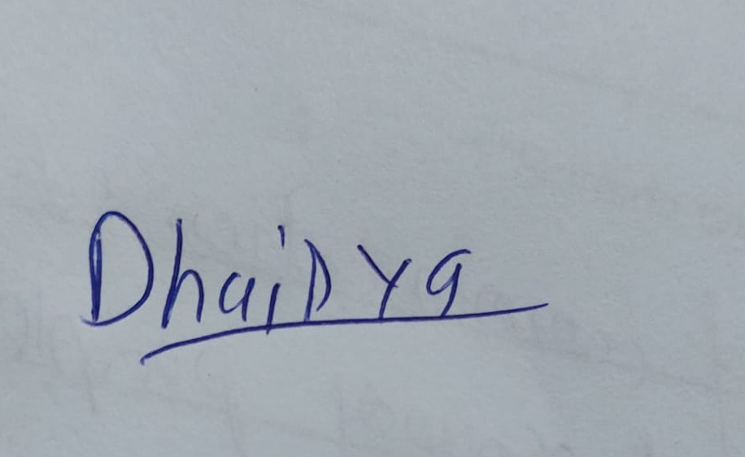
Authorized Signatory

If you have any questions about this invoice, please contact.
Contact No. – 6353699428 E-mail – dlimbachiya@synoptek.com
Thank you for your business!

