|  |
| --- |
| **ABOUT ME:-**   * **NAME: - KETANBEN KESHAVLAL GUPTA** * Adders: - 5/103 Shraddha Residency Dhundiawadi near gas Office, Palanpur 385001(B.K) * Date Of Birth: - 26/04/1975 * Mother Tongue: - Hindi * Other Tongue: - English, Gujarati * Religion: - Hindu * Nationality: Indian * Sex: - Female * Marital Status: - Divorced * Contact: - 9512433878 |

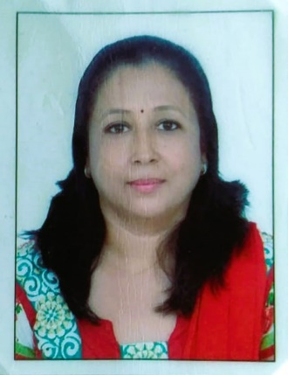

**CAREER OBJECTIVE: -**

A Challenging position in an organization where my technical and analytical skill would be applied for the betterment of the reputed organization.

**EDUCATION QULIFICATION: -**

|  |  |  |  |  |
| --- | --- | --- | --- | --- |
| **Sr. No** | **Exam** | **Board/ Uni.** | **Passing Year** | **Percentage** |
| 1 | S.S.C | G.S.E.B  Gandhinagar | 1990 | 60% |
| 2 | H.S.C | G.S.E.B  Gandhinagar | 1992 | 56% |
| 3 | T.Y.B.COM | N.G.U  Patan | 1996 | 52.77% |
| 4 | Computer Skills | Basic Knowledge | - | - |

**EXPERIENCE: -**

|  |  |
| --- | --- |
| **School** | **Year** |
| Kidzone | 3 Year |
| Silver Bells English Medium School (CBSE) | 8 Year |

**REFRENCE: -**

|  |  |  |
| --- | --- | --- |
| Monmoyuri Mukherji | Ex principal of Silver Bells School | +91 98795 38452 |
| Chhaya Parmar | Teacher at CJM School | +91 98982 50335 |
| Chaitali Mam | Principal of Shree Ram Vidyalaya | +91 98795 38452 |

**HOBBY: -**

* Listen Song
* Meet New People
* Traveling

**DECLARATION: -**

I hereby declare that all the details given above are true to the best of my knowledge and belief.

**Thanking you,**

**Ketanben Keshavlal Gupta**