Signal Transformation Chain and Inverse Parameter Estimation
Simulation report based on the MATLAB app outputs for six test signals | 29 October 2026
Name: Dhairya Soni
Enrollment No.: 12502060601007
Branch: Electronics & Communication

1. Objective
A test signal x(t) is passed through a four-stage chain (shift, time scaling, reversal and amplitude scaling), and an inverse routine then tries to recover the chain parameters from the original and final signals alone. Six standard signals were tested: sine, cosine, ramp, Gaussian, impulse and unit step. The goal is to check how accurately the parameters are recovered and to explain the cases where they are not unique.

2. Method

2.1 Forward transformation chain
The same settings were used for every signal: Shift = 2, Time Scale = 2, Amplitude = 5 and Reverse enabled. The app plots each stage on the window −10 ≤ t ≤ 10, in panels 1 to 5.
Panel | Operation | Resulting signal | Effect
1 | Original | x(t) | Reference signal
2 | Shift by 2 | x₁(t) = x(t − 2) | Delays the signal by 2 units
3 | Time scaling by 2 | x₂(t) = x₁(2t) = x(2t − 2) | Compresses the time axis by a factor of 2
4 | Reversal | x₃(t) = x₂(−t) = x(−2t − 2) | Mirrors the signal about t = 0
5 | Amplitude scaling by 5 | y(t) = 5·x(−2t − 2) | Multiplies every value by 5

Combining the stages gives the single closed form y(t) = 5·x(−2t − 2), which is the target the inverse routine should return. Because the plotting window is limited to [−10, 10], the original signal is only known on that interval. After compression and reversal, the visible support of the final signal shrinks to roughly −6 ≤ t ≤ 4. This truncation explains the sharp vertical edges seen in several panels.

2.2 Inverse chain
The Inverse Chain button estimates four parameters (shift, scale, reverse flag and amplitude) for a model of the form y(t) = A·x(±s·t − b). Panel 6 overlays the original signal (grey), the final signal (solid blue) and the estimated signal (dashed red). The status line above the plots lists the parameters found and the RMSE between the final and the estimated signals. An RMSE near zero (10⁻¹⁶ is machine precision) means the estimate reproduces the final signal.

3. Summary of results
Signal | Shift found | Scale found | Reverse | Amp. | Recovered y(t) | RMSE
Sine | 2.000 | 2.000 | 1 | 5.000 | 5·x(−2.000t − 2.000) | 4.5 × 10⁻¹⁶
Cosine | 2.000 | 2.000 | 1 | 5.000 | 5·x(−2.000t − 2.000) | 0
Ramp | 2.000 | 2.000 | 1 | 5.000 | 5·x(−2.000t − 2.000) | 0
Gaussian | −2.000 | 2.000 | 0 | 5.000 | 5·x(2.000t + 2.000) | 1.6 × 10⁻¹⁶
Impulse | 4.000 | 3.000 | 1 | 0.000 | 0·x(−3.000t − 4.000) | 0
Unit step | 2.002 | 1.997 | 1 | 5.000 | 5·x(−1.997t − 2.002) | 0

The sine, cosine and ramp are recovered exactly. The Gaussian is recovered with a different but equivalent parametrisation. The unit step is recovered to within about 0.003. The impulse cannot be identified, because its plotted signal is zero everywhere.

4. Results by signal

4.1 Sine
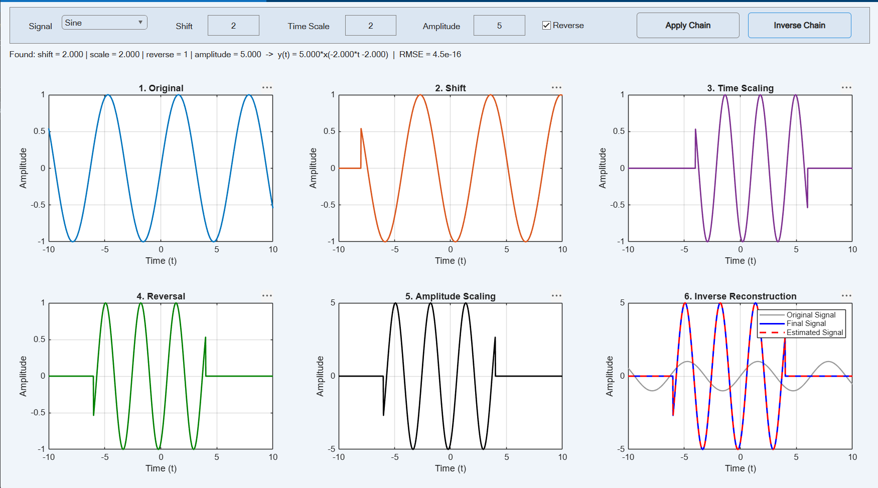
Figure 1. Transformation chain and inverse reconstruction for x(t) = sin(t).
The sine is delayed by 2 units, compressed to half its period, mirrored and scaled to a peak of 5. The small jump of about 0.54 at the left edge of panels 2 to 5 comes from the truncation described in Section 2: sin(−10) is not zero, so the shifted signal starts abruptly. Panel 6 shows the estimated signal lying exactly on the final signal. The recovered parameters (shift 2, scale 2, reverse 1, amplitude 5) match the inputs, with RMSE = 4.5 × 10⁻¹⁶.

4.2 Cosine
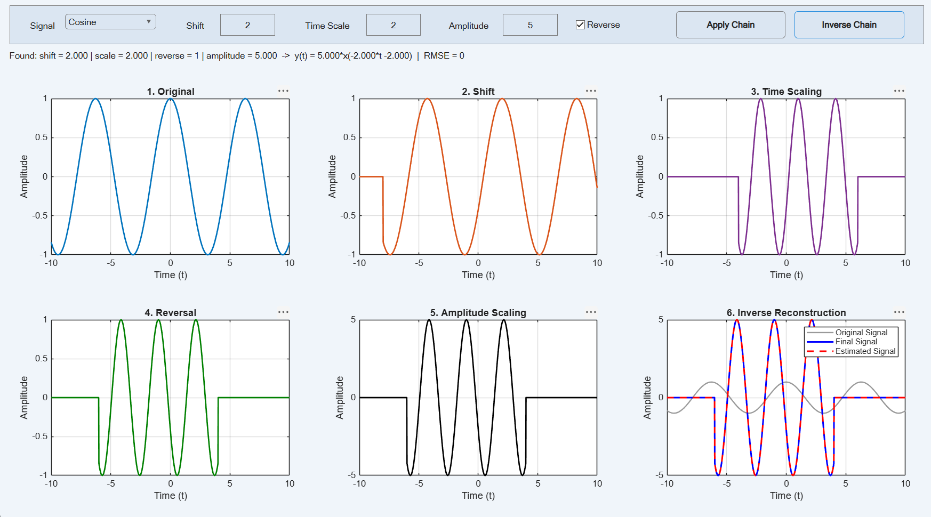
Figure 2. Transformation chain and inverse reconstruction for x(t) = cos(t).
The cosine behaves like the sine but begins at a different phase, so the truncation edge falls near −0.84 instead of +0.54. The final signal contains three full cycles inside −6 ≤ t ≤ 4 with peaks of ±5. The inverse routine returns the exact input parameters and RMSE = 0. The cosine is not symmetric under the combined shift-and-reverse operation, so the reverse flag is determined without ambiguity.

4. Results by signal (continued)

4.3 Ramp
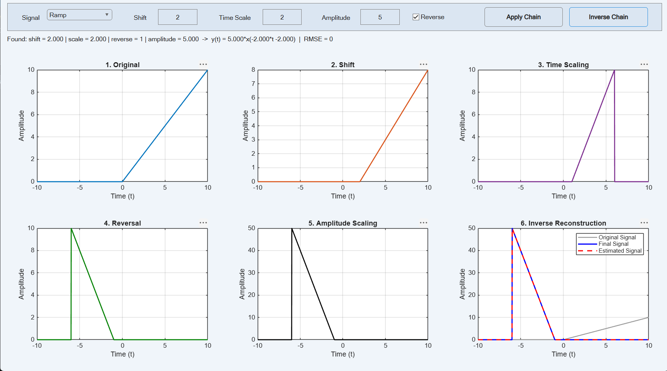
Figure 3. Transformation chain and inverse reconstruction for the ramp signal.
The ramp starts at t = 0 and rises to 10 at t = 10. After the shift it starts at t = 2, and time scaling moves its start to t = 1. In panel 3 it reaches 10 at t = 6, even though the shifted ramp in panel 2 only reaches 8 at the window edge. The values between t = 10 and 12 of the shifted signal lie outside the plot window and come back into view after compression. Reversal turns the ramp into a falling edge that ends at t = −1, and amplitude scaling lifts the peak to 50. The recovery is exact (RMSE = 0), as the ramp has a clear start point and a constant slope.

4.4 Gaussian
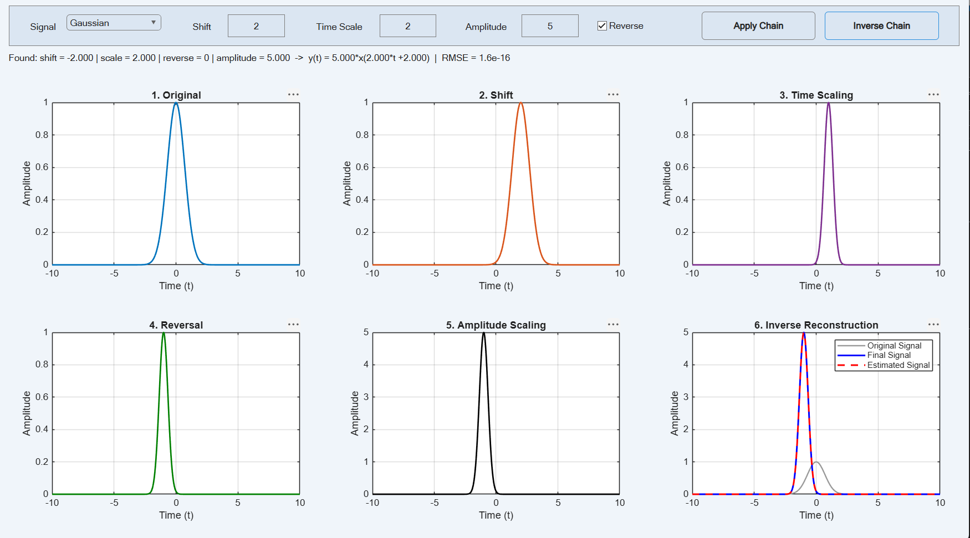
Figure 4. Transformation chain and inverse reconstruction for the Gaussian pulse.
The Gaussian pulse moves from t = 0 to t = 2, narrows to half its width, and ends up centred at t = −1 with a peak of 5. The inverse routine reports shift = −2, reverse = 0, giving 5·x(2t + 2) instead of 5·x(−2t − 2). Both are the same signal, since the Gaussian is an even function (x(−u) = x(u)), so reversal has no visible effect. The estimate is correct (RMSE = 1.6 × 10⁻¹⁶) but the reversal step cannot be recovered uniquely.

4. Results by signal (continued)

4.5 Impulse
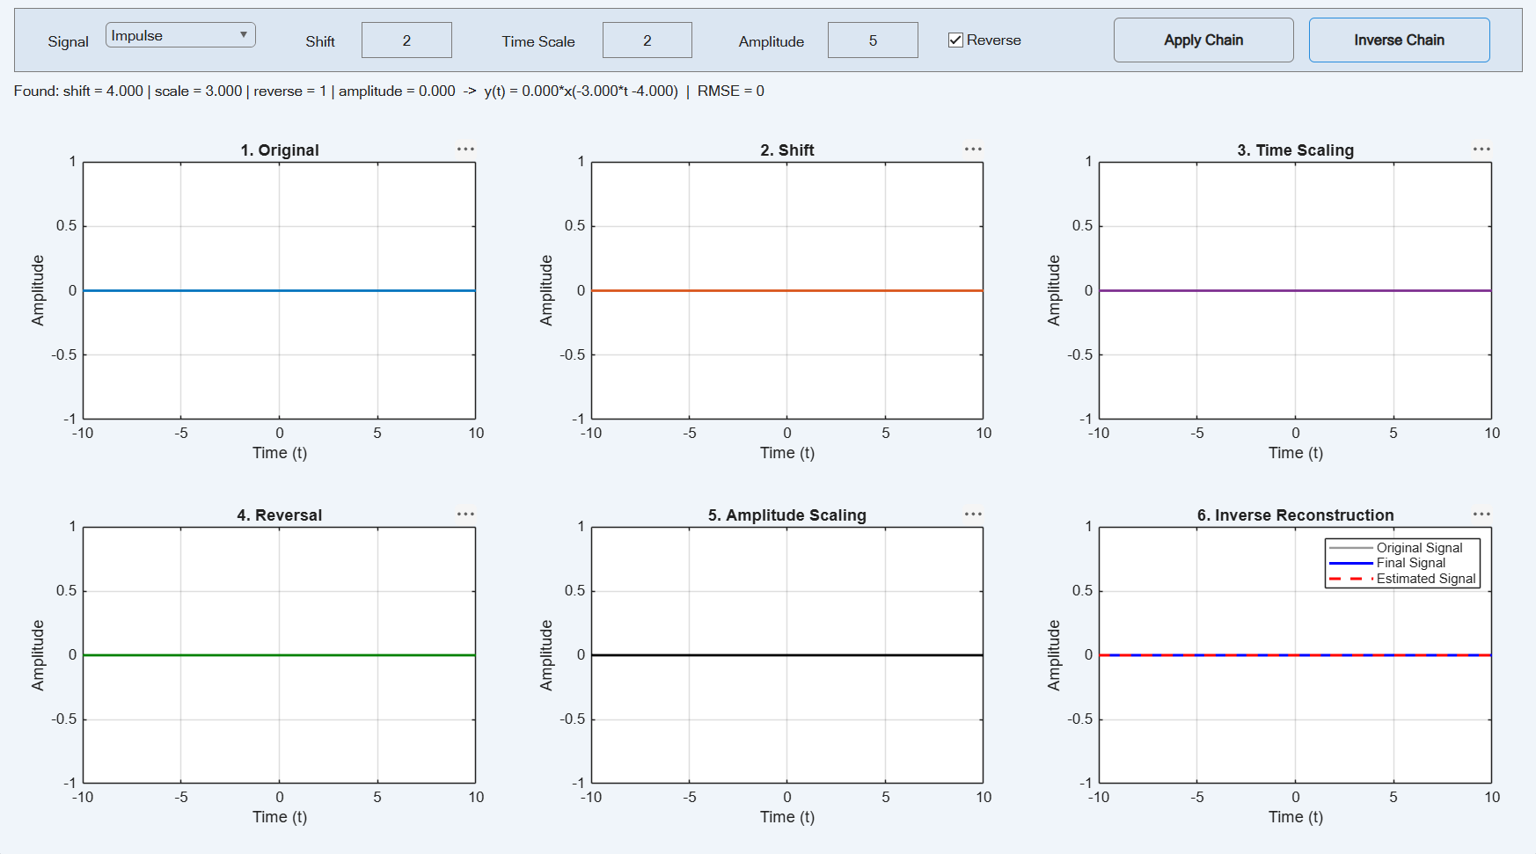
Figure 5. Transformation chain and inverse reconstruction for the impulse signal.
Every panel is a flat line at zero, including the original signal. A single-point impulse is not visible on the sampled time grid, and after shifting and scaling it is likely to fall between samples. The inverse routine reports amplitude = 0, so the other values (shift 4, scale 3, reverse 1) are arbitrary. The RMSE of 0 only shows that two zero signals match; the chain is not identifiable from this data.

4.6 Unit step
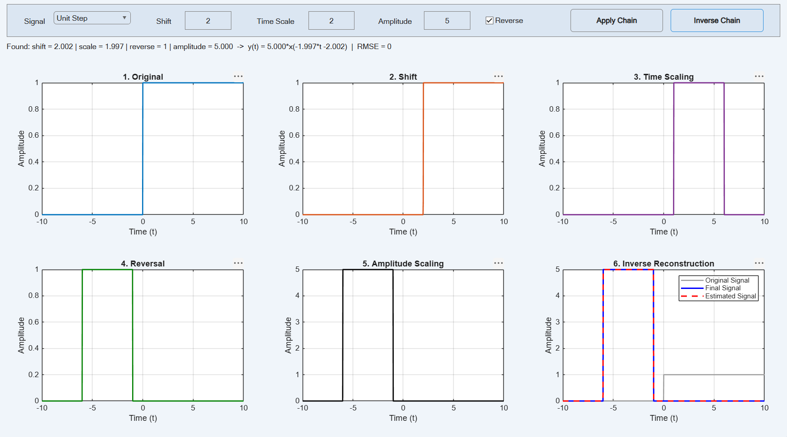
Figure 6. Transformation chain and inverse reconstruction for the unit step.
The step turns on at t = 0 in the original, at t = 2 after the shift, and appears as a pulse between t = 1 and t = 6 after scaling because the data ends at the window edge. Reversal moves this pulse to −6 ≤ t ≤ −1, and its height becomes 5. The recovered shift (2.002) and scale (1.997) differ slightly from 2 and 2. A step is constant between its edges, so only the edge positions carry information, and nearby parameter values produce identical samples on the time grid (RMSE = 0).

5. Conclusions
- The chain combines into y(t) = 5·x(−2t − 2); the sine, cosine and ramp were recovered exactly (RMSE ≤ 10⁻¹⁵).
- Symmetric signals (Gaussian) make the reverse flag ambiguous: shift = −2 with no reversal is equivalent.
- Piecewise-constant signals (unit step) are identified only to sampling resolution, with errors of about 0.003 in shift and scale.
- The impulse is not identifiable on a sampled grid; a finer grid or an explicit delta model is needed.

