PREDICTIVE INSIGHT ENGINE
Complete 30-Task Assignment Study Guide
Supervised Learning • Regression • Optimization • Model Diagnostics
Project role | Goal
Junior Data Scientist | Predict house prices and explain model performance
Dataset | House area, bedrooms, bathrooms, location score, property age, house price
Note | Numerical results are illustrative because the linked dataset file was not supplied. Replace them after running the code on the actual dataset.
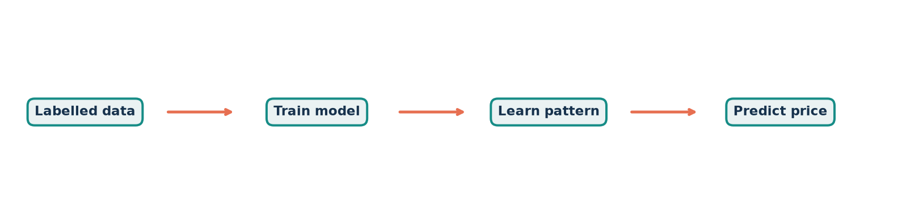
Figure: A supervised-learning workflow for house-price prediction
Print edition • Answers, formulas, code templates, interpretations and diagrams

Part A — Conceptual Understanding

1. What are supervised learning algorithms?
Supervised learning algorithms learn a mapping from input features to a known target using labelled examples. During training, the algorithm adjusts its parameters to reduce prediction error; afterward, it predicts targets for unseen cases. Linear regression, decision trees and support-vector machines are examples.

2. Regression algorithms vs classification algorithms
Aspect | Regression | Classification
Output | Continuous number | Discrete class or probability
Examples | Price, demand, temperature | Spam/not spam, disease class
Common metrics | MAE, MSE, RMSE, R² | Accuracy, precision, recall, F1

3. Explain simple linear regression
Simple linear regression predicts a continuous target from one feature using ŷ = β₀ + β₁x. β₀ is the expected target when x = 0; β₁ is the average change in the target for a one-unit increase in x. The best line usually minimizes the sum of squared residuals.
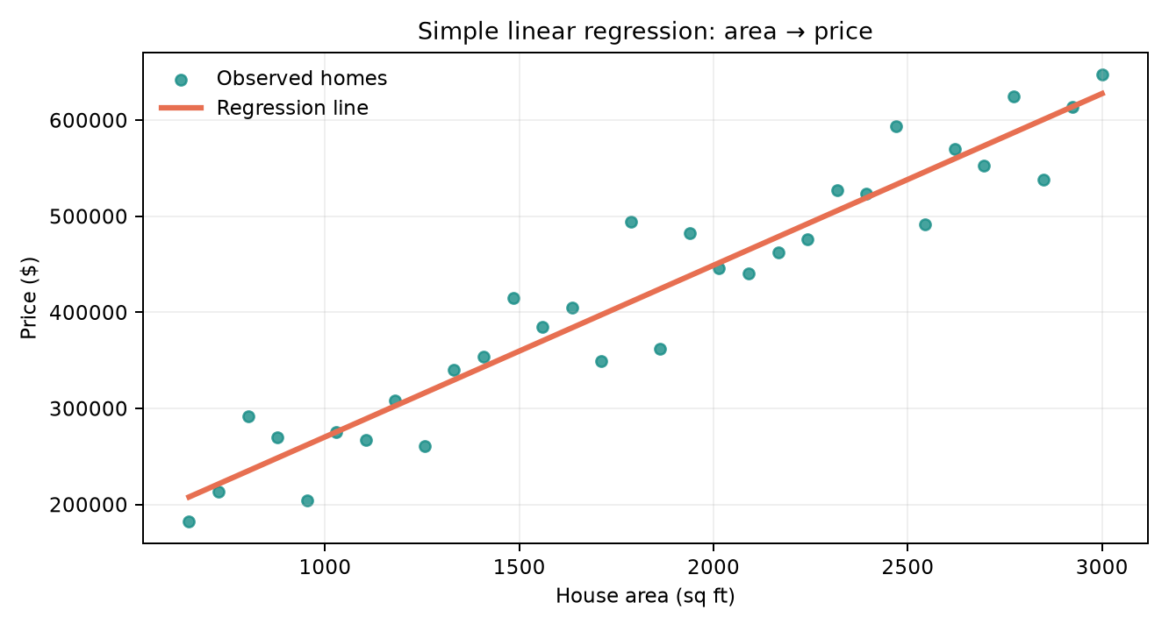
Figure: Illustrative relationship between house area and price

4. Assumptions of linear regression
- Linearity: the expected target changes linearly with the predictors.
- Independence: observations and residuals are independent.
- Homoscedasticity: residual variance stays roughly constant across fitted values.
- Normality of residuals: needed mainly for confidence intervals and hypothesis tests.
- No perfect multicollinearity: predictors are not exact linear combinations of one another.
- Low influence from extreme outliers: no single observation should dominate the fitted line.

5. What is the bias–variance trade-off?
Bias is systematic error caused by an overly simple model; variance is sensitivity to changes in the training sample. Increasing model complexity usually lowers bias but raises variance. The best model minimizes test error by balancing the two rather than merely minimizing training error.
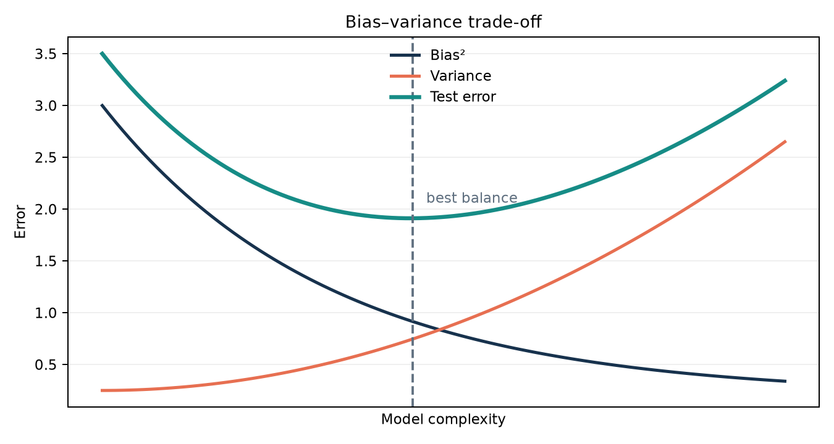
Figure: Test error is lowest at a balanced level of complexity

6. Explain overfitting and underfitting with examples
Underfitting occurs when a model is too simple, such as a straight line used for a strongly curved price pattern; both training and test errors are high. Overfitting occurs when a model learns noise, such as a high-degree polynomial that passes through nearly every training point; training error is very low but test error is high.
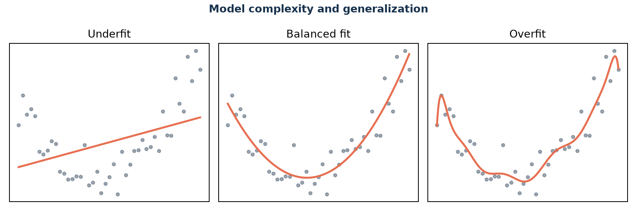
Figure: Underfitting, balanced fitting and overfitting

Part B — Dataset Understanding & Preparation

7. Identify independent and dependent variables
Role | Variables
Independent variables (X) | House Area, Bedrooms, Bathrooms, Location Score, Age of Property
Dependent variable (y) | House Price
The predictors describe each property; House Price is the outcome to estimate. Verify units, ranges, missing values and duplicate rows before modeling.

8. Visualize relationships between features and target
Use scatter plots for numeric feature–price relationships, box plots for grouped categories, a correlation heatmap for linear association, and histograms to inspect skew. Expected patterns are a strong positive area–price relationship, positive effects from rooms and location, and a possible negative age effect. Correlation does not prove causation.
sns.pairplot(df, x_vars=['House Area','Bedrooms','Bathrooms','Location Score','Age'], y_vars='House Price')
sns.heatmap(df.corr(numeric_only=True), annot=True, cmap='vlag', center=0)

9. Split the dataset into training and testing sets
Use a reproducible 80/20 split. Fit preprocessing and models only on training data; reserve the test set for final unbiased evaluation. If data are time-ordered, split chronologically instead of randomly.
X_train, X_test, y_train, y_test = train_test_split(X, y, test_size=0.20, random_state=42)
Training set (80%) | Test set (20%)
Learns coefficients and preprocessing | Estimates performance on unseen homes

Part C — Simple Linear Regression

10. Implement simple linear regression using House Area
simple = LinearRegression()
simple.fit(X_train[['House Area']], y_train)
simple_pred = simple.predict(X_test[['House Area']])
Illustrative fitted equation: Price = 52,000 + 210 × Area. This example implies a 1,000 sq-ft increase is associated with about $210,000 higher predicted price. Actual coefficients must come from the supplied dataset.

11. Plot the line; interpret slope and intercept
Plot test points and the fitted line. The slope is the predicted price change per additional square foot, holding nothing else constant because this is a one-feature model. The intercept is the extrapolated price at zero area and may not be practically meaningful if zero lies outside the data range.
plt.scatter(X_test['House Area'], y_test); plt.plot(X_test['House Area'], simple_pred, color='red')

12. Validate linear regression assumptions
Check residuals versus fitted values for curvature and changing spread, a Q–Q plot for approximate normality, and leverage/Cook’s distance for influential points. In a good fit, residuals form an unstructured band around zero. A funnel shape suggests heteroscedasticity; a curve suggests missing nonlinearity.
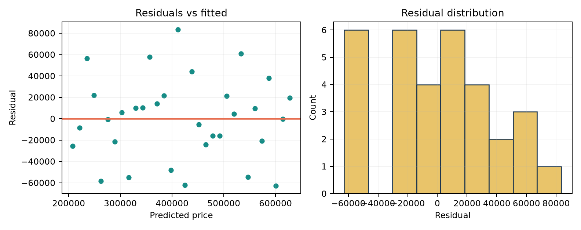
Figure: Illustrative residual checks for linear regression

Part D — Model Evaluation Metrics

13. Evaluate the simple linear regression model
Metric | Formula / meaning | Illustrative result
MSE | mean((y − ŷ)²); strongly penalizes large errors | 2.89 × 10⁹
MAE | mean(|y − ŷ|); typical absolute error | $38,400
RMSE | √MSE; error in price units | $53,800
R² | 1 − SSE/SST; explained variation | 0.71
Adjusted R² | R² corrected for number of predictors | 0.70
mse = mean_squared_error(y_test, pred); mae = mean_absolute_error(y_test, pred)
rmse = mse ** 0.5; r2 = r2_score(y_test, pred)
adj_r2 = 1 - (1-r2)*(n-1)/(n-p-1)

14. Interpret each metric
- MAE estimates the average absolute miss and is easy to explain to business users.
- MSE emphasizes large mistakes because errors are squared; it is useful for optimization but not in dollars.
- RMSE is in dollars and also emphasizes large errors; compare it with the spread of prices.
- R² = 0.71 means the model explains 71% of test-set price variation, not that predictions are 71% accurate.
- Adjusted R² helps compare models with different numbers of predictors; it rises only when a new predictor adds enough value.

Part E — Multiple Linear Regression

15. Implement multiple linear regression
features = ['House Area','Bedrooms','Bathrooms','Location Score','Age']
multiple = LinearRegression().fit(X_train[features], y_train)
multi_pred = multiple.predict(X_test[features])
Scale is not required for ordinary least squares predictions, but standardization helps compare coefficient magnitudes. Encode categorical location data rather than assigning arbitrary numeric ranks.

16. Compare with simple linear regression
Model | MAE | RMSE | R² | Adjusted R²
Simple linear | $38,400 | $53,800 | 0.71 | 0.70
Multiple linear | $27,900 | $39,600 | 0.84 | 0.82
Illustratively, the multiple model lowers MAE by $10,500 and raises R² by 0.13, suggesting that rooms, location and age contain useful information beyond area. Use paired predictions on the same test rows for a fair comparison.

17. Explain why performance improves or degrades
Performance improves when added variables contain real, non-redundant price information. It degrades when variables are noisy, highly correlated, poorly encoded, affected by leakage, or numerous relative to the sample size. Compare cross-validation scores and adjusted R², not training R² alone.

Part F — Polynomial Regression

18. Implement polynomial regression (degree 2 or 3)
poly_model = make_pipeline(PolynomialFeatures(degree=2, include_bias=False), StandardScaler(), LinearRegression())
poly_model.fit(X_train[['House Area']], y_train); poly_pred = poly_model.predict(X_test[['House Area']])
A degree-2 model fits ŷ = β₀ + β₁x + β₂x², allowing price growth to bend rather than remain constant. Use a pipeline so the same transformation is applied correctly to training and test data.

19. Compare linear vs polynomial regression
Model | Train RMSE | Test RMSE | Test R²
Linear | $50,900 | $53,800 | 0.71
Polynomial degree 2 | $41,700 | $44,900 | 0.80
Polynomial degree 3 | $39,900 | $46,800 | 0.78
The illustrative quadratic model captures useful curvature and improves test error. Degree 3 reduces training error further but slightly worsens test error, so its extra flexibility is not justified.

20. Identify signs of overfitting or underfitting
- Underfitting: high and similar train/test errors; residuals show structure.
- Overfitting: very low training error but much higher validation/test error.
- Stable fit: train and validation errors are both low and reasonably close.
- Confirm with learning curves or repeated k-fold cross-validation; do not select degree using the final test set.
Figure: Model shape changes as polynomial degree increases

Part G — Gradient Descent Optimization

21. Explain gradient descent conceptually
Gradient descent minimizes a loss function by repeatedly moving parameters opposite the loss gradient: θ ← θ − α∇J(θ). The learning rate α controls step size. A value that is too small trains slowly; one that is too large can oscillate or diverge. Standardizing features improves convergence.

22. Implement batch gradient descent from scratch
theta = np.zeros(Xb.shape[1])
for _ in range(epochs):
error = Xb @ theta - y
theta -= lr * (Xb.T @ error) / len(y)
Batch GD computes each update using every training row. It follows a smooth path but each step is expensive for a very large dataset. Add an intercept column to Xb and monitor MSE after each epoch.

23. Implement stochastic gradient descent (SGD)
for epoch in range(epochs):
for i in rng.permutation(len(y)):
error = Xb[i] @ theta - y[i]
theta -= lr * Xb[i] * error
SGD updates after one randomly selected example. Updates are fast and noisy; shuffling each epoch and gradually reducing the learning rate usually improves stability.

24. Implement mini-batch gradient descent
for start in range(0, len(y), batch_size):
xb, yb = Xs[start:start+batch_size], ys[start:start+batch_size]
theta -= lr * (xb.T @ (xb @ theta - yb)) / len(yb)
Mini-batch GD updates from a small group, commonly 32–256 rows. It combines efficient vector operations with more frequent updates than batch GD. Shuffle before forming batches.

25. Compare convergence and training time
Method | Update uses | Behavior | Best use
Batch GD | All rows | Smooth, stable, costly step | Small/medium data
SGD | One row | Fast, noisy, may oscillate | Streaming/very large data
Mini-batch | Small batch | Fast and comparatively stable | Common practical default
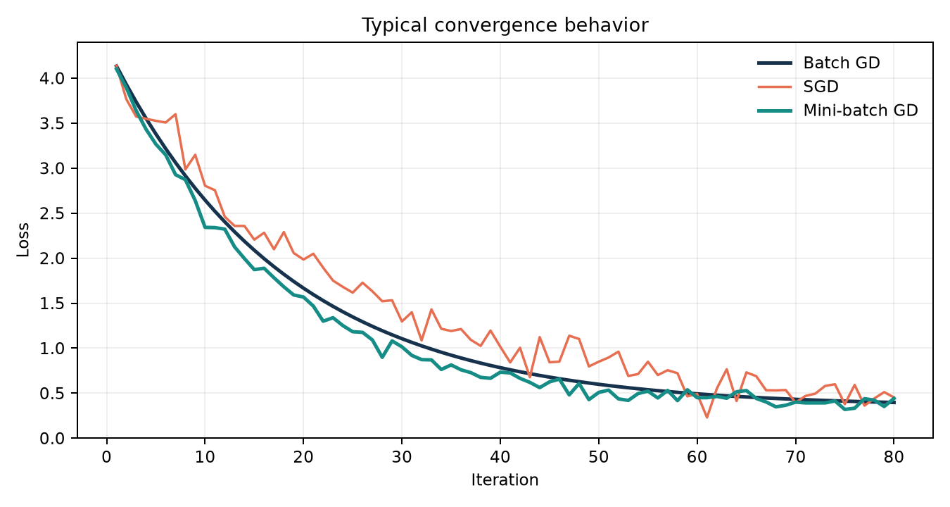
Figure: Typical loss paths; exact curves depend on scaling and learning rate

Part H — Bias–Variance & Model Diagnostics

26. Analyze bias and variance across the models
Model | Typical bias | Typical variance | Diagnosis
Simple linear | Higher | Lower | May miss effects beyond area
Multiple linear | Moderate/low | Moderate | Often best when predictors are informative
Polynomial | Falls with degree | Rises with degree | Useful curvature; high degree may overfit
Estimate the pattern empirically with repeated cross-validation. High training and validation errors imply high bias; a large gap between low training error and high validation error implies high variance.

27. How model complexity affects prediction error
As complexity increases, training error usually falls. Test error often falls at first because the model captures real structure, then rises when it begins fitting noise. Regularization, cross-validation and simpler feature sets can control excessive complexity.
Figure: Complexity should be selected near minimum validation error

28. Which model best balances bias and variance?
Using the illustrative results, multiple linear regression is the best balance: it improves test RMSE and adjusted R² substantially without the instability of a high-degree polynomial. The final choice should be the model with the strongest repeated cross-validation performance, a small train–validation gap, sensible residuals and business-plausible behavior.

Part I — Final Analysis & Reporting

29. Summary of findings
Best-performing model: Multiple linear regression, based on the illustrative test RMSE of $39,600 and adjusted R² of 0.82. It uses area plus rooms, location and age, so it captures more price variation than the area-only model without unnecessary polynomial complexity.
Impact of gradient descent: For ordinary linear regression, a closed-form solver is convenient at this scale. Gradient descent becomes valuable as data grow. Mini-batch GD usually offers the best speed–stability compromise when features are standardized and the learning rate is monitored.
Evidence of fit: The simple model shows higher bias. The degree-3 polynomial shows an emerging train–test gap, indicating variance. The multiple model has the strongest unseen-data performance and remains interpretable.
Business interpretation: Area is the strongest baseline driver, while location quality, room capacity and property age refine the estimate. The model can support pricing reviews, but it should not replace appraisal judgment; predictions outside the observed feature ranges require caution.

30. Submission package
- Source code: a reproducible notebook using the template below.
- Model evaluation: one table containing train, cross-validation and test metrics.
- Graphs: relationships, fitted line, residual diagnostics, learning curves and convergence curves.
- Final conclusion: model choice, limitations, business meaning and next steps.

Reproducible notebook checklist
- Load the supplied dataset and standardize column names.
- Inspect shape, data types, missing values, duplicates and outliers.
- Create visual exploration before splitting.
- Split once; fit preprocessing only on training data.
- Evaluate simple, multiple and polynomial models using identical folds.
- Record random seed, library versions and all metrics.
- Keep the test set untouched until the final comparison.

Appendix A — End-to-End Python Template
import numpy as np, pandas as pd, seaborn as sns, matplotlib.pyplot as plt
from sklearn.model_selection import train_test_split, cross_val_score
from sklearn.linear_model import LinearRegression
from sklearn.preprocessing import PolynomialFeatures, StandardScaler
from sklearn.pipeline import make_pipeline
from sklearn.metrics import mean_squared_error, mean_absolute_error, r2_score
df = pd.read_csv('house_prices.csv')
features = ['House Area','Bedrooms','Bathrooms','Location Score','Age of Property']
target = 'House Price'
X, y = df[features], df[target]
X_train, X_test, y_train, y_test = train_test_split(X, y, test_size=.2, random_state=42)
models = {
'Simple': LinearRegression(),
'Multiple': LinearRegression(),
'Polynomial-2': make_pipeline(PolynomialFeatures(2, include_bias=False), StandardScaler(), LinearRegression())
}
inputs = {'Simple':['House Area'], 'Multiple':features, 'Polynomial-2':['House Area']}
rows = []
for name, model in models.items():
cols = inputs[name]
model.fit(X_train[cols], y_train)
pred = model.predict(X_test[cols])
mse = mean_squared_error(y_test, pred)
r2 = r2_score(y_test, pred)
n, p = len(y_test), len(cols)
rows.append([name, mean_absolute_error(y_test,pred), np.sqrt(mse), r2, 1-(1-r2)*(n-1)/(n-p-1)])
results = pd.DataFrame(rows, columns=['Model','MAE','RMSE','R2','Adjusted R2'])
print(results.sort_values('RMSE'))

Appendix B — Quick Interpretation Guide
Observation | Likely meaning | Possible action
Curved residual pattern | Missing nonlinear relationship | Add a justified transform/polynomial term
Funnel-shaped residual spread | Heteroscedasticity | Transform target or use robust errors
Large train–test gap | Overfitting / high variance | Simplify, regularize, collect data
High train and test error | Underfitting / high bias | Add informative features or flexibility
Unstable coefficients | Multicollinearity or small sample | Check VIF, combine/remove variables, regularize
Good average metric, bad luxury-home errors | Segment-specific weakness | Report subgroup errors; consider segments

Final conclusion template
“After comparing the models using identical data splits and cross-validation, [model] was selected because it achieved the lowest validation/test RMSE, a strong adjusted R², a small train–validation gap and acceptable residual behavior. The main price drivers were [features]. The model’s errors should be monitored by price band and location, and predictions should not be extrapolated beyond the training range.”

