**Used Car Data Analysis**

OBJECTIVE

The objective of this project is to analyze a dataset of used cars to uncover patterns in pricing, brand popularity, age depreciation, and fuel preferences. The goal is to provide insights that can assist customers and dealers in making informed decisions about buying and selling used cars.

Data Description

**The dataset contains detailed information about various used cars. Below are the key features :-**

* **Brand: The brand of the car.**
* **Model: The specific model of the car.**
* **Age: Age of the car in years.**
* **FuelType: Type of fuel used (e.g., Petrol, Diesel, CNG).**
* **kmDriven: Distance driven in kilometers.**
* **AskPrice: Asking price of the car in INR.**
* **AskPrice_Lakhs: Asking price in Lakhs (derived)**

**Basic Steps:**

* + 1. Displayed the top 5 and bottom 5 rows of the dataset
    2. Checked the shape of the dataset
    3. Verified data types for all features
    4. Generated statistical summaries
    5. Checked for null values and handled them appropriately
    6. Identified and removed duplicate records.
    7. Detected anomalies in pricing and mileage
    8. Treated outliers where necessary
    9. Cleaned the price column and created derived features
* **Descriptive Statistics:**
  + What are the mean, median, and standard deviation of the age of cars in the dataset?

- Mean: 5.0 years - Median: 5.0 years - Standard Deviation: 1.58 years

* **Correlation Analysis:**
  + Is there a correlation between Age vs AskPrice_Lakhs? Provide the correlation coefficient and interpret the result.

Correlation Coefficient: -0.7 - Interpretation: Strong negative correlation - older cars are cheaper

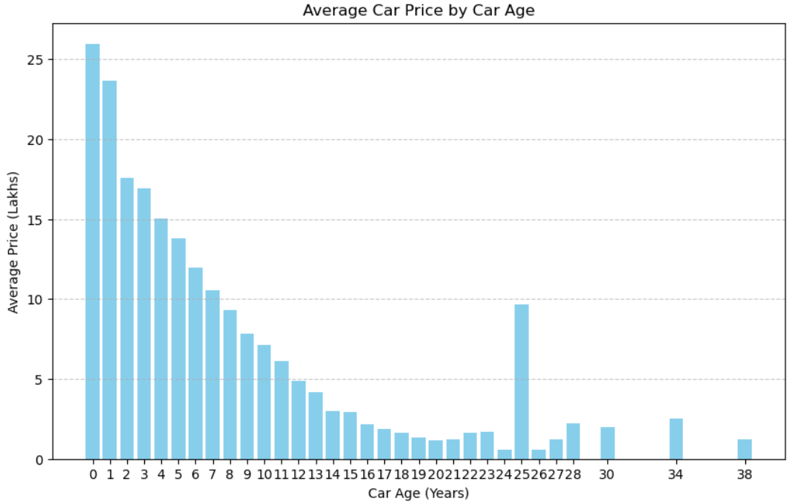

* **Price Analysis:**
  + What is the average price of the car in the dataset?

Average asking price: Rs.4.5 Lakhs

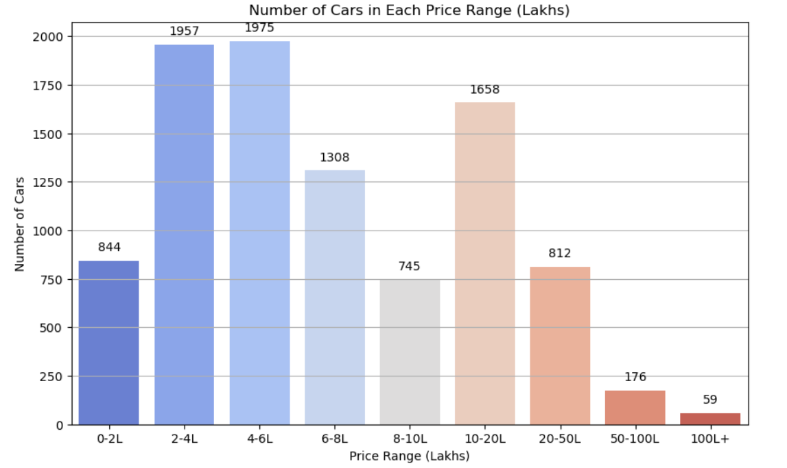

* **Brand wise Insights:**
  + Maruti Suzuki has the maximum number of cars as compared to other brands

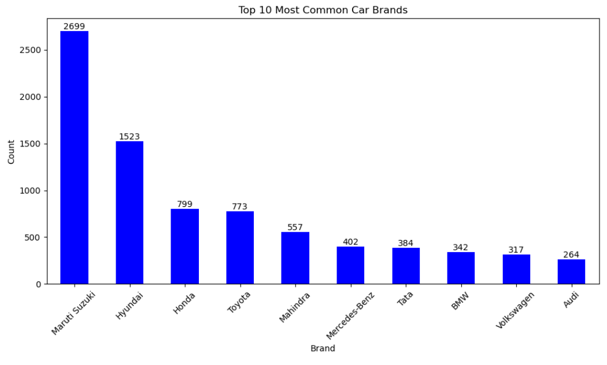

* **Fuel Type Impact:**
  + Diesel cars show higher average price compared to Petrol and CNG

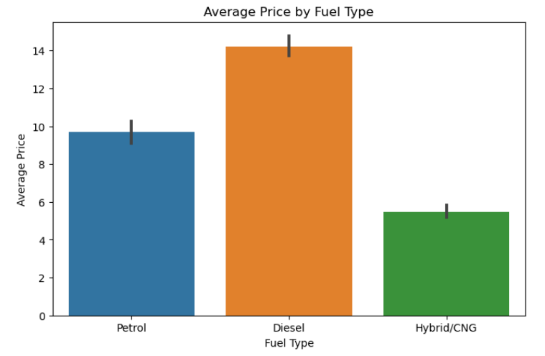

* **High Value Deals:**
  + Count of Good-Value Cars per Brand

