**Project on**

**House Rental System**



**Rupesh Dhakal**

**00172917**

**Computing Project**

**Level 5 Diploma in Computing**

**Softwarica college of IT and E-Commerce**

**Kathmandu, Nepal**

**2019-01-04**

# Abstract

# Acknowledgement

# Chapter 1: Introduction

HajurKo property is the web application which allows all the people to keep direct relationship between owners and buyers. In this application you can find all the listed house and rooms that is for rent or sale along with best deals. This web application is an ingenious solution to the problem for searching property. Any person that uses this application will have the privilege of listing their own property as along with booking the property they desire. Old ways of searching house, rooms or flat will be minimized with the help of this application. In Short it is an unlimited resource for property and intelligent solution to find suitable home, office and any other property for you.

## Background to the system

The main purpose of this project is to provide the facility of buying and selling of houses and rooms to the people.

Tension, frustration evolves in human if they have to search for an apartment/ rooms or a house. It is difficult to find the suitable property in reasonable price and in desired location. People tends to satay with bad owner then finding the new place to stay all because it’s hard to find place to stay until now. This is the reason behind developing a web application that provide the facility of buying and selling of houses and rooms just in one click. You can access the web application anytime, anywhere. People will have free access to all of our services without any noise and stress which can also be said as voice like your own. I tend to see that many people heir personal real estate agent to get property for them which costs more and you might not get property according to your choice and test. Our application eliminated you to heir the external agent to get the property.

This project can minimize the old ways of searching houses and room for work places or resident. Way of visiting every home and asking for room are bit old trends that are time consuming and frustrating this in my notion this project will definitely overcome that problem.

My main moto is to develop the web application that will have variety of houses and rooms that can be choose. Spending relatively less time compared to the old ways if we can get better result then why not adapt the new trends.

## Justification

## Aims

The overall goals that will be fulfilled via this application are:

* **Guidance:**

This web application will provide proper guidance to get the desired property. The main moto behind this is to provide user facility to choose their property without any hustle.

* **Flexibility:**

providing flexible service that will make user feel application butter smooth. Allowing user to use the application freely and without any errors. Allows user to perform multiple function without any difficulty.

* **Security:**

Security is the key to make any application success. HajurKo property provides extra layer of security to user’s data. Also, to the advertisement process.

* **Time and Efficiency:**

Storing any new data to the application is rocket fast, without any lag and flaws. Same goes to retrieving and removing the data. User can invest their expensive time to other work rather than finding suitable property. Frustration regarding the property will be carried by hajurKo property.

## Objectives:

Objectives are the things that helps to meet the aims we expect to be fulfilled. Some individual stage that leads to achieve those overall goal is listed below:

* Basically, hajurko Property is simple to understand hence providing guidance is mandatory nut in case if needed people can contact admin by clicking on support listed in footer area of website.
* By make older process of searching property automated I can save time and make the property searching process more efficient.
* Security and verification are also quite strong regarding it is the first-generation product. You will have to get verified by admin to post any kinds of property information which will make sure that the property is genuine.
* You require login to access to your panel which will restrict other user accessing your information. Plus, point is that your password is hashed which can not be easily hacked by the hackers.
* Look and feel regarding the interface is detailly studied keeping in mind that user may get bored with outdated and ugly design.

## Overview of the project design

The main need of the project is to minimize the human effort, time that goes for searching the property. In the current scenario of the society it’s very hard to find the desired homes and property. Even if the property is found there are lots of negotiation and scarification because of different factors and due to lack of choices.

This web application can minimize this problem to some extent by letting you to choose from wide ranges and varieties of properties. All kinds of properties are listed in this application where you can get information of the owner and contact them Realtime. Keep things simple is the main motto behind developing this application where user can understand the application easily.

I am very fortunate to provide such service to the people which makes their daily life lot easier.

# Chapter 2: Analysis

## Introduction to analysis

Analysis is an examination and evaluation of the information is called analysis. Analysis of any project can be done by breaking down it into various parts which helps us to understand the project more clearly. We can also identify the relationship of different topics and we can also identify how they fit together by analyzing. Without analysis we might not get what is the main purpose of the project.

### Needs for analysis

* It is important to identify the opinion of person that uses the final product hence analysis is needed. Eg: things like design of an application is acceptable by the end-user or not?
* Analysis is necessary to identify the best ways to design and built the frame work for successful product at the end.
* It is also important because it allows us to identify the core problems that to be solved after product is built.
* It is basically the first step of the software development.

### Object oriented analysis

**Object-oriented analysis** is a popular technical approach for analyzing and designing an application, system, or business by applying OOP. (Point, 2019)

By implementing object-oriented analysis, we can minimize the complexity of the product because we divide project according to their modularity. As the system is divided into different models it is easier for us to upgrade from small system to larger in future as project might not get completed at the first phase it also helps during updating the project. Modifying the application in certain module will not affect the other parts as they are modularized according to their functions.

### Pitfalls and merits of the project

## Requirement

Gathering requirement is the crucial phase of any software development as this is the phase where we will know the purpose of the application. How application final output should be and other. If requirement is not clear it might create problem during implementation phase. As I am following waterfall model it’s very important to clarify the requirement as it is hard to reverse the process once it is done in case of waterfall model. In this phase I will also prioritize the requirements that I have identified. I will be creating different Diagrams which have their own purpose of making development work run smoothly.

### Functional and non- functional requirements

**Functional requirement** specifies the behaviors or function. Any requirements that specifies something the system should do is functional requirements. (ReqTest, 2019) For example: user should be able to update their profile without any errors.

Typical example of functional requirement is:

* Business rules
* Transaction corrections
* Administrative Functions
* Authentication
* Certification etc.

**Non-Functional requirement** specifies the criteria that judge the operation of the oystercatcher that the specific behaviors. It specifies how the system should behave. For example: the database value of the user should be updated in just a mater of a second. Here, performance, efficiency matters.

Typical example of non-functional requirement is:

* Performance
* Availability
* Scalability
* Recoverability
* Reliability
* Maintainability etc.

### Requirement prioritization

Requirement prioritization is done to identify which requirement is more precious and should be completed first in order to achieve the minimum goals (requirements) gathered from the user or clients. We should also prioritize the requirement to minimize the risk that may arise during the development i.e. Highly risky requirements can be implemented at first.

I have prioritized my requirements to understand its importance on the project. For prioritizing the task, I have used MoSCoW prioritization.

**M – Must have**

**S – Should have**

**C – Could have**

**W – Won’t have**

**Functional prioritization:**

|  |  |  |  |
| --- | --- | --- | --- |
| **S/N** | **Functional Requirement** | **MoSCoW Prioritization** | **Justification** |
|  | Registration | M | Allows user to register to the system. |
|  | Login | M | Login grants access to the user to use facility of an application. |
|  | Post(add) advertisement | M | Allows user to post advertisement about the property |
|  | Book property | M | Buyer can book the property and contact owner later to buy the property |
|  | Search property | M | Desired property can be searched. Property can be searched according to location and own customization. |
|  | Add to Wishlist | C | Property that is liked by a user can be added to Wishlist so they can check it later. |
|  | View detail | M | Detail of the property can be viewed. |
|  | Filter property | S | Filtering the search of property according to the wish. |
|  | Comment | S | Comment can be provided so owner can get feedback regarding the price and other. |
|  | Update property | M | Added property can be updated. |
|  | Delete property | M | If we are not interested on posting an advertisement then we can delete it. |
|  | View property | M | Basically, we can view the property. |
|  | Edit profile | S | Profile of the user can be updated. |
|  | Chat | C | Buyer can directly chat with the owner if they are online. |
|  | Cost calculation | M | Cost of the product can be calculated by including the tax. |
|  | Online payment | W | This feature might no be available in the final product but it basically helps to pay for property online. |
|  | Bid property | W | Bidding for the price where owner starts the bit from low possible price. |

**Non-Functional prioritization**

|  |  |  |  |
| --- | --- | --- | --- |
| **S/N** | **Non-Functional Requirement** | **MoSCoW Prioritization** | **Justification** |
|  | Scalability | M | Application should be able to run in different environment. |
|  | Efficiency | M | Application should be effective regarding time, cost and other. |
|  | Verification | M | Verification of the user should be done to know their identity (Via login). |
|  | Reliability | M | Application should be trustworthy (should be able to generate correct result ). |
|  | Usability | M | Should be easily useable. |
|  | Interoperability | S | Exchange of the information. |
|  | Maintainability | M | Application can be easily maintainable. |

## Natural Language Analysis (NLA)

**Natural language analysis** helps to get the list of candidate class for any project. Relationships among the classes and their attributes can also be identified.

Before drawing class diagram, it is necessary to identify the possible classes, attributes and relation between different classes. NLA is the analysis process which helps to identify Nouns, Verb and adjective in the form of the descriptive text.

* **Nouns are the candidate class**
* **Verb are the are the potential functions of the class**
* **Adjectives are the potential attributes.**

Steps of constructing class diagram:

* Identify all the possible nouns and verbs
* Filtration is necessary as I am required to identify the genuine classes among all the classes.

For filtration following task was performed:

* Got rid of duplicate
* Complex words were removed
* Removing Irrelevancies candidate class (out of scope)
* Synonymous word was removed example: Meeting and Gathering
* Technical word was removed since they should be mention in the future example: keep a database.

Similar filtration process is also performed to identify the verbs. All the above filtration process was done to identify the suitable class for the project.

## Initial class diagram

It is not a final class diagram but it helps to provide small overview and structure of system in term of classes. Relation between the classes can also be identified (Inheritance, Association etc.). Initial class diagram is shown below.

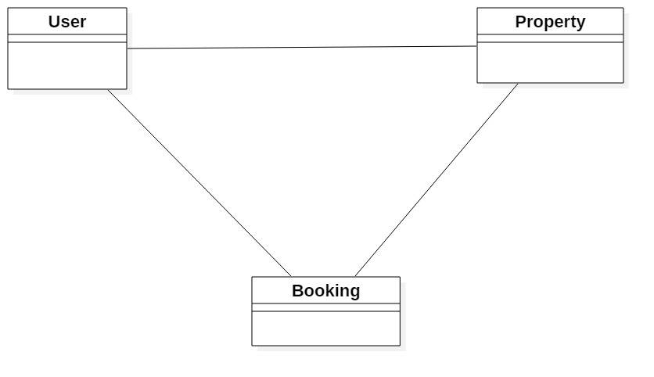

Figure 1 Initial Class Diagram

## Use case Diagram

Use case diagram helps to represent the action that will be performed by different **actors**. Action performed by the actor is shown is **use cases.** Actor can be user, customers etc. it is based on the requirement of the system.

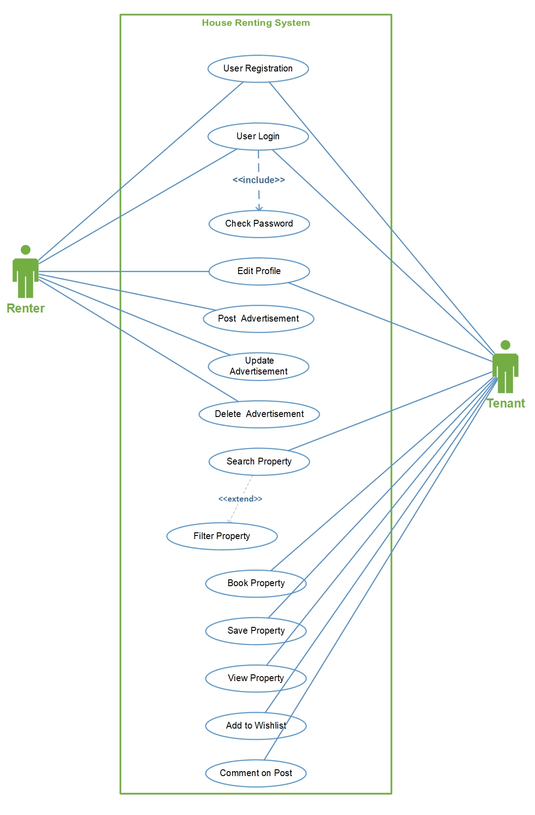

Figure 2 Use case diagram

* **Stickman** Figures represents the **actor** of the system.
* **Oval shape** represents the different **use case** that is performed by the actors.
* **Line** helps to represent the **relationship** of the actor (in above figure relationship is association).
* **Boundary** around the use case helps to represent the system boundary.

Some of the advantage of use case diagram are:

* Helps to understand who is directly related with the system.
* Helps to identify the different tasks that can be performed by the system.
* It also can help to identify the functional requirement of the system.

## System Architecture

I am going to use 3-tier Architecture. 3-tier architecture is a hierarchical software architecture which is divided into three layers: A presentation layer, An application layer and A data layer. Reasons for using this architecture are:

* **Increase in efficiency:** Work is divided into several system as each tier has their own function which will help to increase efficiency.
* **Increase in security:** Since RDBMS provides single point access and governs who is retrieving the data and how it is updated.
* **Increase in scalability:** Since System can run in different hardware and OS. The technological stack (OS or related utilities) can be updated without impacting other areas of application.

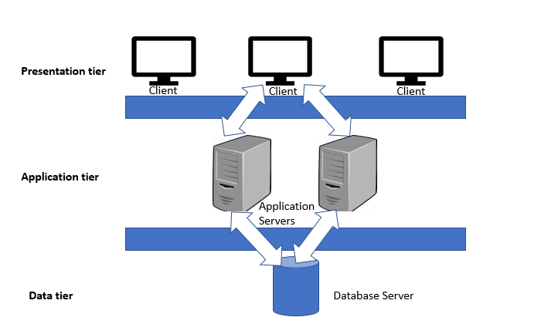

Figure 3 Three tier architecture

**Presentation tier:** Presentation tire is the frontend layer primarily consists of user interface. Interface is commonly available in graphical form from which user interacts with the application.

**Application tier:** Application tier contains the business logics which drives the application which may be written in different programming languages example: C#, PHP, JAVA etc.

**Data tier:** Consists the database/ data storage system Example: MySQL, Oracle

# Chapter 3: Design

## Justification