**Project Proposal**

**On**

**House/Room rental system**

**Rupesh Dhakal**

**00172917**

**Computing Project**

**Level 5 Diploma in Computing**

**Softwarica college of IT and E-Commerce**

**Kathmandu, Nepal**

**2019-01-04**

**Submitted to: Kiran Rana**

**Table of Contents**

1 Introduction 4

1.1 Project Introduction 4

1.2 Justification for project 4

1.2.1 Background of the project 4

1.2.2 Problem Statement 4

1.3 Description of project 5

1.3.1 Features 5

2 Project Scope 6

2.1 Scope and limitation of project 6

2.2 Aims and Objectives 6

3 Development Methodology 7

3.1 Methodology used 7

3.2 Design Pattern 8

3.3 System Architecture 9

4 Work Breakdown Structure (WBS) / Scheduling 10

4.1 Work Breakdown Structure 10

4.2 Milestones 11

4.3 Scheduling / Gantt Chart 13

5 Risk Management 14

6 Configuration Management 16

7 Conclusion of the project 17

8 References 18

Figure 1 Phases of waterfall model 7

Figure 2 MVC Architecture 8

Figure 3 Three tier architecture 9

Figure 4 Work Breakdown Structure (WBS) 10

Figure 5 Date and time assigned for tasks 13

Figure 6 Gantt Chart 14

Figure 7 Git hub Repository 16

Figure 8 Folder path listing 16

# Introduction

## Project Introduction

House/Room rental system is an application which allows all the people to keep direct relationship between owners and buyers. In this application you can find all the listed house and rooms that is for rent or sale. Best deals can be viewed at top of the applications. This application is not limited up to the list you can also search for specific rooms, house and flats that you prefer. Old ways of searching house, rooms or flat will be removed with the help of this application. You can also list down your property or view applied properties by other users. In Short it is an intelligent solution to find suitable home, office for you.

## Justification for project

### Background of the project

The main purpose of this project is to provide the facility of buying and selling of houses and rooms. People

Tension, frustration evolves in human if they have to search for an apartment/ rooms or a house. It is difficult to find the suitable property in reasonable price and in desired location. People tends to satay with bat owner then finding the new place to stay all because it’s hard to find place to stay until now. This is the reason behind developing a web application that provide the facility of buying and selling of houses and rooms just in one click. You can access the web application anytime, anywhere.

### Problem Statement

Problem statement determines the problem that the project can solve after the project is ready. This project can minimize the old ways of searching houses and room for work places or resident. Way of visiting every home and asking for room are bit old trends that are time consuming and frustrating this in my notion this project will definitely overcome that problem.

My main moto is to develop the web application that will have variety of houses and rooms that can be choose. Spending relatively less time compared to the old ways if we can get better result then why not adapt the new trends.

## Description of project

### Features

The features of the project are listed below:

* **User Signup and Login**

User can create their account incase they haven’t and can login to the application which will allow them to access rest of the feature.

* **Quick view of best value**

User can view the best value of property pinned at top of the application. It will primarily focus for least price products.

* **Can chat with owner of the property**

User will have a facility to chat with the owner of the property which will allow them to negotiate the price and other things

* **Feature of booking the property**

Desired property can be booked to make secure the purchase.

* **Can search property according to location**

User can search the property to the desired location where they find comfortable to commit their daily task

* **User friendly**

There are lots of application that may have similar moto as this very project but this project will surely give better user experience.

This project also consists other minor features which will make using the interface easy and convenient.

# Project Scope

## Scope and limitation of project

This project is user friendly and allows user to register and login. User can also add their advertisement of their own property (House/ Room). They will have a facility to buy the Rooms and houses they desire. The best tool is the chat that will allow user to chat with the owners and can communicate about the property itself.

Everything has its limitation and this project has one. This project is not ready for online payment. If online payment was a thing in this project then user would have a privilege of secure payment user would also have a facility to buy the property on the spot. In future it is possible to eliminate this limitation.

## Aims and Objectives

**Aims:** The aims that I want to achieve are listed below:

* Make available of the facility of posting their property information.
* User should be able to buy the desired property.
* To make user friendly environment
* Make application run smoothly along with performing functionality of the application without any error.

**Objectives:** Action that I will take to achieve my aim are:

* User will have the facility to sign-up and login which will allow them to use the facility of posting the advertisement and also buy the property they desired (Rooms and Houses).
* User can provide the detail along with uploading the picture once they are logged in.
* To make application run user friendly I will understand the requirement clearly first and make sure that all the requirement is well documented to understand what actually project should do.
* To make program free from error I would perform different testing like: Black box testing, Integration testing, Unit testing etc

# Development Methodology

## Methodology used

I have used waterfall methodology to develop the application. Waterfall is the sequential process of developing application i.e. step by stem process so by implementing this methodology I can track my progress pretty smoothly. Other reasons for choosing waterfall methodology are:

* Waterfall model is simple and easy to understand
* Since my project is small and requirements are well understood so using this model will be suitable.
* Project will be easy to manage because the model is rigid itself.

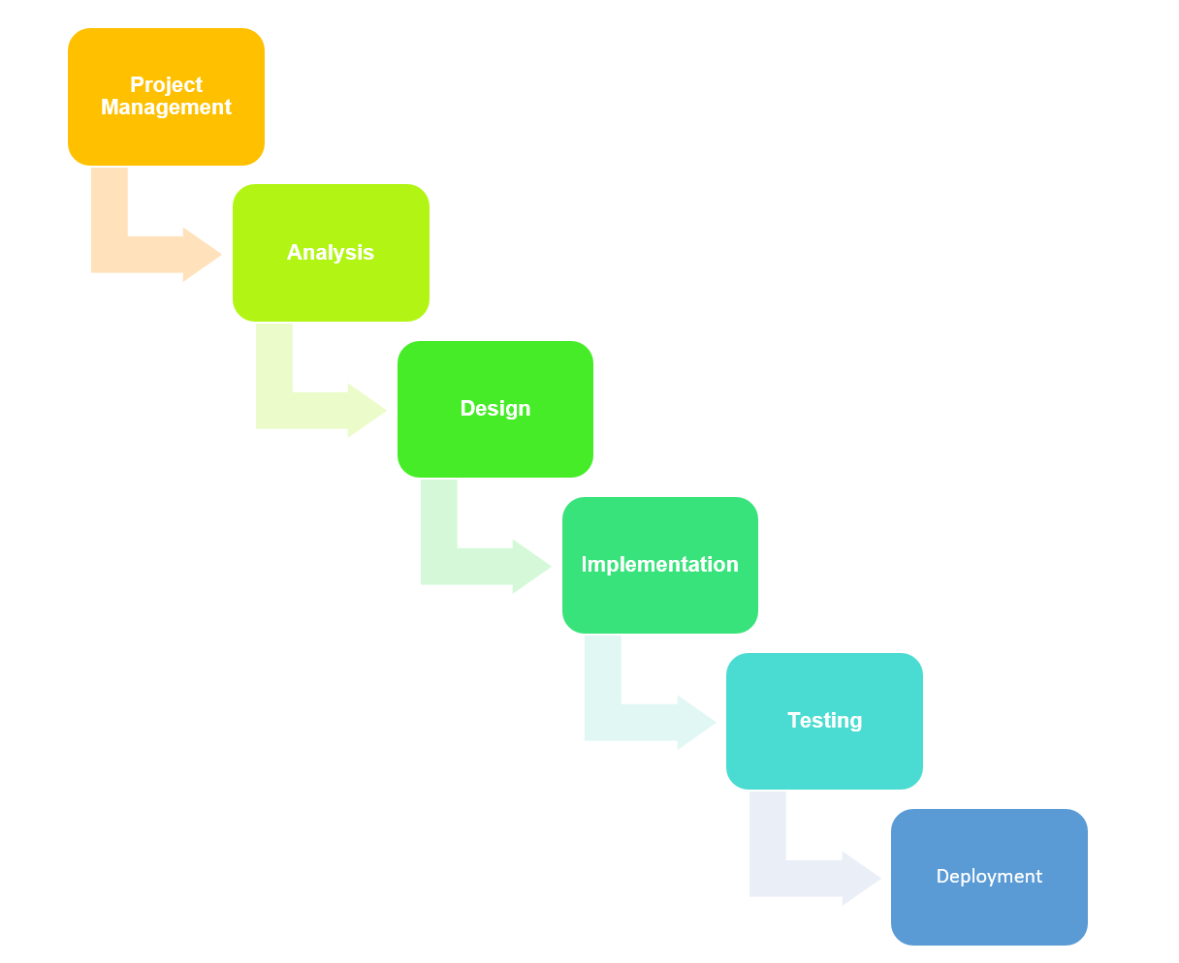

Figure 1 Phases of waterfall model

## Design Pattern

I have used MVC design pattern. Here M - Model, V - View and C – Controller. The reasons for using MVC pattern are: (Solution, 2019)

* Since Model deals with the logical implementation, View deals with the interface (UI) and controller handles user interaction MVC helps to categorize the responsibility of each fields.
* Modification: If we are requiring to make any sort of modification in the code then it will be easier as code are well managed. If modification is done in one class then it will not affect other classes since functionality are divided into individual classes.
* High Cohesion and Low coupling

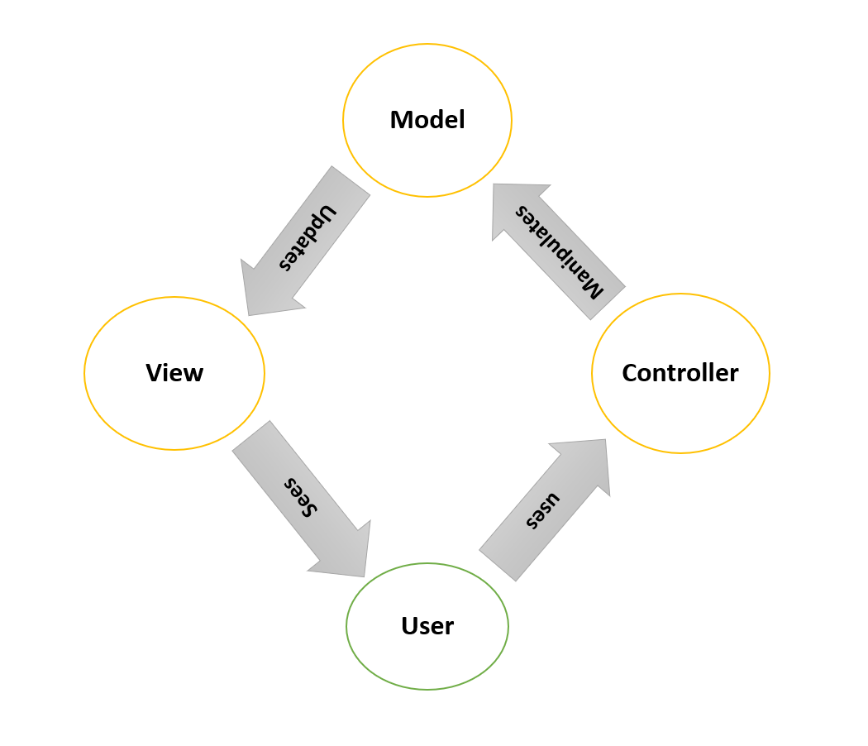

Figure 2 MVC Architecture

## System Architecture

I am going to use 3-tier Architecture. 3-tier architecture is a hierarchical software architecture which is divided into three layers: A presentation layer, An application layer and A data layer. Reasons for using this architecture are:

* Increase in efficiency: Work is divided into several system as each tier has their own function which will help to increase efficiency.
* Increase in security:

Since RDBMS provides single point access and governs who is retrieving the data and how it is updated.

* Increase in scalability

Since System can run in different hardware and OS. The technological stack (OS or related utilities) can be updated without impacting other areas of application.

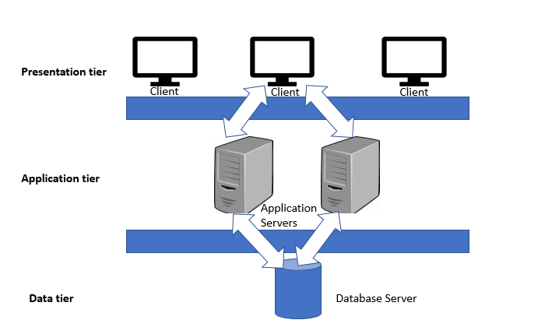

Figure 3 Three tier architecture

# Work Breakdown Structure (WBS) / Scheduling

## Work Breakdown Structure

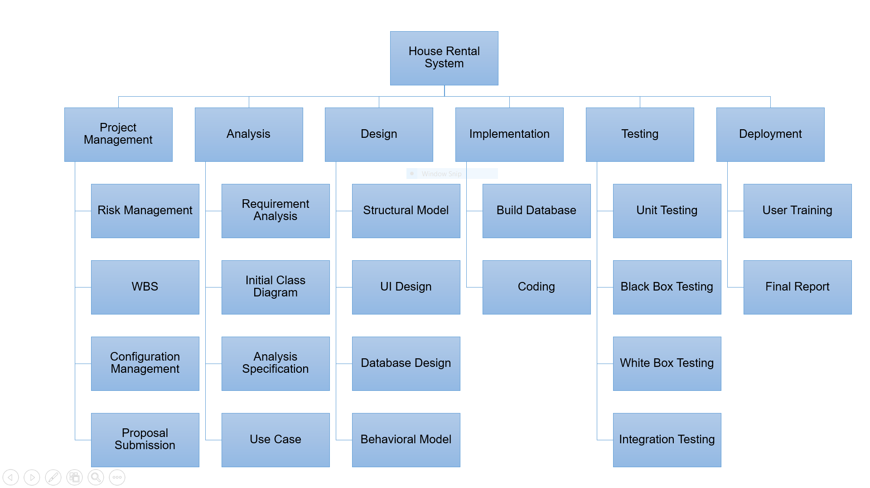

Figure 4 Work Breakdown Structure (WBS)

**Work Breakdown Structure (WBS)**

Process of dividing complex project to simpler and manageable form is called Work Breakdown structure. Larger tasks that is hard for us to understand are broken down into small chunks which is more manageable and can be understand easily. By dividing large project into smaller chunk, we can also keep track of our work and allocate the time as per the importance of the tasks. This will definitely help to manage time and remove frustration which may cause due to project. (Target, 2019)

## Milestones

|  |  |
| --- | --- |
| **Milestones** | **Date** |
| **Project Management**  Risk Management  Work Breakdown Structure  Configuration Management  Proposal Submission | **12/21/2018 -1/1/2019**  12/21/2018 - 12/23/2018  12/24/2018 - 12/26/2018  12/27/2018 - 12/30/2018  12/31/2018 - 1/1/2019 |
| **Analysis**  Requirement Analysis  Use Case  Architecture (Initial Class Diagram)  Analysis Specification | **1/2/2019 - 1/25/2019**  1/2/2019 - 1/8/2019  1/9/2019 - 1/13/2019  1/14/2019 - 1/18/2019  1/19/2019 - 1/25/2019 |
| **Design**  Structural Diagram  Behavioral Diagram  UI Design  Database Design (ER, Data Dictionary) | **1/26/2019 - 2/24/2019**  1/26/2019 - 2/4/2019  2/5/2019 - 2/14/2019  2/15/2019 - 2/19/2019  2/20/2019 - 2/24/2019 |
| **Implementation**  Building Database  Coding | **2/25/2019 - 3/28/2019**  2/25/2019 - 3/1/2019  3/2/2019 - 3/28/2019 |
| **Testing**  Unit Testing  Integration Testing  Blackbox Testing  Whitebox Testing | **3/29/2019 - 4/8/2019**  3/29/2019 - 3/31/2019  4/1/2019 - 4/3/2019  4/4/2019 - 4/6/2019  4/7/2019 - 4/8/2019 |
| **Deployment**  User Training  Final Report | 4/9/2019 - 4/18/2019  4/9/2019 - 4/149*-/2019  4/15/2019 - 4/18/2019 |

**Description of Milestones:**

* **Project Management (12 days)**
  + - Risk Management (3 days)
    - Work Breakdown Structure (3 days)
    - Configuration Management (4 days)
    - Proposal Submission (2 days)
* **Analysis (24 days)**
  + - Requirement Analysis (7 days)
    - Use Case (5 days)
    - Architecture (Initial Class Diagram) (5 days)
    - Analysis Specification (7 days)
* **Design (30 days)**
  + - Structural Diagram (10 days)
    - Behavioral Diagram (10 days)
    - UI Design (5 days)
    - Database Design (ER, Data Dictionary) (5 days)
* **Implementation (32 days)**
  + - Building Database (5 days)
    - Coding (27 days)
* **Testing (11 days)**
  + - Unit Testing (3 days)
    - Integration Testing (3 days)
    - Blackbox Testing (3 days)
    - Whitebox Testing (2 days)
* **Deployment (10 days)**
  + - User Training (6 days)
    - Final Report (4 days)

## Scheduling / Gantt Chart

Scheduling is a process of arranging the daily tasks that is to be performed. I computing we schedule to keep track of our work and move forward. To see the complete plan of the project (When is it going to start and end) scheduling is done. There are various means of scheduling the project one of them is Gantt chart. I have addressed milestone using Gantt chart shown below.

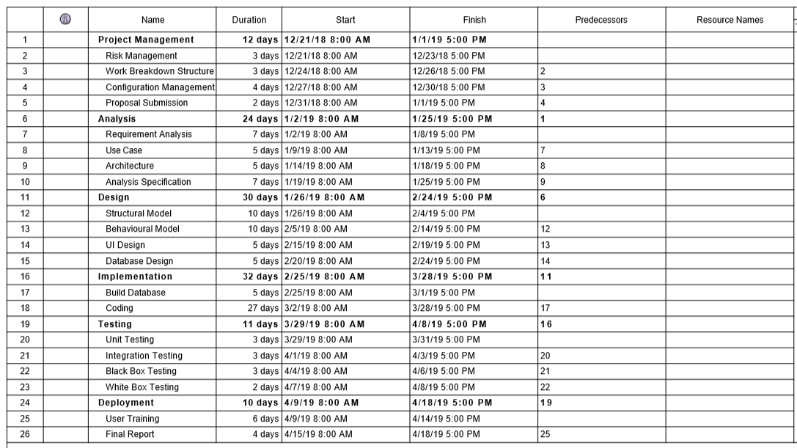

Figure 5 Date and time assigned for tasks

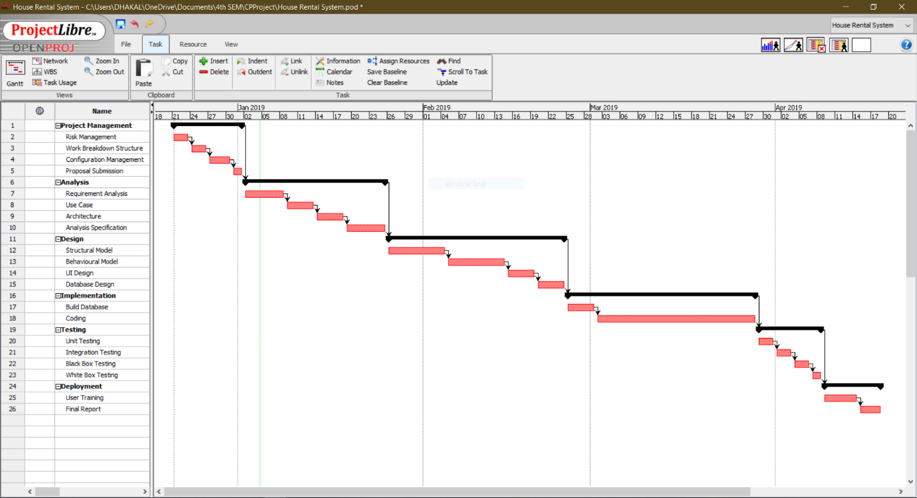

Figure 6 Gantt Chart

# Risk Management

Risk management is the process of identifying, accessing and prioritizing the risk that may occur in the system. Risk is prioritized according to the harmfulness of the risk and the risk that harms the most is either solved or an alternative solution is prepared for it.

In this particular project I have calculated risk by using formula that is:

**Impact = Likelihood * Consequences**

Risk Likelihood values are shown as follows

|  |  |
| --- | --- |
| Likelihood | Value |
| Low | 1 |
| Medium | 2 |
| High | 3 |

Risk Consequence values are shown below

|  |  |
| --- | --- |
| Consequence | Value |
| Very low | 1 |
| Low | 2 |
| Medium | 3 |
| High | 4 |
| Very High | 5 |

Some of the risk that I have identified are:

|  |  |  |  |  |  |
| --- | --- | --- | --- | --- | --- |
| S.NO | Risks | Likelihood | Consequences | Impact | Solution |
| 1 | Schedule risk | 2 | 4 | 8 | Task should be completed in time from the very beginning to an end |
| 2 | Cost and resources risk | 2 | 3 | 6 | Available resources should be managed properly to use them in future. |
| 3 | Failure to meet requirement | 2 | 5 | 10 | We should not proceed our work until we are clear about the requirement. |
| 4 | System failure | 1 | 5 | 5 | Project should be backed up properly so it can be used even there is system failure. Eg: backup in cloud. |
| 5 | Lack of planning | 2 | 4 | 8 | Better planning should be done to avoid above mentioned risks. |

# Configuration Management

Configuration Management is the process of establishing and maintaining consistency of the product’s performance, functional and physical attributes with its requirements, design and operation information through its life (Rouse, 2019) . In Information Technology it is also called **Software Configuration Management (SCM). SCM** process is looked up by the active person searching for the best solution to handling changes in software projects. Git hub is also one of the ways to manage the modified code where all of the changes are updated regularly.

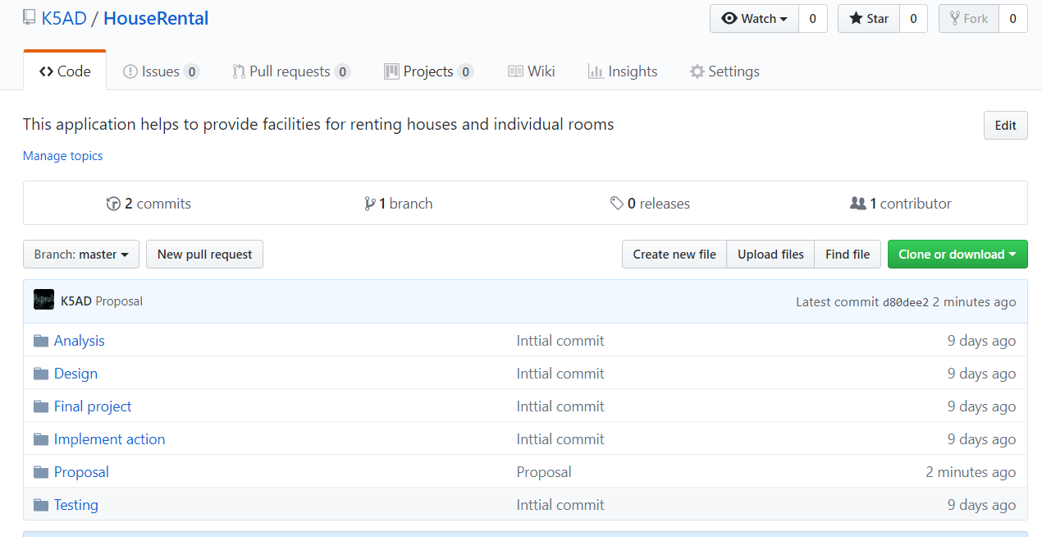

Figure Git hub Repository

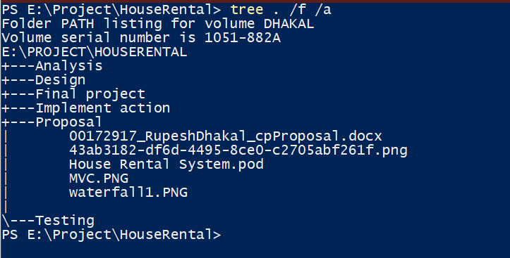

Figure Folder path listing

# Conclusion of the project

At conclusion I could successful built my project if above mention things are done properly, if the requirement of the project is clear. Methodology used for developing the project is described along with the architecture and design pattern used in the project. WBS of the project is given to minimize the complexity of the project. Milestone tracking and Scheduling for the project is done to ensure that project completes in time. Finally, Risk control management is done to identify and solve the risk that will arrive in the project.

# References

Rouse, M. (2019, 1 5). *Tech Target*. Retrieved from Tech Target: https://searchitoperations.techtarget.com/definition/configuration-management-CM

Solution, S. (2019, 1 3). *Medium corporation*. Retrieved from https://medium.com/@socraticsol/why-mvc-architecture-e833e28e0c76

Target, T. (2019, 1 5). *Tutorial point*. Retrieved from https://www.tutorialspoint.com/management_concepts/work_breakdown_structure.htm