Client: | ACS Infotech (P) Ltd. | Sub - Topic: | Geographical Structure
Product: | SamdhanV2 ( EM3 ) | Submit To: | Vinoj Xavier
Version: | 2.0 | Made By: | Hari Krashna
Target Date: | 08/09/2019 | Submit By: | Hari Krashna
Submit Date: | 07/09/2019

1. We can add a link on Geography Structure page to add Geography using mark location on Google Map. When user click on link after that a Popup open with Google map and user can Mark a location and submit to insert new Geographical structure.

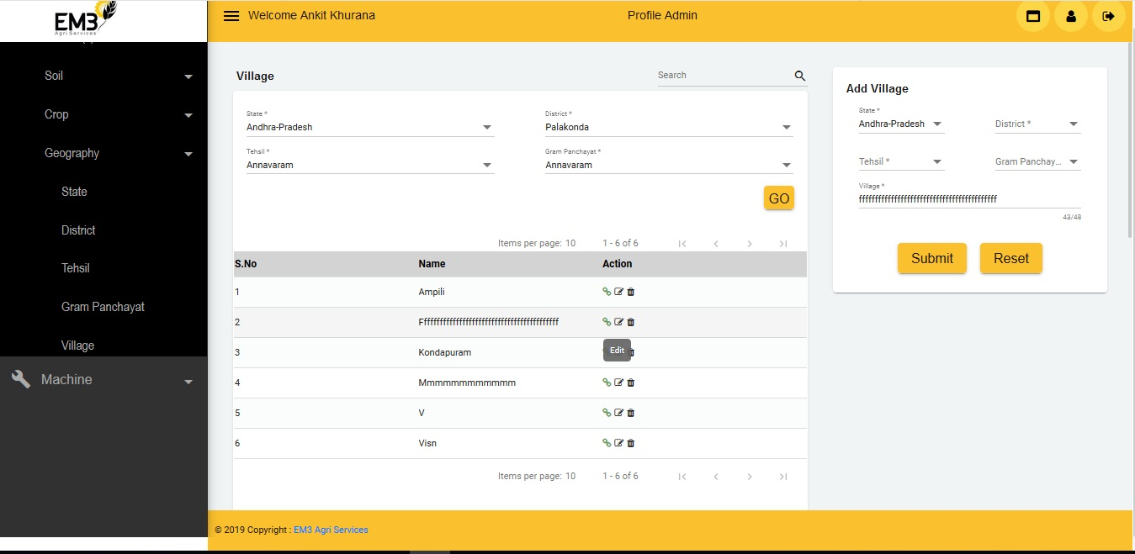

2. We can add icon in geography listing to link Soil details with selected Geography. When user click on Soil Link icon then a popup window open with existing Soil and user select Soil and submit to link with selected Geography structure.

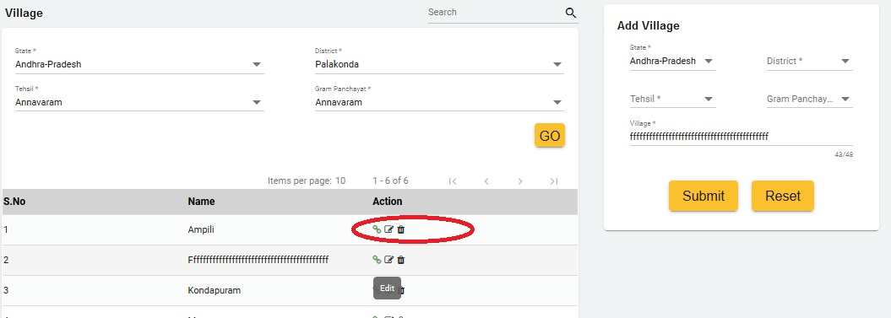

3. We can add icon in geography listing to link Crop details with selected Geography. When user click on Crop Link icon then a popup window open with existing Crop and user select Crop and submit to link with selected Geography structure.

