Group no: 9

**Title: NFA to DFA**

|  |  |  |  |  |
| --- | --- | --- | --- | --- |
| SNo | Roll No | Name | Contribution | Photo |
| 1 | CB.EN.U4CSE22003 | Aswin Sriram | Wrote java script logic for NFA to DFA conversion |  |
| 2 | CB.EN.U4CSE22018 | Harini Priyanka W | Determined and wrote the code for the input and output format for the automata. Efficient storing and retrieval of the automata.  (ndatodfa.py) |  |
| 3 | CB.EN.U4CSE22023 | Nishnath | Wrote code for lambda transitions |  |
| 4 | CB.EN.U4CSE22027 | Mogitha S M | Wrote java script code to get input and display input nfa as diagram |  |
| 5 | CB.EN.U4CSE22037 | Dhaksana | Wrote python logic to convert given NFA to DFA. (ndatodfa.py) |  |

Output:

nfatodfa.py output:

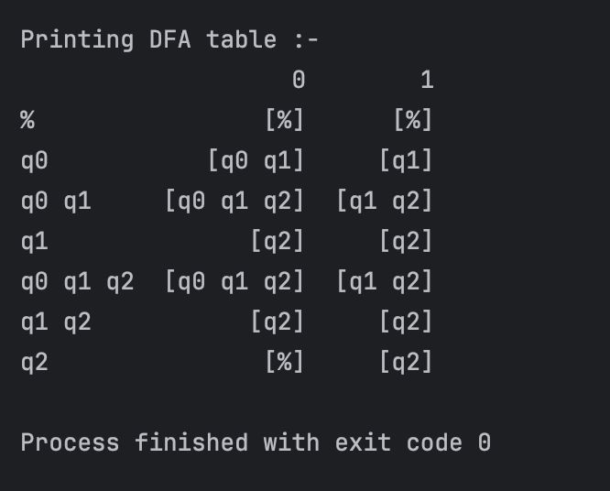

Js output:

