[vsspandiprabha@gmail.com](mailto:vsspandiprabha@gmail.com)

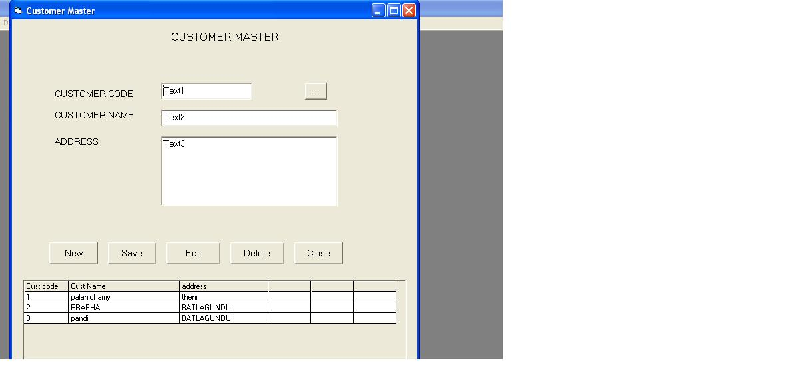

Dim rs As New ADODB.Recordset

Dim flag

Dim rsv As New ADODB.Recordset

Private Sub cmddel_Click()

Dim ans

ans = MsgBox("Are You Sure", vbYesNo, "Delete")

If ans = vbYes Then

con.Execute "delete from customermaster where cuscode='" & Trim(txtcuscode.Text) & "'"

End If

Call txtclear

End Sub

Private Sub cmdedit_Click()

Call txtunlock

txtcuscode.Enabled = False

txtcusname.SetFocus

flag = "EDIT"

End Sub

Private Sub cmdexit_Click()

Unload Me

End Sub

Private Sub cmdnew_Click()

Call txtunlock

Call txtclear

txtcuscode.SetFocus

flag = "NEW"

End Sub

Private Sub cmdsave_Click()

If flag = "NEW" Then

ssql = "select * from customermaster"

If rs.State = adStateOpen Then rs.Close

rs.Open ssql, con, adOpenKeyset, adLockPessimistic

rs.AddNew

rs.Fields("cuscode") = Trim(txtcuscode.Text)

rs.Fields("cusname") = Trim(txtcusname.Text)

rs.Fields("address") = Trim(txtaddress.Text)

rs.Update

MsgBox "Record saved"

Else

ssql = "select * from customermaster where cuscode='" & Trim(txtcuscode.Text) & "'"

If rs.State = adStateOpen Then rs.Close

rs.Open ssql, con, adOpenKeyset, adLockPessimistic

rs.Fields("cusname") = Trim(txtcusname.Text)

rs.Fields("address") = Trim(txtaddress.Text)

rs.Update

MsgBox "Record Modified"

End If

Call call_data

End Sub

Private Sub cmdview_Click()

frmempview.Show

End Sub

Private Sub Form_Activate()

Call txtlock

Call call_data

End Sub

Private Sub Form_Load()

Call txtlock

End Sub

Private Sub txtclear()

txtcuscode.Text = ""

txtcusname.Text = ""

txtaddress.Text = ""

End Sub

Private Sub txtlock()

txtcuscode.Locked = True

txtcusname.Locked = True

txtaddress.Locked = True

End Sub

Private Sub txtunlock()

txtcuscode.Locked = False

txtcusname.Locked = False

txtaddress.Locked = False

End Sub

Private Sub mshformat()

MSHFlexGrid1.Cols = 6

MSHFlexGrid1.TextMatrix(0, 0) = "Cust code"

MSHFlexGrid1.TextMatrix(0, 1) = "Cust Name"

MSHFlexGrid1.TextMatrix(0, 2) = "address"

MSHFlexGrid1.ColWidth(0) = 1000

MSHFlexGrid1.ColWidth(1) = 2500

MSHFlexGrid1.ColWidth(2) = 2000

End Sub

Private Sub call_data()

ssql = "select cuscode,cusname,address from customermaster"

If rsv.State = adStateOpen Then rsv.Close

rsv.Open ssql, con, adOpenKeyset, adLockPessimistic

Set MSHFlexGrid1.DataSource = rsv.DataSource

MSHFlexGrid1.Refresh

Call mshformat

End Sub

Private Sub MSHFlexGrid1_Click()

txtcuscode.Text = MSHFlexGrid1.TextMatrix(MSHFlexGrid1.Row, 0)

txtcusname.Text = MSHFlexGrid1.TextMatrix(MSHFlexGrid1.Row, 1)

txtaddress.Text = MSHFlexGrid1.TextMatrix(MSHFlexGrid1.Row, 2)

End Sub

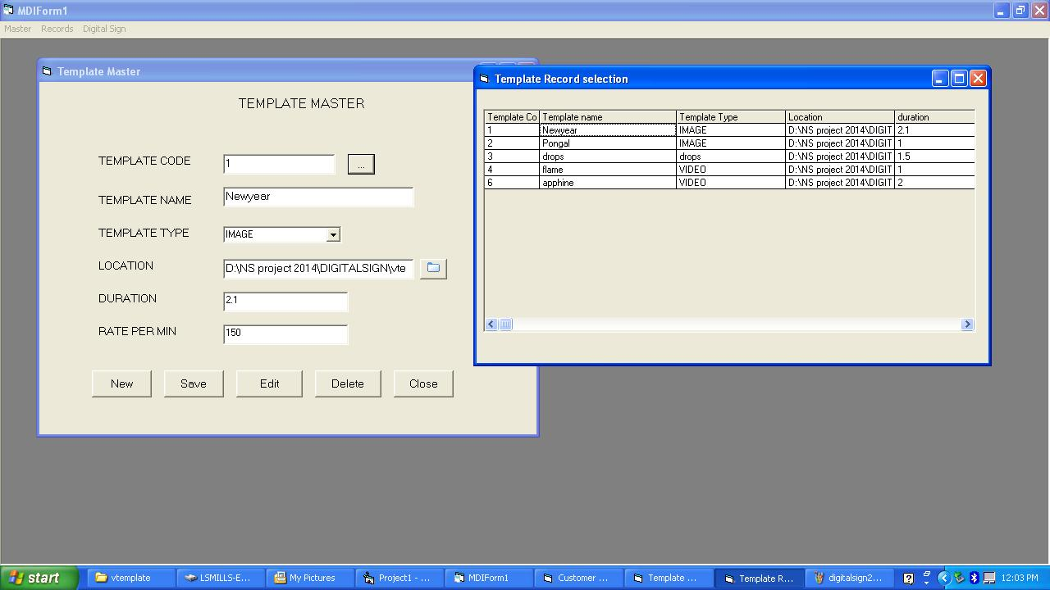

Dim rs As New ADODB.Recordset

Dim flag

Private Sub Adodc1_WillMove(ByVal adReason As ADODB.EventReasonEnum, adStatus As ADODB.EventStatusEnum, ByVal pRecordset As ADODB.Recordset)

End Sub

Private Sub cmddel_Click()

Dim ans

ans = MsgBox("Are You Sure", vbYesNo, "Delete")

If ans = vbYes Then

con.Execute "delete from templatemaster where temcode='" & Trim(txttemcode.Text) & "'"

End If

Call txtclear

End Sub

Private Sub cmdedit_Click()

Call txtunlock

flag = "EDIT"

End Sub

Private Sub cmdexit_Click()

Unload Me

End Sub

Private Sub cmdnew_Click()

Call txtunlock

Call txtclear

txttemcode.SetFocus

flag = "NEW"

End Sub

Private Sub cmdsave_Click()

If flag = "NEW" Then

ssql = "select * from templatemaster"

If rs.State = adStateOpen Then rs.Close

rs.Open ssql, con, adOpenKeyset, adLockPessimistic

rs.AddNew

rs.Fields("temcode") = Trim(txttemcode.Text)

rs.Fields("temname") = Trim(txttemname.Text)

rs.Fields("temtype") = Trim(txttemtype.Text)

rs.Fields("location") = Trim(txtlocation.Text)

rs.Fields("duration") = Val(txtduration.Text)

rs.Fields("ratepermin") = Val(txtratepermin.Text)

rs.Update

MsgBox "Record saved"

Else

ssql = "select * from templatemaster where temcode='" & Trim(txttemcode.Text) & "'"

If rs.State = adStateOpen Then rs.Close

rs.Open ssql, con, adOpenKeyset, adLockPessimistic

'rs.AddNew

'rs.Fields("temcode") = Trim(txttemcode.Text)

rs.Fields("temname") = Trim(txttemname.Text)

rs.Fields("temtype") = Trim(cbotemtype.Text)

rs.Fields("location") = Trim(txtlocation.Text)

rs.Fields("duration") = Val(txtduration.Text)

rs.Fields("ratepermin") = Val(txtratepermin.Text)

rs.Update

MsgBox "Record Modified"

End If

End Sub

Private Sub cmdselect_Click()

CommonDialog1.ShowOpen

txtlocation.Text = CommonDialog1.FileName

End Sub

Private Sub cmdview_Click()

frmtemview.Show

Call txtlock

End Sub

Private Sub Form_Load()

Call txtlock

Call temtype_load

End Sub

Private Sub txtclear()

txttemcode.Text = ""

txttemname.Text = ""

txtlocation.Text = ""

txtduration.Text = ""

txtratepermin.Text = ""

End Sub

Private Sub txtlock()

txttemcode.Locked = True

txttemname.Locked = True

cbotemtype.Locked = True

txtlocation.Locked = True

txtduration.Locked = True

txtratepermin.Locked = True

End Sub

Private Sub txtunlock()

txttemcode.Locked = False

txttemname.Locked = False

cbotemtype.Locked = False

txtlocation.Locked = False

txtduration.Locked = False

txtratepermin.Locked = False

End Sub

Private Sub temtype_load()

cbotemtype.AddItem "IMAGE"

cbotemtype.AddItem "VIDEO"

End Sub