**COVID CASES ANALYSIS**

**CREATE CHARTS AND GRAPHS**

**import pandas as np**

**Covid_cases=np.read_csv("C:\\Users\\sunda\\Downloads\\Covid_19_cases4 (1).csv",header=0,sep=",")**

**print(Covid_cases)**

**Output:**

**dateRep day month year cases deaths countriesAndTerritories**  
**0 31-05-2021 31 5 2021 366 5 Austria**  
**1 30-05-2021 30 5 2021 570 6 Austria**  
**2 29-05-2021 29 5 2021 538 11 Austria**  
**3 28-05-2021 28 5 2021 639 4 Austria**  
**4 27-05-2021 27 5 2021 405 19 Austria**  
**... ... ... ... ... ... ... ...**  
**2725 06-03-2021 6 3 2021 3455 17 Sweden**  
**2726 05-03-2021 5 3 2021 4069 12 Sweden**  
**2727 04-03-2021 4 3 2021 4884 14 Sweden**  
**2728 03-03-2021 3 3 2021 4876 19 Sweden**  
**2729 02-03-2021 2 3 2021 6191 19 Sweden**  
  
**[2730 rows x 7 columns]**

**import pandas as np**

**Covid_cases=np.read_csv("C:\\Users\\sunda\\Downloads\\Covid_19_cases4 (1).csv",header=0,sep=",")**

**print(Covid_cases.head())**

**Output:**

dateRep day month year cases deaths countriesAndTerritories  
0 31-05-2021 31 5 2021 366 5 Austria  
1 30-05-2021 30 5 2021 570 6 Austria  
2 29-05-2021 29 5 2021 538 11 Austria  
3 28-05-2021 28 5 2021 639 4 Austria  
4 27-05-2021 27 5 2021 405 19 Austria

print(Covid_cases.info)

Output:

dateRep day month year cases deaths countriesAndTerritories  
0 31-05-2021 31 5 2021 366 5 Austria  
1 30-05-2021 30 5 2021 570 6 Austria  
2 29-05-2021 29 5 2021 538 11 Austria  
3 28-05-2021 28 5 2021 639 4 Austria  
4 27-05-2021 27 5 2021 405 19 Austria  
... ... ... ... ... ... ... ...  
2725 06-03-2021 6 3 2021 3455 17 Sweden  
2726 05-03-2021 5 3 2021 4069 12 Sweden  
2727 04-03-2021 4 3 2021 4884 14 Sweden  
2728 03-03-2021 3 3 2021 4876 19 Sweden  
2729 02-03-2021 2 3 2021 6191 19 Sweden  
  
[2730 rows x 7 columns]

import matplotlib.pyplot as plt

Covid_cases.plot(x='cases',y='deaths',kind='line')

Plt.ylim(ymin=0)

Plt.xlim(xmin=0)

Plt.show()

Output:

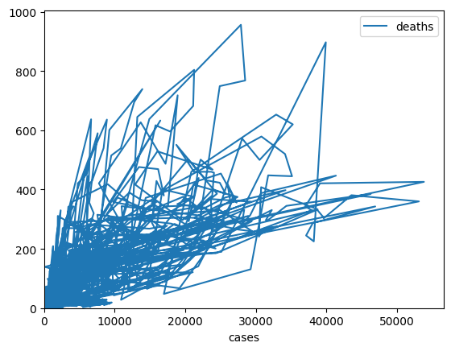

import matplotlib.pyplot as plt

Covid_cases.plot(x='cases',y='day',kind='line')

Plt.ylim(ymin=0)

Plt.xlim(xmin=0)

Plt.show()

Output:

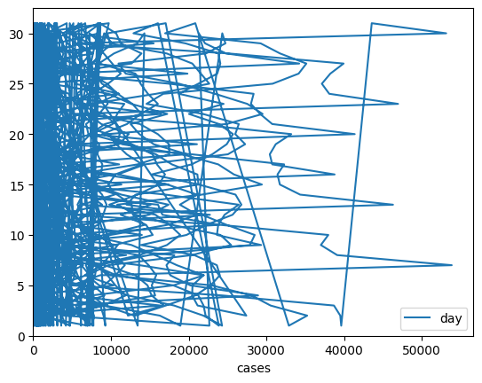

import matplotlib.pyplot as plt

Covid_cases.plot(x='cases',y='month',kind='scatter')

Plt.ylim(ymin=0)

Plt.xlim(xmin=0)

Plt.show()

Output:

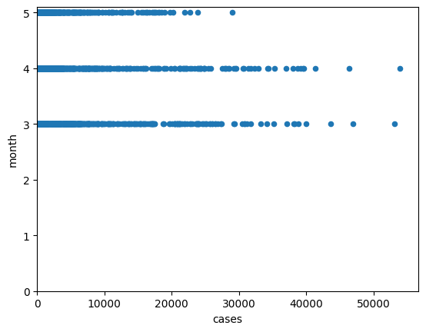

import matplotlib.pyplot as plt

Covid_cases.plot(x='cases',y='year',kind='line')

Plt.ylim(ymin=0)

Plt.xlim(xmin=0)

Plt.show()

Output:

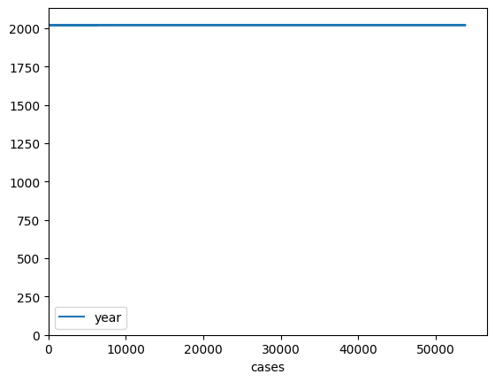

print(Covid_cases.describe())

Output:

day month year cases deaths  
count 2730.000000 2730.000000 2730.0 2730.000000 2730.000000  
mean 16.000000 4.010989 2021.0 3661.010989 65.291941  
std 8.765919 0.818813 0.0 6490.510073 113.956634  
min 1.000000 3.000000 2021.0 -2001.000000 -3.000000  
25% 8.000000 3.000000 2021.0 361.250000 2.000000  
50% 16.000000 4.000000 2021.0 926.500000 14.500000  
75% 24.000000 5.000000 2021.0 3916.250000 72.000000  
max 31.000000 5.000000 2021.0 53843.000000 956.00000

import numpy as np

# Assuming 'cases' and 'deaths' are NumPy arrays

cases = Covid_cases["cases"].to_numpy()

deaths = Covid_cases["deaths"].to_numpy()

# Extract the 10th element from the 'deaths' array

deaths_10th = deaths[10]

print(deaths_10th)

Output:

8

import numpy as np

import pandas as pd

# Assuming 'Covid_cases' is a DataFrame with the 'cases' column

cv = np.std(Covid_cases['cases']) / np.mean(Covid_cases['cases'])

print(cv)

Output:

1.7725489613643086

import numpy as np

import pandas as pd

# Assuming 'Covid_cases' is a DataFrame with the 'cases' column

cv = np.std(Covid_cases['deaths']) / np.mean(Covid_cases['deaths'])

print(cv)

Output:

1.7450202664995842

import numpy as np

import pandas as pd

# Assuming 'Covid_cases' is a DataFrame with a 'cases' column

variance = np.var(Covid_cases['cases'])

print(variance)

Output:

42111289.97570342

import pandas as pd

import numpy as np

import seaborn as sns

import matplotlib.pyplot as plt

Covid_cases=pd.read_csv("C:\\Users\\sunda\\Downloads\\Covid_19_cases4 (1).csv")

Covid_cases.head()

Output:

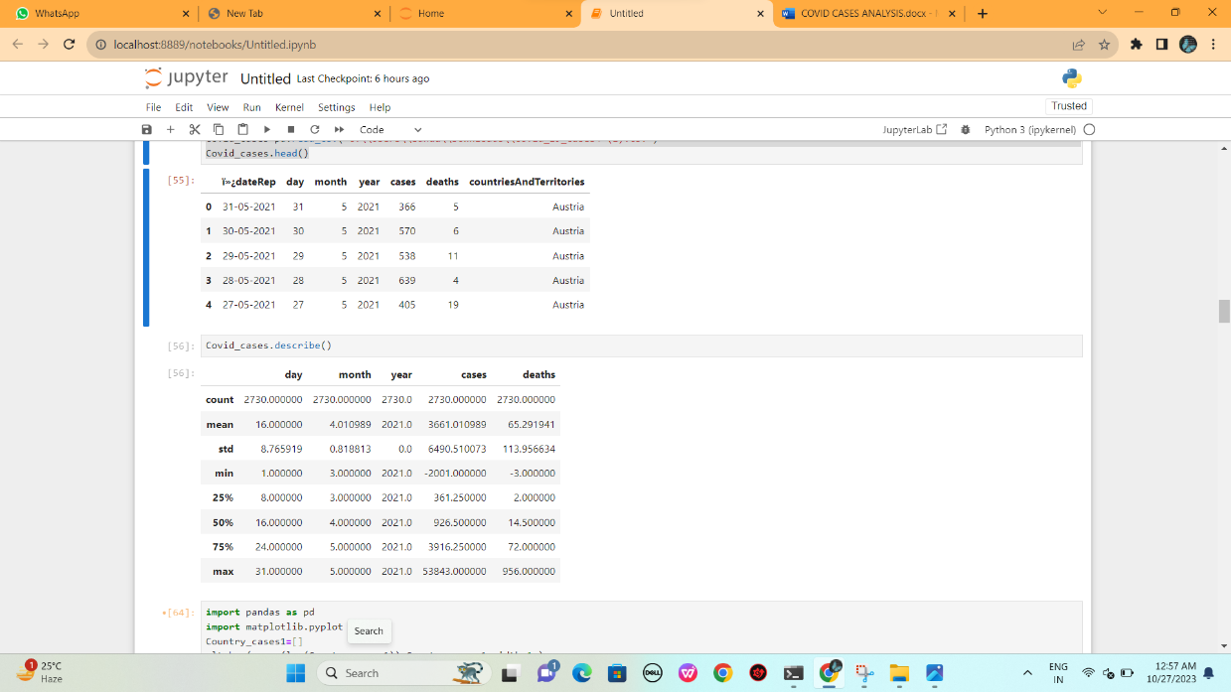

import pandas as pd

import matplotlib.pyplot as plt

Country_cases1=[5.,25.,50.,20.,]

plt.bar(range(len(Country_cases1)),Country_cases1,width=1.)

plt.show()

Output

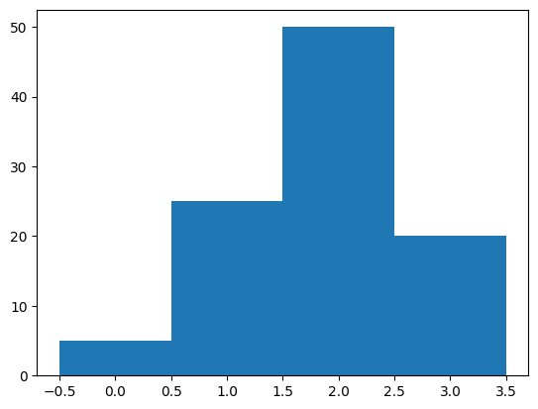

import pandas as pd

import matplotlib.pyplot as plt

Country_cases_2=[5.,25.,50.,20.,]

plt.barh(range(len(Country_cases_2)),Covid_cases_2)

plt.show()

Output:

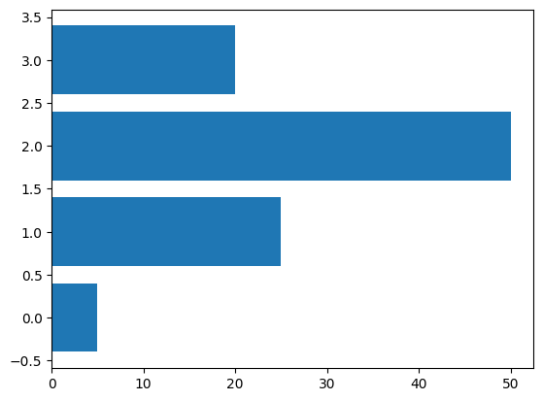

import pandas as pd

import numpy as np

import seaborn as sns

import matplotlib.pyplot as plt

sns.set()

Covid_cases=np.random.multivariate_normal([0,0],[[5,2],[2,2]],size=2000)

Covid_cases=pd.DataFrame(Covid_cases,columns=['cases','deaths'])

plt.hist(Covid_cases["cases"],alpha=0.5)

plt.hist(Covid_cases["deaths"],alpha=0.5)

plt.show()

Output:

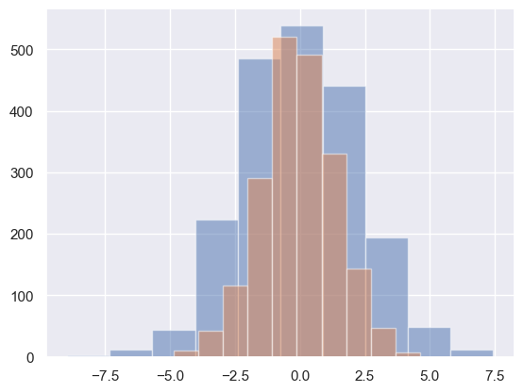

import pandas as pd

import numpy as np

import seaborn as sns

import matplotlib.pyplot as plt

sns.set()

Covid_cases=np.random.multivariate_normal([0,0],[[5,2],[2,2]],size=2000)

Covid_cases=pd.DataFrame(Covid_cases,columns=['cases','deaths'])

sns.kdeplot(Covid_cases["cases"],alpha=0.5)

sns.kdeplot(Covid_cases["deaths"],alpha=0.5)

plt.show()

Output:

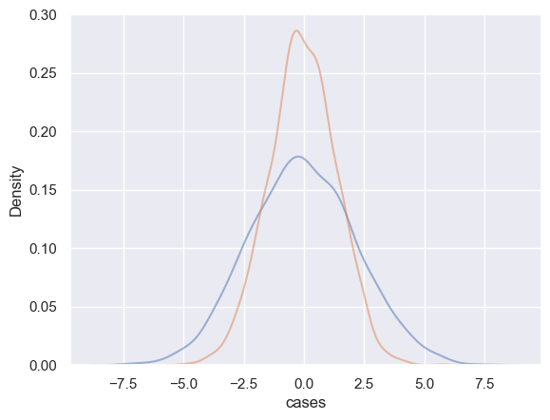

import pandas as pd

import numpy as np

import seaborn as sns

import matplotlib.pyplot as plt

sns.set()

Covid_cases=np.random.multivariate_normal([0,0],[[5,2],[2,2]],size=2000)

Covid_cases=pd.DataFrame(Covid_cases,columns=['cases','deaths'])

sns.distplot(Covid_cases["cases"])

sns.distplot(Covid_cases["deaths"])

plt.show()

Output:

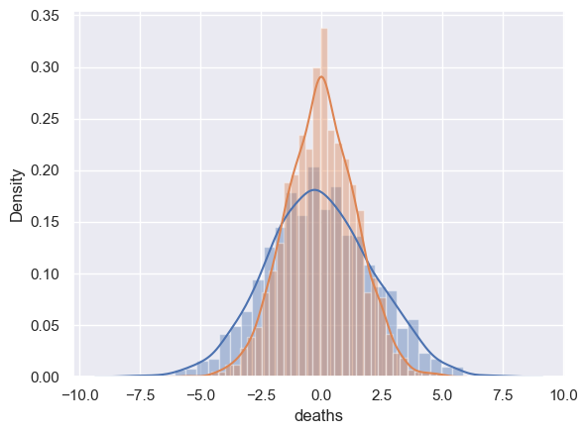

import pandas as pd

# Read the CSV file into a DataFrame

df = pd.read_csv("C:\\Users\\sunda\\Downloads\\Covid_19_cases4 (1).csv")

# Group by 'countriesAndTerritories' and calculate the sum of 'cases' for each group

Country_cases = df.groupby('countriesAndTerritories')['cases'].sum()

print(Country_cases)

Output:

countriesAndTerritories  
Austria 184416  
Belgium 288119  
Bulgaria 171236  
Croatia 113168  
Cyprus 37700  
Czechia 421221  
Denmark 69188  
Estonia 62916  
Finland 34760  
France 2020808  
Germany 1234058  
Greece 210201  
Hungary 371613  
Iceland 527  
Ireland 42057  
Italy 1290738  
Latvia 46912  
Liechtenstein 437  
Lithuania 77040  
Luxembourg 14464  
Malta 7586  
Netherlands 557983  
Norway 53995  
Poland 1164964  
Portugal 44096  
Romania 275590  
Slovakia 178475  
Slovenia 63550  
Spain 552723  
Sweden 404019  
Name: cases, dtype: int64

**BARGRAPH AND PIE CHARTS:**

Country_cases.plot(kind = "pie", ylabel = "", title = "CountriesAndTerritories cases", startangle = 0)

plt.show()

Output:

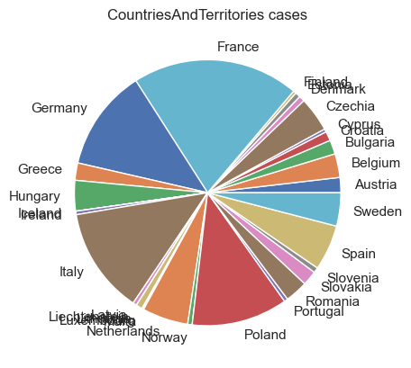

import pandas as pd

# Read the CSV file into a DataFrame

df = pd.read_csv("C:\\Users\\sunda\\Downloads\\Covid_19_cases4 (1).csv")

# Group by 'countriesAndTerritories' and calculate the sum of 'cases' for each group

Country_cases = df.groupby('countriesAndTerritories')['cases'].sum().head(10)

print(Country_cases)

Output:

countriesAndTerritories  
Austria 184416  
Belgium 288119  
Bulgaria 171236  
Croatia 113168  
Cyprus 37700  
Czechia 421221  
Denmark 69188  
Estonia 62916  
Finland 34760  
France 2020808  
Name: cases, dtype: int64

import pandas as pd

# Read the CSV file into a DataFrame

df = pd.read_csv("C:\\Users\\sunda\\Downloads\\Covid_19_cases4 (1).csv")

# Group by 'countriesAndTerritories' and calculate the sum of 'cases' for each group

Country_cases = df.groupby('countriesAndTerritories')['cases'].sum().sort_values(ascending=False).head(10)

print(Country_cases)

Output:

countriesAndTerritories  
France 2020808  
Italy 1290738  
Germany 1234058  
Poland 1164964  
Netherlands 557983  
Spain 552723  
Czechia 421221  
Sweden 404019  
Hungary 371613  
Belgium 288119  
Name: cases, dtype: int64

Country_cases.plot(kind = "pie", ylabel = "", title = "CountriesAndTerritories cases", startangle = 0)

plt.show()

Output:

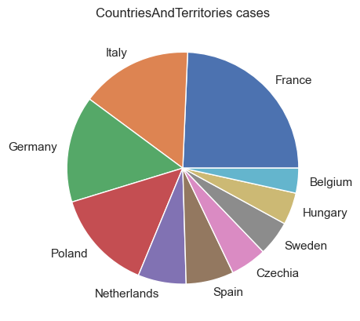

import pandas as pd

# Read the CSV file into a DataFrame

df = pd.read_csv("C:\\Users\\sunda\\Downloads\\Covid_19_cases4 (1).csv")

# Group by 'countriesAndTerritories' and calculate the sum of 'cases' for each group

Country_cases1 = df.groupby('cases')['deaths'].sum()

print(Country_cases)

Output:

countriesAndTerritories  
France 2020808  
Italy 1290738  
Germany 1234058  
Poland 1164964  
Netherlands 557983  
Spain 552723  
Czechia 421221  
Sweden 404019  
Hungary 371613  
Belgium 288119  
Name: cases, dtype: int64

import pandas as pd

# Read the CSV file into a DataFrame

df = pd.read_csv("C:\\Users\\sunda\\Downloads\\Covid_19_cases4 (1).csv")

# Group by 'countriesAndTerritories' and calculate the sum of 'cases' for each group

Country_cases_2 = df.groupby('day')['cases'].sum().sort_values(ascending=False).head(10)

print(Country_cases)

Output:

day  
3 355644  
13 355426  
10 352345  
2 349264  
4 346223  
11 344705  
12 343549  
9 341365  
7 341264  
20 341185  
Name: cases, dtype: int64

Country_cases_2.plot(kind = "pie", ylabel = "", title = "CountriesAndTerritories cases", startangle = 0)

plt.show()

Output:

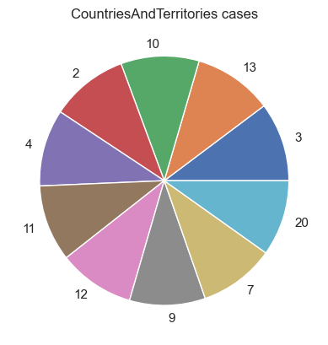

import pandas as pd

# Read the CSV file into a DataFrame

df = pd.read_csv("C:\\Users\\sunda\\Downloads\\Covid_19_cases4 (1).csv")

# Group by 'countriesAndTerritories' and calculate the sum of 'cases' for each group

Country_cases_3 = df.groupby('deaths')['day'].sum().sort_values(ascending=False).head(10)

print(Country_cases)

Output:

day  
3 355644  
13 355426  
10 352345  
2 349264  
4 346223  
11 344705  
12 343549  
9 341365  
7 341264  
20 341185  
Name: cases, dtype: int64

Country_cases_3.plot(kind = "pie", ylabel = "", title = "CountriesAndTerritories cases", startangle = 0)

plt.show()

Output:

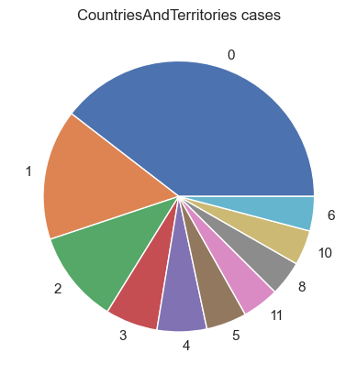

import pandas as pd

import numpy as np

import matplotlib.pyplot as plt

data=Country_cases1

plt.bar(range(len(data)),(data),color='r',width=1.)

plt.show()

Output:

