TRANSCRIPTS
Semester 1 | GPA = 8.8 | CGPA = 8.8
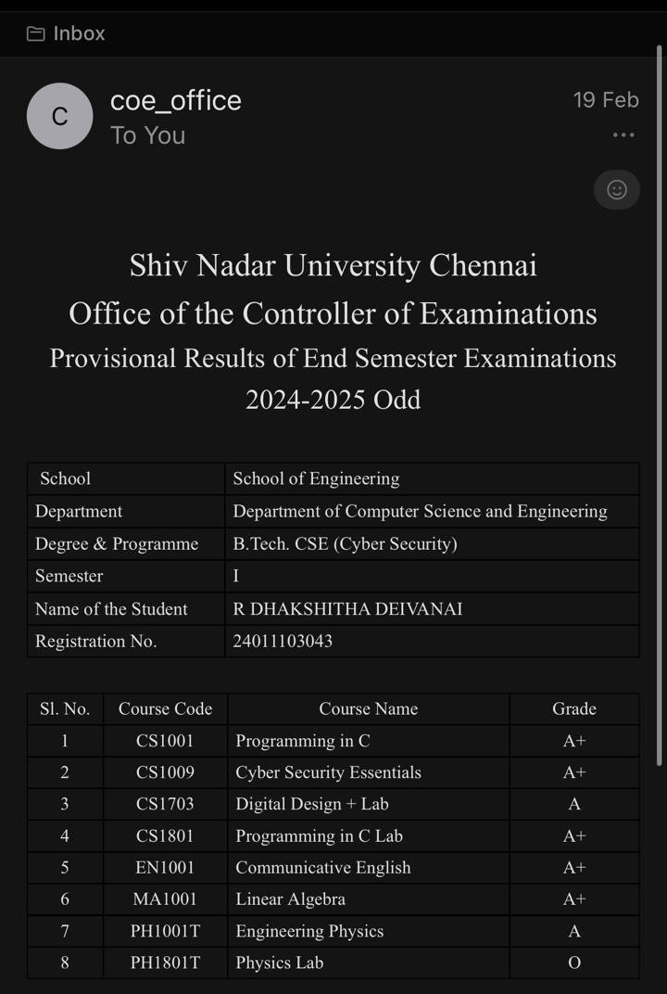

Semester 2 | GPA = 9.05 | CGPA = 8.91
