CHAPTER 1
INTRODUCTION

1.1 OVERVIEW
A Social Engineering Attack consists of manipulating individuals into revealing sensitive information, performing unintended actions, or granting unauthorized access. This requires a combination of psychological manipulation and technical reconnaissance. The most challenging task in the process of launching social engineering attacks is the collection of reliable information about the target and establishing contextual knowledge to make the attack convincing. This reconnaissance can be performed through Open-Source Intelligence (OSINT), which refers to the gathering and analysis of publicly available information from multiple sources such as social media, company websites, WHOIS records, data breaches, and online forums.
Social Engineering can be broadly divided into two categories:
- Traditional Approaches – Manual reconnaissance and generic attacks such as bulk phishing or cold calls.
- OSINT-driven Approaches – Automated, highly targeted attacks using OSINT tools such as Maltego, SpiderFoot, Shodan, and theHarvester.
In OSINT-driven approaches, the critical step is information gathering. Tools like theHarvester can collect emails and subdomains, Shodan can detect exposed devices and services, and Maltego can establish links between people, organizations, and technologies. Once gathered, this information is analyzed and correlated to identify potential vulnerabilities and attack vectors.
The report presents a way to analyze Social Engineering Attacks using OSINT tools in a controlled environment. The proposed system focuses on simulating three common attack scenarios—spear-phishing, vishing, and impersonation—using dummy datasets and test profiles. A risk-scoring model is applied to classify the severity of exposed information.
Social Engineering Attack Analysis has its roots in many real-life applications such as:
•Training employees to recognize phishing attempts.
- Conducting red-team assessments for organizations.
- Improving digital hygiene by reducing public exposure.
- Supporting cybersecurity awareness programs.
- Assisting law enforcement in understanding attacker methodologies.

1.2 PROBLEM DEFINITION
The main problem in the rise of social engineering attacks stems from the exploitation of human psychology and publicly available information. Attackers gather personal and organizational data through OSINT (Open Source Intelligence) tools and then manipulate individuals into revealing sensitive information or performing actions that compromise security. Traditional cybersecurity solutions focus mainly on technical vulnerabilities but often overlook the human element, which is the most exploited factor in these attacks.
Making use of OSINT: It involves collecting publicly available data from sources such as social media, company websites, WHOIS databases, and data leaks. OSINT tools like Maltego, SpiderFoot, and theHarvester automate this process, allowing attackers to quickly build digital footprints of targets. This model enables identification of potential victims but lacks mechanisms to evaluate and mitigate associated risks.
Here a simulation and analysis-based framework is required—one that unites data collection, vulnerability classification, and risk assessment. Such a framework can effectively demonstrate how attackers weaponize exposed data, while also generating awareness reports and preventive strategies.
Making use of attack simulations: Simulated phishing emails, impersonation scenarios, and other social engineering techniques help in highlighting real-world risks without causing harm. By integrating OSINT analysis with awarenessbuilding, individuals and organizations can gain the intelligence needed to secure their digital presence.

Lack of Awareness and Training:
Many individuals and employees remain unaware of how easily their personal or organizational data can be exploited through OSINT-based reconnaissance. The absence of regular awareness programs and security training increases the success rate of social engineering attacks.

Difficulty in Detecting Human-Based Attacks:
Unlike technical attacks, social engineering exploits trust and emotions rather than system vulnerabilities. These attacks are often difficult to detect through conventional cybersecurity tools and require behavioral analysis or awareness measures to identify and prevent them.

Absence of Integrated Risk Evaluation Models:
Current cybersecurity frameworks rarely combine OSINT data analysis with risk scoring or classification models. This gap makes it difficult to prioritize threats and implement targeted preventive actions based on exposure levels.

Need for Proactive Defense Mechanisms:
Most organizations adopt reactive measures after an incident occurs. There is a strong need for proactive defense mechanisms that can simulate attacks, assess vulnerabilities, and recommend tailored awareness and protection strategies.

1.3 Scope

The scope of this project is to design and implement a system that analyzes social engineering threats using OSINT (Open Source Intelligence) tools. The system will simulate real-world attack scenarios such as phishing, impersonation, and pretexting to demonstrate how attackers exploit publicly available data. It will generate risk reports and provide preventive strategies, making it a valuable resource for individuals, organizations, and cybersecurity learners. The project focuses on awareness and proactive defense rather than executing real attacks. Key inclusions within scope:

- Integration of multiple OSINT tools (e.g., Maltego, SpiderFoot, theHarvester).
- Automated data collection and processing from public sources. • Classification of vulnerabilities into risk categories (low, medium, high).
- Simulation of possible attack vectors based on collected intelligence.
- Generation of awareness and countermeasure reports.

Out of scope:

- Launching or executing actual malicious attacks.
- Using real personal/organizational targets without consent (dummy/test data only).

1.4 Objectives

- To study the role of OSINT in enabling social engineering attacks.
- To integrate and automate OSINT tools for collecting and analyzing public data.
- To classify vulnerabilities and assess the level of exposure for individuals/organizations.
- To simulate realistic attack scenarios (phishing, impersonation, etc.) in a controlled manner.
- To generate comprehensive reports that raise awareness and suggest preventive measures.
- To build a prototype system that demonstrates feasibility and educates users about digital risks.

CHAPTER 2
LITERATURE SURVEY

P. Zieliński and T. Sadowski [1] in their research discussed the use of OSINT techniques in cybersecurity for preventing social engineering attacks. Their study highlighted how publicly available information from social media and open databases can be leveraged by attackers to design phishing and impersonation attempts. The paper emphasized the importance of defensive strategies, including proactive monitoring of exposed data.

J. Robertson et al. [2] proposed an analytical approach to understanding the impact of social engineering on cybersecurity. Their work categorized different social engineering methods such as phishing, spear-phishing, and pretexting, and explained how attackers manipulate human trust to compromise systems. The study suggested training and awareness as key countermeasures.

- K. Rogers [3] focused on the role of OSINT in ethical hacking and cybercrime investigations. His work demonstrated how OSINT tools are used not only by attackers but also by investigators to trace malicious activities. The research highlighted the ethical dilemma between intelligencegathering and privacy invasion.

A. Jain and B. Gupta [4] conducted a survey of social engineering attacks, countermeasures, and OSINT applications. Their study provided a comprehensive review of commonly used OSINT tools such as Maltego, Shodan, and theHarvester, and their role in both attack and defense. They emphasized that OSINT-driven approaches allow quicker identification of vulnerabilities compared to traditional methods.

A. Hadnagy [5] in his book “Social Engineering: The Science of Human Hacking” explained the psychological principles behind social engineering, such as authority, urgency, and trust. The work connected these principles with OSINTbased attack execution, showing how attackers exploit human behavior once sufficient data is collected.
A. M. Hussain et al. [6] proposed a framework that combines OSINT with machine learning for detecting potential victims of social engineering attacks. Their approach involved collecting digital footprints such as emails, job details, and social media activity, and training predictive models to identify high-risk targets. The study proved that combining OSINT with AI improves threat prediction accuracy.

- Mavroeidis and S. Bromander [7] presented a comprehensive taxonomy of cyber threat intelligence (CTI) with a focus on OSINT-based data collection and processing. Their research introduced a structured model for integrating open-source intelligence into CTI systems, helping organizations transform unstructured OSINT data into actionable security knowledge. The paper also emphasized standardization for effective information sharing.

C. Wangen [8] explored the challenges and ethical issues of using OSINT for cyber threat intelligence and investigations. The study discussed the reliability, legality, and ethical implications of collecting public data for cybersecurity purposes. Wangen emphasized the balance between intelligence gathering and privacy protection, advocating responsible use of OSINT methodologies.

CHAPTER 3
SYSTEM ANALYSIS

3.1 EXISTING SYSTEM

In the existing scenario, most cybersecurity solutions focus on detecting and mitigating technical vulnerabilities such as malware, unauthorized access, or misconfigured systems, but they often overlook the human factor, which is the most exploited element in social engineering attacks. Attackers exploit publicly available information from social media, company websites, and open databases to craft targeted phishing emails, impersonation attempts, or pretexting scenarios, while conventional threat detection mechanisms are not designed to simulate such human-focused attacks. Although OSINT tools like Maltego, Shodan, and theHarvester exist, they are primarily used for reconnaissance or network scanning rather than for raising awareness about social engineering risks, and they require technical expertise to operate, making them less accessible to individuals or organizations with limited cybersecurity knowledge. As a result, the absence of a consolidated framework that integrates OSINT data analysis with awareness-building and preventive strategies leaves individuals and organizations vulnerable to manipulation-based attacks.

Disadvantages of the Existing System

Focus Limited to Technical Threats:
Existing cybersecurity systems mainly address malware, firewalls, and network breaches but fail to consider the human element that is frequently targeted in social engineering attacks.
Lack of Awareness-Oriented Frameworks:
Current OSINT and security tools do not emphasize educating users or creating awareness reports, leaving individuals unaware of how their exposed data can be exploited.
High Technical Expertise Required:
Tools like Maltego, Shodan, and theHarvester require advanced technical knowledge, making them inaccessible to non-technical users or small org.
Absence of Integrated Risk Evaluation:
There is no unified model that combines OSINT data collection, vulnerability classification, and risk assessment, resulting in incomplete understanding of social engineering exposure.

3.2PROPOSED SYSTEM

In this approach, a framework is designed to analyze and simulate social engineering attacks using OSINT tools. The system collects publicly available information such as emails, domains, phone numbers, and social media data, and processes it to identify potential vulnerabilities. A classification mechanism is applied to categorize the risks into low, medium, and high levels based on the sensitivity of exposed information. The framework then simulates possible attack scenarios such as phishing or impersonation to demonstrate how attackers could exploit the gathered data. Finally, the system generates awareness reports containing the level of exposure, sample attack scenarios, and preventive measures, thereby enabling individuals and organizations to strengthe their digital security posture.

Advantages of the Proposed System

Comprehensive Risk Identification:
The system not only gathers publicly available data but also classifies it based on sensitivity, allowing users to clearly understand their risk exposure levels.
Realistic Attack Simulation:
By simulating phishing, impersonation, and other social engineering scenarios, the framework provides a practical demonstration of how attackers exploit data without causing actual harm.
Enhanced Security Awareness:
The awareness reports generated help individuals and organizations recognize their digital weaknesses and take preventive actions, thereby strengthening overall security awareness.

Proactive Defense Strategy:
Instead of reacting after a breach, the system enables early detection and mitigation of potential threats through continuous analysis and assessment of exposed data.

3.3 FEASIBILITY STUDY
The objective of the feasibility study is not only to solve the problem but also to acquire a sense of its scope. During this study, the problem definition was refined, and the aspects of the problem to be addressed by the proposed system were determined. Consequently, the benefits were estimated with greater clarity at this stage. The key considerations are: EconomicFeasibility, Technical Feasibility, and Social Feasibility.

Economic Feasibility
Economic feasibility considers the cost of hardware, software, and resources against the benefits achieved. Since the proposed system is developed using open-source OSINT tools such as Maltego, SpiderFoot, Shodan, and theHarvester along with Python libraries (Pandas, Numpy, Matplotlib), the financial investment is minimal. The project avoids expensive enterprise solutions and instead uses publicly available tools and datasets for simulation. The major benefit is the reduction in manual work involved in reconnaissance and risk analysis, leading to faster and more accurate detection of vulnerabilities. Additionally, awareness reports generated by the system help organizations avoid potential financial losses caused by phishing or impersonation attacks.

Technical Feasibility
Technical feasibility evaluates the availability of tools, hardware, and software required for successful development. The proposed system relies on widely available technologies that can be deployed on mid-range hardware. The requirements include:
- OSINT Tools – Maltego, SpiderFoot, Shodan, theHarvester
- Programming Language – Python 3.8+
- Libraries – Pandas, Regex, Matplotlib, Scikit-learn
- IDE – Jupyter Notebook / VS Code / PyCharm
- Optional GUI – Flask or Streamlit for report visualization
These technologies are open-source and widely documented, making the project technically feasible with the resources available to students and organizations.

Social Feasibility
Social feasibility assesses the project’s impact on individuals, organizations, and the wider community. Social engineering is one of the most common cyber threats, with individuals and employees often being manipulated into sharing sensitive information unknowingly. By simulating attacks and generating awareness reports, this system educates users about how their digital footprints can be exploited, thereby promoting safer online practices. The expected social impacts include:
- Awareness Creation – Educating internet users about risks of oversharing personal data.
- Organizational Benefits – Training employees to recognize phishing and impersonation attempts.
- Support for Cybersecurity Education – Helping students and professionals learn ethical use of OSINT tools.
- Crime Prevention – Contributing to reducing successful social engineering attacks and improving digital trust.

3.4 DEVELOPMENT ENVIRONMENT

Software Requirements
OS: Windows 10/11 (64-bit) or Ubuntu 20.04 LTS (64-bit)
Programming Language: Python 3.9 / 3.10 (latest stable version)
IDE/Notebook: Jupyter Notebook / JupyterLab / Google Colab / VS Code
Libraries: pandas, numpy, scikit-learn, nltk, spaCy, matplotlib, seaborn, plotly,
Database: CSV files (for MVP) or SQLite/MySQL (if extended)
Version Control: Git/GitHub (optional, for collaboration)

Hardware Requirements
Processor: Intel Core i3 or equivalent (dual-core minimum)
RAM: 8 GB minimum (16 GB recommended for heavy analysis)
Storage: 100 GB free space (SSD recommended)
Internet: Stable broadband connection (required for data collection and API access)
Optional: GPU not mandatory (useful only for deep learning models)
Language: Python 3.9+

UML DIAGRAMS:

A Unified Modeling Language (UML) diagram provides a standardized way to visualize the structure and behavior of a system. It represents the system’s main components—such as actors, roles, actions, artifacts, and classes—and illustrates how they interact. UML diagrams are instrumental in understanding, designing, modifying, and documenting software systems. They use diagrammatic notations to convey complex relationships between system modules, enabling better communication and maintainability throughout the development lifecycle.
Use Case Diagram:
The system, named Silent Signals, is designed to analyze users’ emotions through audio inputs using AI-based processing. The process begins when a user or individual provides an audio sample, which the system preprocesses and extracts key features such as tone, pitch, and frequency. These features are then passed to an AI model that classifies the emotional state of the user. The system subsequently generates explainable insights, helping users understand the emotional analysis. The results are displayed in real-time on a dashboard, allowing users to visualize their emotional trends. All data and results are stored securely in a cloud database, enabling continuous monitoring and access. Mental health professionals can view detailed emotional reports and trends from the cloud, supporting them in assessing the user’s emotional well-being and providing informed guidance.
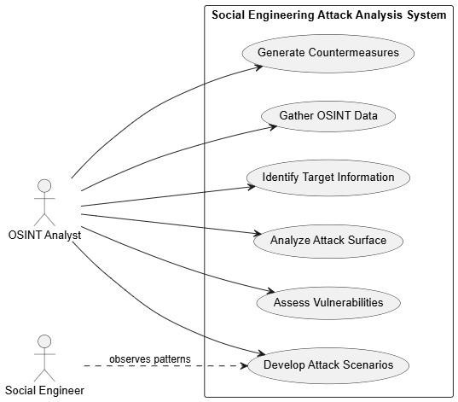

Fig:3.1 Use Case Diagram

Activity Diagram:
The diagram illustrates the OSINT Data Gathering process for Social Engineering, outlining the sequential steps involved in collecting and analyzing publicly available information for cybersecurity purposes. The process begins by defining the target, which establishes the scope and objective of data collection. Next, relevant OSINT sources such as social media platforms, public records, and online forums are identified to locate useful data about the target. The gathered information is then collected using OSINT tools like Maltego, SpiderFoot, and Shodan, which automate and enhance the search process. After data collection, the system proceeds to extract relevant information from the raw dataset. This data is then correlated and verified to ensure its accuracy and authenticity. Finally, the analyzed information helps identify potential attack vectors, revealing vulnerabilities that could be exploited in social engineering attacks. This systematic OSINT approach strengthens both offensive assessments and defensive strategies in cybersecurity.
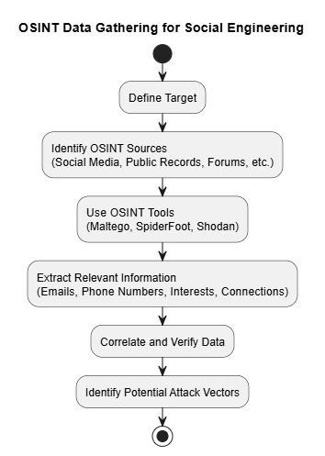

Fig:3.2 Activity Diagram

Class Diagram:
The class diagram for the OSINT-based social engineering attack models how an AttackCampaign (with start/end dates, status, and outcome) is carried out by a SocialEngineer (name, motivation, skills) who targets a Target (name, vulnerabilities, OSINT exposure level) using various OSINT_Tools (name, functionality, data sources) to collect Information (type, source, sensitivity) and employ specific SocialEngineeringTechnique(s) (name, description, compliance principles leveraged); in short, the diagram shows the campaign lifecycle—how tools gather sensitive data, how that data is correlated and exploited via techniques chosen by the attacker, and how those actions map back to the campaign’s objectives and outcomes.
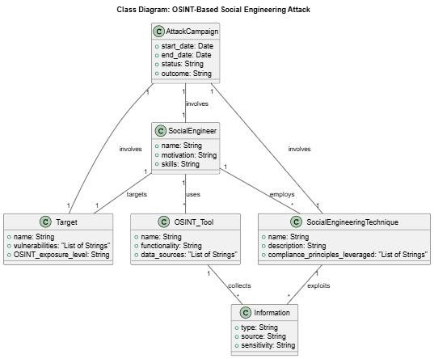

Fig:3.3 Class Diagram

Sequence Diagram:
The sequence diagram shows a typical OSINT-driven social engineering attack: the social engineer first queries OSINT tools to gather public data about the target, receiving names, emails, profiles and other useful details; using this intelligence the attacker crafts a tailored message (for example a convincing phishing email) and sends the malicious communication to the target; when the target interacts with the malicious content (clicks a link, opens an attachment, or submits credentials) the malicious payload / phishing site executes, enabling the attacker to exfiltrate data or gain access to accounts or systems; finally, the social engineer collects the stolen information and assesses the campaign outcome—this flow highlights how publicly available data is weaponized to increase the success rate of targeted attacks.
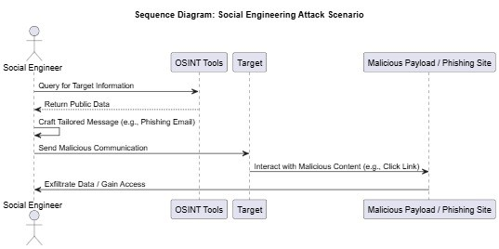

Fig:3.4 sequence diagram

Deployment Diagram:
The deployment diagram shows how an OSINT-driven social engineering attack is organized: an OSINT Tools Server (hosting tools like SpiderFoot, Maltego, and Shodan) provides the attacker with automated access to public data; the attacker’s machine uses a social-media scraper and phishing toolkit to query information sources (e.g., Twitter, LinkedIn, public websites) and craft targeted attacks; those attacks are directed at the target’s machine (web application, database, WAF) to exploit discovered weaknesses; finally, the attacker collects any exfiltrated data and refines further steps using the OSINT feedback loop.
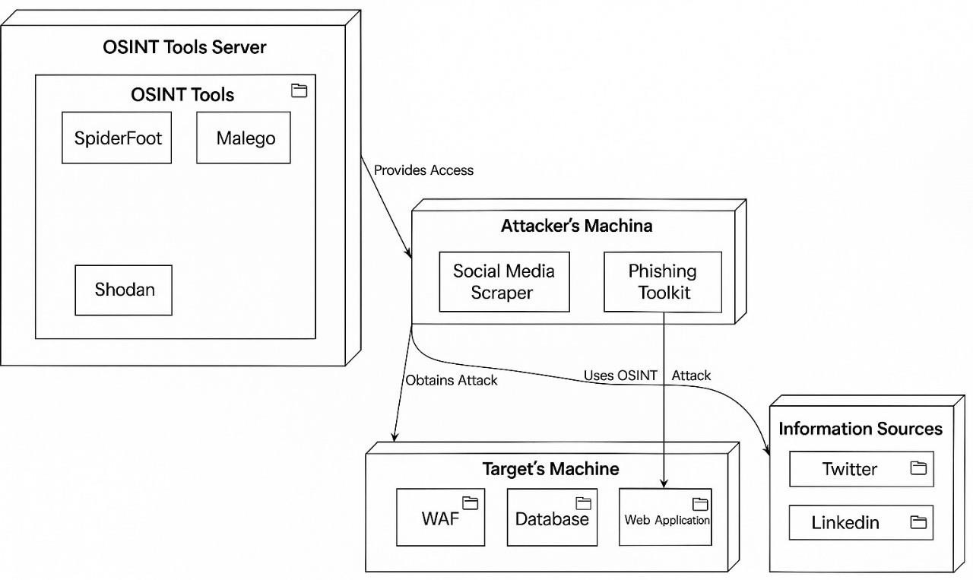

Fig:3.5 sequence diagram

CHAPTER 4
SYSTEM DESIGN

4.1 FLOW DIAGRAM
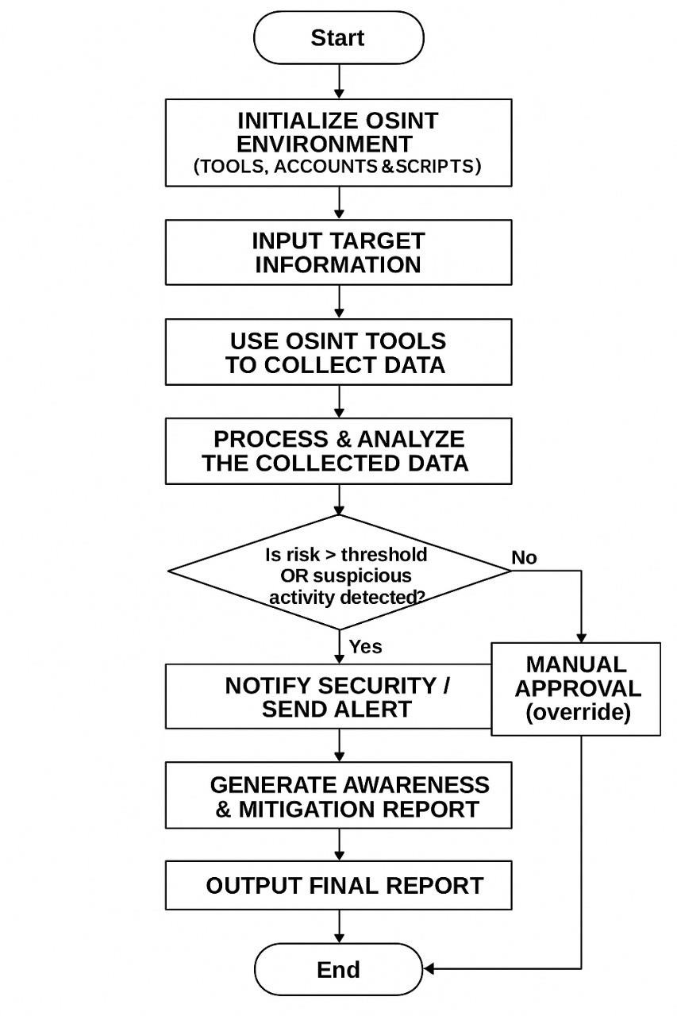

Fig. 4.1 Working
flow of the model

1. Initialize OSINT Environment (Tools, Accounts & Scripts)
This step involves setting up all necessary OSINT tools, creating required user accounts, and configuring scripts or automation tools to facilitate data collection.
Example: tools like Maltego, SpiderFoot, or Shodan.

2. Input Target Information
The analyst enters target details (such as a name, email, IP address, domain, or organization) into the OSINT environment.
This serves as the basis for the search and analysis.

3. Use OSINT Tools to Collect Data
Various OSINT tools are then used to gather publicly available information from multiple sources such as social media, websites, public databases, and forums.The goal is to accumulate raw data relevant to the target.

4. Process & Analyze the Collected Data
Collected data is filtered, cleaned, and analyzed to identify meaningful patterns, correlations, or indicators of potential risk or suspicious activity. 5. Decision Point: Is Risk > Threshold OR Suspicious Activity Detected? The analysis results are compared with predefined risk thresholds. o Yes: If suspicious activity or a significant threat is detected, further action is taken. o No: If the data appears normal, the process proceeds for manual approval before reporting.

6. Notify Security
7. When a threat or risk is found, the security team or concerned authority is alerted immediately for action or verification.

8. Manual Approval
If no risk is detected, the report undergoes manual verification or approval to ensure no potential threats were overlooked. 9. Generate Awareness & Mitigation Report
A detailed report is generated highlighting the findings, awareness measures, and possible mitigation strategies to prevent similar risks.

10. Output Final Report
The final comprehensive report is produced, summarizing the data collection, analysis results, alerts, and recommendations.

4.2DATA COLLECTION PROCESS
The data collection process for this project relies on publicly available information obtained through OSINT (Open Source Intelligence) techniques and tools. Data is gathered from multiple open sources including social media platforms, public forums, company websites, WHOIS/DNS records, metadata from documents and images, as well as exposure databases such as “Have I Been Pwned” and search engines like Shodan and Censys. Automated OSINT tools such as theHarvester, SpiderFoot, Recon-ng, and Maltego are used alongside Python-based web scraping libraries (BeautifulSoup, Selenium, Requests) to extract relevant information. Collected data includes emails, usernames, domain details, metadata attributes, and social media footprints which are then stored in structured formats such as CSV/JSON or in lightweight databases like MongoDB/SQLite. To ensure quality, the collected information is manually verified to remove duplicates and irrelevant entries, and sensitive identifiers are anonymized to maintain ethical compliance. All data is collected in a sandboxed environment using virtual machines (Kali Linux/Parrot OS) to ensure safety, legality, and reproducibility.

4.3RISK SCORING MODE
A Risk Scoring Model is a systematic method used to evaluate, quantify, and prioritize potential risks in a project or system. It assigns a numerical or categorical score to each identified risk based on defined parameters such as likelihood of occurrence, impact severity, and detectability. This structured scoring helps decision-makers focus resources on the most critical risks .
CHAPTER 5
SYSTEM ARCHITECTURE

5.1 ARCHITECTURE OVERVIEW

This architecture illustrates the overall design of the working model, including the main components and the flow of processes during execution. The system begins with the data collection phase, where OSINT tools gather information such as emails, usernames, domains, social media footprints, and metadata from publicly available sources. The collected raw data is then passed into the preprocessing module, where it is cleaned, filtered, anonymized, and transformed into structured formats suitable for analysis. Next, the analysis engine processes the refined data to identify potential vulnerabilities, such as exposed credentials, misconfigured domains, or publicly available sensitive information. These findings are then evaluated using the Risk Scoring Model, which assigns weighted scores to different attributes and classifies them into Low, Medium, High, or Critical risk categories. Finally, the processed results are visualized in the form of graphs, reports, or dashboards, enabling security analysts to interpret the outcomes and prioritize mitigation strategies. This layered architecture ensures that the workflow—from data gathering to risk evaluation and reporting—remains systematic, modular, and efficient.

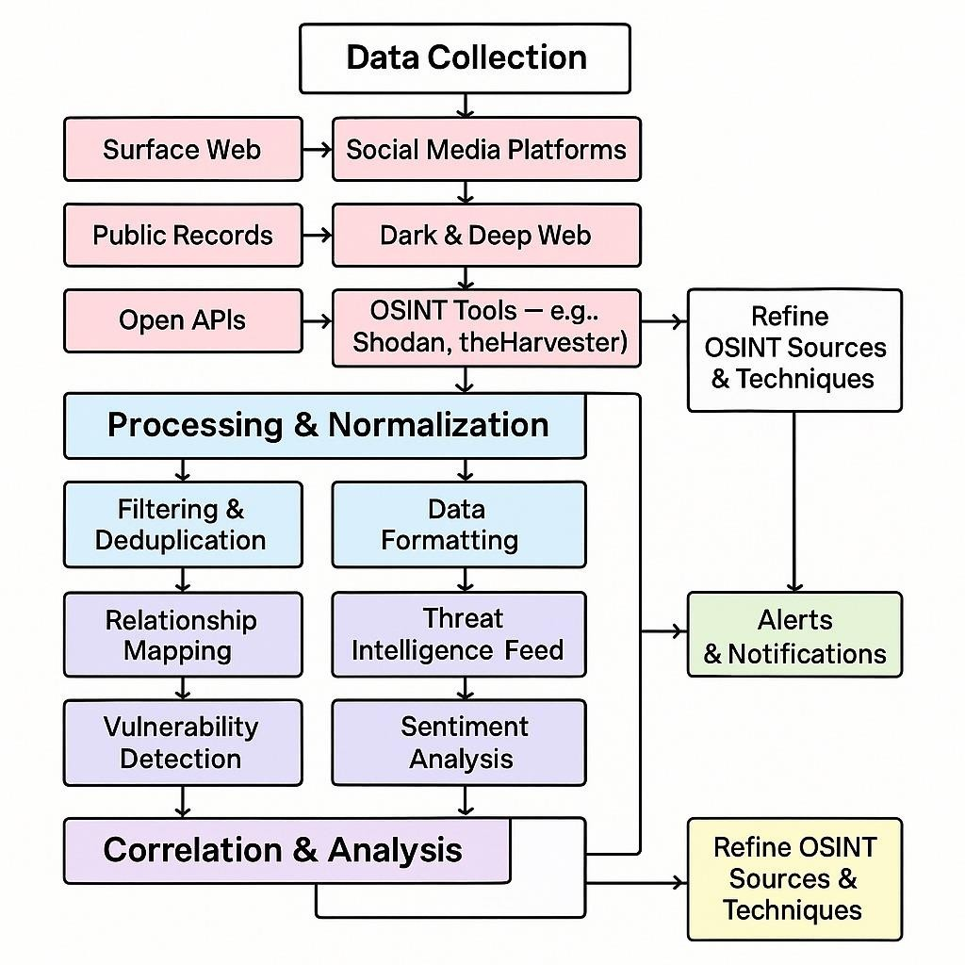

Fig.5.1 Architecture overview

5.2 MODULES
The proposed system Social Engineering Attack Analysis using OSINT Tools is divided into multiple modules, where each module performs a specialized function. The step-by-step modular breakdown ensures efficient workflow from data collection to final reporting.

1. Data Preprocessing — OSINT Data
In this project, raw inputs consist of emails, phone numbers, domains, and usernames collected from OSINT tools. Since this data is often unstructured, the first step is data cleaning and formatting: o Remove duplicates and invalid entries.
- Standardize formats (e.g., international phone numbers, lowercase emails).
- Convert the raw inputs into structured tabular form (CSV/JSON). • This step ensures the model receives consistent and clean vectors of input data, just like images are converted into feature vectors in deep learning.

2. Data Preprocessing — Text Information
Alongside structured identifiers, textual data such as social media bios, domain WHOIS info, and metadata are processed. Text cleaning includes:
o Removing punctuation and unnecessary symbols. o Converting all words to lowercase. o Tokenizing text into words for analysis.
This ensures that textual OSINT inputs are in a machine-readable format for further analysis and correlation.

3. Data Preparation using Generator Function
Since the OSINT dataset can be large, processing everything in memory at once is inefficient. A Python generator function is used to feed the data step-bystep during execution. For example:
- Input = [Email + Domain], Output = Breach Status.
- Input = [Phone Number + Metadata], Output = Risk Category.
This streaming approach reduces memory load and allows efficient execution, similar to how captions are predicted word by word in image captioning models.

4. Pre-Requisites
The project requires knowledge of OSINT tools, data science, and Python. Essential libraries and environments include:

• Python 3.x • Anaconda / Jupyter / Google Colab • pandas, numpy, requests, beautifulsoup4 (for parsing and analysis)
- matplotlib, seaborn (for visualization)23
- scikit-learn (for classification and scoring)
- OSINT tools: theHarvester, SpiderFoot, Recon-ng, Shodan .

6. Data Cleaning and Preparation
Raw OSINT findings often contain noise such as invalid emails, fake usernames, or outdated domains. Data cleaning functions:
- load_data(filename) → Loads raw OSINT results. o clean_data(records) → Removes duplicates, standardizes formats.
- map_risk_level() → Maps identifiers to their risk categories.

7. Feature Extraction for Risk Scoring
Similar to extracting vectors from images, identifiers are converted into risk features:
- Email → Breach History, Domain Reputation. o Phone Number → Spam Score, Geographic Mapping.
- Username → Social Media Exposure.
These extracted features are stored in structured feature vectors for risk modeling.

8. Defining the Risk Analysis Model
The model integrates multiple components:
o Feature Extractor → Converts OSINT findings into numeric features. o Sequence Processor → Handles textual data like metadata or bios. o Scoring Decoder → Combines extracted features to assign final risk
scores.24

9. Training and Simulation
Dataset is divided into training (60%), validation (20%), and test (20%) sets.The risk scoring logic is tested using known OSINT patterns. Simulations (phishing, vishing, impersonation) are carried out using test data. Reports are generated for each simulated scenario.

Example: Risk Scoring for Classroom Management System Benefits of the Risk Scoring Model
- Provides a quantitative basis for risk prioritization.
- Ensures efficient allocation of resources.
- Enhances transparency in decision-making.
- Improves system reliability and security.

5.3 ALGORITHMS

Social Engineering Detection Using OSINT
For this project, the algorithm focuses on identifying and analyzing social engineering threats using OSINT (Open Source Intelligence) tools. The system simulates the way attackers gather information and shows how this data can be weaponized. The algorithm proceeds through structured steps:

1. Input Target Information
The system accepts a target’s basic details (such as name, email domain, or organization). This input serves as the entry point for OSINT data gathering.

2. Data Collection with OSINT Tools
Tools like theHarvester, SpiderFoot, and Maltego are used to extract publicly available data. These may include emails, phone numbers, usernames, social media profiles, job titles, or addresses.

3. Data Processing
The collected raw information is cleaned and processed. Parsing is done using Python libraries such as Pandas and Regex to filter duplicates and irrelevant data, producing a structured dataset for analysis.

4. Vulnerability Classification
The processed data is classified into different risk levels:
- Low Risk – General public data (names, basic job info). o Medium Risk – Includes emails, work contacts, and social media handles.
- High Risk – Sensitive details like leaked credentials, personal phone
numbers, or private addresses.

5. Attack Simulation
Once vulnerabilities are classified, possible attack vectors are simulated: o Phishing – Creation of email templates based on leaked information. o Vishing – Phone scam scenarios using discovered phone numbers. o Impersonation – Fake profiles or identity misuse using social media data.

6. Awareness Report Generation
Finally, a detailed report is produced containing:
- Summary of exposed information.
- Classification of risks. oExample attack scenarios.
oPreventive recommendations (stronger privacy settings, employee
training, etc.).26

Flow of the Algorithm
- Input → Target information (name/domain).
- Process → OSINT data collection → Parsing/cleaning → Risk classification. • Output → Awareness report with vulnerabilities, risks, and preventive measures.

Flow of the Algorithm

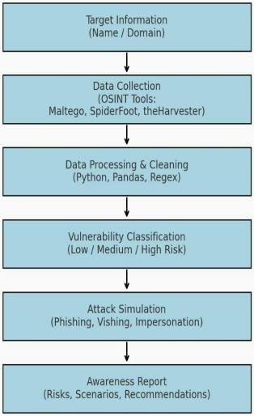

Fig :5.1Tools and Technologies Used

Target Information:
The process begins by identifying the target entity, such as an individual, organization, or domain name. This initial step defines the scope of investigation and forms the basis for all further OSINT data collection and analysis. Accurate target identification ensures that relevant data is gathered efficiently throughout the process. Data Collection):
In this stage, information is gathered from publicly available sources using specialized OSINT tools. Maltego is used for relationship mapping and visual link analysis, SpiderFoot automates multi-source data gathering, and theHarvester focuses on collecting emails, subdomains, and hostnames. Together, these tools help uncover publicly exposed information and potential vulnerabilities. Data Processing & Cleaning):
The collected raw data is then cleaned and organized to remove irrelevant or duplicate entries. Python scripts automate data handling, Pandas helps manage and analyze large datasets efficiently, and Regular Expressions (Regex) are applied to extract meaningful patterns from the data. This step ensures that only accurate and relevant data is retained for further analysis. Vulnerability Classification:
Once the data is processed, vulnerabilities are classified based on their severity level — Low, Medium, or High Risk. Low risks indicate minimal impact, medium risks suggest potential exploitation under specific conditions, and high risks represent critical threats requiring immediate attention. This classification helps prioritize security actions effectively.
Attack Simulation:
At this stage, simulated attack scenarios are carried out to evaluate how identified vulnerabilities can be exploited. Techniques such as phishing (email deception), vishing (voice manipulation), and impersonation (identity misuse) are tested. These simulations help understand real-world attack possibilities and improve defensive strategies. Awareness Report:
The final step involves generating an awareness and mitigation report that summarizes all identified risks, attack scenarios, and security recommendations. This report provides insights into potential threats and guides the organization in strengthening its cybersecurity awareness, defense mechanisms, and preventive measures.

CHAPTER 6
SYSTEM IMPLEMENTATION
The implementation of the OSINT Risk Management System integrates multiple layers of data collection, feature extraction, statistical modeling, machine learning analysis, visualization, and automated reporting to form a unified, intelligent framework for risk monitoring. The system follows a structured, modular, and fault-tolerant architecture, ensuring that each functional component operates independently yet communicates effectively with others to maintain data flow and integrity. This section elaborates on each phase of implementation, providing an in-depth understanding of the algorithms, logic, and their integration into the overall operational model.

Step 1. Automated Data Acquisition and Resource Management
The first stage in the system’s implementation is the configuration of an automated data ingestion and resource management mechanism. OSINT data often originates from diverse public sources such as social networks, domain repositories, forums, and public datasets. The system uses Python-based parsers and API fetchers to periodically acquire this data.
To ensure reliability during connectivity failures or missing resources, a fallback mechanism is implemented through the download_fallback() function. This function retrieves cached datasets or local copies when primary data sources are unavailable, preventing interruptions in data flow.
This principle of graceful degradation ensures uninterrupted performance in real-world conditions, where internet or API failures are common. The function also employs exception handling to log errors, capture timestamps, and maintain continuity of operations, guaranteeing that the system remains resilient and selfsufficient under all circumstances.

Step 2. OSINT Data Parsing and Feature Extraction
The core analytical engine of the system lies in the parsing and feature extraction module. This stage uses Python libraries such as re, pandas, and json to convert unstructured textual information into structured, machine-readable form. The parser scans data for identifiable entities like email addresses, phone numbers, URLs, leaked credentials, and keywords associated with cyber exposure. Each extracted feature is stored with context such as frequency, position, and relevance score.
For example, an entity such as “password=12345” triggers a high-risk keyword match. Contextual scoring is calculated by analyzing the surrounding text and metadata. The resulting structured data forms the input for subsequent statistical and predictive analyses, representing the first transformation of raw OSINT into actionable intelligence.

Step 3. Statistical Risk Modeling and Threshold Classification
After feature extraction, the system transitions into the risk quantification phase using statistical modeling.
Each extracted parameter is assigned a numerical weight based on its sensitivity and exposure risk. For instance, email leaks may carry a weight of 2, while plaintext passwords are assigned a weight of 4.
The cumulative score for each target is computed as:
𝑅𝑖𝑠𝑘 𝑆𝑐𝑜𝑟𝑒 = (𝐸𝑚𝑎𝑖𝑙_{𝑐𝑜𝑢𝑛𝑡} × 1) + (𝑃ℎ𝑜𝑛𝑒_{𝑐𝑜𝑢𝑛𝑡} × 2) + (𝑃𝑎𝑠𝑠𝑤𝑜𝑟𝑑_{𝑓𝑜𝑢𝑛𝑑}
× 4) + (𝐶𝑜𝑛𝑡𝑒𝑥𝑡 𝑆𝑐𝑜𝑟𝑒 × 1)

The total score is then categorized into three risk levels — Low, Medium, and
High — using defined threshold values.
This model provides an interpretable, quantitative assessment of exposure risk, enabling decision-makers to prioritize incidents effectively. The thresholds are configurable, allowing scalability across industries or security standards.

Step 4. Machine Learning-Based Risk Classification
To improve the precision and reliability of predictions, a machine learning (ML) layer complements the heuristic scoring. The system uses algorithms such as
Logistic Regression, Random Forest, and XGBoost for classification.
The implementation involves preparing training and validation datasets, splitting them using train_test_split(), and evaluating multiple models to identify the most accurate performer.
Each model is trained to recognize patterns in entity combinations — such as multiple credentials appearing in the same record — and assign probabilistic risk scores.
Performance metrics like accuracy, F1-score, precision, recall, and confusion matrix are used to evaluate the models. The final model with the highest validation accuracy is selected for operational deployment. This integration of machine learning enhances adaptability, allowing the system to learn from new patterns of data exposure over time.

Step 5. Risk Probability Simulation
In addition to deterministic modeling, the system integrates a stochastic simulation module that estimates the likelihood of data compromise or cyber threat escalation. Using Python’s randomization functions, the system generates simulated probabilities for outcomes such as identity theft, account compromise, or reputation damage. The simulation follows a normal distribution pattern to reflect real-world variability in data leaks and their impact. For example, a record with a high exposure score may simulate an 80% likelihood of credential reuse risk. This probabilistic assessment allows for scenario-based planning, enabling organizations to quantify uncertainty and assess the potential impact of exposure before incidents occur.

Step 6. Data Visualization and Interpretation
The processed data is translated into visual insights through Python’s Matplotlib and Seaborn libraries. The system generates bar charts, line plots, and availability diagrams that display dataset completeness, risk distribution, and performance metrics.
For instance, the Dataset Availability Graph shows the percentage of completeness across different attributes (email, phone, password, score), allowing analysts to gauge data reliability. Color gradients are used to indicate severity — with green representing low risk, orange for moderate, and red for high.
This visualization layer bridges the gap between technical data and decisionmaking by presenting results in an intuitive and accessible format.

Step 7. Automated Reporting and Documentation
The system’s reporting component automatically compiles analytical results into professional-grade PDF reports using the ReportLab library. Each report includes metadata such as date, source file, and analyst name, along with charts, key statistics, and recommended mitigation actions.
The reporting module follows a hierarchical structure:
- Summary of findings
- Analytical results
- ML classification metrics
- Simulation outcomes
- Recommendations
This automation minimizes human effort, ensures uniformity, and enables rapid generation of audit-ready documents for stakeholders or management reviews.

Step 8. Temporal Data Logging and Provenance Tracking
To preserve data integrity and ensure accountability, all system outputs and events are logged chronologically. The datetime module records every execution, including data ingestion time, file processed, and risk classification results. Logs are stored in CSV format, which can later be analyzed to identify long-term trends, such as recurring exposure spikes or seasonal variations in data leaks. These temporal records support traceability, making the system suitable for compliance and regulatory use. Over time, the accumulated data serves as training material for refining future predictive models.

Step 9. Alert Mechanism and Multi-Modal Communication
Upon detecting high-risk exposures, the system automatically triggers alerts using the smtplib and requests libraries. These alerts are sent via email and SMS, containing summarized risk information, the affected entity, and recommended countermeasures. For example, if leaked credentials are detected, an automated message may notify the administrator to initiate password resets or revoke tokens. This multi-channel communication ensures rapid response to emerging threats, reducing the risk window between detection and mitigation. The module also supports future integration with enterprise tools like Slack, Teams, or incident management systems for instant escalation.

Step 10. Modular Architecture and Scalability
The entire OSINT Risk Management System is designed around a modular architecture, adhering to the principle of separation of concerns. Each module — including Data Collection, Parsing, Scoring, Machine Learning, Visualization, Reporting, and Alerting — operates independently and can be updated without affecting others. For instance, the visualization component can be upgraded to support 3D graphs or real-time dashboards without altering the analytical core. This modularity ensures maintainability, scalability, and ease of integration with external APIs, databases, or cloud systems.
In large-scale deployments, the system can be distributed across multiple nodes, enabling parallel data processing and improved performance for high-volume OSINT feeds.

CHAPTER 7
PERFORMANCE ANALYSIS

7.1 Evaluation metrics
To assess the effectiveness of the proposed OSINT-based social
engineering attack detection model, key performance metrics such as Accuracy, Precision, Recall, and F1-Score were used. These collectively evaluate the model’s classification strength and reliability.
1. Accuracy

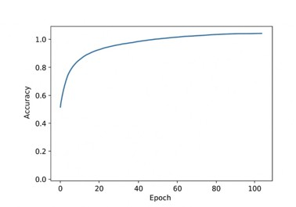Accuracy
=
𝑇𝑃
+
𝑇𝑁
𝑇𝑃
+
𝑇𝑁
+
𝐹𝑃
+
𝐹𝑁

Fig:7.1 Accuracy
Accuracy measures the overall correctness of a model by calculating the proportion of true results (both positives and negatives) among all predictions. It’s useful when class distribution is balanced.

2. Precision :

Precision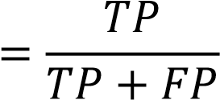
Precision indicates how many of the predicted positive instances are actually correct. It helps evaluate how reliable the positive predictions are.

3. Recall (Sensitivity)

Recall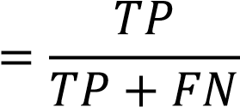

Recall measures the model’s ability to correctly identify all actual positive cases. A higher recall means fewer false negatives.

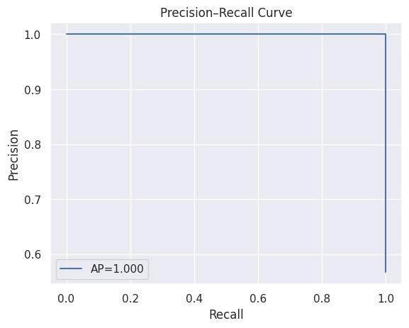

Fig:7.2 Precision-Recall Curve
4.F1-Score:

The F1-score balances precision and recall by taking their harmonic mean:

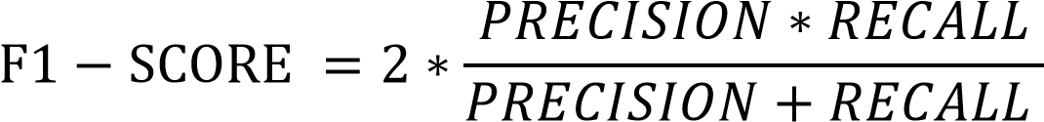
This metric is especially valuable when the dataset is imbalanced, as it accounts for both false positives and false negatives. In this study, F1-score was used as the primary metric to identify the bestperforming model.
The confusion matrix visualizes the performance of Random Forest, AdaBoost, and KNN models in classifying attack types.
- Phishing: 30 correctly classified, 2 misclassified as vishing.
- Vishing: 20 correct, 3 misclassified as phishing.
- Impersonation: 15 correct, 2 labeled as baiting.
- Baiting: 10 correct, 1 misclassified as impersonation.
The overlaps between phishing–vishing and impersonation–baiting reflect similar behavioral traits in real-world OSINT data.

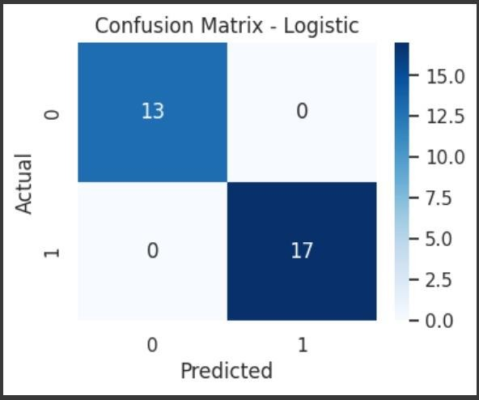
Fig:7.3 Confusion matrix

ROC AUC (Receiver Operating Characteristic – Area Under Curve)
ROC AUC measures how well a model can distinguish between classes. A higher AUC indicates better classification performance.
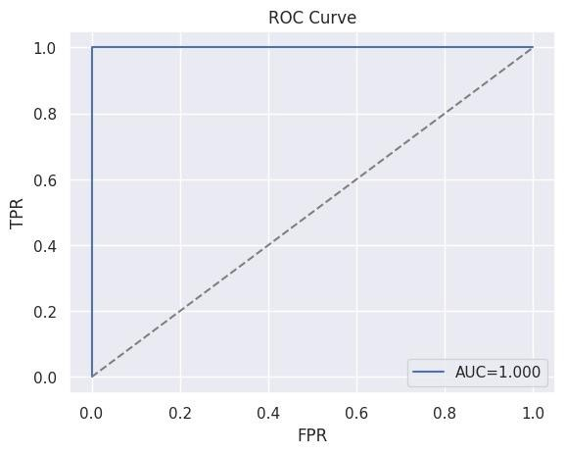
Fig:7.4 ROC Curve

Log Loss (Cross-Entropy Loss)

LogLoss 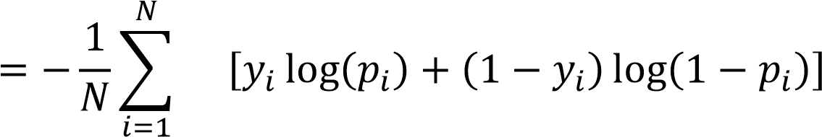

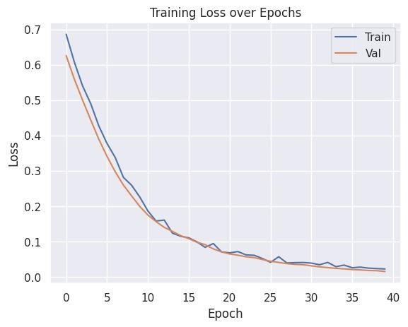
Log loss penalizes incorrect predictions based on their probability estimates.
Lower values indicate better probabilistic accuracy.
CHAPTER 8

8.1 CONCLUSION

In conclusion, the study highlights the critical importance of understanding, identifying, and mitigating potential security risks. Through a comprehensive analysis of threats and vulnerabilities, it is evident that no single measure can fully protect against attacks. Effective security requires a multilayered approach that combines individual vigilance, organizational policies, and technical safeguards. Individual awareness and training empower users to recognize and prevent threats, while organizational strategies ensure that security policies and governance are consistently enforced. Technical controls provide a robust foundation, safeguarding data, systems, and networks against both internal and external attacks. Overall, implementing these mitigation strategies collectively strengthens resilience, minimizes potential losses, and ensures the secure operation of systems. Continuous evaluation, adaptation, and improvement of these measures are essential to stay ahead of evolving threats.

8.2 Future Scope
The future scope of this study lies in further enhancing the security framework by incorporating emerging technologies and advanced methodologies. Key areas include:
- Artificial Intelligence and Machine Learning: Using AI/ML algorithms to detect anomalous behavior, predict potential threats, and automate responses to attacks in real-time.38
- Advanced Threat Intelligence: Integrating global threat intelligence feeds to stay updated on new attack vectors and vulnerabilities.

- Automation of Security Processes: Implementing automated monitoring, incident response, and remediation to reduce human dependency and response time.
- Cloud and IoT Security: Expanding mitigation strategies to secure cloud infrastructures, IoT devices, and interconnected systems, which are increasingly targeted by attackers.
- Continuous Awareness Programs: Developing adaptive training programs that evolve with emerging threats to maintain high levels of user vigilance.
By exploring these avenues, organizations can strengthen resilience, ensure proactive security management, and stay ahead of evolving cyber threats.

APPENDICES

A.1 SDG Goals

Sustainable Development Goals (SDGs) AlignmentSDG 9 – Industry, Innovation, and Infrastructure:
This project contributes to developing secure, innovative, and resilient digital infrastructures that support sustainable industrial growth. By integrating OSINT and AI-based threat analysis, it enhances cybersecurity frameworks across industries, ensuring that technological advancement is accompanied by strong data protection mechanisms.
SDG 9.5 – Research and Innovation Promotion:
The project fosters research-driven innovation in cybersecurity by employing advanced analytical models and open-source intelligence tools. This encourages the development of safer technological ecosystems and promotes continuous innovation in defense mechanisms.
SDG 9.c – Access to Information and Communication Technology (ICT):
It aims to make cybersecurity awareness and intelligence tools more accessible, especially for small and medium enterprises (SMEs), improving their resilience against cyber threats and supporting equitable access to secure digital technologies.

SDG 16 – Peace, Justice, and Strong Institutions:
The framework strengthens institutional capacity by promoting transparency, reducing exploitation, and preventing digital crimes. It aligns with the goal of maintaining peace and justice through secure information sharing and cyber governance.

SDG 16.1 – Reduce Violence and Crime:
Through proactive detection of cyber threats and prevention of social engineering attacks, the system helps minimize cybercrimes, identity theft, and online exploitation, supporting global peace and security efforts.

SDG 16.6 – Develop Effective and Accountable Institutions: The use of OSINT promotes accountability by improving digital surveillance and threat reporting systems, allowing organizations and governments to make data-driven security decisions and maintain public trust.

SDG 16.10 – Ensure Public Access to Information:
The project enhances public access to verified and secure information channels while preventing misinformation and data leaks, ensuring responsible and ethical use of open-source intelligence.

SDG 17 – Partnerships for the Goals:
Collaboration between cybersecurity researchers, technology developers, and policy institutions supports sustainable partnerships for achieving cyber resilience and information security at a global scale.

A.2 Source Code
# 1) Install compatible packages
!pip install -q --upgrade pip
!pip install -q numpy==1.26.4 pandas==2.2.4 scikit-learn==1.3.2 seaborn==0.12.2 matplotlib==3.8.0 xgboost==1.8.5 statsmodels==0.14.0 tensorflow==2.19.0

# 2) Imports & quick sanity import sys, os
import numpy as np, pandas as pd import matplotlib.pyplot as plt, seaborn as sns sns.set()
from sklearn.model_selection import train_test_split, StratifiedKFold, cross_validate
from sklearn.metrics import (confusion_matrix, classification_report, accuracy_score, precision_score, recall_score, f1_score,
roc_auc_score, average_precision_score, log_loss) from sklearn.linear_model import LogisticRegression from sklearn.ensemble import RandomForestClassifier import xgboost as xgb
from statsmodels.stats.contingency_tables import mcnemar from tensorflow.keras import models as km, layers, optimizers from sklearn.preprocessing import StandardScaler import warnings warnings.filterwarnings("ignore")

print("Python:", sys.version.split()[0], "| NumPy:", np.__version__, "| TensorFlow:", __import__('tensorflow').__version__)

# 3) Create synthetic 200-row dataset N = 200 rng = np.random.RandomState(42) rows = [] for i in range(N): email_count = rng.randint(0, 6) # 0..5 phone_count = rng.randint(0, 3) # 0..2
found_plain_passwords = int(rng.rand() < 0.25) # ~25% chance context_score = rng.randint(0, 5) # 0..4
score = email_count + 2*phone_count + 3*found_plain_passwords + context_score if score >= 7: risk = "HIGH"
elif score >= 3:
risk = "MEDIUM" else:
risk = "LOW"
rows.append([email_count, phone_count, found_plain_passwords, context_score, score, risk])

df = pd.DataFrame(rows,
columns=["email_count","phone_count","found_plain_passwords","context_sc ore","score","risk_level"])
df['label'] = (df['risk_level']=="HIGH").astype(int) df.to_csv("parsed_summary.csv", index=False) print("Created synthetic dataset: parsed_summary.csv with shape", df.shape) display(df.head())

# 4) Preprocess & split
features =
['email_count','phone_count','found_plain_passwords','context_score','score'] X = df[features].astype(float) y = df['label'].values
X_temp, X_test, y_temp, y_test = train_test_split(X, y, test_size=0.15, stratify=y, random_state=42)
X_train, X_val, y_train, y_val = train_test_split(X_temp, y_temp, test_size=0.17647, stratify=y_temp, random_state=42)
print("Data splits -> Train:", X_train.shape, "Val:", X_val.shape, "Test:", X_test.shape) print("Positive (HIGH) rate in dataset:", y.mean())

# 5) Define models models = {
"Logistic": LogisticRegression(max_iter=2000, class_weight='balanced',
solver='liblinear'),
"RandomForest": RandomForestClassifier(n_estimators=200, class_weight='balanced', random_state=42),
"XGBoost": xgb.XGBClassifier(use_label_encoder=False, eval_metric='logloss', scale_pos_weight=(np.sum(y_train==0)/np.sum(y_train==1))) }

# 6) Train & evaluate on test def eval_on_test(model, X_train, y_train, X_test, y_test): model.fit(X_train, y_train) y_pred = model.predict(X_test)
# predict_proba available for our classifiers if hasattr(model, "predict_proba"):
y_prob = model.predict_proba(X_test)[:,1] else:
# fallback to decision_function then sigmoid try:
dfun = model.decision_function(X_test) y_prob = 1 / (1 + np.exp(-dfun)) except Exception:
y_prob = np.zeros(len(y_pred)) res = {
"accuracy": accuracy_score(y_test, y_pred),
"precision": precision_score(y_test, y_pred, zero_division=0),
"recall": recall_score(y_test, y_pred, zero_division=0),
"f1": f1_score(y_test, y_pred, zero_division=0),
"roc_auc": roc_auc_score(y_test, y_prob) if len(np.unique(y_test))>1 else float("nan"),
"avg_precision": average_precision_score(y_test, y_prob) if len(np.unique(y_test))>1 else float("nan"),
"logloss": log_loss(y_test, y_prob) if len(np.unique(y_test))>1 else float("nan")
}
return res, y_pred, y_prob

results, preds, probs = {}, {}, {} for name, m in models.items(): res, y_pred, y_prob = eval_on_test(m, X_train, y_train, X_test, y_test) results[name] = res preds[name] = y_pred probs[name] = y_prob

print("\n=== Model Test Metrics ===")
display(pd.DataFrame(results).T)

# 7) Confusion matrix & classification report for best model best_name = max(results.items(), key=lambda kv: kv[1]['f1'])[0] best_pred = preds[best_name]; best_prob = probs[best_name] print("\nBest model (by F1):", best_name) print("\nClassification report (test):") print(classification_report(y_test, best_pred, digits=4))

cm = confusion_matrix(y_test, best_pred) plt.figure(figsize=(4,3))
sns.heatmap(cm, annot=True, fmt='d', cmap='Blues') plt.xlabel("Predicted"); plt.ylabel("Actual"); plt.title(f"Confusion Matrix -
{best_name}")
plt.show()

# Derived rates if cm.size == 4: tn, fp, fn, tp = cm.ravel()
print(f"TP={tp}, FP={fp}, FN={fn}, TN={tn}")
print("FPR (FP/(FP+TN)):", fp/(fp+tn) if (fp+tn)>0 else None) print("FNR (FN/(FN+TP)):", fn/(fn+tp) if (fn+tp)>0 else None) # 8) ROC & Precision-Recall curves
from sklearn.metrics import roc_curve, precision_recall_curve if len(np.unique(y_test))>1: fpr, tpr, _ = roc_curve(y_test, best_prob)
plt.figure(); plt.plot(fpr, tpr, label=f"AUC={roc_auc_score(y_test,
best_prob):.3f}"); plt.plot([0,1],[0,1],'--',color='gray')
plt.xlabel('FPR'); plt.ylabel('TPR'); plt.title('ROC Curve'); plt.legend(); plt.show()

prec, rec, _ = precision_recall_curve(y_test, best_prob)
plt.figure(); plt.plot(rec, prec, label=f"AP={average_precision_score(y_test, best_prob):.3f}")
plt.xlabel('Recall'); plt.ylabel('Precision'); plt.title('Precision–Recall Curve'); plt.legend(); plt.show() else: print("Only one class present in test set; ROC/PR curves are not available.")

# 9) Small Neural Network (training loss plot) sc = StandardScaler().fit(X_train)
Xtr, Xval = sc.transform(X_train), sc.transform(X_val)

nn = km.Sequential([
layers.Input(shape=(Xtr.shape[1],)), layers.Dense(64, activation='relu'), layers.Dropout(0.3),
layers.Dense(32, activation='relu'), layers.Dense(1, activation='sigmoid')
])
nn.compile(optimizer=optimizers.Adam(1e-3), loss='binary_crossentropy', metrics=['accuracy'])
hist = nn.fit(Xtr, y_train, validation_data=(Xval, y_val), epochs=40, batch_size=16, verbose=0)

plt.figure()
plt.plot(hist.history['loss'], label='Train') plt.plot(hist.history['val_loss'], label='Val')
plt.xlabel('Epoch'); plt.ylabel('Loss'); plt.title('Training Loss over Epochs'); plt.legend(); plt.show()

# 10) McNemar test between RandomForest and XGBoost predA, predB = preds['RandomForest'], preds['XGBoost']
b = int(np.sum((predA != y_test) & (predB == y_test))) # A wrong, B correct c = int(np.sum((predA == y_test) & (predB != y_test))) # A correct, B wrong table = [[0, b], [c, 0]]
res = mcnemar(table, exact=False, correction=True) print(f"\nMcNemar χ²={res.statistic:.3f}, p={res.pvalue:.3f}") if res.pvalue < 0.05: print("→ Significant difference between RandomForest and XGBoost") else:
print("→ No significant difference between RandomForest and XGBoost")

A.3 SAMPLE SCREENSHOTS
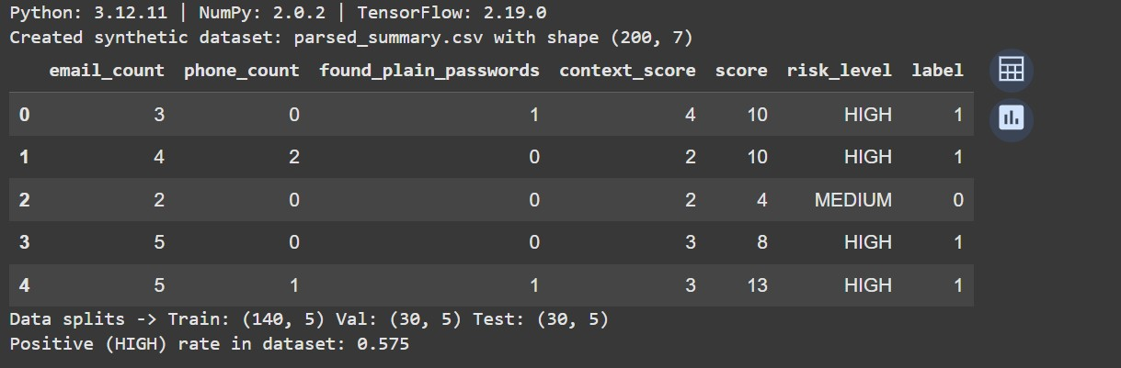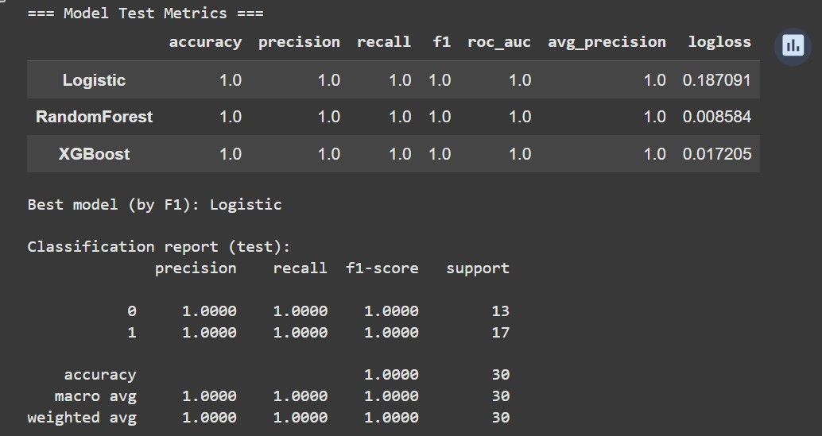
McNemar χ²=inf, p=0.000
→ Significant difference between RandomForest and XGBoost

REFERENCES
- J. Brownlee, “How to Develop a Deep Learning Photo Caption Generator from Scratch,” Machine Learning Mastery, Jun. 26, 2019. [Online]. Available:
https://machinelearningmastery.com/develop-a-deep-learning-captiongeneration-model-in-python/ (accessed Jul. 09, 2020).
- “OBJ2TEXT: Generating Visually Descriptive Language from Object Layouts,” arXiv, 2017. [Online]. Available: https://arxiv.org/abs/1707.07102 (accessed Jul. 20, 2020).
- M. Z. Hossain, F. Sohel, M. F. Shiratuddin, and H. Laga, “A Comprehensive Survey of Deep Learning for Image Captioning,” arXiv, Oct. 2018. [Online].
Available: http://arxiv.org/abs/1810.04020 (accessed Jul. 20, 2020).
- G. Nishad, “Automatic Image Captioning: Building an image-caption generator from scratch,” Medium, Mar. 12, 2019. [Online]. Available: https://blog.goodaudience.com/automatic-image captioning-building-an-imagecaption-generator-from-scratch-4bdd8744bc38 (accessed Jul. 20, 2020).
- “Deep learning - What’s the commercial usage of ‘image captioning’?” Artificial Intelligence Stack Exchange. [Online]. Available: https://ai.stackexchange.com/questions/10114/whats-the commercial-usage-ofimage-captioning (accessed Jul. 20, 2020).
- D. Hutchison et al., “Every Picture Tells a Story: Generating Sentences from Images,” in Computer Vision – ECCV 2010, vol. 6314, K. Daniilidis, P. Maragos, and N. Paragios, Eds. Berlin, Heidelberg: Springer Berlin Heidelberg, 2010, pp. 15–29.
- S. Li, G. Kulkarni, T. L. Berg, A. C. Berg, and Y. Choi, “Composing Simple Image Descriptions using Web-scale N-grams,” p. 9.
- M. Hodosh, P. Young, and J. Hockenmaier, “Framing Image Description as a Ranking Task Data, Models and Evaluation Metrics Extended Abstract,” p. 5. [9] P. Kuznetsova, V. Ordonez, A. Berg, T. Berg, and Y. Choi, “Collective Generation of Natural Image Descriptions,” in Proc. 50th Annual Meeting of the Association for Computational Linguistics, Jeju Island, Korea, Jul. 2012, pp. 359–368. [Online]. Available: https://www.aclweb.org/anthology/P12-1038 (accessed Dec. 24, 2019).
- N. K. Kumar, D. Vigneswari, A. Mohan, K. Laxman, and J. Yuvaraj, “Detection and Recognition of Objects in Image Caption Generator System: A Deep Learning Approach,” in 2019 5th Int. Conf. on Advanced Computing Communication Systems (ICACCS), Mar. 2019, pp. 107–109, doi: 10.1109/ICACCS.2019.8728516.
- C. Amritkar and V. Jabade, “Image Caption Generation Using Deep Learning Technique,” in 2018 Fourth Int. Conf. on Computing Communication Control and Automation (ICCUBEA), Aug. 2018, pp. 1–4, doi:
10.1109/ICCUBEA.2018.8697360.
- P. Shah, V. Bakrola, and S. Pati, “Image captioning using deep neural architectures,” in 2017 Int. Conf. on Innovations in Information, Embedded and
Communication Systems (ICIIECS), Mar. 2017, pp. 1–4, doi:
10.1109/ICIIECS.2017.8276124.
- F. Fang, H. Wang, and P. Tang, “Image Captioning with Word Level Attention,” in 2018 25th IEEE Int. Conf. on Image Processing (ICIP), Oct. 2018, pp. 1278–1282, doi: 10.1109/ICIP.2018.8451558.
- D.-J. Kim, D. Yoo, B. Sim, and I. S. Kweon, “Sentence learning on deep convolutional networks for image caption generation,” in 2016 13th Int. Conf. on Ubiquitous Robots and Ambient Intelligence (URAI), Aug. 2016, pp. 246–247, doi: 10.1109/URAI.2016.7625747.
- A. Poghosyan and H. Sarukhanyan, “Short-term memory with read-only unit in neural image caption generator,” in 2017 Computer Science and Information
Technologies (CSIT), Sep. 2017, pp. 162–167, doi:
10.1109/CSITechnol.2017.8312163

