LoMar: A Local Defence Against Poisoning Attack on Federated Learning
Machine Learning or deep learning algorithms are running everywhere from healthcare predictions to road size traffic prediction. All machine learning algorithms get trained on past dataset and can predict future values. Training all models at centralized server by collecting data from clients may leak clients dataset values so to provide security to client data Federated Learning was introduced. In federated learning client will train model on its data and then upload trained model to centralized server without releasing data so all clients will update weights or model to server and can get global weights from server.
Federated learning provide security to clients data but sometime some malicious hackers can hack clients and then update its training data which will generate corrupted model and updating this corrupted model to server will result into wrong model updating at all clients which will further result into wrong prediction.
To overcome from above issue author of this paper employing LOMAR algorithm which will defence all clients’ models from malicious data alteration called as poison training data. In poison technique attacker will update training labels and whenever client trained on such data then weights of the model will have huge variation. This variation author checking with Kernel Density Estimation which will utilized closed neighbour techniques, if data poison then neighbours will have huge distance and server will understand model got trained on poison data and then reject such model from updating. KDE variation will check with threshold values and if threshold value has high difference then model is poisoned otherwise model is genuine.
Author evaluating propose LOMAR model detection accuracy by employing various dataset but we are utilizing MNIST DIGIT recognition dataset. We have designed separate models called client and server where client will train model and send to server and then server will employ LOMAR technique to detect weather model is normal or poisoned. To make model poisoned we have intentionally update dataset labels from 1 to 0 which is showing in below screen
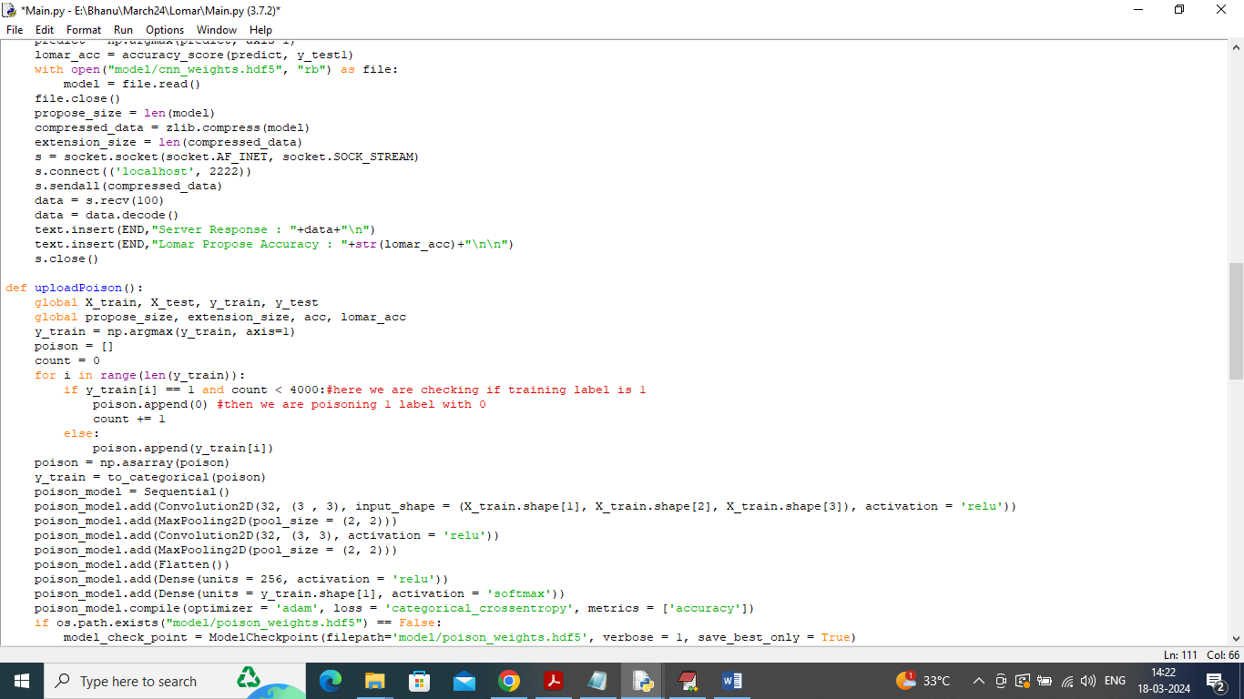
In above screen in red colour text can see we are manually poisoning training label and by server will detect such poison and cancel model updating.
Extension Concept
In federated learning all clients will send trained model to server and this model will be having huge size and sending such huge models will required lots of network bandwidth and uploading time will also high. So to reduce model size as extension we are employing model compression technique which will compress model before uploading to server and this compress model will save space upto 10% and network uploading will be faster
To implement this project we have designed following modules
- Server Module: this is a separate module which will receive trained model from client and then apply LOMAR technique to identify model is genuine or poison
- Client Application: this application consists of following modules
- Upload MNIST Dataset: using this module will upload dataset to application
- Pre-process Dataset: this module will read dataset values and then remove missing values, shuffle, normalize and split dataset into train and test where application using 80% dataset for training and 20% for testing
- Upload Genuine Model to Server: this module will train model by using training data and update to server and here we are uploading genuine model
- Upload Poison Model to Server: this module will poison the data and then update to server and then server will predict weather model is normal or poison
- Propose Lomar & No Defence Accuracy: using this module will plot accuracy comparison graph without defence and LOMAR defence
- Extension Model Size Graph: using this module will plot model size comparison between propose and extension algorithms
SCREEN SHOTS
Double click on ‘runServer.bat’ file to start server and get below page
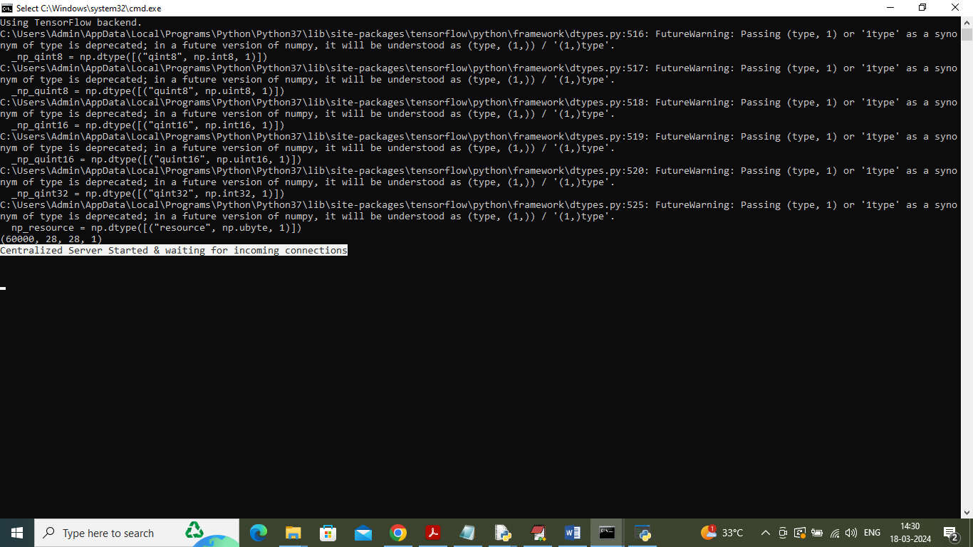
In above screen centralized federated learning server started and now let it run and then double click on ‘run.bat’ file to start client application
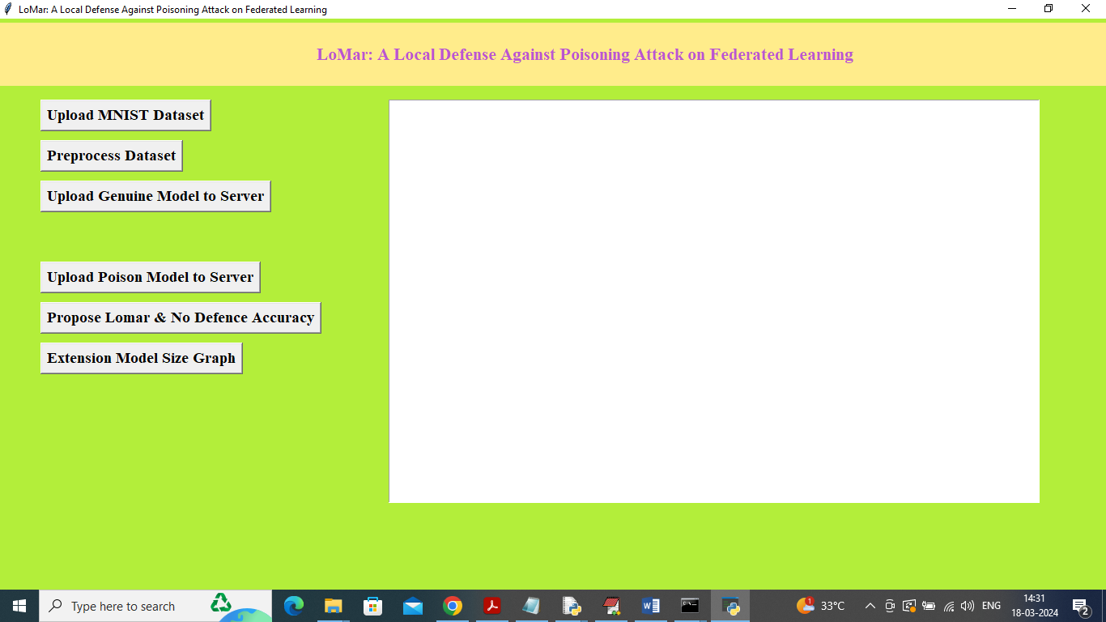
In above screen client application started and now click on ‘Upload MNIST Dataset’ button to upload dataset and get below page
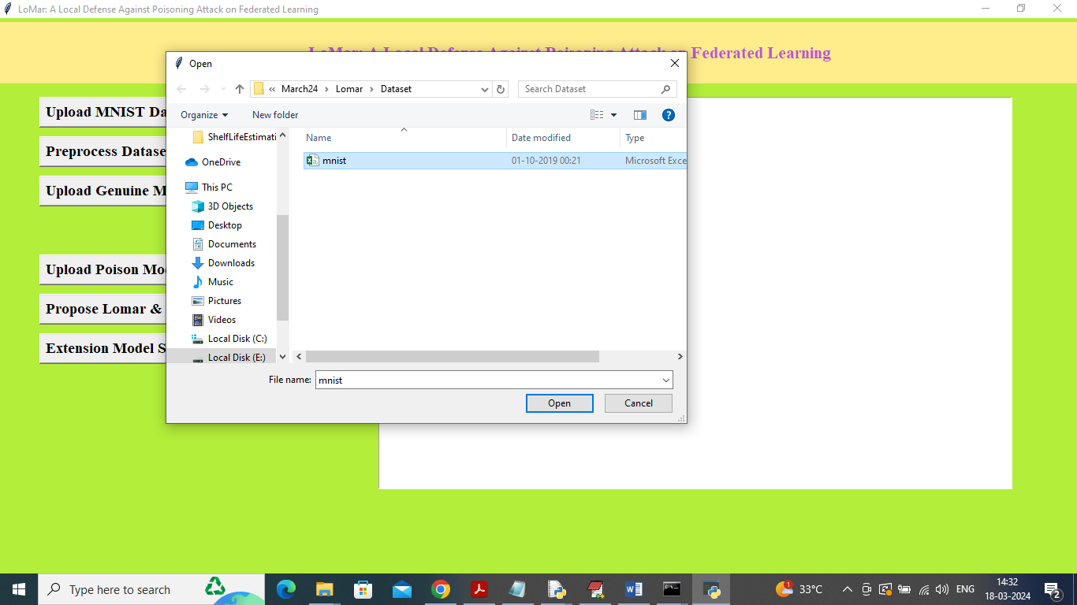
In above screen selecting and uploading ‘MNIST’ dataset file and then click on ‘Open’ button to load dataset and get below page
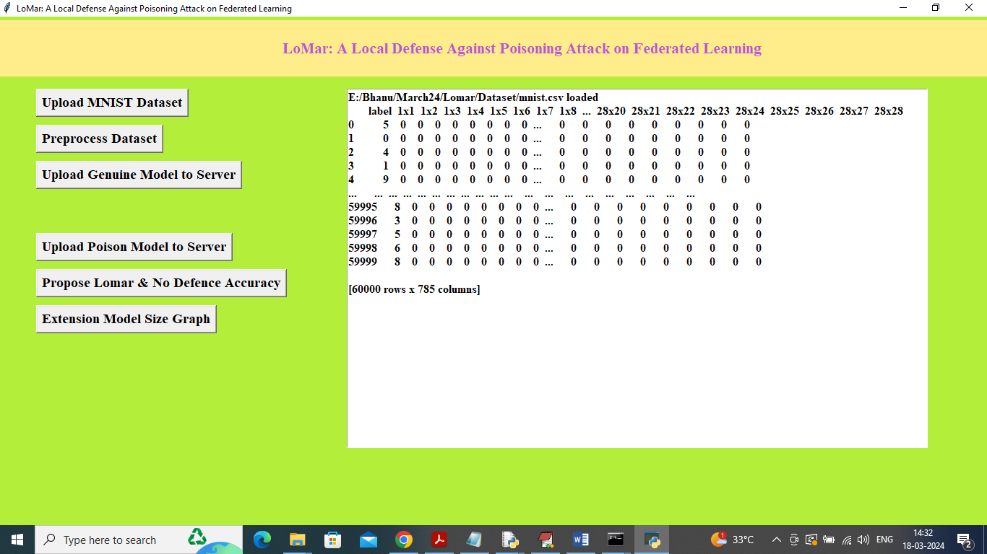
In above screen dataset loaded and now click on ‘Pre-process Dataset’ button to normalize dataset and get below page
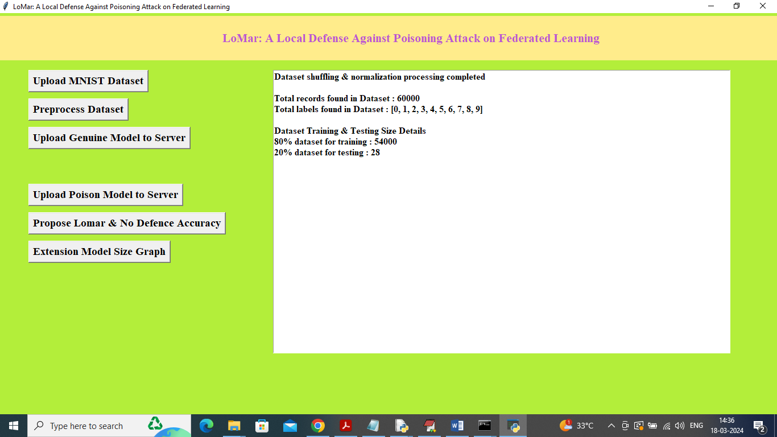
In above screen dataset processing completed and can read all processing details in above screen and now click on ‘Upload Genuine Model to Server’ button to train genuine model on training dataset and then upload to server as federated learning and then will get below response
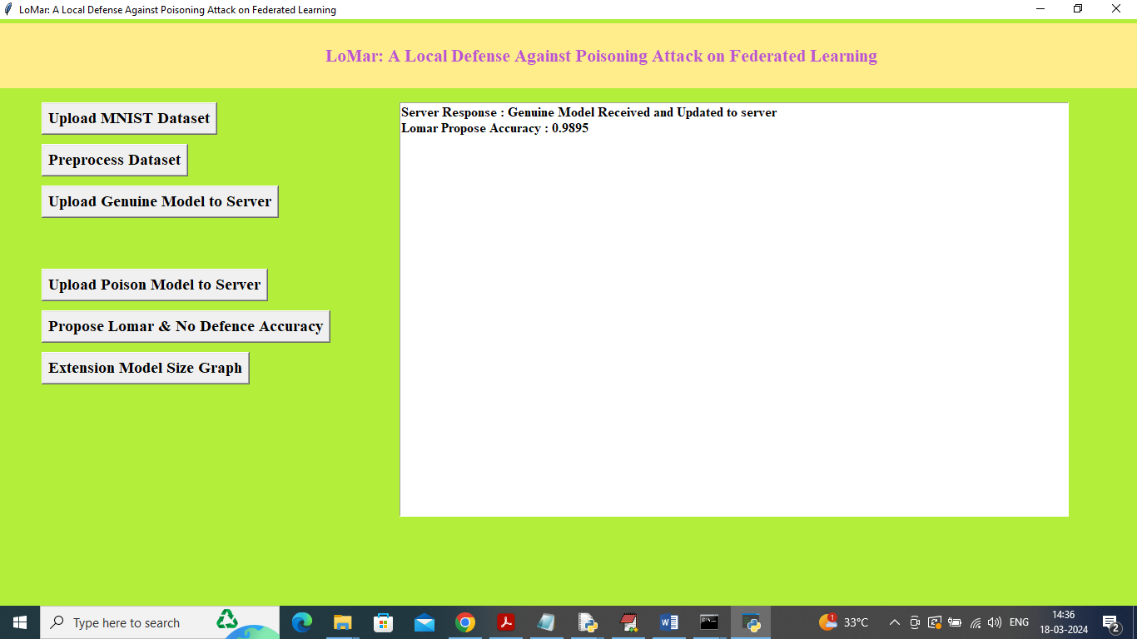
In above screen application got response from server as ‘Genuine Model’ received and it got accuracy as 98% and in below server screen we can see calculated accuracy on received model
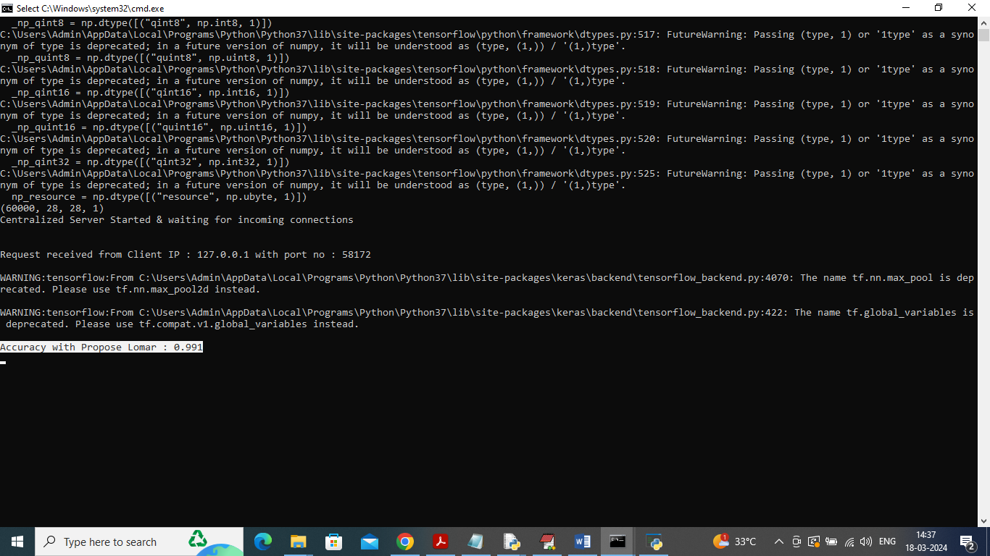
In above screen in white colour text can see server got 99% accuracy on LOMAR techniques on its own test data and now in application click on ‘Upload Poison Model to Server’ button to upload poison model and get below output
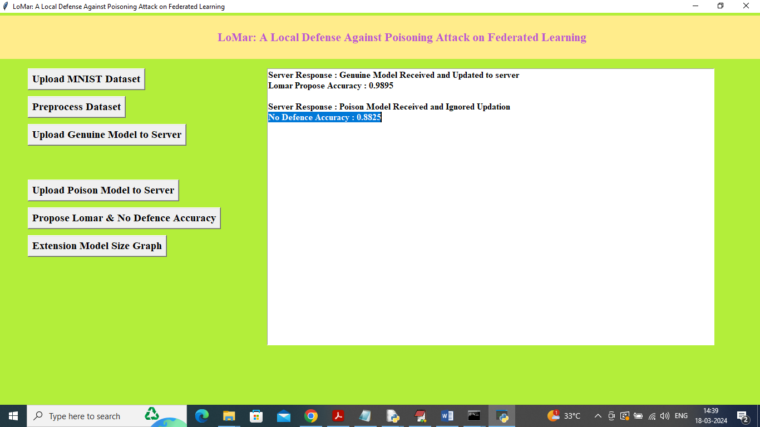
In above screen server received poison model and ignored updation and client got 88% accuracy on poison model so by employing propose techniques application predicting weather model is normal or poisoned and now click on ‘Propose Lomar & No Defence Accuracy’ button to get below graph
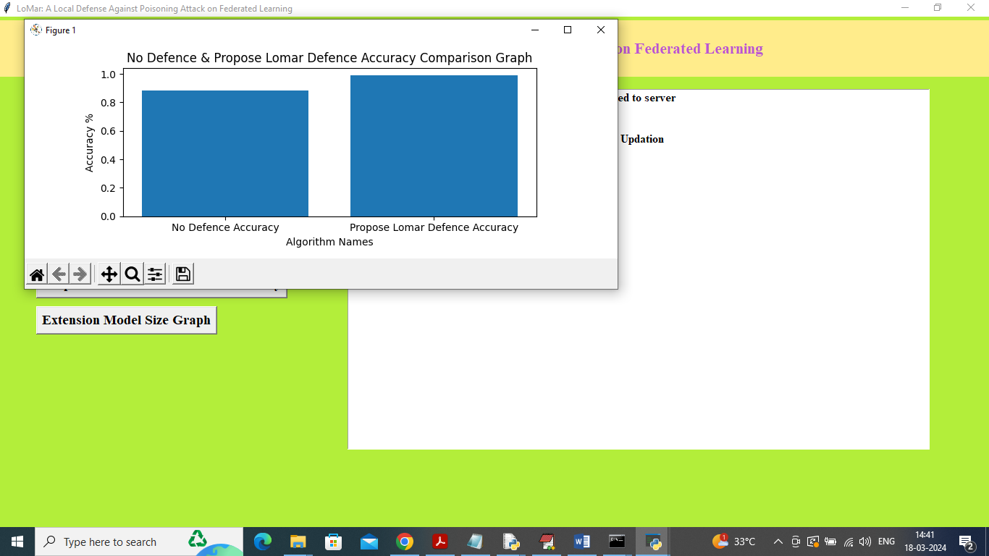
In above screen x-axis represents algorithm names and y-axis represents accuracy and in both techniques propose LOMAR got high accuracy and now click on ‘"Extension Model Size Graph’ button to get below comparison graph
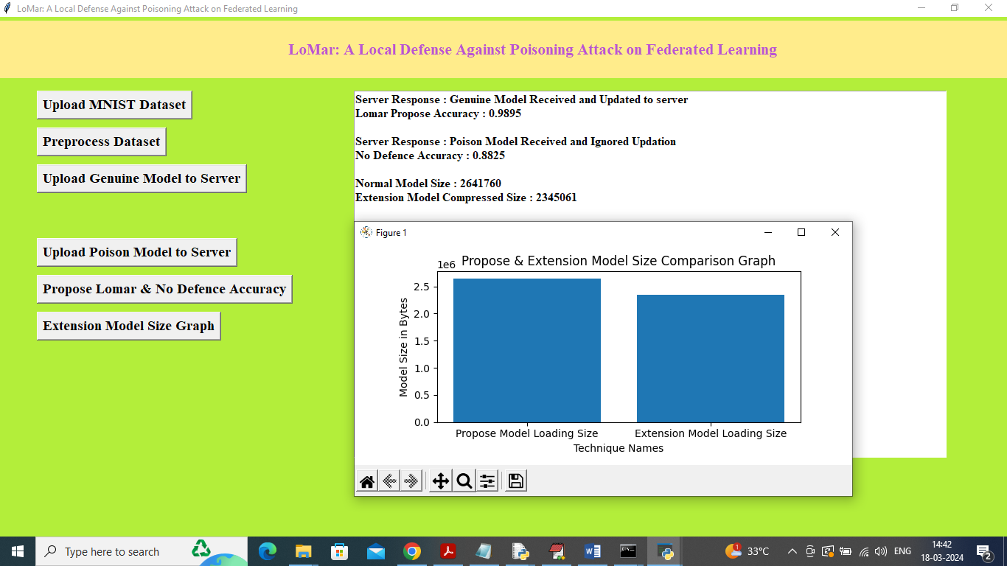
In above graph x-axis represents technique names and y-axis represents model size and in both techniques compress model extension got less size compare to normal model uploading. In text area output also we can see normal model size and after compression also we can see the model size.

