Walmart Black Friday Purchase Behavior Analysis

# 1. Project Objective

Analyze customer purchase behavior at Walmart during Black Friday, focusing on:  
- Gender-based differences in spending  
- Impact of age, city category, and other factors on purchase amounts

# 2. Dataset Description

Real transactional data from Walmart customers during Black Friday.  
Features included: User_ID, Gender, Age, Occupation, City_Category, Stay_In_Current_City_Years, Marital_Status, Product_ID, Purchase, etc.

# 3. Data Preparation

Imported data using Pandas.  
Checked for missing values and basic descriptive statistics.  
Cleaned the data (if necessary).

# 4. Exploratory Data Analysis (EDA)

Performed detailed EDA using groupby operations, visualizations, and statistical summaries.

## 4.1 Gender vs Purchase Amount

Compared mean purchase amounts between Male and Female customers.  
Visualized using bar plots.

Insight: Male customers spend slightly more on average than female customers, but the difference is not very significant.

## 4.2 Age Group vs Purchase Amount

Grouped data by Age and calculated average purchase amounts.  
Plotted Age vs Purchase Amount.

Insight: The 26–35 years age group has the highest average purchase amount.

## 4.3 City Category Analysis

Compared purchase behavior across different City Categories (A, B, C).

Insight: Customers from City Category B spend the most, followed by City A and City C.

## 4.4 Occupation and Marital Status

Analyzed how Occupation and Marital Status affect purchase amount.

Insight: Certain occupations (professionals) spend more; Single customers show a slightly higher average purchase amount compared to married customers.

## 4.5 Distribution of Purchase Amount

Plotted the distribution of Purchase amounts using a histogram.

Insight: Purchase amounts are right-skewed, with most purchases in the moderate range and few very high-value purchases.

# 5. Key Visualizations

Boxplots showing Gender vs Purchase, Age vs Purchase, City Category vs Purchase.

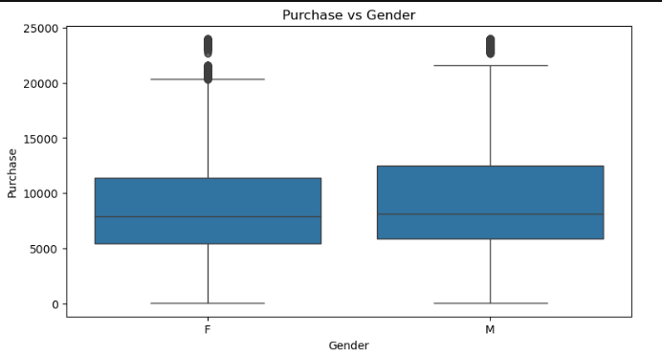

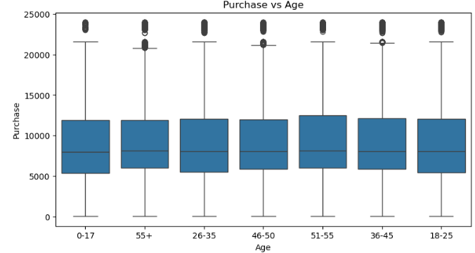

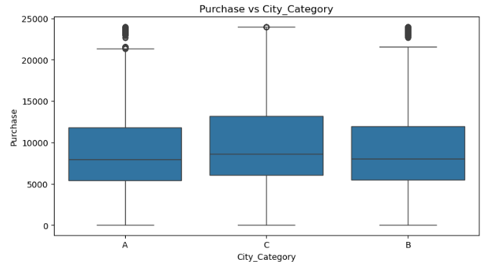

Histograms of average amount spend per customer- male and female

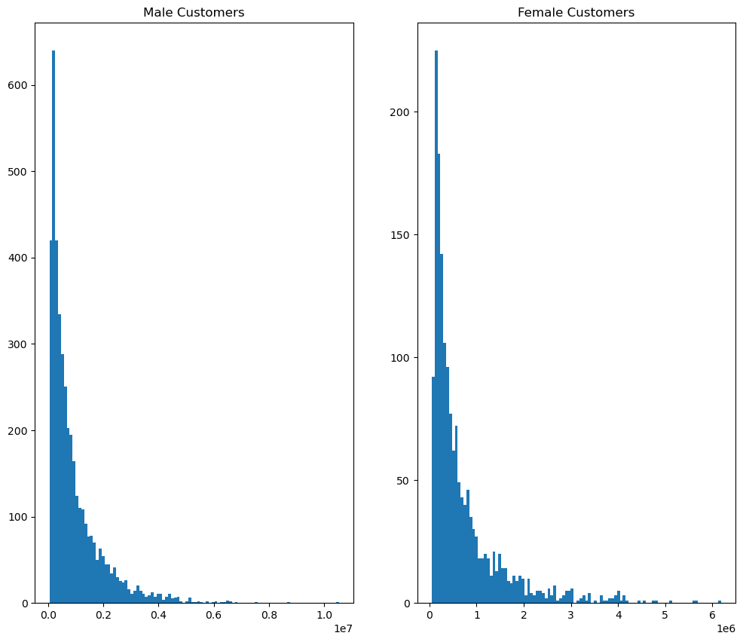

# 6. Conclusion

- Male customers tend to spend slightly more, but women are equally important contributors.  
- The 26–35 age group represents the most valuable customer segment.  
- City B residents are major spenders — Walmart can target promotions in those cities.  
- Overall, purchases during Black Friday are moderately priced, with few outliers making very high purchases.

# 7. Recommendations

- Focus marketing efforts on young adults (26–35), especially in City B.  
- Design gender-neutral promotions as both genders actively spend during Black Friday.  
- Special deals for professionals and singles could boost sales.