



### Contents

Introduction 2

Objective/Question 2

Assumptions 3

Analytical Setup 3

Analysis 3

Interpretations/Implications 7

Recommendations 7

Limitations 8

Conclusion 8

# Introduction

In today's fast-changing tech world, the IT industry is a big deal. It's not just about computers and gadgets; it's about shaping the way we live, work, and interact. But there's a problem lurking beneath the surface: diversity and inclusion are not at the desired levels. This presentation is all about digging into that issue. We want to understand what's going on with diversity in the IT field in the USA. By shining a light on the problems, figuring out what's causing them, and giving practical advice, we hope to make workplaces fairer and more welcoming. Because when the tech industry gets diversity right, it's not just good for the people who work there—it's good for everyone. Our goal is to lead the way towards a better future, where every industry follows suit and everyone feels valued and included.

# Objective/Question

At the core of our analysis lies a fundamental question: What is the true state of diversity in the USA's IT industry, and what are the driving factors behind these dynamics? Our inquiry extends beyond mere demographics, seeking to unravel the intricate web of influences shaping employment distribution across age, career trajectories, gender gaps, representation in leadership roles, and the efficacy of diversity initiatives within the sector. By dissecting these multifaceted issues, we aim to unearth actionable insights empowering organizations to foster a more inclusive and equitable workplace environment, driving not only organizational success but also societal progress.

# Assumptions

Our analysis rests on reliable data sourced from reputable institutions such as the DEI dataset. We assume that this data accurately reflects the demographic landscape and diversity metrics within the IT industry. Additionally, we are confident that our analytical methods provide a robust framework. for uncovering insights and identifying trends, allowing us to draw meaningful conclusions about the state of diversity within the sector.

# Analytical Setup

Our analysis relies on a wide range of data collected from different places. This data covers things like people's race, ethnicity, gender, whether they have a disability, scores related to diversity, how people move up in their careers, how many people stay in their jobs, and whether everyone gets paid fairly in the IT industry. We've put a lot of effort into cleaning up and organizing this data, then analyzing it carefully. Our goal is to find useful insights that can help us understand the challenges related to diversity in the industry better. We're not just looking at numbers; we're trying to see the bigger picture and understand how these issues fit into the wider world. Ultimately, we want to give companies a clear path for dealing with diversity and inclusion in today's digital world.

# Analysis

1. Descriptive Analysis: Our journey begins with a visual exploration of the demographic landscape within the IT industry. Through a series of detailed visualizations, we unveil the diversity pattern, identifying underrepresented groups and disparities that lie beneath the surface.

Based on the provided dataset, here are some key observations and insights that can be summarized for the report:

Demographic Overview:

* + The dataset contains information on **10,000** employees.
  + The demographic information includes attributes such as gender, sexual orientation, LGBTQ status, indigenous status, ethnicity, disability, minority status, and veteran status.

Age Distribution:

* + The age of employees ranges from **24** to **65** years, with a mean age of approximately

**38.83** years.

* + The distribution of age appears to be relatively uniform, with a slight skew towards younger age groups.

Sentiment Analysis

* + Employee sentiments towards Diversity (D), Equity (E), and Inclusion (I) are measured across five questions for each category.
  + The mean scores for D_Positive, E_Positive, and I_Positive indicate generally positive sentiments towards diversity, equity, and inclusion initiatives within the organization.

Gender Representation:

* + The dataset includes gender information, allowing for analysis of gender representation within the workforce.
  + Visual analysis of gender distribution can provide insights into potential gender disparities or imbalances within the organization.

Ethnicity Representation:

* + Similarly, ethnicity information is available, enabling analysis of ethnic diversity within the workforce.
  + Visualizing the count of different ethnicities can highlight the representation of various ethnic groups and identify potential areas for improvement in diversity and inclusion efforts.

1. 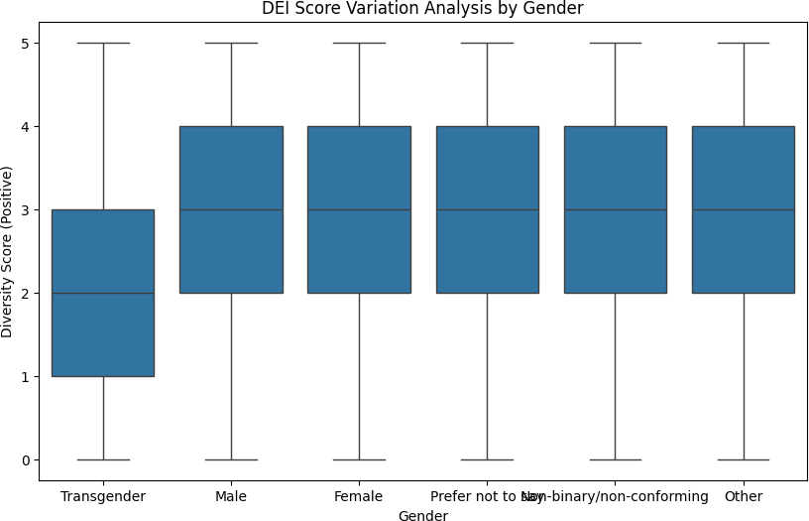DEI Score Variation Analysis: Delving deeper, we examine variations in DEI scores across different demographic groups, unraveling the implications of these disparities on organizational dynamics and employee experiences.
2. Representation and Inclusion Efforts Analysis: Turning our gaze towards organizational practices, we explore patterns in representation and inclusion efforts based on demographic factors.

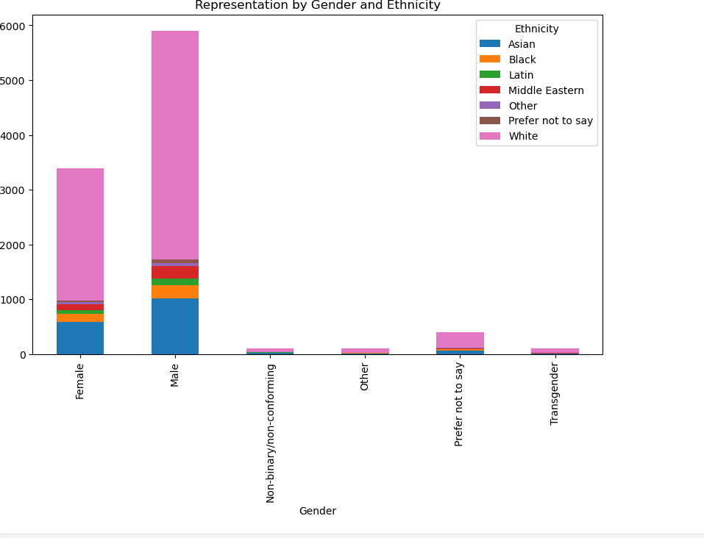

1. Career Progression Barriers Analysis: Moving up the corporate ladder, we identify barriers faced by certain age groups in career progression.

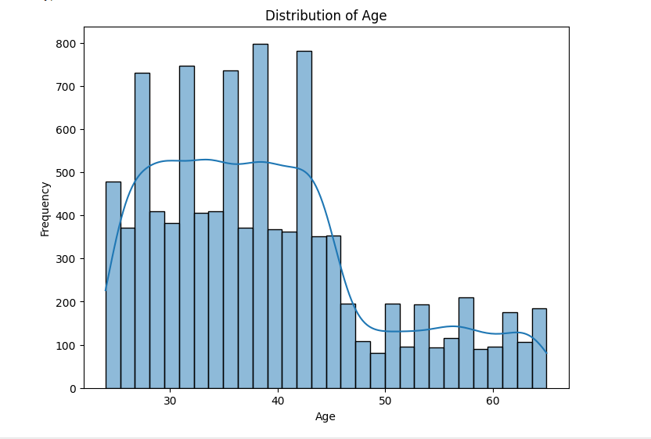

1. Retention Rates Analysis: As employees navigate their professional journeys, we examine differences in retention rates among demographic groups.

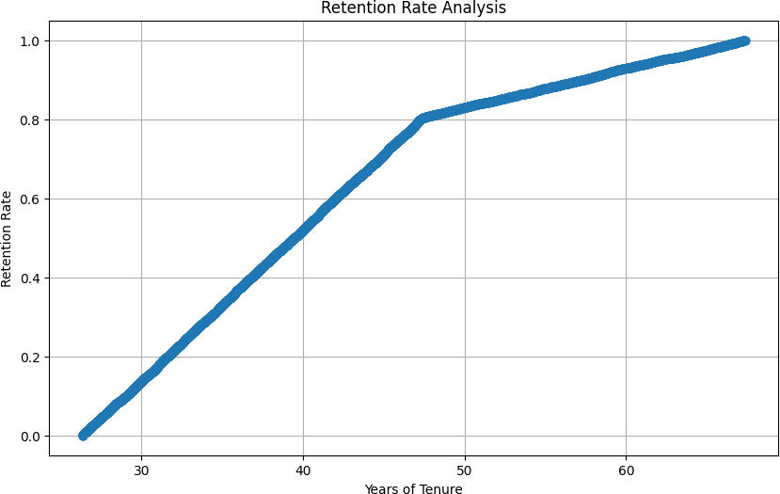

1. Impact of Diversity Initiatives Analysis: Evaluating the efficacy of diversity initiatives, we analyze their impact on diversity metrics and the demographics of hires.

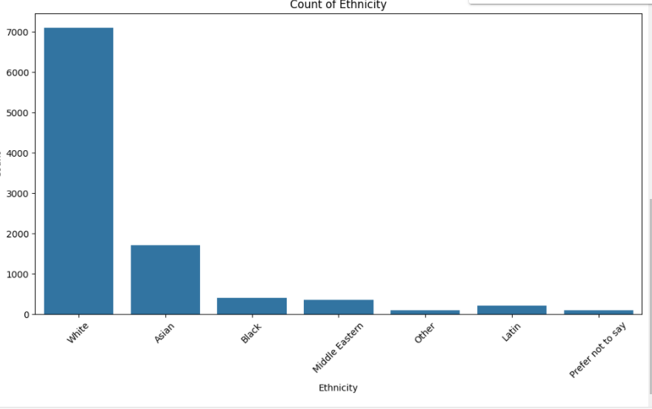

8. Leadership Representation Analysis: Finally, we turn our attention to the upper echelons of organizational hierarchies, examining the representation of demographic groups in leadership roles.

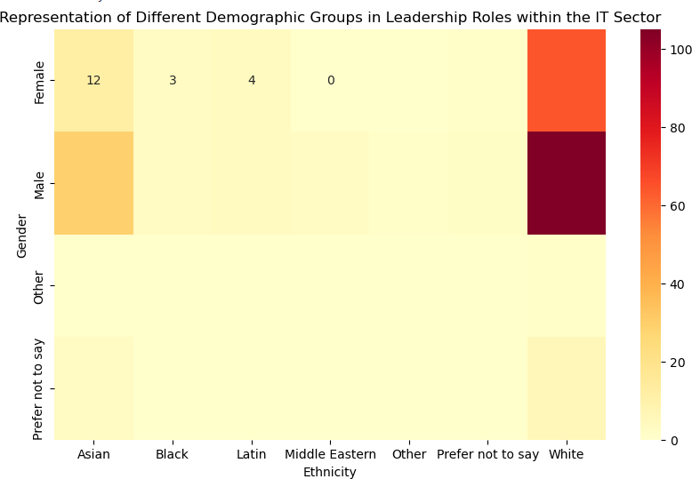

# Interpretations/Implications

Interpretations / Implications:

As we wrap up our analysis, we're faced with some harsh realities. We have uncovered big gaps in how people are represented, paid, promoted, and given leadership roles in the IT industry. These gaps aren't just random numbers; they show that there are deep problems with how things work. But it's not all doom and gloom. We have a chance to make things better. By taking action now, companies can make the workplace fairer and more equal for everyone. It's about making sure that every person is respected, valued, and given the chance to do their best.

# Recommendations

1. We can Implement Targeted Recruitment Strategies: Develop targeted recruitment and hiring strategies to attract a diverse pool of candidates, leveraging community partnerships, and outreach programs to tap into underrepresented talent pools.
2. We can foster Inclusive Work Environments: Cultivate inclusive work environments that embrace diversity and foster a sense of belonging for all employees, promoting open dialogue, cultural competence, and mutual respect.
3. We should invest in Professional Development: Invest in professional development and

mentorship programs to support career advancement for underrepresented groups, providing access to training, networking opportunities, and leadership development initiatives.

1. We should ensure Pay Equity: Ensure pay equity by conducting regular audits of

compensation practices, addressing wage differentials based on demographic factors, and implementing transparent and equitable remuneration policies.

1. We should Promote Diverse Leadership: Promote diverse leadership by implementing succession planning processes that prioritize diversity and inclusion, providing pathways for

advancement and leadership development for individuals from underrepresented backgrounds.

1. Detailed analysis can be conducted on specific demographic attributes, such as disability status, minority status, and veteran status, to understand their representation and experiences within the organization.
2. Correlation analysis between demographic attributes and sentiment scores can provide insights into how different groups perceive diversity, equity, and inclusion initiatives.

# Limitations

1. Data Limitations: The analysis relies on available data, which may not capture all dimensions of diversity-related and the pay gaps challenges within the IT industry. Additional research may be needed to fill gaps in our understanding of these complex issues.
2. External Factors: The findings may be influenced by external factors not accounted for in the analysis, such as changes in market dynamics, regulatory environments, or socio-political

landscapes.

1. Recommendation Generalization: The recommendations provided are based on the current state of knowledge and may require further refinement based on organizational context

# Conclusion

By summarizing these key points, the report provides stakeholders with valuable insights into the current state of diversity, equity, and inclusion within the organization and informs strategic decision-making processes aimed at fostering a more inclusive workplace culture.