**Sales Analysis Project**

**Project Overview**

This project involves a comprehensive sales analysis using Adventure Works 2022 dataset. The analysis encompasses data cleaning, extraction, modeling, and visualization to provide actionable insights for the sales team.

**Tools Used**

- SQL Server Management Studio

- Power BI

**Project Phases**

**1. Data Cleaning and Extraction**

- Used SQL Server Management Studio to clean and extract relevant data

- Focused on customer, product, and sales data

- Ensured data quality and consistency

**2. Data Modeling**

- Imported cleaned data into Power BI

- Created a star schema data model with the following tables:

- FactInternetSales (central fact table)

- DimProduct (product dimension)

- DimCustomers (customer dimension)

- DimDate (date dimension)

- SalesBudget (for budget comparisons)

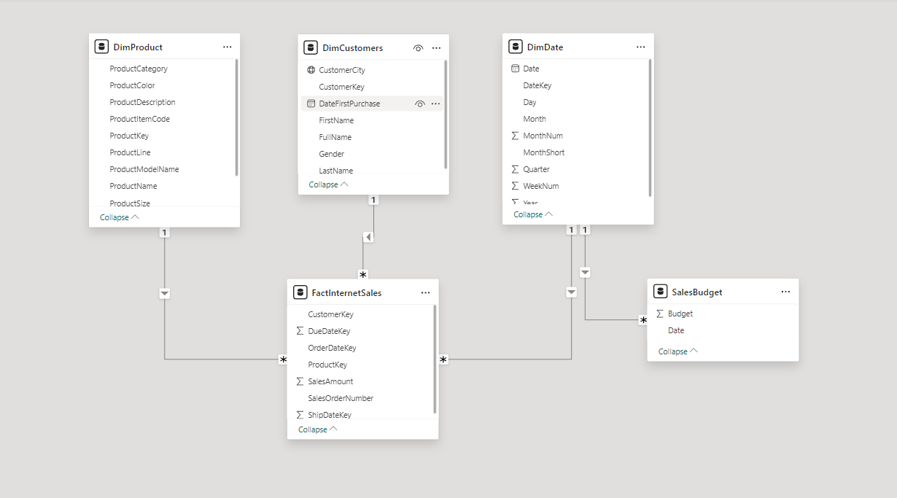

**3. Dashboard Creation**

Developed three main dashboards in Power BI:

* Sales Overview

- Key Performance Indicators (KPIs) comparing actual sales to budget

- Sales by Product Category

- Sales and Budget by Month (line chart)

- Top 10 Customers by Sales

- Top 10 Products by Sales

- Geographical sales distribution

* Customer Details

- Customer-specific KPIs

- Sales by Product Category for selected customer(s)

- Top 10 Customers

- Top 10 Products sold to customers

- Detailed customer sales table by month

* Product Details

- Product-specific KPIs

- Sales by Product Category

- Top 10 Customers for selected product(s)

- Top 10 Products

- Detailed product sales table by month

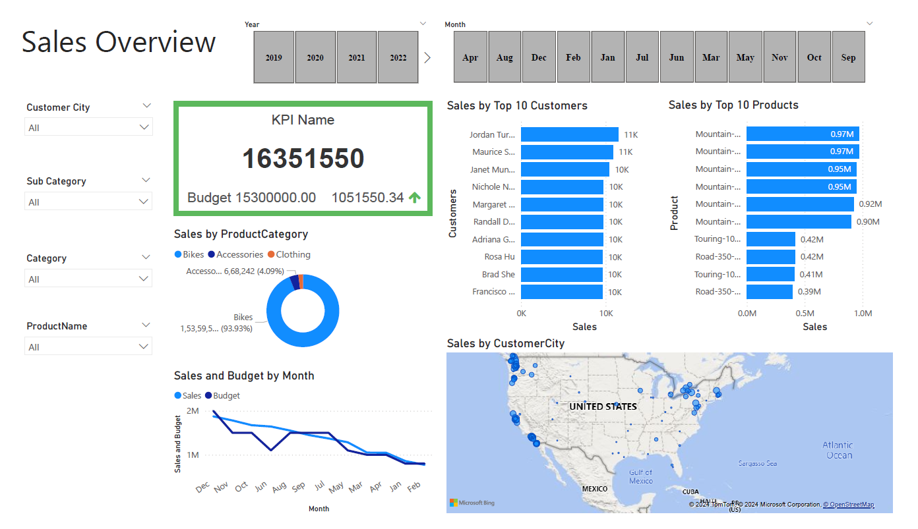

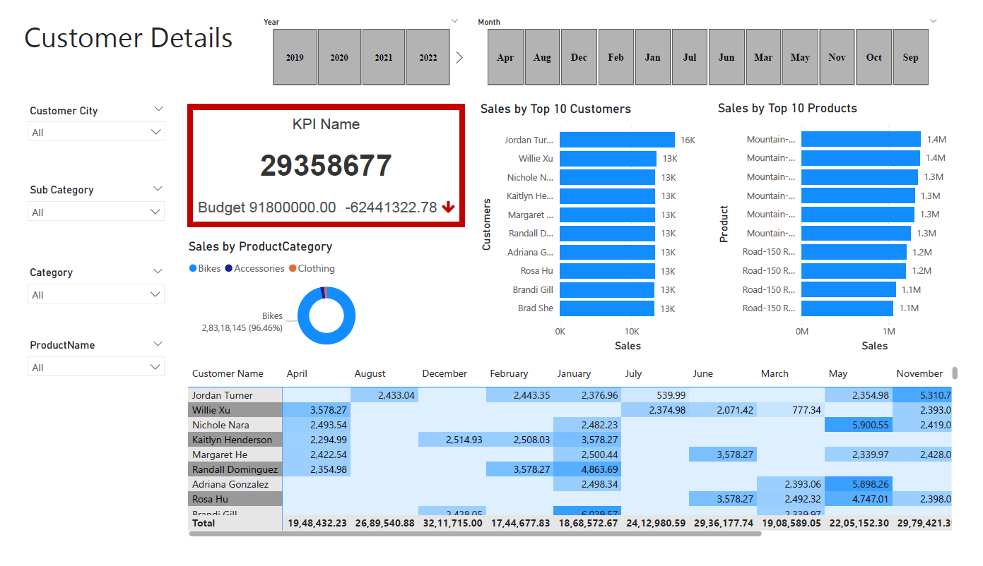

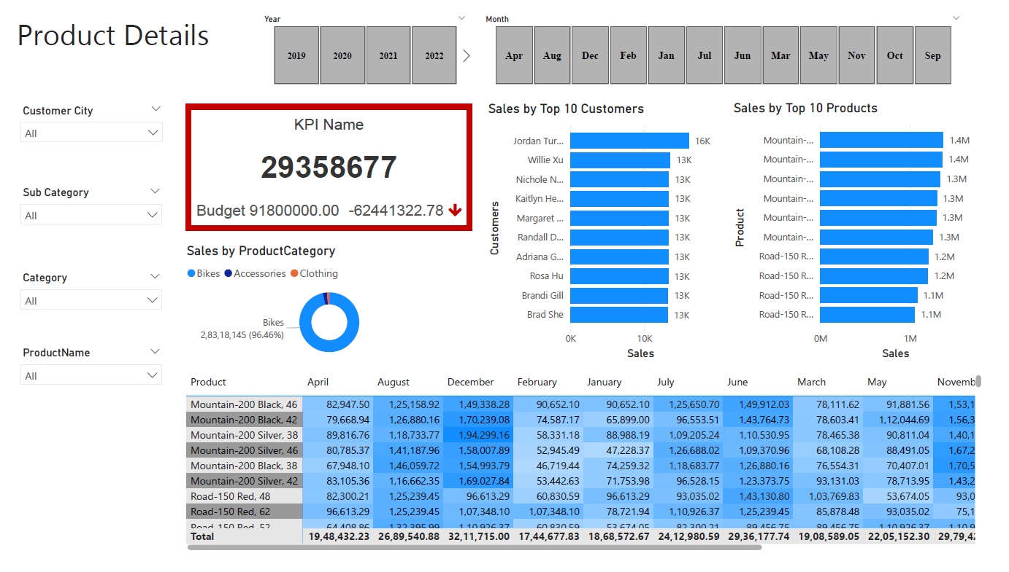

**4. Key Insights**

* Sales Performance: Recent sales ($16,351,550) exceeded the budget ($15,300,000), showing strong short-term performance. However, the overall dataset indicates a significant negative variance against the total budget.
* Product Mix: The Bikes category dominates sales (96.46%), while Accessories and Clothing contribute minimally.
* Customer Base: Top 10 customers contribute significantly to sales, with a relatively even distribution among them.
* Product Trends: Mountain bikes, particularly the Mountain-200 model, are the best-selling products, followed by Road-150 bikes.
* Seasonal Patterns: Sales peak in November and December, with noticeable dips in February and April.
* Geographic Variations: Sales performance varies across regions, suggesting opportunities for targeted strategies.