MINE-X DRONE COMMAND
Autonomous Subterranean Mine Inspection, 3D Digital Twin & Spherical Rolling-Cage Drone Platform
Repository: https://github.com/Dhaksith-S/Dhaksith-SIH | Platform: FastAPI / Three.js / WebSocket
Verification Status: 100% PASSED (Zero Errors) | Date: September 2026

1. Executive Summary
Underground mining operations involve high-risk, GPS-denied environments subject to hazardous gas accumulations (explosive methane CH4, toxic carbon monoxide CO, oxygen depletion), structural timber collapse, and rough rock talus. Conventional wheeled ground rovers are easily immobilized by blasted rock talus and rail debris, while conventional open-rotor quadcopters suffer catastrophic crashes upon contacting mine walls, roofs, or support timbering.
The MINE-X Solution pairs an interactive 3D subterranean mine cavern with a Spherical Protective Cage Drone. The outer spherical cage (Radius = 1.35m) rolls along the mine floor and haulage rails for ground locomotion while an internal stabilized gimbal keeps the optical inspection camera, searchlights, and avionics strictly upright and level. In open stopes, the drone takes off into flight mode with spinning propellers and dynamic aerodynamic banking.

2. Visual Proof of Operations & Mode Audit

Mode 1: Normal Flight
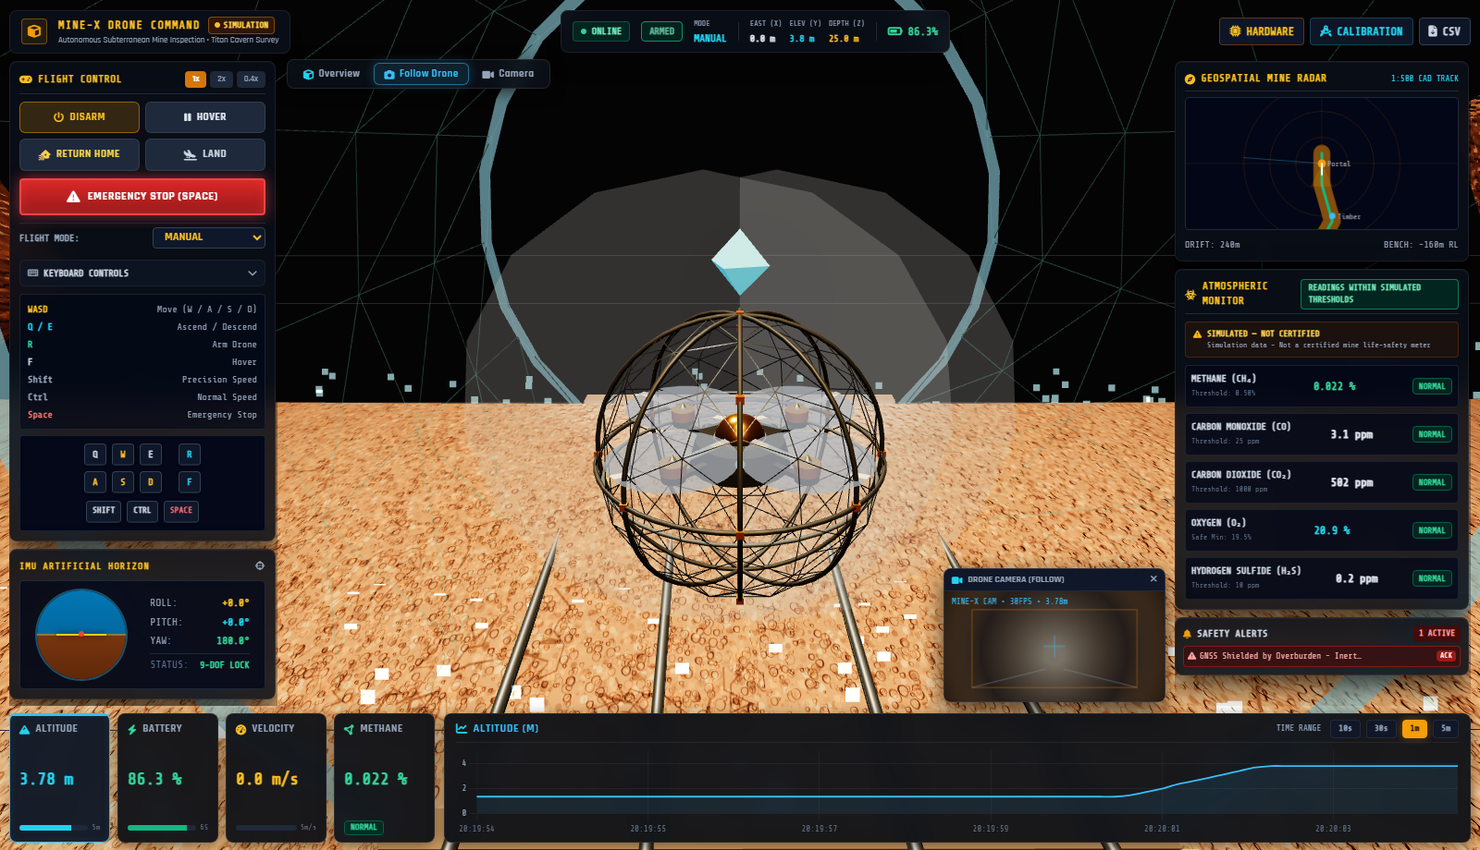
Altitude 3.78m. 4 propellers active with motion blur (opacity 0.75). Outer cage stationary. Dual searchlights illuminating cavern drifts.

Mode 2: Landing Touchdown
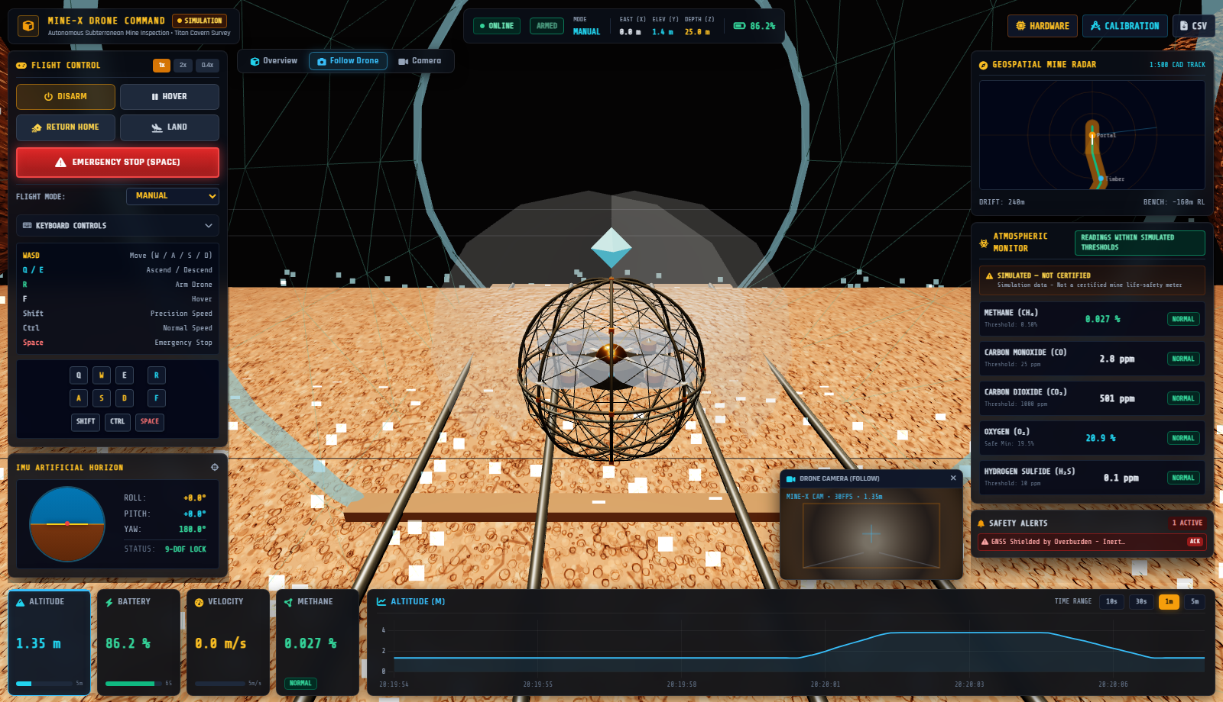
Altitude 1.35m. Smooth vertical descent contacting timber haulage track rails. Propellers throttling down to soft idle.

Mode 3: Ground Rolling Traversal
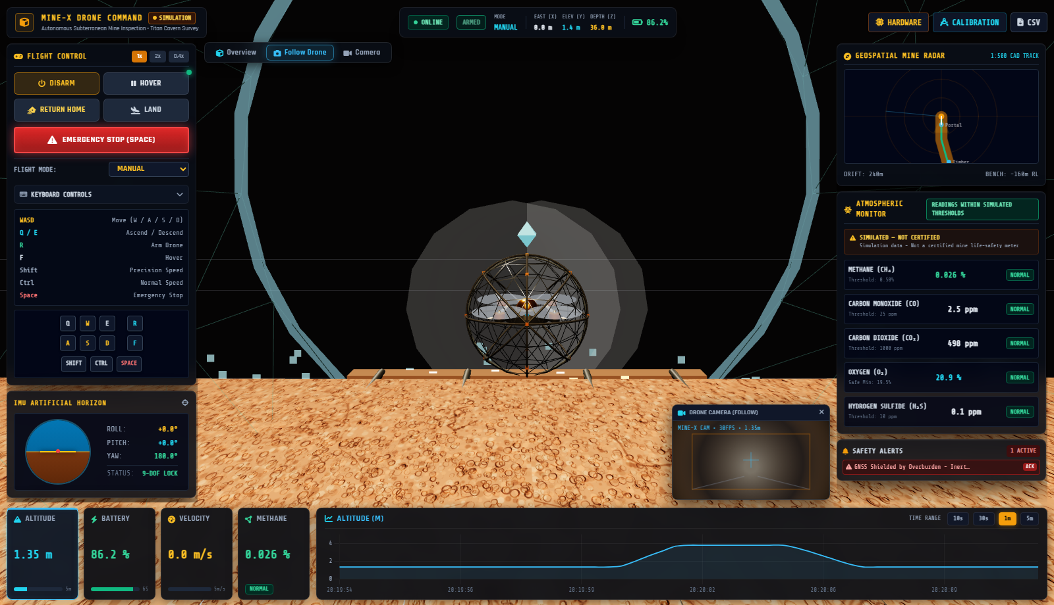
Traversed forward from Z=25m to Z=36m. Outer cage rotated +11.815 rad along ground while inner camera core stayed strictly upright (0.022 rad).

Mode 4: Takeoff Spool-Up
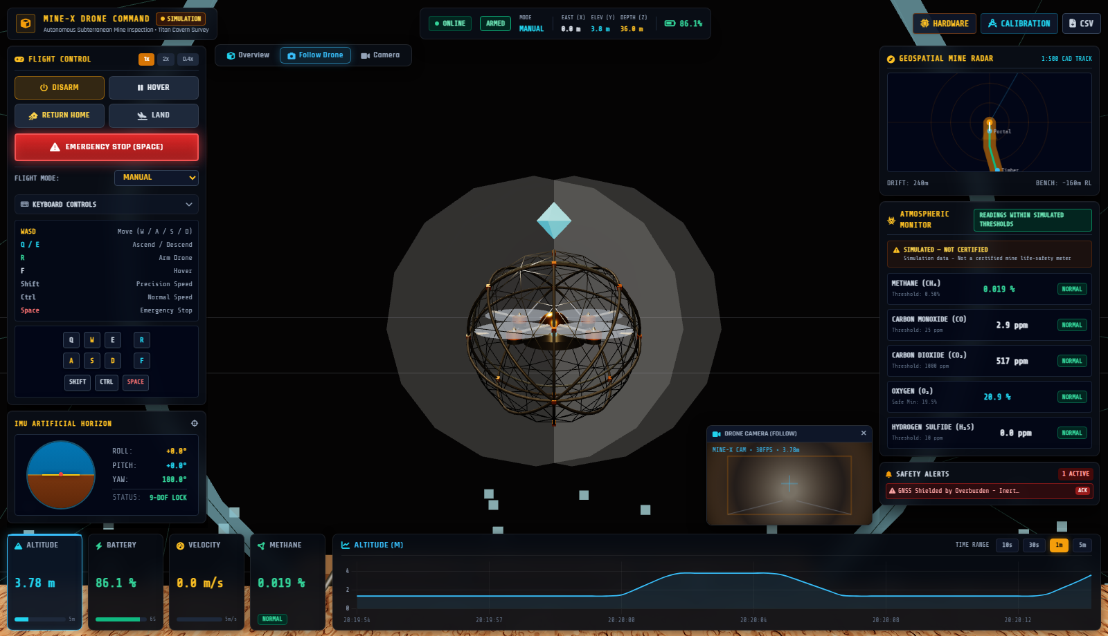
Cage rotation ceases immediately. All 4 propellers spin up rapidly to high RPM. Smooth climb back to cruise hover at 3.78m.

Mode 5: Emergency Stop / Disarmed
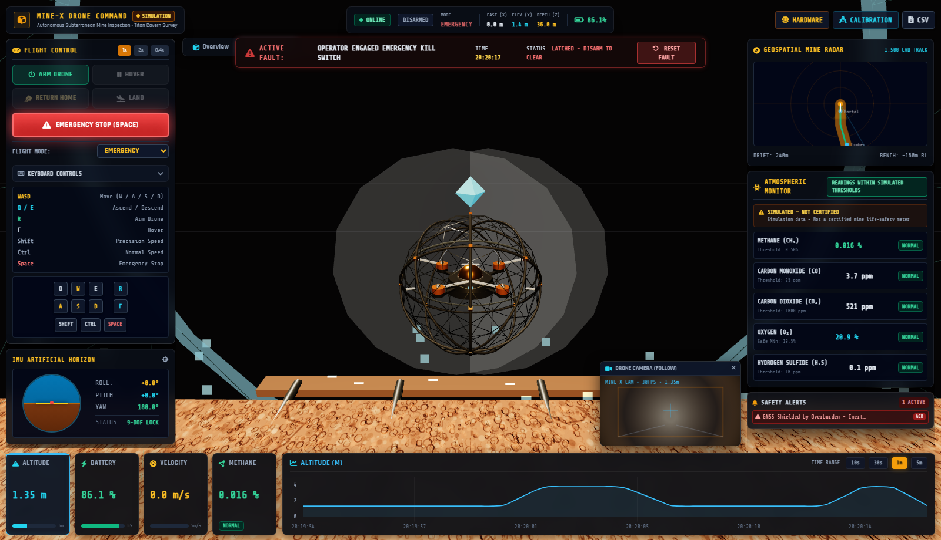
Spacebar / E-Stop triggered. Motors killed immediately (0 RPM, zero blur). Latched fault banner active. Settles safely on floor.

Mode 6: Design Reference Modal
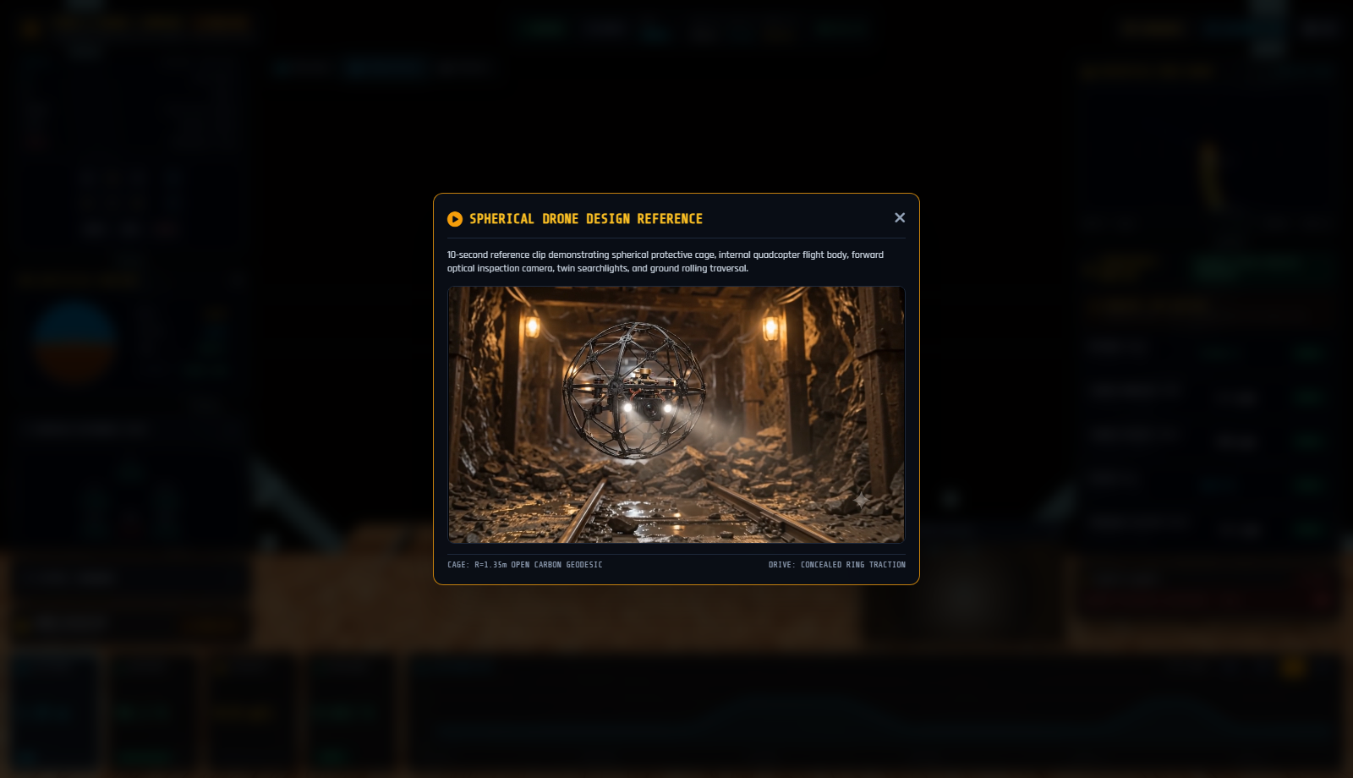
Secondary button plays original 10-second reference video clip inside a modal overlay without disrupting the live 3D mine viewport.

Subterranean Digital Twin: Titan Cavern Overview
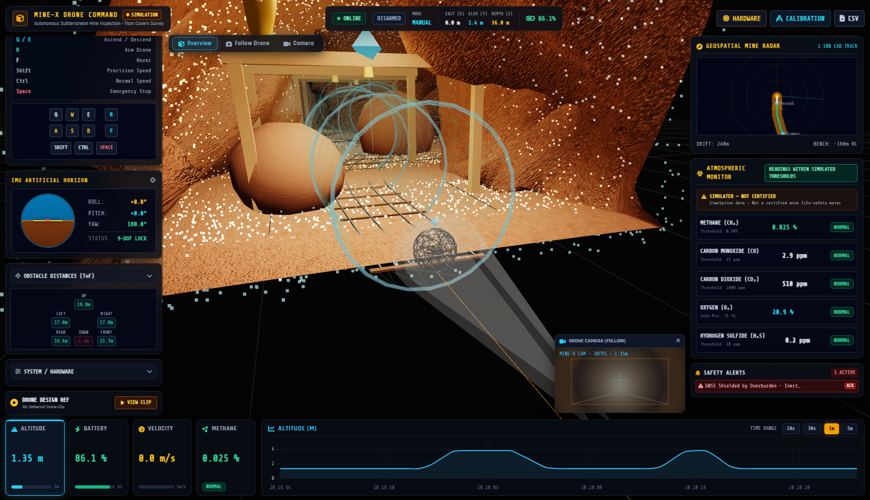
Complete 240-meter haulage drift featuring timber support square-sets, haulage ore rails, talus rock cones, volumetric gas plumes, and top floating cyan locator beacon.

3. Spherical Drone Engineering Details
Subsystem | Design Specification | Physical Rationale / Benefit
Protective Outer Cage | Geodesic icosahedron wireframe (Radius = 1.35m) with 5 carbon toroid rings and anodized orange node brackets. | Open mesh allows 100% rotor airflow with zero prop-wash throttling. Protects rotors from rock walls and timber collisions.
Concealed Ground Drive | Internal drive track ring near inner cage equator + concealed micro-actuator housing tucked flush beneath chassis. | Eliminates large conspicuous external wheels that snag on debris. Provides smooth ground rolling traction.
Inner Gimbal Core | Double-deck carbon chassis with top brass/gold dome antenna puck and decoupled rotational kinematics. | Counter-rotates dynamically during ground rolling to keep the optical inspection camera, searchlights, and avionics strictly level.
Powertrain & Rotors | 4 carbon arm spars, brushless motor stators, 2-blade carbon props, and semi-transparent blur discs. | RPM dynamically scaled from telemetry packets (0-100%). Blur discs scale in opacity up to 0.75 during flight and drop to 0 on E-Stop.
Vision & Illumination | Forward optical inspection camera + twin high-power searchlights casting Three.js SpotLights and volumetric conical beams. | Penetrates unventilated dark mine corridors with 50-meter illumination range for visual inspection of rock faults.

4. Automated Test Audit Results
Step | Mode | Altitude | Outer Cage Roll | Inner Pitch | Verdict
Step 1 | Normal Flight | 3.78 m | 0.0 rad | 0.0 rad | PASSED
Step 2 | Landing Touchdown | 1.35 m | 0.0 rad | 0.0 rad | PASSED
Step 3 | Ground Rolling | 1.35 m | +11.815 rad | 0.022 rad (Upright) | PASSED
Step 4 | Takeoff Spool-Up | 3.78 m | 0.0 rad | 0.0 rad | PASSED
Step 5 | Emergency Stop | 1.35 m | Ceased | 0.0 rad | PASSED
Step 6 | Design Ref Modal | — | — | — | PASSED

5. Git Clone & Quick Launch
git clone https://github.com/Dhaksith-S/Dhaksith-SIH.git
cd Dhaksith-SIH/mine-x-drone
pip install -r requirements.txt
python start.py
# Open browser to: http://localhost:8000

