**RESEARCH**

1. [https://eaadeboye.com//](https://eaadeboye.com/)

Official Website of my Hero (Pastor E.A Adeboye).

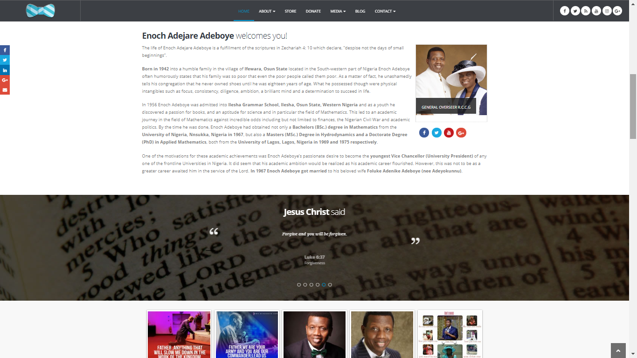

1. <http://www.rccg.org/>

Official Page of the Redeemed Christian Church of God where my Hero is the General Overseer.

1. <https://www.wikipedia.org/>

A Search Encyclopaedia engine where I made further research so as to justify all the facts I gathered about my Hero.

1. <https://www.w3schools.com/>

Mostly got all the Ideas here and it`s being recommended by my lecturer. It`s very easy to navigate and it gives a lot explanation on any block of codes you are working with.

