SQL PRACTICE SET – RETAIL EVENTS DATASET
20 QUESTIONS | EASY → MEDIUM → HARD

DATASET OVERVIEW
================

This practice set uses the retail_events_db database.

Main tables:

1. dim_campaigns
- campaign_id
- campaign_name
- start_date
- end_date

2. dim_products
- product_code
- product_name
- category

3. dim_stores
- store_id
- city

4. fact_events
- event_id
- store_id
- campaign_id
- product_code
- base_price
- promo_type
- quantity_sold(before_promo)
- quantity_sold(after_promo)

The fact_events table stores product-level promotional event information.
Use the dimension tables to obtain campaign, product and store details.

IMPORTANT:
- Use MySQL syntax.
- Column names containing parentheses may need backticks.
Example:
`quantity_sold(before_promo)`
`quantity_sold(after_promo)`
- Do not modify the data.
- Write a separate SQL query for each question.
- Questions are arranged from easy to hard.
- Focus especially on JOINs, GROUP BY, HAVING, CASE, CTEs and window functions.

============================================================
#Preset to avoid backticks while using column name with paranthesis
-- SET sql_mode = 'ANSI_QUOTES';
============================================================

============================================================
EASY QUESTIONS
============================================================

Q1. Basic Filtering – High-Value Products
Find all event records where the base_price is greater than 1,000.

Display:
- event_id
- store_id
- product_code
- base_price
- promo_type

Concepts:
SELECT, WHERE, comparison operators.

SELECT event_id,store_id,product_code,base_price,promo_type
FROM fact_events
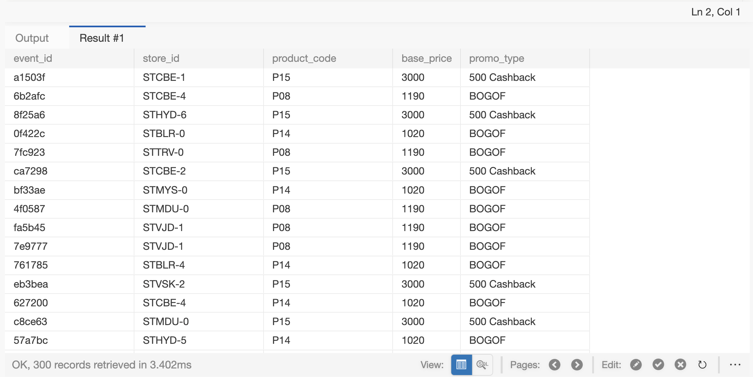
WHERE base_price>1000
------------------------------------------------------------

Q2. Sorting Promotional Events
Display all events where quantity sold after the promotion was greater than 100.

Display:
- event_id
- product_code
- promo_type
- quantity_sold(before_promo)
- quantity_sold(after_promo)

Sort by quantity_sold(after_promo) in descending order.

Concepts:
WHERE, ORDER BY, DESC.

SELECT event_id, product_code, promo_type,
"quantity_sold(before_promo)", "quantity_sold(after_promo)"
FROM fact_events
WHERE "quantity_sold(after_promo)" > 100
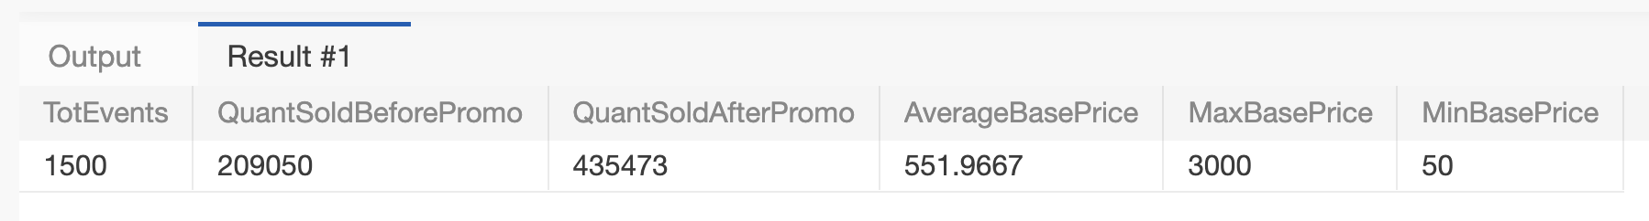
ORDER BY "quantity_sold(after_promo)" DESC
------------------------------------------------------------

Q3. DISTINCT Promotion Types
Find all unique promotion types used in the dataset.

Display only the unique promo_type values.

Concepts:
DISTINCT.

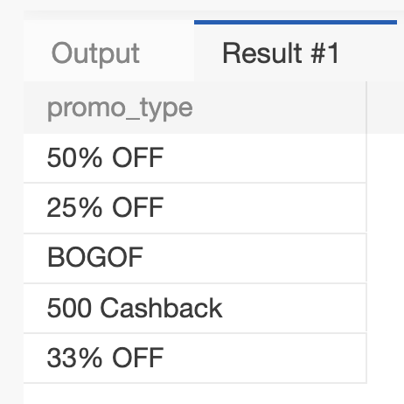
SELECT DISTINCT promo_type FROM fact_events
------------------------------------------------------------

Q4. Basic Aggregation
Calculate the following for the complete fact_events table:

- Total number of events
- Total quantity sold before promotion
- Total quantity sold after promotion
- Average base price
- Maximum base price
- Minimum base price

Return all metrics in one row.

Concepts:
COUNT, SUM, AVG, MAX, MIN.

SELECT COUNT(event_id) as TotEvents,SUM("quantity_sold(before_promo)") AS QuantSoldBeforePromo,
SUM("quantity_sold(after_promo)") AS QuantSoldAfterPromo, AVG(base_price) AS AverageBasePrice,
MAX(base_price) AS MaxBasePrice,MIN(base_price) AS MinBasePrice
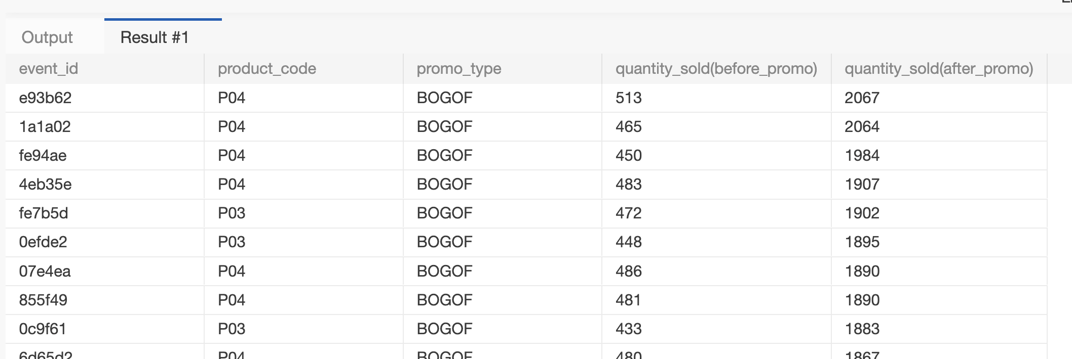
FROM fact_events

============================================================
MEDIUM QUESTIONS
============================================================

Q5. Sales Volume by Promotion Type
For each promo_type, calculate:

- Number of events
- Total quantity sold before promotion
- Total quantity sold after promotion

Sort by total quantity sold after promotion in descending order.

Concepts:
GROUP BY, COUNT, SUM, ORDER BY.

SELECT promo_type,COUNT(event_id) AS 'Number of events',SUM("quantity_sold(before_promo)") AS 'Total quantity sold before promotion',
SUM("quantity_sold(after_promo)") AS 'Total quantity sold after promotion'
FROM fact_events
GROUP BY promo_type
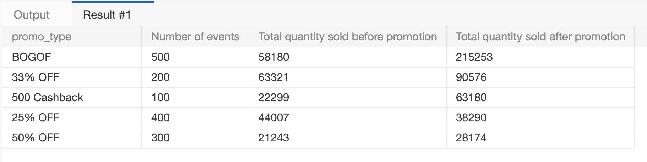
ORDER BY SUM("quantity_sold(after_promo)") DESC

------------------------------------------------------------

Q6. Promotion Uplift
For every promotion type, calculate:

- Total quantity before promotion
- Total quantity after promotion
- Quantity increase/decrease

Use:

Quantity Change = After Promo Quantity - Before Promo Quantity

Display:
- promo_type
- total_before
- total_after
- quantity_change

Sort by quantity_change descending.

Concepts:
GROUP BY, SUM, arithmetic calculations, aliases.

SELECT promo_type,SUM("quantity_sold(before_promo)") AS 'total_before',
SUM("quantity_sold(after_promo)") AS 'total_after',
SUM("quantity_sold(after_promo)")-SUM("quantity_sold(before_promo)") AS 'quantity_change'
FROM fact_events
GROUP BY promo_type
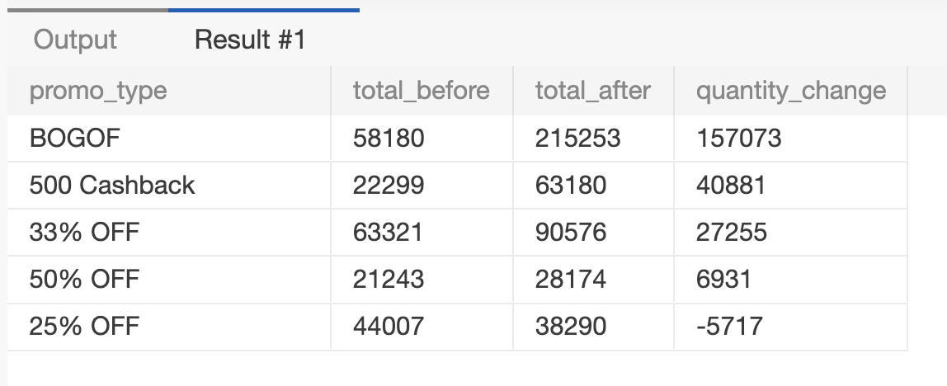
ORDER BY SUM("quantity_sold(after_promo)")-SUM("quantity_sold(before_promo)") DESC
------------------------------------------------------------

Q7. Product Performance
Using fact_events and dim_products, calculate total quantity sold after promotion for every product.

Display:
- product_code
- product_name
- category
- total quantity after promotion

Sort by total quantity after promotion descending.

Concepts:
INNER JOIN, GROUP BY, SUM, ORDER BY.

SELECT dp.product_code,product_name,category,SUM("quantity_sold(after_promo)") AS 'total quantity after promotion'
FROM fact_events f
INNER JOIN dim_products dp ON f.product_code=dp.product_code
GROUP BY dp.product_code,product_name,category
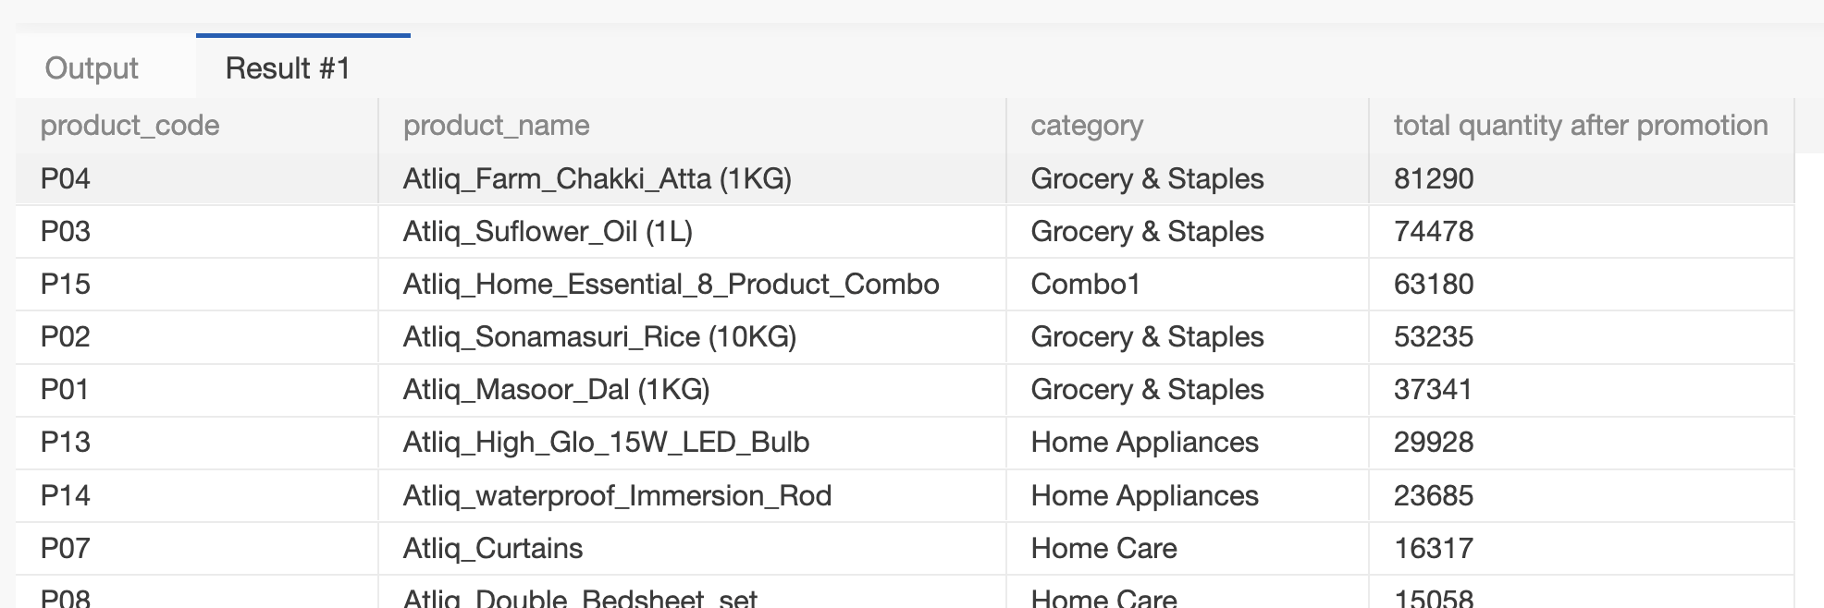
ORDER BY SUM("quantity_sold(after_promo)") DES
------------------------------------------------------------

Q8. Category-Level Performance
Using fact_events and dim_products, calculate for every product category:

- Number of events
- Total quantity before promotion
- Total quantity after promotion
- Quantity change

Sort categories by total quantity after promotion descending.

Concepts:
JOIN, GROUP BY, SUM, COUNT, arithmetic calculations.

SELECT dp.category,COUNT(event_id) AS 'Number of events',SUM("quantity_sold(before_promo)") AS 'total_before',
SUM("quantity_sold(after_promo)") AS 'Total quantity after promotion',
SUM("quantity_sold(after_promo)")-SUM("quantity_sold(before_promo)") AS 'Quantity change'
FROM fact_events f
JOIN dim_products dp ON f.product_code=dp.product_code
GROUP BY dp.category
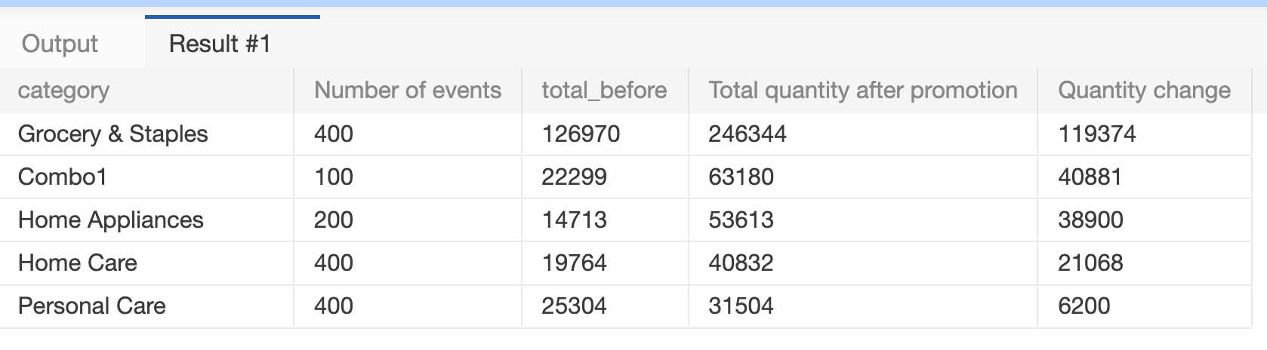
ORDER BY SUM("quantity_sold(after_promo)") DESC
------------------------------------------------------------

Q9. Store Performance
Using fact_events and dim_stores, calculate for every city:

- Number of promotional events
- Total quantity before promotion
- Total quantity after promotion

Display:
- city
- event_count
- total_before
- total_after

Sort cities by total_after descending.

Concepts:
JOIN, GROUP BY, aggregation, ORDER BY.

SELECT ds.city,
COUNT(f.event_id) AS event_count,SUM(f."quantity_sold(before_promo)") AS total_before,
SUM(f."quantity_sold(after_promo)") AS total_after
FROM fact_events f
JOIN dim_stores ds ON f.store_id = ds.store_id
GROUP BY ds.city
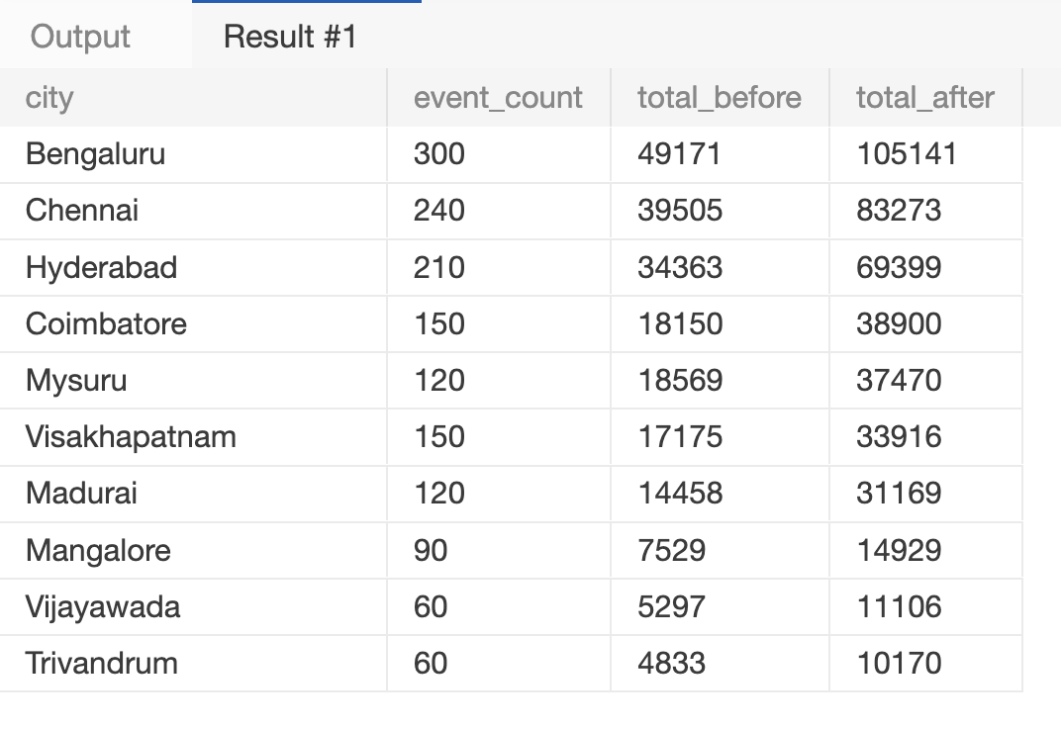
ORDER BY total_after DESC

------------------------------------------------------------

Q10. Campaign Performance
Using fact_events and dim_campaigns, calculate for each campaign:

- Campaign name
- Start date
- End date
- Number of events
- Total quantity before promotion
- Total quantity after promotion

Sort by total quantity after promotion descending.

Concepts:
JOIN, GROUP BY, date columns, aggregation.

SELECT dc.campaign_name, dc.start_date, dc.end_date,COUNT(f.event_id) AS event_count,
SUM(f."quantity_sold(before_promo)") AS total_before,SUM(f."quantity_sold(after_promo)") AS total_after
FROM fact_events f
JOIN dim_campaigns dc ON f.campaign_id = dc.campaign_id
GROUP BY dc.campaign_id, dc.campaign_name, dc.start_date, dc.end_date
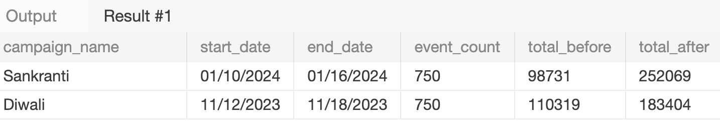
ORDER BY total_after DESC

------------------------------------------------------------

Q11. Product Category with HAVING
Find product categories where the total quantity sold after promotion is greater than 1,000.

Display:
- category
- total quantity after promotion
- average base price

Sort by total quantity after promotion descending.

Concepts:
JOIN, GROUP BY, HAVING, AVG, SUM.

SELECT dp.category,SUM(f."quantity_sold(after_promo)") AS total_quantity_after,AVG(f.base_price) AS avg_base_price
FROM fact_events f
JOIN dim_products dp ON f.product_code = dp.product_code
GROUP BY dp.category
HAVING SUM(f."quantity_sold(after_promo)") > 1000
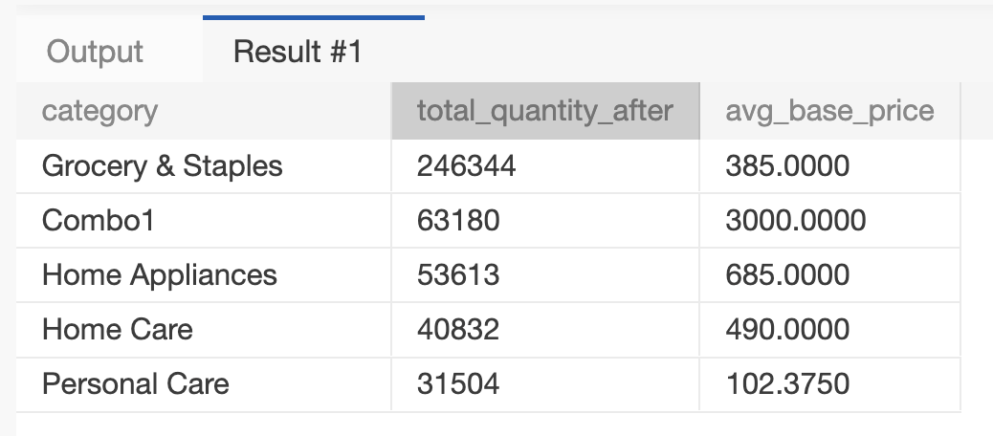
ORDER BY total_quantity_after DESC
------------------------------------------------------------

Q12. Store + Category Analysis
Using fact_events, dim_stores and dim_products, calculate total quantity sold after promotion for every combination of:

- City
- Product category

Display:
- city
- category
- total quantity after promotion

Sort first by city and then by total quantity descending.

Concepts:
Multiple JOINs, GROUP BY, ORDER BY.

SELECT ds.city,dp.category,SUM(f."quantity_sold(after_promo)") AS total_quantity_after
FROM fact_events f
JOIN dim_stores ds ON f.store_id = ds.store_id
JOIN dim_products dp ON f.product_code = dp.product_code
GROUP BY ds.city, dp.category
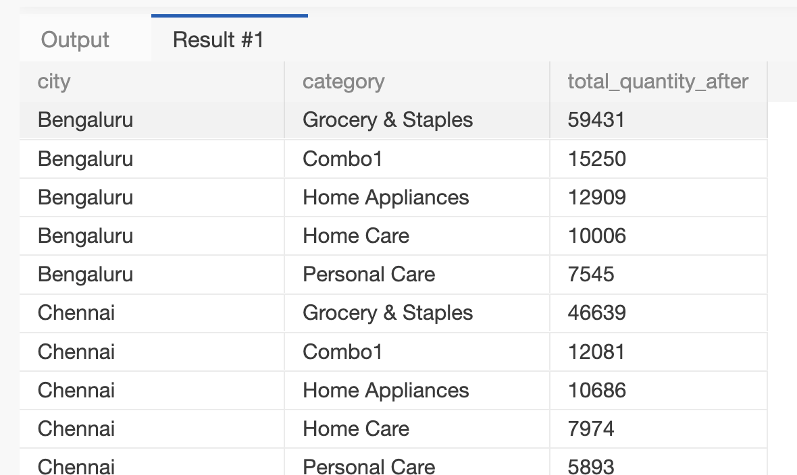
ORDER BY ds.city, total_quantity_after DESC

------------------------------------------------------------

Q13. Promotion Effectiveness by Product
For each product, calculate:

- Product name
- Category
- Total quantity before promotion
- Total quantity after promotion
- Quantity change
- Percentage change

Use:

Percentage Change =
((After Promo - Before Promo) / Before Promo) * 100

Handle division by zero appropriately.

Sort by percentage change descending.

Concepts:
JOIN, GROUP BY, arithmetic calculations, NULLIF, percentage calculations.

SELECT dp.product_name,dp.category,SUM(f."quantity_sold(before_promo)") AS total_before,
SUM(f."quantity_sold(after_promo)") AS total_after,
SUM(f."quantity_sold(after_promo)")-SUM(f."quantity_sold(before_promo)") AS quantity_change,
ROUND((SUM(f."quantity_sold(after_promo)")-SUM(f."quantity_sold(before_promo)"))
/NULLIF(SUM(f."quantity_sold(before_promo)"),0)*100,2) AS percentage_change
FROM fact_events f
JOIN dim_products dp ON f.product_code = dp.product_code
GROUP BY dp.product_code, dp.product_name, dp.category
ORDER BY percentage_change DESC

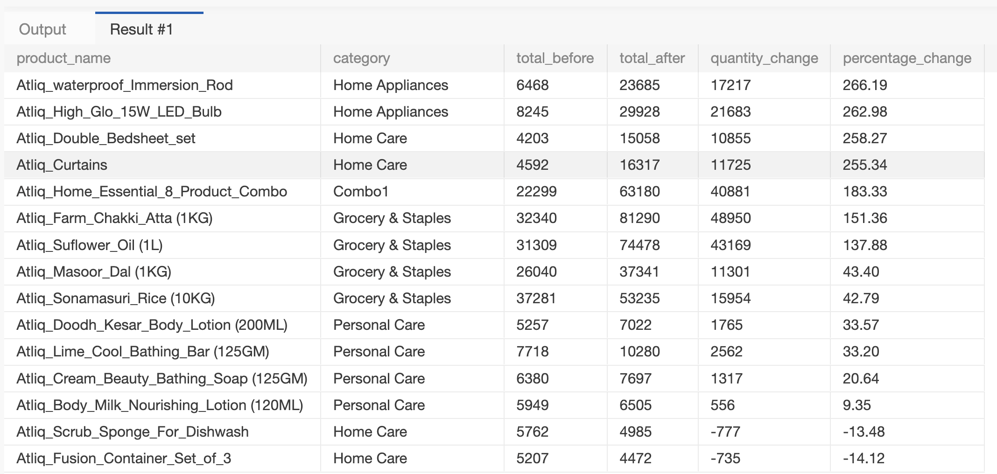
------------------------------------------------------------
Q14. Campaign and Promotion Type Analysis
For each campaign and promo_type combination, calculate:

- Number of events
- Total quantity before promotion
- Total quantity after promotion
- Quantity change

Display:
- campaign_name
- promo_type
- event_count
- total_before
- total_after
- quantity_change

Sort by campaign_name and quantity_change descending.

Concepts:
Multiple GROUP BY columns, JOIN, aggregation, ORDER BY.

SELECT dc.campaign_name, f.promo_type,COUNT(f.event_id) AS event_count,
SUM(f."quantity_sold(before_promo)") AS total_before,SUM(f."quantity_sold(after_promo)")AS total_after,
SUM(f."quantity_sold(after_promo)")-SUM(f."quantity_sold(before_promo)") AS quantity_change
FROM fact_events f
JOIN dim_campaigns dc ON f.campaign_id = dc.campaign_id
GROUP BY dc.campaign_name, f.promo_type
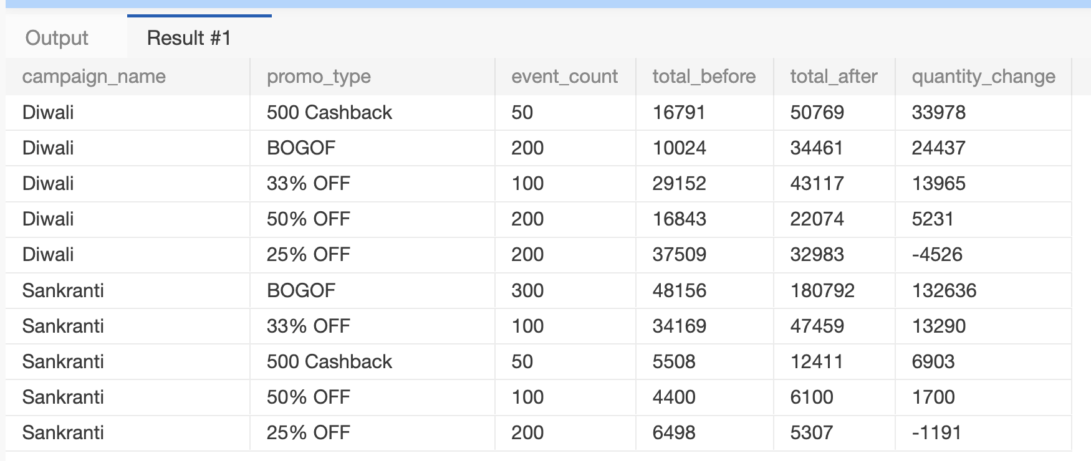
ORDER BY dc.campaign_name, quantity_change DESC
------------------------------------------------------------

Q15. Product Revenue Before and After Promotion
For each product, calculate:

1. Revenue before promotion =
base_price × quantity_sold(before_promo)

2. Revenue after promotion =
base_price × quantity_sold(after_promo)

3. Revenue difference =
Revenue after - Revenue before

Display:
- product_name
- category
- revenue_before
- revenue_after
- revenue_difference

Sort by revenue_difference descending.

Concepts:
JOIN, GROUP BY, SUM, arithmetic calculations, aliases.

SELECT dp.product_name, dp.category,SUM(f.base_price * f."quantity_sold(before_promo)") AS revenue_before,
SUM(f.base_price * f."quantity_sold(after_promo)") AS revenue_after,
SUM(f.base_price * f."quantity_sold(after_promo)")
- SUM(f.base_price * f."quantity_sold(before_promo)") AS revenue_difference
FROM fact_events f
JOIN dim_products dp ON f.product_code=dp.product_code
GROUP BY dp.product_code,dp.product_name,dp.category
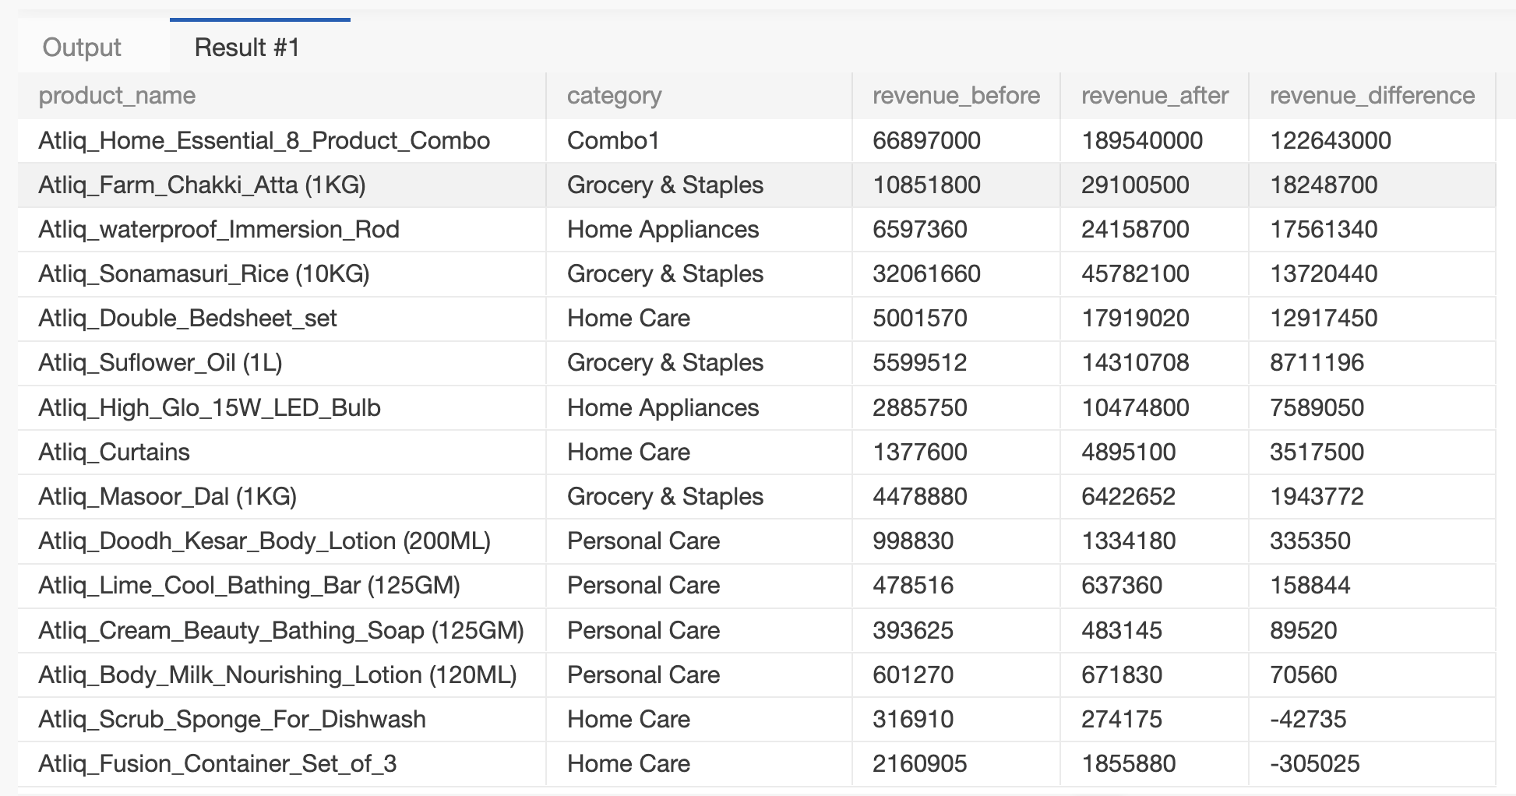
ORDER BY revenue_difference DESC

------------------------------------------------------------

Q16. Classify Promotion Performance
For every promotion type, calculate total quantity before and after promotion.

Then classify the promotion using CASE:

- Percentage change >= 50% → "High Impact"
- Percentage change >= 20% → "Medium Impact"
- Percentage change < 20% → "Low Impact"

Display:
- promo_type
- total_before
- total_after
- percentage_change
- performance_category

Sort by percentage_change descending.

Concepts:
GROUP BY, CASE, arithmetic calculations, NULLIF, aliases.

WITH promo_totals AS (SELECT promo_type,SUM("quantity_sold(before_promo)") AS total_before,
SUM("quantity_sold(after_promo)") AS total_after
FROM fact_events
GROUP BY promo_type),
promo_pct AS (SELECT promo_type, total_before, total_after,
ROUND((total_after - total_before) / NULLIF(total_before, 0) * 100, 2) AS percentage_change
FROM promo_totals)

SELECT promo_type, total_before, total_after, percentage_change,
CASE WHEN percentage_change >= 50 THEN 'High Impact'
WHEN percentage_change >= 20 THEN 'Medium Impact'
ELSE 'Low Impact'
END AS performance_category
FROM promo_pct
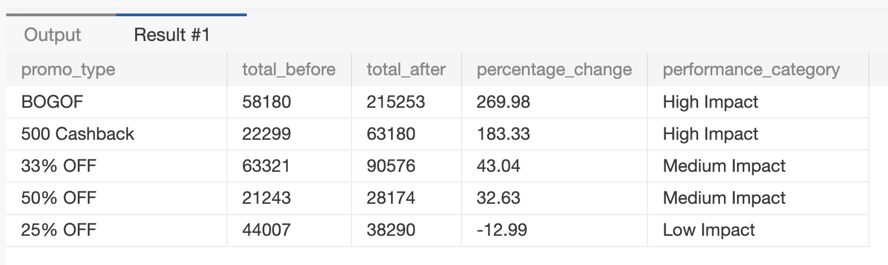
ORDER BY percentage_change DESC
============================================================
HARD QUESTIONS
============================================================

Q17. Top Products Within Each Category
Using a CTE:

1. Calculate total quantity sold after promotion for every product.
2. Rank products within each category based on total quantity sold after promotion.
3. Return only the top 2 products from every category.

Display:
- category
- product_name
- total_quantity_after
- category_rank

Concepts:
CTE, JOIN, GROUP BY, DENSE_RANK/ROW_NUMBER,
PARTITION BY, window functions.

WITH product_totals AS (SELECT dp.category,dp.product_name,SUM(f."quantity_sold(after_promo)") AS total_quantity_after
FROM fact_events f
JOIN dim_products dp ON f.product_code = dp.product_code
GROUP BY dp.category, dp.product_code, dp.product_name),
ranked AS (SELECT category, product_name, total_quantity_after,
DENSE_RANK() OVER (PARTITION BY category ORDER BY total_quantity_after DESC) AS category_rank
FROM product_totals)

SELECT category,product_name,total_quantity_after,category_rank
FROM ranked
WHERE category_rank <= 2
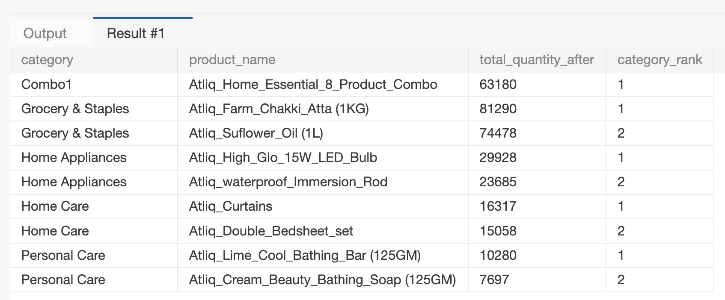
ORDER BY category,category_rank

------------------------------------------------------------

Q18. Best-Performing Stores Within Each City
Calculate total quantity sold after promotion for each store.

Join dim_stores to obtain the city.

Then rank stores within each city based on total quantity sold after promotion.

Return the top 2 stores from each city.

Display:
- city
- store_id
- total_quantity_after
- city_rank

Concepts:
JOIN, CTE, GROUP BY, window functions,
PARTITION BY, RANK/DENSE_RANK.

WITH store_totals AS (SELECT ds.city,ds.store_id,SUM(f."quantity_sold(after_promo)") AS total_quantity_after
FROM fact_events f
JOIN dim_stores ds ON f.store_id = ds.store_id
GROUP BY ds.city,ds.store_id),
ranked AS (SELECT city, store_id, total_quantity_after,
DENSE_RANK() OVER (PARTITION BY city ORDER BY total_quantity_after DESC) AS city_rank
FROM store_totals)
SELECT city, store_id, total_quantity_after, city_rank
FROM ranked
WHERE city_rank <= 2
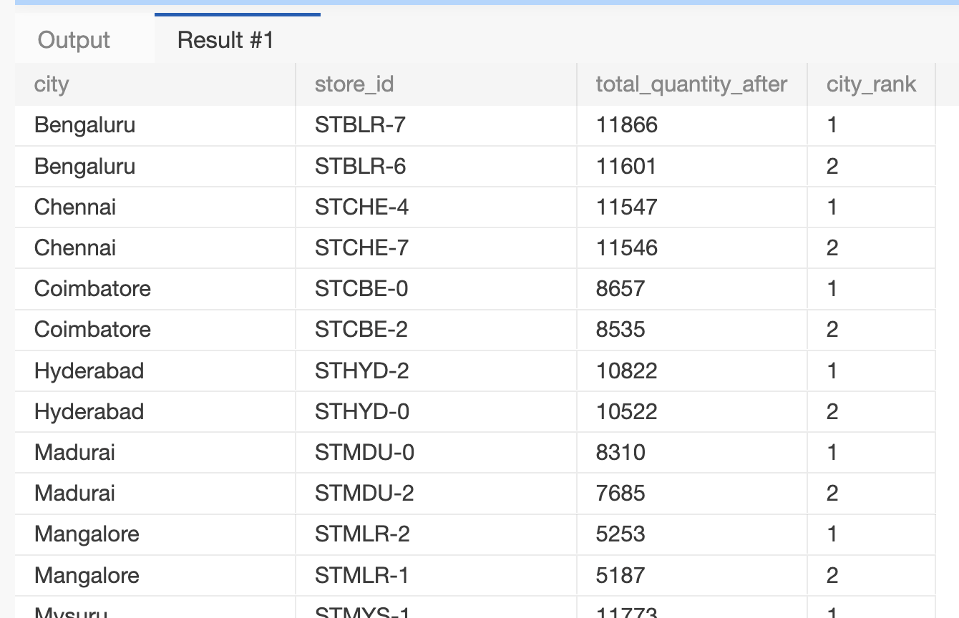
ORDER BY city, city_rank

------------------------------------------------------------

Q19. Campaign-Level Product Performance
For every campaign and product:

Calculate:
- Total quantity before promotion
- Total quantity after promotion
- Quantity change
- Percentage change

Then rank products within each campaign based on percentage change.

Return the top 3 products for every campaign.

Display:
- campaign_name
- product_name
- total_before
- total_after
- quantity_change
- percentage_change
- campaign_rank

Concepts:
Multiple JOINs, CTE, GROUP BY, arithmetic calculations,
NULLIF, window functions, PARTITION BY, ranking.

WITH campaign_product AS (SELECT dc.campaign_name, dp.product_name,SUM(f."quantity_sold(before_promo)") AS total_before,
SUM(f."quantity_sold(after_promo)") AS total_after
FROM fact_events f
JOIN dim_campaigns dc ON f.campaign_id = dc.campaign_id
JOIN dim_products dp ON f.product_code = dp.product_code
GROUP BY dc.campaign_id, dc.campaign_name, dp.product_code, dp.product_name),

calc AS (SELECT campaign_name, product_name, total_before, total_after,total_after - total_before AS quantity_change,
ROUND((total_after - total_before) / NULLIF(total_before, 0) * 100, 2) AS percentage_change
FROM campaign_product),

ranked AS (SELECT *,DENSE_RANK() OVER (PARTITION BY campaign_name ORDER BY percentage_change DESC) AS campaign_rank
FROM calc)

SELECT campaign_name, product_name, total_before, total_after,quantity_change, percentage_change, campaign_rank
FROM ranked
WHERE campaign_rank<=3
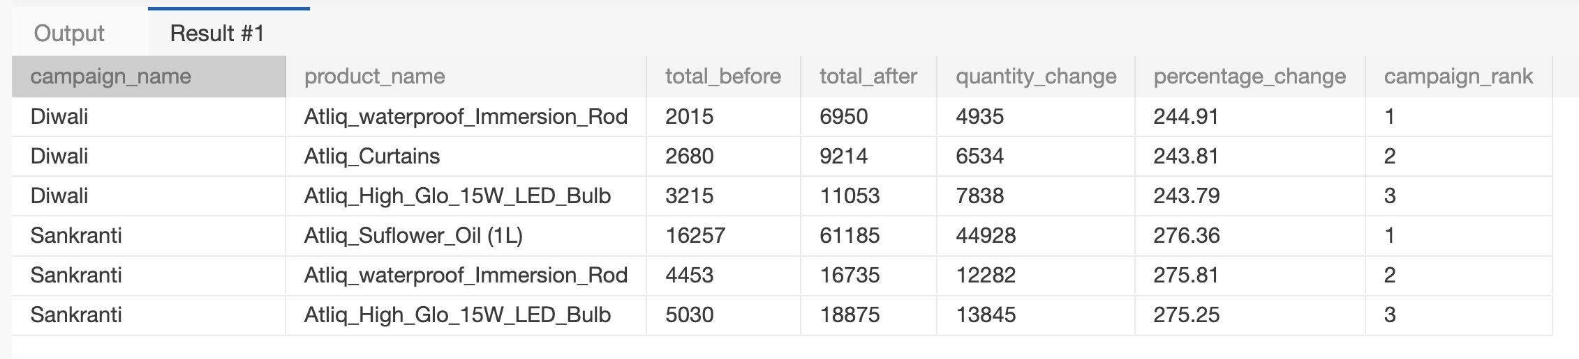
ORDER BY campaign_name,campaign_rank

------------------------------------------------------------

Q20. Complete Promotional Performance Analysis
Create a complete analytical report at the product-category level.

For every product, calculate:

- Product name
- Category
- Number of promotional events
- Total quantity before promotion
- Total quantity after promotion
- Quantity change
- Percentage change
- Revenue before promotion
- Revenue after promotion
- Revenue change
- Average base price
- Product rank within its category

Use:

Quantity Change =
Total After - Total Before

Percentage Change =
((Total After - Total Before) / Total Before) * 100

Revenue Before =
SUM(base_price × quantity_before)

Revenue After =
SUM(base_price × quantity_after)

Revenue Change =
Revenue After - Revenue Before

Then:

1. Rank products within each category by Revenue Change.
2. Return only the top 2 products from each category.
3. Use appropriate handling for division by zero.

Concepts:
- Multiple JOINs
- CTEs
- GROUP BY
- COUNT
- SUM
- AVG
- CASE
- NULLIF
- Arithmetic calculations
- Percentage calculations
- Window functions
- PARTITION BY
- DENSE_RANK / ROW_NUMBER
- Filtering ranked results
- Business analysis

WITH product_stats AS (SELECT dp.product_name, dp.category,COUNT(f.event_id) AS promo_events,
SUM(f."quantity_sold(before_promo)") AS total_before,SUM(f."quantity_sold(after_promo)") AS total_after,
SUM(f.base_price * f."quantity_sold(before_promo)") AS revenue_before,
SUM(f.base_price * f."quantity_sold(after_promo)") AS revenue_after,AVG(f.base_price) AS avg_base_price
FROM fact_events f
JOIN dim_products dp ON f.product_code = dp.product_code
GROUP BY dp.product_code, dp.product_name, dp.category),
calc AS (SELECT product_name, category, promo_events,total_before, total_after,
total_after - total_before AS quantity_change,
ROUND((total_after - total_before) / NULLIF(total_before, 0) * 100, 2) AS percentage_change,
revenue_before, revenue_after,revenue_after - revenue_before AS revenue_change,ROUND(avg_base_price, 2) AS avg_base_price
FROM product_stats),
ranked AS (SELECT *,DENSE_RANK() OVER (PARTITION BY category ORDER BY revenue_change DESC) AS category_rank
FROM calc)

SELECT *
FROM ranked
WHERE category_rank<3
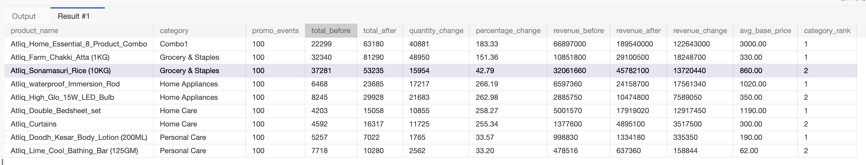
ORDER BY category,category_rank

============================================================
CONCEPT COVERAGE
============================================================

SELECT Q1-Q20
WHERE Q1-Q3
DISTINCT Q3
ORDER BY Q2-Q20
COUNT Q4-Q20
SUM Q4-Q20
AVG Q4, Q11, Q16, Q20
MIN / MAX Q4
GROUP BY Q5-Q20
HAVING Q11
INNER JOIN Q7-Q20
Multiple JOINs Q12, Q14, Q17-Q20
Arithmetic Q6, Q13, Q15-Q20
NULLIF Q13, Q16, Q19, Q20
CASE Q16, Q20
CTE Q17-Q20
Window Functions Q17-Q20
PARTITION BY Q17-Q20
RANK/DENSE_RANK Q17-Q20
Business Analysis Q13-Q20

============================================================
RECOMMENDED LEARNING FLOW
============================================================

Q1-Q4:
SQL fundamentals, filtering and aggregation.

Q5-Q10:
GROUP BY, JOINs and basic business analysis.

Q11-Q16:
HAVING, multiple JOINs, calculations, percentages and CASE.

Q17-Q20:
CTEs, window functions, ranking and advanced business analysis.

============================================================
IMPORTANT BUSINESS QUESTIONS LEARNERS SHOULD THINK ABOUT
============================================================

While solving the questions, learners should think about:

1. Which promotion types generate the highest increase in quantity?
2. Which products respond most strongly to promotions?
3. Which categories perform best after promotions?
4. Which cities/stores have the highest promotional volume?
5. Which campaigns generate the strongest product performance?
6. Does a higher quantity increase necessarily mean higher revenue?
7. Which products have the highest revenue improvement after promotion?
8. Which products should be investigated for weak promotional performance?

Do not answer these questions separately. Use SQL queries to derive the answers.

