**P1: Test a Perceptual Phenomenon (Stroop Effect)**

Lekhraj Sharma

Data Analyst Nanodegree

Oct 2016

# **Statistics: The Science of Decisions Project Instructions**

# **Background Information**

In a Stroop task, participants are presented with a list of words, with each word displayed in a color of ink. The participant’s task is to say out loud the *color of the ink* in which the word is printed. The task has two conditions: a congruent words condition, and an incongruent words condition. In the *congruent words* condition, the words being displayed are color words whose names match the colors in which they are printed: for example RED, BLUE. In the *incongruent words* condition, the words displayed are color words whose names do not match the colors in which they are printed: for example PURPLE, ORANGE. In each case, we measure the time it takes to name the ink colors in equally-sized lists. Each participant will go through and record a time from each condition.

Now it’s your chance to try out the Stroop task for yourself. Go to [this link](https://faculty.washington.edu/chudler/java/ready.html), which has a Java-based applet for performing the Stroop task. Record the times that you received on the task (you do not need to submit your times to the site.) Now, download [this dataset](https://drive.google.com/file/d/0B9Yf01UaIbUgQXpYb2NhZ29yX1U/view?usp=sharing) which contains results from a number of participants in the task. Each row of the dataset contains the performance for one participant, with the first number their results on the congruent task and the second number their performance on the incongruent task.

Dataset: [stroopdata.csv](https://drive.google.com/file/d/0B9Yf01UaIbUgQXpYb2NhZ29yX1U/view?usp=sharing)

I used [Google spreadsheet](https://docs.google.com/spreadsheets/d/10zhYYg2d8YpTGirC5Ai6iOF8Tinxzg0q5ozN1-jAnjQ/edit?usp=sharing) to do the calculations for this project.

# **Questions For Investigation**

As a general note, be sure to keep a record of any resources that you use or refer to in the creation of your project. You will need to report your sources as part of the project submission.

1. *What is our independent variable? What is our dependent variable?*

Independent Variable: **Stroop Task Conditions: Congruent and Incongruent word reading**

Stroop task is to say out loud the *color of the ink* in which the word is printed. The task has two conditions: a congruent words condition, and an incongruent words condition. In the *congruent words* condition, the words being displayed are color words whose names match the colors in which they are printed: for example RED, BLUE. In the *incongruent words* condition, the words displayed are color words whose names do not match the colors in which they are printed: for example PURPLE, ORANGE.

Dependent Variable: **Reaction Time**

Time it takes to do the Stroop task. Stroop task has two conditions: congruent and incongruent. In each case, we measure the time it takes to name the ink colors in equally-sized lists. Each participant goes through and records a time from each condition in seconds.

2. *What is an appropriate set of hypotheses for this task? What kind of statistical test do you expect to perform? Justify your choices.*

NULL Hypothesis ($H_{0}$): There is not much difference in reaction times for two conditions of Stroop task (congruent and incongruent). Therefore **difference in** **population means (congruent - incongruent) is ZERO**.

$H_{0 }$**: $μ_{D }$ = 0**

where $μ_{D }$ = $μ_{C }$- $μ_{I }$, difference of population mean of congruent ($μ_{C}$) and incongruent ($μ_{I}$) condition

Alternative Hypothesis ($H_{A}$): There is significant difference in reaction times for two conditions of Stroop task (congruent and incongruent). Directionally reaction times of congruent condition are significantly less than incongruent condition. Therefore **difference in population means (congruent - incongruent) is less than ZERO**.

$H_{A }$**: $μ_{D }$ < 0**

where $μ_{D }$ = $μ_{C }$- $μ_{I }$, difference of population mean of congruent ($μ_{C}$) and incongruent ($μ_{I}$) condition

Statistical Test: **One-tail paired t-test**

We are doing t-test since we only have small samples (less than 30) and do not know population mean and variance. We need to do one-tail test since we are interested in directional value of difference in mean of reaction time (i.e. reaction time of congruent condition < reaction time of incongruent condition). We are doing paired t-test as we are doing repeated measurements of reaction time of the same Stroop task under two different conditions for same subject (dependent samples, within-subject design).

3. *Report some descriptive statistics regarding this dataset. Include at least one measure of central tendency and at least one measure of variability.*

**Sample Size** (n): **24**

**Mean** reaction time for congruent ($\underline{X_{congruent}}$): **14.05** seconds,

**Standard Deviation of** reaction time for congruent ($S_{congruent}$): **3.56** seconds

**Mean** reaction time for incongruent ($\underline{X_{incongruent}}$): **22.02** seconds

**Standard Deviation of** reaction time for incongruent ($S_{incongruent}$): **4.80** seconds

**Mean of difference** in reaction time (congruent - incongruent )($\underline{X_{D}}$): **-7.96** seconds

**Standard deviation of difference** in reaction time (congruent - incongruent )($S_{D}$): **4.86** seconds

4. Provide one or two visualizations that show the distribution of the sample data. Write one or two sentences noting what you observe about the plot or plots.

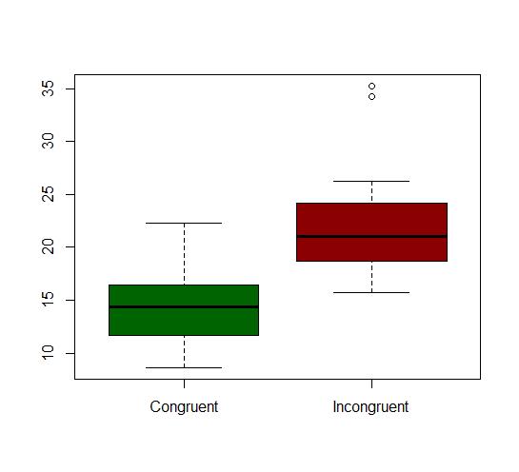

We can see from above box plot that IQR (interquartile range) of reaction time for congruent condition is completely below the IQR of incongruent condition. Therefore reaction times of congruent sample are mostly lesser than incongruent sample. We can also see that median reaction time of congruent samples (14.36 seconds) is considerably less than median of incongruent samples (21.02 seconds).

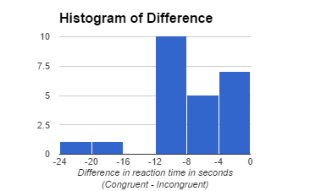

We can see all differences are in negative and most of difference are centered around -8 to -10 (close to our difference mean of -7.96 seconds).

5. *Now, perform the statistical test and report your results. What is your confidence level and your critical statistic value? Do you reject the null hypothesis or fail to reject it? Come to a conclusion in terms of the experiment task. Did the results match up with your expectations?*

**Kind of test**: One-tail paired t-test

**Confidence Level**: 95% ($α = 0.05$)

**Degree of Freedom (**df**)**: 23

**Direction of one-tail t-test**: Negative Tail

**Standard Error of Mean (**SEM**)**: 0.99

**t-statistic** (corresponding to mean difference): -8.02

$t_{critical}$ (one-tail): -1.71

**p-value** (one-tail, alpha=0.05): 0.00000002

**Confidence Interval** (95%): -10.02 to -5.91

**Cohen’s d**: -1.64

**r2**: 0.11

Results Summary: A related sample paired t test showed that the difference in reaction times between the congruent group (n = 24, M = 14.05, SD = 3.56) and the incongruent group (n = 24, M = 22.02, SD = 4.80) were statistically significant, t(23) = -8.02, p = .00000002, 95% CI [-10.02, -5.91], d = -1.64, r2=0.11.

We **reject the null hypothesis** since our t-statistic value of -8.02 is way less than $t_{critical}$ value of -1.71 as well as p-value is way less than 0.05. Therefore we can now say that for Stroop task, reaction time of congruent condition is significantly less than incongruent condition. Further the difference in mean reaction time is around -1.64 away in terms of standard deviation. We can only account for 11% of the observed difference in reaction time with our Stroop task independent variables.

Therefore we have sufficient evidence (95% confidence) to come to conclusion that it does take significantly less time to recognize the color of congruent words than incongruent words.

While it may not have been intuitive to begin with, when I tried out Stroop task for myself, I was mostly slower in reading out actual color in case of incongruent condition. So, the **results matched up to my expectations**.

6. *Optional: What do you think is responsible for the effects observed? Can you think of an alternative or similar task that would result in a similar effect? Some research about the problem will be helpful for thinking about these two questions!*

The reason we are slower in doing Stroop task for incongruent condition (where actual color do not match up with the label text) is that our brains are trained to be faster in reading text than recognizing colors. We are used to processing word meaning while ignoring physical features of the written text. Whereas recognizing the color (and ignoring the semantic meaning of the word being read, which is our usual learned response) is not normally what we learn and in fact opposite of what we regularly train our brains to do. Therefore a kid who is yet to learn to read (but knows colors) or somebody who does not know the language the words are being presented in, may not show this effect.

One similar task is called numerical Stroop effect, which demonstrates relationship between numerical values and physical sizes. When digits are presented visually, they can be physically large or small, irrespective of their actual values. Congruent pairs occur when size and value correspond (e.g., large 5 small 3) while incongruent pairs occur when size and value are incompatible (e.g., large 3 small 5). It was found that when people are asked to compare digits, their reaction time tends to be slower in the case of incongruent pairs.

# References

1. Statistics course at Udacity
2. <https://en.wikipedia.org/wiki/Stroop_effect>
3. <https://en.wikipedia.org/wiki/Numerical_Stroop_effect>
4. <http://www.psytoolkit.org/lessons/stroop.html>
5. <https://faculty.washington.edu/chudler/java/ready.html>
6. <https://s3.amazonaws.com/udacity-hosted-downloads/t-table.jpg>
7. Google Spreadsheet help pages