Student - Performance Report

This report provides detailed insights into student's performance by topic, subtopic, and learning fundamentals.

# Learning Fundamentals

Listening: 97.86%

Grasping: 20.00%

Retention: 20.00%

Application: nan%

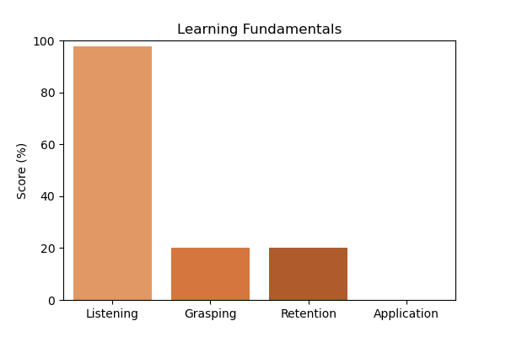

# Topic Accuracy

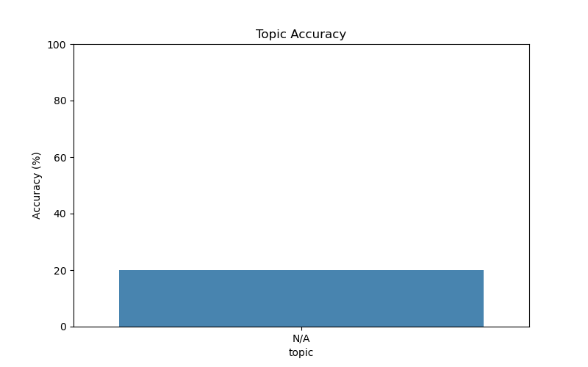

# Subtopic Accuracy

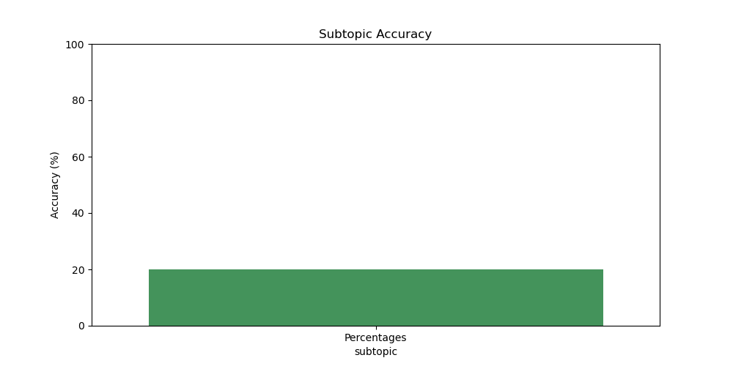

# Question-wise Performance

Q: Half of 1 percent written as a decimal is  
Topic/Subtopic: N/A / Percentages  
Your Answer: b | Correct Answer: a | ❌ Incorrect | Time Taken: 1.78s

Q: A student scored 75 out of 150. Find the percentage.  
Topic/Subtopic: N/A / Percentages  
Your Answer: c | Correct Answer: c | ✅ Correct | Time Taken: 2.61s

Q: 0.2 expressed as a percent is ?  
Topic/Subtopic: N/A / Percentages  
Your Answer: a | Correct Answer: b | ❌ Incorrect | Time Taken: 2.15s

Q: What percent of 2 hours is 30 minutes?  
Topic/Subtopic: N/A / Percentages  
Your Answer: a | Correct Answer: b | ❌ Incorrect | Time Taken: 1.6s

Q: A student scored 240 marks out of 300. Percentage?  
Topic/Subtopic: N/A / Percentages  
Your Answer: a | Correct Answer: c | ❌ Incorrect | Time Taken: 2.57s