Dhamo - Performance Report

This report provides detailed insights into student's performance by topic, subtopic, and learning fundamentals.

# Learning Fundamentals

Listening: 98.11%

Grasping: 30.00%

Retention: 30.00%

Application: nan%

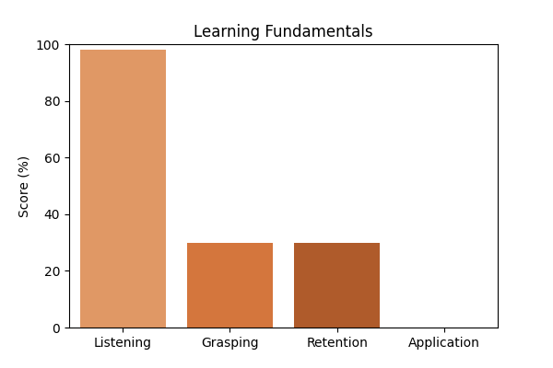

# Topic Accuracy

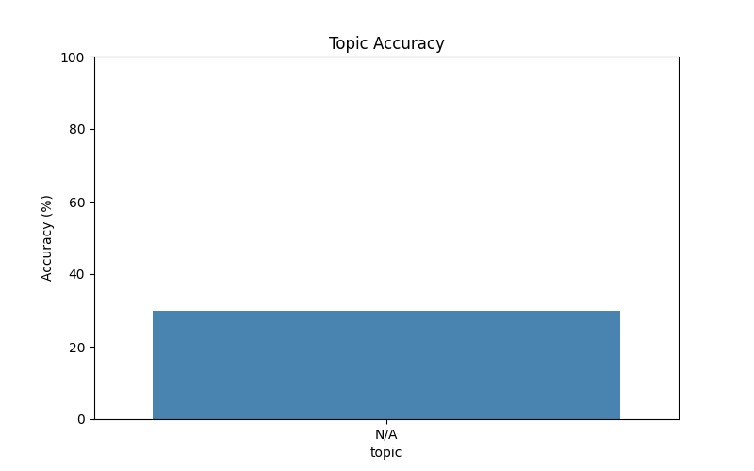

# Subtopic Accuracy

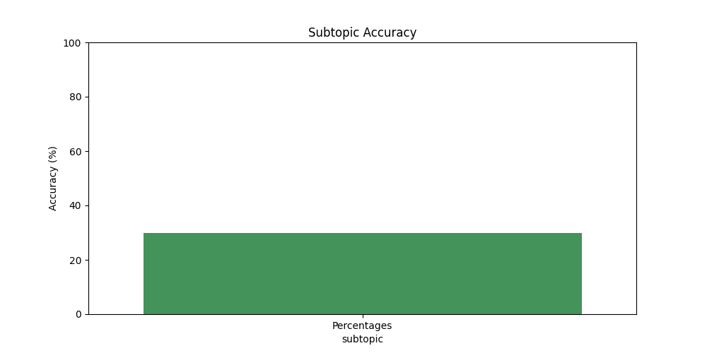

# Question-wise Performance

Q: The ratio 5 : 4 expressed as a percent equals:  
Topic/Subtopic: N/A / Percentages  
Your Answer: b | Correct Answer: d | ❌ Incorrect | Time Taken: 2.02s

Q: What is 15 percent of Rs. 34?  
Topic/Subtopic: N/A / Percentages  
Your Answer: a | Correct Answer: d | ❌ Incorrect | Time Taken: 2.74s

Q: 63% of 3 4/7 is:  
Topic/Subtopic: N/A / Percentages  
Your Answer: a | Correct Answer: a | ✅ Correct | Time Taken: 1.9s

Q: 88% of 370 + 24% of 210 - ? = 118?  
Topic/Subtopic: N/A / Percentages  
Your Answer: b | Correct Answer: b | ✅ Correct | Time Taken: 1.99s

Q: 860% of 50 + 50% of 860 =?  
Topic/Subtopic: N/A / Percentages  
Your Answer: b | Correct Answer: c | ❌ Incorrect | Time Taken: 2.0s

Q: 270 candidate appeared for an examination, of which 252 passed. The pass percentage is:  
Topic/Subtopic: N/A / Percentages  
Your Answer: b | Correct Answer: d | ❌ Incorrect | Time Taken: 1.79s

Q: 0.01 is what percent of 0.1?  
Topic/Subtopic: N/A / Percentages  
Your Answer: b | Correct Answer: b | ✅ Correct | Time Taken: 1.95s

Q: What percent of Rs. 2650 is Rs. 1987.50?  
Topic/Subtopic: N/A / Percentages  
Your Answer: a | Correct Answer: b | ❌ Incorrect | Time Taken: 2.68s

Q: How many litres of pure acid are there in 8 litres of a 20% solution?  
Topic/Subtopic: N/A / Percentages  
Your Answer: b | Correct Answer: c | ❌ Incorrect | Time Taken: 0.0s

Q: Which one of the following shows the best percentage?  
Topic/Subtopic: N/A / Percentages  
Your Answer: a | Correct Answer: b | ❌ Incorrect | Time Taken: 1.87s

# AI Analysis & Motivation

Dhamo's performance in this report is based on the results of the study.