fds - Performance Report

This report provides detailed insights into performance by topic, subtopic, and learning fundamentals.

# Learning Fundamentals

Listening: 96.37%

Grasping: 0.00%

Retention: 0.00%

Application: nan%

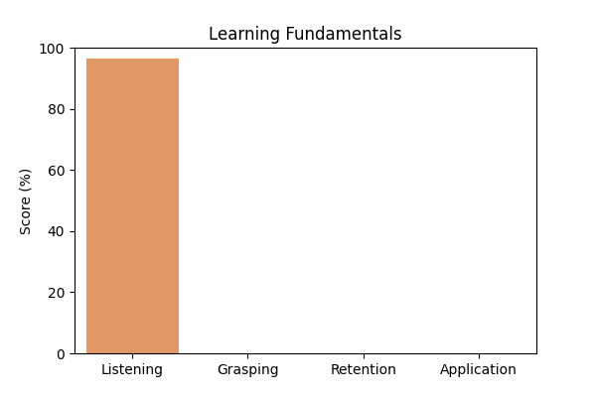

# Topic Accuracy

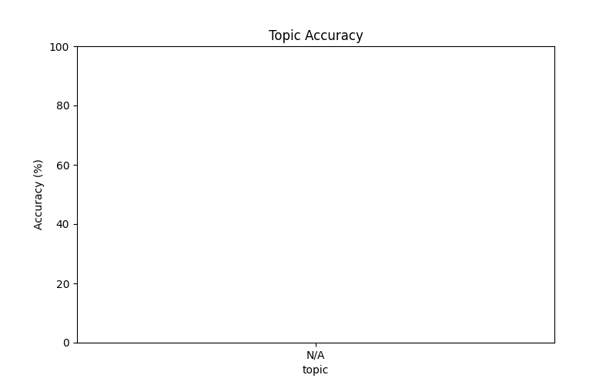

# Subtopic Accuracy

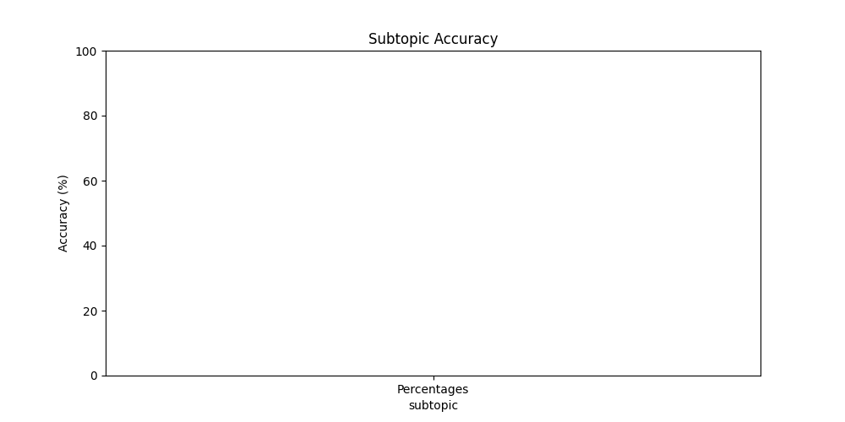

# Result Analysis

Total Questions: 1

Correct Answers: 0

Incorrect Answers: 1

Average Time per Question: 3.63 seconds

# Question-wise Performance

Q: 860% of 50 + 50% of 860 =?  
Topic/Subtopic: N/A / Percentages  
Your Answer: a | Correct Answer: c | ❌ Incorrect | Time Taken: 3.63s

# AI Analysis

The performance in this assessment demonstrates a diligent approach to learning. Topics requiring further attention include: N/A. Areas that may benefit from additional practice: Percentages. Overall accuracy: 0.00%, Average time per question: 3.63s. Maintaining consistent effort and reviewing challenging topics will lead to better outcomes.