jibu - Performance Report

This report provides detailed insights into student's performance by topic, subtopic, and learning fundamentals.

# Learning Fundamentals

Listening: 98.20%

Grasping: 30.00%

Retention: 30.00%

Application: nan%

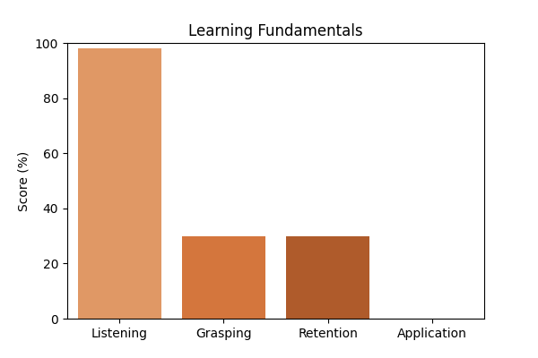

# Topic Accuracy

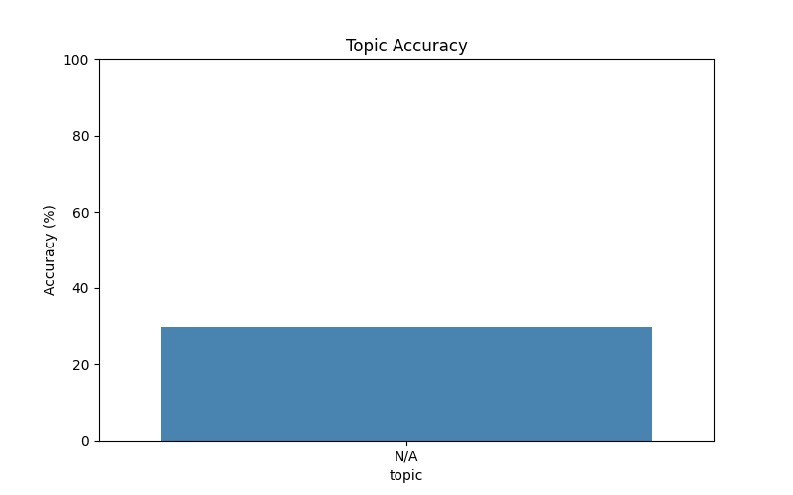

# Subtopic Accuracy

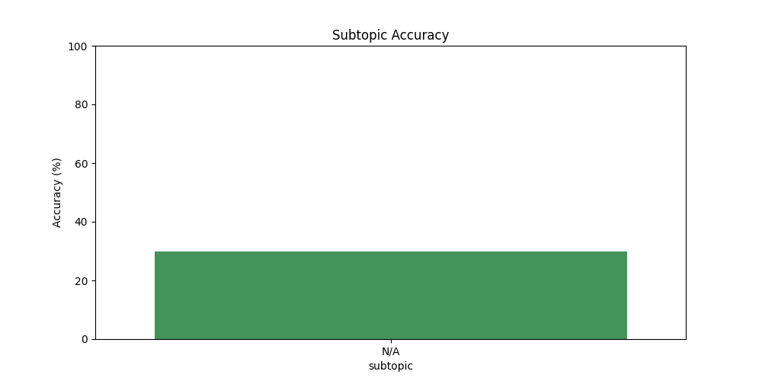

# Question-wise Performance

Q: Which data structure is used to implement a cache with a least recently used (LRU) eviction policy?  
Topic/Subtopic: N/A / N/A  
Your Answer: b | Correct Answer: B | ✅ Correct | Time Taken: 2.18s

Q: What is the time complexity of the best-case scenario for quicksort?  
Topic/Subtopic: N/A / N/A  
Your Answer: b | Correct Answer: B | ✅ Correct | Time Taken: 2.55s

Q: Which machine learning algorithm is used for clustering data points into groups based on their similarity?  
Topic/Subtopic: N/A / N/A  
Your Answer: c | Correct Answer: D | ❌ Incorrect | Time Taken: 2.35s

Q: Which of the following is not a valid access specifier in Java?  
Topic/Subtopic: N/A / N/A  
Your Answer: b | Correct Answer: D | ❌ Incorrect | Time Taken: 1.61s

Q: What is the purpose of the virtual keyword in C++?  
Topic/Subtopic: N/A / N/A  
Your Answer: a | Correct Answer: D | ❌ Incorrect | Time Taken: 1.87s

Q: Which of the following is not a type of software testing?  
Topic/Subtopic: N/A / N/A  
Your Answer: d | Correct Answer: D | ✅ Correct | Time Taken: 1.98s

Q: Which of the following is not a type of virtualization?  
Topic/Subtopic: N/A / N/A  
Your Answer: b | Correct Answer: D | ❌ Incorrect | Time Taken: 1.7s

Q: What is the primary purpose of a load balancer in a network?  
Topic/Subtopic: N/A / N/A  
Your Answer: b | Correct Answer: C | ❌ Incorrect | Time Taken: 1.85s

Q: In the context of computer networks what does TCP stand for?  
Topic/Subtopic: N/A / N/A  
Your Answer: c | Correct Answer: A | ❌ Incorrect | Time Taken: 1.86s

Q: What is the key difference between GPU and CPU?  
Topic/Subtopic: N/A / N/A  
Your Answer: c | Correct Answer: A | ❌ Incorrect | Time Taken: 0.0s

# AI Analysis & Motivation

The views expressed by contributors are their own and not the views of The Hill.