jiburan - Performance Report

This report provides detailed insights into student's performance by topic, subtopic, and learning fundamentals.

# Learning Fundamentals

Listening: 93.77%

Grasping: 0.00%

Retention: 0.00%

Application: nan%

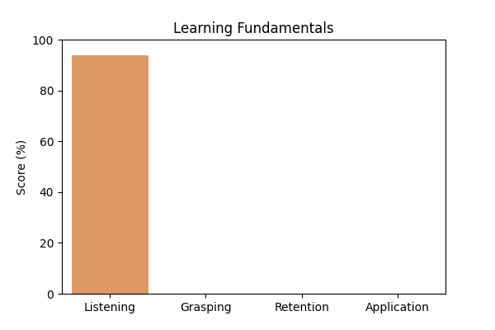

# Topic Accuracy

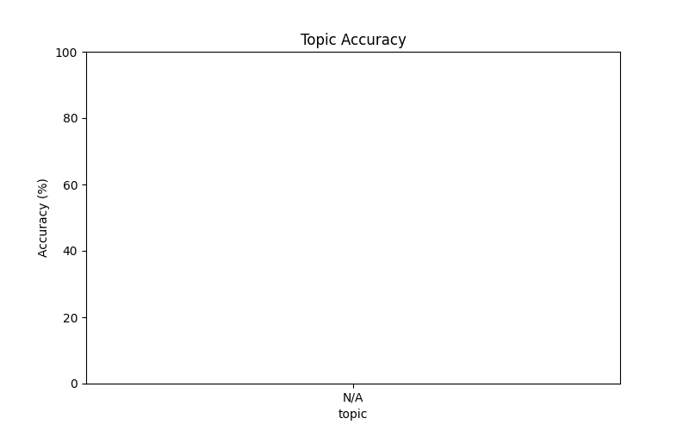

# Subtopic Accuracy

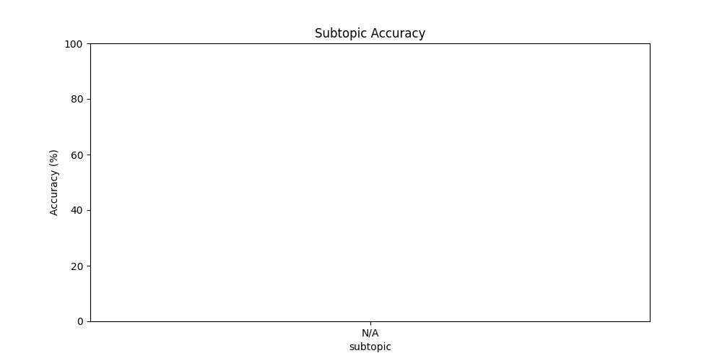

# Question-wise Performance

Q: Which sorting algorithm is known for its stability?  
Topic/Subtopic: N/A / N/A  
Your Answer: b | Correct Answer: A | ❌ Incorrect | Time Taken: 0.0s

Q: What is the process of preparing raw data by cleaning transforming and normalizing it for machine learning?  
Topic/Subtopic: N/A / N/A  
Your Answer: c | Correct Answer: A | ❌ Incorrect | Time Taken: 1.48s

Q: Which machine learning algorithm is inspired by the behavior of neurons in the human brain?  
Topic/Subtopic: N/A / N/A  
Your Answer: a | Correct Answer: D | ❌ Incorrect | Time Taken: 48.37s

Q: The loss function in a machine learning model measures:  
Topic/Subtopic: N/A / N/A  
Your Answer: d | Correct Answer: C | ❌ Incorrect | Time Taken: 1.5s

Q: What is the name of the technique used to deal with overfitting in machine learning models?  
Topic/Subtopic: N/A / N/A  
Your Answer: d | Correct Answer: B | ❌ Incorrect | Time Taken: 1.47s

Q: What is the purpose of feature scaling in machine learning?  
Topic/Subtopic: N/A / N/A  
Your Answer: b | Correct Answer: A | ❌ Incorrect | Time Taken: 2.6s

Q: Which machine learning algorithm is used for recommendation systems and can predict the preferences of users based on their past behavior?  
Topic/Subtopic: N/A / N/A  
Your Answer: b | Correct Answer: D | ❌ Incorrect | Time Taken: 1.82s

Q: Which of the following is not a type of software testing?  
Topic/Subtopic: N/A / N/A  
Your Answer: b | Correct Answer: D | ❌ Incorrect | Time Taken: 1.68s

Q: What is the key difference between public and private inheritance in C++?  
Topic/Subtopic: N/A / N/A  
Your Answer: b | Correct Answer: A | ❌ Incorrect | Time Taken: 1.67s

Q: What is the key difference between depth-first search (DFS) and breadth-first search (BFS)?  
Topic/Subtopic: N/A / N/A  
Your Answer: a | Correct Answer: D | ❌ Incorrect | Time Taken: 1.76s

# AI Analysis & Motivation

Summarize this student's performance and add a motivational paragraph for jiburan: “I have a lot of respect for you, and I have my respect for you,“ he said. “I am grateful to you.“