Dhamo123 - Performance Report

This report provides detailed insights into performance by topic, subtopic, and learning fundamentals.

# Learning Fundamentals

Listening: 98.32%

Grasping: 30.00%

Retention: 30.00%

Application: nan%

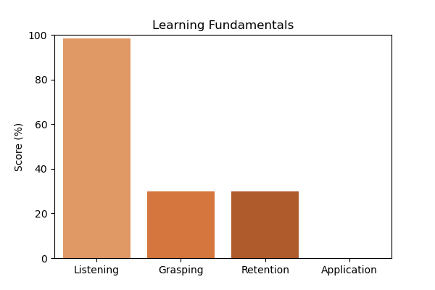

# Topic Accuracy

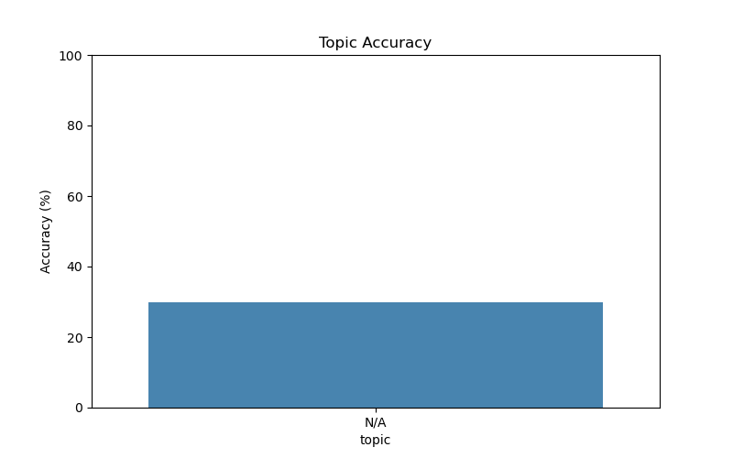

# Subtopic Accuracy

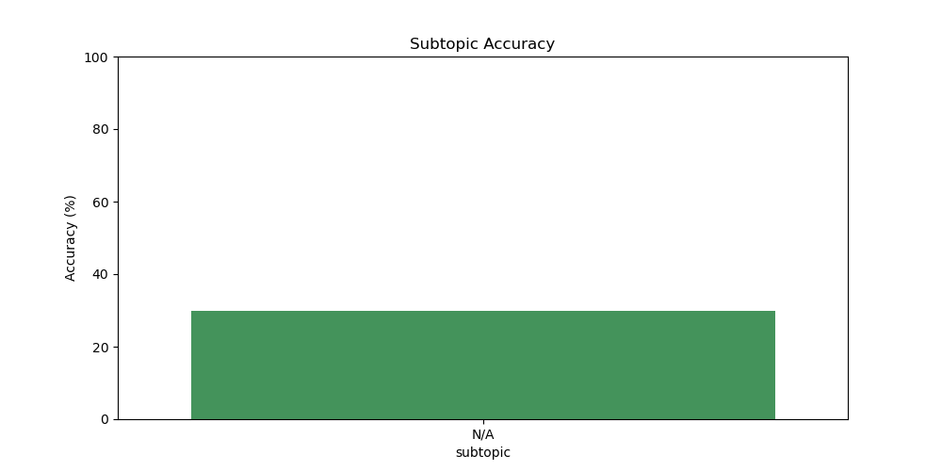

# Result Analysis

Total Questions: 10

Correct Answers: 3

Incorrect Answers: 7

Average Time per Question: 1.68 seconds

# Question-wise Performance

Q: Which data structure is used to implement a cache with a least recently used (LRU) eviction policy?  
Topic/Subtopic: N/A / N/A  
Your Answer: a | Correct Answer: B | ❌ Incorrect | Time Taken: 2.65s

Q: What is the time complexity of the best-case scenario for quicksort?  
Topic/Subtopic: N/A / N/A  
Your Answer: a | Correct Answer: B | ❌ Incorrect | Time Taken: 1.62s

Q: Which of the following is not a fundamental data type in C?  
Topic/Subtopic: N/A / N/A  
Your Answer: c | Correct Answer: B | ❌ Incorrect | Time Taken: 1.49s

Q: What is the process of preparing raw data by cleaning transforming and normalizing it for machine learning?  
Topic/Subtopic: N/A / N/A  
Your Answer: d | Correct Answer: A | ❌ Incorrect | Time Taken: 1.53s

Q: What is the purpose of feature scaling in machine learning?  
Topic/Subtopic: N/A / N/A  
Your Answer: c | Correct Answer: A | ❌ Incorrect | Time Taken: 1.65s

Q: What is the purpose of the static keyword in C++?  
Topic/Subtopic: N/A / N/A  
Your Answer: c | Correct Answer: C | ✅ Correct | Time Taken: 2.24s

Q: What is the purpose of the yield statement in Python?  
Topic/Subtopic: N/A / N/A  
Your Answer: c | Correct Answer: B | ❌ Incorrect | Time Taken: 0.0s

Q: What is the purpose of the lambda keyword in Python?  
Topic/Subtopic: N/A / N/A  
Your Answer: a | Correct Answer: A | ✅ Correct | Time Taken: 2.35s

Q: What is the primary purpose of a compiler in programming?  
Topic/Subtopic: N/A / N/A  
Your Answer: a | Correct Answer: A | ✅ Correct | Time Taken: 1.57s

Q: In the context of operating systems what is thrashing?  
Topic/Subtopic: N/A / N/A  
Your Answer: b | Correct Answer: A | ❌ Incorrect | Time Taken: 1.66s

# AI Analysis

This report highlights the results across various topics and subtopics, reflecting strengths and areas for improvement. Topics requiring further attention include: N/A. Areas that may benefit from additional practice: N/A. Overall accuracy: 30.00%, Average time per question: 1.68s. Optimizing time management and concentrating on improvement areas can enhance overall performance.