dhamo1 - Performance Report

This report provides detailed insights into performance by topic, subtopic, and learning fundamentals.

# Learning Fundamentals

Listening: 91.15%

Grasping: 33.33%

Retention: 33.33%

Application: nan%

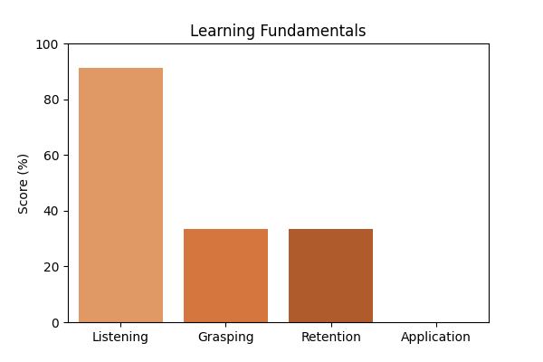

# Topic Accuracy

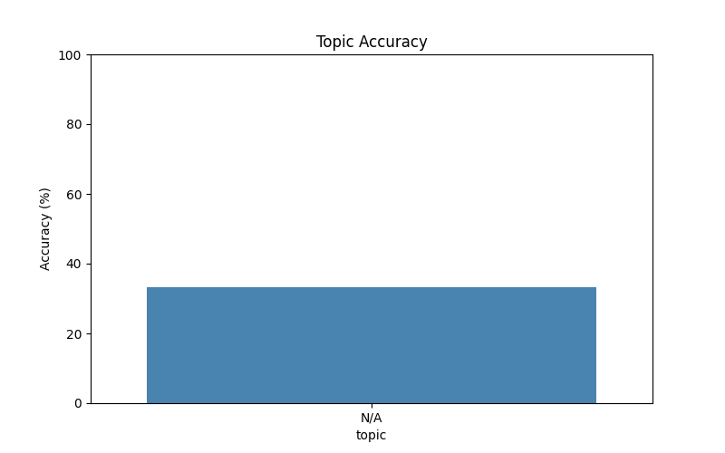

# Subtopic Accuracy

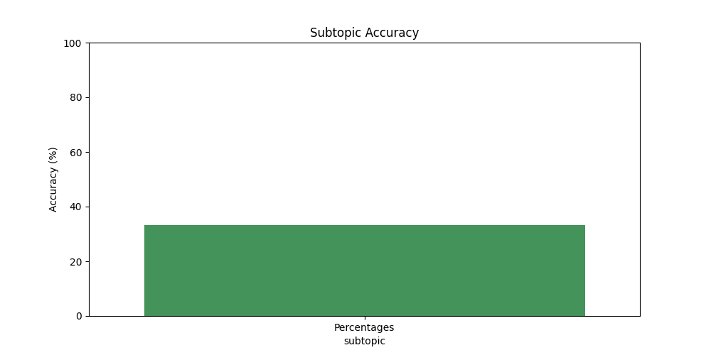

# Result Analysis

Total Questions: 6

Correct Answers: 2

Incorrect Answers: 4

Average Time per Question: 8.85 seconds

# Question-wise Performance

Q: Half of 1 percent written as a decimal is:  
Topic/Subtopic: N/A / Percentages  
Your Answer: c | Correct Answer: a | ❌ Incorrect | Time Taken: 1.6s

Q: 63% of 3 4/7 is:  
Topic/Subtopic: N/A / Percentages  
Your Answer: c | Correct Answer: a | ❌ Incorrect | Time Taken: 44.75s

Q: 88% of 370 + 24% of 210 - ? = 118?  
Topic/Subtopic: N/A / Percentages  
Your Answer: b | Correct Answer: b | ✅ Correct | Time Taken: 1.79s

Q: 860% of 50 + 50% of 860 =?  
Topic/Subtopic: N/A / Percentages  
Your Answer: c | Correct Answer: c | ✅ Correct | Time Taken: 2.39s

Q: 0.01 is what percent of 0.1?  
Topic/Subtopic: N/A / Percentages  
Your Answer: d | Correct Answer: b | ❌ Incorrect | Time Taken: 0.0s

Q: Which one of the following shows the best percentage?  
Topic/Subtopic: N/A / Percentages  
Your Answer: a | Correct Answer: b | ❌ Incorrect | Time Taken: 2.58s

# AI Analysis

The performance in this assessment demonstrates a diligent approach to learning. Topics requiring further attention include: N/A. Areas that may benefit from additional practice: Percentages. Overall accuracy: 33.33%, Average time per question: 8.85s. Focused practice on weaker areas is recommended to achieve higher accuracy in future assessments.