ghghj - Performance Report

This report provides detailed insights into student's performance by topic, subtopic, and learning fundamentals.

# Learning Fundamentals

Listening: 97.56%

Grasping: 40.00%

Retention: 40.00%

Application: nan%

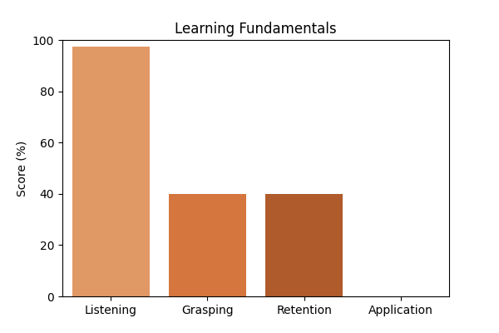

# Topic Accuracy

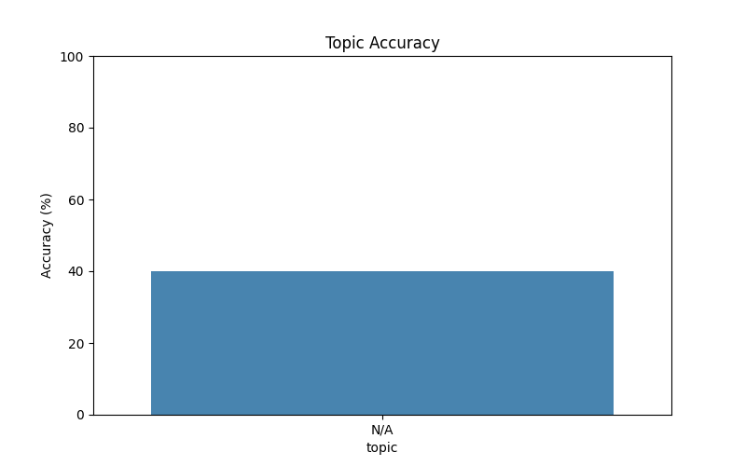

# Subtopic Accuracy

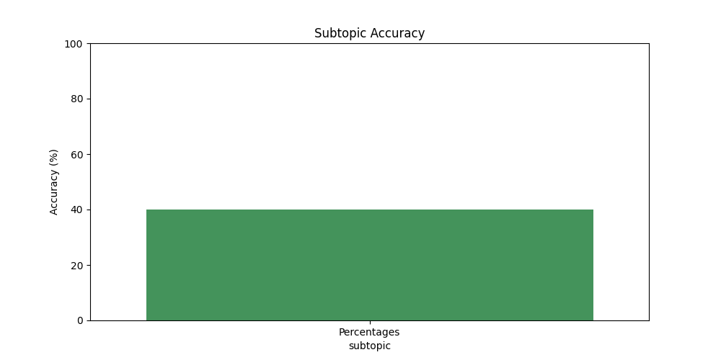

# Question-wise Performance

Q: Half of 1 percent written as a decimal is:  
Topic/Subtopic: N/A / Percentages  
Your Answer: b | Correct Answer: a | ❌ Incorrect | Time Taken: 1.81s

Q: What is 15 percent of Rs. 34?  
Topic/Subtopic: N/A / Percentages  
Your Answer: b | Correct Answer: d | ❌ Incorrect | Time Taken: 2.52s

Q: 88% of 370 + 24% of 210 - ? = 118?  
Topic/Subtopic: N/A / Percentages  
Your Answer: b | Correct Answer: b | ✅ Correct | Time Taken: 7.0s

Q: 40% of 1640 + ? = 35% of 980 + 150% of 850  
Topic/Subtopic: N/A / Percentages  
Your Answer: c | Correct Answer: c | ✅ Correct | Time Taken: 2.96s

Q: 60% of 264 is the same as:  
Topic/Subtopic: N/A / Percentages  
Your Answer: c | Correct Answer: b | ❌ Incorrect | Time Taken: 1.72s

Q: What percent of 7.2 kg is 18 gms?  
Topic/Subtopic: N/A / Percentages  
Your Answer: b | Correct Answer: b | ✅ Correct | Time Taken: 0.0s

Q: What percent of Rs. 2650 is Rs. 1987.50?  
Topic/Subtopic: N/A / Percentages  
Your Answer: c | Correct Answer: b | ❌ Incorrect | Time Taken: 1.65s

Q: What percent of day is 3 hours?  
Topic/Subtopic: N/A / Percentages  
Your Answer: b | Correct Answer: a | ❌ Incorrect | Time Taken: 1.73s

Q: How many litres of pure acid are there in 8 litres of a 20% solution?  
Topic/Subtopic: N/A / Percentages  
Your Answer: c | Correct Answer: c | ✅ Correct | Time Taken: 2.0s

Q: Which one of the following shows the best percentage?  
Topic/Subtopic: N/A / Percentages  
Your Answer: a | Correct Answer: b | ❌ Incorrect | Time Taken: 3.01s

# AI Analysis & Motivation

Write a short, professional paragraph summarizing ghghj's performance in this report and include a motivational sentence to encourage improvement. Keep it concise, positive, and suitable for an academic report.