hjkl - Performance Report

This report provides detailed insights into performance by topic, subtopic, and learning fundamentals.

# Learning Fundamentals

Listening: 98.32%

Grasping: 33.33%

Retention: 33.33%

Application: nan%

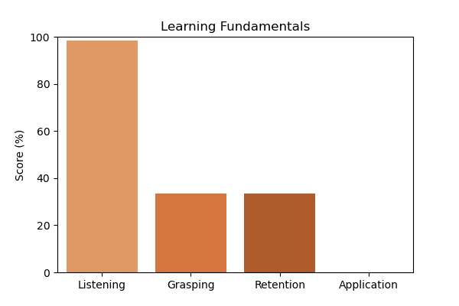

# Topic Accuracy

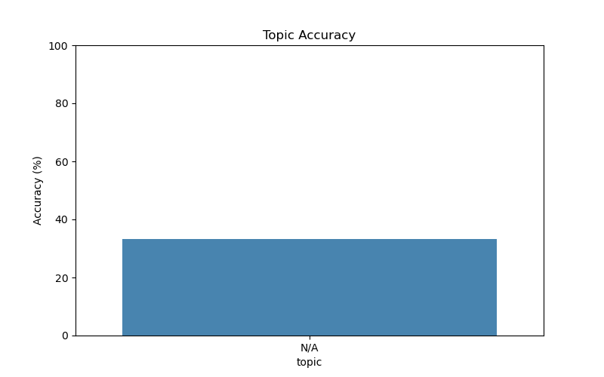

# Subtopic Accuracy

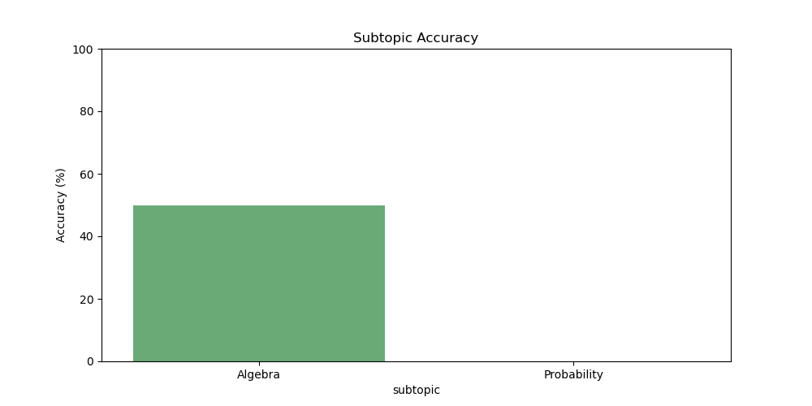

# Result Analysis

Total Questions: 3

Correct Answers: 1

Incorrect Answers: 2

Average Time per Question: 1.68 seconds

# Question-wise Performance

Q: If x + 2 = 7, then the value of x is:  
Topic/Subtopic: N/A / Algebra  
Your Answer: c | Correct Answer: c | ✅ Correct | Time Taken: 2.83s

Q: If 3x = 12, then x = ?  
Topic/Subtopic: N/A / Algebra  
Your Answer: a | Correct Answer: c | ❌ Incorrect | Time Taken: 2.2s

Q: The probability of getting a head in tossing a fair coin is:  
Topic/Subtopic: N/A / Probability  
Your Answer: a | Correct Answer: b | ❌ Incorrect | Time Taken: 0.0s

# AI Analysis

The performance in this assessment demonstrates a diligent approach to learning. Topics requiring further attention include: N/A. Areas that may benefit from additional practice: Algebra, Probability. Overall accuracy: 33.33%, Average time per question: 1.68s. Maintaining consistent effort and reviewing challenging topics will lead to better outcomes.