jiburan - Performance Report

This report provides detailed insights into performance by topic, subtopic, and learning fundamentals.

# Learning Fundamentals

Listening: 98.46%

Grasping: 66.67%

Retention: 66.67%

Application: nan%

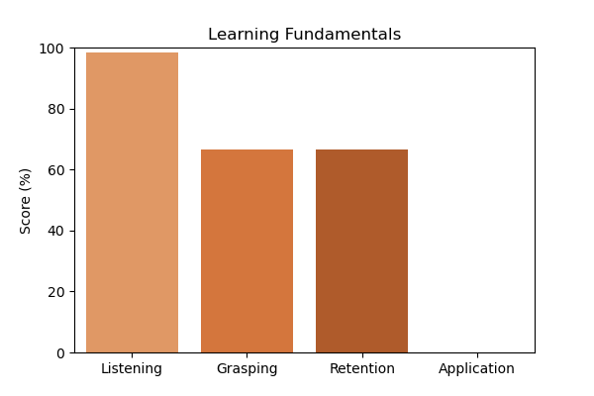

# Topic Accuracy

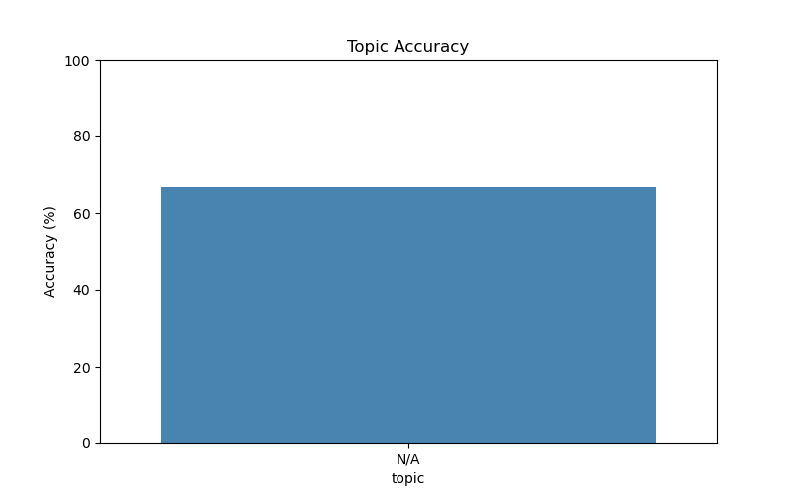

# Subtopic Accuracy

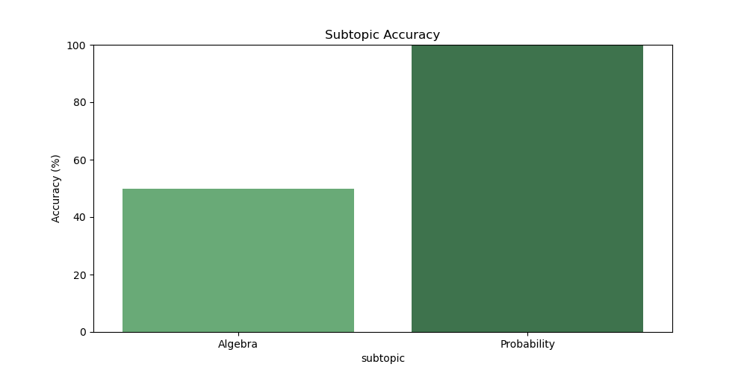

# Result Analysis

Total Questions: 3

Correct Answers: 2

Incorrect Answers: 1

Average Time per Question: 1.54 seconds

# Question-wise Performance

Q: If x + 2 = 7, then the value of x is:  
Topic/Subtopic: N/A / Algebra  
Your Answer: c | Correct Answer: c | ✅ Correct | Time Taken: 1.94s

Q: If 3x = 12, then x = ?  
Topic/Subtopic: N/A / Algebra  
Your Answer: a | Correct Answer: c | ❌ Incorrect | Time Taken: 2.67s

Q: The probability of getting a head in tossing a fair coin is:  
Topic/Subtopic: N/A / Probability  
Your Answer: b | Correct Answer: b | ✅ Correct | Time Taken: 0.0s

# AI Analysis

This report highlights the results across various topics and subtopics, reflecting strengths and areas for improvement. Topics requiring further attention include: N/A. Areas that may benefit from additional practice: Algebra. Overall accuracy: 66.67%, Average time per question: 1.54s. Maintaining consistent effort and reviewing challenging topics will lead to better outcomes.