***Vehicle Bazar***

***OLX***: We can buy or sale second hand items Max--vehicles.

***Problem***: we can buy only second hand vehicle in olx.

***Solution***: Vehicle Bazar.

***Vehicle Bazar***: - You can buy old vehicle as well as brand new vehicle.

By merging old vehicle owner's and new vehicle showroom in Vehicle Bazar.

***Abstrac***t: we can buy new or old vehicle in your preferred location.

We no need to jump multiple website to search new and old vehicles.

Gathering all Information in “VEHICLE BAZAR’

***Type Of User***:

*Customers.

*Showroom Owners.

*Old Vehicle owner.

*Admin.

***Modular:***

***Admin***.

* Crate a storage for users.
* Configure security settings with several protection levels.(Protecting data from data theft)
* Add and manage the membership planes.
* Create a payment page based membership plans.
* Filter the User's based on membership plane.
* Create a Profile for user after payment. Base on membership plane.
* Design the profile based on user proposal.
* Enable the customer to view the users.
* Enable the customer to interact with users.
* Enable the payment process between user and customer.
* Enable the user to sale their vehicle to customers.

***\*Showroom owner:-***

* The showroom owner should register themself to become a member in Vehicle Bazar.
* The SR owner should select the membership plane.
* After selected the membership plane. They redirected to payment page.
* After the payment process get finished by SR owner.
* The Sw room will be a member in Vehicle Bazar.
* Based on a membership plane profile will create for Sr owner.
* The showroom owner can propose the design of their page.
* SR owner have enable to provide detail about vehicle's model and prize.
* SR owner have enable to update the detail about stock of vehicles [availability].
* SR owner enabled to provide detail about opening time, close, & emi detail & insurance...
* Etc........
* SR owner have enabled to interact with customer.
* SR owner have Enabled for payment process with customer.
* After all this process SR owner can advertise the vehicle.
* Now the showroom owner can sale the vehicle to customers via Vehicle Bazar.

***Old Vehicle owner***.

* The old vehicle seller should register themself to become a member.
* The old vehicle seller should select the type of membership.
* After selecting the membership plane. They redirect to payment page.
* After the payment process have completed.
* The new profile will create for Old vehicle owner based on plane.
* The old vehicle owner have enabled to add a detail about vehicle.
* OV owner have enabled to interact with customer.
* OV owner have Enabled for payment process with customer.
* Now the bike data will enabled to show customer.
* Now the bike owner enabled to interact with customers.
* After this all process vehicle owner can sale the bike to customers.

***Customer***

* Customer need to register by using mobile number or E-mail.
* After registration get success.
* The profile will create for customer.
* The customer enabled to view the bikes availability.
* The customer was enabled to interact with dealers.
* The customer was enabled to make payment with dealers.
* The customer was enabled to buy a bike in Vehicle Bazar

***Work Flow with Functionalities & Wire Frame***

***User’s Main Page***

Main page Functionalities

* About
* Contact
* Membership
* Login
* Available vehicles in screen
* Location Search
* Dream Bike Search

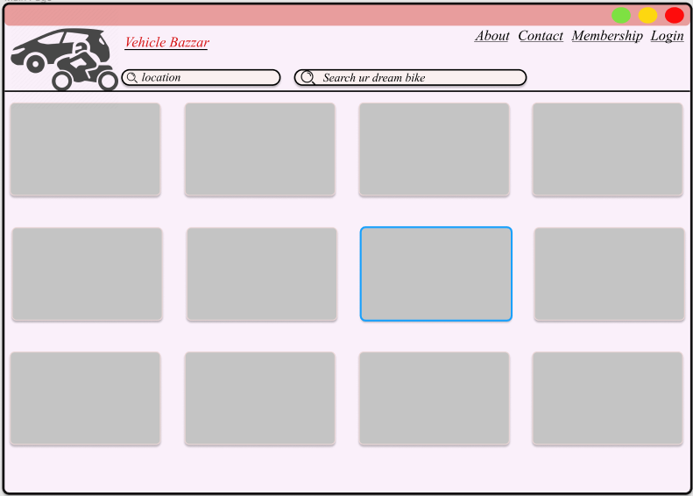

***User’s Selection Page***

***Functionalities***

* About
* Contact
* Membership
* Login
* Submit
* Location

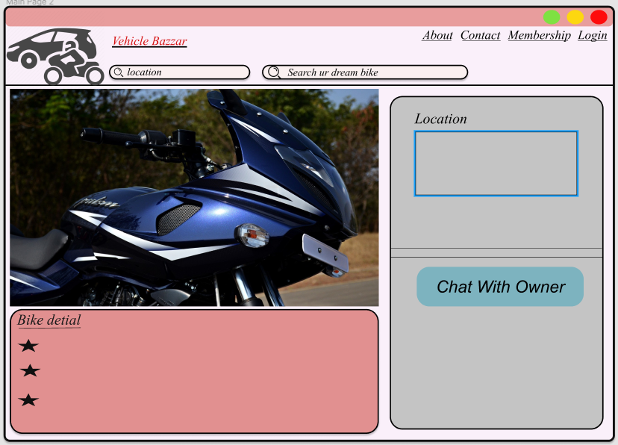

***Login page***

***Functionalities***

* Google Account
* Face book
* Create Account

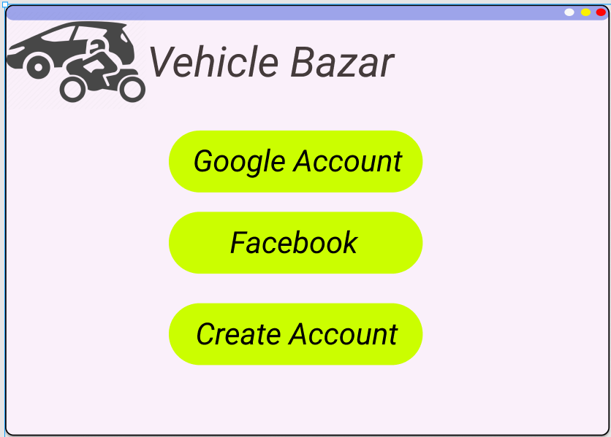

***Create Account***

***Functionalities***

* Submit
* Help
* Forget Password
* Show Password

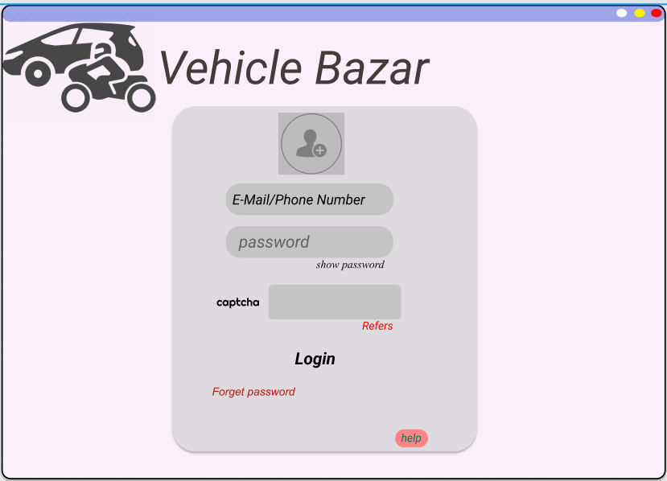

Login

Functionalities

* Verify
* Resend OTP
* Change

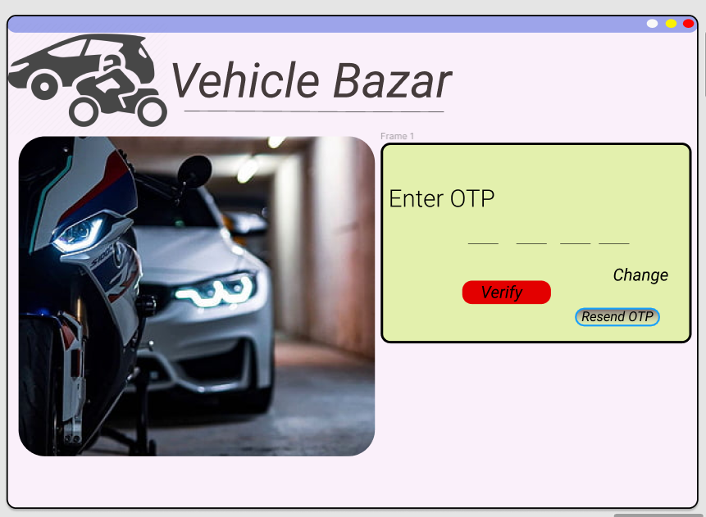

Forget Password

Functionalities

* Verify
* Resend OTP
* Change

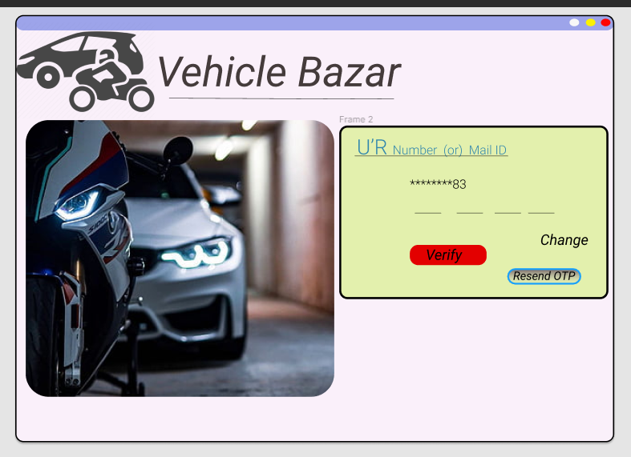

***Membership plane***

***Functionalities***

* Pay Now

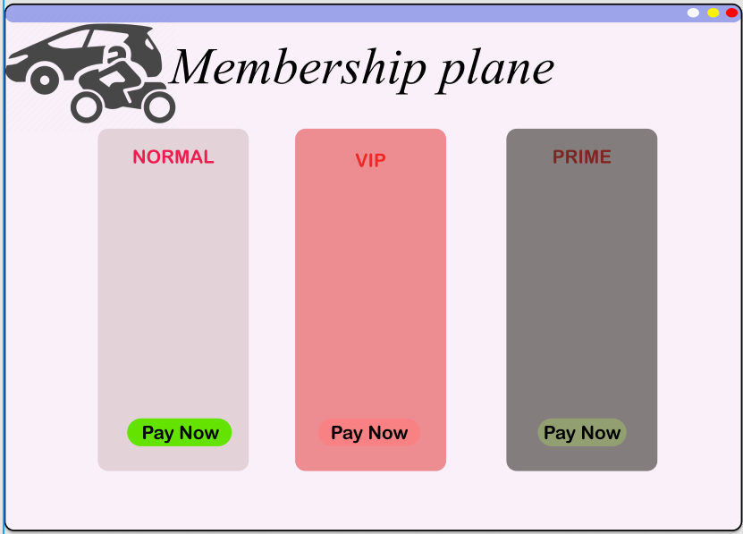

***Payment Method***

***Functionalities***

* About
* Contact
* Membership
* Login
* Location
* Search ur dream vehicle
* Credit card
* Debit card
* Account
* UPI

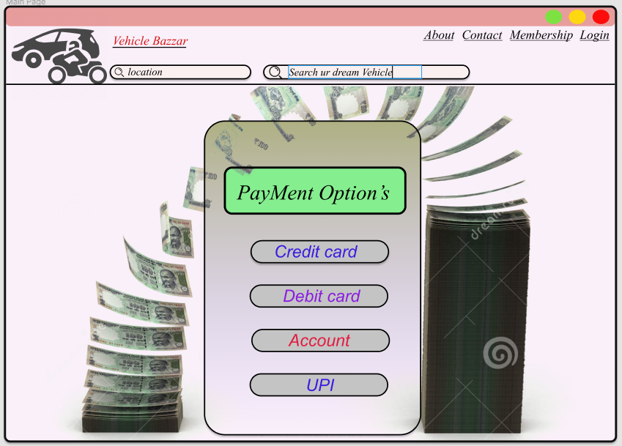

***Account Pay***

***Functionalities***

* Clear
* Pay now

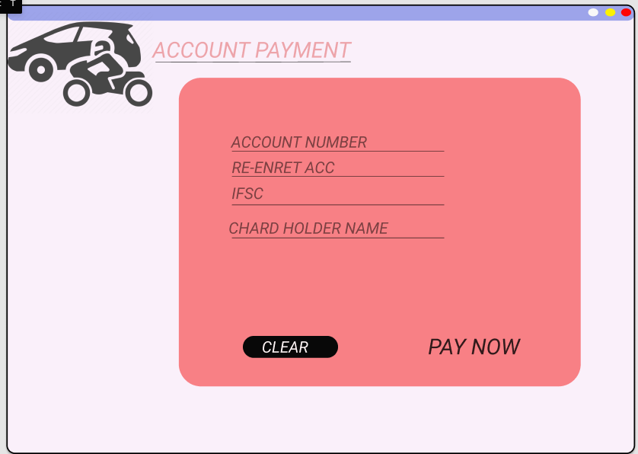

***Credit Card Pay***

***Functionalities***

* Clear
* Pay now

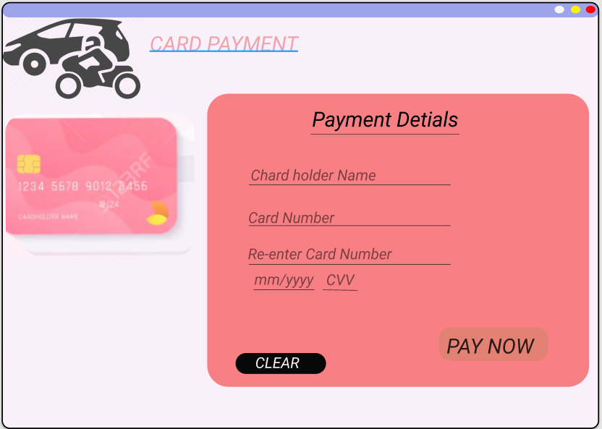

***Payment Process***

***Functionalities***

* Resend OTP
* Refresh
* Pay
* Clear

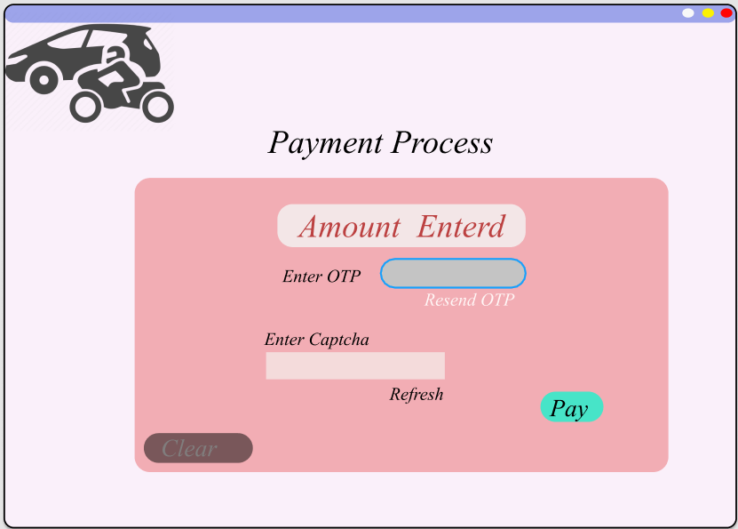

**Creating a Database**

**\*\*User_Master**

User_Id User_Type

Vb1 Showroom_Owner

Vb2 Old_Vehicle_Owner

Vb3 Customer

Vb4 Admin

**\*\*Vehicle_catogery _Master**

**Catogery_ID (PK) Vehicle_Catogery**

Vc1 New Car

Vc2 New Bike

Vc3 Old Car

Vc4 Old Bike

**\*\*Bike_Brand Master**

**Brand_ID Brand-named Model**

Bo1 Yamaha ----------

Bo2 Bajaj ----------

Bo3 Honda ----------

Bo4 KTM ----------

Bo5 RE ----------

**\*\*car_Brand Master**

**Brand_ID Brand-named Model**

Co1 Tata ----------

Co2 Hyundai ----------

Co3 Ford ----------

Co4 Nissan ----------

Co5 KIA ----------

**\*\*Payment Method _ Master**

**Pay Method ID (PK) Payment Method Payment Data**

Pay_Met_1 Credit Card Necessary Data

Pay_Met_2 Debit Card Necessary Data

Pay_Met_3 Account Pay Necessary Data

Pay_Met_4 Net Banking` Necessary Data

Pay_Met_5 UPI ID Necessary Data

**\*\*Login**

1. User ID (PK)
2. First Name
3. Last Name
4. Password
5. Contact Number
6. Location
7. User_Type Id-----<MASTER>

**\*\*Showroom_Owner Profile**

1. SW_Id(PK)
2. Showroom Name
3. Shop Open Time
4. Shop Close Time
5. Banner Details
6. Vehicle_Catogery(FK)-----<MASTER>

**\*\*Showroom_vehicle**

1. SR_Vehicle ID(PK)
2. Vehicle_catogery_ID(FK)---<MASTER>
3. Bike_Brand_ID(FK)---<MASTER>
4. Car_Brand_ID(FK)---<MASTER>
5. Stock vehicle
6. Prize
7. Photo
8. Stock Details

**\*\*New Vehicle Payment Data**

1. New_Vehicle_Payment ID(PK)
2. Pay_Met_ID(FK) ----<MASTER>

**\*\*New Vehicle Bill Data**

1. New_Bill_ID(PK)
2. Invoice Number
3. User ID(FK)
4. Bike_Brand_ID(FK)---<MASTER>
5. Car_Brand_ID(FK)---<MASTER>
6. Bill Amount
7. Bill Date
8. Bill Time
9. Description

**\*\*Second _Hand Vehicle Profile**

1. SH_ID(PK)
2. Vehicle_catogery_ID(FK)
3. Bike_Brand_ID(FK)
4. Car_Brand_ID(FK)
5. kilometre Driven
6. Photo
7. Prize

**\*\*Old_Vehicle_Payment Data**

1. Old_Vehicle_Payment ID(PK)
2. Pay_Met_ID(FK) ----<MASTER>

**\*\*Old Vehicle Bill Data**

1. OlD_Bill_ID(PK)
2. Invoice Number
3. User ID(FK)
4. Bike_Brand_ID(FK)---<MASTER>
5. Car_Brand_ID(FK)---<MASTER>
6. Bill Amount
7. Bill Date
8. Bill Time
9. Description

**\*\*Customer Booked**

1. Customer_ID(PK)
2. User ID(FK)
3. Bike_Brand_ID(FK)---<MASTER>
4. Car_Brand_ID(FK)---<MASTER>
5. Pay_Met_ID(FK) ----<MASTER>
6. OlD_Bill_ID(PK)
7. New_Bill_ID(PK)