**AIM -**Design a system for a box with four cabinets such that, whenever an empty cabinet is occupied by anything, it automatically changes its color from green to blue.

**Apparatus :-**

1. Breadboard.
2. Arduino Uno.
3. Wires.
4. Ultrasonic sensors.
5. RGB LED.
6. Resistor.

**Circuit Diagram :-**

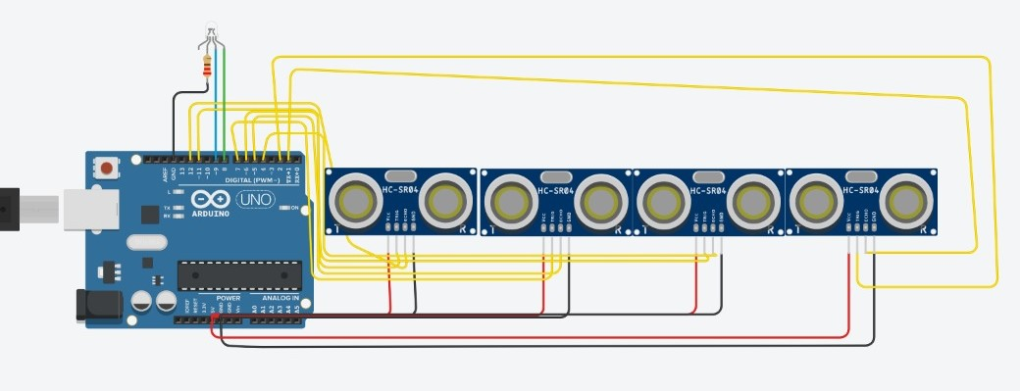

**Theory : -**

Code –

int led1 = 8;

int led2 = 9;

int trigPin1 = 11;

int echoPin1 = 12;

int trigPin2 = 7;

int echoPin2 = 6;

int trigPin3 = 5;

int echoPin3 = 4;

int trigPin4 =2 ;

int echoPin4 = 1;

long cm1, cm2, cm3,cm4, duration1, duration2, duration3,duration4;

void setup()

{

pinMode(trigPin1, OUTPUT);

pinMode(echoPin1, INPUT);

pinMode(trigPin2, OUTPUT);

pinMode(echoPin2, INPUT);

pinMode(trigPin3, OUTPUT);

pinMode(echoPin3, INPUT);

pinMode(trigPin4, OUTPUT);

pinMode(echoPin4, INPUT);

Serial.begin(9600);

}

void loop()

{

digitalWrite(led1, HIGH);

digitalWrite(trigPin1, LOW);

digitalWrite(trigPin1, HIGH);

digitalWrite(trigPin1, LOW);

pinMode(echoPin1, INPUT);

duration1 = pulseIn(echoPin1, HIGH);

cm1 = (duration1)*0.0342/2;

if (cm1<50)

{

digitalWrite(led1, LOW);

digitalWrite(led2, HIGH);

}

digitalWrite(trigPin2, LOW);

digitalWrite(trigPin2, HIGH);

digitalWrite(trigPin2, LOW);

pinMode(echoPin2, INPUT);

duration2 = pulseIn(echoPin2, HIGH);

cm2 = (duration2)*0.0342/2;

if (cm2<50)

{

digitalWrite(led1, LOW);

digitalWrite(led2, HIGH);

}

digitalWrite(trigPin3, LOW);

digitalWrite(trigPin3, HIGH);

digitalWrite(trigPin3, LOW);

pinMode(echoPin3, INPUT);

duration3 = pulseIn(echoPin3, HIGH);

cm3 = (duration3)*0.0342/2;

if (cm3<50)

{

digitalWrite(led1, LOW);

digitalWrite(led2, HIGH);

}

digitalWrite(trigPin4, LOW);

digitalWrite(trigPin4, HIGH);

digitalWrite(trigPin4, LOW);

pinMode(echoPin4, INPUT);

duration4 = pulseIn(echoPin4, HIGH);

cm4 = (duration4)*0.0342/2;

if (cm4<50)

{

digitalWrite(led1, LOW);

digitalWrite(led2, HIGH);

}

}

Concepts Used -

1. Arduino Uno’s digital output pins.
2. Code for LED according to Ultrasonic wave distance.
3. Bread-board.
4. Ultrasonic sensor to detect distance between object and sensor.

Learnings and Observations -

1. Improved problem solving and using Arduino UNO IDE.
2. Learned about echo and its working.
3. The concept of echo and why we take distance as 2*Distance between object and sensor.

Precautions -

1. RGB should be connected correctly.
2. Check for any damages in the arduino cable.
3. Check proper connections RGB LED and Arduino.
4. Check all the connections properly.

Learning Outcomes -

1. Working of a bread-board.
2. Improved understanding of the code used in Arduino IDE.
3. Connections on breadboard and working of Arduino IDE and Breadboard.
4. Use of Ultrasonic sensor in Arduino to control RGB LED.
5. Learned about echo and its principle.