Development

Configuration Activities
- Creation of Laptop Request Catalog Item.
- Configuration of catalog variables.
- Implementation of Catalog UI Policies.
- Creation of Reset Form UI Action.
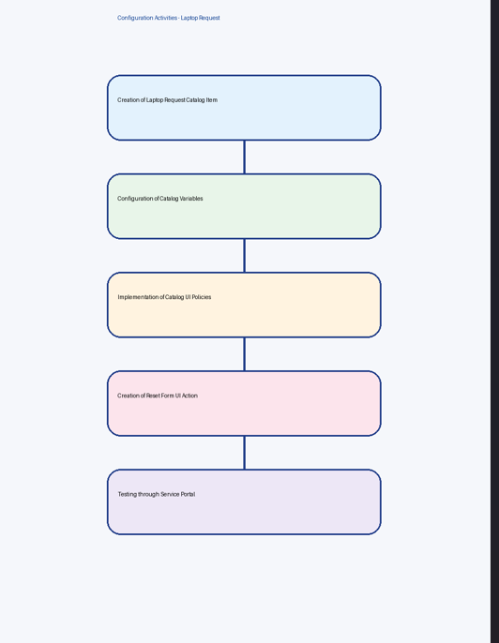
- Testing through Service Portal.

Application Development
- Laptop Request Catalog Item created under Service Catalog.
- Dynamic behavior implemented using UI Policies.
- Reset functionality added using UI Action.
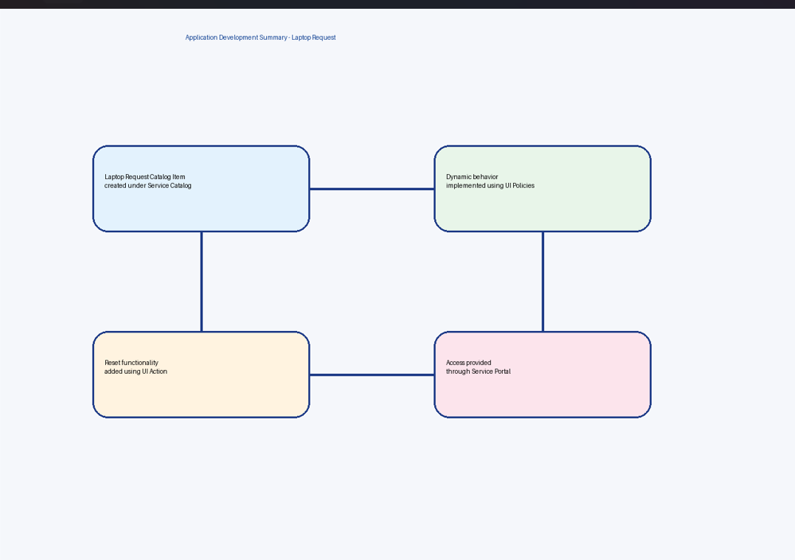
- Access provided through Service Portal.

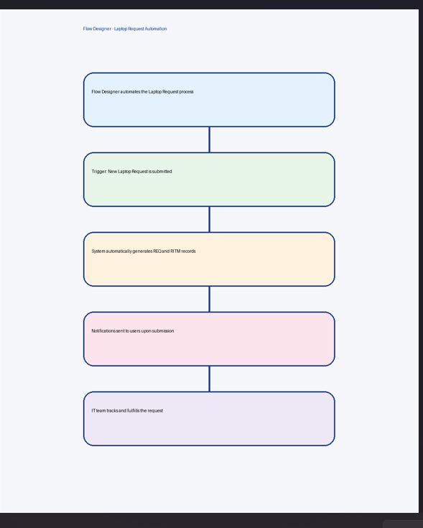
Workflow Development
Flow Designer is used to automate the laptop request process.

- The flow is triggered when a new laptop request is submitted.
- The system automatically generates REQ and RITM records.
- Notifications can be sent to users upon submission.
- IT team can track and fulfill the request efficiently.

References
https://developer.servicenow.com

https://docs.servicenow.com https://community.servicenow.com https://nowlearning.servicenow.com

