System Analysis

Existing System Analysis
- Laptop requests are handled manually through emails or verbal communication.
- There is no centralized system to track laptop requests.
- Lack of proper validation leads to incomplete or incorrect requests.
- Communication gaps cause delays in laptop provisioning.

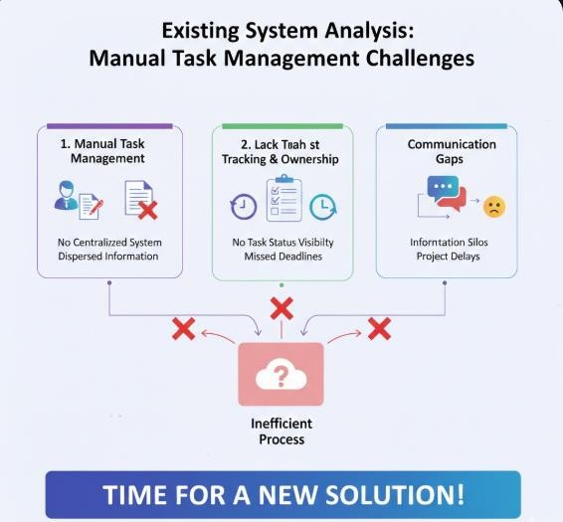

Problems Identified
- No visibility into request status.
- No proper access control for request submission.

The existing laptop request process lacks a centralized and structured approach, resulting in poor visibility and accountability. Employees currently request laptops through informal methods such as emails or manual forms, which often leads to incomplete information and processing delays. Without a standardized catalog form, IT teams face difficulties in tracking

requests and ensuring timely fulfillment. Communication gaps further contribute to inefficiencies and reduced user satisfaction.
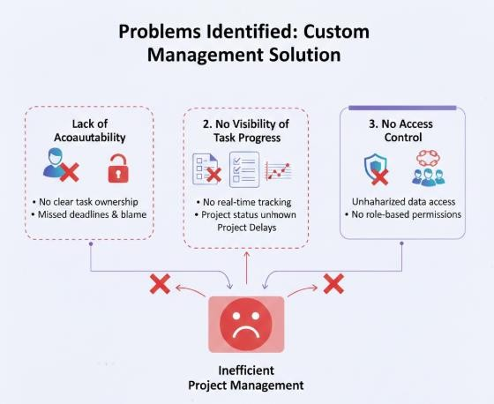
- No access control or role management.

Proposed System Analysis
A centralized Laptop Request Catalog Item will be developed using the ServiceNow Service Catalog.
- Laptop requests will be submitted through the Service Portal.
- User inputs will be captured using catalog variables.
- Catalog UI Policies will provide dynamic form behavior.
- Requests will automatically generate REQ and RITM records.
- Administrators will be able to track and manage requests efficiently.

Feasibility Study
Technical Feasibility: ServiceNow platform supports required features. Operational Feasibility: Users can easily adopt the system.
Economic Feasibility: Developer instance is free.

References
https://developer.servicenow.com https://docs.servicenow.com

https://community.servicenow.com

