System Design

System Architecture Design
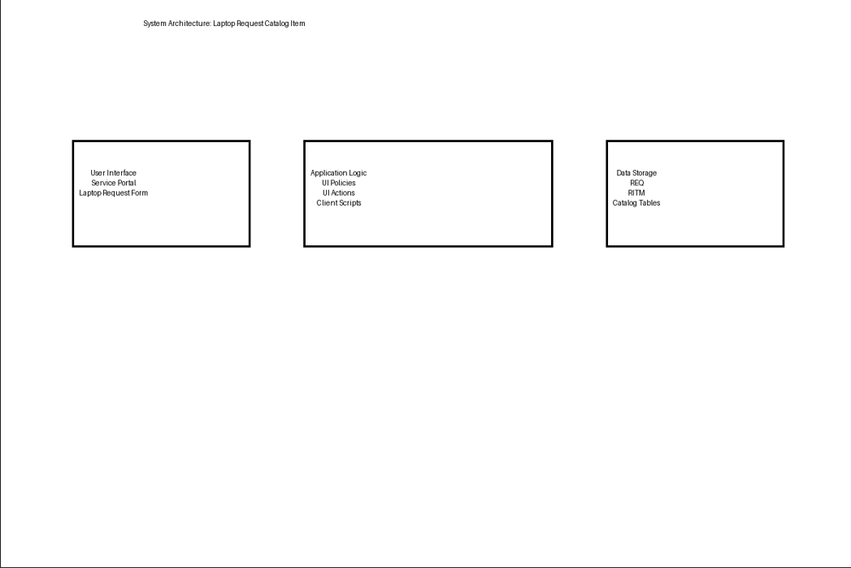
Users interact with the system through the ServiceNow Service Portal to submit laptop requests.

The architecture consists of three main layers:

- User Interface: Employees access the Laptop Request Catalog Item through the Service Portal.
- Application Logic: Implemented using Catalog configurations, UI Policies, and UI Actions to control dynamic behavior and validation.
- Data Storage: Request data is stored in ServiceNow tables such as Request (REQ) and Requested Item (RITM).

Database Design
ServiceNow uses standard catalog tables to store laptop request information.

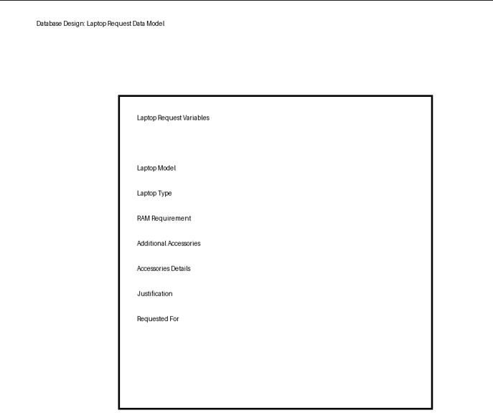

The Laptop Request Catalog Item captures user input through catalog variables. When a request is submitted, records are created in:
- Request table (REQ)
- Requested Item table (RITM)
- Task tables (if fulfillment tasks are generated)

Security Design
- Only authorized users can access the Service Catalog.
- Catalog visibility can be restricted using user criteria.
- Administrative roles manage catalog configuration and updates.

Process Design
he laptop request process is automated using ServiceNow catalog capabilities.

- Users submit requests through the Service Portal.
- Catalog UI Policies dynamically show or hide fields (e.g., Accessories Details).
- The Reset Form UI Action allows users to clear entered data quickly.
- Upon submission, the system automatically generates REQ and RITM records.
- Request status can be tracked by users and administrators.

References
https://developer.servicenow.com https://docs.servicenow.com https://community.servicenow.com References

