LAPTOP REQUEST CATALOG ITEM
Study & Literature Review

Problem Statement
An organization requires a simple and efficient system for employees to request laptops for official work. The current manual process causes delays, lack of transparency, and difficulty in tracking requests. There is also no proper validation or dynamic form behavior to guide users.To overcome these issues, a structured Laptop Request Catalog Item

Introduction
This phase focuses on designing and implementing a Laptop Request Catalog Item using the ServiceNow platform.
The work involves creating catalog variables, applying UI policies for dynamic behavior, and configuring a user-friendly request process. The solution aims to simplify laptop requests and improve request tracking and user experience.

ServiceNow Platform Overview
ServiceNow is a cloud-based enterprise platform used for workflow automation and service management
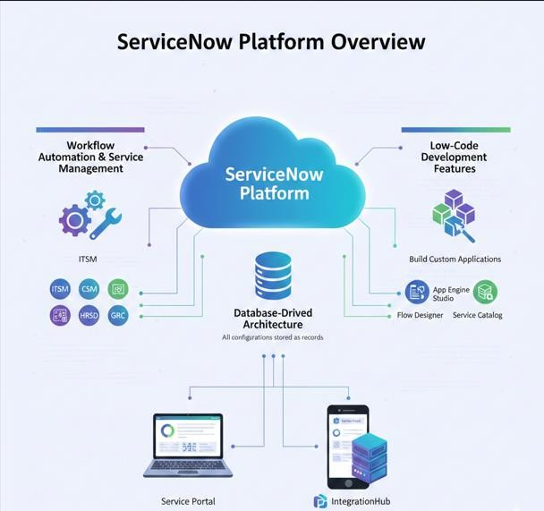

It provides low-code development features to build custom applications without extensive programming.

The platform follows a database-driven architecture where all configurations are stored as records.

Concepts Studied
Users, roles, and groups management for access control. Creation of custom tables and fields.
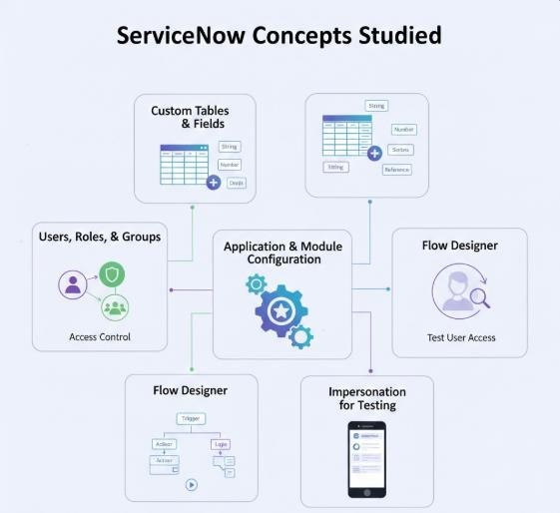
Application and module configuration. Flow Designer for process automation. Impersonation for testing user access.

Outcome of Study
- Gained understanding of Service Catalog configuration in ServiceNow
- Successfully developed a Laptop Request Catalog Item
- Implemented dynamic form behavior using UI Policies
- Enabled users to submit laptop requests efficiently
- Improved request tracking through automated request generation
- Learned best practices for update set management and deployment

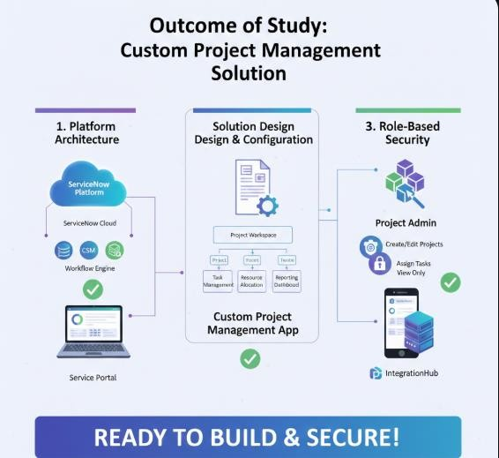

References
https://developer.servicenow.com https://docs.servicenow.com https://community.servicenow.com https://nowlearning.servicenow.com

