Road Damage Classification Using Deep
Learning Models
Custom CNN | VGG16 | ResNet-50 | MobileNetV2
SE4050 - Deep Learning 2026
BSc (Hons) in Information Technology

Project Group No: [Group Number]

Name | Registration Number
[Member 1 - group leader] | [IT2xxxxxxx]
[Member 2] | [IT2xxxxxxx]
[Member 3] | [IT2xxxxxxx]
[Member 4] | [IT2xxxxxxx]

Submission date: 30 September 2026

Table of Contents
1. Introduction and Problem Definition
2. Background and Related Work
3. Dataset Description and Exploratory Data Analysis
4. Data Preprocessing and Feature Engineering
5. Experimental Design
6. Model Architectures
7. Results and Model Comparison
8. Critical Analysis and Discussion
9. Conclusion
10. References
Acknowledgement and Declaration

1. Introduction and Problem Definition
Roads wear out. Cracks, potholes and surface damage appear every day, and someone has to find them. Manual road inspection is slow. It costs money, and it puts inspectors in traffic. Governments therefore need an automatic way to read road images and report the damage they contain.
This project tackles that problem with deep learning on a real public dataset. We classify road images into the four damage types defined by the dataset's label map:
- D00 - longitudinal crack: a crack running along the direction of travel.
- D10 - transverse crack: a crack running across the road.
- D20 - alligator crack: a connected network of cracks, like animal skin.
- D40 - pothole: a bowl-shaped hole in the surface.
The damage task is multi-label, not multi-class. One image can hold several damage types at the same time - 1,300 of our 4,295 labelled images do - so each damage type is modelled as an independent binary decision with a sigmoid output and binary cross-entropy loss. A second framing crops the road surface around each annotated bounding box and classifies each crop as exactly one damage type; the two framings complement each other and are compared in section 7.
As a group we build and compare four deep learning models: a from-scratch Custom CNN, VGG16, ResNet-50 and MobileNetV2. VGG16 and ResNet-50 run the identical multi-label experiment on the identical split, which gives us a controlled backbone comparison; MobileNetV2 adds the crop-level view with its own leakage-guarded split; and the Custom CNN works as a baseline architecture trained end to end on the raw country folders. All four run on the same machine, the same Python environment and the same seed.
Everything in this report is produced by executable Jupyter notebooks committed to the group repository [repository link]. Metric files, split manifests and figures are saved under results/<registration number>/ so every number below can be traced back to a run.

2. Background and Related Work
Convolutional neural networks learn visual features directly from pixels [4]. Stacking convolutions builds a hierarchy - edges first, then textures, then objects - and image classification benchmarks moved rapidly from AlexNet to very deep architectures once that recipe proved itself.
Training a deep network from scratch needs a lot of data and a lot of compute. Our labelled set holds only 4,295 images and we run on a CPU-only laptop. Transfer learning solves both problems: we take networks pretrained on ImageNet, freeze them, and train only a small head on top. The frozen layers become a fixed feature extractor whose outputs we cache on disk, so the expensive forward pass happens once and training happens on vectors instead of images.

2.1 VGG16
VGG16 is a sixteen-layer network built entirely from 3x3 convolutions [2]. The small, repeated filters were a key finding of the original paper: two stacked 3x3 filters cover a 5x5 receptive field with fewer parameters and one more non-linearity. VGG16 is simple, well studied, and a strong baseline for transfer learning. We use it as the reference backbone of our main experiment.

2.2 ResNet-50
ResNet-50 uses residual connections that skip one or more layers [3]. The identity skip path keeps gradients alive in deep stacks, which made very deep training stable for the first time. With 50 layers it is both deeper and more parameter-efficient than VGG16, and it is a standard choice for transfer learning. We train it under exactly the same protocol as VGG16 so the two backbones can be compared without confounding factors (section 5).

2.3 MobileNetV2
MobileNetV2 was designed for mobile devices [11]. Its core idea is the inverted residual block: a lightweight depthwise-separable convolution that keeps parameter count low while preserving representational power, with linear bottlenecks that avoid destroying feature richness. As our lightest ImageNet backbone, it represents the efficiency end of the spectrum and is fine-tuned in two phases rather than kept fully frozen.

2.4 Custom CNN
A small CNN built from scratch shows how much data alone can teach us. It has no pretrained weights, so every filter has to be learned from our own images. Such models are light and fast, and they make a useful lower baseline against the pretrained networks [4]. We train it on the three country folders of the dataset as a sanity-check task that shares the dataset and the image pipeline but not the damage labels, and we use it to verify that our pipeline (seeding, splitting, training, early stopping) behaves correctly before the damage experiments.

2.5 Multi-label learning and road damage detection
Multi-label learning handles targets that are not mutually exclusive [5]. Standard practice is one sigmoid per class, per-class thresholds at decision time, and micro/macro averages at evaluation time. Micro F1 pools all decisions and follows the frequent classes. Macro F1 treats every class as equally important. Reporting both matters when classes are imbalanced, as ours are.
Road damage detection is an active research area. The Global Road Damage Detection Challenge (GRDDC 2020) [6] evaluated teams on the same test images we use, with an object-detection task; the best entry reached an F1 score of 0.67. The follow-up challenge (CRDDC 2022) [7] reported 0.76 with a YOLO and Faster-RCNN ensemble over six countries. These numbers come from a detection task with bounding boxes, so they are not directly comparable to our image-level and crop-level classification scores. We cite them only as context for the difficulty of the data.

3. Dataset Description and Exploratory Data Analysis

3.1 Source and content
We use the RDD2020 road damage dataset, released for the GRDDC 2020 challenge [1][6]. It contains road images collected with vehicle-mounted smartphones in India, Japan and the Czech Republic, with annotations in PASCAL VOC XML format [10]. The paper describes 26,336 images in total: about 21,041 training images from the three countries plus the public test sets test1 (2,631 images) and test2 (2,664 images).
Our local copy matches these counts exactly: the training folder holds 13,142 images (India 7,706, Czechia 2,829, Japan 2,607), test1 holds 1,313 Japanese, 969 Indian and 349 Czech images, and test2 holds 1,314, 990 and 360 - 18,437 images in all. This confirms that we worked with the same distribution the challenge published.
The data comes as train, test1 and test2 folders. Each training country folder holds images, and Czechia and India additionally hold XML annotations plus a label_map.pbtxt that defines the four damage codes. Images are square, mostly 600x600 or 720x720 pixels.

3.2 Annotations: what is labelled, and what is not
The archive ships 10,535 VOC annotation files - all of them for Czechia and India. The Japanese training images arrive without damage annotations in this distribution, and test1/test2 ship image-only as challenge test material. Unlabelled images cannot supervise a damage classifier, so Japan and the two test sets are used for dataset description and for the Custom CNN's country task, never for scoring damage models.
Of the 10,535 annotated training images, 5,678 contain no annotated object at all and 562 carry only damage types outside our four classes. The remaining 4,295 images contain at least one of D00, D10, D20 or D40 and form our labelled multi-label dataset. A full decode scan of every image found exactly one corrupt file (Japan_004643.jpg) and zero exact duplicates; the corrupt file is detected and skipped automatically wherever it would be read.

3.3 Labelled subset
Image-level class counts in the labelled subset are shown below.
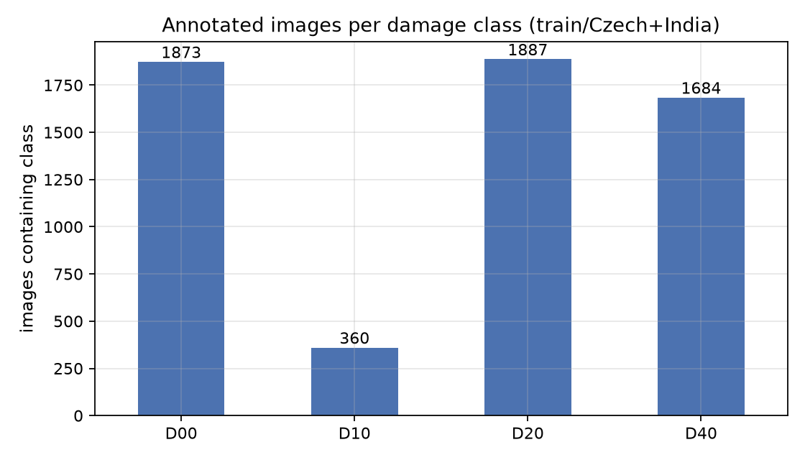
Fig 1. Images per damage class in the labelled subset (4,295 images).
Class sizes are uneven. D20 (alligator crack) appears in 1,887 images, D00 in 1,873 and D40 in 1,684. D10 (transverse crack) appears in only 360 images - about 7.5% of the labelled set. This imbalance becomes the single biggest influence on our results, and section 8.4 returns to it.
Damage types often co-occur. 2,995 images carry exactly one damage label and 1,300 images carry two or more. The distribution of label counts is shown below.
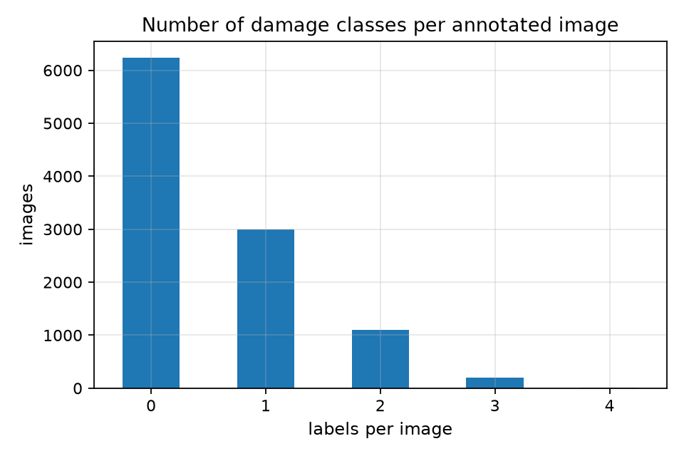
Fig 2. Number of damage labels per image. Most images carry one label, but a sizeable group carries several.

3.4 Country bias
The two labelled countries contribute very different data. India supplies 7,706 images and Czechia 2,829. The class mix also differs: India holds 1,758 D20 and 1,530 D40 images, while Czechia holds only 129 and 154. Czechia, however, holds 300 of the 360 D10 images - 83% of all transverse-crack data. A model that sees mostly Indian potholes may struggle on Czech roads, and section 8.7 measures exactly that effect.
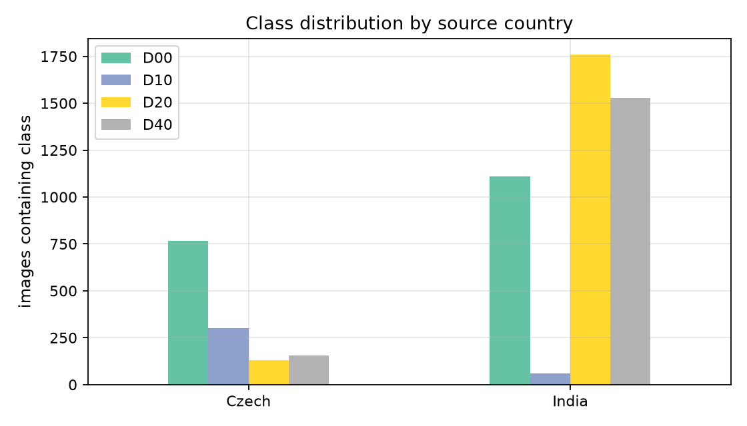
Fig 3. Per-class image counts by source country. The class mix differs strongly between India and Czechia.

3.5 Train, validation and test split
We split the 4,295 labelled images into 3,005 training, 645 validation and 645 test images (70/15/15). A random split is not safe here, because road photos contain near-duplicate frames: a dashcam records the same stretch of road several times, and such frames leak across a random split. We therefore hash every image with a 64-bit difference hash and group frames whose Hamming distance is 4 or less. The scan found 4,095 clusters, 82 of them containing duplicates, with the largest cluster holding 53 frames. Clusters are then assigned to splits as whole units.
The leakage report is clean: zero clusters span multiple splits, and zero duplicate paths appear on both sides of any split. Test-set class support is 275 D00, 51 D10, 290 D20 and 265 D40 images; the test set holds 137 Czech and 508 Indian images.
split | images | share
train | 3,005 | 70%
validation | 645 | 15%
test | 645 | 15%
Tab 1. Leakage-safe split of the labelled subset (cluster-grouped).
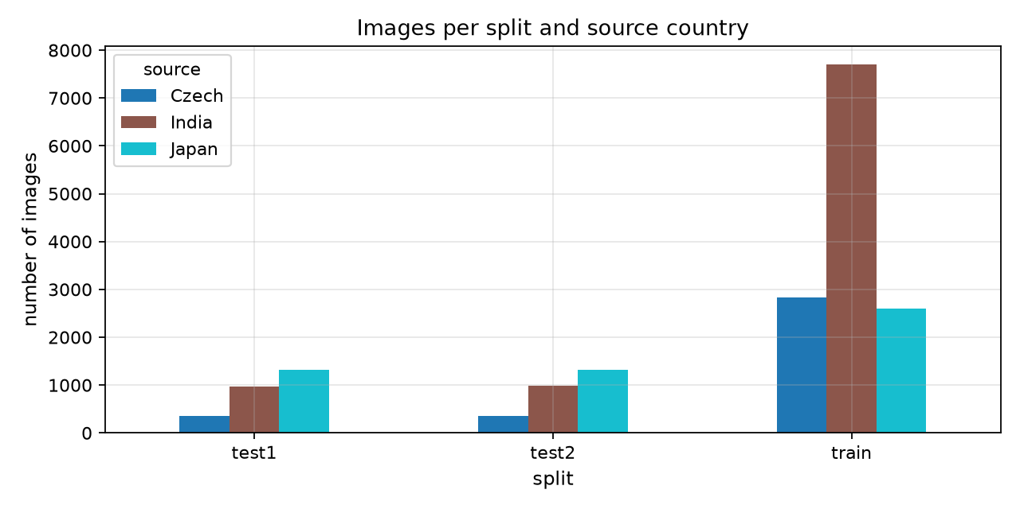
Fig 4. Class distribution across the three splits. Every class keeps a similar share in each split.
VGG16 and ResNet-50 consume the same manifest file; the split MD5 is 5fac8fa95389101fde12da21ab93388b for both runs, and ResNet-50's built-in cross-check against VGG16's manifest reports 100% agreement over 4,295 images.

3.6 Data quality issues
- One corrupt image (Japan_004643.jpg): truncated JPEG, skipped by every pipeline.
- Annotations missing for Japan and both test sets: 13,142 - 10,535 = 2,607 train images plus 5,295 test images cannot be used for damage evaluation.
- Severe class imbalance: D10 has 360 images against 1,887 for D20.
- Country bias: the class mix and image style differ between India and Czechia.
- Near-duplicate frames: 82 duplicate clusters, handled by cluster-grouped splitting.
- Image-level labels only for the main models: XML files contain bounding boxes, but VGG16, ResNet-50 classify whole images, so a small corner defect labels the entire image. The MobileNetV2 crop pipeline partially repairs this.

4. Data Preprocessing and Feature Engineering
Preprocessing runs inside the notebooks, so every model in the group starts from the same cleaned data. The shared steps are listed first, then the model-specific pipelines.

4.1 Validation and label parsing (shared)
Every image is opened and decoded before training; corrupt files are reported and skipped. Exact duplicates are found by content hash. Each XML file is parsed for its damage tags, and each image becomes a four-bit vector: one bit per class, set when at least one bounding box of that class is present. Images with no target class are excluded from the damage experiments (see section 8.5).

4.2 Image standardisation (VGG16 and ResNet-50)
All images are resized to 224x224 pixels. Each backbone applies its own ImageNet normalisation: vgg16.preprocess_input (RGB to BGR, channel-mean subtraction) for VGG16 and resnet50.preprocess_input for ResNet-50 - in both cases the exact normalisation the pretrained weights were trained with. Neither model uses data augmentation: features are computed once by a frozen backbone, so augmented copies would multiply CPU cost while never being seen again. Section 8.11 discusses this as a limitation.

4.3 Near-duplicate handling
The 64-bit difference-hash clustering described in section 3.5 keeps near-duplicate frames inside one split. This is our defence against data leakage, and it is verified on every run: the split report must show zero spanning clusters and zero duplicate paths.

4.4 Feature extraction (the key efficiency step)
A frozen backbone with global average pooling reduces any 224x224 image to a dense feature vector in one forward pass - 512 values for VGG16, 2,048 for ResNet-50. We run that pass once per image and cache the results to disk (npz files under results/<reg>/cache/). Training then happens on these vectors, not on images, which is why a CPU can train either head in under ten seconds. First-run feature extraction costs 261.9 seconds for VGG16 and 151.6 seconds for ResNet-50; later runs read the cache.

4.5 Crop pipeline (MobileNetV2)
The crop pipeline walks every VOC annotation of the labelled countries, takes each box with 15% context padding on each side, discards boxes smaller than 20 pixels, and resizes the result to 224x224. Only the four target classes are kept; other RDD tags (D44, D01, D11, D50, D43, D0w0) are dropped, as are 242 boxes that are too small to classify. The result is 8,334 crops drawn from 4,234 source images, split 70/15/15 into 5,892 train, 1,263 validation and 1,179 test crops. The split is assigned per source image before cropping, so no crop of the same road surface can appear on two sides - the pipeline asserts this at runtime. Training-time augmentation (horizontal flip, 5% rotation, 10% zoom, 10% contrast) is applied to crops only, because every epoch sees them again.

4.6 Country folders (Custom CNN)
The Custom CNN trains on three plain folders - one per country - assembled from data/train into data/cnn_train. Images are fully decoded while copying so the corrupt JPEG is skipped (13,141 files remain), resized to 224x224 by Keras and split 80/20 by image_dataset_from_directory with seed 42. No other preprocessing is needed for this baseline task.

4.7 Handling class imbalance
For the multi-label models we do not oversample or undersample. Instead we keep the real distribution, use per-class metrics that expose the rare class, and tune a separate decision threshold per class on the validation set. MobileNetV2 additionally trains with class weights, which up-weight the rare classes inside the loss. Section 8.4 analyses how much each measure changes the results.

5. Experimental Design
The assignment requires a fair comparison between at least four deep models, and the marking guide asks for fair and comparable experimental conditions. Fairness is a design choice, so we fixed the rules before training anything:
- One split for everyone. VGG16 and ResNet-50 read the same split manifest (results/IT22064868/metrics/split_manifest.csv, MD5 5fac8fa95389101fde12da21ab93388b); ResNet-50 re-computes the split and verifies 100% agreement before training. MobileNetV2 and the Custom CNN split their own data (different prediction unit) with the same algorithm, proportions and seed.
- One seed. Seed 42 is set for Python, NumPy and TensorFlow before each run.
- One test protocol. The test set is touched only in the final evaluation cells. Early stopping, learning-rate scheduling and threshold tuning use validation data only - the rule the assignment states explicitly.
- One metric suite for the damage task: precision, recall, F1, ROC-AUC and confusion matrices, reported per class and as micro/macro averages, plus subset and hamming accuracy for the multi-label framing.
- One environment. Windows 11, Python 3.11, TensorFlow 2.21, CPU only (TensorFlow has no native Windows GPU support), identical for all four models.

5.1 Configuration tables
setting | value
input size | 224 x 224
batch size | 64
optimizer | Adam, learning rate 1e-3
loss | binary cross-entropy (4 sigmoid outputs)
max epochs | 100
early stopping | patience 12 on validation AUC, restore best weights
LR schedule | ReduceLROnPlateau, factor 0.5, patience 5, floor 1e-6
checkpoint | best validation AUC (epoch 18: val AUC 0.8293)
seed | 42 (Python / NumPy / TensorFlow)
Tab 2. VGG16 training configuration (identical to ResNet-50 except the backbone and its normalisation).
setting | value
input size | 224 x 224 (crops with 15% box context)
batch size | 32
optimizer | Adam - phase 1 lr 1e-3, phase 2 lr 1e-5
loss | sparse categorical cross-entropy + class weights
phase 1 | backbone frozen, 10 epochs
phase 2 | unfrozen from layer 100, up to 20 epochs
early stopping | patience 5 on validation loss
augmentation | flip, 5% rotation, 10% zoom, 10% contrast
seed | 42
Tab 3. MobileNetV2 training configuration.
setting | value
input size | 224 x 224
batch size | 32
optimizer | Adam (default learning rate)
loss | sparse categorical cross-entropy (3 country classes)
max epochs | 20
early stopping | patience 5 on validation loss, restore best weights
LR schedule | ReduceLROnPlateau, factor 0.2, patience 2, floor 1e-6
seed | 42
Tab 4. Custom CNN training configuration.
VGG16 and ResNet-50 differ only in the backbone and its normalisation; every other hyperparameter in the first table applies to both, which makes their comparison a controlled backbone ablation.

6. Model Architectures

6.1 VGG16 - transfer-learned backbone with a trained head
Our reference model has two parts: a frozen ImageNet VGG16 backbone that turns pixels into features, and a small trainable head that turns features into four probabilities.
layer | shape | parameters | state
Input | 224 x 224 x 3 | 0 | -
VGG16 conv blocks (FC layers removed) | 7 x 7 x 512 | 14,714,688 | frozen
GlobalAveragePooling2D | 512 | 0 | -
Dense 256, ReLU | 256 | 131,328 | trainable
Dropout 0.5 | 256 | 0 | -
Dense 4, sigmoid | 4 | 1,028 | trainable
Total | - | 14,847,044 | 132,356 trainable (0.9%)
Tab 5. VGG16 architecture and parameter budget.
Design justification. The dataset is small and the machine is a CPU laptop, so training 14.8 million parameters from scratch was out of the question. Freezing the backbone reduces the training problem to 132,356 parameters, which fit in memory and train in 6.6 seconds. Dropout 0.5 and early stopping keep the head from memorising the training set. The four sigmoid outputs express the multi-label nature of the task: each class is an independent yes/no decision.
Training behaviour is shown below. Validation AUC peaks at 0.8293 in epoch 18; early stopping ends the run at epoch 30. The learning-rate schedule halved the rate twice, in epochs 23 and 28.
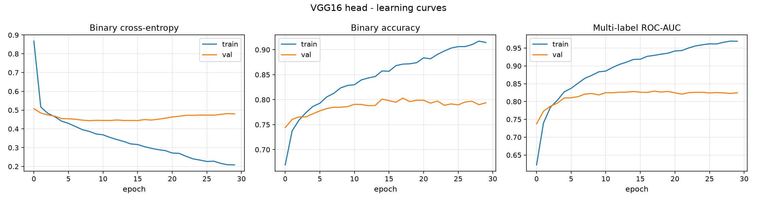
Fig 5. VGG16 training and validation learning curves. Validation AUC peaks at 0.8293 (epoch 18); early stopping ends training at epoch 30.

6.2 ResNet-50 - the controlled second backbone
ResNet-50 replaces the VGG16 trunk while the head protocol stays byte-for-byte identical: a frozen backbone with global average pooling feeds the same 256-unit ReLU head with dropout 0.5 and four sigmoid outputs, trained with binary cross-entropy and Adam 1e-3 under the same callbacks.
layer | shape | parameters | state
Input | 224 x 224 x 3 | 0 | -
ResNet-50 (bottleneck stages) | 7 x 7 x 2048 | 23,587,712 | frozen
GlobalAveragePooling2D | 2048 | 0 | -
Dense 256, ReLU | 256 | 524,544 | trainable
Dropout 0.5 | 256 | 0 | -
Dense 4, sigmoid | 4 | 1,028 | trainable
Total | - | 24,113,284 | 525,572 trainable (2.2%)
Tab 6. ResNet-50 architecture and parameter budget.
Justification. The residual trunk is deeper and more parameter-efficient than VGG16, and its 2,048-dimensional pooled features give the head four times the input width. Because both models share the split manifest (section 3.5) and the training configuration (section 5.1), any metric difference between them is attributable to the backbone alone. Feature extraction took 151.6 s, head training 7.8 s, and early stopping ended the run at epoch 26 after the best epoch 14 (validation AUC 0.8350).
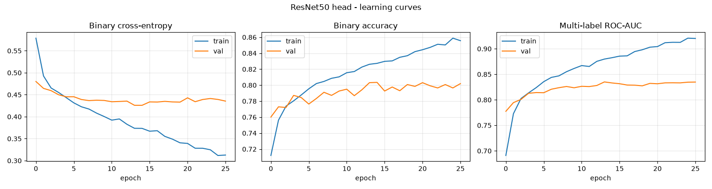
Fig 6. ResNet-50 training and validation learning curves. Validation AUC peaks at 0.8350 (epoch 14) with early stopping at epoch 26.

6.3 MobileNetV2 - light backbone, crop-level classification
MobileNetV2 classifies crops rather than whole images. The ImageNet-pretrained backbone (alpha 1.0) is followed by global average pooling, dropout 0.3, a 128-unit dense layer with L2 weight decay (1e-4) and a 4-way softmax. Training is two-phase: 10 epochs with the backbone frozen at learning rate 1e-3, then up to 20 epochs with the trunk unfrozen from layer 100 at learning rate 1e-5. Class weights inside the loss compensate for the D10/D20 imbalance among crops, and early stopping (patience 5) stops on validation loss.
component | configuration
backbone | MobileNetV2, ImageNet weights, alpha 1.0, frozen then partial
head | GAP -> Dropout 0.3 -> Dense 128 (L2 1e-4) -> Dense 4 softmax
trainable params | 164,484 (phase 1) / 2,004,100 (phase 2) of 2,422,468
epochs run / best | 26 / 21 (best val loss 0.6112)
total training time | 45.1 minutes (~104 s per epoch)
Tab 7. MobileNetV2 architecture and training summary.
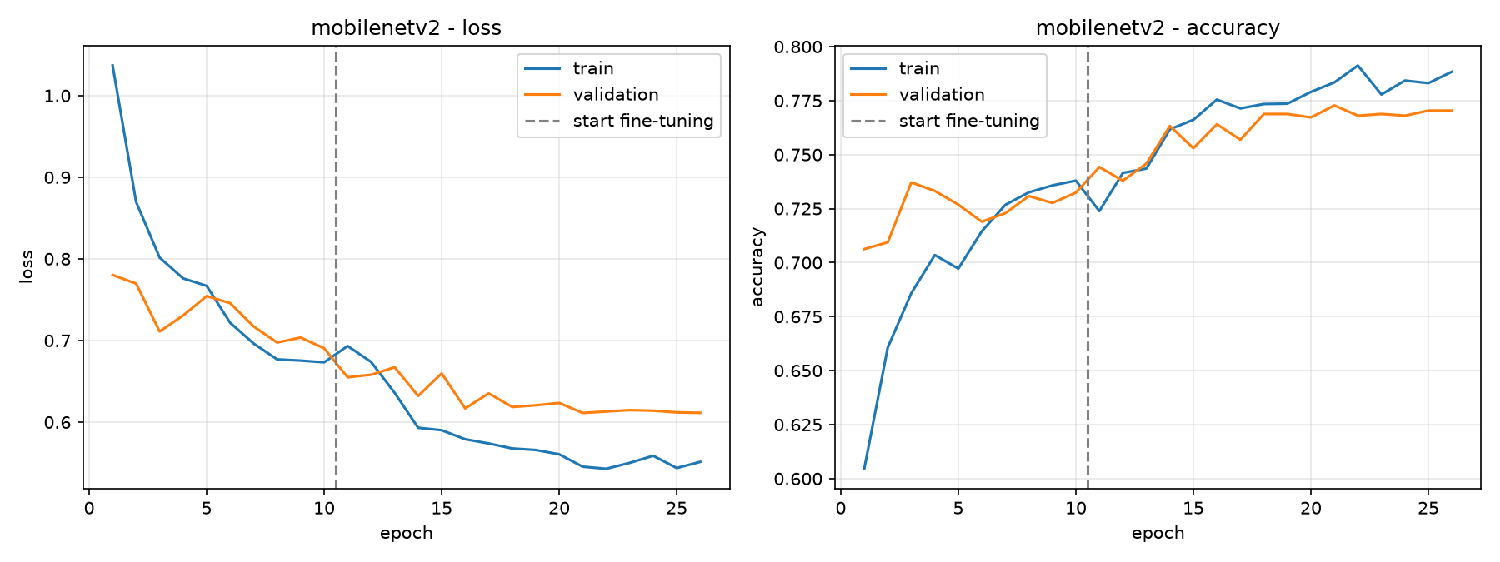
Fig 7. MobileNetV2 training and validation curves across both phases (26 epochs, best epoch 21).

6.4 Custom CNN - from-scratch baseline
The Custom CNN is a small sequential network trained end to end without any pretrained weights. Four convolutional blocks (32, 64, 128, 256 filters, 3x3, ReLU, max-pool after each) extract features; a flatten layer feeds a 128-unit dense layer with 50% dropout and a 3-way softmax. Inputs are rescaled to [0, 1]; everything else is learned from scratch.
component | configuration
convolutional trunk | 4 blocks: Conv2D 32/64/128/256 + MaxPool
head | Flatten -> Dense 128 ReLU -> Dropout 0.5 -> Dense 3 softmax
parameters | 5,107,523 (19.5 MB), all trainable
optimizer / loss | Adam, sparse categorical cross-entropy
epochs run / best | 19 / 14 (early stopping, patience 5)
saved model | custom_cnn_model.keras (61.3 MB)
Tab 8. Custom CNN architecture and training summary.
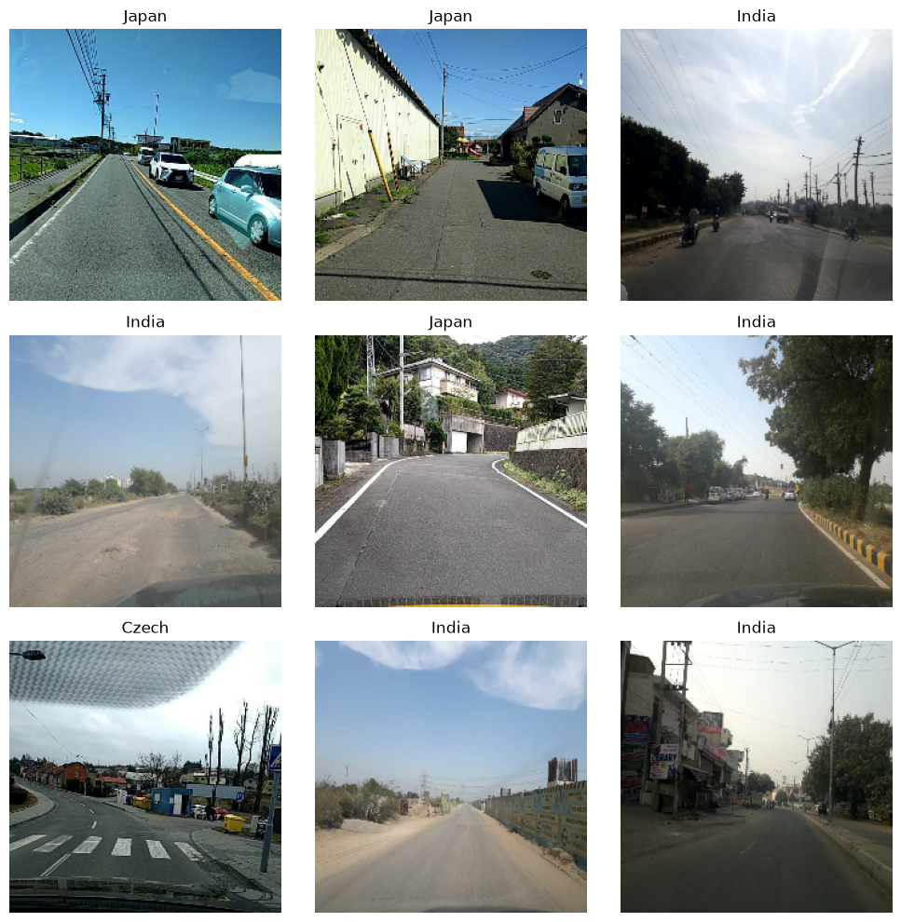
Fig 8. Sample images from the three country folders after resizing to 224x224.
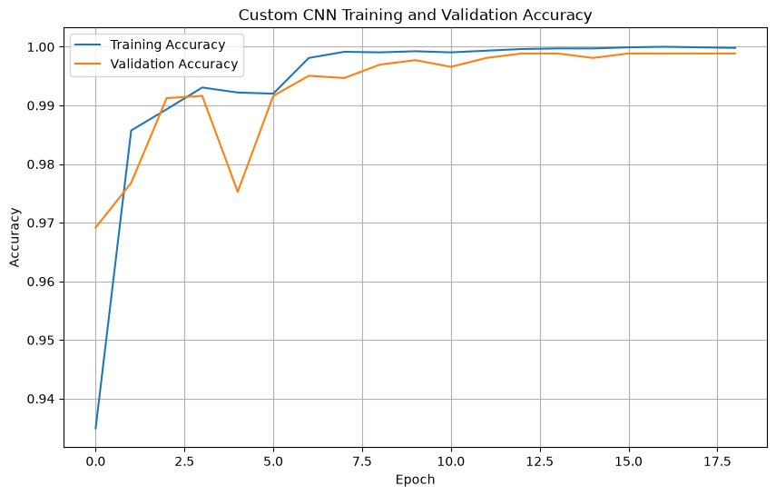
Fig 9. Custom CNN training and validation accuracy. Both curves saturate near 1.0.

7. Results and Model Comparison
Unless stated otherwise, damage-model numbers are measured on the shared held-out test set of 645 images; MobileNetV2 numbers are measured on its 1,179 test crops; the Custom CNN reports its validation split. Every table below is generated from the JSON files committed under results/<reg>/metrics/.

7.1 VGG16 headline results
Both threshold settings are reported: the fixed 0.5 threshold first, then the validation-tuned thresholds (D00: 0.40, D10: 0.05, D20: 0.40, D40: 0.50).
metric | @ threshold 0.5 | tuned thresholds
subset accuracy | 0.4806 | 0.3891
hamming accuracy | 0.7946 | -
micro precision | 0.709 | 0.635
micro recall | 0.675 | 0.771
micro F1 | 0.692 | 0.696
macro F1 | 0.556 | 0.649
micro ROC-AUC | 0.864 | -
macro ROC-AUC | 0.832 | -
Tab 9. VGG16 test results at the fixed and the tuned thresholds (645 test images).

7.2 VGG16 per-class results
class | precision | recall | F1 | ROC-AUC | support
D00 (longitudinal) | 0.709 | 0.549 | 0.619 | 0.767 | 275
D10 (transverse) | 0.375 | 0.059 | 0.102 | 0.845 | 51
D20 (alligator) | 0.740 | 0.814 | 0.775 | 0.865 | 290
D40 (pothole) | 0.686 | 0.774 | 0.727 | 0.851 | 265
Tab 10. VGG16 per-class results at threshold 0.5.
class | threshold | precision | recall | F1
D00 (longitudinal) | 0.40 | 0.646 | 0.651 | 0.649
D10 (transverse) | 0.05 | 0.317 | 0.745 | 0.444
D20 (alligator) | 0.40 | 0.687 | 0.886 | 0.774
D40 (pothole) | 0.50 | 0.686 | 0.774 | 0.727
Tab 11. VGG16 per-class results at validation-tuned thresholds.
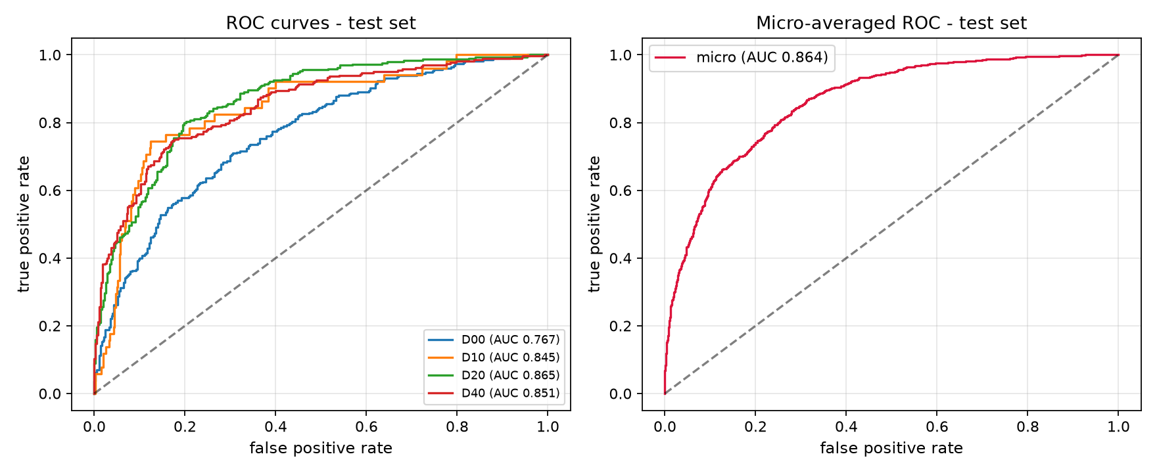
Fig 10. VGG16 ROC curves per class on the test set.
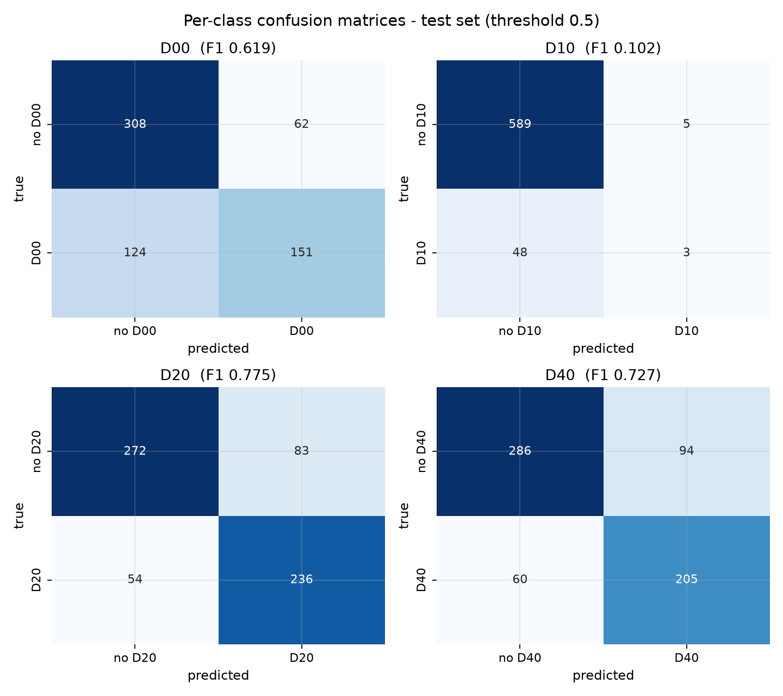
Fig 11. VGG16 per-class confusion matrices at threshold 0.5 (positive = class present).

7.3 ResNet-50 results
metric | @ threshold 0.5 | tuned thresholds
subset accuracy | 0.4574 | 0.3271
hamming accuracy | 0.7957 | -
micro precision | 0.725 | 0.612
micro recall | 0.648 | 0.778
micro F1 | 0.684 | 0.685
macro F1 | 0.528 | 0.641
micro ROC-AUC | 0.861 | -
macro ROC-AUC | 0.832 | -
Tab 12. ResNet-50 test results at the fixed and the tuned thresholds (same 645 test images as VGG16).
class | precision | recall | F1 | ROC-AUC | support
D00 (longitudinal) | 0.707 | 0.596 | 0.647 | 0.757 | 275
D10 (transverse) | 0.000 | 0.000 | 0.000 | 0.875 | 51
D20 (alligator) | 0.735 | 0.728 | 0.731 | 0.842 | 290
D40 (pothole) | 0.729 | 0.740 | 0.734 | 0.855 | 265
Tab 13. ResNet-50 per-class results at threshold 0.5.
class | threshold | precision | recall | F1
D00 (longitudinal) | 0.35 | 0.561 | 0.818 | 0.666
D10 (transverse) | 0.10 | 0.298 | 0.765 | 0.429
D20 (alligator) | 0.35 | 0.664 | 0.859 | 0.749
D40 (pothole) | 0.60 | 0.811 | 0.649 | 0.721
Tab 14. ResNet-50 per-class results at validation-tuned thresholds.
class | missed (FN) | spurious (FP) | support
D00 | 50 | 176 | 275
D10 | 12 | 92 | 51
D20 | 41 | 126 | 290
D40 | 93 | 40 | 265
Tab 15. ResNet-50 error counts at tuned thresholds.
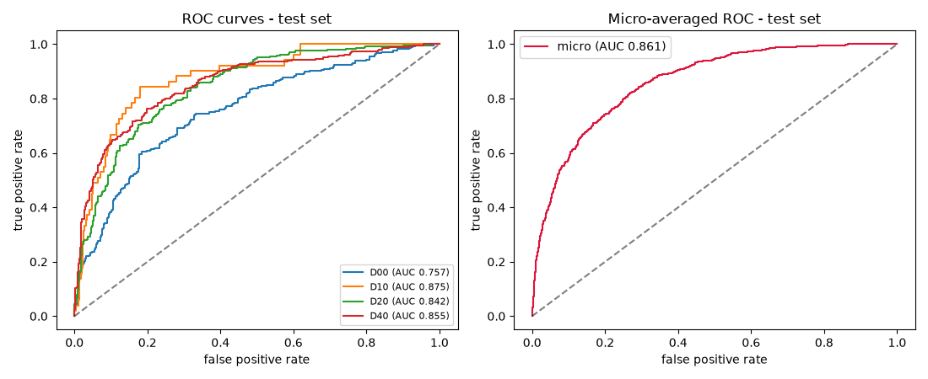
Fig 12. ResNet-50 ROC curves per class on the shared test set.
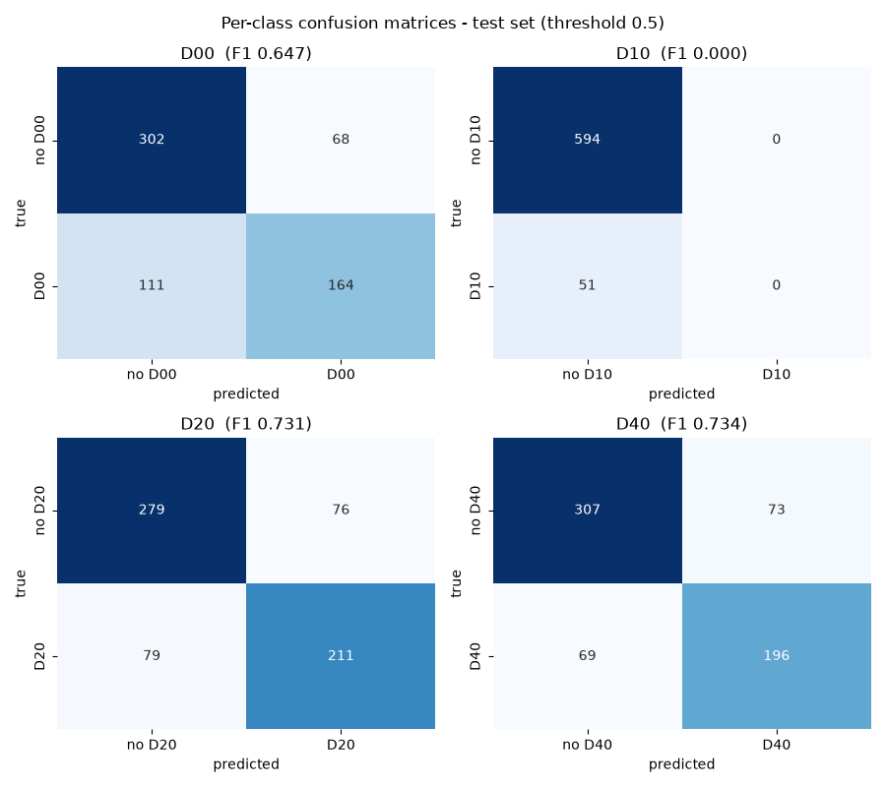
Fig 13. ResNet-50 per-class confusion matrices at threshold 0.5.

7.4 Results by source country
source | threshold | test images | micro F1 | subset accuracy
Czech | 0.5 | 137 | 0.647 | 0.4745
Czech | tuned | 137 | 0.648 | 0.2409
India | 0.5 | 508 | 0.702 | 0.4823
India | tuned | 508 | 0.710 | 0.4291
Tab 16. VGG16 results per source country.
source | threshold | test images | micro F1 | subset accuracy
Czech | 0.5 | 137 | 0.636 | 0.5036
Czech | tuned | 137 | 0.636 | 0.1971
India | 0.5 | 508 | 0.695 | 0.4449
India | tuned | 508 | 0.699 | 0.3622
Tab 17. ResNet-50 results per source country.
Both backbones show the same pattern: Czechia and India are close at the fixed threshold, but after tuning, Czech subset accuracy collapses while India only slips. The tuned thresholds were fitted to a validation set that is 75% Indian.

7.5 MobileNetV2 results
metric | value
accuracy | 0.7820
macro precision | 0.720
macro recall | 0.784
macro F1 | 0.740
weighted F1 | 0.785
macro ROC-AUC (OvR) | 0.942
test crops | 1,179
Tab 18. MobileNetV2 test results on 1,179 held-out crops.
class | precision | recall | F1 | support
D00 | 0.790 | 0.701 | 0.743 | 354
D10 | 0.477 | 0.808 | 0.600 | 52
D20 | 0.740 | 0.788 | 0.763 | 321
D40 | 0.871 | 0.838 | 0.855 | 452
Tab 19. MobileNetV2 per-class results on test crops.
true \ predicted | D00 | D10 | D20 | D40
D00 | 248 | 25 | 47 | 34
D10 | 4 | 42 | 5 | 1
D20 | 31 | 16 | 253 | 21
D40 | 31 | 5 | 37 | 379
Tab 20. MobileNetV2 confusion matrix on test crops.
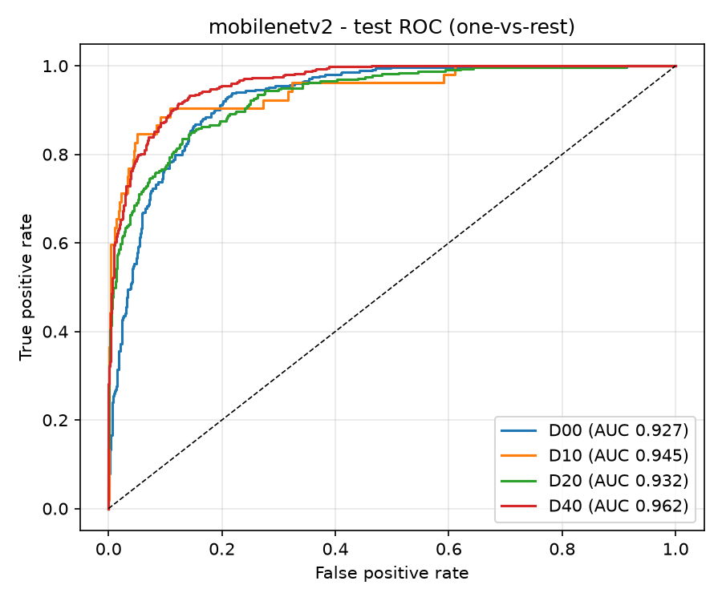
Fig 14. MobileNetV2 ROC curves per damage class on test crops.
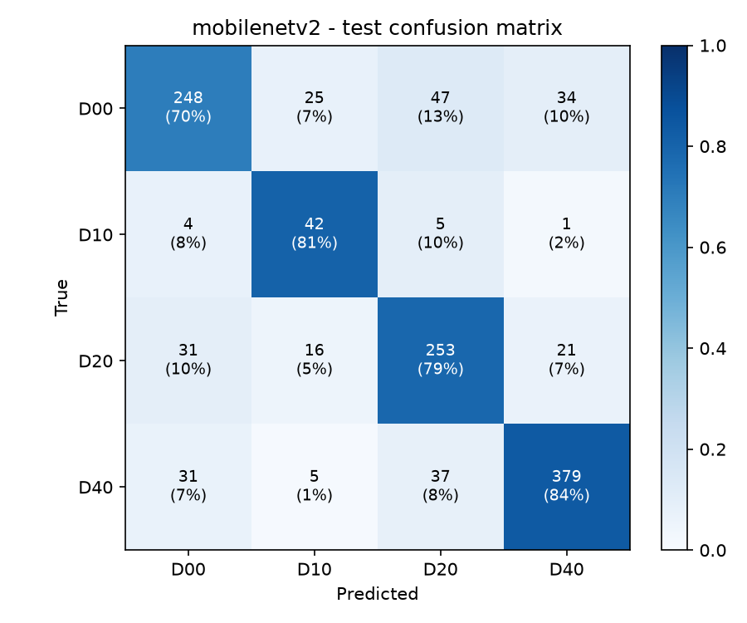
Fig 15. MobileNetV2 confusion matrix (rows = true class, columns = prediction).

7.6 Custom CNN results
metric | value
task | 3-class country classification (demo baseline)
train / validation images | 10,513 / 2,628
validation accuracy | 0.9989
validation loss | 0.0078
final training accuracy | 0.9998
epochs run / best | 19 / 14
parameters | 5,107,523
Tab 21. Custom CNN validation results (no damage labels are involved).
The Custom CNN reaches near-perfect validation accuracy within fourteen epochs. That is not a claim about road damage: the country task is easy because camera colour, lighting and road texture differ strongly between India, Czechia and Japan. Its role is to prove the shared pipeline end to end and to quantify how strongly a plain CNN can latch onto dataset-level visual bias - the same bias explored for damage data in section 8.7.
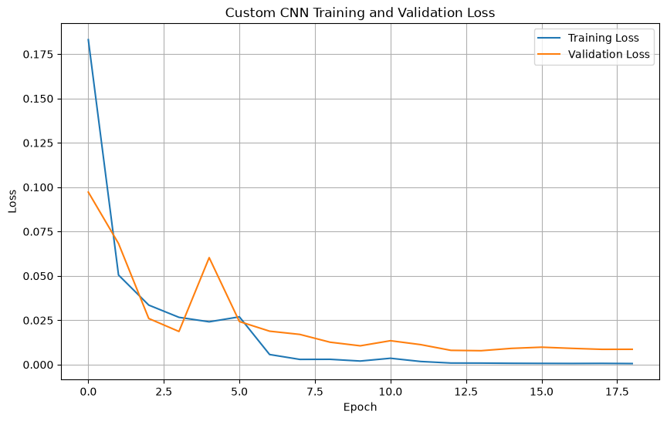
Fig 16. Custom CNN training and validation loss.

7.7 Cross-model comparison
The two multi-label backbones can be compared line for line because they share split, seed, labels, metrics and evaluation code:
metric | VGG16 | ResNet-50 | difference
micro F1 @0.5 | 0.692 | 0.684 | -0.0076
micro F1 tuned | 0.696 | 0.685 | -0.0111
macro F1 @0.5 | 0.556 | 0.528 | -0.0275
macro F1 tuned | 0.649 | 0.641 | -0.0074
micro ROC-AUC | 0.864 | 0.861 | -0.0026
subset accuracy @0.5 | 0.4806 | 0.4574 | -0.0233
trainable parameters | 132,356 | 525,572 | +393,216
feature extraction | 261.9 s | 151.6 s | -110.3 s
head training | 6.6 s | 7.8 s | +1.2 s
Tab 22. Controlled backbone comparison: VGG16 vs ResNet-50 on the shared test set.
The full four-model sheet puts every model next to each other. The prediction units differ (whole images vs crops vs country folders), so the numbers are not a single league table; the task column makes the framing explicit:
model | task / prediction unit | headline metric | macro F1 | macro AUC | trainable params
Custom CNN | 3-class country (demo, validation) | val acc 0.9989 | - | - | 5,107,523
VGG16 | 4-label whole image (test) | micro F1 0.692 | 0.556 | 0.832 | 132,356
ResNet-50 | 4-label whole image (test) | micro F1 0.684 | 0.528 | 0.832 | 525,572
MobileNetV2 | 4-class crop (test) | acc 0.7820 | 0.740 | 0.942 | 2,004,100
Tab 23. Four-model summary. VGG16 and ResNet-50 are directly comparable; MobileNetV2 and the Custom CNN answer different prediction questions.

7.8 Computational efficiency
measure | VGG16 | ResNet-50 | MobileNetV2 | Custom CNN
total parameters | 14,847,044 | 24,113,284 | 2,422,468 | 5,107,523
trainable (final phase) | 132,356 | 525,572 | 2,004,100 | 5,107,523
saved model size | 60.6 MB | 101.3 MB | 26.4 MB | 61.3 MB
feature extraction | 262 s | 152 s | n/a (end-to-end) | n/a (end-to-end)
head / training time | 6.6 s | 7.8 s | 45 min | ~89 min
epochs run / best | 30 / 18 | 26 / 14 | 26 / 21 | 19 / 14
inference latency | not measured | not measured | 114.2 ms/image | not measured
device | CPU | CPU | CPU | CPU
Tab 24. Computational profile of the four models (same laptop, CPU only).

8. Critical Analysis and Discussion

8.1 What actually worked
The two multi-label models land within one point of each other: VGG16 micro F1 0.692 and ResNet-50 0.684 at the fixed threshold, with micro ROC-AUC 0.864 and 0.861. MobileNetV2 reaches 0.7820 accuracy and macro AUC 0.942 on crops. Transfer learning did what it promised on all three: a few hundred thousand trainable parameters were enough, and head training finished in seconds. The cluster-grouped split keeps the evaluation honest - zero duplicate frames cross splits, and ResNet-50's independent re-computation of the split matched VGG16's manifest exactly, so none of these scores are inflated by leakage.

8.2 VGG16 versus ResNet-50: does depth buy anything?
This is the cleanest question in the study because everything except the backbone is held constant. The answer is: almost nothing at the headline level, and the differences that do exist cancel out. ResNet-50 wins subset accuracy at 0.5 (0.4574 vs 0.4806) but loses slightly on micro F1; after threshold tuning VGG16 leads macro F1 (0.649 vs 0.641) while micro F1 stays within half a point. Per class, ResNet-50's advantage is real where gradients and depth matter - its D10 ROC-AUC is 0.875 against VGG16's 0.845 - but it converts none of that into F1 at 0.5, where its D10 recall is literally zero. Deeper, residual features are marginally better ranked but no better thresholded. Practically, the frozen feature space of a 2015-era backbone is the ceiling in both cases; swapping backbones inside that regime is not the lever that moves the results. Fine-tuning would be.

8.3 Threshold tuning: a real trade-off, not a free win
Moving from the fixed 0.5 threshold to validation-tuned thresholds lifts macro F1 from 0.556 to 0.649 on VGG16 (+9.3 points) and from 0.528 to 0.641 on ResNet-50 (+11.3 points). D10 benefits most in both cases because its tuned threshold drops to 0.05 and 0.10 respectively. Micro recall rises from 0.675 to 0.771 (VGG16) and from 0.648 to 0.778 (ResNet-50).
The cost shows up in subset accuracy, which falls from 0.4806 to 0.3891 on VGG16 and 0.4574 to 0.3271 on ResNet-50. Lower thresholds predict more labels per image, and exact-match accuracy punishes every extra label. Both numbers are correct; they answer different questions. For a maintenance team that can inspect a flagged area cheaply, missing damage is worse than a false alarm, so the tuned setting is arguably the better operating point. For a fully automatic ranking with no human in the loop, the fixed threshold is safer. We report both, and we do not claim one is universally better.

8.4 The rare class problem (D10)
D10 has 360 images in the whole labelled set and only 51 positives in the test set. Its ROC-AUC is healthy everywhere - 0.845 (VGG16), 0.875 (ResNet-50) - which proves both models rank D10 images correctly. At threshold 0.5, however, VGG16 finds only 5.9% of them and ResNet-50 finds none at all (recall 0.000). The ranking is fine; the global threshold is wrong. Tuning rescues the class to F1 0.444 and 0.429 - but at the price of precision (0.317 and 0.298), because the threshold was fitted on a validation set with roughly fifty D10 positives. ResNet-50's error table makes it concrete: 92 spurious D10 tags for 38 true ones.
MobileNetV2 tells the same story from the crop side and offers the one genuinely better lever we tried: class weights inside the loss. Its D10 recall on test crops is 0.808 with F1 0.600 - the best D10 result in the group - yet D10 still has the lowest F1 of the four classes. Weighting the loss moves recall; only more D10 data moves precision. The fix is not a cleverer threshold; it is more D10 images, ideally collected where they are under-represented.
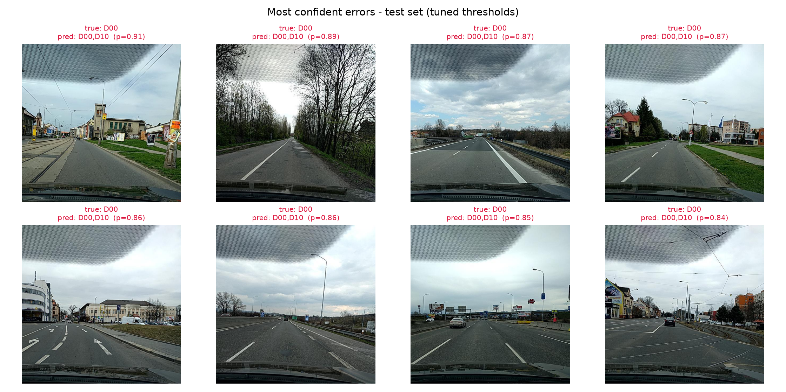
Fig 17. VGG16's most confident errors at tuned thresholds: true D00 images that also receive a D10 tag with probability 0.84-0.91.
The figure makes the failure concrete. The model does not fail randomly - it makes one specific mistake: adding D10 to images that already carry D00, with high confidence. This is exactly the behaviour a 0.05 D10 threshold invites, and it may connect to the country bias in section 3.4: most D10 training images come from one country, so the model can learn a country-flavoured shortcut for it.

8.5 A structural weakness: no clean images in training
The multi-label training set contains only images that carry at least one target damage label. The 6,240 annotated images with no target class were excluded. The model therefore never sees a clean road during training and never learns to answer "no damage". This has three concrete consequences: false positives are structurally encouraged (the model must pick something), the low tuned thresholds partly compensate for a bias the training data created, and subset accuracy is measured only on damaged images, so it does not describe real deployment where many frames are clean. The MobileNetV2 crop pipeline suffers the same exclusion in its own unit. Adding clean images or clean crops as all-zero targets is the highest-value fix on our list.

8.6 Overfitting, convergence and training stability
VGG16 shows mild overfitting: training AUC climbs towards 0.97 while validation peaks at 0.8293 in epoch 18 - a gap near 0.14 that early stopping (patience 12) then freezes at epoch 30. ResNet-50 behaves similarly but turns earlier: best validation AUC 0.8350 at epoch 14, run stopped at epoch 26. MobileNetV2 is the most stable model - the train-test gap is only 0.015 - because two-phase training with a tiny second learning rate and heavy crop augmentation regularises it; its validation curve also flattens after epoch 21, and early stopping cuts the tail. The Custom CNN simply saturates: accuracy reaches 1.000 on train and 0.999 on validation, with no visible gap, because the country task is far below the model's capacity. Across all four models the generalisation pattern is consistent: frozen backbones underfit gently, partially fine-tuned ones are balanced, and only the trivial task saturates.

8.7 Generalisation across countries
The source-country tables are the most important generalisation evidence we have. At the fixed threshold, VGG16 scores Czech micro F1 0.647 and India 0.702; ResNet-50 gives 0.636 and 0.695. After tuning, Czech subset accuracy falls from 0.474 to 0.241 on VGG16 and from 0.504 to 0.197 on ResNet-50, while India only slips to 0.429 and 0.362. The tuned thresholds fit the validation composition (75% Indian images), not Czech conditions. This mirrors published findings: models trained on one country's road data degrade when moved elsewhere [1][7]. A production system would need country-specific calibration or far more diverse training data. Japan cannot be tested at all in this distribution - an honest gap in this study, partially bridged only by the Custom CNN's country view.

8.8 Computational cost and practicality
Everything runs on a laptop CPU, and the cost table in section 7.8 is the honest account. Feature extraction is a one-off: 262 seconds for VGG16 and 152 seconds for ResNet-50 - the deeper backbone is faster here because its ops map better to the CPU's AVX-512/VNNI kernels, a reminder that parameter count does not predict wall-clock cost. Head training then costs under ten seconds. MobileNetV2 pays the full price of end-to-end learning: 45 minutes of fine-tuning plus data preparation, for the smallest saved model (26.4 MB) and the only measured latency in the group (114 ms per crop). The Custom CNN's 89-minute run is dominated by decoding 13,141 images on every epoch's cache fill. For a low-budget municipality the frozen-backbone option is attractive - full reproducibility in minutes on a laptop - but a frozen 224px backbone is still a heavy extractor for a real inspection vehicle, and we did not measure multi-label inference latency. A distilled or quantised backbone would be the practical next step.

8.9 Label quality and evaluation limits
For the two main models the labels are image-level: the XML files contain bounding boxes, but VGG16 and ResNet-50 predict presence, not location. An image with a small pothole in one corner counts the same as one dominated by the hole. That noise sets a ceiling no image-level model can pass - and it is visible in the MobileNetV2 comparison: given the box itself, the same four classes become 0.740 macro F1 on crops against 0.556 on whole images. D10's thin transverse cracks are the worst case: at 224x224 they may occupy a handful of pixels in a full image. Further limits: one seed (no variance estimates), one split, thresholds tuned once on a small validation set, the Custom CNN evaluated on validation only (it has no damage labels to test), and no non-deep baseline (the assignment allows baselines but they do not count toward the model quota).

8.10 Fairness of the cross-model comparison
VGG16 and ResNet-50 are directly comparable: identical manifest (MD5 5fac8fa95389101fde12da21ab93388b), identical labels, seed, callbacks, metrics and evaluation code. Differences between them can be attributed to the backbone. MobileNetV2 shares the dataset, classes, seed and environment but changes the prediction unit to crops and therefore uses its own source-image-grouped split; its scores are not in the same league table, and section 7.7 says so explicitly rather than hiding it. The Custom CNN answers a different question entirely (country identity) and functions as a pipeline control, not a competitor. Two caveats apply to all models: the test set is fixed, so repeated tuning against it would overfit it (we tuned only on validation), and training cost differs by design, which is why every performance table in this report is paired with the cost table.

8.11 Proposed improvements
Each proposal follows directly from the evidence above, in priority order:
- Add the 6,240 clean annotated images (and clean crops) as all-zero targets. This fixes the structural bias in section 8.5 and is cheap to do.
- Fine-tune instead of freeze: unfreeze the last convolutional block of each backbone with a low learning rate (about 1e-5) on a GPU machine. Section 8.2 shows the frozen feature space, not the backbone choice, is the ceiling.
- Use class-balanced or focal loss for the multi-label heads so D10 misses cost more - MobileNetV2's class-weight result (section 8.4) is the group's own evidence that weighting helps recall.
- Collect or synthesise more D10 data, especially from the under-represented country; no threshold fix substitutes for support.
- Raise input resolution or use multi-scale crops so thin cracks survive resizing. Careful: horizontal flips change transverse cracks into longitudinal ones, so augmentation for full images must respect crack orientation.
- Calibrate thresholds per class with stratified cross-validation instead of a single validation split, especially for D10's low tuned thresholds.
- Combine the framings: detect boxes with a small detector (following the GRDDC winners [6][7]) and classify the crop with the MobileNetV2 head - the evidence in section 8.9 says localization is where the accuracy lives.
- Ensemble VGG16 and ResNet-50 on the shared manifest; their errors are only partially correlated (different D10 behaviour), so diversity usually cancels.
- Restore Japanese damage labels or train on the six-country CRDDC 2022 release [7] to test cross-country transfer directly.

9. Conclusion
We built and compared four deep learning models for road damage understanding on the public RDD2020 dataset, under a protocol designed for fairness before any training happened. The results stand on their own:
- VGG16 (frozen ImageNet backbone, multi-label) reaches micro F1 0.692 and micro ROC-AUC 0.864 at threshold 0.5, with macro F1 0.556.
- ResNet-50 under the identical protocol reaches micro F1 0.684, micro ROC-AUC 0.861 and the highest single-class ranking quality (D10 AUC 0.875) - evidence that backbone depth alone does not lift a frozen-feature pipeline.
- Validation-tuned thresholds raise macro F1 to 0.649 (VGG16) and 0.641 (ResNet-50), at the cost of lower exact-match accuracy - a documented trade-off, not a free win.
- MobileNetV2 on localized crops reaches 0.7820 accuracy and macro AUC 0.942 with only 2.4M parameters, confirming that seeing the damage itself matters more than backbone size.
- The Custom CNN solves the country demo to 0.9989 validation accuracy, verifying the shared pipeline and quantifying how easily CNNs exploit dataset-level visual bias.
- The whole study is reproducible: one seed, one shared manifest with a published MD5, leakage checks with zero violations, and every metric, figure and model file saved under results/<reg>/.
The weaknesses are equally clear. The rare class D10 needs more data, not just a better threshold. Training excludes clean images, which biases the multi-label models toward over-predicting. The backbones are frozen, which caps accuracy but keeps the system honest about its CPU budget. Country-specific behaviour differs and matters for deployment. The improvement list in section 8.11 turns each of these findings into a concrete next step, starting with fine-tuning and clean negatives.

10. References
[1] D. Arya, H. Maeda, S. K. Ghosh, D. Toshniwal, A. Mraz, T. Kashiyama, and Y. Sekimoto, "RDD2020: An annotated image dataset for automatic road damage detection using deep learning," Data in Brief, vol. 36, 107133, 2021. https://doi.org/10.1016/j.dib.2021.107133
[2] K. Simonyan and A. Zisserman, "Very Deep Convolutional Networks for Large-Scale Image Recognition," in Proc. ICLR, San Diego, CA, USA, 2015. arXiv:1409.1556.
[3] K. He, X. Zhang, S. Ren, and J. Sun, "Deep Residual Learning for Image Recognition," in Proc. CVPR, Las Vegas, NV, USA, 2016, pp. 770-778. arXiv:1512.03385.
[4] I. Goodfellow, Y. Bengio, and A. Courville, Deep Learning. Cambridge, MA, USA: MIT Press, 2016. https://www.deeplearningbook.org
[5] M.-L. Zhang and Z.-H. Zhou, "A Review on Multi-Label Learning Algorithms." IEEE Transactions on Knowledge and Data Engineering, vol. 26, no. 8, pp. 1819-1837, 2014. https://doi.org/10.1109/TKDE.2013.39
[6] D. Arya et al., "Global Road Damage Detection: State-of-the-art Solutions." in Proc. IEEE Int. Conf. Big Data, Atlanta, GA, USA, 2020, pp. 5540-5549. arXiv:2011.08740. https://doi.org/10.1109/BigData50022.2020.9377790
[7] D. Arya et al., "Crowdsensing-based Road Damage Detection Challenge (CRDDC'2022)," in Proc. IEEE Int. Conf. Big Data, Osaka, Japan, 2022, pp. 6378-6386. arXiv:2211.11362. https://doi.org/10.1109/BigData55660.2022.10021040
[8] D. P. Kingma and J. Ba, "Adam: A Method for Stochastic Optimization," in Proc. ICLR, San Diego, CA, USA, 2015. arXiv:1412.6980.
[9] M. Abadi et al., "TensorFlow: A System for Large-Scale Machine Learning," in Proc. USENIX OSDI, Santa Clara, CA, USA, 2016, pp. 265-283.
[10] M. Everingham, L. Van Gool, C. K. I. Williams, J. Winn, and A. Zisserman, The PASCAL Visual Object Classes (VOC) Challenge, International Journal of Computer Vision, vol. 88, no. 2, pp. 303-338, 2010.
[11] M. Sandler, A. Howard, M. Zhu, A. Zhmoginov, and L. Chen, "MobileNetV2: Inverted Residuals and Linear Bottlenecks," in Proc. CVPR, Salt Lake City, UT, USA, 2018, pp. 4510-4520. arXiv:1801.04381.

Acknowledgement and Declaration
Dataset: RDD2020 [1], publicly released for the Global Road Damage Detection Challenge under CC BY 4.0. Pretrained weights: ImageNet VGG16, ResNet-50 and MobileNetV2, distributed with Keras/TensorFlow [9]. All experiments were run by this group on a local machine; every number in this report was produced by the project notebooks and saved under results/<registration number>/. AI-assisted tools were used for code scaffolding and proofreading; the experimental results, analysis and conclusions are our own.
[GitHub repository link]
[Team member contributions: who did which model, the shared pipeline, the report and the presentation video.]

