Report
Date
Team ID | MCA
Project Name | Smartphone Usage, Digital Addiction & Well-Being Analytics
Maximum Marks | 5 Marks

A report is a comprehensive document that provides a detailed and structured account of data analysis, findings, and insights. It is typically used for in-depth behavioral analysis, user habit documentation, and communication of systemic patterns. Reports are suitable for a diverse audience, including clinical psychologists, university administrators, tech product managers, and public health stakeholders who need acomprehensive understanding of human-computer interaction trends.
Designing this report in Power BI involved connecting to active user logs and survey data, tracking metrics like active runtime and app categories, organizing them logically across the canvas using card metrics, and formatting elements to emphasize unhealthy digital loops.

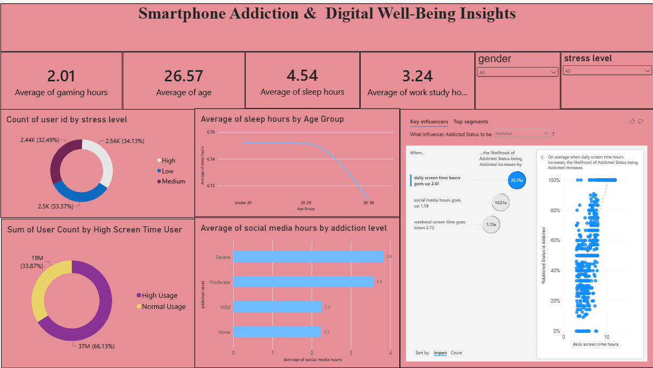
Key Observation Metric Dimensions:
Observations drawn from reports in Power BI can provide valuable insights into business performance and trends.
1.Trends Over Time:
- Daily and Weekly Tracking: Analyze how key metrics (e.g., average screen time, notification frequency, or pickup counts) change over different periods (hourly, daily, weekly) to identify usage spikes, weekend patterns, or late-night scrolling behaviors.

2. Performance & Behavior Comparisons:
- Platform and Application Categories: Compare engagement metrics across different categories—such as Social Media, Productivity, Gaming, or Entertainment—to determine which application environments drive the highest levels of continuous user presence or potential digital dependency.
3. User Segmentation:
- Demographic Grouping: Assess demographic data (age cohorts, student/professional status, occupational fields) to understand specific behavioral profiles and tailor customized digital wellness or focus strategies accordingly.
4. Goal Achievement & Interventions:
- Wellness KPI Tracking: Measure user trends against established KPIs (e.g., screen time limits, app downtime compliance, minimum sleep windows) to evaluate whether personal wellness objectives are being successfully met.
Core Behavioral Insights & Examples:
1. Gender Distribution & Device Engagement:
- The gender distribution metrics indicate that higher screen time accumulation and dependency flags are observed among males (425,601 active hours) compared to females (247,174 active hours) across the surveyed sample environment.
2. Age Cohort Risk Assessment
- Among the monitored user base, the youth category (under 18) exhibits the highest density of critical addiction scores at 464,000 recorded alerts. This indicates an intense vulnerability to platform loops within younger populations. This trend strongly suggests the immediate need for protective product parameters, educational interventions, and tailored features focused on youth time limits.
3. Platform Anomalies & Overuse Patterns
- The Android platform segment demonstrates the highest sum of continuous session overruns (59,888 threshold breaches), pointing to potential optimization gaps or higher notification friction on those interfaces. Addressing these specific triggers through smart notification filtering can significantly mitigate daily compulsive device pickups.
4. Peak Well-Being Engagement
- A cumulative total of 706,000 intervention prompts have been deployed, indicating a strong baseline framework for user alerts. Cohorts utilizing specific feature packages—such as Focus Mode at 162,407 active sessions—should be analyzed closely to replicate successful retention patterns across less engaged segments.

