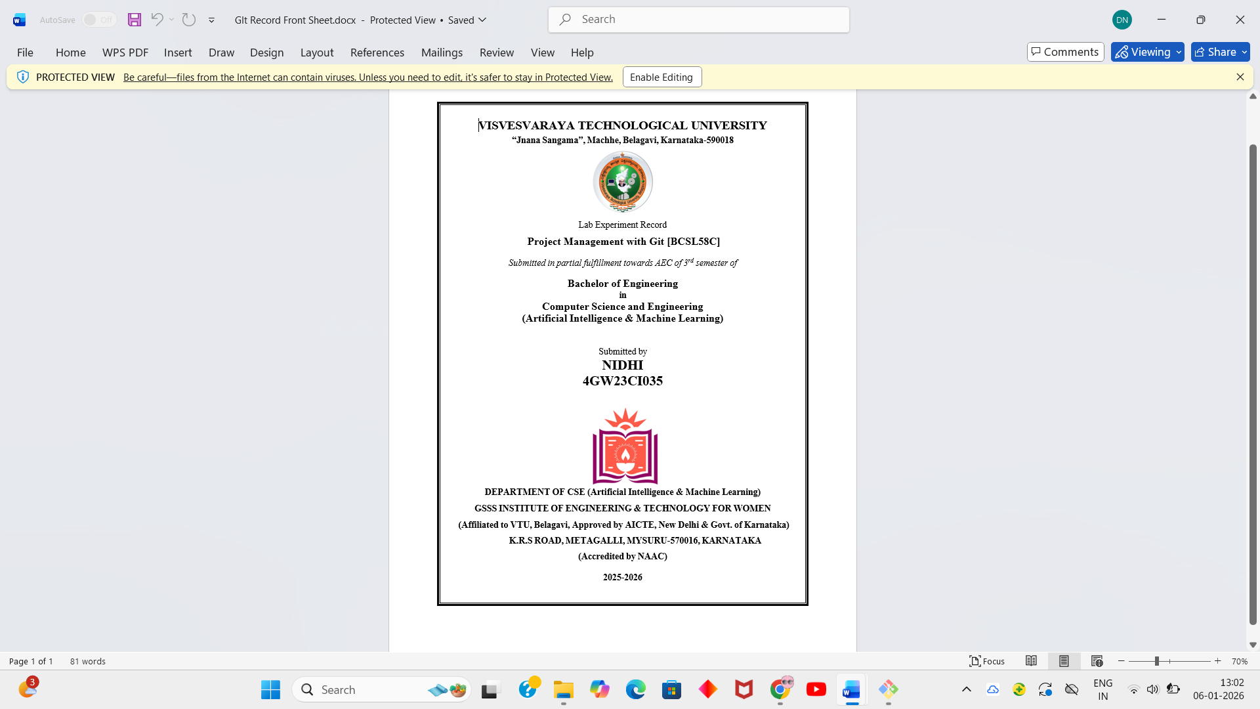
Dhanalakshmi N
4GW24CI012
TABLE OF CONTENT

- Setting Up and Basic Commands Initialize a new Git repository in a directory. Create a new file and add it to the staging area and commit the changes with an appropriate commit message.

2. Creating and Managing Branches Create a new branch named "feature-branch." Switch to the "master" branch. Merge the "feature-branch" into "master."

3. Creating and Managing Branches Write the commands to stash your changes, switch branches, and then apply the stashed changes.

4. Collaboration and Remote Repositories Clone a remote Git repository to your local machine.
5. Collaboration and Remote Repositories Fetch the latest changes from a remote repository and rebase your local branch onto the updated remote branch.
6. Collaboration and Remote Repositories Write the command to merge "feature-branch" into "master" while providing a custom commit message for the merge.

7. Git Tags and Releases Write the command to create a lightweight Git tag named "v1.0" for a commit in your local repository.

8. Advanced Git Operations Write the command to cherry-pick for a range of commits from "source-branch" to the current.
9. Analyzing and Changing Git History Given a commit ID, how would you use Git to view the details of that specific commit, including the author, date, and commit message?

10. Analyzing and Changing Git History Write the command to list all commits made by the author "JohnDoe" between "2023-01 01" and "2023-12-31."
11. Analyzing and Changing Git History Write the command to display the last five commits in the repository's history.

12. Analyzing and Changing Git History Write the command to undo the changes introduced by the commit with the ID "abc123".

Subject: Project Management with Git
Course Code: BCSL358C

Name: Dhanalakshmi.N
USN: 4GW24CI012
Semester: 3rd Semester

Program 1: Setting Up Git and Basic Commands

Aim
To initialize a Git repository, configure user details, create a file, and perform the first commit.

Procedure
A new folder is created and Git Bash is opened in that directory.
The Git repository is initialized using:
- git init
User identity is configured so that Git can track authorship:
git config user.name "Dhanalakshmi242"
git config user.email "dhanu2006gowda@gmail.com"
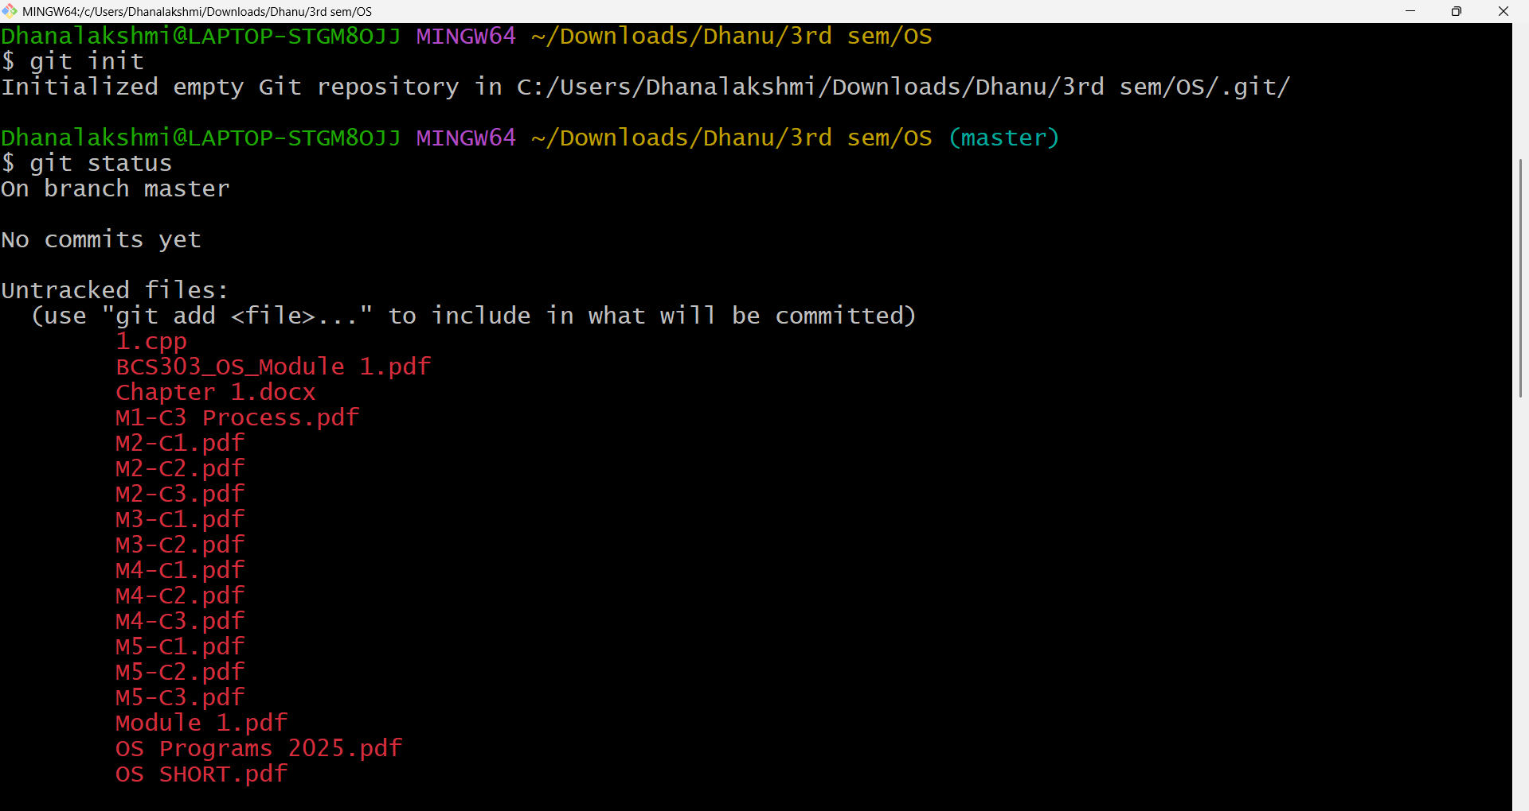
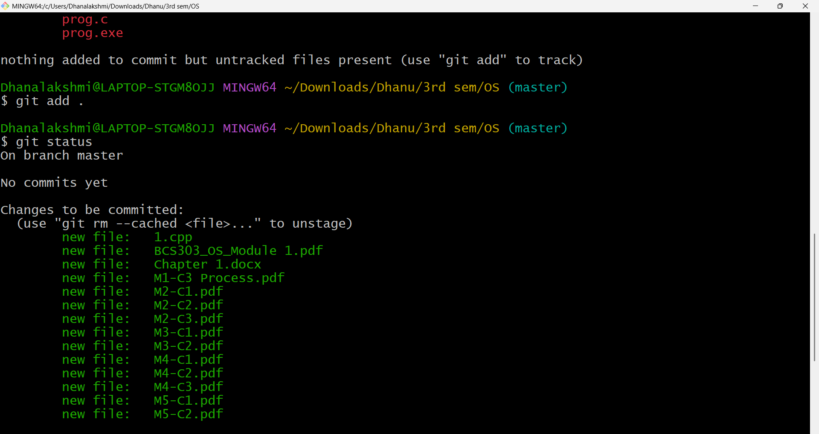

Result
Git repository was successfully initialized and the first commit was created.

Program 2: Creating and Managing Branches Create a new branch named "feature-branch." Switch to the "master" branch. Merge the "feature-branch" into "master."

Aim
To create a new branch and merge it into the main branch.

Procedure
1.After initializing the repository and making the initial commit, a new branch is created
git branch feature-branch
2.The branch is switched using:
git checkout feature-branch
3.Changes are made and committed in the feature branch.
The branch is switched back to the main branch:
git checkout main
4.The feature branch is merged into main:
git merge feature-branch
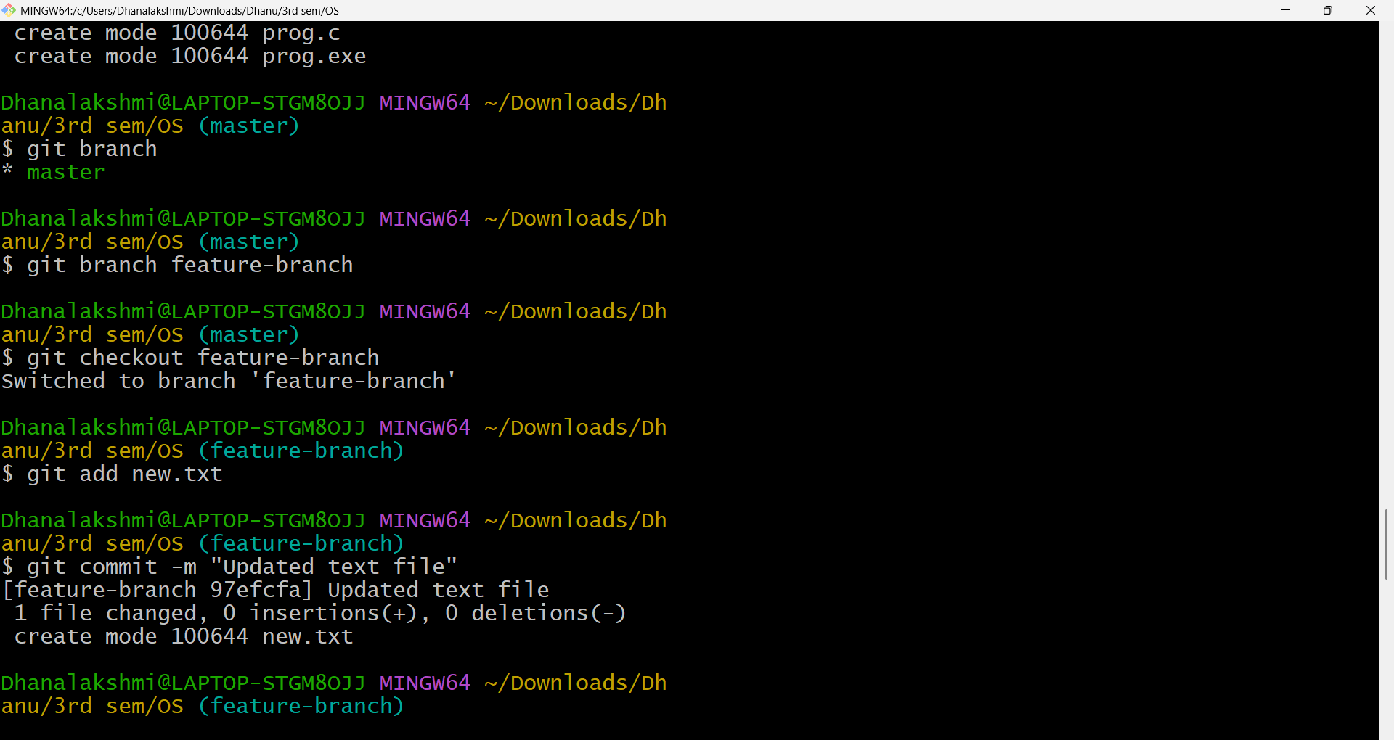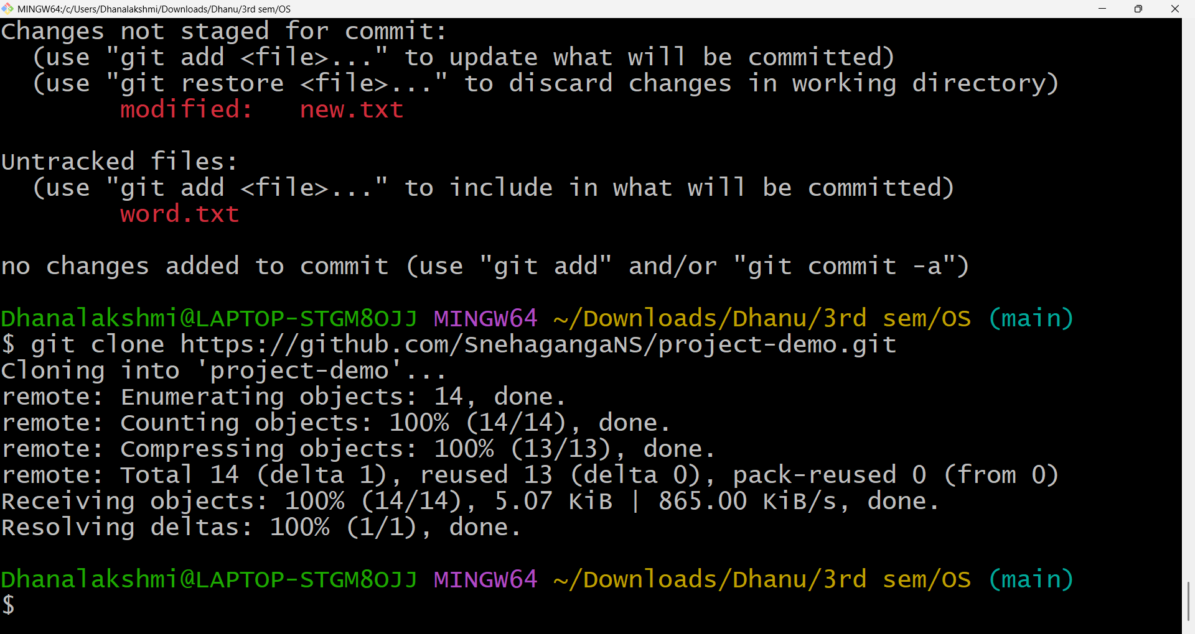

Result
Changes from feature-branch were successfully merged into the main branch.

Program 3: Creating and Managing Branches Write the commands to stash your changes, switch branches, and then apply the stashed changes.

Aim
To temporarily store uncommitted changes using Git stash and apply them on another branch.
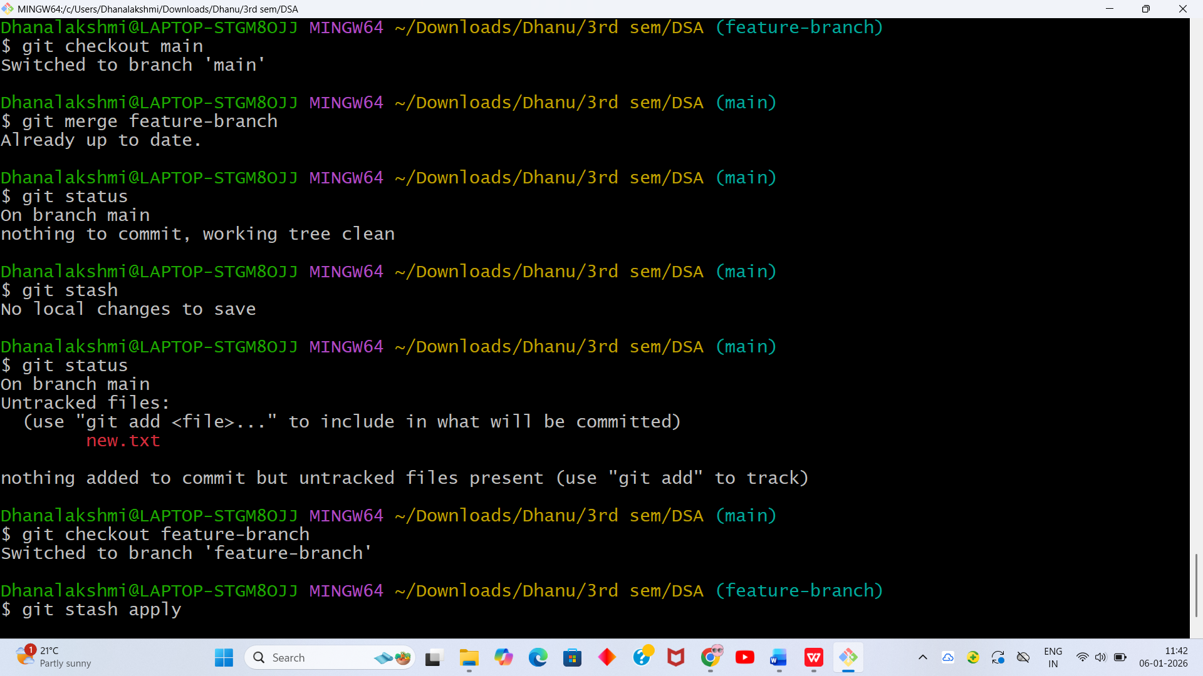

Result
Uncommitted changes were successfully transferred to another branch using stash.

Program 4: Collaboration and Remote Repositories Clone a remote Git repository to your local machine.

Aim
To clone a remote GitHub repository to the local system.
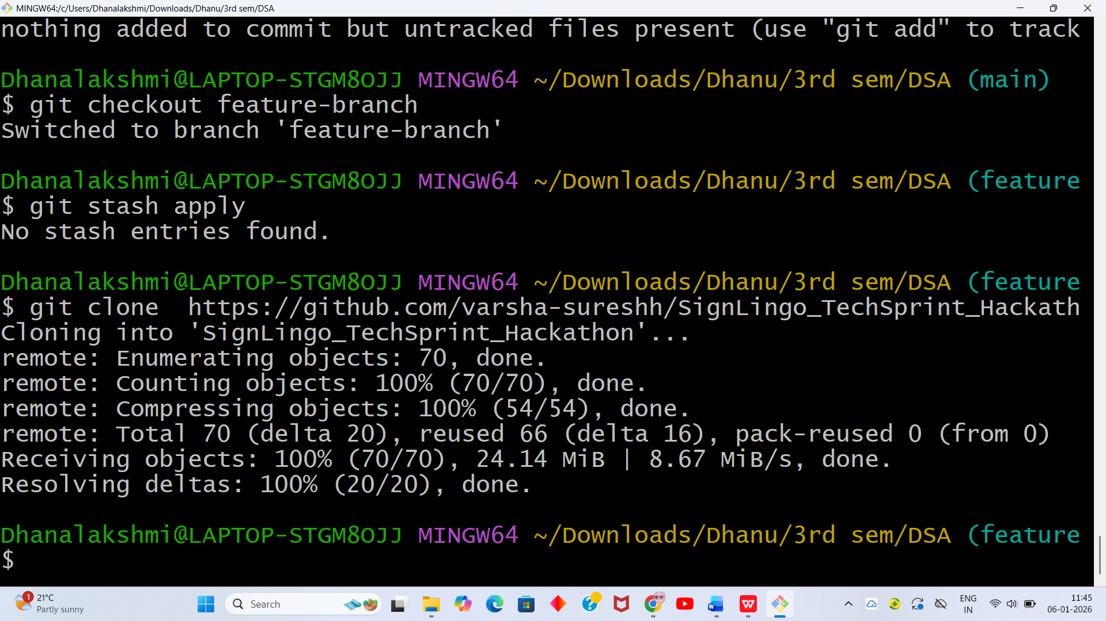

Result
Remote GitHub repository was successfully cloned.

Program 5: Collaboration and Remote Repositories Fetch the latest changes from a remote repository and rebase your local branch onto the updated remote branch.

Aim
To fetch remote changes and rebase a local branch onto the updated remote branch.
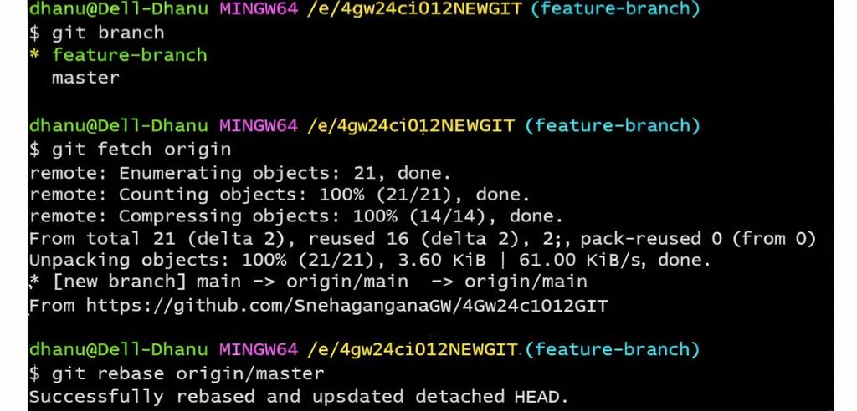

Result
Local branch was successfully rebased with remote updates.

Program 6: Collaboration and Remote Repositories Write the command to merge "feature-branch" into "master" while providing a custom commit message for the merge.

Aim
To merge a branch using a custom merge commit message.
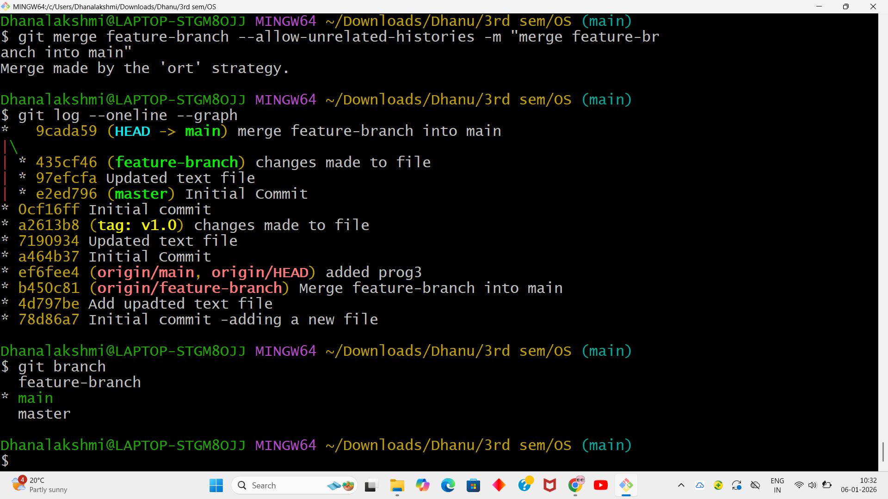

Result
A lightweight tag v1.0 was successfully created.

Program 7: Git Tags and Releases Write the command to create a lightweight Git tag named "v1.0" for a commit in your local repository.
Aim : To create a lightweight tag for a commit.
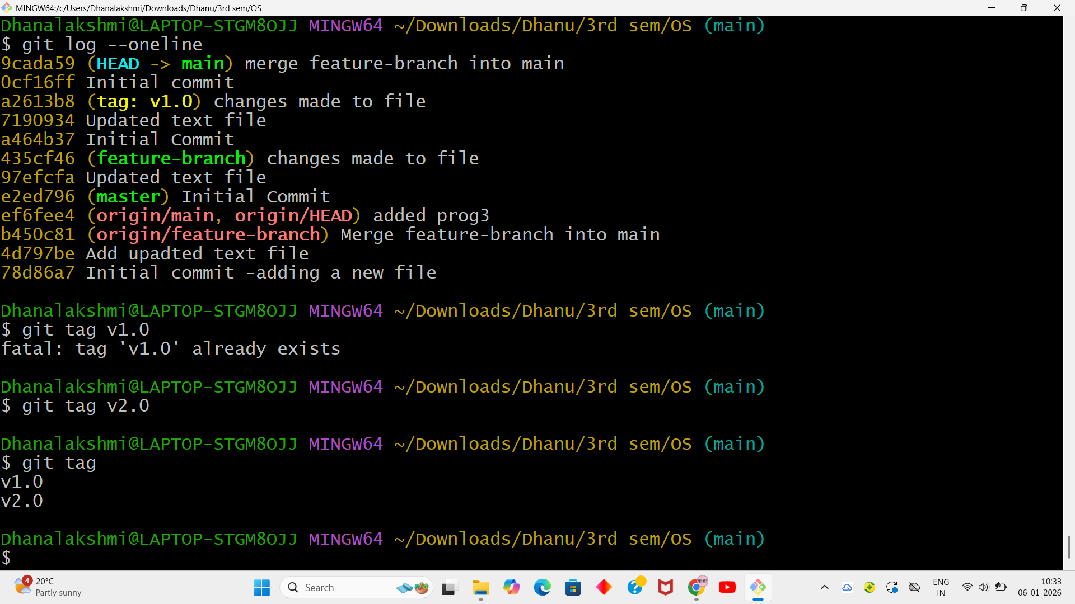
Using ‘log’ command we can see the commit with the tag we have used.
git log --oneline

Result
A lightweight tag v1.0 was successfully created.

Program 8: Advanced Git Operations: Write the command to cherry-pick a range of commits from "source-branch" to the current branch
Aim
To apply a selected range of commits from one branch to another.
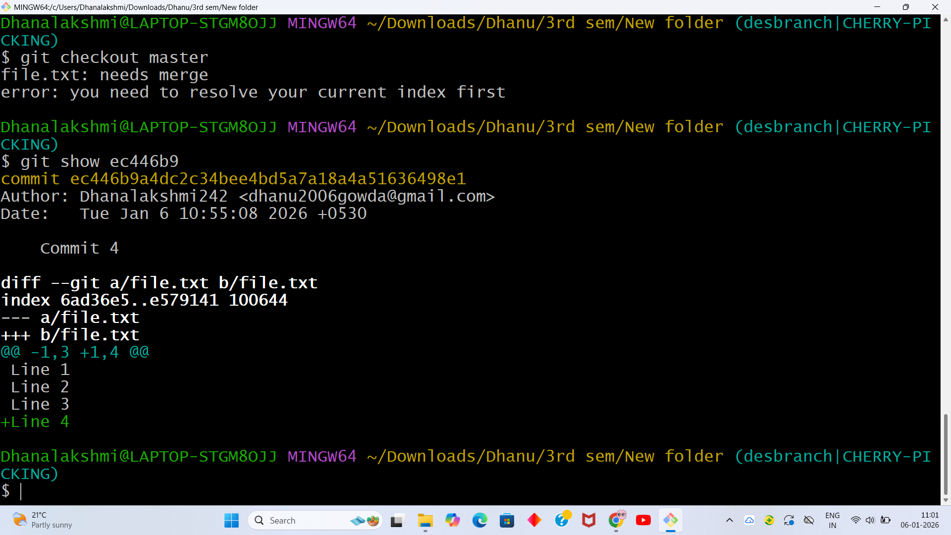
Result
Selected commits were successfully applied to the destination branch.

Program 9: Analysing and Changing Git History Given a commit ID, how would you use Git to view the details of that specific commit, including the author, date, and commit message
Aim
To view details of a specific commit.
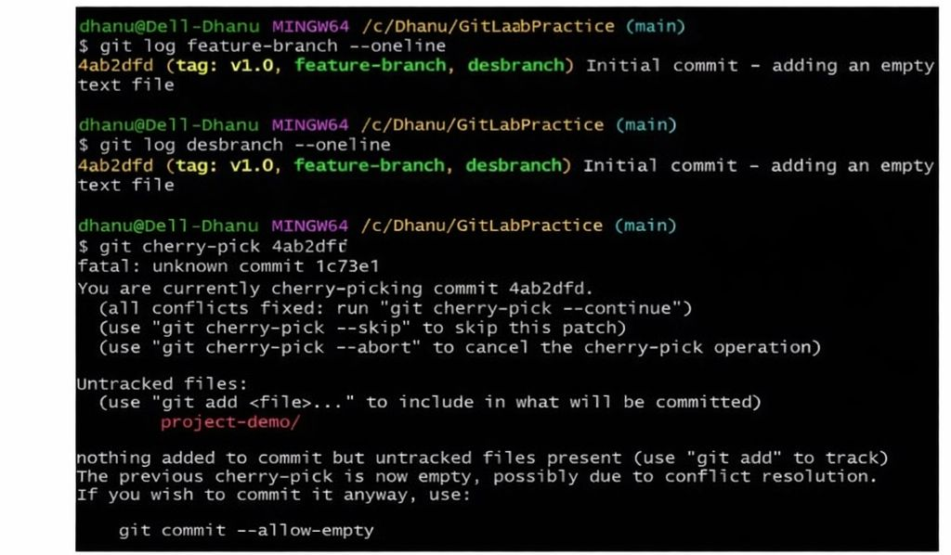
Result
Commit details including author, date, and message were displayed.

Program 10: Analysing and Changing Git History
Aim
To list commits made by a specific author within a date range.
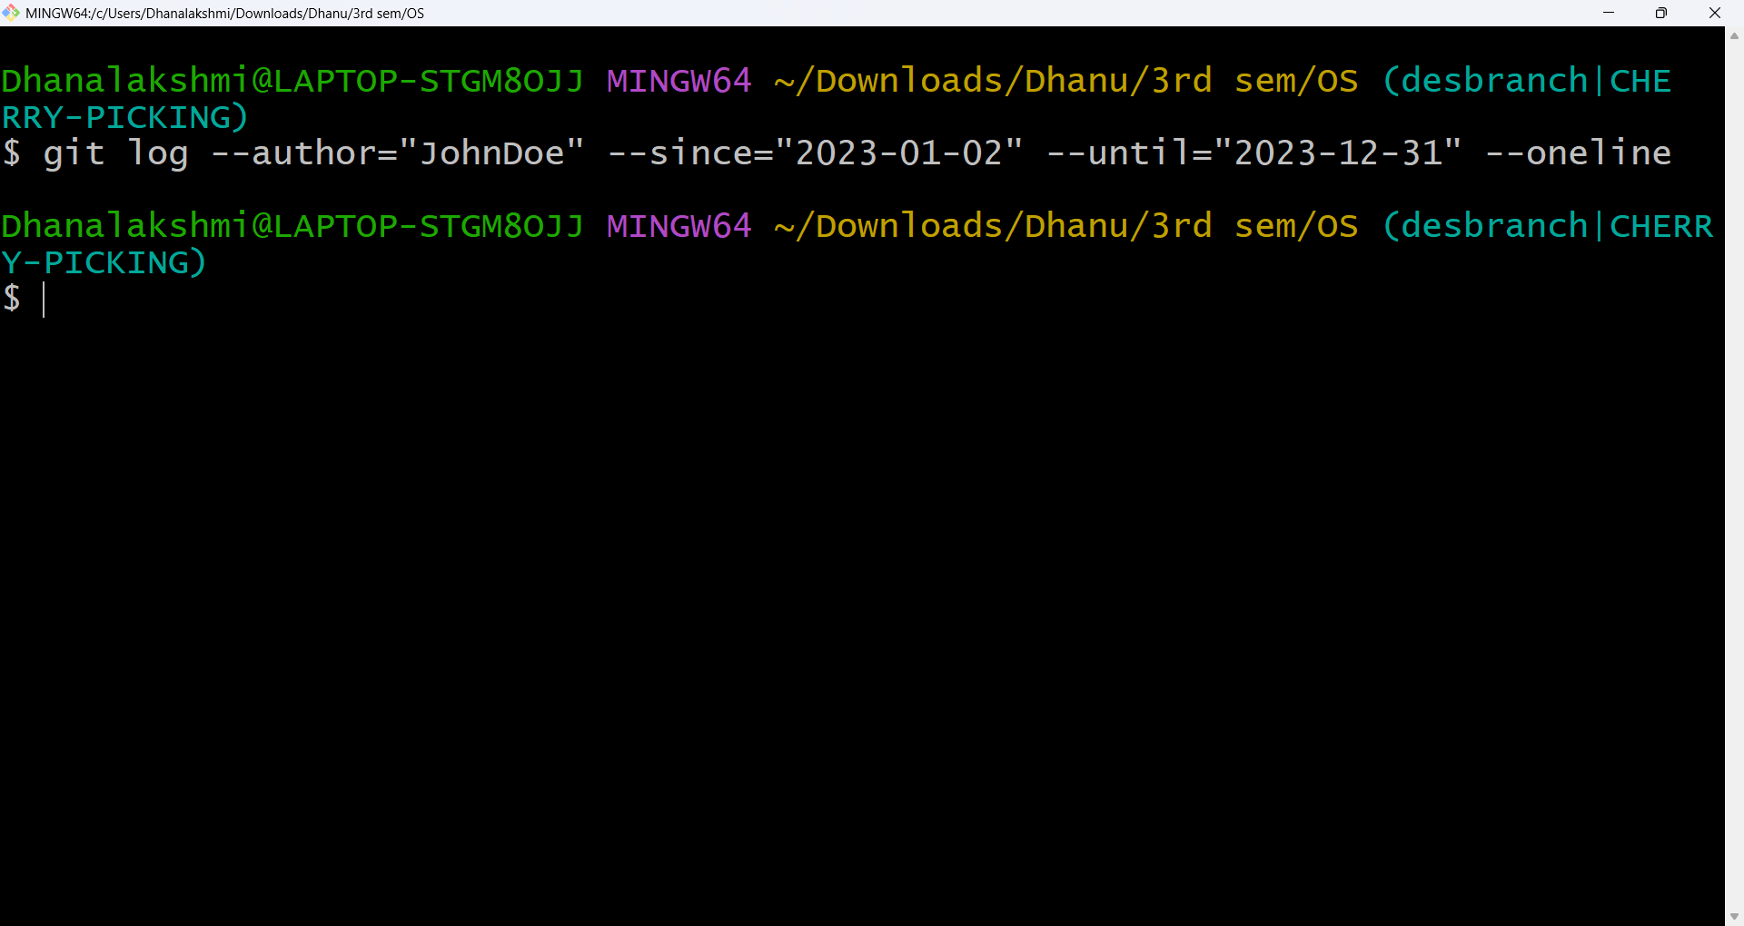

Result
Commits matching the author and date criteria were listed.

Program 11: Analysing and Changing Git History Write the command to display the last five commits in the repository's history.
Aim
To display the last five commits.
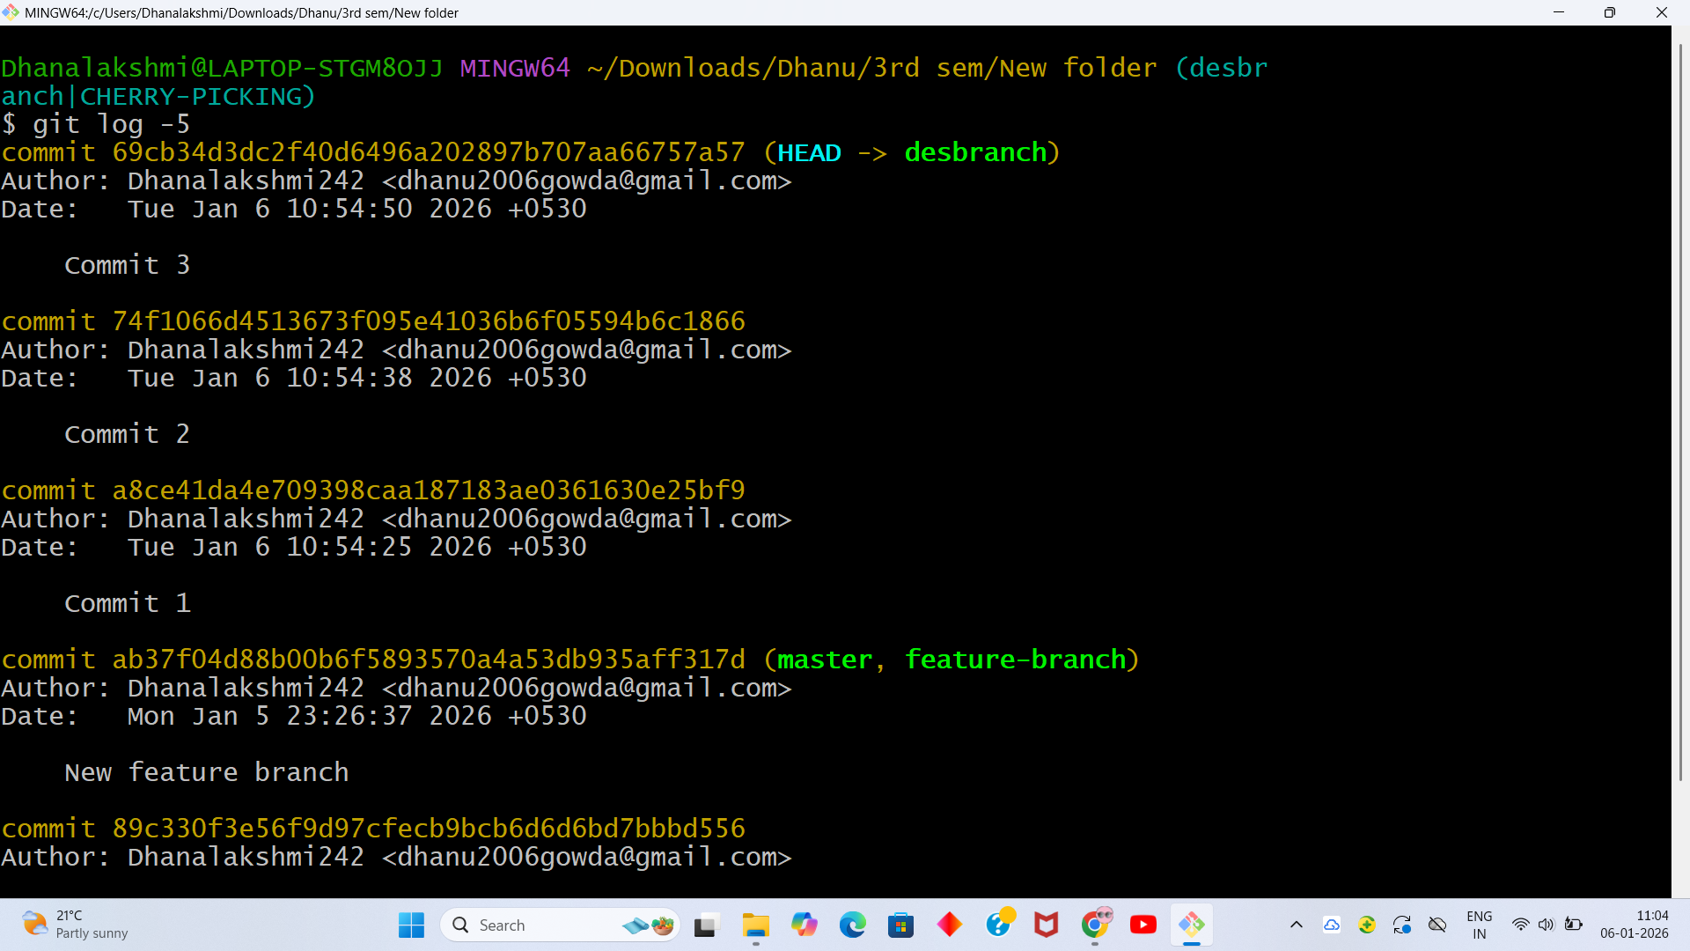
Result
The five most recent commits were displayed.

Program 12: Analyzing and Changing Git History Write the command to undo the changes introduced by the commit with the ID "abc123".
Aim:To undo the changes introduced by a specific commit.
To reverse the effect of a particular commit in Git, the revert operation is used. Instead of deleting the commit from history, Git generates a new commit that applies the opposite changes of the selected commit. This approach ensures that the commit history remains intact and traceable.
The command used is:
git revert abc123
When this command is executed, Git analyzes the changes introduced by commit abc123 and automatically creates another commit that cancels those changes. This method is preferred in collaborative environments because it does not rewrite history and avoids issues for other contributors working on the same repository.
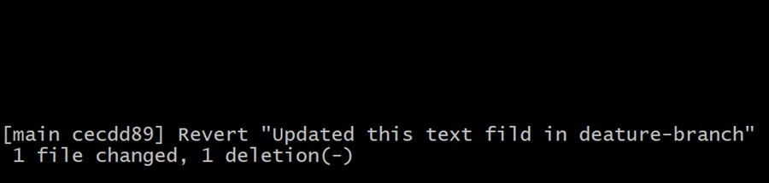

Result
A new commit was created that reversed the changes of the specified commit.

