**MANIFOLD EMBEDDING AND SEMANTIC SEGMENTATION FOR INTRAOPERATIVE GUIDANCE WITH HYPERSPECTRAL BRAIN IMAGING**

**TABLE OF CONTENTS**

|  |  |  |
| --- | --- | --- |
| **S.NO** | **TITLE** | **Page No** |
| 1 | Abstract | 3 |
| 2 | Introduction | 5 |
| 3 | Existing system | 19 |
| 4 | Disadvantages | 21 |
| 5 | Proposed system | 22 |
| 6 | Advantages | 23 |
| 7 | Flow Diagram | 25 |
| 8 | Use case Diagram | 26 |
| 9 | Sequential Diagram | 27 |
| 10 | System Architecture | 28 |
| 11 | Block Diagram | 29 |
| 12 | Modules | 30 |
| 13 | Modules Description | 31 |
| 14 | Literature Survey | 41 |
| 15 | Testing of Product | 63 |
| 16 | System Requirements | 70 |
| 17 | Software Description | 71 |
| 18 | System Design | 77 |
| 19 | Screenshot | 81 |
| 20 | Conclusion | 95 |
| 21 | Future Enhancement | 96 |
| 22 | References | 97 |

**ABSTRACT**

Recent advances in hyperspectral imaging have made it a promising solution for intra-operative tissue characterization, with the advantages of being non-contact, non-ionizing, and non-invasive. Working with hyperspectral images in vivo, however, is not straightforward as the high dimensionality of the data makes real-time processing challenging. In this paper, a novel dimensionality reduction scheme and a new processing pipeline are introduced to obtain a detailed tumour classiﬁcation map for intra- operative margin deﬁnition during brain surgery. However, existing approaches to dimensionality reduction based on manifold embedding can be time consuming and may not guarantee a consistent result, thus hindering ﬁnal tissue classiﬁcation. The proposed framework aims to overcome these problems through a process divided into two steps: dimensionality reduction based on an extension of the T-distributed stochastic neighbour approach is ﬁrst per- formed and then a semantic segmentation technique is applied to the embedded results by using a Semantic Textron Forest for tissue classiﬁcation. Detailed in vivo validation of the proposed method has been performed to demonstrate the potential clinical value of the system. Due to signiﬁcant improvements and miniaturization of hyperspectral cameras in recent years, hyperspectral imaging is becoming a well-established technique for disease diagnosis in a wide range of medical applications. In this section, we brieﬂy describe the mechanisms behind the optical processes steps involved during a hyperspectral image acquisition. Speciﬁcally, when the light hits a biological tissue, it can deﬂect in three main components called absorbed, reﬂected and scattered light. While reﬂection appears on surfaces built from a non-absorbing powder, or from ﬁbres and polycrystalline material, scattering occurs where there is a spatial variation in the refractive index of the substances, generally caused by inhomogeneous structures; ﬁnally, absorption happens when the photons’ energy matches the energy gap of the molecules of the tissues and is usually signiﬁcantly high in haemoglobin, melanin, and water. The penetration depth of the light depends on the molecular composition of the tissue. Consequently, the absorption, reﬂection and the scattering characteristics change across tissues, showing differences also during the progression of a disease. Measurement of these tissue characteristics can provide quantitative diagnostic information about pathology. Hyperspectral images tend to have a high dimensionality, making real-time processing difﬁcult. In the context of this paper, the high dimensionality is due to the large number of wavelength bands that create the hyperspectral cube. Dimensionality reduction transforms high-dimensional data into a reduced dimensional representation that is still capable of describing the initial data. The intrinsic dimensionality is, therefore, the minimum number of parameters required to accurately describe all the observed properties of the data.

**INTRODUCTION**

While malignant primary brain tumours rank only 13th in the list of cancer incidence rates, their particularly poor prognosis elevates it as the ﬁfth most common cause of cancer deaths in those under the age of 65. Among children, they are the second most common form of cancer and the most common cause of cancer death. Gliomas are the most frequent primary brain tumours and they are currently incurable.

Research has shown that life expectancy increases with an extensive resection of these tumours. Gross total resection is a challenging task since gliomas inﬁltrate the surrounding tissue and their borders are indistinctive and difﬁcult to identify.

Currently, different techniques have been developed to help achieve this goal, but none have succeeded in reliable real-time and non-invasive tissue differentiation.

For example, neuro-navigation is plagued with brain shift, while ultrasound is highly operator dependant and Magnetic Resonance Imaging (MRI) is still not accessible for real-time intra-operative use. Consequently, clinical routines are still based on subjective visual assessment by the surgeon, who decides which areas should be removed during the operation. Without accurate guidance, margin deﬁnition is poor even for experts.

This is mainly due to signiﬁcant visual variations between adjacent structures of the brain when they are partially obscured, and because tumour structures vary considerably across patients in terms of location, size, and extension, prohibiting the use of priors on shape and location. Hyperspectral imaging, also called imaging spectroscopy, is an emerging technology that can assist surgeons to classify tumour from healthy tissue in real-time. In this paper, we propose a novel manifold embedding framework where the output generated from a hyperspectral image is semantically segmented into a tumour map. The proposed method has the main goal of delineating the exact boundaries of the brain tumours, allowing a complete resection of the malignant cells while saving as much healthy brain tissue as possible. The proposed system can also be used to improve diagnosis and treatment planning, as well as follow-up of individual patients. Hyper-spectral imaging is a non-contact, non-ionizing and minimally-invasive sensing technique. Whereas a conventional camera captures images in three color channels (red, blue and green), a hyper spectral camera captures data over a large number of contiguous and narrow spectral bands.

Classiﬁcation of the tissue under evaluation can be achieved by analysing there ﬂectance or ﬂuorescence of every pixel in the hyperspectral image and the spatial structures that these pixels form. For example, it has been demonstrated that biological tissues exhibit ﬂuorescent properties when excited with ultra-violet light, and signiﬁcant differences in these ﬂuorescent properties occur between malignant and healthy tissues.

Previous works demonstrate that hyperspectral imaging can be used for certain cancer detection in animals. Thus far, limited work has been performed by using the technique for detecting cancer in vivo and none has been used for brain tissue. The work described in this paper presents results obtained from our collaborative EU project HELICoiD where four universities, three industrial partners and two hospitals were involved.

To the best of our knowledge, we are the ﬁrst to explore hyperspectral imaging for the identiﬁcation of cancer tissue during in-vivo brain surgery. Dimensionality reduction transforms high-dimensional data into a reduced dimensional representation that is still capable of describing the initial data.

The intrinsic dimensionality is, therefore, the minimum number of parameters required to accurately describe all the observed properties of the data. Since in our application we want to use dimensionality reduction just to project the data into a lower dimensional space and make the subsequent tissue categorization as precise as possible, the constraint of preserving all these initial properties is not strictly necessary. Consequently, in this case, the intrinsic dimension can be made small, as long as the new representation allows the correct classiﬁcation of all the tissue types.

**DOMAIN INTRODUCTION**

**Digital image processing**:

Digital image processing is the use of computer [algorithms](https://en.wikipedia.org/wiki/Algorithm) to perform [image processing](https://en.wikipedia.org/wiki/Image_processing) on [digital images](https://en.wikipedia.org/wiki/Digital_image). As a subcategory or field of [digital signal processing](https://en.wikipedia.org/wiki/Digital_signal_processing), digital image processing has many advantages over [analogue image processing](https://en.wikipedia.org/wiki/Analog_image_processing). It allows a much wider range of algorithms to be applied to the input data and can avoid problems such as the build-up of noise and signal distortion during processing. Since images are defined over two dimensions (perhaps more) digital image processing may be modeled in the form of [multidimensional systems](https://en.wikipedia.org/wiki/Multidimensional_systems).

Digital image processing deals with manipulation of digital images through a digital computer. It is a subfield of signals and systems but focus particularly on images. DIP focuses on developing a computer system that is able to perform processing on an image. The input of that system is a digital image and the system process that image using efficient algorithms, and gives an image as an output.

**Digital Image:**

Digital image are electronic snapshots taken of a scene or scanned from documents, such as photographs, manuscripts, printed texts, and artwork. The digital image is sampled and mapped as a grid of dots or picture elements (pixels).

Image processing is a method to perform some operations on an image, in order to get an enhanced image or to extract some useful information from it. It is a type of signal processing in which input is an image and output may be image or characteristics/features associated with that image.

Nowadays, image processing is among rapidly growing technologies. It forms core research area within engineering and computer science disciplines too.

Image processing basically includes the following three steps:

* Importing the image via image acquisition tools;
* Analysing and manipulating the image;
* Output in which result can be altered image or report that is based

on image analysis.

There are two types of methods used for image processing namely,

* Analogue image processing
* Digital image processing.

**Analogue image processing** can be used for the hard copies like printouts and photographs. Image analysts use various fundamentals of interpretation while using these visual techniques.

**Digital image processing** techniques help in manipulation of the digital images by using computers. The three general phases that all types of data have to undergo while using digital technique are pre-processing, enhancement, and display, information extraction. In this lecture we will talk about a few fundamental definitions such as image, digital image, and digital image processing.

Different sources of digital images will be discussed and examples for each source will be provided. The continuum from image processing to computer vision will be covered in this lecture.

Finally we will talk about image acquisition and different types of image sensors.

**Digital image processing techniques**

* Digital image processing Topic Image Enhancement And analysis Of Thermal Image Using Various Techniques Of Image Processing
* **Image Enhancement**
* Image enhancement is to process an image so that result is more suitable than original image for specific application.
* Image enhancement make images more useful.
* The reasons for doing this include:
* Highlighting interesting detail in images
* Removing noise from images,
* Making images more visually appealing
* Edge enhancement
* Increase the contrast of the image
* **Thermal Image enhancement**
* Thermal image enhancement used in
* Problem Diagnostics
* Research and Development,
* Insurance Risk Assessment
* Digital infrared thermal imaging in health care
* law enforcement and defence.
* Image enhancement has two domains:
* Spatial Domain
* Frequency Domain Filtering
* Image Enhancement and Analysis Techniques
* Conversion of the RGB to GRAYSCALE
* Histogram ,histogram equalization and contrast enhancement
* Linear filtering and noise removal
* Morphology
* FFT transforms
* **PROPOSED FLOW CHART** of Image Enhancement Read the image Convert RGB into Gray scale image Apply Histogram equalization Compare with gray image and its histogram Perform linear filtering operation in the above image Remove the noise by adaptive filtering Compare result with linear filtering image
* **PROPOSED FLOW CHART** of Image Enhancement Successive Erosion and dilation of the image using Morphological operation Compare histogram with original image Histogram plotting and mesh plotting Subtracting non uniform background from original image and plot histogram Apply FFT transform on the Morphological image and obtained restored image by IFFT Original image with uniform background is attained Enhanced image(result)
* Conversion of the RGB image into GRAYSCALE image
* In RGB image, for every pixel there are correspond 3 values. Where as in grayscale each pixel is a shade of gray, normally from 0 (black) to 255 (white). This range means that each pixel can be represented by eight bits, or exactly one byte. Other grayscale ranges are used, but generally they are a power of.
* Gray image takes less space in memory in comparison to RGB images Histogram
* The histogram of an image shows us the distribution of grey levels in the image massively useful in image processing.
* Histogram of images provide a global description of their appearance.
* The shape of the histogram of an image gives us useful information about the possibility for contrast enhancement
* Histogram equalization
* Histogram equalization Gray scale image histogram Resulting histogram after histogram equalization
* **Filtering**
  + Filtering is a technique for modifying or enhancing an image. For example, you can filter an image to emphasize certain features or remove other features.
  + Image processing operations implemented with filtering include **smoothing, sharpening,** and **edge enhancement**.
* Two main types of spatial domain filtering
* linear spatial filtering
* nonlinear spatial filtering
* **Linear filtering:**
  + It is filtering in which the value of an output pixel is a linear combination of the values of the pixels in the input pixel's neighbourhood.
* **Linear spatial filtering**

There are two closely related concepts that must be understood clearly when performing linear spatial filtering. One is Correlation, the other is Convolution.

* **Correlation:** is the process of passing the mask w by the image array f.
* **Convolution:** is the same process, except that w is rotated by 180 degrees prior to passing it by f. If the filter mask is symmetric then correlation and convolution yield the same result
* **Linear spatial filtering**

Smoothing Spatial Filters Smoothing filters are used for noise reduction and blurring operations.

* There are two main types of Smoothing filters:
* Smoothing Linear Filters
* Smoothing Nonlinear Filters
* Smoothing Linear Filters/Averaging Filters The response of a smoothing linear spatial filter is simply the average of the pixels contained in the neighbourhood of the filter mask. These kind of filters are called averaging filters or low pass filters.
* Smoothing Linear Filters/Averaging Filters
* In smoothing filters it replace the value of every pixel in an image by the average of the grey levels defined by the filter mask.
* This process result in an image with reduced sharp transitions in intensities.
* The most obvious application is noise reduction.
* Because random noise is typically consist of sharp transitions in intensity level.
* Smoothing Linear Filters/Averaging Filters
* Smoothing Linear Filters/Averaging Filters
* **Adaptive filtering-noise filter**

Adaptive filter is performed on the degraded image that contains original image and noise. The mean and variance are the two statistical measures that a local adaptive filter depends with a defined m x n window region.

* **Adaptive filtering-noise filter**
* Define a window of size mxn.
* For instance consider a matrix B
* Pad matrix with zero.
* Adaptive filtering-noise filter Noisy image After adaptive filtering
* Morphology
  + The word morphology refers to the scientific branch that deals the forms and structures of animals/plants.
  + Morphology in image processing is a tool for extracting image components that are useful in the representation and description of region shape, such as boundaries, Skeletons
  + The language of the Morphology comes from the set theory, where image objects can be represented by sets.
* Morphological image processing
  + Mathematically Morphologic image processing technology is based on geometry.
  + The theoretical foundations of morphological image processing lies in Set theory.
  + The operators are particularly useful for the analysis of binary images and common usages include edge detection, noise removal, image enhancement and image segmentation.
* Basic set theory
* Logical Operation Involving Binary Images
* Morphological image processing
  + Morphological techniques typically probe an image with a small shape or template known as a structuring element.
  + The structuring element is positioned at all possible locations in the image and it is compared with the corresponding neighbourhood of pixels.
  + The structuring element is sometimes called the kernel.
  + small set to probe the image under study
  + for each SE, define origin
  + shape and size must be adapted to geometric properties for the objects
* Morphological image processing
  + Capable of removing noise
  + Medical image analysis: Tumor detection, measurement of size and shape of internal organs.
  + Recognition and interpretation of objects in a scene.
* Basic morphological operations
* Erosion
* Dilation
* Opening
* Closing
* **Dilation:** bridging gaps the simplest application of Dilation
  + Given the following distorted text image where the maximum length of the broken characters are 2 pixels.
* Erosion
  + erosion of a set A by structuring element B: all z in A such that B is in A when origin .
  + shrink the object
* Erosion A A Ө B
* Useful
  + Erosion removal of structures of certain shape and size, given by SE.
  + Dilation filling of holes of certain shape and size, given by SE
* Combining Erosion and Dilation
  + WANTED: remove structures / fill holes without affecting remaining parts.
  + SOLUTION: combine erosion and dilation (using same SE)
* **Erosion**: Eliminating irrelevant detail structure ❑ Given the following binary image with squares on size 1,3,5,7,9 and 15. You can get rid of all the squares less than size of 15 by erosion followed by dilation of a structuring element of 13x13.
* Opening and Closing
  + The process of erosion followed by dilation is called opening. It has the effect of eliminating small and thin objects, breaking the objects at thin points and smoothing the boundaries/contours of the objects.
  + Opening of A by structuring element B is defined by: The process of dilation followed by erosion is called closing. It has the effect of filling small and thin holes, connecting nearby objects and smoothing the boundaries/contours of the objects. • Closing of A by structuring element B is defined by:
* **Noise Filtering:**

The morphological operations can be used to remove the noise as in the following example: result of opening followed by closing

In digital image processing Fast Fourier Transform is applied to convert an image from the image (spatial) domain to the frequency domain.

* The image is converted into spatial frequencies using a Fast Fourier Transform, the appropriate filter is applied. •
* Then the image is converted back using an inverse FFT.
* The advantage of representing an image in the frequency space is that performing some operations on the frequencies is much more efficient than doing the same in the image space i.e. ✓ Applying filters to images in frequency domain is computationally faster than to do the same in the image domain
* Outcomes
  + Image improved
  + The histogram obtained from these images is also improved which shows that image is enhanced, the intensity range is also better.
  + The mesh plot is also better in the morphology operation and the FFT mesh plot is only change the domain.

**PROCESS INTRODUCTION**

**Dimensionality reduction**

Dimensionality reduction or dimension reduction is the process of reducing the number of random variables under consideration by obtaining a set of principal variables. It can be divided into feature selection and feature extraction.

[**Feature selection**](https://en.wikipedia.org/wiki/Feature_selection)**:**

[Feature selection](https://en.wikipedia.org/wiki/Feature_selection) approaches try to find a subset of the original variables (also called features or attributes). There are three strategies: the filter strategy (e.g. [information gain](https://en.wikipedia.org/wiki/Information_gain_in_decision_trees)), the wrapper strategy (e.g. search guided by accuracy), and the embedded strategy. Data analysis such as regression or classification can be done in the reduced space more accurately than in the original space.

**Feature extraction:**

Feature extraction transforms the data in the high-dimensional space to a space of fewer dimensions. The data transformation may be linear, as in principal component analysis (PCA), but many nonlinear dimensionality reduction techniques also exist. For multidimensional data, tensor representation can be used in dimensionality reduction through multilinear subspace learning.

## **Advantages of dimensionality reduction:**

* It reduces the time and storage space required.
* Removal of multi-collinearity improves the performance of the machine learning model.
* It becomes easier to visualize the data when reduced to very low dimensions such as 2D or 3D.

**Applications:**

A dimensionality reduction technique that is sometimes used in [neuroscience](https://en.wikipedia.org/wiki/Neuroscience) is [maximally informative dimensions](https://en.wikipedia.org/wiki/Maximally_informative_dimensions), which finds a lower-dimensional representation of a dataset such that as much [information](https://en.wikipedia.org/wiki/Mutual_information) as possible about the original data is preserved.

**Methods of Dimensionality Reduction**

The various methods used for dimensionality reduction include:

* Principal Component Analysis (PCA)
* Linear Discriminant Analysis (LDA)
* Generalized Discriminant Analysis (GDA)

Dimensionality reduction may be both linear and non-linear, depending upon the method used. The prime linear method, called Principal Component Analysis, or PCA.

**Advantages of Dimensionality Reduction:**

* It helps in data compression, and hence reduced storage space.
* It reduces computation time.
* It also helps remove redundant features.

**Disadvantages of Dimensionality Reduction:**

* It may lead to some amount of data loss.
* PCA tends to find linear correlations between variables, which is sometimes undesirable.
* PCA fails in cases where mean and covariance are not enough to define datasets.
* We may not know how many principal components to keep- in practice, some thumb rules are applied.

**EXISTING SYSTEM**

Existing approaches to brain tumour visualisation are commonly based on the use of Computed Tomography (CT) or MRI. Current methods try to automatically discover glial tumour, meningioma or gliomas sub- types that can occur in the brain tissues. In general, medical imaging approaches for brain tissue characterization can be categorized into two types:

The generative probabilistic methods that segment the brain by exploiting detailed prior information about the appearance and spatial distribution of the different tissue types

Discriminative approaches that learn from labelled images about different appearance of tissues, analysing local features that are relevant to tumour segmentation task.

These features usually represent local intensity differences, intensity distributions, texture and spatial regularity of tissue labels. Once these features are extracted, they are fed into a classiﬁer to obtain a semantic segmentation of the image.

The semantic segmentation can be thought of as an extension of the popular scene classiﬁcation problem where the entity to classify is no longer the whole image, but a single group of pixels.

The output of the semantic segmentation classiﬁer, therefore, highlights the tumour classiﬁcation map. Generative models represent the state-of-the-art for brain tissue segmentation.

However, the main problem is that they require a signiﬁcant effort for transforming an arbitrary semantic interpretation of the image into appropriate probabilistic models.

Hyperspectral imaging is a relatively new area of research that can be also used in this context. In the literature, few techniques based on this technology have been proposed for tissue characterization and tumour analysis.

Due to the high-dimensionality of the hyperspectral images, most of the existing approaches classify the tissues by exploiting just spectral information without taking into account the spatial correlations, essential for describing the underlying brain structures.

Therefore, they classify the spectral signature of each sample independently using standard classiﬁers such as the Support Vector Machine (SVM).

We propose to extend this idea and reduce the problem of segmenting a hyperspectral image by analysing an embedded version of it so that the spatial information can be considered in the low-dimensional space. This makes our method capable of processing a hyperspectral image in real-time.

**DISADVANTAGES**

* The main weaknesses of the traditional approach are twofold.
* It is invasive with many potential side effects and complications.
* Diagnostic information is not available in real-time and requires off-line histopathology sample preparation and analysis.
* It can be time consuming and may not guarantee a consistent result

**PROPOSED SYSTEM**

In the proposed system we have followed these techniques.

**Tissue Characterization through Hyper spectral Image**:

Due to signiﬁcant improvements and miniaturization of hyper spectral cameras in recent years, hyper spectral imaging is becoming a well-established technique for disease diagnosis in a wide range of medical applications.

We brieﬂy describe the mechanisms behind the optical processes steps involved during a hyper spectral image acquisition. Speciﬁcally, when the light hits a biological tissue, it can deﬂect in three main components called absorbed, reﬂected and scattered light. While reﬂection appears on surfaces built from a non-absorbing powder, or from ﬁbers and polycrystalline material, scattering occurs where there is a spatial variation in the refractive index of the substances, generally caused by inhomogeneous structures; ﬁnally, absorption happens when the photons’ energy matches the energy gap of the molecules of the tissues and is usually signiﬁcantly high in haemoglobin, melanin, and water.

The penetration depth of the light depends on the molecular composition of the tissue. Consequently, the absorption, reﬂection and the scattering characteristics change across tissues, showing differences also during the progression of a disease.

Measurement of these tissue characteristics can provide quantitative diagnostic information about pathology. For example, absorption spectra characterize the concentration and oxygen saturation of haemoglobin, which can reveal if an angiogenesis or hyper metabolism is present. In other words, when the light is absorbed by the tissue, it is either converted to heat or radiated in the form of luminescence (ﬂuorescence and phosphorescence). Therefore, cells in different disease states may have different intrinsic characteristics, resulting in different ﬂuorescence emission spectra.

Hyperspectral images have the capability of measuring this ﬂuorescence, making a possible real-time investigation of the tissues for diagnosis purposes. These changes of the optical properties make this technology an ideal non-invasive probe for tissue analysis.

The output of a hyperspectral camera is a three dimensional matrix that contains samples arranged in columns (x dimension), lines (y dimension) and bands.

Dimensionality Reduction Hyperspectral images tend to have a high dimensionality, making real-time processing difﬁcult. In the context of this paper, the high dimensionality is due to the large number of wavelength bands that create the hyperspectral cube (for example, an image that has 400 × 400 pixels captured at 200 wavelengths will be represented by 160000 vectors lying in the space R200). In order to handle a hyperspectral image adequately for real-time applications, its dimensionality needs to be reduced through the projection of the hyperspectral cube to a space with only a few dimensions.

Dimensionality reduction transforms high-dimensional data into a reduced dimensional representation that is still capable of describing the initial data. The intrinsic dimensionality is, therefore, the minimum number of parameters required to accurately describe all the observed properties of the data. Since in our application we want to use dimensionality reduction just to project the data into a lower dimensional space and make the subsequent tissue categorization as precise as possible, the constraint of preserving all these initial properties is not strictly necessary. Consequently, in this case, the intrinsic dimension can be made small, as long as the new representation allows the correct classiﬁcation of all the tissue types.

**ADVANTAGES**

* Hyper spectral imaging is a non-contact, non-ionizing and minimally invasive sensing technique.
* It helps in understanding the cancer progression.
* This techniques can improve surgical accuracy, providing additional information that can also reduce the probability of erroneous resectioning of healthy tissue.
* It can be seen that the high quality and accuracy of the obtained tumour maps can be achieved by using a suitable embedding approach.

**DATA FLOW DIAGRAM**

Yes

No

Load a Dataset

Pick a file

Select a correct type of file

Preprocessing

Image Calibration

Noise Removal

Data Normalization

Manifold Embedding

Semantic Segmentation

Validation

Accuracy

Sensitivity

Specificity

Form a chart

imnoise()

imadjust()

imread()

random-forest

**SYSTEM ARCHITECTURE**

Calibration

Manifold Embedding

Read a file

Preprocessing

Noise Removal

Data Normalization

Semantic Segmentation

Accuracy

Measuring Performance

Sensitivity

Specificity

**SEQUENCE DIAGRAM**

Read a file

Preprocessing

Manifold Embedding

Segmentation

Performance

imread()

imrotate(),

imnoise(),

norm()

Accuracy

Sensitivity

Specificity

Red, GreenBlue

imadjust()

random-forest

**USECASE DIAGRAM**

Hyper spectral Image

Dataset

**BLOCK DIAGRAM**

Semantic Segmentation

Load Dataset

Preprocessing

Manifold Embedding

Performance

**MODULES**

* Read the file
* Preprocessing
* Manifold Embedding
* Semantic Segmentation
* Validation

**MODULE DESCRIPTION**

**1. Read a File**

In our process we have to load a hyper-spectral dataset to process. First, we group a hyperspectral images into dataset. We can select the any of the image from the dataset. It can be possible by the use of **uigetfile ()** function. It has two parameters, these are type of file and message. If we use ‘*.*’ for the type of file, we can select any type of file at runtime. If we use this type it displayed all type of files.

**Structures**

MATLAB has structure data types. Since all variables in MATLAB are arrays, a more adequate name is "structure array", where each element of the array has the same field names. In addition, MATLAB supports dynamic field names. Unfortunately, MATLAB JIT does not support MATLAB structures, therefore just a simple bundling of various variables into a structure will come at a cost

**Imread():**

A = imread(filename)

Reads the image from the file specified by filename, inferring the format of the file from its contents.

If filename is a multi-image file, then imread reads the first image in the file.

A = imread (filename.fmt) additionally specifies the format of the file with the standard file extension indicated by fmt.

If imread () cannot find a file with the name specified by filename, it looks for a file named filename.fmt.

**Read a file - Flow**

Load a Dataset

Select a correct type

Pick a file

No

Yes

Go to Preprocessing

**READ A FILE** 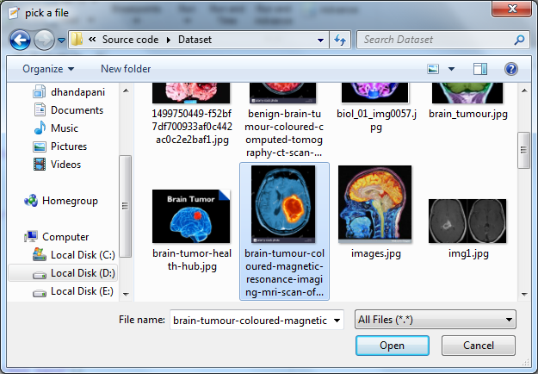

**ORIGINAL IMAGE** 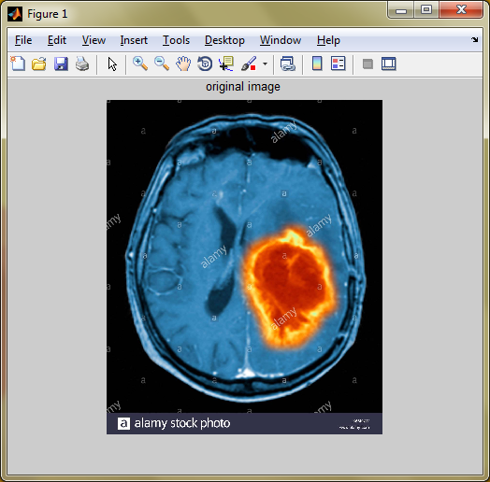

**CLUSTER INDEX IMAGE** 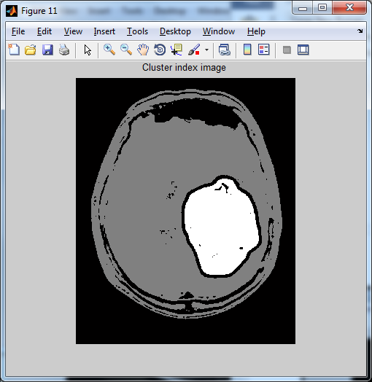

**2. Pre-processing:**

Pre-processing is a common name for operations with images at the lowest level of abstraction. The aim of pre-processing is an improvement of the image data that suppresses unwanted distortions or enhances some image features important for further processing. The pre-processing is the size adjusting of the considered image, luminance normalization, statistical normalization, filtering noise with specified filter, conversion to certain class.

A color image is usually stored in memory as a **raster map**, a two-dimensional array of small integer triplets; or (rarely) as three separate raster maps, one for each channel.

Separate R, G, and B image layers Eight bits per sample (24 bits per pixel) seem adequate for most uses, but faint banding artifacts may still be visible in some smoothly varying images, especially those subject to processing. Particularly demanding applications may use 10 bits per sample or more. On the other hand, some widely used image file formats and graphics cards may use only **8 bits** per pixel, i.e., only **256 different colours**, or 2–3 bits per channel. Converting continuous-tone images like photographs to such formats requires dithering and yields rather grainy and fuzzy results. Graphics cards that support **16 bits** per pixel provide **65536 distinct colours**, or 5–6 bits per channel. This resolution seems satisfactory for non-professional uses, even without dithering.

Pre-processing gives a 3 band images to us.

These are

* Red band
* Green band
* Blue band

**Red Band:**

To display the original image into Red band image, the value is 1. **Red=img(:,:,1);**

**Green Band:**

To display the original image into Red band image, the value is 2.

**green=img(:,:,2);**

**Blue Band:**

To display the original image into Red band image, the value is 1.

**Red=img(:,:,3);**

**Methods:**

In Pre-processing, we followed three techniques. There are,

* Image Calibration
* Noise Removal
* Data Normalization

**Image Calibration:**

Geometric camera calibration, also referred to as camera resectioning, estimates the parameters of a lens and image sensor of an image or video camera. You can use these parameters to correct for lens distortion, measure the size of an object in world units, or determine the location of the camera in the scene. These tasks are used in applications such as machine vision to detect and measure objects. They are also used in robotics, for navigation systems, and 3-D scene reconstruction.

**Noise Removal:**

Digital images are prone to various types of noise. Noise is the result of errors in the image acquisition process that result in pixel values that do not reflect the true intensities of the real scene. There are several ways that noise can be introduced into an image, depending on how the image is created.

For example: If the image is scanned from a photograph made on film, the film grain is a source of noise. Noise can also be the result of damage to the film, or be introduced by the scanner itself. If the image is acquired directly in a digital format, the mechanism for gathering the data (such as a CCD detector) can introduce noise. Electronic transmission of image data can introduce noise. To simulate the effects of some of the problems listed above, the toolbox provides the **imnoise()** function, which you can use to add various types of noise to an image. The examples in this section use this function.

* Remove Noise by Linear Filtering
* Remove Noise Using an Averaging Filter and a Median Filter
* Remove Noise By Adaptive Filtering

**Data Normalization:**

In image processing, normalization is a process that changes the range of pixel intensity values. Applications include photographs with poor contrast due to glare, for example. Normalization is sometimes called contrast stretching or histogram stretching. In more general fields of data processing, such as digital signal processing, it is referred to as dynamic range expansion. The purpose of dynamic range expansion in the various applications is usually to bring the image, or other type of signal, into a range that is more familiar or normal to the senses, hence the term normalization. Often, the motivation is to achieve consistency in dynamic range for a set of data, signals, or images to avoid mental distraction or fatigue. For example, a newspaper will strive to make all of the images in an issue share a similar range of grayscale.

**Pre-processing – Flow:**

Hyper spectral Image

Calibration

Red Band

Preprocessing

Green Band

Noise Removal

Group

Data Normalization

Blue Band

**PREPROCESSED IMAGE** 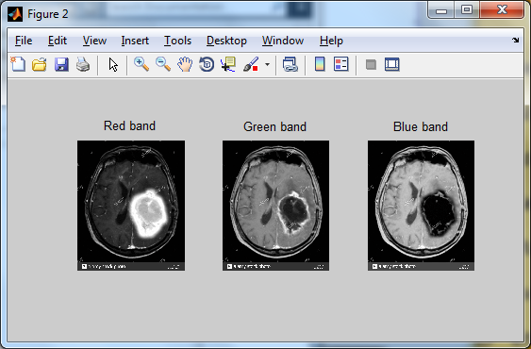

**ROTATED IMAGE** 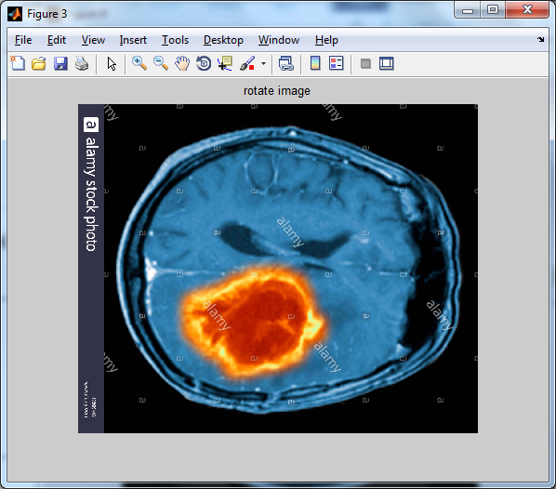

**REVERSE ROTATE IMAGE**

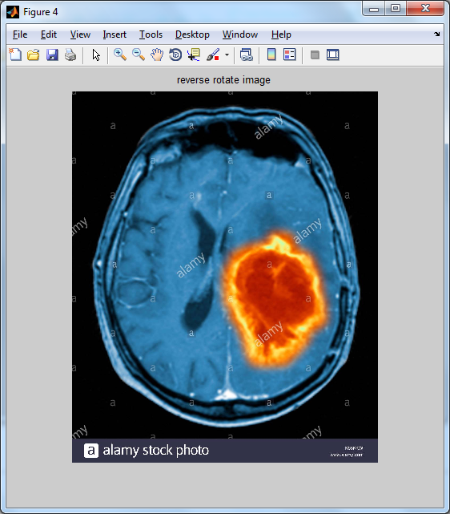

**MEDIAN COMBINE IMAGE** 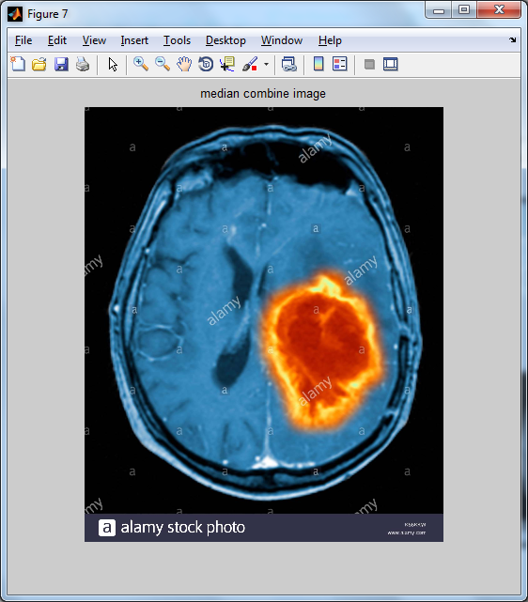

**NOISY IMAGE** 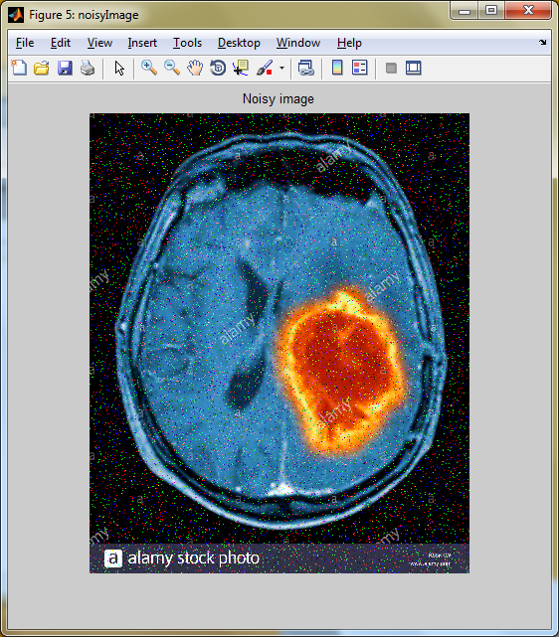

**NORMALIZED IMAGE** 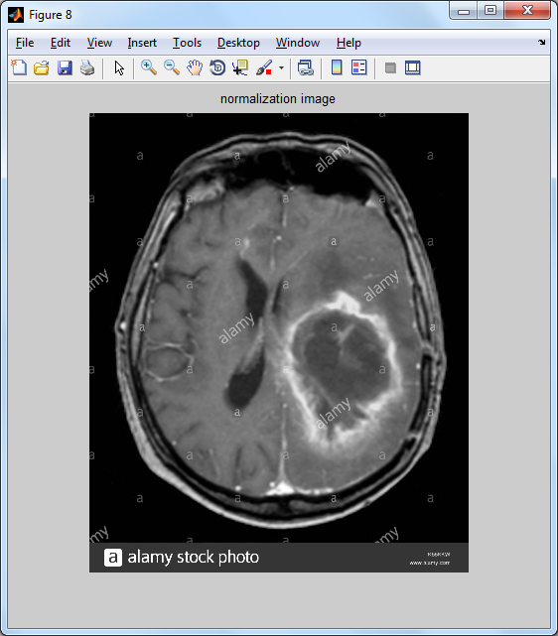

**Manifold Embedding:**

**Non Linear Dimensionality Reduction:**

Non-linear methods can be broadly classified into two groups: those that provide a mapping (either from the high-dimensional space to the low-dimensional embedding or vice versa), and those that just give a visualisation. In the context of machine learning, mapping methods may be viewed as a preliminary feature extraction step, after which pattern recognition algorithms are applied. Typically those that just give a visualisation are based on proximity data that is, distance measurements.

**Manifold Embedding – Flow:**

Data Normalization

Histogram Equalization

Contrast Adjust

imadjust()

imhist()

**CONTRAST ADJUST IMAGE 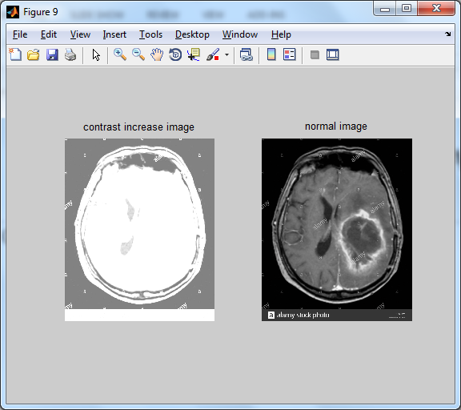HISTOGRAM EQUALIZATION** 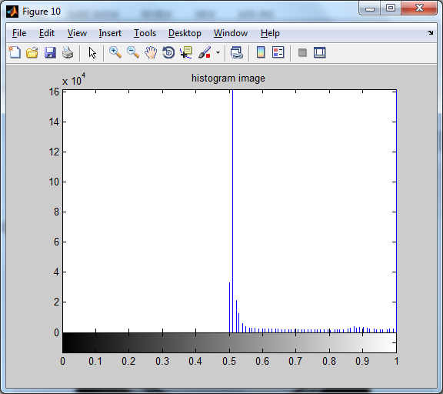

**Semantic Segmentation:**

Image segmentation is the process of partitioning a digital image into multiple segments.

Image segmentation is typically used to locate objects and boundaries in images.

It is the process of assigning a label to every pixel in an image such that pixels with the same label share certain characteristics.

Each of the pixels in a region are similar with respect to some characteristic or computed property, such as colour, intensity, or texture. Adjacent regions are significantly different with respect to the same characteristics.

**Clustering Methods:**

The K-means algorithm is an iterative technique that is used to partition an image into *K* clusters.

**Applications:**

* Content-based image retrieval
* Machine vision
* Medical imaging, including volume rendered images from computed tomography and magnetic resonance imaging.
* Locate tumors and other pathologies
* Measure tissue volumes
* Diagnosis,
* study of anatomical structure
* Surgery planning
* Virtual surgery simulation
* Intra-surgery navigation
* Object detection
* Pedestrian detection
* Face detection
* Brake light detection
* Locate objects in satellite images (roads, forests, crops, etc.)
* Recognition Tasks
* Face recognition
* Fingerprint recognition
* Iris recognition
* Traffic control systems
* Video surveillance

**Semantic Segmentation – Flow:**

Embedded Image

Cluster Image

random_forest

**SEGMENTED REGION** 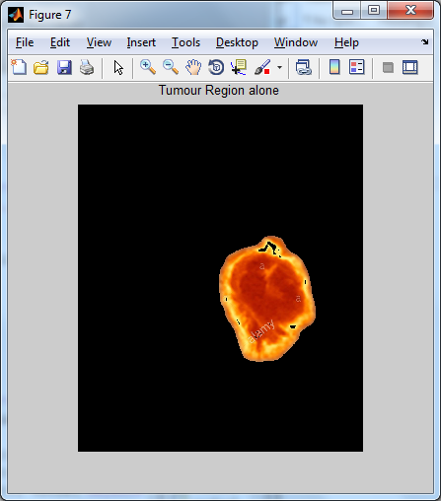

**5. Validation:**

Classification models in machine learning are evaluated for their performance by common performance measures.

**Mean-Class Accuracy:**

Is obtained averaging the accuracies achieved in each of the classes. It is a more reliable measure than the overall accuracy when, as in this case, the sample distributions for the same classes are limited in number, causing an unbalanced dataset.

**Sensitivity:**

Is the proportion of actual positives which are correctly identiﬁed as positives by the classiﬁer.

**Speciﬁcity:**

Is the proportion of the actual negatives which the classiﬁer successfully identiﬁes as negative.

**VALIDATION – BAR CHART** 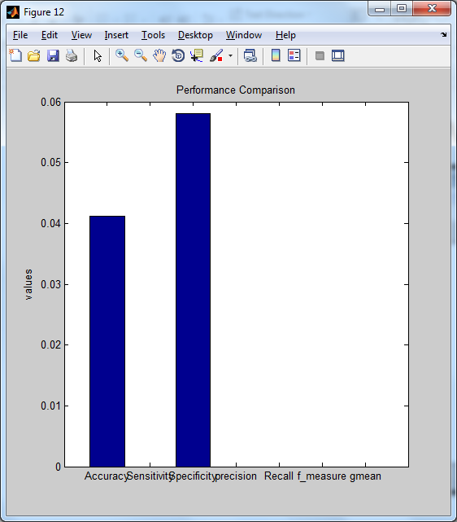

**LITERATURE SURVEY**

**Title 1: Hessian Eigen maps: Locally linear embedding techniques for high-**

**Dimensional data.**

**Author: L. Donoho and C. Grimes**

**Year: 2003**

We describe a method for recovering the underlying parameterization of scattered data (mi) lying on a manifold M embedded in high-dimensional Euclidean space. The method, Hessian-based locally linear embedding, derives from a conceptual framework of local isometric in which the manifold M, viewed as a Riemannian sub manifold of the ambient Euclidean space ℝn, is locally isometric to an open, connected subset Θ of Euclidean space ℝd. Because Θ does not have to be convex, this framework is able to handle a significantly wider class of situations than the original ISOMAP algorithm.

The theoretical framework revolves around a quadratic form ℋ (f) = ∫M ∥Hf (m) ∥Formulism defined on functions f: M ↦ ℝ. Here Hf denotes the Hessian of f, and ℋ (f) averages the Frobenius norm of the Hessian over M. To define the Hessian, we use orthogonal coordinates on the tangent planes of M. The key observation is that, if M truly is locally isometric to an open, connected subset of ℝd, then ℋ (f) has a (d + 1)-dimensional null space consisting of the constant functions and a d-dimensional space of functions spanned by the original isometric coordinates. Hence, the isometric coordinates can be recovered up to a linear isometry. Our method may be viewed as a modification of locally linear embedding and our theoretical framework as a modification of the Laplacian eigenmaps framework, where we substitute a quadratic form based on the Hessian in place of one based on the Laplacian.

A recent article in Science proposed to recover a low-dimensional parameterization of high-dimensional data by assuming that the data lie on a manifold M which, viewed as a Riemannian sub manifold of the ambient Euclidean space, is globally isometric to a convex subset of a low-dimensional Euclidean space. This bold assumption has been surprisingly fruitful, although the extent to which it holds is not fully understood. It is now known that there exist high-dimensional libraries of articulated images for which the corresponding data manifold is indeed locally isometric to a subset of a Euclidean space; however, it is easy to see that, in general, the assumption that the subset will be convex is unduly restrictive. Convexity can fail in the setting of image libraries due to

1. exclusion phenomena, where certain regions of the parameter space would correspond to collisions of objects in the image,
2. Unsystematic data sampling, which investigates only a haphazardly chosen region of the parameter space.

We describe a method that works to recover a parameterization for data lying on a manifold that is locally isometric to an open, connected subset Θ of Euclidean space ℝd. Because this subset need not be convex, whereas the original method proposed in ref. 1 demands convexity, our proposal significantly expands on the class of cases that can be solved by isometry principles. Justification of our method follows from properties of a quadratic form ℋ (f) = ∫M ∥Hf (m) ∥Formulism defined on functions f: M ↦ ℝ. ℋ (f) measures the average, over the data manifold M, of the Frobenius norm of the Hessian off. To define the Hessian, we use orthogonal coordinates on the tangent planes of M.

The key observation is that, if M is locally isometric to an open, connected subset of ℝd, then ℋ (f) has a (d + 1)-dimensional null space consisting of the constant function and a d-dimensional space of functions spanned by the original isometric coordinates. Hence, the isometric coordinates can be recovered, up to a rigid motion, from the null space of ℋ(f).We describe an implementation of this procedure on sampled data and demonstrate that it performs consistently with the theoretical predictions on a variant of the “Swiss roll” example, where the data are not sampled from a convex region in parameter space.

**Advantage:**

Easy to seea subset of a Euclidean space.

**Disadvantage:**

Low-dimensional parameterization of high-dimensional data

**Title 2: Principal Component Analysis.**

**Author: Jolliffe, Wiley, Hoboken**

**Year: 2002**

Explored various feature extraction methods for use in automated diagnosis of Attention-Deficit Hyperactivity Disorder (ADHD) from functional Magnetic Resonance Image (fMRI) data. Each participant's data consisted of a resting state fMRI scan as well as phenotypic data (age, gender, handedness, IQ, and site of scanning) from the ADHD-200 dataset. We used machine learning techniques to produce support vector machine (SVM) classifiers that attempted to differentiate between all ADHD patients vs. healthy controls and ADHD combined (ADHD-c) type vs.

ADHD inattentive (ADHD-i) type vs. controls. In different tests, we used only the phenotypic data, only the imaging data, or else both the phenotypic and imaging data. For feature extraction on fMRI data, we tested the Fast Fourier Transform (FFT), different variants of Principal Component Analysis (PCA), and combinations of FFT and PCA.

PCA variants included PCA over time (PCA-t), PCA over space and time (PCA-st), and kernelized PCA (kPCA-st). Baseline chance accuracy was 64.2% produced by guessing healthy control (the majority class) for all participants. Using only phenotypic data produced 72.9% accuracy on two class diagnosis and 66.8% on three class diagnosis.

Diagnosis using only imaging data did not perform as well as phenotypic-only approaches. Using both phenotypic and imaging data with combined FFT and kPCA-st feature extraction yielded accuracies of 76.0% on two class diagnosis and 68.6% on three class diagnosis—better than phenotypic-only approaches.

Our results demonstrate the potential of using FFT and kPCA-st with resting-state fMRI data as well as phenotypic data for automated diagnosis of ADHD. These results are encouraging given known challenges of learning ADHD diagnostic classifiers using the ADHD-200 dataset.

Over the past decade, many researchers have applied statistical analysis to functional Magnetic Resonance Images (fMRIs) in order to better understand neuropsychiatric phenomena. Much of this research has used fMRI to identify group differences between subjects that have a specific neuropsychiatric disorder and healthy controls.

There has also been a more recent focus on developing methodologies for diagnosing neuropsychiatric illnesses with high accuracy using advanced statistical methods. With large-scale fMRI studies including hundreds of participants or more, tractability becomes an issue.

Each fMRI volume contains roughly ~105 voxel locations, each with a waveform that may be composed of hundreds of time points. Some patterns in these voxel waveforms may be diagnostic for a neuropsychiatric disorder, but there is also substantial variance in the data that is not related to diagnosis.

**Advantage:**

High accuracy using advanced statistical methods.

**Disadvantage:**

Some substantial variance is not related to diagnosis.

**Title 3: Training data selection for cancer detection in multispectral**

**Endoscopy images**

**Author: C. V. Dinh, M. Loog, R. Leitner, O. Rajadell, and R. P. Duin**

**Year: Nov. 2012**

Multispectral endoscopy images provide potential for early stage cancer detection. It considers this relatively novel imaging technique and presents a supervised method for cancer detection using such multispectral data. The data under consideration include different types of cancer.

This poses a challenge for the detection as different cancer types may exhibit different spectral signatures. Consequently, it is not always feasible to transfer the knowledge learnt from one data set to another data set. In our approach, we select suitable training data for a given test set based on a similarity measurement between data sets.

Experimental results demonstrate that the classification results can be significantly improved if a few data sets that are presumably similar to a given test set are selected for training instead of using all available data sets.

The accuracy of computerized diagnosis can be facilitated by feature extraction during pre-processing.

Feature extraction methods reduce the size of the original fMRI data by extracting a smaller number of features for each subject (i.e., reducing the dimensionality of each subject's data). The challenge is to do this without diminishing the diagnostic value of each subject's data—i.e., while preserving the information needed to produce an effective classifier.

Spectral analysis, cancer, endoscopes, learning (artificial intelligence), medical image processing.

Similarity measurement, training data selection, multispectral endoscopy images, early stage cancer detection, imaging technique, supervised method for, multispectral data, spectral signatures, knowledge transfer

**Advantage:**

Test set are selected for training instead of using all available data sets**.**

**Disadvantage:**

Different cancer types may exhibit different spectral signatures

**Title 4: A new use of hyperspectral imaging for brain cancer detection in**

**Real- time during neurosurgical operations**

**Author: H. Fabelo et al**

**Year: May 2016**

Hyperspectral images allow obtaining large amounts of information about the surface of the scene that is captured by the sensor. Using this information and a set of complex classification algorithms is possible to determine which material or substance is located in each pixel.

The HELICoiD (Hyper spectral Imaging Cancer Detection) project is a European FET project that has the goal to develop a demonstrator capable to discriminate, with high precision, between normal and tumour tissues, operating in real-time, during neurosurgical operations.

This demonstrator could help the neurosurgeons in the process of brain tumour resection, avoiding the excessive extraction of normal tissue and unintentionally leaving small remnants of tumour. Such precise delimitation of the tumour boundaries will improve the results of the surgery.

The HELICoiD demonstrator is composed of two hyperspectral cameras obtained from Headwall. The first one in the spectral range from 400 to 1000 nm (visible and near infrared) and the second one in the spectral range from 900 to 1700 nm (near infrared). The demonstrator also includes an illumination system that covers the spectral range from 400 nm to 2200 nm.

A data processing unit is in charge of managing all the parts of the demonstrator, and a high performance platform aims to accelerate the hyperspectral image classification process.

Each one of these elements is installed in a customized structure specially designed for surgical environments. Preliminary results of the classification algorithms offer high accuracy in the discrimination between normal and tumour tissues.

CitationHimar Fabelo, Samuel Ortega, Silvester Kabwama, Gustavo M. Callico, Diederik Bulters, Adam Szolna, Juan F. Pineiro, Roberto Sarmiento, "HELICoiD

**Advantages:**

Delimitation of the tumour boundaries will improve the results of the surgery.

High accuracy between normal and tumour tissues.

**Disadvantage:**

Brain tumour resection, avoiding the excessive extraction.

**Title 5: Segmentation of meningioma as and low grade gliomas in MRI**

**Author: M. Kaus et al**

**Year: 1999**

Computer assisted surgical planning and image guided technology have become increasingly used in neurosurgery. We have developed a system based on ATmC (Adaptive Template moderated Classification) for the automated segmentation of 3D MRI brain data sets of patients with brain tumours (meningioma as and low grade gliomas) into the skin, the brain, the ventricles and the tumour.

In a validation study of 13 patients with brain tumours, the segmentation results of the automated method are compared to manual segmentations carried out by 4 independent trained human observers. It is shown that the automated method segments brain and tumour with accuracy comparable to the manual method and with improved reproducibility.

Computer assisted surgical planning and image guided technology have become increasingly used in neurosurgery. 2D images accurately describe the size and location of anatomical objects.

The process of generating 3D views to highlight structural information and spatial relationships of the anatomy, however, is a difficult task and usually carried out in the clinician’s mind.

Image processing tools can provide the surgeon with interactively displayed 3D visual information to facilitate the comprehension of the entire anatomy, and improve the spatial information about relationships of critical structures (e.g. motory and sensory cortex, vascular structures) and pathology. Today commercially available systems usually provide the surgeon only with 2D cross-sections of the intensity value images and a 3D model of the C. The main limiting factor for the routine use of 3D models of other important structures in clinical practice is the amount of time that an operator has to spend in the preparation of the data. The availability of automated methods will significantly reduce the time and is necessary to make such methods practical. Conventional segmentation methods for tumour segmentation such as statistical classification or mathematical morphological operations may work well in some cases but may not differentiate between enhancing tumour, enema and nor-mal tissue. For the separation of these tissues, the acquisition of several tissue parameters alone has been shown to be insufficient.

A combination of statistical classification and anatomical information has been used for the segmentation of MRI images of the brain. In a recent study, an anatomical knowledge guided fuzzy c-means method was used for automatic detection and segmentation of glioblastoma multiform from a combination of T1-, T2- and Proton density (PD) MR images with promising results. We have developed an automated segmentation method based on ATmC (Adaptive Template moderated Classification) [19] that combines statistical classification with anatomical knowledge from a digital atlas. The algorithm segments the skin surface, the brain, the ventricles and some of the most common tumour types, meningioma as and low grade gliomas.

**Advantage:**

More accuracy and Robustness.

**Disadvantage:**

More amount of time spend to prepare a data.

**Title 6: Automated model-based bias ﬁeld correction of MR images of the**

**Brain.**

**Author: K. Van Leemput, F. Maes, D. Vandermeulen, and P. Suetens**

**Year: Oct. 1999**

The authors propose a model-based method for fully automated bias field correction of MR brain images. The MR signal is modelled as a realization of a random process with a parametric probability distribution that is corrupted by a smooth polynomial inhomogeneity or bias field. The method the authors propose applies an iterative expectation-maximization (EM) strategy that interleaves pixel classification with estimation of class distribution and bias field parameters, improving the likelihood of the model parameters at each iteration.

The algorithm, which can handle multichannel data and slice-by-slice constant intensity offsets, is initialized with information from a digital brain atlas about the a priori expected location of tissue classes. This allows full automation of the method without need for user interaction, yielding more objective and reproducible results. The authors have validated the bias correction algorithm on simulated data and they illustrate its performance on various MR images with important field in homogeneities. They also relate the proposed algorithm to other bias correction algorithms.

The main goal of MIC is to extract clinically relevant information or knowledge from medical images. While closely related to the field of medical imaging, MIC focuses on the computational analysis of the images, not their acquisition. The methods can be grouped into several broad categories: image segmentation, image registration, image-based physiological modelling, and others.

Brain models, biomedical MRI, medical image processing, image classification, iterative methods.

Tissue classification, automated model-based bias field correction, MR brain images, digital brain atlas, a priori expected location, tissue classes, important field in homogeneities, slice-by-slice constant intensity offsets, magnetic resonance imaging, medical diagnostic imaging.

Algorithms, Bias (Epidemiology), Brain, Humans, Magnetic Resonance Imaging, Models, Neurological, Reproducibility of Results, Schizophrenia

**Advantage:**

It allows full automation of the method without need for user interaction.

**Disadvantage:**

It focuses on the computational analysis of the images, not their acquisition.

**Title 7: 3D Variational Brain Tumor Segmentation using a High**

**Dimensional Feature Set**

**Author: Dana Cobzas, Neil Birkbeck, Mark Schmidt, Martin Jagersand,**

**Albert Murtha**

**Year: 2012**

Tumor segmentation from MRI data is an important but time consuming task performed manually by medical experts. Automating this process is challenging due to the high diversity in appearance of tumor tissue, among different patients and, in many cases, similarity between tumor and normal tissue. One other challenge is how to make use of prior information about the appearance of normal brain. We propose a variational brain tumor segmentation algorithm that extends current approaches from texture segmentation by using a high dimensional feature set calculated from MRI data and registered atlases. Using manually segmented data we learn a statistical model for tumor and normal tissue. We show that using a conditional model to discriminate between normal and abnormal regions significantly improves the segmentation results compared to traditional generative models. Validation is performed by testing the method on several cancer patient MRI scans.

Radiation oncologists, radiologists, and other medical experts spend a substantial portion of their time segmenting medical images. Accurately labeling brain tumors and associated edema in MRI (Magnetic Resonance Images) is a particularly time-consuming task, and considerable variation is observed between labellers. Furthermore, in most settings the task is performed on a 3D data set by labeling the tumor slice-by-slice in 2D, limiting the global perspective and potentially generating sub-optimal segmentations. Subsequently, over the last 15 years, a large amount of research has been focused on semi-automatic and fully automatic methods for detecting and/or segmenting brain tumors from MRI scans.

We use the available MRI modalities (T1, T1c, T2) and their texture characteristics to construct a multidimensional feature set. Then, we extract clusters which provide a compact representation of the essential information in these features. The main idea in this work is to incorporate these clustered features into the 3D variational segmentation framework. In contrast to previous variational approaches, we propose a segmentation method that evolves the contour in a supervised fashion. The segmentation boundary is driven by the learned region statistics in the cluster space. We incorporate prior knowledge about the normal brain tissue appearance during the estimation of these region statistics. In particular, we use a Dirichlet prior that discourages the clusters from the normal brain region to be in the tumor region. This leads to a better disambiguation of the tumor from brain tissue.

**Keywords:**

Neoplasms, Image segmentation, Magnetic resonance imaging, Biomedical imaging, Level set, Computer science, Brain, Data mining, Layout, Shape.

**Advantage:**

High diversity in appearance of tumor tissue.

**Disadvantage:**

Large amount of research segmentation and methods are followed.

**Title 8: A unifying approach to registration, segmentation, and intensity**

**Correction**

**Author: K. M. Pohl et al.**

**Year: 2005**

We present a statistical framework that combines the registration of an atlas with the segmentation of magnetic resonance images. We use an Expectation Maximization-based algorithm to find a solution within the model, which simultaneously estimates image in homogeneities, anatomical label map, and a mapping from the atlas to the image space.

An example of the approach is given for a brain structure-dependent affine mapping approach. The algorithm produces high quality segmentations for brain tissues as well as their substructures. We demonstrate the approach on a set of 22 magnetic resonance images. In addition, we show that the approach performs better than similar methods which separate the registration and segmentation problems.

With notable exceptions, segmentation and registration have been treated as two separate problems in medical imaging research. However, these techniques complement each other. For example, segmentation simplifies the registration of anatomical structures with ambiguous intensity patterns. On the other hand, aligning an atlas to the anatomical structures aids the detection of indistinct boundaries and therefore simplifies the segmentation problem. We describe a simultaneous solution to both problems by combining them in a unified Bayesian framework.

The idea of the unified Bayesian framework was motivated by boundary localization techniques, such as, which align an atlas to the subject and simultaneously estimate the shape of a structure. These methods relate both problems to each other by extending the definition of the shape to include its pose.

It describes an integrated segmentation and registration approach for voxel-based classification methods. In contrast to boundary localization approaches, voxel-based classification methods consider the anatomical structure associated with each voxel.

In addition, they often explicitly model the image in homogeneities of Magnetic Resonance Images (MRI) to segment large data sets without manual intervention. Voxel-based classification methods have coupled registration and segmentation of misaligned images, however, we wish to align an atlas to MRI and separate the J. Duncan and G. Gerig Springer Verlag Berlin Heidelberg 2005A Unifying Approach to Registration, Segmentation, and Intensity Correction311images into anatomical structures. Previous voxel-based classification methods perform this task sequentially increasing the risk of systematic biases.

In contrast, our new approach is based on the principle of least commitment so that an initial imperfect estimation converges to a good approximation for each problem. Similar to, It is based on an instance of the Expectation Maximization Algorithm (EM) using non-stationary priors to outline structures with indistinct boundaries and to estimate image in homogeneities. Instead of sequentially performing registration and segmentation, we propose in a Bayesian framework describing the relationship between atlas registration, intensity correction, and image segmentation.

This framework is based on a Maximum A posteriori Probability (MAP) estimation formulation approximating the solution to these three interrelated problems. It applies the concept to a hierarchical registration framework modelling global and structure-dependent deformations.

The limits and benefits of the implementation are illustrated in by presenting a study comparing the robustness of our algorithm with respect to other EM implementations. In this study, the automatic methods outline a set of 22 MRIs into the major brain tissue classes as well as the thalamus and caudate, which are structures with indistinct boundaries.

**Advantages:**

* + Robustness.
  + Give approximate solution.
  + High quality segmentation.

**Disadvantage:**

More number of brain tissue class.

**Title 9: Level-set evolution with region competition: Automatic 3-D**

**Segmentation of brain tumours**

**Author: S. Ho, L. Bullitt, and G. Gerig**

**Year: Aug. 2002**

We develop a new method for automatic segmentation of anatomical structures from volumetric medical images. Driving application is tumor segmentation from 3-D MRIs, which is known to be a very challenging problem due to the variability of tumor geometry and intensity patterns. Level-set snakes offer significant advantages over conventional statistical classification and mathematical morphology, however snakes with constant propagation need careful initialization and can leak through weak or missing boundary parts. Our region competition method overcomes these problems by modulating the propagation term with a signed local statistical force, leading to a stable solution. A pre- vs. post-contrast difference image is used to calculate probabilities for background and tumor regions, with a mixture-modelling fit of the histogram. Preliminary results on five cases with significant shape and intensity variability demonstrate that the new method might become a powerful and efficient tool for the clinic. Validity is demonstrated by comparison with manual expert segmentation.

Segmentation of volumetric image data is still a challenging problem, and successful solutions either often are based on simple intensity Thresholding or by model-based deformation of templates. Classical snakes have had the problem of being “only as good as their initialization”, even when using level-set snakes in 3-D. A powerful extension is obtained by combining level-set evolution with statistical shape constraints, but the statistical prior is not easily obtainable in some applications. Level-set evolution with fixed propagation direction must be initialized either completely inside or outside sought objects. At locations of missing or fuzzy boundaries, the constant propagation force is often strong enough to counteract global smoothness, and “leaks” through these gaps. This observation led to a new concept of region competition, where two adjacent regions compete for the common boundary, additionally constrained by a smoothness term.

Biomedical MRI, brain, tumours, image segmentation, medical image processing.

Histogram, automatic segmentation, anatomical structures, volumetric medical images, tumor geometry, tumor intensity patterns, level-set snakes, region competition method, propagation term, signed local statistical force, mixture-modelling fit.

**Advantage:**

Statistical classification and mathematical morphology is applied.

**Disadvantage:**

Missing or fuzzy boundaries.

**Title 10: 3D variational brain tumour segmentation using a high**

**Dimensional feature set**

**Author: D. Cobzas, N. Birkbeck, M. Schmidt, M. Jagersand, and A. Murtha**

**Year: Oct. 2007**

Tumour segmentation from MRI data is an important but time consuming task performed manually by medical experts. Automating this process is challenging due to the high diversity in appearance of tumour tissue, among different patients and, in many cases, similarity between tumour and normal tissue. One other challenge is how to make use of prior information about the appearance of normal brain. We propose a variational brain tumour segmentation algorithm that extends current approaches from texture segmentation by using a high dimensional feature set calculated from MRI data and registered atlases. Using manually segmented data we learn a statistical model for tumor and normal tissue. We show that using a conditional model to discriminate between normal and abnormal regions significantly improves the segmentation results compared to traditional generative models. Validation is performed by testing the method on several cancer patient MRI scans.

Radiation oncologists, radiologists, and other medical experts spend a substantial portion of their time segmenting medical images. Accurately labeling brain tumors and associated edema in MRI (Magnetic Resonance Images) is a particularly time-consuming task, and considerable variation is observed between labellers. Furthermore, in most settings the task is performed on a 3D data set by labeling the tumor slice-by-slice in 2D, limiting the global perspective and potentially generating sub-optimal segmentations. Subsequently, over the last 15 years, a large amount of research has been focused on semi-automatic and fully automatic methods for detecting and/or segmenting brain tumors from MRI scans.

We use the available MRI modalities (T1, T1c, and T2) and their texture characteristics to construct a multidimensional feature set. Then, we extract clusters which provide a compact representation of the essential information in these features. The main idea in this work is to incorporate these clustered features into the 3D variational segmentation framework. In contrast to previous variational approaches, we propose a segmentation method that evolves the contour in a supervised fashion. The segmentation boundary is driven by the learned region statistics in the cluster space. We incorporate prior knowledge about the normal brain tissue appearance during the estimation of these region statistics. In particular, we use a Dirichlet prior that discourages the clusters from the normal brain region to be in the tumour region. This leads to a better disambiguation of the tumour from brain tissue.

**Advantage:**

High diversity compared to other techniques.

Better disambiguation of the tumour.

**Disadvantage:**

Its provide a compact representation.

**TESTING OF PRODUCT**

System testing is the stage of implementation, which aimed at ensuring that system works accurately and efficiently before the live operation commence.

Testing is the process of executing a program with the intent of finding an error. A good test case is one that has a high probability of finding an error. A successful test is one that answers a yet undiscovered error.

Testing is vital to the success of the system.  System testing makes a logical assumption that if all parts of the system are correct, the goal will be successfully achieved.  The candidate system is subject to variety of tests-on-line response, Volume Street, recovery and security and usability test.

 A series of tests are performed before the system is ready for the user acceptance testing. Any engineered product can be tested in one of the following ways.

Knowing the specified function that a product has been designed to from, test can be conducted to demonstrate each function is fully operational.

Knowing the internal working of a product, tests can be conducted to ensure that “al gears mesh”, that is the internal operation of the product performs according to the specification and all internal components have been adequately exercised.

**UNIT TESTING:**

Unit testing is the testing of each module and the integration of the overall system is done.  Unit testing becomes verification efforts on the smallest unit of software design in the module.  This is also known as ‘module testing’.

The modules of the system are tested separately.  This testing is carried out during the programming itself.  In this testing step, each model is found to be working satisfactorily as regard to the expected output from the module.  There are some validation checks for the fields.

For example, the validation check is done for verifying the data given by the user where both format and validity of the data entered is included.  It is very easy to find error and debug the system.

**INTEGRATION TESTING:**

Data can be lost across an interface, one module can have an adverse effect on the other sub function, when combined, may not produce the desired major function.

Integrated testing is systematic testing that can be done with sample data.  The need for the integrated test is to find the overall system performance. There are two types of integration testing. They are:

1. Top-down integration testing.
2. Bottom-up integration testing.

**WHITE BOX TESTING:**

White Box testing is a test case design method that uses the control structure of the procedural design to drive cases.  Using the white box testing methods, we derived test cases that guarantee that all independent paths within a module have been exercised at least once.

**BLACK BOX TESTING:**

* + Black box testing is done to find incorrect or missing function
  + Interface error
  + Errors in external database access
  + Performance errors
  + Initialization and termination errors

In ‘functional testing’, is performed to validate an application conforms to its specifications of correctly performs all its required functions. So this testing is also called ‘black box testing’.  It tests the external behavior of the system.  Here the engineered product can be tested knowing the specified function that a product has been designed to perform, tests can be conducted to demonstrate that each function is fully operational.

**VALIDATION TESTING:**

After the culmination of black box testing, software is completed assembly as a package, interfacing errors have been uncovered and corrected and final series of software validation tests begin validation testing can be defined as many, but a single definition is that validation succeeds when the software functions in a manner that can be reasonably expected by the customer.

# **USER ACCEPTANCE TESTING:**

User acceptance of the system is the key factor for the success of the system.  The system under consideration is tested for user acceptance by constantly keeping in touch with prospective system at the time of developing changes whenever required.

# **OUTPUT TESTING:**

After performing the validation testing, the next step is output asking the user about the format required testing of the proposed system, since no system could be useful if it does not produce the required output in the specific format.  The output displayed or generated by the system under consideration.  Here the output format is considered in two ways.  One is screen and the other is printed format.

The output format on the screen is found to be correct as the format was designed in the system phase according to the user needs.  For the hard copy also output comes out as the specified requirements by the user. Hence the output testing does not result in any connection in the system.

**System Implementation:**

Implementation of software refers to the final installation of the package in its real environment, to the satisfaction of the intended users and the operation of the system. The people are not sure that the software is meant to make their job easier.

* The active user must be aware of the benefits of using the system
* Their confidence in the software built up
* Proper guidance is impaired to the user so that he is comfortable in using the application

Before going ahead and viewing the system, the user must know that for viewing the result, the server program should be running in the server. If the server object is not running on the server, the actual processes will not take place.

**User Training:**

To achieve the objectives and benefits expected from the proposed system it is essential for the people who will be involved to be confident of their role in the new system. As system becomes more complex, the need for education and training is more and more important.

Education is complementary to training. It brings life to formal training by explaining the background to the resources for them. Education involves creating the right atmosphere and motivating user staff. Education information can make training more interesting and more understandable.

**Training on the Application Software:**

After providing the necessary basic training on the computer awareness, the users will have to be trained on the new application software. This will give the underlying philosophy of the use of the new system such as the screen flow, screen design, type of help on the screen, type of errors while entering the data, the corresponding validation check at each entry and the ways to correct the data entered. This training may be different across different user groups and across different levels of hierarchy.

**Operational Documentation:**

Once the implementation plan is decided, it is essential that the user of the system is made familiar and comfortable with the environment. A documentation providing the whole operations of the system is being developed. Useful tips and guidance is given inside the application itself to the user. The system is developed user friendly so that the user can work the system from the tips given in the application itself.

**System Maintenance:**

The maintenance phase of the software cycle is the time in which software performs useful work. After a system is successfully implemented, it should be maintained in a proper manner. System maintenance is an important aspect in the software development life cycle. The need for system maintenance is to make adaptable to the changes in the system environment. There may be social, technical and other environmental changes, which affect a system which is being implemented. Software product enhancements may involve providing new functional capabilities, improving user displays and mode of interaction, upgrading the performance characteristics of the system.

**Corrective Maintenance:**

The first maintenance activity occurs because it is unreasonable to assume that software testing will uncover all latent errors in a large software system. During the use of any large program, errors will occur and be reported to the developer. The process that includes the diagnosis and correction of one or more errors is called Corrective Maintenance.

**Adaptive Maintenance:**

The second activity that contributes to a definition of maintenance occurs because of the rapid change that is encountered in every aspect of computing. Therefore Adaptive maintenance termed as an activity that modifies software to properly interfere with a changing environment is both necessary and commonplace.

**Perceptive Maintenance:**

The third activity that may be applied to a definition of maintenance occurs when a software package is successful. As the software is used, recommendations for new capabilities, modifications to existing functions, and general enhancement are received from users. To satisfy requests in this category, Perceptive maintenance is performed. This activity accounts for the majority of all efforts expended on software maintenance.

**Preventive Maintenance:**

The fourth maintenance activity occurs when software is changed to improve future maintainability or reliability, or to provide a better basis for future enhancements. Often called preventive maintenance, this activity is characterized by reverse engineering and re-engineering techniques.

**SYSTEM REQUIREMENTS**

**Hardware Requirements:**

* System : Intel Core
* Hard Disk : 160 GB
* Ram : 2GB

**Software Requirements:**

* O/S : Windows 7.
* IDE : MATLAB R2013a

**SOFTWARE DESCRIPTION**

**MATLAB:**

MATLAB is a high-performance language for technical computing. It integrates computation, visualization, and programming in an easy-to-use environment where problems and solutions are expressed in familiar mathematical notation. MATLAB is a [fourth-generation programming language](http://whatis.techtarget.com/definition/programming-language-generations) and numerical analysis environment.

Typical uses include:

* Math and computation
* Algorithm development
* Modeling, simulation, and prototyping
* Data analysis, exploration, and visualization
* Scientific and engineering graphics
* Application development, including Graphical User Interface building

MATLAB is an interactive system whose basic data element is an array that does not require dimensioning. This allows you to solve many technical computing problems, especially those with matrix and vector formulations, in a fraction of the time it would take to write a program in a scalar noninteractive language such as C or FORTRAN.

The name MATLAB stands for matrix laboratory. MATLAB was originally written to provide easy access to matrix software developed by the LINPACK and EISPACK projects, which together represent the state-of-the-art in software for matrix computation.

MATLAB has evolved over a period of years with input from many users. In university environments, it is the standard instructional tool for introductory and advanced courses in mathematics, engineering, and science. In industry, MATLAB is the tool of choice for high-productivity research, development, and analysis.

**MATLAB features**

* A family of application-specific solutions called toolboxes.
* Very important to most users of MATLAB, toolboxes allow you to *learn* and *apply* specialized technology.
* Toolboxes are comprehensive collections of MATLAB functions (M-files) that extend the MATLAB environment to solve particular classes of problems.
* Areas in which toolboxes are available include signal processing, control systems, neural networks, fuzzy logic, wavelets, simulation, and many others.

**The MATLAB System:**

The MATLAB system consists of five main parts:

1. **The MATLAB language.**

This is a high-level matrix/array language with control flow statements, functions, data structures, input/output, and object-oriented programming features. It allows both "programming in the small" to rapidly create quick and dirty throw-away programs, and "programming in the large" to create complete large and complex application programs.

1. **The MATLAB working environment.**

This is the set of tools and facilities that you work with as the MATLAB user or programmer. It includes facilities for managing the variables in your workspace and importing and exporting data. It also includes tools for developing, managing, debugging, and profiling M-files, MATLAB's applications.

1. **Handle Graphics.**

This is the MATLAB graphics system. It includes high-level commands for two-dimensional and three-dimensional data visualization, image processing, animation, and presentation graphics. It also includes low-level commands that allow you to fully customize the appearance of graphics as well as to build complete Graphical User Interfaces on your MATLAB applications.

1. **The MATLAB mathematical function library.**

This is a vast collection of computational algorithms ranging from elementary functions like sum, sine, cosine, and complex arithmetic, to more sophisticated functions like matrix inverse, matrix eigenvalues, Bessel functions, and fast Fourier transforms.

1. **The MATLAB Application Program Interface (API).**

This is a library that allows you to write C and FORTRAN programs that interact with MATLAB. It include facilities for calling routines from MATLAB (dynamic linking), calling MATLAB as a computational engine, and for reading and writing MAT-files.

Uses for MATLAB include [matrix](http://whatis.techtarget.com/definition/matrix) calculations, developing and running [algorithms](http://whatis.techtarget.com/definition/algorithm), creating user interfaces ([UI](http://searchsoa.techtarget.com/definition/user-interface)) and [data visualization](http://searchbusinessanalytics.techtarget.com/definition/data-visualization). The multi-[paradigm](http://whatis.techtarget.com/definition/paradigm) numerical computing environment allows developers to interface with programs developed in different languages, which makes it possible to harness the unique strengths of each language for various purposes.

MATLAB is used by engineers and scientists in many fields such as image and signal processing, communications, control systems for industry, [smart grid](http://whatis.techtarget.com/definition/smart-grid) design, [robotics](http://whatis.techtarget.com/definition/robotics) as well as computational finance.

Cleve Moler, a professor of Computer Science at the University of New Mexico, created MATLAB in the 1970s to help his students. MATLAB's commercial potential was identified by visiting engineer Jack little in 1983. Moler, Little and Steve Bangart founded MathWorks and rewrote MATLAB in [C](http://searchwindowsserver.techtarget.com/definition/C) under the auspices of their new company in 1984.

## **MATLAB Programming Language**

The MATLAB programming language is simpler than most programming languages and easier to learn. It is known as a high-level language because it is closer to the human language than the computer or machine language.

* The **semi-colon** in MATLAB indicates the end of statement. It can also be used to stop a statement from executing. For example, if you type in x=5+3 without the semicolon and click the Execute button, MATLAB will display the result as x=8. If you type in x=5+3; with the semicolon, and click Execute, MATLAB will not display the result of the computation.
* The **% sign** is used to indicate that the text following is a comment and not to be interpreted by MATLAB. Programmers use comments to provide explanations about the code they are writing. For example, in MATLAB you can write a=b+5 and the use the % sign to explain that 'a' is the length of a room and 'b' is the width.
* **Variable names** in MATLAB are case sensitive. For example, if you create a variable 'TempEveryHour' to represent the temperatures every hour, and need it to use this variable in a mathematical formula, you would need to call the variable by its exact same name: TempEveryHour and not TemperatureEveryHour or tempeveryhour.

MATLAB has several **advantages** over other methods or languages:

 Its basic data element is the matrix. A simple integer is considered a matrix of one row and one column. Several mathematical operations that work on arrays or matrices are built-in to the Matlab environment. For example, cross-products, dot-products, determinants, inverse matrices.

* Vectorized operations. Adding two arrays together needs only one command, instead of a for or while loop.
* The graphical output is optimized for interaction. You can plot your data very easily, and then change colors, sizes, scales, etc, by using the graphical interactive tools.
* Matlab’s functionality can be greatly expanded by the addition of toolboxes. These are sets of specific functions that provided more specialized functionality. Ex: Excel link allows data to be written in a format recognized by Excel, Statistics Toolbox allows more specialized statistical manipulation of data (Anova, Basic Fits, etc)

There are also **Disadvantages**:

* It uses a large amount of memory and on slow computers it is very hard to use.
* It sits “on top” of Windows, getting as much CPU time as Windows allows it to have. This makes real-time applications very complicated.

**SYSTEM DESIGN**

**Introduction:**

System design is the process or art of defining the architecture, components, modules, interfaces and data for a system to satisfy specified requirements. One could see it as the application of systems theory to product development. Design is the first phase in development phase for any engineer’s product system. Design is the creative process. It deals with the creative ability of the programmer. A good design is the key to effective system. The term “Design” is defined as “The process of applying various techniques and principles for the purpose of defining a process or a system in sufficient details to permit its physical realization”.

**Input design**

The user interface design is very important for any application. The interface design describes how the software communicated within itself, to system that interpreted with it and with humans who use it. The interface is a packing for computer software if the interface is easy to learn, simple to use. If the interface design is very good, the user will fall into an interactive software application.

The input design is the process of converting the user-oriented inputs into the computer-based format. Errors entered by data entry operations can be controlled by input design. The data is fed into the system using simple interactive forms. The forms have been supplied with messages so that user can enter data without facing any difficulty.

The data is validated wherever it requires in the project. This ensures that only the correct data have been incorporated into the system. The goal for designing input data is to make data entry as easy, logical and free from errors.

The objectives of input design are:

* To produce a cost effective method of input
* To make the input forms understandable to the user
* To ensure the validation of data input
* To achieve the highest position level of accuracy

The various activities to be performed for the overall input processors are:

* Data recording at its source.
* Data transfer to input form.
* Data conversation to computer acceptable mode.
* Data validation.
* Data flow control.
* Data correction if necessary.

**Output Design**

The system output is the most important and direct source of information to the user. So intelligible output design improves the relationship with the user and helps in decision-making. Outputs from the computer systems are required primarily to communicate the results of processing to users. They are also used to provide a permanent copy of these results for later consultation.

A major form of output is a hard copy obtained from the printer. These printouts are designed to include the exact requirements of the user. The outputs required by the end-user are defined during the logical design stages.

Two phases of the output design are:

* Output definition.
* Output specification

Computer outputs are the most important and direct source of information to the user. A quality output is one which meets the requirements of the end user and which presents information in a way which is clear, easy to read and visually attractive. The screens are designed in such a way that the outputs are provided to the user in an understandable form.

The objectives of output design are:

* Design output to serve the indented purpose.
* Provide output on time.
* Assume that output is where it is needed.
* Design output to fit the user

**FEASIBILITY STUDY**

The feasibility study is carried out to test whether the proposed system is worth being implemented. The proposed system will be selected if it is best enough in meeting the performance requirements.

The feasibility carried out mainly in three sections namely.

**•** Economic Feasibility

• Technical Feasibility

• Behavioural Feasibility

**Economic Feasibility**

Economic analysis is the most frequently used method for evaluating effectiveness of the proposed system. More commonly known as cost benefit analysis. This procedure determines the benefits and saving that are expected from the system of the proposed system. The hardware in system department if sufficient for system development.

**Technical Feasibility**

This study center around the system’s department hardware, software and to what extend it can support the proposed system department is having the required hardware and software there is no question of increasing the cost of implementing the proposed system. The criteria, the proposed system is technically feasible and the proposed system can be developed with the existing facility.

**Behavioural Feasibility**

People are inherently resistant to change and need sufficient amount of training, which would result in lot of expenditure for the organization. The proposed system can generate reports with day-to-day information immediately at the user’s request, instead of getting a report, which doesn’t contain much detail.

**CONCLUSION**

we have proposed a novel manifold embedding framework FR-t-SNE with which the output generated from a hyperspectral image can be used as input for a semantic segmentation classifier of brain tissues in vivo, in situ. The proposed method aims to determine the boundaries of tumours, saving healthy brain tissue and allowing a complete resection of the malignant cells. Conventional diagnoses of internal tumours are based on excisional biopsy followed by histology or cytology. The main weaknesses of the traditional approach are twofold. Firstly, it is invasive with many potential side effects and complications; and secondly, diagnostic information is not available in real-time and requires off-line histopathology sample preparation and analysis. The real-time nature of the techniques can improve surgical accuracy, providing additional information that can also reduce the probability of erroneous resectioning of healthy tissue.

**FUTURE ENHANCEMENTS**

Future research in the segmentation of medical images will lead towards improving the accuracy, exactness, and computational speed of segmentation approaches, as well as minimising the amount of manual interaction. These can be improved by incorporating discrete and continuous-based segmentation methods. Computational effectiveness will be crucial in real-time processing applications. Segmentation methods have proved their utility in research areas and are now emphasizing increased use for automated diagnosis and radiotherapy. These will be particularly important in applications such as computer integrated surgery, where envision of the anatomy is a significant component.

**REFERENCES:**

* B.H.Menze et al., “The multimodal brain tumor image segmenta-tion benchmark (BRATS),” IEEETrans.Med.Imag., vol. 34, no. 10,pp. 1993–2024, Oct. 2015.
* M.T.Eismann, Hyperspectral Remote Sensing. Bellingham, WA, USA:SPIE, 2012.
* N. Ramanujam, “Fluorescence spectroscopy of neoplastic and non-neoplastic tissues,” Neoplasia, vol. 2, nos. 1–2, pp. 89–117, 2000.
* H. Akbari et al., “Hyperspectral imaging and quantitative analysis for prostate cancer detection,” J. Biomed. Opt., vol. 17, no. 7,pp. 076005-1–076005-10, 2012.
* N. Amharref et al., “Discriminating healthy from tumor and necrosistissue in rat brain tissue samples by Raman spectral imaging,” Biochim.Biophys. Acta (BBA)-Biomembranes, vol. 1768, no. 10, pp. 2605–2615,2007.
* A.Cerussi, N.Shah, D.Hsiang, A.Durkin, J.Butler, B.J.Tromberg,“In vivo absorption, scattering, and physiologic properties of 58 malig-nant breast tumours determined by broadband diffuse optical spectroscopy,” J. Biomed. Opt., vol. 11, no. 4, p. 044005, 2006.
* C. V. Dinh, M. Loog, R. Leitner, O. Rajadell, and R. P. Duin,“Training data selection for cancer detection in multispectral endoscopyimages,” in Proc. 21st Int. Conf. Pattern Recognit. (ICPR), Nov. 2012
* H. Akbari, K. Uto, Y. Kosugi, K. Kojima, and N. Tanaka, “Cancerdetection using infrared hyperspectral imaging,” Cancer Sci., vol. 102,no. 4, pp. 852–857, 2011.
* H. Fabelo et al., “HELICoiD project: A new use of hyperspectralimaging for brain cancer detection in real-time during neurosurgicaloperations,” Proc. SPIE, vol. 9860, p. 986002, May 2016.
* S. Kabwama et al., “Intra-operative hyperspectral imaging for braintumour detection and delineation: Current progress on the HELICoidproject,” Int. J. Surgery, vol. 36, no. 2, p. S140, 2016.
* E. D. Angelini, O. Clatz, E. Mandonnet, E. Konukoglu, L. Capelle,and H. Duffau, “Glioma dynamics and computational models: A reviewof segmentation, registration, and in silico growth algorithms andtheir clinical applications,” Current Med. Imag. Rev., vol. 3, no. 4,pp. 262–276, 2007.
* S. Bauer, R. Wiest, L.-P. Nolte, and M. Reyes, “A survey of MRI-based medical image analysis for brain tumour studies,” Phys. Med. Biol.,vol. 58, no. 13, p. R97, 2013.
* M. Kaus et al., “Segmentation of meningiomas and low grade gliomasin MRI,” in Medical Image Computing and Computer-AssistedIntervention—MICCAI. Cambridge, U.K.: Springer, 1999, pp. 1–10.
* L. M. Fletcher-Heath, L. O. Hall, D. B. Goldgof, and F. R. Murtagh,“Automatic segmentation of non-enhancing brain tumors in magneticresonance images,” Artif. Intell. Med., vol. 21, nos. 1–3, pp. 43–63,2001.
* Y.-F. Tsai, I.-J. Chiang, Y.-C. Lee, C.-C. Liao, and K.-L. Wang, “Auto-matic MRI meningioma segmentation using estimation maximization,”in Proc. 27th Annu. Int. Conf. Eng. Med. Biol. Soc. (IEEE-EMBS),Jan. 2005,
* E. Konukoglu et al., “Monitoring slowly evolving tumors,” in Proc.5th IEEE Int. Symp. Biomed. Imag., Nano Macro (ISBI), May 2008,pp. 812–815.[18] M. B. Cuadra, M. D. Craene, V. Duay, B. Macq, C. Pollo, andJ.-P. Thiran, “Dense deformation ﬁeld estimation for atlas-based segmen-tation of pathological MR brain images,” Comput. Methods ProgramsBiomed., vol. 84, no. 2, pp. 66–75, 2006.
* L. Weizman et al., “Automatic segmentation, internal classiﬁcation, andfollow-up of optic pathway gliomas in MRI,” Med. Image Anal., vol. 16,no. 1, pp. 177–188, 2012.
* K. Van Leemput, F. Maes, D. Vandermeulen, and P. Suetens, “Automatedmodel-based bias ﬁeld correction of MR images of the brain,” IEEETrans. Med. Imag., vol. 18, no. 10, pp. 885–896, Oct. 1999.
* M. R. Kaus, S. K. Warﬁeld, A. Nabavi, P. M. Black, F. A. Jolesz, andR. Kikinis, “Automated segmentation of MR images of brain tumors 1,”Radiology, vol. 218, no. 2, pp. 586–591, 2001.
* M. Prastawa, E. Bullitt, S. Ho, and G. Gerig, “A brain tumor segmen-tation framework based on outlier detection,” Med. Image Anal.,vol.8,no. 3, pp. 275–283, 2004.
* K. M. Pohl et al., “A unifying approach to registration, segmentation,and intensity correction,” in Medical Image Computing and Computer-Assisted Intervention–MICCAI. Palm Springs, CA, USA: Springer, 2005,pp. 310–318.
* F. O. Kaster, B. H. Menze, M.-A. Weber, and F. A. Hamprecht,“Comparative validation of graphical models for learning tumor segmen-tations from noisy manual annotations,” in Medical Computer Vision.Recognition Techniques and Applications in Medical Imaging. Beijing,China: Springer, 2010, pp. 74–85.
* B. Fischl et al., “Whole brain segmentation: Automated labeling ofneuroanatomical structures in the human brain,” Neuron, vol. 33, no. 3,pp. 341–355, 2002.
* J. Ashburner and K. J. Friston, “Uniﬁed segmentation,” NeuroImage,vol. 26, no. 3, pp. 839–851, 2005.
* D. Cobzas, N. Birkbeck, M. Schmidt, M. Jagersand, and A. Murtha,“3D variational brain tumor segmentation using a high dimensionalfeature set,” in Proc. IEEE 11th Int. Conf. Comput. Vis. (ICCV),Oct. 2007, pp. 1–8.
* E. Lefohn, J. E. Cates, and R. T. Whitaker, “Interactive, GPU-based level sets for 3D segmentation,” in Medical Image Computingand Computer-Assisted Intervention—MICCAI. Montreal, QC, Canada:Springer, 2003, pp. 564–572.
* S. Ho, L. Bullitt, and G. Gerig, “Level-set evolution with regioncompetition: Automatic 3-D segmentation of brain tumours,” in Proc.16th Int. Conf. Pattern Recognit., vol. 1. Aug. 2002, pp. 532–535.
* D. Zikic et al., “Decision forests for tissue-speciﬁc segmentation of high-grade gliomas in multi-channel MR,” in Medical Image Computing and Computer-Assisted Intervention—MICCAI. Nice, France: Springer,2012, pp. 369–376.
* E. Geremia, O. Clatz, B. H. Menze, E. Konukoglu, A. Criminisi, andN. Ayache, “Spatial decision forests for ms lesion segmentation inmulti-channel magnetic resonance images,” NeuroImage, vol. 57, no. 2,pp. 378–390, 2011.
* S. Bauer, L.-P. Nolte, and M. Reyes, “Fully automatic segmentationof brain tumor images using support vector machine classiﬁcation incombination with hierarchical conditional random ﬁeld regularization,”in Medical Image Computing and Computer-Assisted Intervention—MICCAI. Toronto, ON, Canada: Springer, 2011, pp. 354–361.
* W. Wu, A. Y. C. Chen, L. Zhao, and J. J. Corso, “Brain tumor detectionand segmentation in a CRF (conditional random ﬁelds) framework withpixel-pairwise afﬁnity and superpixel-level features,” Int. J. Comput.Assist. Radiol. Surgery, vol. 9, no. 2, pp. 241–253, 2014.
* G. Lu and B. Fei, “Medical hyperspectral imaging: A review,” J. Biomed.Opt., vol. 19, no. 1, p. 010901, 2014.
* T. Vo-Dinh, Biomedical Photonics Handbook: Biomedical Diagnostics.Boca Raton, FL, USA: CRC Press, 2014.
* S. L. Jacques, “Optical properties of biological tissues: A review,” Phys.Med. Biol., vol. 58, no. 11, p. R37, 2013.RAVÌ et al.: MANIFOLD EMBEDDING AND SEMANTIC SEGMENTATION FOR INTRAOPERATIVE GUIDANCE 1857
* V. V. Tuchin and V. Tuchin, Tissue Optics: Light Scattering Methods and Instruments for Medical Diagnosis, vol. 642. Bellingham, WA, USA:SPIE, 2007.
* Balas, “Review of biomedical optical imaging—A powerful, non-invasive, non-ionizing technology for improving in vivo diagnosis,”Meas. Sci. Technol., vol. 20, no. 10, p. 104020, 2009.
* Jolliffe, Principal Component Analysis. Hoboken, NJ, USA: Wiley,2002.
* L. J. P. van der Maaten, E. O. Postma, and H. J. van den Herik,“Dimensionality reduction: A comparative review,” J. Mach. Learn. Res.,vol. 10, nos. 1–41, pp. 66–71, Oct. 2009.
* M. Balasubramanian and E. L. Schwartz, “The isomap algorithm andtopological stability,” Science, vol. 295, no. 5552, p. 7, 2002.
* S. T. Roweis and L. K. Saul, “Nonlinear dimensionality reduction bylocally linear embedding,” Science, vol. 290, no. 5500, pp. 2323–2326,Dec. 2000.
* L. Donoho and C. Grimes, “Hessian eigenmaps: Locally linearembedding techniques for high-dimensional data,” Proc. Nat. Acad.Sci. USA, vol. 100, no. 10, pp. 5591–5596, 2003.
* S. Mika, B. Schólkopf, A. J. Smola, K.-R. Müller, M. Scholz, andG. Rätsch, “Kernel pca and de-noising in feature spaces,” in Proc. NIPS,vol. 11. 1998, pp. 536–542.
* K. Q. Weinberger and L. K. Saul, “An introduction to nonlineardimensionality reduction by maximum variance unfolding,” in Proc.AAAI, vol. 6. 2006, pp. 1683–1686.