**A Novel Side Face Contour Extraction**

**Algorithm for Driving Fatigue**

**Statue Recognition**

**TABLE OF CONTENTS**

|  |  |  |
| --- | --- | --- |
| **S.NO** | **TITLE** | **Page No** |
| 1 | Abstract | 3 |
| 2 | Introduction | 5 |
| 3 | Existing system | 19 |
| 4 | Disadvantages | 21 |
| 5 | Proposed system | 22 |
| 6 | Advantages | 23 |
| 7 | Flow Diagram | 21 |
| 8 | Use case Diagram | 22 |
| 9 | Sequential Diagram | 23 |
| 10 | Block Diagram | 24 |
| 11 | Modules | 35 |
| 12 | Modules Description | 36 |
| 13 | Literature Survey | 38 |
| 14 | Testing of Product | 59 |
| 15 | System Requirements | 67 |
| 16 | Software Description | 68 |
| 17 | System Design | 74 |
| 18 | Screenshot | 78 |
| 19 | Conclusion | 90 |
| 20 | Future Enhancement | 92 |
| 21 | References | 93 |

**ABSTRACT**

Fatigued driving detection, which employs pattern recognition to discover the state of a driver's fatigue, is considered a key technique to improve road safety. However, the widely used frontal face recognition systems have problems, such as low recognition accuracy, poor real-time ability, and highly complex algorithms. A new color space modeling, which uses multi-threshold decision criteria is used to enhance facial skin extraction performance, and a three-step strategy is designed to eliminate noise and other adverse effects. Experiments show that the proposed algorithm can extract side face contour lines effectively and provide a scientific basis for real-time tracking of fatigue.

**INTRODUCTION**

Road safety is a ‘grand challenge’ for a modern industrial society with close to a billion vehicles on the road today that are projected to double over the next 20 years. Traffic accidents take tens of thousands of lives each year, outnumbering deadly diseases or natural disasters. The increasing number of traffic accidents due to a driver's diminished vigilance level has become a serious problem. A number of studies have shown that driver drowsiness is one of the major causes of road accidents, and driver hypo-vigilance related accidents always lead to severe injuries and losses. Therefore, researchers are committed to develop new techniques to detect fatigued driving and suggest corresponding alarm methods.

The design of a fatigued-driving detection system is based on identifying variables relating to the fatigue level of drivers. Face detection, which detects the presence and subsequently the position of a face, is the first step in automated facial image analysis. It is generally accepted that pattern recognition is an effective measure to detect fatigued driving, while related techniques, such as face location detection and eye detection, are considered key issues in this field of research.

A video camera is useful in detecting driver drowsiness symptoms, such as yawning, eye closure, eye blinking, head poses, etc. The mainstream driving fatigue detecting methods focus on eye, mouth and head posture from frontal images. The major challenge in face detection is the wide variations in the facial patterns caused by factors such as lighting, orientation, size, expressions and ethnicity.

The presence of complex backgrounds or facial features, such as glasses, beards, and moustaches, also adds to complexity. The variations of frontal face images caused by ambient illumination are even greater than the variations of facial images of different people.

To overcome the issues with frontal fatigue detection, researchers feel that side face contour detection is an effective approach. Unlike frontal image detection, side face contour detection focuses on the relationship between facial profile and driver fatigue instead of facial status and makes a decision based on the profile change of nose, mouth and chin.

Therefore, we need to distinguish skin-color areas from complex background images and extract a contour line. Two key points are involved. One is skin color modeling; the other is noise removal technique. A new color space modeling, which uses multi-threshold decision criteria, is used to enhance facial skin extraction, and a three-step strategy is used to eliminate noise and other adverse effects.

The rest of the paper is organized as follows. Related works are analyzed describes basic definitions of several common color spaces. The proposed side face recognition method is described in detail, and image processing effects are exhibited.

Skin color modeling is another key technique for face recognition. We believe a histogram model, which shows advantages in recognition accuracy with low computational cost, is a good approach. By analysis and comparison of the chrominance of different colors, the skin color area can be distinguished from non-skin colors. Unfortunately, the chrominance based method only performs well under medium luminance conditions. Both low and high luminance could make the boundary between skin and non-skin areas hard to distinguish. Based on YCbCr color space related method, a new color space model, which uses multi-threshold decision criteria, is used to enhance facial skin extraction performance. Color correction and mathematical morphology are used to enhance the extractive effect.

**DOMAIN INTRODUCTION**

**Digital image processing**:

Digital image processing is the use of computer [algorithms](https://en.wikipedia.org/wiki/Algorithm) to perform [image processing](https://en.wikipedia.org/wiki/Image_processing) on [digital images](https://en.wikipedia.org/wiki/Digital_image). As a subcategory or field of [digital signal processing](https://en.wikipedia.org/wiki/Digital_signal_processing), digital image processing has many advantages over [analogue image processing](https://en.wikipedia.org/wiki/Analog_image_processing). It allows a much wider range of algorithms to be applied to the input data and can avoid problems such as the build-up of noise and signal distortion during processing. Since images are defined over two dimensions (perhaps more) digital image processing may be modeled in the form of [multidimensional systems](https://en.wikipedia.org/wiki/Multidimensional_systems).

Digital image processing deals with manipulation of digital images through a digital computer. It is a subfield of signals and systems but focus particularly on images. DIP focuses on developing a computer system that is able to perform processing on an image. The input of that system is a digital image and the system process that image using efficient algorithms, and gives an image as an output.

**Digital Image:**

Digital image are electronic snapshots taken of a scene or scanned from documents, such as photographs, manuscripts, printed texts, and artwork. The digital image is sampled and mapped as a grid of dots or picture elements (pixels).

Image processing is a method to perform some operations on an image, in order to get an enhanced image or to extract some useful information from it. It is a type of signal processing in which input is an image and output may be image or characteristics/features associated with that image.

Nowadays, image processing is among rapidly growing technologies. It forms core research area within engineering and computer science disciplines too.

Image processing basically includes the following three steps:

* Importing the image via image acquisition tools;
* Analyzing and manipulating the image;
* Output in which result can be altered image or report that is based

on image analysis.

There are two types of methods used for image processing namely,

* Analogue image processing
* Digital image processing.

**Analogue image processing** can be used for the hard copies like printouts and photographs. Image analysts use various fundamentals of interpretation while using these visual techniques.

**Digital image processing** techniques help in manipulation of the digital images by using computers. The three general phases that all types of data have to undergo while using digital technique are pre-processing, enhancement, and display, information extraction. In this lecture we will talk about a few fundamental definitions such as image, digital image, and digital image processing.

Different sources of digital images will be discussed and examples for each source will be provided. The continuum from image processing to computer vision will be covered in this lecture.

Finally we will talk about image acquisition and different types of image sensors.

**Digital image processing techniques**

* Digital image processing Topic Image Enhancement And analysis Of Thermal Image Using Various Techniques Of Image Processing
* **Image Enhancement**
* Image enhancement is to process an image so that result is more suitable than original image for specific application.
* Image enhancement make images more useful.
* The reasons for doing this include:
* Highlighting interesting detail in images
* Removing noise from images,
* Making images more visually appealing
* Edge enhancement
* Increase the contrast of the image
* **Thermal Image enhancement**
* Thermal image enhancement used in
* Problem Diagnostics
* Research and Development,
* Insurance Risk Assessment
* Digital infrared thermal imaging in health care
* law enforcement and defence.
* Image enhancement has two domains:
* Spatial Domain
* Frequency Domain Filtering
* Image Enhancement and Analysis Techniques
* Conversion of the RGB to GRAYSCALE
* Histogram ,histogram equalization and contrast enhancement
* Linear filtering and noise removal
* Morphology
* FFT transforms
* **PROPOSED FLOW CHART** of Image Enhancement Read the image Convert RGB into Gray scale image Apply Histogram equalization Compare with gray image and its histogram Perform linear filtering operation in the above image Remove the noise by adaptive filtering Compare result with linear filtering image
* **PROPOSED FLOW CHART** of Image Enhancement Successive Erosion and dilation of the image using Morphological operation Compare histogram with original image Histogram plotting and mesh plotting Subtracting non uniform background from original image and plot histogram Apply FFT transform on the Morphological image and obtained restored image by IFFT Original image with uniform background is attained Enhanced image(result)
* Conversion of the RGB image into GRAYSCALE image
* In RGB image, for every pixel there are correspond 3 values. Where as in grayscale each pixel is a shade of gray, normally from 0 (black) to 255 (white). This range means that each pixel can be represented by eight bits, or exactly one byte. Other grayscale ranges are used, but generally they are a power of.
* Gray image takes less space in memory in comparison to RGB images Histogram
* The histogram of an image shows us the distribution of grey levels in the image massively useful in image processing.
* Histogram of images provide a global description of their appearance.
* The shape of the histogram of an image gives us useful information about the possibility for contrast enhancement
* Histogram equalization
* Histogram equalization Gray scale image histogram Resulting histogram after histogram equalization
* **Filtering**
  + Filtering is a technique for modifying or enhancing an image. For example, you can filter an image to emphasize certain features or remove other features.
  + Image processing operations implemented with filtering include **smoothing, sharpening,** and **edge enhancement**.
* Two main types of spatial domain filtering
* linear spatial filtering
* nonlinear spatial filtering
* **Linear filtering:**
  + It is filtering in which the value of an output pixel is a linear combination of the values of the pixels in the input pixel's neighbourhood.
* **Linear spatial filtering**

There are two closely related concepts that must be understood clearly when performing linear spatial filtering. One is Correlation, the other is Convolution.

* **Correlation:** is the process of passing the mask w by the image array f.
* **Convolution:** is the same process, except that w is rotated by 180 degrees prior to passing it by f. If the filter mask is symmetric then correlation and convolution yield the same result
* **Linear spatial filtering**

Smoothing Spatial Filters Smoothing filters are used for noise reduction and blurring operations.

* There are two main types of Smoothing filters:
* Smoothing Linear Filters
* Smoothing Nonlinear Filters
* Smoothing Linear Filters/Averaging Filters The response of a smoothing linear spatial filter is simply the average of the pixels contained in the neighbourhood of the filter mask. These kind of filters are called averaging filters or low pass filters.
* Smoothing Linear Filters/Averaging Filters
* In smoothing filters it replace the value of every pixel in an image by the average of the grey levels defined by the filter mask.
* This process result in an image with reduced sharp transitions in intensities.
* The most obvious application is noise reduction.
* Because random noise is typically consist of sharp transitions in intensity level.
* Smoothing Linear Filters/Averaging Filters
* Smoothing Linear Filters/Averaging Filters
* **Adaptive filtering-noise filter**

Adaptive filter is performed on the degraded image that contains original image and noise. The mean and variance are the two statistical measures that a local adaptive filter depends with a defined m x n window region.

* **Adaptive filtering-noise filter**
* Define a window of size mxn.
* For instance consider a matrix B
* Pad matrix with zero.
* Adaptive filtering-noise filter Noisy image After adaptive filtering
* Morphology
  + The word morphology refers to the scientific branch that deals the forms and structures of animals/plants.
  + Morphology in image processing is a tool for extracting image components that are useful in the representation and description of region shape, such as ✓ boundaries ✓ Skeletons
  + The language of the Morphology comes from the set theory, where image objects can be represented by sets.
* Morphological image processing
  + Mathematically Morphologic image processing technology is based on geometry.
  + The theoretical foundations of morphological image processing lies in Set theory.
  + The operators are particularly useful for the analysis of binary images and common usages include edge detection, noise removal, image enhancement and image segmentation.
* Basic set theory
* Logical Operation Involving Binary Images
* Morphological image processing
  + Morphological techniques typically probe an image with a small shape or template known as a structuring element.
  + The structuring element is positioned at all possible locations in the image and it is compared with the corresponding neighbourhood of pixels.
  + The structuring element is sometimes called the kernel.
  + small set to probe the image under study
  + for each SE, define origin
  + shape and size must be adapted to geometric properties for the objects
* Morphological image processing
  + Capable of removing noise
  + Medical image analysis: Tumor detection, measurement of size and shape of internal organs.
  + Recognition and interpretation of objects in a scene.
* Basic morphological operations
* Erosion
* Dilation
* Opening
* Closing
* **Dilation:** bridging gaps the simplest application of Dilation
  + Given the following distorted text image where the maximum length of the broken characters are 2 pixels.
* Erosion
  + shrink the object
* Useful
  + Erosion removal of structures of certain shape and size, given by SE.
  + Dilation filling of holes of certain shape and size, given by SE
* Combining Erosion and Dilation
  + WANTED: remove structures / fill holes without affecting remaining parts.
  + SOLUTION: combine erosion and dilation (using same SE)
* **Erosion**: Eliminating irrelevant detail structure. Given the following binary image with squares on size 1,3,5,7,9 and 15. You can get rid of all the squares less than size of 15 by erosion followed by dilation of a structuring element of 13x13.
* Opening and Closing
  + The process of erosion followed by dilation is called opening. It has the effect of eliminating small and thin objects, breaking the objects at thin points and smoothing the boundaries/contours of the objects.
  + Opening of A by structuring element B is defined by: The process of dilation followed by erosion is called closing. It has the effect of filling small and thin holes, connecting nearby objects and smoothing the boundaries/contours of the objects. Closing of A by structuring element B is defined by:
* **Noise Filtering:**

The morphological operations can be used to remove the noise as in the following example: result of opening followed by closing

In digital image processing Fast Fourier Transform is applied to convert an image from the image (spatial) domain to the frequency domain.

* The image is converted into spatial frequencies using a Fast Fourier Transform, the appropriate filter is applied. •
* The advantage of representing an image in the frequency space is that performing some operations on the frequencies is much more efficient than doing the same in the image space i.e. Applying filters to images in frequency domain is computationally faster than to do the same in the image domain
* Outcomes
  + Image improved
  + The histogram obtained from these images is also improved which shows that image is enhanced, the intensity range is also better.
  + The mesh plot is also better in the morphology operation and the FFT mesh plot is only change the domain.

**PROCESS INTRODUCTION**

**Facial recognition system**

A facial recognition system is a computer application capable of identifying or verifying a person from a digital image or a video frame from a video source. One of the ways to do this is by comparing selected facial features from the image and a face database. It is typically used in security systems and can be compared to other biometrics such as fingerprint or eye iris recognition systems. Recently, it has also become popular as a commercial identification and marketing tool.

**Contour Line**

A contour line (also isocline, isopleth, isarithm, or equipotential curve) of a function of two variables is a curve along which the function has a constant value, so that the curve joins points of equal value. It is a plane section of the three-dimensional graph of the function parallel to the x, y plane. In cartography, a contour line (often just called a "contour") joins points of equal elevation (height) above a given level, such as mean sea level. A contour map is a map illustrated with contour lines, for example a topographic map, which thus shows valleys and hills, and the steepness or gentleness of slopes. The contour interval of a contour map is the difference in elevation between successive contour lines. More generally, a contour line for a function of two variables is a curve connecting points where the function has the same particular value. The gradient of the function is always perpendicular to the contour lines. When the lines are close together the magnitude of the gradient is large: the variation is steep. A level set is a generalization of a contour line for functions of any number of variables. Contour lines are curved, straight or a mixture of both lines on a map describing the intersection of a real or hypothetical surface with one or more horizontal planes.

The configuration of these contours allows map readers to infer relative gradient of a parameter and estimate that parameter at specific places. Contour lines may be either traced on a visible three-dimensional model of the surface, as when a photogrammetric viewing a stereo-model plots elevation contours, or interpolated from estimated surface elevations, as when a computer program threads contours through a network of observation points of area centroids. In the latter case, the method of interpolation affects the reliability of individual isoclines and their portrayal of slope, pits and peaks.

**Color Model**

A color model is an abstract mathematical model describing the way colors can be represented as tuples of numbers, typically as three or four values or color components. When this model is associated with a precise description of how the components are to be interpreted (viewing conditions, etc.), the resulting set of colors is called color space. This section describes ways in which human color vision can be modeled.

**Face Detection**

Face detection is a computer technology being used in a variety of applications that identifies human faces in digital images.[1] Face detection also refers to the psychological process by which humans locate and attend to faces in a visual scene.

**EXISTING SYSTEM**

Previous system follow a face recognition, such as frontal face algorithms, side contour extraction techniques, and skin color modeling.

Edge detection includes a variety of mathematical methods that aim at identifying points in a digital image at which the image brightness changes sharply or, more formally, has discontinuities. The points at which image brightness changes sharply are typically organized into a set of curved line segments termed edges. The same problem of finding discontinuities in one-dimensional signals is known as step detection and the problem of finding signal discontinuities over time is known as change detection. Edge detection is a fundamental tool in image processing, machine vision and computer vision, particularly in the areas of feature detection and feature extraction.

**DISADVANTAGES**

* We can only use the digital images.
* We can’t detect the accurate portion of image.
* To contour line extraction, we use the edge detection techniques.

**PROPOSED SYSTEM**

One of the mainstream methods, a knowledge base algorithm is a means to achieve frontal face recognition. It proposed a knowledge division level based face detection method in which a three-layer system is defined to fulfill feature filtering, equalization and ruler detection. Knowledge base is the major factor influencing performance of all knowledge based methods. Detection accuracy in the literature is relatively low. However, this method provided a viable basic solution, from which a number of improved algorithms are derived.

Feature based methods are considered effective for frontal face recognition. Scientists are devoted to finding algorithms to distinguish facial features such as outline, eyes, nose, mouth, jaw, etc. The face outline position is the first step of recognition. Employing a Canny operator, Canny John presented a method to extract image edges from a complex background.

A heuristic search method is used to revise the edge line. In the literature, a geometric features oriented algorithm is presented. There are two stages to this algorithm: face coarse position by boundary detection and fine position based on a CART (Classification and Regression Tree) algorithm. In addition to face outline position, facial features are important in driver fatigue detection.

To better recognize facial features, scientists have developed several methods, such as image feature vector based, PCA (Principal Component Analysis), K-L transform, neural network, and support vector machines. Proposed vision features extraction method, in which an eigenvectors mean and covariance matrix is constructed based on training facial feature data. Rowley presented a neural network based face detection method in which all images are pretreated with multiple constraints before being sent into the neural network.

**ADVANTAGES**

* Hyper spectral imaging is a non-contact, non-ionizing and minimally invasive sensing technique.
* It helps in understanding the cancer progression.
* This techniques can improve surgical accuracy, providing additional information that can also reduce the probability of erroneous re-sectioning of healthy tissue.
* It can be seen that the high quality and accuracy of the obtained tumour maps can be achieved by using a suitable embedding approach.

**DATA FLOW DIAGRAM**

Select correct type of Image

Read an Image

Facial Contour Extraction

Start

Color correction

Extract RGB components

Reconstruct Images

Skin Color Modelling

Calculate Threshold Value

Corrosion & Expansion

Contour Line Extraction

Yes

No

Validation

**USE CASE DIAGRAM**

Dataset

**SEQUENCE DIAGRAM**

Read an Image

Basic Extraction

Side Face Extraction

Facial Contour Extraction

imread()

Color correction

Extract RGB components

Reconstruct Images

Skin Color Modelling

Calculate Threshold Value

Corrosion & Expansion

Contour Line Extraction

Validation

Evaluate

**BLOCK DIAGRAM**

Validation

Read an Image

Basic Extraction

Side Face Extraction

Facial Contour Extraction

imread()

Color correction

Skin Color Modelling

Corrosion & Expansion

Line Extraction

Facial Contour Image

Evaluate

**MODULES**

* + Read a file
  + Basic Extraction
  + Side Face Extraction
  + Facial contour Extraction
  + Validation

**MODULES DESCRIPTION**

1. **READ AN IMAGE**

In our process we have to load a hyper-spectral dataset to process. First, we group a hyperspectral images into dataset. We can select the any of the image from the dataset. It can be possible by the use of **uigetfile ()** function. It has two parameters, these are type of file and message. If we use ‘*.*’ for the type of file, we can select any type of file at runtime. If we use this type it displayed all type of files.

**Structures**

MATLAB has structure data types. Since all variables in MATLAB are arrays, a more adequate name is "structure array", where each element of the array has the same field names. In addition, MATLAB supports dynamic field names. Unfortunately, MATLAB JIT does not support MATLAB structures, therefore just a simple bundling of various variables into a structure will come at a cost

**Imread():**

A = imread(filename)

Reads the image from the file specified by filename, inferring the format of the file from its contents.

If filename is a multi-image file, then imread reads the first image in the file.

A = imread (filename.fmt) additionally specifies the format of the file with the standard file extension indicated by fmt.

If imread () cannot find a file with the name specified by filename, it looks for a file named filename.fmt.

**Read an Image - Flow**

Load a Dataset

Pick a file

Select a correct type

Go to Extraction

No

Yes

**READ AN IMAGE**

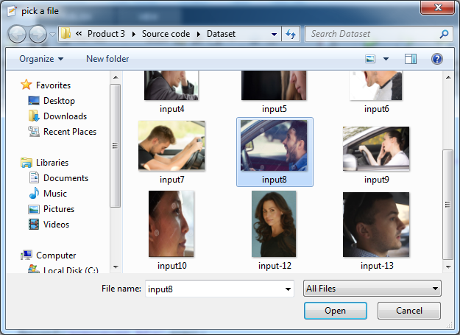

**ORIGINAL IMAGE**

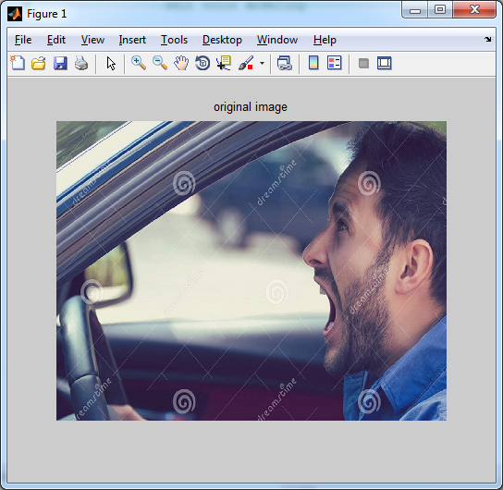

1. **BASIC EXTRACTION**

The goal of side face extraction is to obtain a side facecontour line. During this phase, color correction and skincolor modeling are performed.

**Color Correction**

We assume that the mean values of the three components ofthe RGB in the image are similar to the same gray value,and they are limited in the range of [0 to 255] so that theadjustment of the RGB image of the three components isclose to Aaver .To reduce the impact of illumination, a color correctionprocedure is the rst step of the proposed method.We followGrayWorld's color equalization method [27] to remove color bias.

**The process** is as follows:

1) Extract the three components of RGB from the originalimage

2) Calculate the mean value of the RGB components

3) Calculate the average gray value

4)Calculate the gain coefficient for all three components of RGB

5) Reconstruct RGB components

6) Restrict the value range of R0, G0 and B0. The valuerange of the reconstructed RGB components is setas [0, 255]

7) Rebuild the image color.

**Skin Color Modeling**

Skin color modeling is the core step for side face regionextraction. As the basis for model establishment, color spaceshould be selected rst. In this paper, the YUV and YIQ colorspaces are used. Multiple threshold values criterion is used toconstruct the skin color model.

Process:

* Transform the RGB values into YUV space and obtain Y, U and V values
* Transform the central block from RGB into YIQ spaceand record the value I
* Calculate both the mean and standard deviation of I
* Obtain four threshold values of and I
* Normalize R, G and B values and obtain Rbase;Gbase;Bbase,Rbase
* Calculate the mean value and variance of base,denoted as basemean and basestd
* Calculate the decision threshold of RGB space
* Convert the image into YUV and YIQ color space Obtain three components Up, Vp, Ip of the object pixelpoint p.
* The false detection probability of a no-skin area is also high.

**BASIC EXTRACTION - FLOW**

Calculate Mean value

Extract RGB components

Reconstruct Images

Skin Color Modelling

Calculate Threshold Value

Calculate co-efficient of RGB

RGB=> YUV & YIQ

Threshold range to meet the R>G>B

Pixel set to 0

Pixel set to 1

No

Yes

**RGB COMPONENTS**

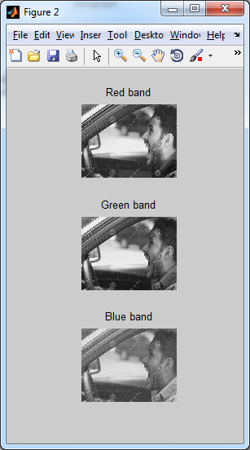

COLOR CORRECTION IMAGE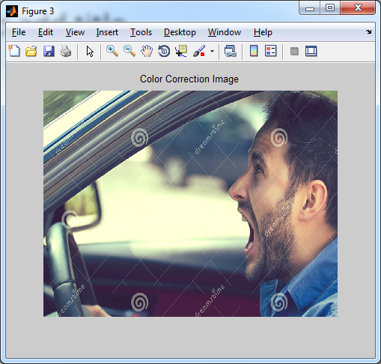

**SKIN COLOR DETECTION IMAGE**

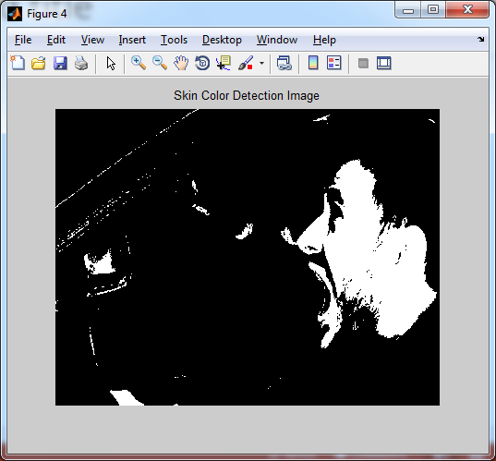

1. **SIDE FACE EXTRACTION**

The skin color modeling method is used to separate skin areas from a complex background. The images include some non-skin points, which are considered noise and should be removed by further processing. The approaches for noise removal include a texture-based method and a mathematical morphology-based method. Many experts believe that the latter is effective in irrelevant noise elimination and useful in image data simplification.

The mathematical morphology uses structural elements to measure and extract the corresponding shape in the image and then analyze the image. Two processes corrosion and expansion, are performed.

Corrosion, which shrinks all points in the subset X+Y to X, is used to reduce target scope, enlarge inner holes in connected domains and eliminate isolated noise points.

It is a filtering process, which removes image detail from a two value image. The inverse process of corrosion, expansion, expands all points in X to X+Y and increases and coarsens the two-value image to fill inner holes and connect separate domains in the image.

**SIDE FACE EXTRACTION - FLOW**

Skin color region

Maximum area preservation

Edge detection

Contour original image

YCrCB threshold segmentation

Corrosion and Expansion

Imoverlay ()

**MAXIMUM AREA PRESERVATION**

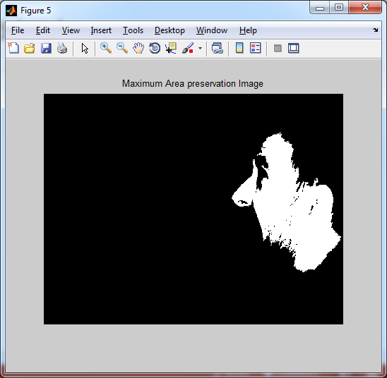

**EDGE DETECTION**

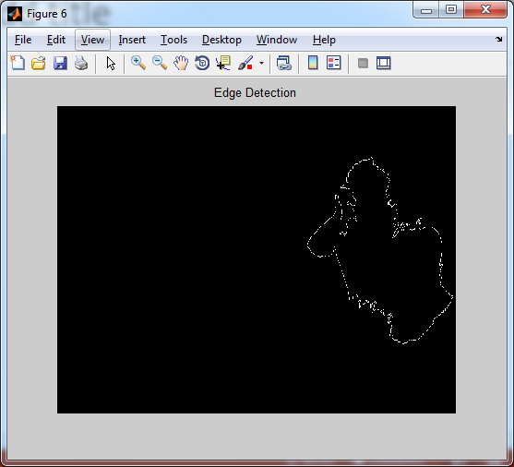

**SIDE FACE REGION EXTRACTION**

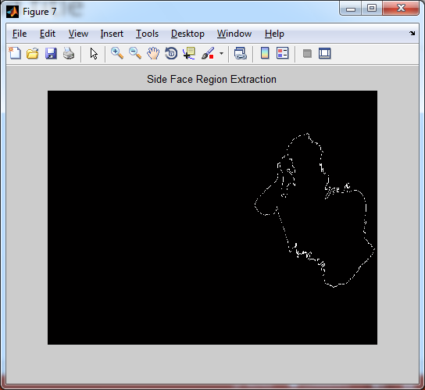

**CONTOUR ORIGINAL IMAGE**

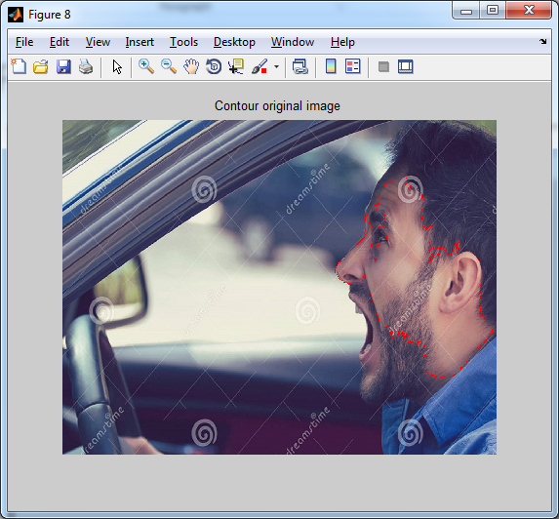

1. **FACIAL CONTOUR EXTRACTION**

* After precisely positioning the side face region, the face contour line extract process is performed.
* Find the position of the first white pixel near the upper left corner of the middle position of the image. Set it as the starting point of the boundary.
* Search for each contour point from the starting in a clockwise direction by a pre-defined 8-neighborhood matrix until return to the starting point.
* Record the coordinates that have been found for each point of the boundary to a chain table in the order of the search.
* The coordinate information stored in the chain table is extracted and connected in order, and the profile curve of the target is obtained.

Inner holes in the connected region are removed and noise is eliminated. The proposed method involves no hole-filling process, which causes high computation complexity.

**FACIAL CONTOUR EXTRACTION – FLOW**

Facial region

Facial line extraction

Search Contour point

**CONTOUR LINE EXTRACTION**

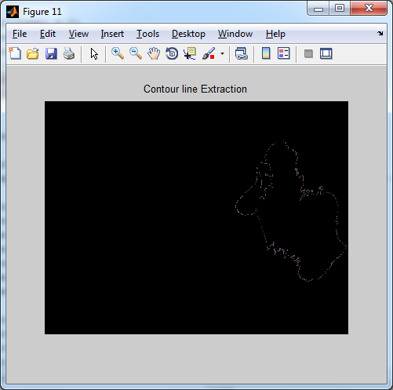

1. **VALIDATION:**

Classification models in machine learning are evaluated for their performance by common performance measures.

**Mean-Class Accuracy:**

Is obtained averaging the accuracies achieved in each of the classes. It is a more reliable measure than the overall accuracy when, as in this case, the sample distributions for the same classes are limited in number, causing an unbalanced dataset.

**Sensitivity:**

It is the proportion of actual positives which are correctly identiﬁed as positives by the classiﬁer.

**Speciﬁcity:**

Is the proportion of the actual negatives which the classiﬁer successfully identiﬁes as negative.

**Precision**

Is the number of true positives (i.e. the number of items correctly labeled as belonging to the positive class) divided by the total number of elements labeled as belonging to the positive class (i.e. the sum of true positives and false positives, which are items incorrectly labeled as belonging to the class).

**Recall**

Recall in this context is defined as the number of true positives divided by the total number of elements that actually belong to the positive class.

Recall is the fraction of the documents that are relevant to the query that are successfully retrieved. In binary classification, recall is often called sensitivity. So it can be looked at as the probability that a relevant document is retrieved by the query. It is trivial to achieve recall of 100% by returning all documents in response to any query. Therefore, recall alone is not enough but one needs to measure the number of non-relevant documents also, for example by computing the precision.

**F-Measure**

A measure that combines precision and recall is the harmonic mean of precision and recall, the traditional F-measure or balanced F-score.

F-measure can be a better single metric when compared to precision and recall; both precision and recall give different information that can complement each other when combined. If one of them excels more than the other, F-measure will reflect it.

**GMean (Geometric Mean)**

The geometric mean is a type of mean or average, which indicates the central tendency or typical value of a set of numbers by using the product of their values.

A geometric mean is often used when comparing different items—finding a single "figure of merit" for these items—when each item has multiple properties that have different numeric ranges.

**VALIDATION – FLOW**

Original binary image

Facial extracted binary image

Performance

Accuracy

Sensitivity

Specificity

F-measure

G-Mean

Recall

Precision

Evaluate

**PERFORMANCE COMPARISON – BAR CHART**

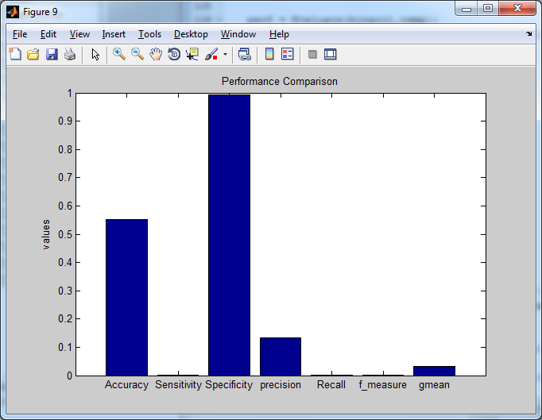

**PERFORMANCE RESULT**

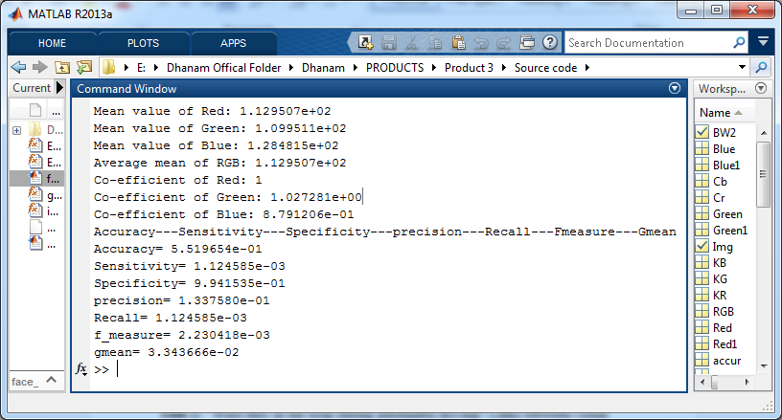

**LITERATURE SURVEY**

**Title 1:** “Were they in the loop during automated driving? Links between visual

Attention and crash potential,'' Injury Prevention,

**Author:** T. Louw et al.,

**Year:** 2016.

**Abstract**

A proposed advantage of vehicle automation is that it relieves drivers from the moment-to-moment demands of driving, to engage in other, non-driving related, tasks. However, it is important to gain an understanding of drivers’ capacity to resume manual control, should such a need arise. As automation removes vehicle control-based measures as a performance indicator, other metrics must be explored.

**Methods**

This driving simulator study, conducted under the European Commission (EC) funded Adaptive project, assessed drivers’ gaze fixations during partially-automated driving, on approach to critical and non-critical events. Using a between-participant design, 75 drivers experienced automation with one of five out-of-the-loop (OOTL) manipulations, which used different levels of screen visibility and secondary tasks to induce varying levels of engagement with the driving task:

* No manipulation,
* Manipulation by light fog,
* Manipulation by heavy fog,
* Manipulation by heavy fog plus a visual task,
* No manipulation plus an n-back task.

**Results**

The OOTL manipulations influenced drivers’ first point of gaze fixation after they were asked to attend to an evolving event. Differences resolved within one second and visual attention allocation adapted with repeated events, yet crash outcome was not different between OOTL manipulation groups. Drivers who crashed in the first critical event showed an erratic pattern of eye fixations towards the road Centre on approach to the event, while those who did not demonstrated a more stable pattern.

**Conclusions**

Automated driving systems should be able to direct drivers’ attention to hazards no less than 6 seconds in advance of an adverse outcome.

**Advantage:**

* Resolved within one second and visual attention allocation adapted with repeated events

**Disadvantage:**

* We did not demonstrated a more stable pattern.

**Title 2:** “Driver fatigue detection system,'' in Proc. Int. Conf. Inf. Process.

**Author:** F. S. C. Clement, A. Vashistha, and E. M Rane

**Year:** 2015

**Abstract:**

Fatigued driving detection, which employs pattern recognition to discover the state of a driver's fatigue, is considered a key technique to improve road safety. However, the widely used frontal face recognition systems have problems, such as low recognition accuracy, poor real-time ability, and highly complex algorithms.

A new color space modeling, which uses multi-threshold decision criteria, is used to enhance facial skin extraction performance, and a three-step strategy is designed to eliminate noise and other adverse effects. Experiments show that the proposed algorithm can extract side face contour lines effectively and provide a scientific basis for real-time tracking of fatigue.

**Introduction**

Road safety is a ‘grand challenge’ for a modern industrial society with close to a billion vehicles on the road today that are projected to double over the next 20 years. Traffic accidents take tens of thousands of lives each year, outnumbering deadly diseases or natural disasters.

The increasing number of traffic accidents due to a driver’s diminished vigilance level has become a serious problem. A number of studies have shown that driver drowsiness is one of the major causes of road accidents, and driver hypo-vigilance related accidents always lead to severe injuries and losses.

**Controlled Indexing**

* decision theory
* face recognition
* feature extraction
* image colour analysis
* image denoising
* skin

**Non-Controlled Indexing**

real-time fatigue tracking, side face contour line extraction, facial skin extraction performance, multi threshold decision criteria, color space modeling, frontal face recognition system, road safety, pattern recognition, fatigued driving detection, driving fatigue statue recognition, side face contour extraction algorithm

**Advantage:**

* Evaluate the fitness of a semantic description for interpreting the emotion of a face image.

**Disadvantage:**

* Facial expression recognition results obtained in terms of low-level features and high-level semantic description is small.

**Title 3:** “Illumination invariant face recognition using near-infrared images,''

**Author:** S. Z. Li, R. Chu, S. Liao, and L. Zhang

**Year:** Apr. 2007.

**Abstract:**

Local binary pattern (LBP) is a nonparametric descriptor, which efficiently summarizes the local structures of images. In recent years, it has aroused increasing interest in many areas of image processing and computer vision and has shown its effectiveness in a number of applications, in particular for facial image analysis, including tasks as diverse as face detection, face recognition, facial expression analysis, and demographic classification.

It presents a comprehensive survey of LBP methodology, including several more recent variations. As a typical application of the LBP approach, LBP-based facial image analysis is extensively reviewed, while its successful extensions, which deal with various tasks of facial image analysis, are also highlighted.

**Introduction:**

During the past few years, local binary patterns (LBPs) have aroused increasing interest in image processing and computer vision. As a nonparametric method, LBP summarizes local structures of images efficiently by comparing each pixel with its neighboring pixels.

The most important properties of LBP are its tolerance regarding monotonic illumination changes and its computational simplicity. LBP was originally proposed for texture analysis, and has proved a simple yet powerful approach to describe local structures.

It has been extensively exploited in many applications, for instance, face image analysis, image and video retrieval, environment modeling, visual inspection, motion analysis, biomedical and aerial image analysis, and remote sensing.

**Keywords**

Image analysis, Feature extraction, Histograms, Face detection, Face recognition, Facial features.

**Controlled Indexing**

Object detection, computer vision, face recognition, nonparametric statistics.

**Non-Controlled Indexing**

LBP, local binary patterns, facial image analysis, nonparametric descriptor, image processing, computer vision, face detection, face recognition, facial expression analysis, demographic classification

**Advantages:**

* Efficiently summarizes the local structures of images.
* Efficiently comparing each pixel with its neighboring pixels.

**Disadvantage:**

* Extensively exploited in many applications

**Title 4:** “Detecting faces in images: A survey,''

**Author:** M.-H. Yang, D. Kriegman, and N. Ahuja

**Year:** Jan. 2002.

**Abstract:**

Images containing faces are essential to intelligent vision-based human-computer interaction, and research efforts in face processing include face recognition, face tracking, pose estimation and expression recognition. However, many reported methods assume that the faces in an image or an image sequence have been identified and localized.

To build fully automated systems that analyze the information contained in face images, robust and efficient face detection algorithms are required. Given a single image, the goal of face detection is to identify all image regions which contain a face, regardless of its 3D position, orientation and lighting conditions. Such a problem is challenging because faces are non-rigid and have a high degree of variability in size, shape, color and texture.

Numerous techniques have been developed to detect faces in a single image, and the purpose is to categorize and evaluate these algorithms. We also discuss relevant issues such as data collection, evaluation metrics and benchmarking. After analyzing these algorithms and identifying their limitations, we conclude with several promising directions for future research.

**Introduction**

With the ubiquity of new information technology and media, more effective and friendly methods for human computer interaction (HCI) are being developed which do not rely on traditional devices such as keyboards, mice, and displays. Furthermore, the ever decreasing price/performance ratio of computing coupled with recent decreases in video image acquisition cost imply that computer vision systems can be deployed in desktop and embedded systems.

The rapidly expanding research in face processing is based on the premise that information about a user's identity, state, and intent can be extracted from images, and that computers can then react accordingly, e.g., by observing a person's facial expression.

In the last five years, face and facial expression recognition have attracted much attention though they have been studied for more than 20 years by psychophysicists, neuroscientists, and engineers. Many research demonstrations and commercial applications have been developed from these efforts.

A first step of any face processing system is detecting the locations in images where faces are present. However, face detection from a single image is a challenging task because of variability in scale, location, orientation (up-right, rotated), and pose (frontal, profile). Facial expression, occlusion, and lighting conditions also change the overall appearance of faces.

**Keywords**

Face detection, Face recognition, Human computer interaction, Facial features, Algorithm design and analysis, Shape, Machine learning algorithms, Pattern recognition, Computer vision, Nose

**Controlled Indexing**

Feature extraction, face recognition, object detection, reviews, and computer vision

**Non-Controlled Indexing**

machine learning, face detection algorithms, face images, survey, intelligent vision-based human-computer interaction, face recognition, face tracking, pose estimation, expression recognition, image sequence, fully automated systems, 3D position, face orientation, lighting conditions, face size, face shape, face color, face texture, data collection, evaluation metrics, benchmarking, object recognition, view-based recognition, statistical pattern recognition

**Advantage:**

* Detect faces in a single image, categorize and evaluate algorithms.

**Disadvantage:**

* Robust and efficient face detection algorithms are required.

**Title 5:** “A performance evaluation of local descriptors,'' IEEE Trans. Pattern Anal.

Mach. Intel.

**Author:** K. Mikolajczyk and C. Schmid

**Year:** Oct. 2005.

**Abstract:**

We compare the performance of descriptors computed for local interest regions, as, for example, extracted by the Harris-Affine detector [Mikolajczyk, K and Schmid, C, 2004]. Many different descriptors have been proposed in the literature. It is unclear which descriptors are more appropriate and how their performance depends on the interest region detector.

The descriptors should be distinctive and at the same time robust to changes in viewing conditions as well as to errors of the detector. Our evaluation uses as criterion recall with respect to precision and is carried out for different image transformations. We compare shape context [Belongie, S, et al., April 2002], steerable filters [Freeman, W and Adelson, E, Setp. 1991], PCA-SIFT [Ke, Y and Sukthankar, R, 2004], differential invariants [Koenderink, J and van Doorn, A, 1987], spin images [Lazebnik, S, et al., 2003], SIFT [Lowe, D. G., 1999], complex filters [Schaffalitzky, F and Zisserman, A, 2002], moment invariants [Van Gool, L, et al., 1996], and cross-correlation for different types of interest regions.

We also propose an extension of the SIFT descriptor and show that it outperforms the original method. Furthermore, we observe that the ranking of the descriptors is mostly independent of the interest region detector and that the SIFT-based descriptors perform best. Moments and steerable filters show the best performance among the low dimensional descriptors.

**Introduction**:

Local photometric descriptors computed for interest regions have proven to be very successful in applications such as wide baseline matching, object recognition, texture recognition, image retrieval, robot localization, video data min in, building panoramas, and recognition of object categories. They are distinctive, robust to occlusion, and do not require segmentation. Recent work has concentrated on making these descriptors invariant to image transformations. The idea is to detect image regions covariant to a class of transformations, which are then used as support regions to compute invariant descriptors.

**Keywords**

Detectors, Filters, Robustness, Image recognition, Information retrieval, Image retrieval, Performance evaluation, Layout, Image databases, Spatial databases

**Controlled Indexing**

Image classification, filtering theory, correlation methods, image matching

**Non-Controlled Indexing**

Image matching, performance evaluation, local descriptors, image transformations, steerable filters, spin images, complex filters, moment invariants, cross-correlation.

**Advantage:**

* Show the best performance among the low dimensional descriptors

**Disadvantage:**

* Invariant to image transformations

**Title 6:** “Semantic-based facial expression recognition using analytical hierarchy

Process,” Expert Syst. Appl.

**Author:** S. C. Cheng, M. Y. Chen, H. Y. Chang, and T. C. Chou

**Year:** Jun. 2007.

**Abstract**

We present an automatic facial expression recognition system that utilizes a semantic-based learning algorithm using the analytical hierarchy process (AHP). All the automatic facial expression recognition methods are similar in that they first extract some low-level features from the images or video, then these features are used as inputs into a classification system, and the outcome is one of the preselected emotion categories.

Although the effectiveness of low-level features in automatic facial expression recognition systems has been widely studied, the success is shadowed by the innate discrepancy between the machine and human perception to the image.

The gap between low-level visual features and high-level semantics should be bridged in a proper way in order to construct a seamless automatic facial expression system satisfying the user perception.

For this purpose, we use the AHP to provide a systematical way to evaluate the fitness of a semantic description for interpreting the emotion of a face image.

A semantic-based learning algorithm is also proposed to adapt the weights of low-level visual features for automatic facial expression recognition.

The weights are chosen such that the discrepancy between the facial expression recognition results obtained in terms of low-level features and high-level semantic description is small.

In the recognition phase, only the low-level features are used to classify the emotion of an input face image. The proposed semantic learning scheme provides a way to bridge the gap between the high-level semantic concept and the low-level features for automatic facial expression recognition.

Experimental results show that the performance of the proposed method is excellent when it is compared with that of traditional facial expression recognition methods.

**Keywords**

Facial expression recognition, Low-level visual feature, High-level semantic concept, Analytical hierarchy process, Semantic learning.

**Advantage:**

It has the effectiveness of low-level features in automatic facial expression recognition systems.

**Disadvantage:**

It extract the low level feature from the image.

**Title 7:** “Stationary features and cat detection''

**Author:** F. Fleuret and D. Geman

**Year:** Mar. 2008.

**Abstract**:

Most discriminative techniques for detecting instances from object categories in still images consist of looping over a partition of a pose space with dedicated binary classifiers. The efficiency of this strategy for a complex pose, that is, for fine-grained descriptions, can be assessed by measuring the effect of sample size and pose resolution on accuracy and computation.

Two conclusions emerge:

Fragmenting the training data, which is inevitable in dealing with high in-class variation, severely reduces accuracy;

The computational cost at high resolution is prohibitive due to visiting a massive pose partition.

To overcome data-fragmentation we propose a novel framework centered on pose-indexed features which assign a response to a pair consisting of an image and a pose, and are designed to be stationary: the probability distribution of the response is always the same if an object is actually present. Such features allow for efficient, one-shot learning of pose-specific classifiers. To avoid expensive scene processing, we arrange these classifiers in a hierarchy based on nested partitions of the pose; as in previous work on coarse-to-fine search, this allows for efficient processing.

The hierarchy is then "folded" for training: all the classifiers at each level are derived from one base predictor learned from all the data. The hierarchy is "unfolded" for testing: parsing a scene amounts to examining increasingly finer object descriptions only when there is sufficient evidence for coarser ones.

In this way, the detection results are equivalent to an exhaustive search at high resolution. We illustrate these ideas by detecting and localizing cats in highly cluttered greyscale scenes.

**Introduction**:

This work is about a new strategy for supervised learning designed for detecting and describing instances from semantic object classes instill images. Conventional examples include faces, cars and pedestrians. We want to do more than say whether or not there are objects in the scene; we want to provide a description of the pose of each detected instance.

For example the locations of certain landmarks. More generally, pose could refer to any properties of object instantiations which are not directly observed; however, we shall concentrate on geometric descriptors such as scales, orientations and locations.

**Advantage:**

**Disadvantage:**

Chance to data fragmentation.

**Title 8:** “Online signature verification based on null component analysis and

principal component analysis,”

**Author:** B. Li, D. Zhang, and K. Wang

**Year:** Oct. 2006.

**Abstract**

It introduces a new approach for point-to-point correspondence finding, which can be used as pre-processing stage of a handwritten signature verification procedure. This approach provides a solid basis for comparing function features of two handwritten signatures. Corner points of the signatures are first extracted based on velocity information.

The characteristics of curvilinear velocity and angular velocity are combined successfully by functions based on membership criteria. The signatures to be compared are then segmented at landmarks obtained by corner matching based on similarity measures.

In the last step, the corresponding pairs of segments are mapped by a point-to-point matching algorithm, minimising a curve deformation energy. The techniques described were applied to a set of 188 signatures from 19 volunteers. The resulting point-to-point matching of signature pairs was satisfactory in all cases where there was a visual agreement between the signatures.

**Keywords:**

Character recognition; Curve characterization; Feature extraction; handwritten text processing; Pattern matching; Signature verification

**Introduction:**

In a signature verification biometric, we compare the features of a test signature against those from a set of genuine signatures of a user enrolled to the system. Based on a matching score, a decision is made to either accept the claimed signature as genuine or to reject it as a forgery. In online signature verification, we make use of the temporal functions of attributes captured during the signing process. The input comprises a set of strokes, each of which in turn are a sequence of points. A stroke starts with a pen-down and ends with the next pen-up status signal. The research area of signature verification falls under the purview of handwriting analysis.

In the area of computerized security, signature verification is becoming more and more important as a technique for personal identification. The early work on signature verification can be traced back to the 1960s. Plamond on and Lorette presented a summary of previous work in 1989,and a further summary was made by Leclerc and Plamond on in 1994 [2]. Approaches to signature verification that have been studied can roughly be classified into two groups, according to the different kinds of features dealt with [1].In the first group, verification is based on comparing ‘function’ features by point-to-point matching.

**Title 9:** “Face detection in color images,'' in Proc. IEEE ICIPZOOI, Thessaloniki,

Greece.

**Author:** R.-L. Hsu, M. Abdel-Mottaleb, and A. K. Jain

**Year:** Mar. 2001

**Abstract:**

Detecting and recognizing human faces automatically in digital images strongly enhance content-based video indexing systems. A novel scheme for human faces detection in color images under no constrained scene conditions, such as the presence of a complex background and uncontrolled illumination, is presented.

Color clustering and filtering using approximations of the YCbCr and HSV skin color subspaces are applied on the original image, providing quantized skin color regions.

A merging stage is then iteratively performed on the set of homogeneous skin color regions in the color quantized image, in order to provide a set of potential face areas. Constraints related to shape and size of faces are applied, and face intensity texture is analyzed by performing a wavelet packet decomposition on each face area candidate inorder to detect human faces.

The wavelet coefficients of the band filtered images characterize the face texture and a set of simple statistical deviations is extracted in order to form compact and meaningful feature vectors.

Then, an efficient and reliable probabilistic metric derived from the Bhattacharyya distance is used in order to classify the extracted feature vectors into face or no face areas, using some prototype face area vectors, acquired in a previous training stage.

**Introduction:**

A general and efficient design approach using a radial basis function (RBF) neural classifier to cope with small training sets of high dimension, which is a problem frequently encountered in face recognition, is presented. In order to avoid overfitting and reduce the computational burden, face features are first extracted by the principal component analysis (PCA) method. Then, the resulting features are further processed by the Fisher's linear discriminant (FLD) technique to acquire lower-dimensional discriminant patterns.

A novel paradigm is proposed whereby data information is encapsulated in determining the structure and initial parameters of the RBF neural classifier before learning takes place.

A hybrid learning algorithm is used to train the RBF neural networks so that the dimension of the search space is drastically reduced in the gradient paradigm. Simulation results conducted on the ORL database show that the system achieves excellent performance both in terms of error rates of classification and learning efficiency.

**Keywords**

Face detection, Skin, Merging, Humans, Face recognition, Image recognition, Digital images, Indexing, Color, Layout

**Controlled Indexing**

pattern clustering, face recognition, wavelet transforms

**Non-Controlled Indexing**

wavelet packet decomposition, quantized skin color, wavelet, merging, recognizing human faces, content-based video indexing, faces detection, color images, skin color

**Title 10:** “Sensitive body image detection technologybased on skin color and texture

cues,” in Proc. Int. Congr. Image SignalProcess.,

**Author:** Y.Wang, X.Wu, and L. Yang.

**Year:** 2010

**Abstract:**

It researches the features of pornographic videos sensitive body videos, and presents a method to recognize and shield the sensitive content automatically. Skin color is one of important cues for pornographic video's detection.

Firstly, transform the color space, calculate Gaussian probability distribution, definite threshold value, analyze texture and noise to extract skin message from a frame image, and then build a skin color mask.

Secondly, study the differences between sensitive body image and normal image in skin color distribution to extract some effective factors for judging and determine threshold values of the judgment factors.

Finally, judge whether there is sensitive content in a frame image using the values of the factors and make the appropriate process for current frame according to the judgment result. Our algorithm achieves the satisfactory experimental results of shielding the sensitive content automatically when people watch video.

**Introduction**

With the development of computers and Internet technology, video will be the main carrier for information and is spreading more broadly and rapidly. Absolutely, this is to enhance the quality of people's life. However, it also brings new risks, especially for the younger.

The possibility for them to come into contact with pornographic videos is much larger, which makes a negative impact to the community. Therefore, it is an important task to prevent the spread of sensitive video content. Filtering sensitive content has become a research focus in image processing field and artificial intelligence field.

**Keywords**

Image color analysis, Skin, Pixel, Videos, Colored noise, Feature extraction.

**Controlled Indexing**

Image texture, feature extraction, Gaussian distribution, image colour analysis.

**Non-Controlled Indexing**

Sensitive body image detection technology, skin color, texture cue, pornographic video detection, Gaussian probability distribution, threshold value, texture analyses, noise analyses, skin color mask, skin color distribution.

**TESTING OF PRODUCT**

System testing is the stage of implementation, which aimed at ensuring that system works accurately and efficiently before the live operation commence.

Testing is the process of executing a program with the intent of finding an error. A good test case is one that has a high probability of finding an error. A successful test is one that answers a yet undiscovered error.

Testing is vital to the success of the system.  System testing makes a logical assumption that if all parts of the system are correct, the goal will be successfully achieved.  The candidate system is subject to variety of tests-on-line response, Volume Street, recovery and security and usability test.

 A series of tests are performed before the system is ready for the user acceptance testing. Any engineered product can be tested in one of the following ways.

Knowing the specified function that a product has been designed to from, test can be conducted to demonstrate each function is fully operational.

Knowing the internal working of a product, tests can be conducted to ensure that “al gears mesh”, that is the internal operation of the product performs according to the specification and all internal components have been adequately exercised.

**UNIT TESTING:**

Unit testing is the testing of each module and the integration of the overall system is done.  Unit testing becomes verification efforts on the smallest unit of software design in the module.  This is also known as ‘module testing’.

The modules of the system are tested separately.  This testing is carried out during the programming itself.  In this testing step, each model is found to be working satisfactorily as regard to the expected output from the module.  There are some validation checks for the fields.

For example, the validation check is done for verifying the data given by the user where both format and validity of the data entered is included.  It is very easy to find error and debug the system.

**INTEGRATION TESTING:**

Data can be lost across an interface, one module can have an adverse effect on the other sub function, when combined, may not produce the desired major function.

Integrated testing is systematic testing that can be done with sample data.  The need for the integrated test is to find the overall system performance. There are two types of integration testing. They are:

1. Top-down integration testing.
2. Bottom-up integration testing.

**WHITE BOX TESTING:**

White Box testing is a test case design method that uses the control structure of the procedural design to drive cases.  Using the white box testing methods, we derived test cases that guarantee that all independent paths within a module have been exercised at least once.

**BLACK BOX TESTING:**

* + Black box testing is done to find incorrect or missing function
  + Interface error
  + Errors in external database access
  + Performance errors
  + Initialization and termination errors

In ‘functional testing’, is performed to validate an application conforms to its specifications of correctly performs all its required functions. So this testing is also called ‘black box testing’.  It tests the external behavior of the system.  Here the engineered product can be tested knowing the specified function that a product has been designed to perform, tests can be conducted to demonstrate that each function is fully operational.

**VALIDATION TESTING:**

After the culmination of black box testing, software is completed assembly as a package, interfacing errors have been uncovered and corrected and final series of software validation tests begin validation testing can be defined as many, but a single definition is that validation succeeds when the software functions in a manner that can be reasonably expected by the customer.

# **USER ACCEPTANCE TESTING:**

User acceptance of the system is the key factor for the success of the system.  The system under consideration is tested for user acceptance by constantly keeping in touch with prospective system at the time of developing changes whenever required.

# **OUTPUT TESTING:**

After performing the validation testing, the next step is output asking the user about the format required testing of the proposed system, since no system could be useful if it does not produce the required output in the specific format.  The output displayed or generated by the system under consideration.  Here the output format is considered in two ways.  One is screen and the other is printed format.

The output format on the screen is found to be correct as the format was designed in the system phase according to the user needs.  For the hard copy also output comes out as the specified requirements by the user. Hence the output testing does not result in any connection in the system.

**System Implementation:**

Implementation of software refers to the final installation of the package in its real environment, to the satisfaction of the intended users and the operation of the system. The people are not sure that the software is meant to make their job easier.

* The active user must be aware of the benefits of using the system
* Their confidence in the software built up
* Proper guidance is impaired to the user so that he is comfortable in using the application

Before going ahead and viewing the system, the user must know that for viewing the result, the server program should be running in the server. If the server object is not running on the server, the actual processes will not take place.

**User Training:**

To achieve the objectives and benefits expected from the proposed system it is essential for the people who will be involved to be confident of their role in the new system. As system becomes more complex, the need for education and training is more and more important.

Education is complementary to training. It brings life to formal training by explaining the background to the resources for them. Education involves creating the right atmosphere and motivating user staff. Education information can make training more interesting and more understandable.

**Training on the Application Software:**

After providing the necessary basic training on the computer awareness, the users will have to be trained on the new application software. This will give the underlying philosophy of the use of the new system such as the screen flow, screen design, type of help on the screen, type of errors while entering the data, the corresponding validation check at each entry and the ways to correct the data entered. This training may be different across different user groups and across different levels of hierarchy.

**Operational Documentation:**

Once the implementation plan is decided, it is essential that the user of the system is made familiar and comfortable with the environment. A documentation providing the whole operations of the system is being developed. Useful tips and guidance is given inside the application itself to the user.

The system is developed user friendly so that the user can work the system from the tips given in the application itself.

**System Maintenance:**

The maintenance phase of the software cycle is the time in which software performs useful work. After a system is successfully implemented, it should be maintained in a proper manner. System maintenance is an important aspect in the software development life cycle.

The need for system maintenance is to make adaptable to the changes in the system environment. There may be social, technical and other environmental changes, which affect a system which is being implemented. Software product enhancements may involve providing new functional capabilities, improving user displays and mode of interaction, upgrading the performance characteristics of the system.

**Corrective Maintenance:**

The first maintenance activity occurs because it is unreasonable to assume that software testing will uncover all latent errors in a large software system. During the use of any large program, errors will occur and be reported to the developer. The process that includes the diagnosis and correction of one or more errors is called Corrective Maintenance.

**Adaptive Maintenance:**

The second activity that contributes to a definition of maintenance occurs because of the rapid change that is encountered in every aspect of computing. Therefore Adaptive maintenance termed as an activity that modifies software to properly interfere with a changing environment is both necessary and commonplace.

**Perceptive Maintenance:**

The third activity that may be applied to a definition of maintenance occurs when a software package is successful. As the software is used, recommendations for new capabilities, modifications to existing functions, and general enhancement are received from users.

To satisfy requests in this category, Perceptive maintenance is performed. This activity accounts for the majority of all efforts expended on software maintenance.

**Preventive Maintenance:**

The fourth maintenance activity occurs when software is changed to improve future maintainability or reliability, or to provide a better basis for future enhancements. Often called preventive maintenance, this activity is characterized by reverse engineering and re-engineering techniques.

**SYSTEM REQUIREMENTS**

**Hardware Requirements:**

* System : Intel Core
* Hard Disk : 160 GB
* Ram : 2GB

**Software Requirements:**

* O/S : Windows 7.
* IDE : MATLAB R2013a

**SOFTWARE DESCRIPTION**

**MATLAB:**

MATLAB is a high-performance language for technical computing. It integrates computation, visualization, and programming in an easy-to-use environment where problems and solutions are expressed in familiar mathematical notation. MATLAB is a [fourth-generation programming language](http://whatis.techtarget.com/definition/programming-language-generations) and numerical analysis environment.

Typical uses include:

* Math and computation
* Algorithm development
* Modeling, simulation, and prototyping
* Data analysis, exploration, and visualization
* Scientific and engineering graphics
* Application development, including Graphical User Interface building

MATLAB is an interactive system whose basic data element is an array that does not require dimensioning. This allows you to solve many technical computing problems, especially those with matrix and vector formulations, in a fraction of the time it would take to write a program in a scalar noninteractive language such as C or FORTRAN.

The name MATLAB stands for matrix laboratory. MATLAB was originally written to provide easy access to matrix software developed by the LINPACK and EISPACK projects, which together represent the state-of-the-art in software for matrix computation.

MATLAB has evolved over a period of years with input from many users. In university environments, it is the standard instructional tool for introductory and advanced courses in mathematics, engineering, and science. In industry, MATLAB is the tool of choice for high-productivity research, development, and analysis.

**MATLAB features**

* A family of application-specific solutions called toolboxes.
* Very important to most users of MATLAB, toolboxes allow you to *learn* and *apply* specialized technology.
* Toolboxes are comprehensive collections of MATLAB functions (M-files) that extend the MATLAB environment to solve particular classes of problems.
* Areas in which toolboxes are available include signal processing, control systems, neural networks, fuzzy logic, wavelets, simulation, and many others.

**The MATLAB System:**

The MATLAB system consists of five main parts:

1. **The MATLAB language.**

This is a high-level matrix/array language with control flow statements, functions, data structures, input/output, and object-oriented programming features. It allows both "programming in the small" to rapidly create quick and dirty throw-away programs, and "programming in the large" to create complete large and complex application programs.

1. **The MATLAB working environment.**

This is the set of tools and facilities that you work with as the MATLAB user or programmer. It includes facilities for managing the variables in your workspace and importing and exporting data. It also includes tools for developing, managing, debugging, and profiling M-files, MATLAB's applications.

1. **Handle Graphics.**

This is the MATLAB graphics system. It includes high-level commands for two-dimensional and three-dimensional data visualization, image processing, animation, and presentation graphics. It also includes low-level commands that allow you to fully customize the appearance of graphics as well as to build complete Graphical User Interfaces on your MATLAB applications.

1. **The MATLAB mathematical function library.**

This is a vast collection of computational algorithms ranging from elementary functions like sum, sine, cosine, and complex arithmetic, to more sophisticated functions like matrix inverse, matrix eigenvalues, Bessel functions, and fast Fourier transforms.

1. **The MATLAB Application Program Interface (API).**

This is a library that allows you to write C and FORTRAN programs that interact with MATLAB. It include facilities for calling routines from MATLAB (dynamic linking), calling MATLAB as a computational engine, and for reading and writing MAT-files.

Uses for MATLAB include [matrix](http://whatis.techtarget.com/definition/matrix) calculations, developing and running [algorithms](http://whatis.techtarget.com/definition/algorithm), creating user interfaces ([UI](http://searchsoa.techtarget.com/definition/user-interface)) and [data visualization](http://searchbusinessanalytics.techtarget.com/definition/data-visualization). The multi-[paradigm](http://whatis.techtarget.com/definition/paradigm) numerical computing environment allows developers to interface with programs developed in different languages, which makes it possible to harness the unique strengths of each language for various purposes.

MATLAB is used by engineers and scientists in many fields such as image and signal processing, communications, control systems for industry, [smart grid](http://whatis.techtarget.com/definition/smart-grid) design, [robotics](http://whatis.techtarget.com/definition/robotics) as well as computational finance.

Cleve Moler, a professor of Computer Science at the University of New Mexico, created MATLAB in the 1970s to help his students. MATLAB's commercial potential was identified by visiting engineer Jack little in 1983. Moler, Little and Steve Bangart founded MathWorks and rewrote MATLAB in [C](http://searchwindowsserver.techtarget.com/definition/C) under the auspices of their new company in 1984.

## MATLAB Programming Language

The MATLAB programming language is simpler than most programming languages and easier to learn. It is known as a high-level language because it is closer to the human language than the computer or machine language.

* The **semi-colon** in MATLAB indicates the end of statement. It can also be used to stop a statement from executing. For example, if you type in x=5+3 without the semicolon and click the Execute button, MATLAB will display the result as x=8. If you type in x=5+3; with the semicolon, and click Execute, MATLAB will not display the result of the computation.
* The **% sign** is used to indicate that the text following is a comment and not to be interpreted by MATLAB. Programmers use comments to provide explanations about the code they are writing. For example, in MATLAB you can write a=b+5 and the use the % sign to explain that 'a' is the length of a room and 'b' is the width.
* **Variable names** in MATLAB are case sensitive. For example, if you create a variable 'TempEveryHour' to represent the temperatures every hour, and need it to use this variable in a mathematical formula, you would need to call the variable by its exact same name: TempEveryHour and not TemperatureEveryHour or tempeveryhour.

MATLAB has several **advantages** over other methods or languages:

 Its basic data element is the matrix. A simple integer is considered a matrix of one row and one column. Several mathematical operations that work on arrays or matrices are built-in to the Matlab environment. For example, cross-products, dot-products, determinants, inverse matrices.

* Vectorized operations. Adding two arrays together needs only one command, instead of a for or while loop.
* The graphical output is optimized for interaction. You can plot your data very easily, and then change colors, sizes, scales, etc, by using the graphical interactive tools.
* Matlab’s functionality can be greatly expanded by the addition of toolboxes. These are sets of specific functions that provided more specialized functionality. Ex: Excel link allows data to be written in a format recognized by Excel, Statistics Toolbox allows more specialized statistical manipulation of data (Anova, Basic Fits, etc)

 There are also **Disadvantages**:

* It uses a large amount of memory and on slow computers it is very hard to use.
* It sits “on top” of Windows, getting as much CPU time as Windows allows it to have. This makes real-time applications very complicated.

**SYSTEM DESIGN**

**Introduction:**

System design is the process or art of defining the architecture, components, modules, interfaces and data for a system to satisfy specified requirements. One could see it as the application of systems theory to product development. Design is the first phase in development phase for any engineer’s product system. Design is the creative process. It deals with the creative ability of the programmer. A good design is the key to effective system. The term “Design” is defined as “The process of applying various techniques and principles for the purpose of defining a process or a system in sufficient details to permit its physical realization”.

**Input design**

The user interface design is very important for any application. The interface design describes how the software communicated within itself, to system that interpreted with it and with humans who use it. The interface is a packing for computer software if the interface is easy to learn, simple to use. If the interface design is very good, the user will fall into an interactive software application.

The input design is the process of converting the user-oriented inputs into the computer-based format. Errors entered by data entry operations can be controlled by input design. The data is fed into the system using simple interactive forms. The forms have been supplied with messages so that user can enter data without facing any difficulty.

The data is validated wherever it requires in the project. This ensures that only the correct data have been incorporated into the system. The goal for designing input data is to make data entry as easy, logical and free from errors.

The objectives of input design are:

* To produce a cost effective method of input
* To make the input forms understandable to the user
* To ensure the validation of data input
* To achieve the highest position level of accuracy

The various activities to be performed for the overall input processors are:

* Data recording at its source.
* Data transfer to input form.
* Data conversation to computer acceptable mode.
* Data validation.
* Data flow control.
* Data correction if necessary.

**Output Design**

The system output is the most important and direct source of information to the user. So intelligible output design improves the relationship with the user and helps in decision-making. Outputs from the computer systems are required primarily to communicate the results of processing to users. They are also used to provide a permanent copy of these results for later consultation.

A major form of output is a hard copy obtained from the printer. These printouts are designed to include the exact requirements of the user. The outputs required by the end-user are defined during the logical design stages.

Two phases of the output design are:

* Output definition.
* Output specification

Computer outputs are the most important and direct source of information to the user. A quality output is one which meets the requirements of the end user and which presents information in a way which is clear, easy to read and visually attractive.

The screens are designed in such a way that the outputs are provided to the user in an understandable form.

The objectives of output design are:

* Design output to serve the indented purpose.
* Provide output on time.
* Assume that output is where it is needed.
* Design output to fit the user

**FEASIBILITY STUDY**

The feasibility study is carried out to test whether the proposed system is worth being implemented. The proposed system will be selected if it is best enough in meeting the performance requirements.

The feasibility carried out mainly in three sections namely.

* Economic Feasibility

• Technical Feasibility

* Behavioural Feasibility

**Economic Feasibility**

Economic analysis is the most frequently used method for evaluating effectiveness of the proposed system. More commonly known as cost benefit analysis. This procedure determines the benefits and saving that are expected from the system of the proposed system. The hardware in system department if sufficient for system development.

**Technical Feasibility**

This study center around the system’s department hardware, software and to what extend it can support the proposed system department is having the required hardware and software there is no question of increasing the cost of implementing the proposed system. The criteria, the proposed system is technically feasible and the proposed system can be developed with the existing facility.

**Behavioural Feasibility**

People are inherently resistant to change and need sufficient amount of training, which would result in lot of expenditure for the organization. The proposed system can generate reports with day-to-day information immediately at the user’s request, instead of getting a report, which doesn’t contain much detail.

**CONCLUSION**

Because of the current number of traffic accidents and the many disadvantages of facial recognition algorithms, it presents a method of facial profile extraction. A three-step strategy is designed to extract side face contours, and a new human skin color model based on multi threshold combined decision is proposed. A series of experiments are carried out to examine the performance of the proposed method. Three typical images, which are a close image with good lighting, a remote image with poor lighting and a close image with poor lighting, are selected to verify performance of the proposed multi threshold combined decision model. An YCrCb threshold segmentation algorithm, Gaussian model and elliptical model are selected as contrast object methods. Experimental results provide solid empirical evidence of the efficiency of the proposed method. Experiments for the three steps involved show that the proposed three-step strategy is more accurate than face recognition algorithms. The hardware requirements for all cases of lower recognition rate and error rate are suitable for a variety of complex backgrounds and brightness and provide a new method for driver fatigue judgment. In future work, self-adaption of the side face extraction process should be considered, and the use of shape and luminance information in removing false detection should be examined.

**FUTURE ENHANCEMENTS**

* Feature based methods are considered effective for frontal face recognition.
* We are devoted to finding algorithms to distinguish facial features such as outline, eyes, nose, mouth, jaw, etc.
* The face outline position is the first step of recognition.
* A heuristic search method is used to revise the edge line.

**REFERENCES**

* Q. Han, L. Zeng, L. Yang, and Y. Liu, ``Experimental analysis ofCCA threshold adjusting for vehicle EWM transmission in V-CPS,''Int. J. Ad Hoc Ubiquitous Comput., vol. 21, no. 1, pp. 1_6, 2016,injuryprev-2016-042155..
* T. Louw et al., “Were they in the loop during automated driving? Linksbetween visual attention and crash potential,'' Injury Prevention, 2016.
* F. S. C. Clement, A. Vashistha, and E. M Rane, ``Driver fatigue detectionsystem,'' in Proc. Int. Conf. Inf. Process., 2015, pp. 229_234.
* S. Z. Li, R. Chu, S. Liao, and L. Zhang, ``Illumination invariant facerecognition using near-infrared images,'' IEEE Trans. Pattern Anal. Mach.Intell., vol. 29, no. 4, pp. 627_639, Apr. 2007.
* Ross and A. Jain, ``Information fusion in biometrics,'' Pattern Recognit.Lett., vol. 24, no. 13, pp. 2115_2125, 2003.
* M.-H. Yang, D. Kriegman, and N. Ahuja, ``Detecting faces in images:A survey,'' IEEE Trans. Pattern Anal. Mach. Intell., vol. 24, no. 1,pp. 34_58, Jan. 2002.
* K. Mikolajczyk and C. Schmid, ``A performance evaluation of localdescriptors,'' IEEE Trans. Pattern Anal. Mach. Intell., vol. 27, no. 10,pp. 1615_1630, Oct. 2005.
* J. Wu and Z. H. Zhou, ``Ef_cient face candidates selector for face detection,''Pattern Recognit., vol. 36, pp. 1175_1186, Jun. 2003.
* L. Breiman, J. H. Friedman, R. Olshen, and C. J. Stone, ``Classi_cationand regression trees,'' Biometrics, vol. 40, pp. 17_23, Jun. 2015.
* B. Li, D. Zhang, and K. Wang, ``Online signature veri_cation based onnull component analysis and principal component analysis,'' Pattern Anal.Appl., vol. 8, pp. 345_356, Oct. 2006.
* N. Rajput, P. Jain, and S. Shrivastava, Face Detection Using HMM_SVMMethod. Berlin, Germany: Springer, 2012.
* G. Hemalatha and C. P. Sumathi, ``A study of techniques for facial detectionand expression classi_cation,'' Int. J. Comput. Sci. Eng. Survey, vol. 5,pp. 27_37, Apr. 2014.
* T. Kohonen, ``Self-organization and associativememory,'' Appl. Opt.,vol. 8, pp. 3406_3409, Oct. 2015.[14] A. Mohan, C. Papageorgiou, and T. Poggio, “Example-based object detection in images by components,'' IEEE Trans. Pattern Anal. Mach. Intell.,vol. 23, no. 4, pp. 349_361, Apr. 2001.
* B. Zitová and J. Flusser, ``Image registration methods: A survey,'' ImageVis. Comput., vol. 21, pp. 977_1000, Jun. 2003.
* T. H. Reddy, ``Multi-view facial recognition using eigen faces by PCA and artificial neural network,'' J. High Perform. Comput., vol. 2, pp. 24_27,Mar. 2012.
* F. Fleuret and D. Geman, ``Stationary features and cat detection,'' J. Mach.Learn. Res., vol. 9, pp. 2549_2578, Mar. 2008.
* S. C. Cheng, M. Y. Chen, H. Y. Chang, and T. C. Chou, ``Semantic-basedfacial expression recognition using analytical hierarchy process,'' ExpertSyst. Appl., vol. 33, pp. 86_95, Jun. 2007.
* H. Tao, Research on Side Face Recognition. Harbin, China: Heilongjiang Univ., 2013.
* M. J. Jones and J. M. Rehg, ``Statistical color models with application to skin detection,'' Int. J. Comput. Vis., vol. 46, no. 1, pp. 8196, Jan. 2002.
* R.-L. Hsu, M. Abdel-Mottaleb, and A. K. Jain ``Face detection in color images,'' IEEE Trans. Pattern Anal. Mach. Intell., vol. 24, no. 5,pp. 696706, May 2002.
* P. Kakumanu, S. Makrogiannis, and N. Bourbakis, “A survey of skin color modeling and detection methods,” Pattern Recognit., vol. 40, no. 3,pp. 11061122, Mar. 2007.
* Y.Wang, X.Wu, and L. Yang, “Sensitive body image detection technologybased on skin color and texture cues,” in Proc. Int. Congr. Image SignalProcess., 2010, pp. 26612664.
* R.-L. Hsu, M. Abdel-Mottaleb, and A. K. Jain, ``Face detection incolor images,'' IEEE Trans. Pattern Anal. Mach. Intell., vol. 24, no. 5,pp. 696706, May 2002.
* R.-L. Hsu, M. Abdel-Mottaleb, and A. K. Jain, ``Face detection in color images,'' in Proc. IEEE ICIPZOOI, Thessaloniki, Greece, Mar. 2001.pp. 12.
* C. Garcia and G. Tziritas, ``Face detection using quantized skin colorregions merging and wavelet packet analysis,'' IEEE Trans. Multimedia, vol. 1, no. 3, pp. 264277, Sep. 1999.
* X. Zhao, ``Research on self-adaptive chroma space model skin-coloralgorithm based on brightness,'' Chin. J. Sci. Instrum., vol. 26,pp. 591594, 2005.