Project Development Phase
Model Performance Test

Date | 03 October 2026
Team ID | Team 5
Project Name | Import Data using Transform Maps (Spreadsheet)
Maximum Marks

Model Performance Testing:
Project team shall fill the following information in model performance testing template.
S.No. | Parameter | Values | Screenshot
 | Model Summary | ServiceNow data-import setup using an Import Set and a Transform Map. Spreadsheet (.xlsx) rows are loaded into an Import Set staging table; the Transform Map maps the columns to target table fields and inserts or updates records (coalesce on a key field). | 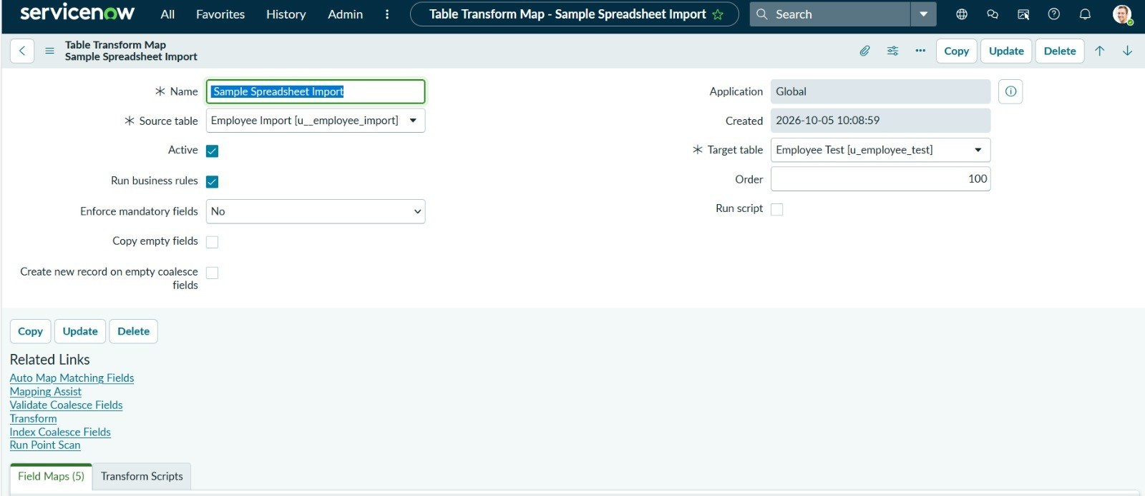
 | Accuracy | Training Accuracy - Not applicable (rule-based Transform Map; no ML model is trained)  Validation Accuracy - Import accuracy: target is 100% of valid rows inserted/updated correctly in the target table (actual: 100% - 15 of 15 rows inserted, 0 errors) | 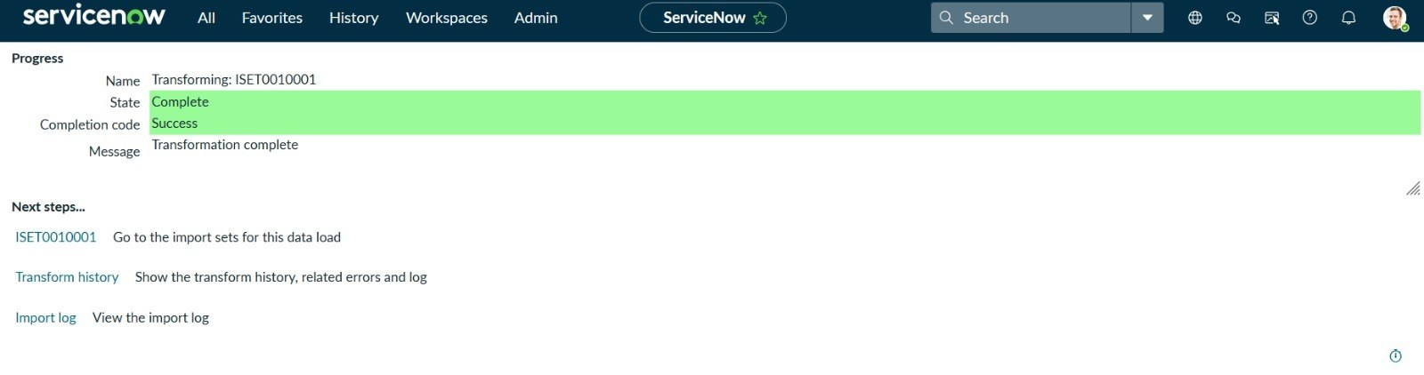  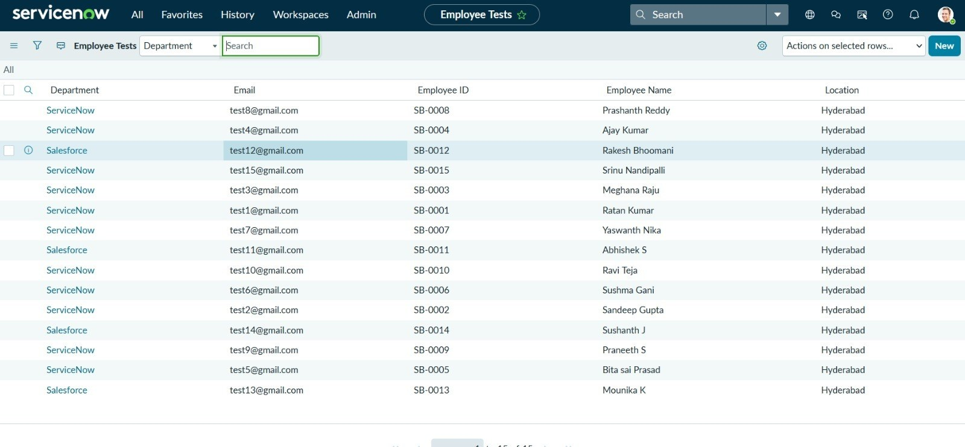
3. | Fine Tunning Result( if Done) | Validation Accuracy - Not done yet. If error or ignored rows appear on the first run, the field maps, coalesce and transform scripts will be adjusted and the transform re-run.

